

**CONTEMPORARY BUSINESS ENVIRONMENT**

**Module Code: BUS4010**

**Module Name: Company Appraisal**

**Date of Submission:**

Table of Contents

Introduction 3

a. Introduction of the organisation 3

Compare and contrast of the forms, aims, objectives, operations, and legal structures 3

Key stakeholders 4

b. Discussion of the role and impact of digitisation on business structures, operations, and strategies 4

Task 1 7

Explanation of components of micro and macroeconomics theories and their impacts on organisational behaviour and national economy 7

Task 2 9

a. Examination of leading theories of management, leadership, and control 9

Discussion on the challenges posed by the leadership 11

b. Investigation of real-world businesses using relevant tools 11

Conclusion 12

Reference list 13

# Introduction

## a. Introduction of the organisation

Contemporary business environment analysis helps to define a company's growth while operating in the continuously changing competitive market. The study presents a thorough evaluation of the key components of two companies and provides a broad understanding on the business structures and compares its operations. The chosen company is Marks & Spencer and compares its operations with H&M to develop the research.

Marks & Spencer is a well-known British multinational retailer operating in the UK and other 62 countries effectively (Corporate.marksandspencer.com, 2022). The company headquarter is in London that specialises in delivering clothing, beauty, accessories, home and food products. H&M is a famous brand that focuses on fashion and style headquartered in Stockholm and operates in more than 74 countries (Hmgroup.com, 2022). Marks and Spencer witnessed revenues of 1,088.5 crores GBP in the year 2022, which is a significant increase than the previous year (Statista.com, 2022). The company has observed a decrease in their sales in the year 2021 because of pandemic.

### Compare and contrast of the forms, aims, objectives, operations, and legal structures

Both Marks & Spencer and H&M are globally renowned companies that are leading in the fashion industry. These brands have been delivering their exclusive products through maintaining the trends of the market and meeting needs of customers. Marks & Spencer formed in the year 1884 in the UK and H&M was formed in the year 1947 in Sweden. Marks & Spencer aims to make long-term value of their products through the efficient use of their resources and materials. The company further intends to enhance their relationships and create more networks across the world in order to focus on emphasising on their core values such as inspiration, integrity, innovation, and engagement (Frc.org.uk, 2019). On the contrary, H&M aims to focus on quality and the presence of the future generations to conduct their business in a way that will fulfil the necessities to overcome challenges, economically, socially, and environmentally. This company also tends to become more sustainable with their clear ambitions and goals (Hmgroup.com, 2021). Thus, it can be determined that both companies are majorly competing with their significant aims and achieving surpassing global barriers to achieve success.

The objective of M&S is to create a sustainable business through their incredible ability to be consistent on their profitable growth and ensuring their complete accordance with responsibilities and accountability with their shareholders. In the case of H&M, their objectives are, to scale innovation, to promote transparency, and to increase the engagement with your partner for achieving global progress (Hmgroup.com, 2021). Furthermore, both companies operate in the retail industry, thus both companies are retail operation-based organisations. Marks and Spencer maintain a flat organisational structure which focuses on administrative level legal authorities and compliance with international laws and regulations to operate their business (Corporate.marksandspencer.com, 2022). On the other hand, H&M corporate governance is based on the external laws, regulations, and internal rules to operate their business.

### Key stakeholders

Stakeholders play a major role in businesses which determines exclusive operation of their organisation through overcoming barriers and global forces. Key stakeholders of Marks & Spencer are employees, customers, suppliers, and the owners (Marketscreener.com, 2022). The company mainly focuses on these key stakeholders and the other stakeholders come in second priority for the company. H&M majorly focuses on their key stakeholders, such as employees and consumers. Furthermore, the community people and specific communities that they operate in or also come in their key stakeholders’ criteria.

## b. Discussion of the role and impact of digitisation on business structures, operations, and strategies

Digitisation is an important and effective factor for businesses in the current environment which helps in achieving sustainability, through smart manufacturing of autonomous operations. Therefore, digitisation has an immense impact on the business structure, operation, and strategies of Marks & Spencer. It has been identified that, especially after pandemic, the company has observed a 62% decline in their sales (Theguardian.com, 2021). Thus, it majorly needed a change in business structure to overcome the challenges and barriers of the environment to regain growth. Therefore, the company majorly focuses on leading through digital transformation and complying with the advanced technologies to change their business structures and operation through undertaking effective strategies.

Marks & Spencer accelerated their digital transformation plans after the drop in their profits in the year 2021. The company uses 73 technology products and services including “HTML5, jQuery, and Google Analytics” (Theguardian.com, 2021). The company further enables the use of Internet of Things in order to accelerate their digitisation process. The company has also obtained an exclusive partnership strategy with digital consulting firm, TCS to accelerate their digital transformation and eliminate legacy IT systems (Newrelic.com, 2022). Therefore, it implies an evolving collaboration of the company with another firm to accelerate their success. Additionally, their collaboration with multiple technical firms also describes their effective e-commerce, networking, and e-business strategic implementation. It also helped the company to perceive a significant growth in their revenue around 1.2 billion (Statista.com, 2023). Thus, the effective usage of digitisation and transformation strategies towards e-business helped the company to accelerate and regain growth.

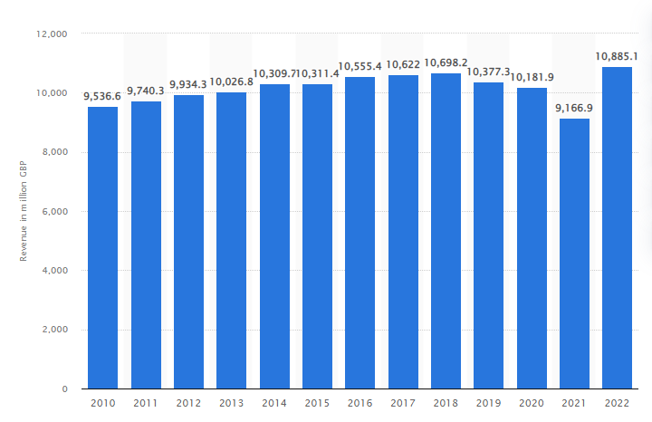

**Figure 1: “Revenue of Marks & Spencer worldwide from financial year 2010 to 2022”**

(Source: Statista.com,2023)

Digital transformation has an immense impact on the business structure in operation of the company and totally transformed into a digitised organisation. The global influence on innovation significantly enhanced their ways of decision making, working and implementation of social technologies to enhance their productivity. Currently the company uses more than 150 technologies for their website. Furthermore, the implementation of advanced technologies helped the company to reduce costs by over £350 m and the company also closed around 100 stores to focus on their digitisation and e-business (Corporate.marksandspencer.com, 2023). It also implies their exclusive corporation with advanced technologies through conducting market research and investing majorly on changing their business structure and operation into e-business.

The company has obtained effective digital marketing strategies such as; innovation, exclusive training to their employees to enhance their digital literacy and expertise in using advanced technologies. Thus, their operations and business structure experienced a significant change and a shift towards digitisation. The effective decision making of Marks & Spencer helped the company to increase their efficiency level in accepting the changes in the behaviour of consumers towards e-commerce. The incredible change in Marks & Spencer operations to comply with digital technologies such as agile applications, DevOps, AppOps, and AIOps to manage their observability and to manage their microservices helps the company to obtain digital transformation.

The change in strategies undertaken by the company is significant. Certain digital transformation strategies obtained by Marks & Spencer are; M&S Technology Theme Focus and M&S ICT Spend by Function and Channel through covering partnerships to integrate their operations with AI, IoT, blockchain technology, big data analytics and cloud computing (Globaldata.com, 2022). The company's total spending on their integration with digitisation is around $395.8 million in the year 2022. Thus, it majorly helps the company to incorporate digital accommodation and through changing business structure, operations, and strategies.

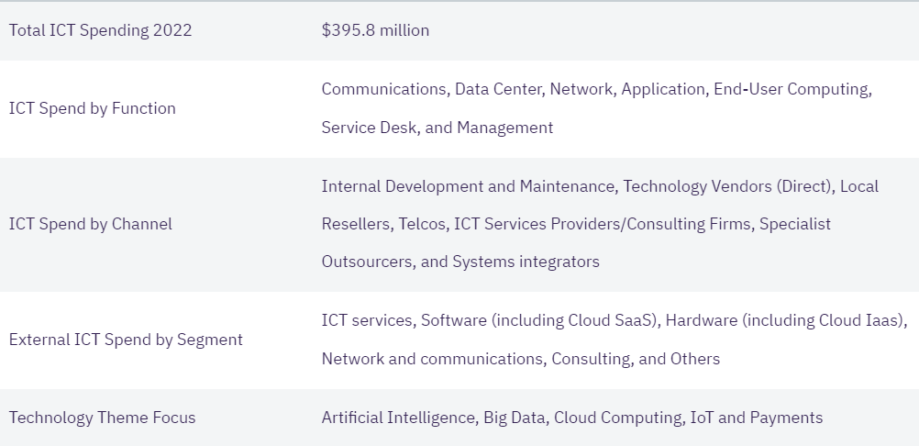

**Figure 2: M&S Digitisation Strategies Overview**

(Source: Globaldata.com, 2022)

# Task 1

## Explanation of components of micro and macroeconomics theories and their impacts on organisational behaviour and national economy

Microeconomic factors depend on the internal business decisions whereas macro-economic factors depend on the decisions of the countries and governments. The further study determines the components of micro and macroeconomic components of M&S.

**Microeconomic components**

***Supply and demand, production and cost of production***

The supply chain of Marks and Spencer is very cost effective with several outsourcing strategies benefiting the company. According to the study of Kadyrovnaet al., (2022), the supply and demand law determines an organisation's strategy of producing products and imposing prices according to it. As per the supply law, when price increases, companies tend to increase their supply of products in order to generate more profit. However, according to demand law, when price increases, consumers buy fewer products. In this case, as Marks & Spencer operates in the fashion industry, it strategically imposes prices and their supply of products regarding the demand of their services and products to satisfy the needs of the consumers. The company provides their services to nearly 30 million consumers and their suppliers move their products across 1000 factories (Corporate.marksandspencer.com, 2019). Therefore, the supply chain and supply and demand. Components have effectively project decisions of Marks & Spencer. The company invests more than £480 million in their production to increase their quality and value of the brand (Magazine.com, 2021). Thus, it helps the company to determine effective branding along with complying with quality to satisfy the needs of their consumers.

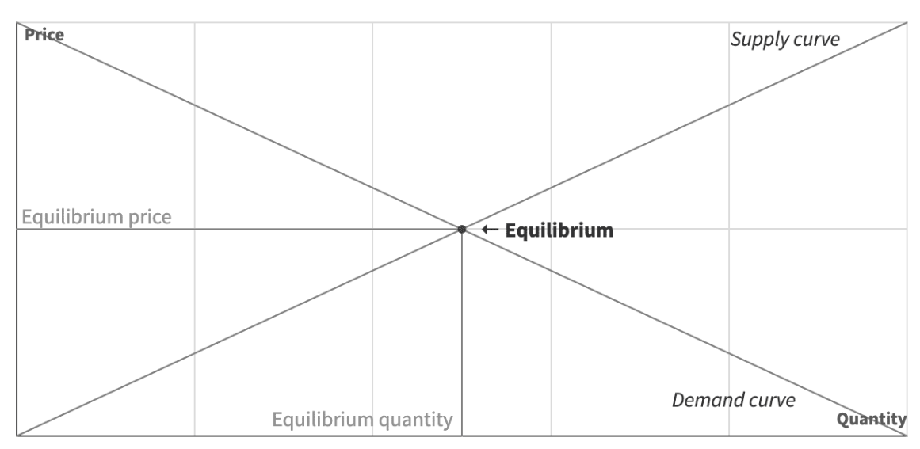

**Figure 3: Law of Supply and Demand**

(Source: Lesson 3, Topic 2)

***Economic Problem***

The company also focuses on the well-being of the employees and labourers across the world. However, the company imposed a labour toolkit for their international suppliers in order to generate significant revenues. The company has almost over 78,000 employees that majorly work for the company to perceive growth. Furthermore, during the pandemic and weak economy the company cut over 7000 employees in three months (Statista.com, 2022). It majorly affected the company and the reputation of it.

**Macroeconomic components**

***Economic, Political, technological, and Social***

Fashion industry contributes around £26 billion to the economy of the UK (Britishcouncil.org, 2022). Thus, it majorly supports the operation of M&S. Stable political environment helps the company to enlarge their business and perceive success. The emergence of the industry 5.0 majorly intrigues the company to further increase their digitisation factors. Social and environmental positive contribution and SDG goals are being supported by M&S to gain long-term sustainability through incorporating renewable energy resource usages. Market structures of the UK and growth towards digitisation compliments the company strategies and operations.

**Circular flow model**

Circular flow model refers to an economic model which represents the process of the flow of money, goods and services, circulation in an economic system. The movement of the money between the sectors are monitored significantly in order to measure and track a country’s income. Therefore, it is called the circular flow of income. Marks & Spencer's circulation of money is also being tracked and monitored in order to measure its contribution to the economy of the UK.

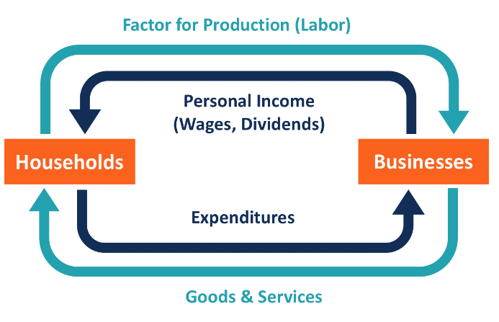

**Figure 4: Circular flow model**

(Source: Lesson 3, Topic 3)

**Keynesian Economics Theory**

Keynesian Economics Theory is a macro economic theory, which refers to the total spending of money in the economy and its impact on the output, employment and inflation. Marks & Spencer follows Keynesian economics in order to use the active government policies to manage their significant demand to address recessions of the economy.

**Fiscal and monetary policies**

The UK government plays a major role in creating monetary and fiscal policies that can help organisations to achieve price stability, economic growth, and full employment. Fiscal and monetary policies in the UK tend to manipulate the aggregate of the demand in the economy. Marks & Spencer is operating effectively and became the largest retail company in the UK through incorporating with the policies in the respective countries they operate.

# Task 2

## a. Examination of leading theories of management, leadership, and control

Leadership theory refers to the activities that illustrate the trait and behaviour of leaders so that an individual can enhance their leadership capability. A good leader needs to motivate the employees to look forward and meet the organisational goals. As per the view of Kanat-Maymonet al.,(2020), leaders must have strong morals and ethics that ensure the success of the organisation. It has primarily four leadership styles that include transformational leadership, transactional leadership, and situational leadership. Among these theories, leaders of Marks and Spencer (M&S) implements transactional leadership theory in their business operation in order to guide their employees. As opined by Cho et al.,(2019), transactional leaders offer compliance in the form of rewards, incentives, or punishments to the employees of an organisation that boosts the performance level of the employees. This reward or punishment system makes the employees stay motivated in their job roles.

Implementation of transactional leadership in M&S enables the company to eradicate the chances of any biases from the business operation and promote fair treatment to all the employees. Clear goals have been set up by the leaders of M&S that lead the employees within the organisation to make appropriate strategies. According to the belief of Nurlina (2022), the adoptions of these strategies are helpful for employees to accomplish business objectives. It has been critically observed that arrangement of training programs, webinars, and seminars helps the employees to boost their productivity in the business operation. These training programs bring organisational success seamlessly in this ever-changing business operation.

Management theory plays an important role in order to establish certain regulations for the company that providence direction to the employees to work. As per the view of Sahu et al., (2020), the management theory provides ideas to the employees regarding ways the managers of the company implement different strategies for bringing business success. The use of management theory within an organisation motivates the employees to boost their performance level and drive success. According to the views of Sahu et al., (2020), different types of management theory include classical management theory, contingency theory, behavioural theory, and system theory. Hence, in this context it can be mentioned that among all of these, M&S is going to implement behavioural theory to understand the employee behaviour within organisational context. Implementation of behavioural theory for M&S is effective as it promotes opportunity to the managers to make decisions regarding the strategies to accomplish the organisational goal.

As per Sahu et al.,(2020) concerned management theory offers employees the flexibility to work according to their desires and create a robust relationship between employees and organisation. It makes the employees of M&S work effectively with the help of both extrinsic as well as intrinsic motivations that develops job satisfaction for the employees (marksandspencer.com, 2023). The concerned management theory focuses on the behaviours of employees of M&S that make the employees make innovative solutions to any business problem. Direct interaction with the employees leads the organisation to enhance the efficiency of the employees and promote business success.

## Discussion on the challenges posed by the leadership

Stuart Machin plays an important role as a leader of M&S to improve the organisational success of the company. However, it has been observed that the company is going through several organisational issues due to the leadership strategy. As per the opinion of Younget al.,(2021),the transactional leadership style offers a definite structure for the employees to work. This minimises the capability of the employees to become innovative. Implementation of transactional leadership reduces the chances of organisational readiness during a scene when the company needs to bring changes in its business operation. Promoting reward and punishment systems within the workplace does not allow the employees to implement new ideas in their business operation and limits the flexibility of the employees.

The lack of flexibility, high-stress levels in the organisation lead to an increase in the high employee turnover rate. M&S focuses on the short-term goals rather than focusing on the long-term vision of the company that hampers the growth of the company (marksandspencer.com, 2023). The communication gap has been observed among employees of M&S, which leads the company to face serious challenges associated with the supply chain. As opined by Nurlina (2022), unclear communication with suppliers lacks transparency within the workplace, which leads the company to decline its sales margin. Employees of M&S, sometimes, found their activities to be monotonous and repetitive, which creates a pessimistic influence on the performance as well as on the morale of the employees. The engagement of behavioural management theory in the business operation of M&S makes the managers biased over certain employees, which increases discrimination within the workplace (marksandspencer.com, 2023). Therefore, conflicts and contradictions arrive within the business operation of M&S that harms both employee growth and organisational growth.

## b. Investigation of real-world businesses using relevant tools

***Understanding of global issues and their place in a globalised economy***

The company Marks and Spencer has incorporated corporate social responsibilities with their company principles to gain sustainability and to address the global issues. It has been identified that the increasing concern regarding climate change and pollution has affected the environment and the real-world businesses. Therefore, in order to address the global issues and contribute positively to the environment, the company has obtained certain sustainable choices, such as; reducing wastage, increasing the use of renewable sources and recycled products (Corporate.marksandspencer.com, 2022). Therefore, they are better caught on initiative wherein they use 100% cotton and its clothes are made from sustainable sources. These, in turn, have significantly impacted the globalised economy through supporting sustainability and global issues regarding economy and environment. The company has also donated £10 million through their incorporation with charities to support the poor during pandemic and contributed to the global issues (Corporate.marksandspencer.com, 2021). Thus, the company has also achieved a significant place in the globalised economy.

***Ethical decision-making and accountability***

The company has also obtained significant self-awareness decision making strategies to enhance their work culture and support equality to contribute positively in the society. The company supports ethical decision making and accountability, through imposing a fair wage to their workers in order to reduce modern slavery, child labour, harassment, and discrimination (Corporate.marksandspencer.com, 2021). Therefore, the company has imposed a great image through undertaking ethical decisions.

# Conclusion

The study concludes effective comparative business analysis of M&S with the company H&M and a major focus on M&S. The company’s exclusive strategy to diversify their work culture not only helps the company to efficiently manage talent acquisition but also helps the company to contribute in the society and spread self-awareness and openness, through project insensitivity and great accountability. However, with the incredible ability to adapt change and digital transformations, Marks and Spencer’s has achieved its target and is sustaining in the market through bringing innovations. The company further intends to expand their business in order to focus on globalisation of their brand and receiving massive exposure of their clothing section.

# Reference list

Britishcouncil.org (2022), *The power of fashion;* Available at: https://www.britishcouncil.org/research-policy-insight/insight-articles/power-fashion#:~:text=Clothing%20has%20always%20been%20big,the%20UK's%20largest%20creative%20industry. [Accessed on: 25th April, 2023]

Cho, Y., Shin, M., Billing, T.K. and Bhagat, R.S. (2019). Transformational leadership, transactional leadership, and affective organizational commitment: a closer look at their relationships in two distinct national contexts. *Asian Business & Management*, *18*, pp.187-210.

Corporate.marksandspencer.com (2019), *Responsible Sourcing and Human Rights;* Available at: https://corporate.marksandspencer.com/sustainability/human-rights-our-supply-chain/supporting-our-clothing-supply-chain#:~:text=We%20directly%20contract%20with%20suppliers,products%20at%20over%201000%20factories. [Accessed on: 25th April, 2023]

Corporate.marksandspencer.com (2021), *Ethically made, trusted value;* Available at: https://corporate.marksandspencer.com/sustainability/reports-quick-reads/ethically-made-trusted-value#:~:text=Our%20priority%20is%20to%20ensure,child%20labour%2C%20discrimination%20and%20harassment. [Accessed on: 25th April, 2023]

Corporate.marksandspencer.com (2021), *Our Communities;* Available at: https://corporate.marksandspencer.com/sustainability/our-communities [Accessed on: 25th April, 2023]

Corporate.marksandspencer.com (2022), *About Us;* Available at: https://corporate.marksandspencer.com/about-us [Accessed on: 25th April, 2023]

Corporate.marksandspencer.com (2022), *Our approach to sustainable fashion;* Available at: https://corporate.marksandspencer.com/our-approach-sustainable-fashion#:~:text=We%20take%20great%20care%20over,%2C%20Fairtrade%2C%20organic%20and%20recycled. [Accessed on: 25th April, 2023]

Corporate.marksandspencer.com (2022), *STRONG TRADING PERFORMANCE AS M&S RESHAPES FOR GROWTH;* Available at: https://corporate.marksandspencer.com/sites/marksandspencer/files/M%26S%20Half%20Year%20Results%2022%20Presentation.pdf [Accessed on: 25th April, 2023]

Frc.org.uk (2019), *Marks and Spencer – supply chain standards;* Available at: https://www.frc.org.uk/directors/corporate-governance/corporate-culture/case-study-marks-and-spencer-%E2%80%93-supply-chain-stand#:~:text=Marks%20and%20Spencer's%20business%20model,innovation%2C%20integrity%20and%20in%20touch. [Accessed on: 25th April, 2023]

Globaldata.com (2022), *Marks & Spencer – Digital Transformation Strategies;* Available at: https://www.globaldata.com/store/report/marks-and-spencer-enterprise-tech-analysis/ [Accessed on: 25th April, 2023]

Hmgroup.com (2021), *Goals and ambition;* Available at: https://hmgroup.com/sustainability/leading-the-change/goals-and-ambitions/ [Accessed on: 25th April, 2023]

Hmgroup.com (2022), *Market overview;* Available at: https://hmgroup.com/about-us/markets-and-expansion/market-overview/ [Accessed on: 25th April, 2023]

Kadyrovna, A.M., Burkhanovich, M.R. and Ortikaliyevna, B.M., (2022). DEMAND AND SUPPLY FOR LABOR FORCES. INTERNATIONAL JOURNAL OF SOCIAL SCIENCE & INTERDISCIPLINARY RESEARCH ISSN: 2277-3630 Impact factor: 7.429, 11(09), pp.85-90.

Kanat-Maymon, Y., Elimelech, M. and Roth, G. (2020). Work motivations as antecedents and outcomes of leadership: Integrating self-determination theory and the full range leadership theory. *European Management Journal*, *38*(4), pp.555-564.

Magazine.com (2021), *M&S to invest £480 million into production;* Available at: https://www.magazine.com/news/188856/ms-invest-480-million-into-stores-creating-3400-new-jobs/ [Accessed on: 25th April, 2023]

Marketscreener.com (2022), *MARKS AND SPENCER GROUP PLC;* Available at: https://www.marketscreener.com/quote/stock/MARKS-AND-SPENCER-GROUP-P-9590119/company/ [Accessed on: 25th April, 2023]

marksandspencer.com, 2023. *Home.* Available at: https://www.marksandspencer.com/ [Accessed on: 18.04.2023]

Newrelic.com (2022), *M&S shifts to digital-first retail with observability;* Available at: https://newrelic.com/blog/how-to-relic/marksandspencer-digital-retail [Accessed on: 25th April, 2023]

Nurlina, N. (2022). Examining Linkage Between Transactional Leadership, Organizational Culture, Commitment and Compensation on Work Satisfaction and Performance. *Golden Ratio of Human Resource Management*, *2*(2), pp.108-122.

Sahu, A.K., Padhy, R.K. and Dhir, A. (2020). Envisioning the future of behavioral decision-making: A systematic literature review of behavioral reasoning theory. *Australasian Marketing Journal*, *28*(4), pp.145-159.

Statista.com (2022),  *Number of employees of Marks & Spencer worldwide from 2014 to 2022;* Available at: https://www.statista.com/statistics/872828/marks-and-spencer-number-of-employees-worldwide-uk/ [Accessed on: 25th April, 2023]

Statista.com (2022), *Revenue of Marks & Spencer worldwide from financial year 2010 to 2022;* Available at: https://www.statista.com/statistics/413349/group-revenue-marks-and-spencer-mands/ [Accessed on: 25th April, 2023]

Statista.com (2023), *Revenue of Marks & Spencer worldwide from financial year 2010 to 2022;* Available at: https://www.statista.com/statistics/413349/group-revenue-marks-and-spencer-mands/ [Accessed on: 25th April, 2023]

Theguardian.com (2021), *M&S aims to open 150 new stores overseas;* Available at: https://www.theguardian.com/business/2021/jun/21/marksspencer.supermarkets[Accessed on: 25th April, 2023]

Theguardian.com (2021), *Marks & Spencer reports sharp drop in annual profits;* Available at: https://www.theguardian.com/business/2018/may/23/marks-and-spencer-reports-sharp-drop-in-annual-profits [Accessed on: 25th April, 2023]

Young, H.R., Glerum, D.R., Joseph, D.L. and McCord, M.A. (2021). A meta-analysis of transactional leadership and follower performance: Double-edged effects of LMX and empowerment. *Journal of Management*, *47*(5), pp.1255-1280.