**REFLECTIVE JOURNAL**

**Table of Contents**

Introduction 2

Description 2

Feeling 2

Evaluation 2

Analysis 3

Conclusion 3

Action plan 3

Conclusion 4

Appendices 5

Appendix 1 5

Appendix 4 6

Appendix 5 6

# Introduction

## Description

As per my experience in the various academic curriculum, participation and engagement in different sessions, I have realised that as an individual there has been immense growth in terms of professional and personal development. Reflecting on the enhancement week as well as my journey throughout this academic year, I have come to know that I have been able to transform the existing skills as well as gather new skills. These skills include numerical abilities and various reasoning skills which include logical reasoning as well as verbal reasoning skills [Refer to Appendix 1 and 2]. I have also developed an understanding to interpret a deep understanding of the given text and extract quality information which can be used for problem-solving [Refer to Appendix 3 and 5]. Interacting with others is associated with the course including the faculty members, I have been able to develop stronger communication skills as well as interpersonal skills. This has enabled me to work in cross-functional teams. Closely working with the stakeholders has helped me develop a clear idea of how the processes are carried on in business organisations in terms of fulfilling the demands of the stakeholders.

## Feeling

Taking part in the different sessions has enhanced my existing skills as well as the sessions have given me an opportunity to develop new skills. Working with abstract materials such as different patterns and sequences, diagrams and even flowcharts has expanded my ideas. As a result of this, I feel that I will be able to take up new challenges and make decisions effectively regarding a vast range of problems in the future. My interesting leadership skills and ability to work with teams will enable me to take on projects and deliver them as per the needs of the stakeholders. This will result in huge professional development enabling me to take up more challenging roles and responsibilities in the future which will contribute to my professional career growth.

## Evaluation

Overall attending the course has enabled me to identify areas that needed me to put in hard work in order to polish my existing knowledge as well as help me identify areas that I am good in. This has given a boost to my confidence level and motivated me to work harder. Engaging in interpersonal interaction as well as taking part in debates and group discussions have enabled me to speak with confidence in places where there will be more audience than just one or two people who are not known to me personally. My communicative, innovative and other behavioural styles have helped me in refining my knowledge [Refer to Appendix 4]. It has also helped me in gathering knowledge to complete professional tasks that require complex calculations and strong decision-making skills.

## Analysis

From the skills and development sessions, I can put in more effort to strengthen my weaknesses. I will put in hard work to become better in areas that require improvement. This will help me to grow in areas which are included in my personal as well as professional development. Participation has resulted in an increase in self-awareness. In order to provide guidance that will enable the team members to perform their tasks in a much better way, understanding different leadership styles as well as their impact on different teams and their performance.

## Conclusion

From the above discussion, it can be concluded that taking part in the session associated with the module and actively participating in the course and associated activities have enabled me to demonstrate my skills in arranged settings as well as helped me establish a deeper understanding of problems in different situations. This has enhanced my capability of handling difficult situations and motivated me to attend to problems That are even more complex and require thoughtful decision-making in order to resolve the issue and reach a solution that is beneficial for developing self-awareness and generating innovative ideas and creativity.

## Action plan

I will take part in programs developed for understanding different styles of leadership. This will help me to work in cross-functional as well as cross-cultural teams. Leadership skills are one of the most important and essential skills that an individual should develop in order to solve complex and challenging roles in their professional career. Hence, taking part in such a training program will help me Identify leadership styles based on different solutions. This will enable me to guide the team members effectively as well as help them enhance their performance in their workplace. In addition to that, in order to achieve comfortability in solving complex calculations as well as demonstrating excellent skills in interpreting data arranged in tabular or graphical forms, I will go through the works of experts and attempt practice problems. This will ultimately help me enhance my skills and contribute towards my professional development. As a result of this, I will be able to grasp the knowledge of different problems and take advantage of opportunities.

# Conclusion

The above discussion gives an insight into my personal skills which I have used in various areas of my journey through the academic year. The module has enabled me to identify opportunities that will help me progress in my professional career as well as help me develop personally.

# 

# Appendices

## Appendix 1

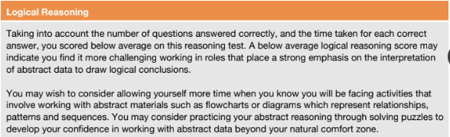

***Appendix 2***

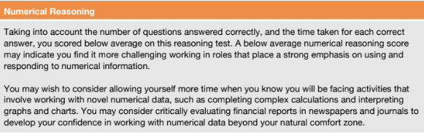

***Appendix 3***

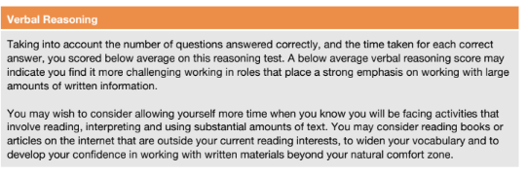

## Appendix 4

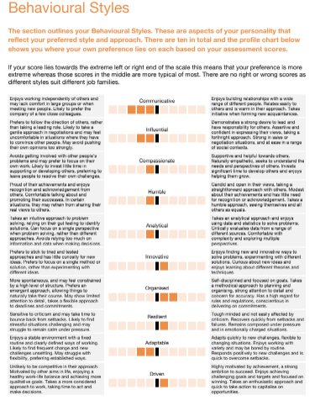

## Appendix 5

<https://onedrive.live.com/?authkey=%21AArI8ehIkQ%2DMkSM&id=815A4C67D0BDC87A%211425&cid=815A4C67D0BDC87A&parId=root&parQt=sharedby&o=OneUp>