**BLOG FOR PRIMARK**



Primark is an international fast-fashion retailer that distributes its stores across Europe and the United States. Primark helps to provide high-quality products at very reasonable costs in addition to extensive stylish clothing products for men, women, and children and also provides beauty products, accessories, and home goods.

The clothing retailer Primark, founded in 1969 in Ireland, started with the name Penneys. Primark is now operating with more than 70,000 employees across 15 countries in Europe and the US. The main goal of Primark is to reach around 530 shops within 2026 by growing their business in new and existing markets. Primark always tries to maintain the quality and price of its products so that it can provide sustainable fashion to all consumers at a reasonable cost.

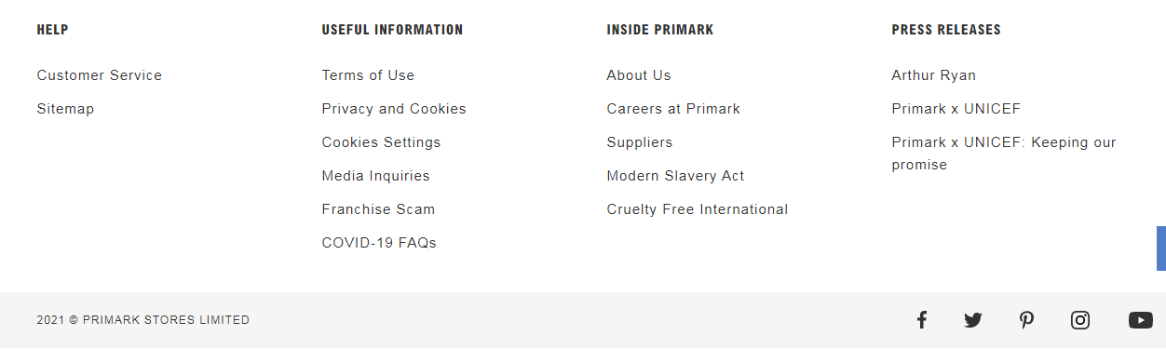

.

The main goal of Primark is to create environmentally friendly products that are affordable for all consumers. This business strategy helps Primark to minimize the environmental impact and also enhance the lives of its employees for the betterment. There are several goals that Primark has planned to develop its business gradually. These goals include using the recycled product or using all clothing materials that are produced sustainably. Primark provides the guarantee that all of its products are recyclable by design which is responsible for reduced carbon emissions throughout the value chain.



There are various kinds of materials that are sold by Primark which includes apparel for Baby and children, clothing garments for men and women, household materials, footwear, accessories, cosmetics, and many more.



Primark provides all its products at amazingly affordable prices. Therefore, consumers are encouraged to buy a large number of products from Primark, which can be discarded after use, and then return them to Primark and purchase a new set of clothes. Primark has introduced the Primark Brand Collabs to acquire branded goods that give it a chance to deal with some popular company owners and entrepreneurs.



There is a huge collection of Primark accessories including women's accessories and men's accessories. Women's accessories include Handbags, Bows, Scrunches and Headbands; Necklaces, Earrings, Bracelets and Rings; Gloves, Hats and Scarves; Crossbody Bags; Earrings; Sunglasses; Purses and Card Holders and many more. Men's accessories include Bags, Hats, Sunglasses and many more. With its huge collection of accessories, Primark is able to give trending touches to complete the look of its consumers.

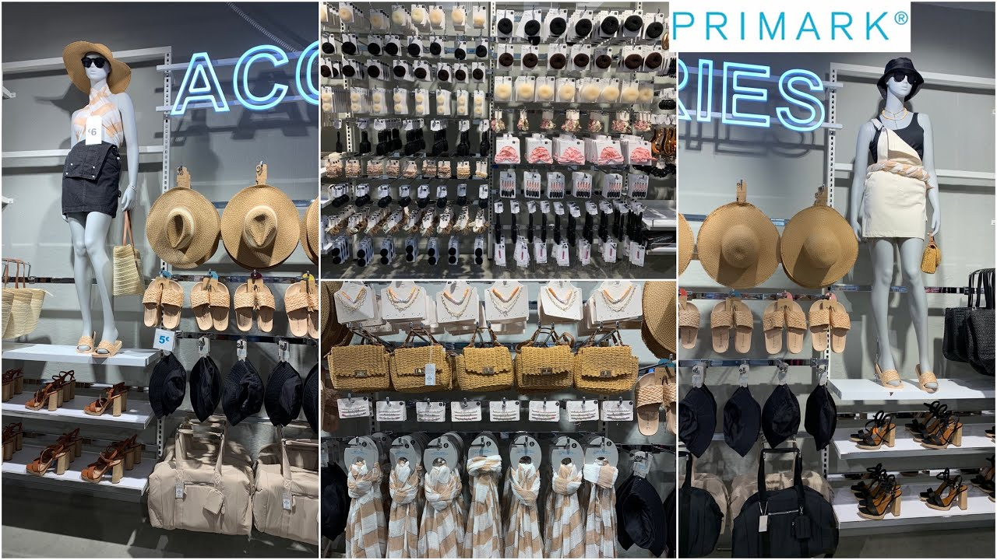

Primark Company competes in the UK's competitive fashion and apparel market. A huge number of consumers in the UK helps Primark to become one of the largest retail shops. All stores of Primark are situated on busy, well-travelled routes. This strategy helps Primark to gather attention from walk-in consumers. Additionally, Primark has a mobile application that helps consumers to check the costs of the product and can choose and pay for the product as well. After that, they can pick them up from the shop as Primark provides no facility for online shopping.



The opening time of the Primark stores is from morning 8 o'clock to evening 9 o'clock generally which can be changed depending on circumstances.

Primark has established its stores in 415 locations spread out throughout the area of Ireland, the United Kingdom, The Netherlands, Spain, Germany, Portugal, Belgium, France, Austria, Slovenia, Italy, Poland, the United States, Slovakia, Romania, and the Czech Republic. 