**INTRODUCTION TO DIGITAL MARKETING AND SOCIAL MEDIA**

# Slide 1: Introduction

* Digital marketing aspects in a company can assist in the acquisition of a high number of consumers.
* Social media marketing (SMM) can help in raising the online marketing aspects through the rate of consumer reach.
* The current study has analysed the feasibility of digital marketing through different concepts.

The implementation of digital marketing and social media aspects in an organisation can help in the growth of the consumer reach of a company. The current study has analysed the online and offline marketing concepts, along with key consumer trends, social media marketing (SMM), digital marketing platforms, digital marketing mix and the limitations of digital marketing.

# Slide 2: Concept of digital marketing

* Digital marketing is a process of selling products through online advertising.
* Digital marketing attracts and creates interest in consumer buying behaviour (Kurdi *et al*. 2022).
* It helps to increase the customer engagement of a business and the brand awareness of a company.
* It also helped to increase the net sales and develop the company's profitability.
* It helps to spread the products all over the world.

Digital marketing refers to the promotion of products with the help of social media platforms worldwide as it helps to connect and interact with potential consumers by using the internet and other digital communication platforms. As per Nair and Gupta (2021), digital marketing helps marketers to achieve their goals of selling and engaging with more customers more easily. The concept of digital marketing in modern days plays a vital role as it helps businesses and marketers to increase their brand awareness with the help of digital advertising. It also increases the sales of the businesses as it increases customer engagement and attracts customers more through digital marketing platforms.

# Slide 3: Differences between online and offline marketing

* Online marketing is a way to continuously interact with more customers.
* Offline marketing refers to marketing which needs the physical efforts of the marketers.
* Online marketing engages more customers than offline (Ugolkov *et al*. 2020).
* Online Marketing has less risk of product losses than offline marketing.
* Offline marketing helps to physically visit the products as online cannot.
* Offline marketing increases loyalty schemes more than online marketing.

The difference between online and offline marketing is that online marketing helps businesses by promoting their products through online platforms whereas offline marketing is a process which needs the physical attention of the marketers for working. According to Jiang *et al*. (2019), another difference between online and offline marketing is that online marketing can engage worldwide and attract more customers which helps to develop the company's growth whereas offline marketing faces limitations in customers. However, according to Suleiman *et al*. (2020), offline marketing gains more trust from the customers than online marketing as the customers can visit stores and check the product quality which helps to satisfy their needs. Offline marketing takes more time to engage with target customers whereas online marketing helps to reach customers all over the world with the help of online advertising.

# Slide 4: Discussion on the key consumer trends for driving the development and growth of digital marketing

* The increasing time of consumers on mobile devices attracts them towards digital marketing.
* The average ads spend in digital advertising by the users is US$58.99 (Statista, 2023).
* The worldwide time spent on social media influences marketers for establishing digital marketing.
* Fast delivery of the products helps in the development of digital marketing.
* High satisfaction is provided to consumers with the help of a digital marketing feedback system.
* It helps to get success with more engagement of customers which helps in the growth of digital marketing.

In modern days consumers are more advanced and adopt new technologies for online marketing. The consumer key trends which help in the development and growth of digital marketing are consumer time engagement with mobile devices, fast delivery process, feedback-taking system and more. Therefore marketers attract more consumers by providing digital advertising to their mobile devices which they always use which helps in attracting and interacting with customers.

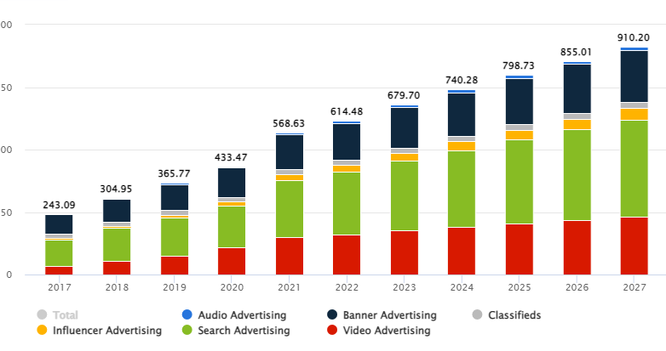

**Figure: Growth of digital advertising worldwide**

(Source: Statista, 2023)

The growth of digital advertising has shown above the graph. The average time spent by the users is US $58.99 in 2023. Another consumer key trend is the fast delivery process as the delay in product delivery creates trust issues and dissatisfies the customer needs. Thus the speedy delivery of the products enhances and influences the trust of the customer towards the company and helps in increasing the sales as well as the profitability of a company with the help of digital marketing. According to Morewedge *et al.* (2021), another consumer key trend is the feedback system as the feedback-taking system with the help of digital marketing help marketers to know the needs and demand of the consumers as well as the view of the consumers and the review of the consumer towards the products which increases the satisfaction level of the customers and also the sales and profitability of the businesses with the help of digital marketing.

# Slide 5: Concept of Social Media

* Social media is a platform which helps in communicating with each other (Voorveld, 2019).
* It is used as a form of Internet marketing by businesses and marketers.
* It helps digital marketing to advertise the products of businesses by using social media apps.
* It consists of several platforms such as Instagram, Facebook, Twitter and more.

Social media refers to the platforms which help in communicating with each other. Social media also refers to internet marketing which uses several SM apps to advertise the products of the businesses to reach a wide range of people as it increases the sales and profitability of the company. According to Ansari *et al.* (2019), social media is a communication system which helps to create and share information and ideas with different SM platforms such as Instagram, Twitter, Facebook and more. In modern days the use of social media is vast as it helps businesses to establish their digital marketing strategy with the help of social media and its various platforms.

# Slide 6: Critical discussion of digital tools and digital marketing platforms

* Digital tools in marketing can help companies to increase their consumer reach through performance and KPI evaluation in international market sectors (Peter and Dalla Vecchia, 2021).
* Platforms for digital marketing, such as Instagram, YouTube and Reddit can enhance the approaches to global market reach through engaging content (Desai and Vidyapeeth, 2019).

Digital marketing approaches through direct marketing, social media marketing (SMM) and many others have enhanced global firms’ approaches to increasing the prospects of gaining a high consumer and market value in order to raise market prospects. The implementation of digital tools and platforms for marketing aspects can enhance the prospects of enhancing the approaches of the firm to increase the management of consumer and brand value in the international and local markets through an increased consumer reach.

# Slide 7: Digital marketing Mix-7ps analysis

* 7ps analysis refers to the necessary marketing mix which is used by businesses for advertising their products.
* 7ps includes products, price, place, promotion, personal evidence, people and process (Chana *et al*. 2021).
* Digital marketing has influenced the strategic approach to promote the product of the organisations to the targeted customers.
* Conversely, digital marketing has influenced the prices of the products which facilitates the consumer to compare the prices.
* Consider the third P digital marketing has influenced the products to reach worldwide through advertising.
* Fourth P denotes promotion where digital marketing has influenced the promotion of the products through social media apps worldwide.

The 7P’s analysis of the digital marketing mix is products, pricing, place, promotion, personal evidence, people and process. According to Desai and Vidyapeeth (2019), digital marketing helps their targeted audiences by the use of social media apps to know about the products and the stock of new products online without wasting time. Hence it affects traditional marketing as it gives facilities for customers to know about the products without visiting stores which attracts the customer more than traditional marketing visiting and purchasing. According to Badawi *et al*. (2019), the second P is pricing with the help of digital marketing the marketers provide information about their prices and also give exciting discounts to the customers which attracts the attention of the customers and also help the customers to compare the prices with other companies or traditional market prices. Hence it also affects traditional marketing as it facilitates the consumers by providing them with prices and various exciting discounts than the traditional market which catches the attention of the consumers. According to Holmes (2020), the third p refers to the place as digital marketing helps marketers to reach their products to different places in the world or worldwide which increases the demand for the products and also helps to know the customers about the products worldwide. Hence it also affects traditional marketing as traditional marketing has limitations and cannot reach high customer engagement as they are not digitized and they have limited customers and parties.

# Slide 8: Contd...

* Digital marketing has also influenced customer satisfaction by facilitating physical evidence (Wang *et al*. 2022).
* It has also influenced the orientation power with others through which the process of evaluating customer insights can be achieved through digital marketing.
* Digital marketing has also influenced the power of the customers' demand and fulfilling it.

The fifth p refers to the physical evidence where digital marketing helps the marketers to know about the customer problems and queries with physical evidence such as screenshots of any problems regarding purchasing products and more. According to Vieira *et al*. (2019), digital marketing increases the power of the evidence with the help of physical evidence tools which facilitate the customers to share their problems to the company websites with proof and evidence. Hence it also affected traditional marketing as they do not have any evidence facility for the customer which sometimes raises problems for the customers in returning the products to the traditional marketers. According to López García *et al*. (2019), the sixth p refers to the people for whom digital marketing is a communication platform that is used by marketers to promote their products by advertising with the help of social media platforms. Therefore it is oriented toward several people to achieve its goals which include the marketers, the social media app creator, the customers using digital marketing through social media apps and more. Hence it also affects traditional marketing as it is a time-consuming process which helps to know about the demand of the customer and also fulfil their requirements.

# Slide 9: Explanation of social media content with two examples

* Sainsbury’s has used video content for promoting its Christmas 2022 offers on YouTube for British consumers (YouTube, 2022a).
* Unilever has used Twitter to promote its services and products using images in the UK and global market sectors for FMCG organisations (Twitter, 2023).
* The video and image content of Sainsbury’s and Unilever in the UK on social media platforms have enhanced the company’s market reach and consumer loyalty and engagement.



Social media marketing (SMM) of a company implements various engaging tools and content to increase the consumer reach of the firm in the local and international markets. The implementation of video and image content in SM platforms for marketing has enhanced the company’s branding aspects and promotional elements to increase the brand value of the firm. The implementation of video and image content by companies in SMM aspects can enhance the approaches of the companies for gaining a high consumer base.

# Slide 10: Evidence from effective companies for the standard of digital marketing

* McDonald's in the UK implemented video content for the digital marketing of Chicken Big Mac (YouTube, 2022b).

| ***Product*** | ***Price*** | ***Place*** | ***Promotion*** | ***People*** | ***Physical evidence*** | ***Processes*** |
| --- | --- | --- | --- | --- | --- | --- |
| Chicken Big Mac | £4.49 | Franchise stores of McDonald’s and online food applications in the UK | YouTube and Instagram | Marketing teams of McDonald’s UK  Consumers who prefer Chicken over Beef | Logo and branding of McDonald’s  Official YouTube channel | Customer focus and design-led |

The implementation of a digital marketing campaign for McDonald’s for its Chicken Big Mac product in the UK has enhanced the company’s approach to engaging with a high rate of consumers in the UK food and beverage market. Moreover, it has also enhanced the company’s approaches to gaining a high market value as one of the leading fast-food companies in the UK market sector.

# Slide 11: Limitations faced by digital marketing

* Absence of skilled employees who know about digital marketing.
* The usage of digital marketing in several businesses creates high competition (Redjeki and Affandi, 2021).
* Security threats threaten businesses which arise limitations of digital marketing.
* Negative feedback and complaints decrease the brand awareness of a company which also arises limitations of digital marketing

There are various limitations of digital marketing. Some of the digital marketing limitations are a lack of skilled employees, high competition, security threats and more. According to Lee and Lee (2020), the digital marketing of a business needs to be handled by a professional employee who knows how to publish advertising in a good manner and can increase customer engagement and also who can provide information and manage the demands of the customers. Therefore lack of skilled employees who know about digital marketing can create a problem for a business while implementing digital marketing in their business and hence it is a limitation faced by digital marketing. According to Dumitriu *et al*. (2019), another limitation is high competition as all businesses nowadays use digital marketing therefore it is a big competition for businesses to adapt in a better way digital marketing than their rivals and hence it is also a limitation of digital marketing as it is used by several businesses. Another limitation is security threats as digital marketing platforms consist of all information about a company. Therefore the security threats of digital marketing threaten the businesses to use it. Hence it is also a limitation of digital marketing due to the insecurity of a company’s private data.

# Slide 12: Conclusion

* It is concluded that digital marketing helps in increasing the profitability of businesses.
* Online marketing engages more customers than offline marketing
* Online marketing consists of the 7 Ps tools such as product price, place, promotion and more.
* Relevant evidence for the standard of digital marketing has been represented in the presentation.
* It also faces limitations which include security threats, high competition and more.

It is concluded this presentation consists of the concept of digital marketing and social media digital marketing includes increasing brand awareness, increasing sales and net profit, spreading the products worldwide and more whereas social media includes communication with each other, which helps digital marketing to advertise with SM apps and more. It also focuses on the differences between online and offline marketing as online marketing includes continuous interaction, more customer engagement and more whereas offline marketing includes loyalty schemes and physical visits to the products, key consumer trends which include high satisfaction and fast delivery, discussion of tools, evidence of digital marketing from different companies and the limitations of digital marketing which includes the absence of skilled employees, high competition, security threats and more.

# 

# Appendices

**Appendix 1: Discussion on the key consumer trends for driving the development and growth of digital marketing**

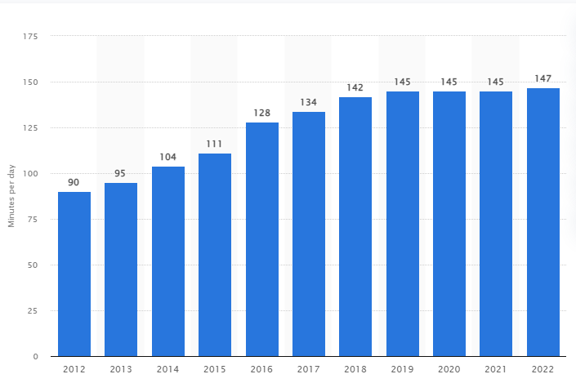

**Figure: Daily time spent global in social media**

(Source: Statista, 2022)

* The average time spent on social media worldwide is 147 minutes daily and was 145 minutes a year ago (Statista, 2022).
* It is more flexible and affordable than stores and also saves time for the consumer.
* Consumers nowadays spend more time on their mobile devices and prefer online marketing (Kayumovich 2020).

In addition, the review of the consumer towards the products increases the satisfaction level which can be explored through the time spending percentage within social media. It also indicates the strategic orientation to increase sales and profitability of the businesses with the help of digital marketing.

**Appendix 2: Digital marketing tools and platforms**

* A recent study demonstrated that YouTube and Instagram have been the most used marketing platforms worldwide (Marketing Charts, 2021).
* Digital marketing platforms of YouTube and Instagram have further helped companies to increase the both local and global reach of the selected firms in the chosen market.
* Another study demonstrated that the implementation of SEO can potentially face changes in third-party cookies and machine learning aspects (Statista, 2023a).
* This aspect can help in the evaluation of consumer reach and KPI aspects for performance analysis of the company in digital marketing.

The implementation of digital platforms such as YouTube and Instagram has enhanced the market value of companies through attractive and engaging content. The application of SEO can enhance the prospects of consumers to analyse options for a product through an online search of products.

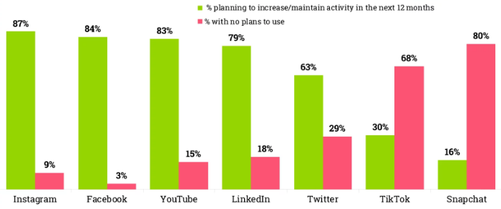

**Appendix 3: Digital marketing Mix-7ps analysis**

* The fourth p is promotion as digital marketing helps businesses to promote their products through advertising by a social media influencer, paid promotions online and more.
* Promotion in digital marketing helps marketers to reach and attract more customers which also enhance the sales and profitability of the business.
* It also affects traditional marketing as traditional marketing cannot promote their products offline through banners and other techniques which digital marketing can.

Promotion in digital marketing helps marketers to reach and attract more customers which also enhances the sales and profitability of the business. Digital marketing affects traditional marketing as it cannot promote its products online through banners and other techniques which digital marketing can.

**Appendix 4: Contd…**

* The seventh p is a process where digital marketing is a platform which helps to know the demand and insights of the targeted consumers (Martínez-Plumed et al. 2019).
* It also fulfils the requirements of the customers which increases the satisfaction level of the customers.
* It helps marketers to promote and sell their products with a well-mannered process.

Digital marketing helps to know the demand and insights of the targeted consumers (Martínez-Plumed *et al.* 2019). Therefore it is oriented toward several people to achieve its goals which include the marketers, the social media app creator, the customers using digital marketing through social media apps and more.

**Appendix 5: Contents of SM ads**

* As of 2023, online video ad spending amounted to nearly $105 billion worldwide (Statista, 2023b).
* The high usage of online video ads has enhanced the management of online ads of companies on SM platforms.
* The implementation of video and image content in SM platforms by companies has enhanced the prospects of gaining high market value in the local and global market sectors.

Digital video and image ads in global market sectors have enhanced the branding aspects of the companies in SMM aspects. The content of SM ads by companies has enhanced the management of the overall aspects of gaining a high consumer base. Moreover, it has also improved the maintenance of consumer loyalty and engagement aspects. Consumer engagement and loyalty of companies have been imposed by their effective and attractive marketing content on SM platforms as a tool and technique for digital marketing. Digital marketing through SM has been beneficial for raising the market feasibility of the company.

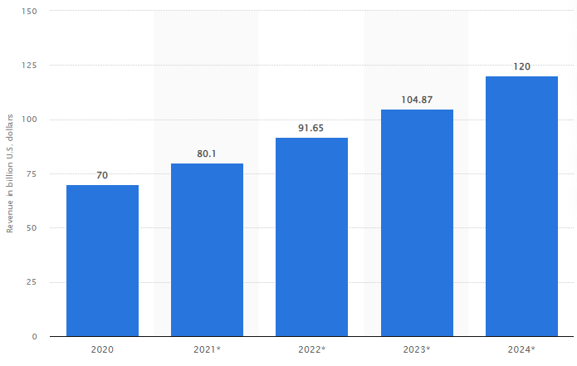

**Appendix 6: The chicken big mac campaign**

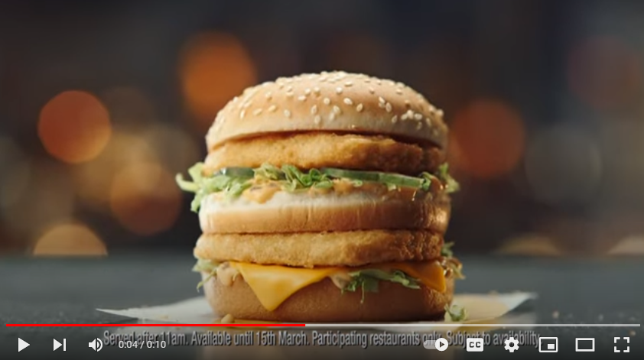

* McDonald’s in the UK conducted extensive consumer research to promote Chicken Big Mac.
* The product was relaunched in the UK market in March 2023 after its initial launch in 2022 (The Sun, 2023).
* The reasonable price of the product has enhanced the buying intention of consumers for raising consumption of Chicken Big Mac in the fast-food market sector of the UK.

McDonald’s digital marketing campaign for Chicken Big Mac has enhanced the company’s brand value and growth as one of the leading fast-food brands in the UK market sector. The implementation of YouTube ads in the initial launch campaign of the firm in the fast-food sector of the United Kingdom was a great success as the products were out of stock in ten days (The Sun, 2023). The reach of the company through the YouTube ad has helped the firm to increase its approaches to gain a high market value from the Chicken Big Mac.

# Slide 13: References

Ansari, S., Ansari, G., Ghori, M.U. and Kazi, A.G. (2019). Impact of brand awareness and social media content marketing on the consumer purchase decision. *Journal of Public Value and Administrative Insight, 2*(2), pp.5-10.

Badawi, R.D., Shi, H., Hu, P., Chen, S., Xu, T., Price, P.M., Ding, Y., Spencer, B.A., Nardo, L., Liu, W. and Bao, J. (2019). First human imaging studies with the EXPLORER total-body PET scanner. *Journal of Nuclear Medicine, 60*(3), pp.299-303.

Chana, P., Siripipatthanakul, S., Nurittamont, W. and Phayaphrom, B. (2021). Effect of the service marketing mix (7Ps) on patient satisfaction for clinic services in Thailand. *International Journal of Business, Marketing and Communication, 1*(2), pp.1-12.

Desai, V. and Vidyapeeth, B. (2019). Digital marketing: A review. *International Journal of Trend in Scientific Research and Development, 5*(5), pp.196-200.

Desai, V. and Vidyapeeth, B. (2019). Digital marketing: A review. *International Journal of Trend in Scientific Research and Development, 5*(5), pp.196-200.

Dumitriu, D., Militaru, G., Deselnicu, D.C., Niculescu, A. and Popescu, M.A.M. (2019). A perspective over modern SMEs: Managing brand equity, growth and sustainability through digital marketing tools and techniques. *Sustainability*, 11(7), p.2111.

Holmes, A.G.D. (2020). Researcher Positionality--A Consideration of Its Influence and Place in Qualitative Research--A New Researcher Guide. *Shanlax International Journal of Education, 8*(4), pp.1-10.

Jiang, Y., Wang, H.H., Jin, S. and Delgado, M.S. (2019). The promising effect of a green food label in the new online market. *Sustainability, 11*(3), p.796.

Kayumovich, K.O. (2020). Particular qualities use of social media in digital tourism. *Gwalior Management Academy, 28*(1), pp.21-28.

King, A.C., Whitt-Glover, M.C., Marquez, D.X., Buman, M.P., Napolitano, M.A., Jakicic, J., Fulton, J.E. and Tennant, B.L. (2019). Physical activity promotion: highlights from the 2018 physical activity guidelines advisory committee systematic review. *Medicine & Science in Sports & Exercise, 51*(6), pp.1340-1353.

Kurdi, B., Alshurideh, M., Akour, I., Alzoubi, H., Obeidat, B. and Alhamad, A. (2022). The role of digital marketing channels on consumer buying decisions through eWOM in the Jordanian markets. *International Journal of Data and Network Science, 6*(4), pp.1175-1186.

Lee, S.M. and Lee, D. (2020). “Untact”: a new customer service strategy in the digital age. *Service Business, 14*(1), pp.1-22.

López García, J.J., Lizcano, D., Ramos, C.M. and Matos, N. (2019). Digital marketing actions that achieve a better attraction and loyalty of users: An analytical study. *Future Internet, 11*(6), p.130.

Marketing Charts (2021). *Social Media Marketing Update: Preferred Platforms and Content Types in 2021* [Online]. Available at: <https://www.marketingcharts.com/digital/social-media-117464> [Accessed on: 22 April 2023].

Martínez-Plumed, F., Contreras-Ochando, L., Ferri, C., Hernández-Orallo, J., Kull, M., Lachiche, N., Ramirez-Quintana, M.J. and Flach, P. (2019). CRISP-DM twenty years later: From data mining processes to data science trajectories. *IEEE Transactions on Knowledge and Data Engineering, 33*(8), pp.3048-3061.

Morewedge, C.K., Monga, A., Palmatier, R.W., Shu, S.B. and Small, D.A. (2021). Evolution of consumption: A psychological ownership framework. *Journal of Marketing, 85*(1), pp.196-218.

Nair, K. and Gupta, R. (2021). Application of AI technology in modern digital marketing environment. *World Journal of Entrepreneurship, Management and Sustainable Development, 17*(3), pp.318-328.

Peter, M.K. and Dalla Vecchia, M. (2021). The digital marketing toolkit: a literature review for the identification of digital marketing channels and platforms. *New trends in business information systems and technology: Digital innovation and digital business transformation*, pp.251-265.

Redjeki, F. and Affandi, A. (2021). Utilization of Digital Marketing for MSME Players as Value Creation for Customers during the COVID-19 Pandemic. *International Journal of Science and Society, 3*(1), pp.40-55.

Statista (2022). *Daily time spent on social networking by internet users worldwide from 2012 to 2022.* Available at: <https://www.statista.com/statistics/433871/daily-social-media-usage-worldwide/> [Accessed on: 21th April, 2023]

Statista (2023). *Digital Advertising - Worldwide.* Available at: <https://www.statista.com/outlook/dmo/digital-advertising/worldwide> [Accessed on: 21th April, 2023]

Statista (2023a). *Leading shifts in search engine optimization (SEO) worldwide in 2022* [Online]. Available at: <https://www.statista.com/statistics/1274488/seo-threats/> [Accessed on: 22 April 2023].

Statista (2023b). *Online video advertising spending worldwide from 2020 to 2024* [Online]. Available at: <https://www.statista.com/statistics/246567/global-online-advertising-revenue/> [Accessed on: 22 April 2023].

Suleiman, M.I., Muhammad, N.B., Yahaya, I.S., Adamu, M.A. and Sabo, A.U. (2020). Benefits and challenges: for marketing strategies online. *European Journal of Molecular & Clinical Medicine, 7*(3), pp.164-179.

The Sun (2023). *When is McDonald’s planning to bring the Chicken Big Mac back?* [Online]. Available at: <https://www.thesun.co.uk/money/17432442/mcdonalds-chicken-big-mac-release-date/> [Accessed on: 22 April 2023].

Twitter (2023). *Unilever* [Online]. Available at: <https://twitter.com/Unilever> [Accessed on: 22 April 2023].

Ugolkov, I., Karyy, O., Skybinskyi, O., Ugolkova, O. and Zhezhukha, V. (2020). The evaluation of content effectiveness within online and offline marketing communications of an enterprise. *Innovative Marketing, 16*(3), pp.26-36.

Vieira, V.A., de Almeida, M.I.S., Agnihotri, R., da Silva, N.S.D.A.C. and Arunachalam, S. (2019). In pursuit of an effective B2B digital marketing strategy in an emerging market. *Journal of the Academy of Marketing Science, 47*, pp.1085-1108.

Voorveld, H.A., 2019. Brand communication in social media: A research agenda. *Journal of Advertising, 48*(1), pp.14-26.

Wang, Z., Li, M., Lu, J. and Cheng, X. (2022). Business Innovation based on artificial intelligence and Blockchain technology. *Information Processing & Management, 59*(1), p.102759.

YouTube (2022a). *Once Upon a Pud | Sainsbury's | Christmas 2022* [Online]. Available at: <https://www.youtube.com/watch?v=RsbUYmK-Ohg> [Accessed on: 22 April 2023].

YouTube (2022b). *The Chicken Big Mac has landed | McDonald's UK* [Online]. Available at: <https://www.youtube.com/watch?v=8DR1CMqyA8Q> [Accessed on: 22 April 2023].