**Slide 1: Introduction**

* Record of various prospects of operations
* Maintenance of Corporate Social Responsibilities
* Professional communications

**Speaker note:**

This report is going to encircle the various prospects related to the various operations of the taken multinational company in the United Kingdom, Unilever. This report is also going to include the various prospects related to the Corporate Social Responsibilities of the mentioned multinational company in the United Kingdom. Apart from that, this report will encompass the various prospects related to effective professional communication. The communication skills and other aspects are supposed to be helpful for the betterment of the business and other operations of Unilever in an effective manner.

**Slide 2: Corporate Social Responsibiity**

* Concept related to the management of a certain business
* Integration of social and environmental concerns (unido.org, 2023)
* Management of communication with the stakeholders (Troise and Camilleri, 2021)

**Speaker note:**

Corporate Social Responsibilities are some basic concepts, which are related to the process of managing a certain business in a dexterous manner. The Corporate Social Responsibilities are considered to be an integration of the social, as well as the environmental concerns related to the business of a certain specified business company or any other type of multinational company around the whole world. More on this, the policies related to the Corporate Social Responsibility in the business of the concerned company can even be helpful for managing effective communication with the stakeholders of the business of the same.

**Slide 3: Social benefits of CSR**

* Recognition of brands
* Saving the cost of production
* Enhancing the reputation of business (nibusinessinfo.co.uk, 2023)

**Speaker note:**

The policies related to the Corporate Social Responsibilities are supposed to be helpful in the process of maintaining various social aspects. These policies can be helpful for the brand in the process of gaining recognition throughout the market of business and finance around the whole world. These policies can even be helpful in the context of enhancing the reputatiokn of the business of the same mentioned business company or other multinational companies around the world. More on this, the CSR policies can even be helpful in the context of saving the cost of production of the concerned product related to the business.

**Slide 4: Financial benefits of CSR**

* Increasing financial performances
* Increasing the value of the business firm (Velte, 2022)
* Enhancement of allover Corporate Financial performance (Wu *et al.,* 2020)

**Speaker note:**

Apart from the impacts on the society, the CSR policies of the concerned multinational company, there can be some financial benefits regarding the business of the same. The CSR policies are supposed to be helpful in the context of increasing the financial performance of the concerned multinational company or other companies in the whole world. More on this, the CSR policies can even be helpful in the context of enhancing the allover Corporate Financial Performance of the business of the mentioned types of business organisations. Apart from this, the CSR policies can be helpful for business organisations for increasing the value of the concerned business firm in an effective manner.

**Slide 5: Environmental impact of CSR**

* Integration of environmental considerations
* Impact on the supply chain of products (Barnett *et al.,* 2020)
* Mitigating the problems of the development of business (Lu *et al.,* 2019)

**Speaker note:**

The CSR policies of the concerned multinational and other business organisations have a major impact on the environmental aspects as well. The CSR policies maintain a sustained integration of the environmental aspects, which are supposed to be helpful, as well as essential for the betterment of the business of the same. These mentioned policies also have an immense impact on the supply chain of the concerned products related to the business of the specified multinational or other types of business organisations. More on this, it can be helpful to mitigate the problems, which are considered to be the major barriers to the development of the business of the same.

**Slide 6: Examples: CSR social benefits**

* Clear note of the CSR policies of Unilever
* Management of business of Unilever based on the trends of the society
* Approach for maintaining sustainability in the business of the same (unilever.com, 2023)

**Speaker note:**

As an example of the social benefits of the CSR policies, there is an example of the policies of Unilever. There can be seen a clear note of the Corporate Social Responsibilities of Unilever in a proper manner. According to the authorities of the business of Unilever, the management of the various aspects related to the business of the same is based upon the trends of the society. This is supposed to be effective for maintaining sustainability in the business of the same in a proper manner. Apart from this, the mentioned multinational business company, Unilever, is witnessed to maintain a unique approach. This approach is supposed to be helpful for maintaining sustainability in the business of the same.

**Slide 7: Example: CSR financial benefits**

* Refinement in the financial behaviours of Unilever
* Achieving financial sustainability
* Maintaining a value chain in a proper manner (Garri, 2022)

**Speaker note:**

The CSR policies of Unilever are evidently effective to maintain various types of financial benefits in its business. There can be seen a proper refinement of the financial behaviours of the business of Unilever. This can only be possible with the help of the various policies related to the CSRs of the same. More on that, the concerned CSR policies of Unilever have been helpful in achieving the various types of financial sustainabilities in the worldwide business of the same. These can even be helpful in the process of maintaining a proper chain of values of the products, as well as the business of the mentioned multinational business organisation in the United Kingdom in a dexterous and effective manner.

**Slide 8: Example: CSR environmental impacts**

* Active role in conserving the environment
* Management of environmental impacts
* Collaboration with government and social communities (Chandra and Jatmika, 2022)

**Speaker note:**

The CSR policies of Unilever have played an active role in conserving the environment in the entire world in a dexterous manner. With the help of the CSR policies, the mentioned multinational business organisation in the United Kingdom, Unilever, has efficiently, dexterously and even professionally managed the impact of the business on the environment. Apart from this, in the context of maintaining the environmental aspects of the business, Unilever has taken effective measures by collaborating with the authorities of the government, as well as the authorities of various social communities in an effective and dexterous manner.

**Slide 9: Additional benefits**

* Management of KPIs
* Ensuring the well-being of communities (forbes.com, 2022)
* Determination of stability of various influential aspects

**Speaker note:**

Apart from the mentioned benefits of CSR policies of the mentioned multinational company, Unilever, there are many other benefits attained by the business of the same. With the help of the CSR policies, the mentioned business organisation has managed the KPIs in a dexterous manner. Apart from this, the authorities of the business of Unilever have ensured the well-being of the various communities in a professional manner. Moreover, they have taken some effective initiatives for determining the stability in the various aspects, which are considered to be influential for the business of Unilever.

**Slide 10: Unilever Annual Report**

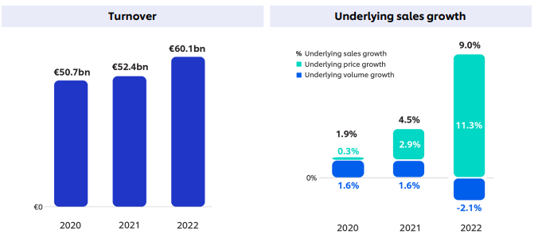

Source: unilever.com, 2023

**Speaker note:**

Through the attachment, the growth in the rate of turnover is visible. In the year 2020, the rate of turnover was €50.7 bn, which in the year 2021 increased to €52.4 bn. This can be considered to be a great achievement for the business of Unilever in a dexterous manner. More on this, it can even be seen that in the year 2022, the rate of turnover was €60.1 bn. This can be very appropriately stated that the business of Unilever has taken effective measures for driving the growth of the multinational company to a notable extent.

**Slide 11: Unilever social impact of CSR**

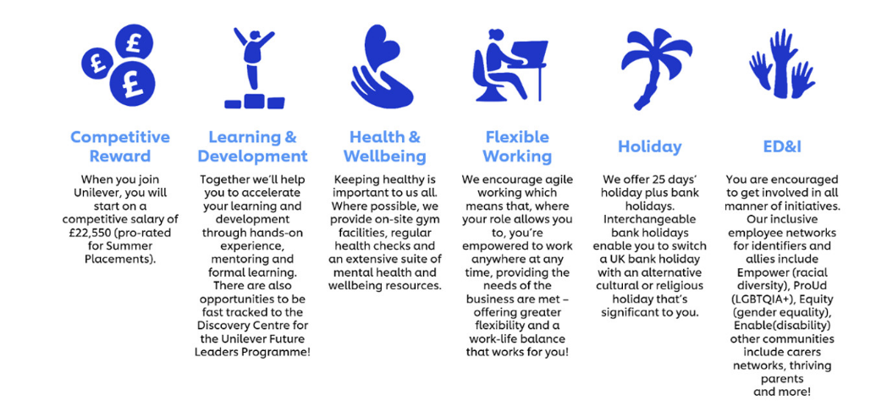

Source: unilever.com, 2023

**Speaker note:**

From this attachment, it can be seen that the authorities of the business of Unilever have taken effective measures in the context of maintaining a sustainable and stable society. In this point, they have taken effective measures in the prospects of employment of the various individuals of the concerned society. This can be considered to be a part of their Corporate Social responsibilities. In this approach, the authorities have taken part in the process of ensuring the employment of the people in the concerned society in an effective manner.

**Slide 12: Unilever financial impact of CSR**

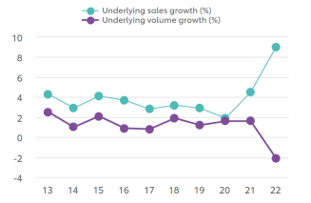

Source: unilever.com, 2023

**Speaker note:**

This graph is capable enough to show that there has been a subtle growth in the sales of the business of Unilever. This can only be possible due to the implementation of the various policies related to Corporate Social responsibilities in an appropriate manner.

**Slide 13: Unilever environmental impact of CSR**

**Speaker note:**

**Slide 14: Revenue of Unilever**

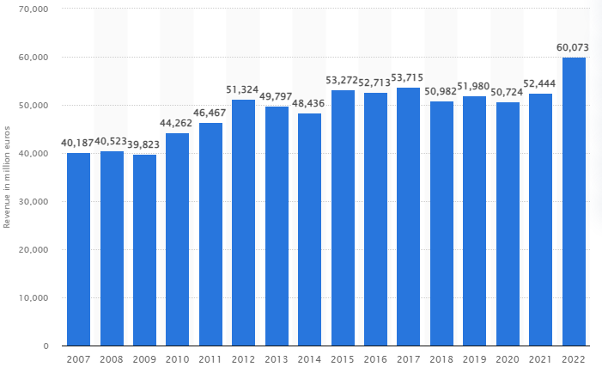

Source: statista.com, 2023

**Speaker note:**

This graph shows the growth in the revenue of the business of Unilever in an appropriate manner. In the year 2012, the revenue grew to a notable extent. After this, there has been a change or decay in the revenue of the business of Unilever. From that point of business, Unilever, in the year 2022, has achieved a revenue of €60,073 million in an effective manner.

**Slide 15: Goals of Unilever**

* Gender equality
* Hygiene and sanitisation

**Speaker note:**

Apart from the various operations, the mentioned multinational business organisation, Unilever, is evident in maintaining a few goals for the betterment of the business of the same. They are witnessed to take effective initiatives for invoking gender equality in the mentioned workplace. Apart from this, the mentioned company is evident in maintaining hygiene and sanitisation in an appropriate manner.

**Slide 16: Sustainable business strategy**

* Action plan for the development of the whole world
* Transformation in work and partnership (unilever.com, 2023)

**Speaker note:**

Unilever has taken some subtle, yet effective strategic approaches for maintaining sustainability in the business of the same. This multinational company has taken effective action plans for the development of the whole world. Apart from this, it has taken effective initiatives in the context of maintaining a sustainable business by making a transformation in the work function and the various prospects related to the partnership in the business.

**Slide 17: Conclusion**

* Record of CSR policies
* Impact of CSR policies of Unilever
* Statistical data and graphs

**Speaker note:**

This report has taken a clear record of the various approaches regarding the CSR policies of a certain multinational company. Along with this, there has been a clear record of the impacts of CSR policies taken up by Unilever, which is a leading multinational company in the United Kingdom. There has also ben an inclusion of the various relevant statistical data and graphs in an appropriate manner.

**Slide 18: References**

* unido.org (2023) *What is CSR?*, *UNIDO*. Available at: https://www.unido.org/our-focus/advancing-economic-competitiveness/competitive-trade-capacities-and-corporate-responsibility/corporate-social-responsibility-market-integration/what-csr (Accessed: April 22, 2023).
* Troise, C. and Camilleri, M.A., 2021. The use of digital media for marketing, CSR communication and stakeholder engagement. In *Strategic corporate communication in the digital age*. Emerald Publishing Limited.
* nibusinessinfo.co.uk (2023) *Corporate Social Responsibility (CSR)*, *Business benefits of corporate social responsibility*. Available at: https://www.nibusinessinfo.co.uk/content/business-benefits-corporate-social-responsibility (Accessed: April 22, 2023).
* Velte, P., 2022. Meta-analyses on corporate social responsibility (CSR): a literature review. *Management Review Quarterly*, *72*(3), pp.627-675.
* Wu, L., Shao, Z., Yang, C., Ding, T. and Zhang, W., 2020. The impact of CSR and financial distress on financial performance—evidence from Chinese listed companies of the manufacturing industry. *Sustainability*, *12*(17), p.6799.
* Lu, J., Ren, L., Lin, W., He, Y. and Streimikis, J., 2019. Policies to promote corporate social responsibility (CSR) and assessment of CSR impacts.
* Barnett, M.L., Henriques, I. and Husted, B.W., 2020. Beyond good intentions: Designing CSR initiatives for greater social impact. *Journal of Management*, *46*(6), pp.937-964.
* unilever.com (2023) *Unilever’s approach Social Review 2000 to Corporate Social Responsibility*. Available at: https://assets.unilever.com/files/92ui5egz/production/b7c407227f4eb0b869ff1b6b50f81d5c50ccdecd.pdf/2000-social-review-of-1999-data.pdf (Accessed: April 22, 2023).
* Garri, M., 2022. MNE’s sustainability strategies in emerging and developing markets. *International Journal of Organizational Analysis*, *30*(3), pp.743-759.
* Chandra, R. and Jatmika, S., 2022, March. Unilever Unilever Surabaya Corporate Social Responsibility (Csr) Policy in Maintaining Environmental Sustainability in Surabaya in 2014-2020. In *International Conference on Public Organization (ICONPO 2021)* (pp. 444-452). Atlantis Press.
* forbes.com (2022) *Council post: The Business Benefits of Corporate Social Responsibility Impact Assessments*, *Forbes*. Forbes Magazine. Available at: https://www.forbes.com/sites/forbestechcouncil/2022/01/24/the-business-benefits-of-corporate-social-responsibility-impact-assessments/?sh=6d05647c3209 (Accessed: April 22, 2023).
* unilever.com (2023) *Annual report and accounts 2022 highlights*, *Unilever*. Unilever PLC. Available at: https://www.unilever.com/investors/annual-report-and-accounts/ (Accessed: April 22, 2023).
* unilever.com (2023) *Placement programmes*. Available at: https://careers.unilever.com/uk-placements (Accessed: April 22, 2023).
* unilever.com (2023) *Unilever charts 2013-2022*. Available at: https://wiop-api-qa.unilever.com/files/7b16737e-82ce-45dc-91b3-98a56ffdb5fa/unilever-charts-2013-to-2022.pdf (Accessed: April 22, 2023).
* statista.com (2023) *Unilever Group's global revenue 2022*, *Statista*. Available at: https://www.statista.com/statistics/269190/global-revenue-of-the-unilever-group-since-2007/ (Accessed: April 22, 2023).
* unilever.com (2023) *Sustainable development goals*, *Unilever*. Unilever PLC. Available at: https://www.unilever.com/planet-and-society/sustainability-reporting-centre/sustainable-development-goals/ (Accessed: April 22, 2023).