**BUS4010**

**CONTEMPORARY BUSINESS ENVIRONMENT**

**COMPANY APPRAISAL**

**Table of Contents**

Introduction 3

a) 3

b) 5

Task 1 6

Task 2 8

a) 8

b) 12

References 14

# Introduction

## a)

Businesses should have a well-defined organisational structure and a set of business objectives to cope with the market regulations and prosper as a business within a specific business domain. As per the views of Fraga-Lamas and Fernández-Caramés (2019), in an attempt to develop a resilient business, the network has to be strong and reliable for a business. This assures the business to share a better degree of collaboration and inclusion of advanced technological solutions in the business. The electric vehicle (EV) industry is a potentially disruptive solution to the modern-day automobile industry problems as fuel alternative vehicles are being engineered by automobile brands. Tesla Inc. is known to be a leader in EV manufacturing as the brand has access to a wide array of financial, technological, and human resources. According to the study by Fernandez-Guadaño, Lopez-Millan and Sarria-Pedroza (2020), there can be different sets of companies such as partnerships, cooperatives, limited liability companies, corporations, and sole proprietorships. As seen from the case of Tesla, Tesla Inc.'s name made it a business registered with a state to become a separate legal entity. Hence, Tesla continues to be an energy and automotive brand. Tesla Inc. needs to follow the legal measures and keep a close tab on the financial and operational proceedings and document it comprehensively to match the legal requirements such as General Motors, Ford, Seat, and MG Hector in the automotive space. Tesla aims to make the world a sustainable place and transform the energy space. The objectives remain as building smarter EVs and growing the clean energy business to reduce the carbon footprint significantly. Exercising corporate social responsibility practices (CSR) in the business stands to be a priority for the business as it looks to mount success with EV sales. As per the study by Meissner (2019), the term incorporated or Inc. is used by businesses that are legally registered in the United States. The formation of Tesla Inc. is referring to the fact that it is legally registered in the United States and is bound to follow the regulations mentioned here.

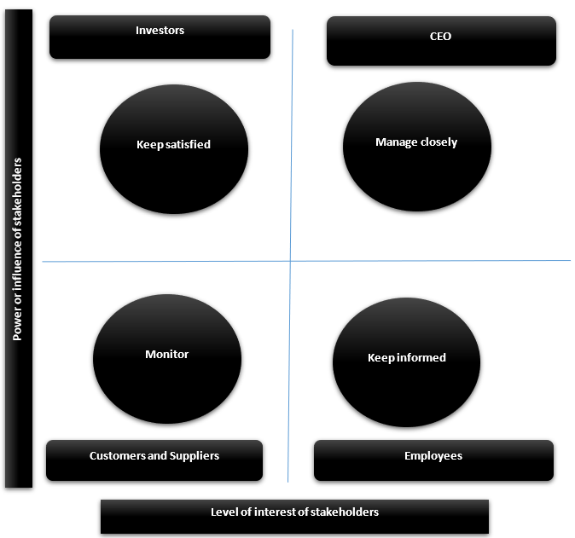

**Figure 1: Stakeholder mapping for Tesla**

(Source: Developed from Wojewnik-Filipkowska et al. 2021)

The key stakeholders in the business can be effectively placed with the help of stakeholder mapping. According to the views of Wojewnik-Filipkowska et al. (2021), depending on the level of interest and power, the stakeholders for businesses can be placed across four separate groups as these are known as keep satisfied, keep informed, manage closely, and monitor. As evident from the case of Tesla, CEO Elon Musk shares the highest power and interest in business operations, thereby finding a suitable place within the manage closely group. On the other end, the investors and the government play a major role in sanctioning the financial and legal actions, thereby being placed under the keep satisfied group. Apart from this, the supplier source remains vital for the business despite the degree of vertical integration achieved as a business. Hence, the suppliers are placed under the keep informed category alongside the customers, as pre-purchase orders for Tesla EVs are evidence of the interests shown by the customers. Lastly, the employees are given the least level of priority in the business as highly authoritative leadership actions are exercised.

## b)

The presence of modern technological tools has helped the automobile businesses such as Tesla to innovate in the industry with products such as smart EVs, which come with automated driving functionalities to a large degree. As stated by Ramazanov et al. (2021), the trend of digitisation has helped contemporary businesses to reshape the supply chain and manufacturing processes and register an ample degree of sustainability. As seen in the case of Tesla, the new EVs share lesser levels of pollution due to lower carbon emissions. The application of digitisation is expected to allow Tesla to digitally transform the business and gain a sustainable competitive advantage in the business field. As mentioned by Aggarwal et al. (2022), several technologies such as artificial intelligence, machine learning, natural language processing, and automation can become part of the operations to reduce errors and foster a sustainable work environment. Hence, resource efficiency from the technology front has enabled Tesla to remain resilient even during the crisis of the Covid-19 pandemic in 2020-2021. The China Gigafactory did stand shut for some time, but once it gained operational access, the company accelerated manufacturing processes with rare technology assets. As discussed by Truant, Broccardo and Dana (2021), the major advantages of following digitisation are recognised to be increased efficiency, lower operational costs, elevated customer experience, increased productivity, enhanced employee morale, higher agility, seamless communication, increased transparency, faster decision making, and competitive advantage. Hence, the Internet of Things (IoT) is adding a significant degree of value to the operations of Tesla.

Tesla sells the vehicles with the direct-to-consumer business model, thereby referring to the use of an eCommerce-based sales strategy. The use of modern technology has helped shape the product landing page with a lot of creativity that instils the need for purchase among customers. While the hierarchical organisational structure has helped take faster decisions and follow the trend of digitisation with merit. According to the views of Ivančić, Vukšić and Spremić (2019), digital solutions in the contemporary business field have made it easier for brands to generate a collaborative work environment. Tesla looks to collect an abundance of employee data and feed it into the big data analytics processing tool to optimise the working conditions for the employees and raise assistance levels with the inclusion of machinery and automated devices in the smart Giga factories. The hierarchical organisational structure has helped in the process of inviting funds from investors. These funds are thereafter used to create a better value chain for the business and produce EVs with a higher degree of efficiency. As per the views of Hardman, Berliner and Tal (2019), driverless vehicles are a thing of the future as the functionality of sensors is improving rapidly. As evident from the case of Tesla, it has already developed autonomous EVs that reflect a major differentiating factor to purchase the EVs. From the corporate strategic point, the business is heavily relying on the idea of product development strategy. This is allowing the business to maximise the benefits of the digitisation trend and launch new models of EVs periodically. Quality assurance and customer satisfaction remain a priority for the business as well. In an attempt to provide hassle-free maintenance, the company offers over-the-air software updates to make the EV's functionality better over time.

# Task 1

The core factors of micro and macroeconomics theories allow to give an overview of the national economy and the organisational dynamics. The taxes, regulations, supply and demand fall within the microeconomics category as compared to the inflation, interest rates, and gross domestic product (GDP) growth referring to the macroeconomic indicators. Apart from this, monetary and fiscal policy also represents major macroeconomic variables. These macroeconomic variables shape the investment opportunities for the shareholders in the business. The operations alongside the pricing mix of the business depend on the nature of the micro and macroeconomic variables. According to the study by Baqaee and Farhi (2022), microeconomics involves key principles such as demand, supply and equilibrium, production theory, cost of production, and labour economics. Microeconomics looks to assess the particular market segments covered under macroeconomics. Therefore, a level of interdependence seems to be there between microeconomics and macroeconomics. As seen from the case of Tesla, the factors that are causing from the microeconomic side are supply and demand fluctuation, scarcity of resources, and regulations.

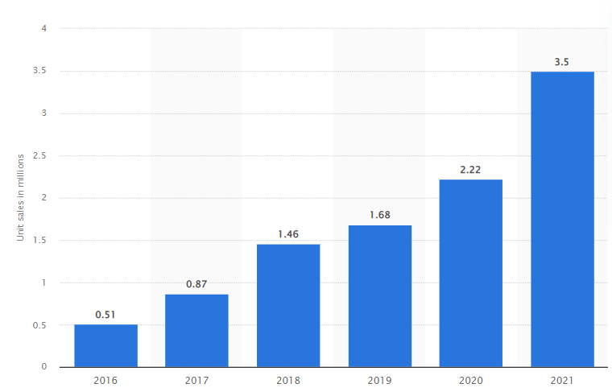

**Figure 2: Battery-electric vehicle sales from the period of 2016-2021 globally**

(Source: Carlier, 2021)

The EVs are expected to be substitutes for traditional fossil fuel-run vehicles and become a major promoter of the economic condition of the country. As per the reported data, battery electric vehicles forecasted sales of 3.5 million units during the year 2021, in comparison to sales of 2.2-2.3 million battery vehicles during the year 2020 (Carlier, 2021). Hence, the EV market is a growing market that is looking to recover from the losses incurred during the period of the Covid-19 pandemic. The utility of the EV is immense considering the current state as the fuel prices are on the rise and environmental pollution is forcing laws to promote EV driving with better battery infrastructure. The supply and demand sharing a dependence on product utility is indicating that supplies for EVs are not as much as the demand, because semiconductor shortage and collapsed global supply chain did not offer the scope to keep EV manufacturing running, even for a resource-heavy brand such as Tesla. As per the study by Masi et al. (2018), Circular Flow Model is suggestive of the ways by which the money moves from the manufacturer to the customers and back again in an endless loop. Land, labour, capital, and entrepreneurship are part of the circular flow of the economy. The two-sector model is applicable for Tesla as the sold goods are brought by the customers, and the earned revenue thereafter flows back into the business for further production. This creates a major GDP impact within a country as well. Hence, in the post-pandemic era, the bigger Tesla sales in the UK would catalyse the GDP to recover and grow systematically.

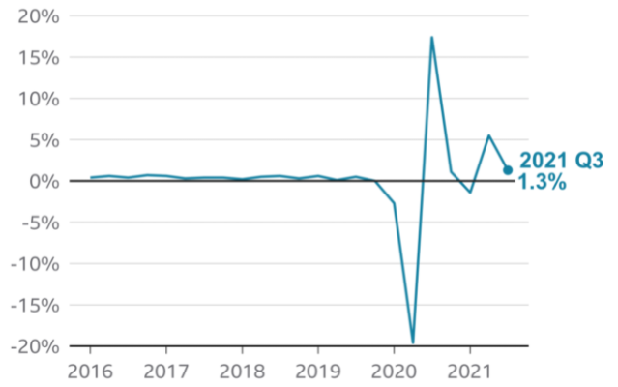

**Figure 3: UK economic growth rate during the Q3 of 2021**

(Source: Hotten, 2021)

As per the current statistics, the Bank of England developed a monetary policy to achieve the target of 2% inflation retention from the end of the UK government. On the other end, the fiscal policies have helped on a greater level as compared to the monetary policies in creating a favourable path for the sales of EVs in the UK in future. Furthermore, across the third quarter of 2021, the economy rose by 1.3%, with the GDP rates projected to be moving in a similar direction (Hotten, 2021). Neoclassical economics refers to the fact that consumers' perception of the value of a product act as a core influencing factor for the pricing of the product. Since the EVs are gaining popularity and are being offered by a wide variety of automotive manufacturing units, the buyer power seems to be increasing, while currently remaining moderate. According to the views of Vlados, Deniozos and Chatzinikolaou (2018), inflation is seen to be an imbalance in the macroeconomics that causes the prices of products to escalate and give major stress to the purchasing power of the population. The UK is facing inflation in the present period as the cost of living has risen to a large extent. This makes the purchasing capacity weaker for EVs unless the pricing mix of Tesla allows them to be more affordable. As discussed by Palley (2018), globalisation and global trading patterns are forecasted in a better way, once the macroeconomic factors are analysed effectively. As evident from the case of Tesla, globalisation benefits the sales of EVs in the UK as it permits sourcing and manufacturing locally to save operational costs and tackle inflation with stable sales.

# Task 2

## a)

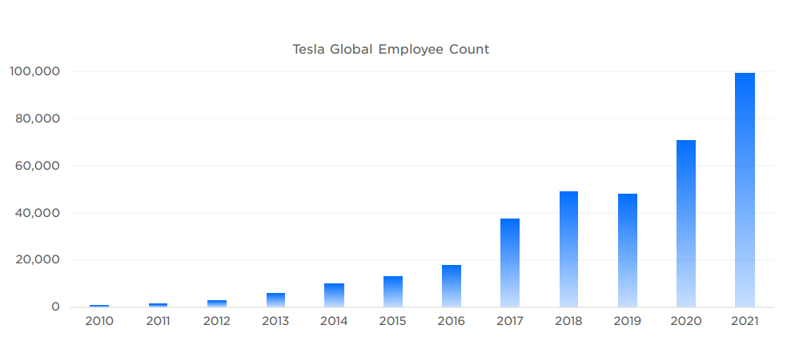

**Figure 4: Employee numbers at Tesla**

(Source: Tesla, 2022)

Leading a multicultural and diverse team becomes a challenging activity for any business leader as loopholes in strategic planning would develop, despite perfecting the tactics. This is because of the fluctuating external business environment. Hence, a leader needs to be flexible and less reluctant to change in the business. At Tesla, Elon Musk is a major supporter of change, thereby suggesting that the CEO holds an ample degree of adaptability in leadership. As stated by Reddy et al. (2021), uncertain future, supply chain crisis, management of financial assets, performance measurement, regulation and compliance, the well-being of employees, managing diversity, technology integration, and facing the globalisation trend. As seen from the case of Tesla, assuring a digital-ready and task-intensive culture in the business has helped Elon Musk scale EV production in different global locations in the recent period, with an abundance of skilled workforce. However, this approach has some major demerits because it pressurises the employees extensively and generates stress. Managing business uncertainty, financial assets, performance measurement, supply chain crisis, regulation and compliance is made easier by Elon Musk with innovative leadership practices and good relations with governments where Tesla operates. The business had close to 3,000,000 unique applicants in the year 2021 across the global scale. Additionally, the dependence on the diversity, equity and inclusion (DEI) hiring strategy aided the business managers to optimise the human resources and operation-related business actions with efficiency (Tesla, 2022). The automotive unit has also looked to prefer a people and culture-centric theme that is evident from the employment of close to 100,000 employees. The skilled labour force shall contribute towards the corporate strategic objective of manufacturing 20x more cars by 2030.

**Figure 5: Lewin's leadership styles**

(Source: Developed from Crosby, 2021)

The drive to attain better performance is one of the major leadership goals at Tesla. According to the study by Crosby (2021), the leadership model of Kurt Lewin proposed three varied leadership styles such as autocratic, democratic, and Laissez-faire or delegative. Elon Musk intends on following autocratic leadership as that gives access to faster decisions and better time management. The application of autocratic leadership invited better workplace communication, improved productivity, optimised crisis management, and micromanagement for quality delivery of services. The DEI framework in the business boosts the credibility of a diversified workforce, as employee retention stood strong for the business because of the DEI framework. The present reports are evidence of the fact that in the fourth quarter of 2022, Tesla managed to produce over 439,000 vehicles and distributes close to 405,000 vehicles (Tesla, 2023). As per the views of Hunt and Fedynich (2019), the trait theory is suggestive of the fact that innate qualities and characteristics make someone a leader. These factors could be anything such as personality factors, physical factors, and intelligence factors. Hence, Elon Musk with a high level of intellect and a preference for innovative solutions that disrupt the industry life cycle shares the trait of a visionary despite having large autocratic traits. The vision to see Tesla become one of the biggest energy companies in future with the EV sales and clean energy distribution holds a massive potential.

**Figure 6: McGregor X and Y styles of management**

(Source: Developed from Prottas and Nummelin, 2018)

The managerial styles differ in businesses as the organisational culture and structure help predict the management style. The hierarchal structure of the business is representative of the strict regulations in the business and the lack of empathy for the base-level employees. As mentioned by Prottas and Nummelin (2018), McGregor X and Y propose two different types of management, with the X style sharing a preference for micromanagement and supervising the work actions as these managers believe that the employees do not remain committed to work unless they are given rewards and punishment. However, the Y style of management suggests that the employees are keen on working with responsibility if the efforts registered by the employees are recognised and valued. Hence, the extrinsic level of motivation and short-term gains remains to be a major factor within the X management style as compared to the intrinsic motivation and sustainable workforce for long-term gains. As evident from the case of Tesla, X style of management is present.

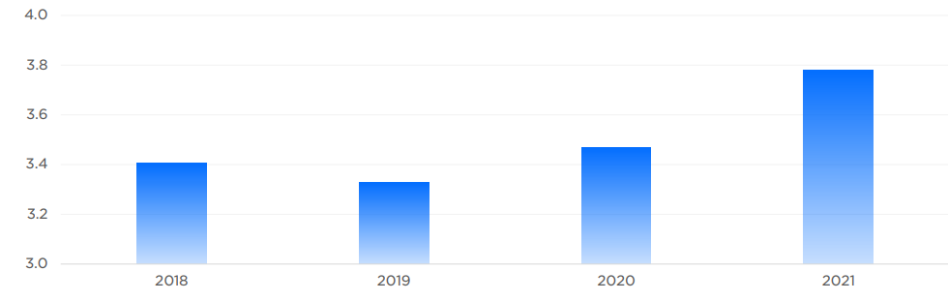

**Figure 7: Tesla employee satisfaction rating**

(Source: Tesla, 2022)

The efforts of rewarding the employees is not a short-term strategy for the business as it looks to offer company shares and several other compensations that associate with the performance of the staff to keep employee engagement levels stronger and reduce employee turnover. As per recent statistics, employee satisfaction levels have improved in the present period based on the Glassdoor rankings, with the year 2021, being significantly better than previous years (Tesla, 2022). Therefore, Tesla is using leadership and managerial practices with efficiency to withstand the detrimental impacts in the contemporary business field.

## b)

Business management, organizational setting, and business environment are linked with each other to a large extent. As per the study by Trindade d’Ávila Magalhães (2018), International Monetary Fund recognises the four key aspects of globalisation to be trade and transactions, capital and investment, migration and people, and dissemination of knowledge. As seen in the case of Tesla, the concept of circularity in the business is helping it operate ethically. While the expansion of services suggests that in the UK, there will be future job opportunities in EV manufacturing.

According to the views of Shao et al. (2021), a person aware of the wider world developments is a participant in the Responsible Global Citizen concept. The responsible Global Citizen theme shall be followed in the businesses to make sure that the business leaders are not pursuing any form of illegal or unethical actions that could cause harm to the environment and the brand's reputation. Complying with the zero carbon emission target and environmental rules has helped Tesla operate in the UK under the influence of the Responsible Global Citizen concept with the efficiency and support of globalisation. As stated by Pais and Costa (2020), the varied drivers of globalisation are seen to be political, market, cost, competitive, and technological. The Industry 4.0 tools have also shaped business proceedings to become more sustainable. Tesla remains accountable and responsible towards the environment as it uses renewable energy across the Smart Giga factories. In the current period, during 2020, 1,300 tons of nickel, 400 tons of copper, and 80 tons of cobalt are recycled by the company (Tesla, 2022). There are several areas such as poor preservation of natural resources, diversity, lack in the workplace and compliance with legal codes that the company wishes to address under the influence of Responsible Global Citizen. As evident from the case of Tesla, in the globalised economy, the brand manages to make ethical decisions and stay accountable. Sequentially, self-awareness, openness, and sensitivity to diversity have helped the Responsible Global Citizen concept emerge as a positive one for the company as it allows it to continue to boost sustainability actions across frameworks such as environmental, social, and governance in the business.

# References

Aggarwal, K., Mijwil, M.M., Al-Mistarehi, A.H., Alomari, S., Gök, M., Alaabdin, A.M.Z. and Abdulrhman, S.H., 2022. Has the future started? The current growth of artificial intelligence, machine learning, and deep learning. *Iraqi Journal for Computer Science and Mathematics*, *3*(1), pp.115-123.

Baqaee, D. and Farhi, E., 2022. Supply and demand in disaggregated Keynesian economies with an application to the Covid-19 crisis. *American Economic Review*, *112*(5), pp.1397-1436.

Carlier, M., 2021. *Battery-electric vehicle sales worldwide from 2016 to 2021*. Statista. Available at: https://www.statista.com/statistics/1059214/global-battery-electric-vehicle-sales/ Available at: [Accessed 12th April 2023]

Crosby, G., 2021. Lewin’s Democratic Style of Situational Leadership: A Fresh Look at a Powerful OD Model. *The Journal of Applied Behavioral Science*, *57*(3), pp.398-401.

Fernandez-Guadaño, J., Lopez-Millan, M. and Sarria-Pedroza, J., 2020. Cooperative entrepreneurship model for sustainable development. *Sustainability*, *12*(13), p.5462.

Fraga-Lamas, P. and Fernández-Caramés, T.M., 2019. A review on blockchain technologies for an advanced and cyber-resilient automotive industry. *IEEE access*, *7*, pp.17578-17598.

Hardman, S., Berliner, R. and Tal, G., 2019. Who will be the early adopters of automated vehicles? Insights from a survey of electric vehicle owners in the United States. *Transportation research part D: transport and environment*, *71*, pp.248-264.

Hotten, R., 2021. *UK economic growth slows as supply problems hit the recovery*. BBC News. Available at: https://www.bbc.com/news/business-59244988 Available at: [Accessed on 12th April 2023]

Hunt, T. and Fedynich, L., 2019. Leadership: Past, present, and future: An evolution of an idea. *Journal of Arts and Humanities*, *8*(2), pp.22-26.

Ivančić, L., Vukšić, V.B. and Spremić, M., 2019. Mastering the digital transformation process: Business practices and lessons learned. *Technology Innovation Management Review*, *9*(2).

Masi, D., Kumar, V., Garza-Reyes, J.A. and Godsell, J., 2018. Towards a more circular economy: exploring the awareness, practices, and barriers from a focal firm perspective. *Production Planning & Control*, *29*(6), pp.539-550.

Meissner, D., 2019. Public-private partnership models for science, technology, and innovation cooperation. *Journal of the Knowledge Economy*, *10*, pp.1341-1361.

Pais, A. and Costa, M., 2020. An ideology critique of global citizenship education. *Critical Studies in Education*, *61*(1), pp.1-16.

Palley, T.I., 2018. Three globalizations, not two: rethinking the history and economics of trade and globalization. *European Journal of Economics and Economic Policies: Intervention*, *15*(2), pp.174-192.

Prottas, D.J. and Nummelin, M.R., 2018. Theory X/Y in the health care setting: Employee perceptions, attitudes, and behaviors. *The health care manager*, *37*(2), pp.109-117.

Ramazanov, I.A., Panasenko, S.V., Cheglov, V.P., Krasil’nikova, E.A.E. and Nikishin, A.F., 2021. Retail transformation under the influence of digitalisation and technology development in the context of globalisation. *Journal of Open Innovation: Technology, Market, and Complexity*, *7*(1), p.49.

Reddy, K.R.K., Gunasekaran, A., Kalpana, P., Sreedharan, V.R. and Kumar, S.A., 2021. Developing a blockchain framework for the automotive supply chain: A systematic review. *Computers & Industrial Engineering*, *157*, p.107334.

Shao, J., Tillaguango, B., Alvarado, R., Ochoa-Moreno, S. and Alvarado-Espejo, J., 2021. Environmental impact of the shadow economy, globalisation, trade and market size: Evidence using linear and non-linear methods. *Sustainability*, *13*(12), p.6539.

Tesla, 2022. *Impact Report 2021.* Available at: https://www.tesla.com/ns_videos/2021-tesla-impact-report.pdf [Accessed 12th April 2023]

Tesla, 2023. *Tesla Vehicle Production & Deliveries and Date for Financial Results & Webcast for Fourth Quarter 2022.* Investor Relations. Available at: https://ir.tesla.com/press-release/tesla-vehicle-production-deliveries-and-date-financial-results-webcast-fourth-quarter [Accessed 12th April 2023]

Trindade d’Ávila Magalhães, D., 2018. The globaliser dragon: how is China changing economic globalisation?. *Third World Quarterly*, *39*(9), pp.1727-1749.

Truant, E., Broccardo, L. and Dana, L.P., 2021. Digitalisation boosts company performance: an overview of Italian listed companies. *Technological Forecasting and Social Change*, *173*, p.121173.

Vlados, C., Deniozos, N. and Chatzinikolaou, D., 2018. Global crisis, innovation and change management: Towards a new systemic perception of the current globalization restructuring. *International Business Research*, *11*(8), pp.9-29.

Wojewnik-Filipkowska, A., Dziadkiewicz, A., Dryl, W., Dryl, T. and Bęben, R., 2021. Obstacles and challenges in applying stakeholder analysis to infrastructure projects: Is there a gap between stakeholder theory and practice?. *Journal of property investment & finance*, *39*(3), pp.199-222.