**POVERTY, INEQUALITY AND INSECURITY**

Table of Contents

Introduction 3

Discussing the issues of Poverty, inequality and Insecurity in the public Domain 3

Explaining why this is a critical issue 3

Diagnosing and analysing the critical issue of poverty, inequality and Insecurity in the public domain 4

Role of a critical issue in the public domain and stating the reason 5

Critical analysis and evaluation of the UN’s Sustainable Development Goals as a solution 6

Developing appropriate and innovative responses regarding poverty, inequality and insecurity in the public domain 7

Conclusion 8

Reference list 9

# Introduction

Economic instability has generated an unstable society with a lot of issues. Poverty is a factor, which has increased inequality in society and insecurity in the individual’s daily lifestyle. The global economy has depended on the income rate of the global population. In decreasing issues of poverty, United Nations (UN) has proposed some sustainable development solutions. Food, clothes, shelter, health safety and education are the basic needs of a human being.

# Discussing the issues of Poverty, inequality and Insecurity in the public Domain

The sustainable development strategies of the UN have assisted to minimise the issues in the public domain by applying innovative solutions. Poverty has increased barriers to leading a healthy lifestyle, which has increased social vulnerability. Based on the opinion of Asare and Barfi (2021), poor individuals cannot afford education and sufficient health security, which has restricted them to get a good job in future and live a healthy lifestyle. In addition, the lack of financial security has influenced the poor population to live a life with minimum expenses. The individuals cannot maintain a hygienic lifestyle by washing clothes every day, using poor sanitation and taking unhygienic foods. According to the opinion of Rowley *et al.* (2021), the death rate of the population is another consequence of extreme poverty. Inequality in society has also been generated by different economic stability of the population. Different financial stability has influenced the individual’s lifestyle and social discrimination has been initiated.

## Explaining why this is a critical issue

The poverty rate has also affected the country’s economic development process as poor people cannot afford higher education and deliver efficient services to an organisation. For instance, ***11.01 million*** individuals stayed below the poverty rate ***in the UK in 2022*** (Statista.com, 2023). The global economy has been affected by this position as the UK cannot improve its present economic condition for this poor population. In addition, the educated population can decrease social risk and improve the economic quality of the country. As per the view of Laborde *et al.* (2021), insecurity in lifestyle has been developed for the low-income rate. The main drivers of poverty are social inequality, lack of jobs with good wages, social infrastructural issues and others. These factors have increased social discrimination, which has separated a specific community from society.

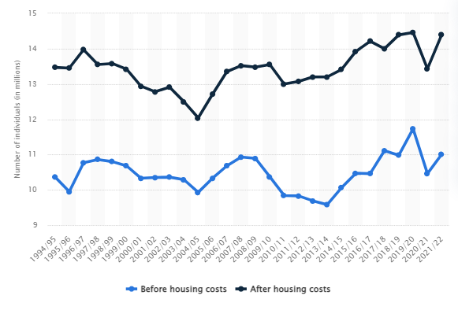

**Figure 1: Number of individuals with relatively low income in the UK**

(Source: Statista.com, 2023)

# Diagnosing and analysing the critical issue of poverty, inequality and Insecurity in the public domain

Poverty and insecurity have developed social inequality, for which, the low-income level is a big reason. Poor economic stability has influenced individuals to use a minimum quality lifestyle with no households, insufficient foods and clean water, no sanitary solutions and no education. Among all OECD countries, ***Costa Rica*** has the highest poverty rate with ***20.3%*** (Statista. com, 2023). Following the world population, South Sudan has the highest poverty rate with ***82.30% poor population*** (Worldpopulationreview.com, 2023). The individuals cannot afford a good and healthy lifestyle for their unemployment issues and illiteracy problems. Countries with low economic stability have faced the poverty issues of high-level poverty. It is noted that awareness of illiterate individuals is low, which has developed social discrimination issues and social inequalities. Poor individuals cannot manage their basic needs, such as food, household, health security and education. These populations are not the resources of the country; however, the government has provided them with household facilities, which has decreased the country’s assets.

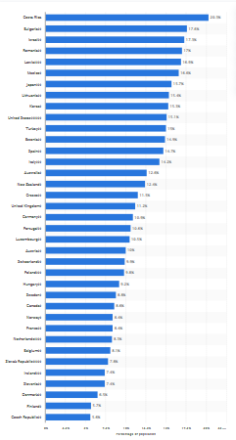

**Figure 2: Poverty rates in OECD countries**

(Source: Statista.com, 2023)

## Role of a critical issue in the public domain and stating the reason

The public domains have faced the issue of poverty, illiteracy and unemployment. Global industries try to recruit educated and efficient workers, but the countries with a below-poverty rate cannot deliver efficient services for high levels of illiteracy. Focusing on the global poverty rate, ***Bulgaria*** has faced poverty issues with ***17.6%*** of poor individuals (statista.com, 2023). Developed countries have also faced poverty issues for migration. For instance, in the USA, ***24% of the African American population*** lived below the poverty level in 2021 (Statista.com, 2023). The global poverty rate has generated barriers to economic development, for which, the work process of the public sector has been hampered by uneducated and inefficient workers. Poor individuals do not have proper health security, which has increased the unhygienic rate in society and discrimination has been generated between the poor population and upper-class individuals.

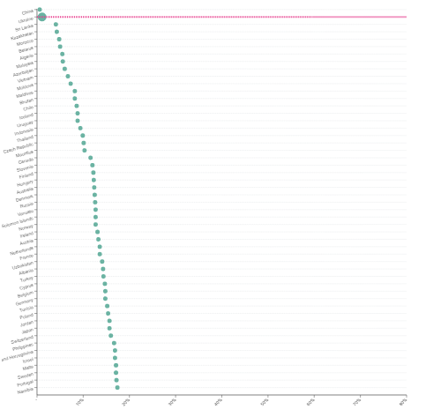

**Figure 3: Poverty rate by country in 2023**

(Source: Worldpopulationreview.com, 2023)

# Critical analysis and evaluation of the UN’s Sustainable Development Goals as a solution

The poverty level has increased during the Covid-19 pandemic situation projected 70 million individuals are facing extreme poverty levels globally. Evidently, ***3% of the world's population is living on $1.90 in 2023*** (Un.org, 2022). This strategy indicates the rapid economic changes in all nations in terms of increasing economic valuation and income rates in terms of addressing poverty levels. For instance, ***17.2% of the poverty level*** has been observed in the UK in 2021-2022 and it ***increased by 18.3% in 2023 where 800,000 individuals*** have low income (Parliament.uk, 2022). On the other hand, ***46% of individuals*** have not yet adopted digital health technology which brings health inequality issues. Besides, ***31% of individuals adopted this technology earlier*** (Statista.com, 2022). According to Peres *et al.* (2019), the poverty level created an inequality scenario in the sector that shows socio-economic inequality. In that case, the UN SDGs strategies have been implemented in this poverty reduction program.

The food insecurity level has also been investigated across the world where 11.7% of the global population faces massive food insecurity in 2021 (Statista.com, 2022). For instance, UK householders face ***22% of food insecurity*** and they skip their meals due to huge poverty levels (Theguardian.com, 2023). The UN organisation focused on zero hunger goals as per SDG 2 in terms of securing hungry issues because “***720 million and 811 million***” individuals have been suffering from hunger issues for the poverty issues during the pandemic (Un.org, 2023). As opined by Yaya and Ghose (2019) global countries have focused on the SDGs in terms of promoting material and childcare inequality issues in the healthcare sector. On the contrary, Pollard and Booth (2019) argued that food insecurity issues occurred due to the massive poverty level where inadequate social security has been found. In that case, SDGs 1, 2, 3, 5, and 12 goals are required to mitigate poverty, insecurity and inequality issues.

# Developing appropriate and innovative responses regarding poverty, inequality and insecurity in the public domain

***Recommendation for poverty issues***

The poverty level can be addressed by adopting the ***empowerment rate, economic growth promotions and fighting against hunger issues***. According to von Braun *et al.* (2021), increasing income rates and food production operations can help to provide food and sufficient income to mitigate food insecurity issues and poverty levels. In that case, higher economic growth and empowerment activities are highly recommended for poverty reduction programs with SDG strategies. With the help of the strategies of SDGs, global crises can be addressed and the UK region can also improve poverty levels, insecurity and inequality issues.

***Recommendation for food insecurity***

On the other hand, ***food donation, and sustainable food consumption*** aspects are needed to include in food insecurity issues so that low-income individuals can improve their health. Food donation and sustainable food consumption strategies are needed to be involved with UN SDGs. As per the suggestion of Fattibene *et al.* (2020), food waste issues need to be addressed in urban regions across the world by following SDG 2 in order to support the zero hunger goals. However, food waste management is recommended for food insecurity issues.

***Recommendation for health inequality***

Inequality issues have also been found globally, where ***46% of individuals are*** deprived of digital healthcare facilities. At this point, government intervention, and physical and mental health developmental promotions are required to manage the healthcare inequality issues. As suggested by World Health Organization, (2020), ***leadership policy development, community engagement and physical healthcare promotions*** can enhance the security level of healthcare of individuals. However, leadership policies and community engagement are highly recommended for healthcare inequality issues based on SDG 3. The WHO organisation has been focused on SDG 3 and other relevant strategies in terms of considering the physical and mental health growth of all individuals without considering income levels. In that case, governance structure and multisectoral policies are needed to be focused on improving the health of underprivileged individuals. Along with that, poverty and food insecurity issues are also highlighted to balance the global crisis.

# Conclusion

It can be concluded that SDG goals are effectively helping to manage the poverty level, food insecurity and health inequality issues. At this point, the UK poverty level has also increased due to low-income issues; however, economic growth needs to be developed to avoid these crises. Leadership policies, government intervention, food donation, food waste and other relevant strategies have been recommended in terms of creating facilities for all underprivileged individuals who are facing health issues, hunger problems and economic problems.

# Reference list

Asare, P. and Barfi, R., (2021). The impact of Covid-19 pandemic on the Global economy: emphasis on poverty alleviation and economic growth. *Economics*, *8*(1), pp.32-43.

Fattibene, D., Recanati, F., Dembska, K. and Antonelli, M., (2020). Urban food waste: A framework to analyse policies and initiatives. *Resources*, *9*(9), p.99.

Laborde, D., Martin, W. and Vos, R., (2021). Impacts of COVID‐19 on global poverty, food security, and diets: Insights from global model scenario analysis. *Agricultural Economics*, *52*(3), pp.375-390.

Parliament.uk, (2022). Poverty in the UK: statistics. Available at: https://commonslibrary.parliament.uk/research-briefings/sn07096/ [Accessed 17 April 2023].

Peres, M.A., Macpherson, L.M., Weyant, R.J., Daly, B., Venturelli, R., Mathur, M.R., Listl, S., Celeste, R.K., Guarnizo-Herreño, C.C., Kearns, C. and Benzian, H., (2019). Oral diseases: a global public health challenge. *The Lancet*, *394*(10194), pp.249-260.

Pollard, C.M. and Booth, S., (2019). Food insecurity and hunger in rich countries—it is time for action against inequality. *International journal of environmental research and public health*, *16*(10), p.1804.

Rowley, J., Richards, N., Carduff, E. and Gott, M., (2021). The impact of poverty and deprivation at the end of life: a critical review. *Palliative Care and social practice*, *15*, p.26323524211033873.

Statista.com, (2022). *Digital health and health inequality initiatives worldwide in 2022*. Available at: https://www.statista.com/statistics/1316666/digital-health-and-health-inequality-initiatives-worldwide/ [Accessed 17 April 2023].

Statista.com, (2022). *Severe food insecurity worldwide by region 2014-2021*. Available at: https://www.statista.com/statistics/987120/prevalence-severe-food-insecurity-worldwide-region/#:~:text=In%202021%2C%2011.7%20percent%20of [Accessed 17 April 2023].

Statista.com, (2023). *Number of individuals in relative low income in the United Kingdom from 1994/95 to 2021/22,* Available at:<https://www.statista.com/statistics/282365/relative-poverty-figures-uk/#:~:text=As%20of%202021%2F22%20approximately,when%20housing%20costs%20are%20considered>. [Accessed on: 17th April, 2023]

Statista.com, (2023). *Poverty rates in OECD countries*, Available at:<https://www.statista.com/statistics/233910/poverty-rates-in-oecd-countries/> [Accessed on: 17th April, 2023]

Theguardian.com, (2023). Number of UK children in food poverty nearly doubles in a year to 4m. 1 Mar. Available at: https://www.theguardian.com/society/2023/mar/01/number-of-uk-children-in-food-poverty-nearly-doubles-in-a-year-to-4m#:~:text=According%20to%20the%20Food%20Foundation [Accessed 17 April 2023].

Un.org, (2020). *Ending Poverty*. Available at: https://www.un.org/en/global-issues/ending-poverty [Accessed 17 April 2023].

Un.org, (2023). *Goal 2: Zero Hunger - United Nations Sustainable Development*. Available at: https://www.un.org/sustainabledevelopment/hunger/ [Accessed 17 April 2023].

von Braun, J., Chichaibelu, B.B., Torero Cullen, M., Laborde, D. and Smaller, C., (2021). Ending hunger by 2030–policy actions and costs, pp.1-8.

World Health Organization, (2020). WHO global meeting to accelerate progress on SDG target 3.4 on noncommunicable diseases and mental health, 9–12 December 2019, Muscat, Oman: meeting report.

Worldpopulationreview.com, (2023). *Poverty Rate by Country 2023,* Available at:<https://worldpopulationreview.com/country-rankings/poverty-rate-by-country> [Accessed on: 17th April, 2023]

Yaya, S. and Ghose, B., (2019). Global inequality in maternal health care service utilization: implications for sustainable development goals. *Health Equity*, *3*(1), pp.145-154.