**CASE STUDY ON E-SUPPLY CHAINS**

Table of Contents

Introduction 3

Video 1. The Future of E-Supply Chains 3

Video 2. Supply Chain 2040 6

Video 3. 8 Trends in Supply Chains 8

Video 4. Supply Chains Enabling E-Commerce 9

Conclusion 11

Reference list 12

# Introduction

In the continuous business environment, the creation of a network of the board is of principal importance. It enables businesses to remain aware of the constantly shifting demands of the commercial centre and serves as the foundation of any successful association. The most recent techniques, instruments, and trends that might help supply chain professionals enhance their supply chain operations must be kept in mind. This becomes more and more significant as technology advances. The motivation behind this paper is to investigate the fate of e-supply chains and how new advances can assist companies with better-overseeing hazards and addressing client issues. There will be watching four supply chain management videos to find out about the most recent trends, tools, and strategies that will be used in e-supply chains in the future. Here will be discussed how the future supply chain will be able to deliver precisely what the customer wants, how risk can be managed with the help of predictive analysis and artificial intelligence, how to reverse flows and circular logistics can be incorporated, and how new technologies can assist with challenging issues like product returns and last-mile delivery. This paper will go into detail about the future of e-supply chain management and how new technologies can make supply chain operations better. Supply chain professionals and other stakeholders who are interested in learning more about supply chain management's future will benefit from it.

# Video 1. The Future of E-Supply Chains

In the field of activities and the store network, the future of e-supply chains may be a fundamental topic (Abdirad and Krishnan, 2022). Given the rapid development of technology, businesses must be prepared to meet their customers' increasingly high expectations. The global supply chain continues to evolve rapidly, keeping pace with the breakneck technological advancements of the modern era. To give a fantastic client experience from now on, supply chains should have the option to furnish clients with the specific item they need, at whatever point and any place they need it.

The most crucial step in providing an exceptional customer experience is clearly understanding the client's expectations (Abdirad and Krishnan, 2020). Businesses must be able to accurately anticipate future demands as well as customer preferences and requirements. Moreover, organisations ought to have the option to rapidly answer moving client needs, guaranteeing that items and administrations are by and large accessible when clients require them. Organisations should likewise have the option to track and utilise client criticism to further develop the client experience.

The following stage is to construct a powerful and viable retail organisation. Future-centred e-supply chains ought to quickly satisfy client needs and give data in an ideal and precise way. To ensure that goods will always be available when customers require them, businesses must be able to measure and control their inventory (Rawat, 2022). If businesses want to deliver goods efficiently and quickly, they must also be able to communicate with other supply chain partners and suppliers.

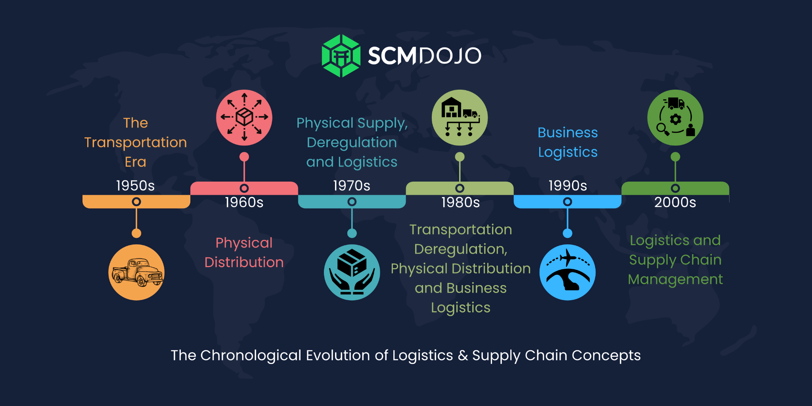

**Figure 1: SCM and logistics**

(Source: https://www.scmdojo.com,)

The third phase is to leverage data and analytics to better understand client needs and improve the customer experience (Abdirad. and Krishnan, 2022). Increase customization becomes more realistic as you work on improving other aspects of your supply chain. To nearly assure that businesses will truly desire to understand their customers' preferences and wants, they should be allowed to gather and segregate data on their clients. They must also be able to use this information to give clients customised experiences and better match products and services to their requirements.

Utilising technology to enhance the customer experience is the fourth step. Businesses ought to be able to automate tasks and provide customers with enhanced forms of assistance through the use of technology. Clients ought to similarly have the choice to follow the progression of their orders and get non-stop updates on available status from associations that can use advancement.

Utilising the Internet of Things (IoT) to enhance customer support is the fifth step. Organisations should have the option to saddle the force of the Web of Things to further develop client assistance (Jing *et al.* 2020). Assuming organisations can utilise IoT to track and screen their items, they will want to give clients constant updates on the situation with their orders.

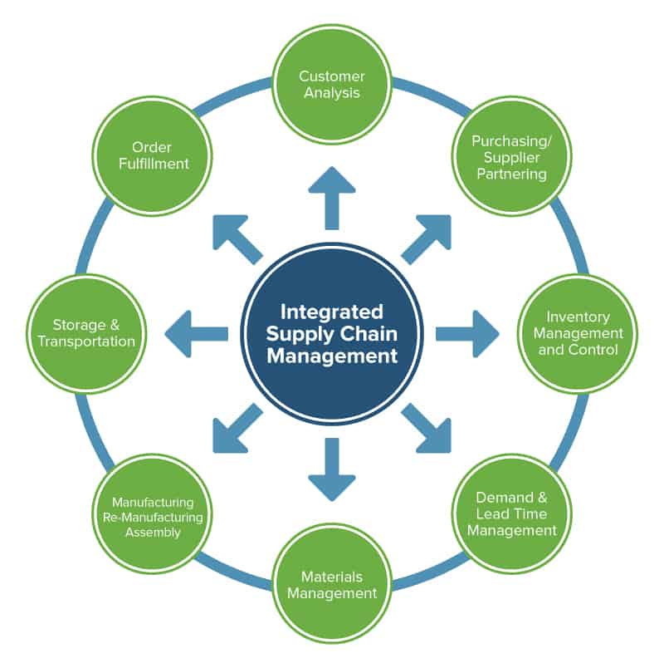

**Figure 2: Integrated SCM**

(Source: https://www.smartsheet.com,)

Last but not least, businesses must be able to leverage artificial intelligence (AI) to provide the greatest experience for their consumers (Adel and Younis, 2021). Using simulated intelligence, procedures may be automated and clients can receive personalised services. To better understand the requirements and preferences of their consumers and determine how to tailor their products and services, businesses should be able to employ computer-based intelligence.

Better customer service will be a priority for upcoming e-supply chains. Businesses need to be ready to offer the skills required to leverage technology to improve customer experiences, use the Internet of Things and artificial intelligence to deliver the best service possible, and use data and analytics to more fully comprehend their customers' wants and requirements. Businesses may ensure that they can continue to serve their consumers' demands and stay competitive by doing this.

E-supply chains are doomed to failure despite their enormous potential and dedication. Associations can encourage the creation network that is effective, responsive, and focused on the client by getting a handle on what their clients need and using development (Guergov, 2022). Businesses need to be ready to meet the requirements of the future of e-supply chains, which will be focused on providing an outstanding customer experience.

Future e-supply chains must be able to accurately meet clients' expectations, including their requirements for when, where, and what specifically they desire (Al Kurdi *et al.* 2022). Businesses must be able to react swiftly to shifting consumer demands and grasp the preferences and needs of their clients. They should have the choice to use analysis and data to more easily understand customer wants and identify their areas of strength for a successful stock business. To provide clients with the optimal experience, they must also be able to employ artificial intelligence and the Internet of Things. They must also be tech-savvy to improve the consumer experience. Businesses may guarantee that they will want to compete in the future and offer top-notch customer service by doing this.

# Video 2. Supply Chain 2040

The Coronavirus pandemic has drastically disrupted global supply networks, making it difficult for certain organisations to survive. Supply chain experts have found it incredibly difficult to manage risk and make plans because of the unpredictability of the world economy (Aloqool *et al.* 2022). They are fortunate to have access to a wide range of instruments that can help them accomplish that aim. Future risk management methods that professionals in the production network can utilise include mental analysis and computerised reasoning, both of which are instances of simulated intelligence. On one hand, results in the Technology topic segment identify standards (e.g. the ISO container, the Euro pallet or the use of paper in freight documents) which are still of great importance.

Experts in production networks can use a fantastic resource called prescient examination to investigate the foreseeable future and anticipate potential threats. By dissecting information from previous events, the prescient examination can provide insight into how a situation might develop in the future (Antoni and Akbar, 2019). This can make it more straightforward for store network experts to arrive at better conclusions about tasks, stock, and other creation network issues.

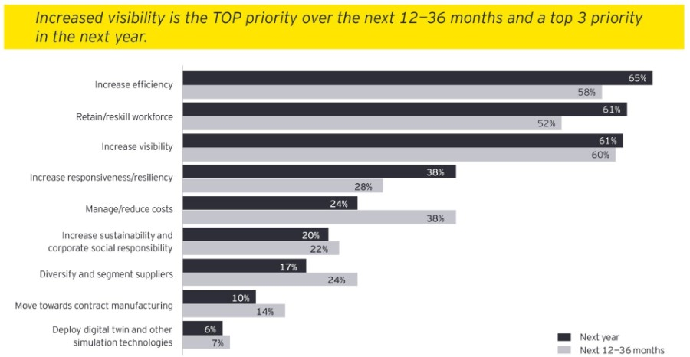

**Figure 3: SCM affected by Covid-19**

(Source: https://www.ey.com,)

AI may also be used by supply chain professionals in the future to better manage risk. Data patterns can be identified, processes can be automated, and insights can be used to make decisions. By investigating information on client interest and stock levels, simulated intelligence, for example, can naturally change creation levels to guarantee that there is an adequate item to fulfil client needs (Guergov, 2022). Additionally, man-made information can be used to identify potential store network interferences and prepare stock organisation specialists so that they can mitigate the impact.

Supply chain professionals may have access to a potent instrument that will enable them to better manage risk in the future by combining AI and predictive analysis (Abdirad, and Krishnan, 2020). By combining these two innovations, professionals in the store network can gain a deeper comprehension of anticipated risks and look for better options to mitigate them.

By utilising the power of the Internet of Things (IoT) in addition to visual analysis and artificial intelligence, experts in-store networks can more likely manage risk in the future. The Internet of Things can provide a real-time view of the entire system by connecting all supply chain components, from suppliers to manufacturers to retailers. Supply chain professionals will be able to stop potential issues in their tracks by employing this strategy.

At last, store network experts can comparably utilise blockchain headway to even more speedily direct gamble from this point until quite a while to come. Supply chain professionals can use blockchain to guarantee data integrity, cut costs, and increase transparency. Additionally, blockchain can serve as a secure platform for the creation of digital contracts and ensure that all participants in the supply chain are operating by the same set of guidelines (Hamadneh *et al.* 2023). The Covid-19 pandemic is severely disrupting global supply chains, making it difficult for numerous businesses to continue operating. Experts may find it easier to monitor risk in the future by utilising vision analysis, computer-based intelligence, and other innovations like the Internet of Things and blockchain. Utilising these tools, production network specialists can ensure that their organisations remain resilient in the face of vulnerability.

# Video 3. 8 Trends in Supply Chains

As the global economy moves toward a framework that is more environmentally conscious and sustainable, it is becoming increasingly important to incorporate "reverse flows" and "circular logistics" into the future supply chain (Subawa *et al.* 2023). Supply chains must immediately begin adjusting their operations to meet the new demands to effectively manage this requirement. This can be achieved in various ways, for example, by carrying out harm to the ecosystem rehearses throughout the whole store network, shaping new associations, and using new advances. The main trends in supply chain management today are artificial intelligence and automation, supply chain as a service, circular supply chains, risk management and stability, and increased focus on sustainability.

In the Models in Supply Chains video, the speaker highlights the need of including "turn streams" and "backhanded made exercises" in the future shop association. He claims that the necessity to reduce waste and the rising popularity of manageability make this imperative. He continues to comprehend how cutting-edge technologies like artificial intelligence, blockchain, and the Internet of Things may be used to improve presentation organisation overall and to encourage thing stream noticing and following (Handojono *et al.* 2022). He also emphasises the significance of forming new partnerships and working with partners such as customers, suppliers, and other stakeholders to create a supply chain that is more durable and effective.

What's more, the speaker makes sense that economical practices should be executed all through the production network to make due "switch streams" and "round operations." He suggests using renewable energy sources like wind and solar power to reduce the supply chain's impact on the environment. The speaker also talks about how important it is to use environmentally friendly packaging and materials to cut down on the amount of waste that comes from shipping products (Jing *et al.* 2020). In addition, he explains that the creation of environmentally friendly and energy-efficient transportation systems, such as electric or hybrid automobiles, can contribute to the reduction of emissions and the improvement of the overall sustainability of the supply chain.

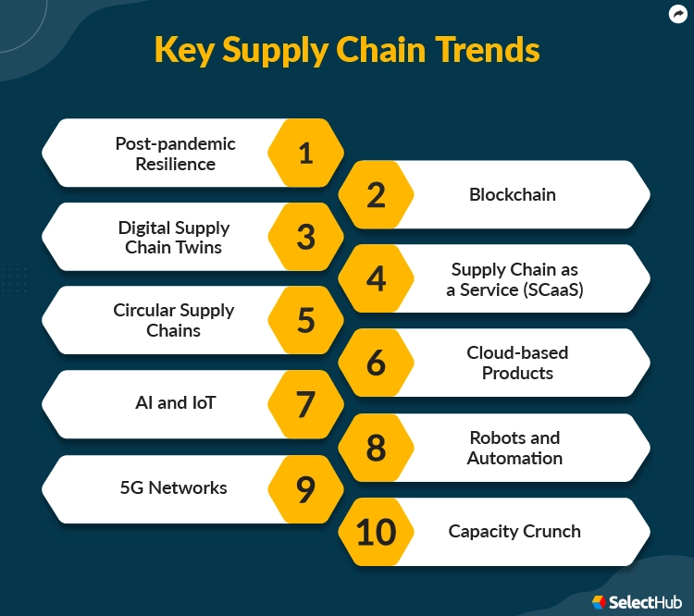

**Figure 4: Trends in SCM**

(Source: https://www.selecthub.com,)

The speaker concludes by stressing the significance of investigating the display of the inventory network and carrying out research. He makes sense of the idea that innovations like computerised reasoning, artificial intelligence, and clairvoyance examination can help ensure that the store network is operating at its most effective and practical level. He goes on to say that inventory network flaws and waste can be identified and addressed with information and investigation. As the global economy shifts toward a framework that is more environmentally friendly and sustainable, it is becoming increasingly important to incorporate "reverse flows" and "circular logistics" into the future supply chain (Kumar *et al.* 2019). Supply chains must immediately begin adjusting their operations to meet the new demands to effectively manage this requirement. This can be accomplished in different ways, for instance, by putting new progressions into use, making new associations, and solidifying innocuous environment practices generally through the entire presentation organisation. Utilising these measures, supply chains can address the issues of their partners and customers to ensure the efficient and cost-effective operation of their operations.

# Video 4. Supply Chains Enabling E-Commerce

Product returns and delivery over the last mile are two of supply chain management's most difficult obstacles. The movement of goods from a transportation hub to the final customer is referred to as "last-mile delivery." Following a customer's purchase, a product is returned to the manufacturer or supplier (Rawat, 2022). These two issues have recently been addressed through customary methods like manual return handling, conveyance, and request satisfaction. However, as e-commerce has grown in popularity, these issues have become more difficult and costly. Supply chain management in e-commerce focusses on procurement of raw material, manufacturing, and distribution of the right product at the right time.

To address these issues, new technologies have emerged. The YouTube video "Supply Chains Enabling Web-based Business" examines how to store organisation efficiency and cost reduction can be aided by computerization and high-level advancements. For instance, order fulfilment can be simplified with the aid of automation, resulting in quicker delivery times and increased accuracy (Kumar *et al.* 2020). Last-mile movement can be improved and monetarily astute with automated transport structures. Also, self-driving vehicles and robots can be used for practical, fast, and safe conveyance. Lastly, digital technologies can be used to speed up the resolution of customer issues and improve customer satisfaction by streamlining the return procedure for products. In addition, the video explains how the application of AI and analytics can facilitate and speed up the decision-making process in the supply chain. Businesses can anticipate demand and prepare for upcoming store network requirements by using examination, for example, to monitor customer behaviour. Businesses can identify areas for improvement and make better choices by analysing data from a variety of sources with the help of artificial intelligence. Predictive maintenance, which reduces downtime and ensures reliable operations, can also be assisted by AI.

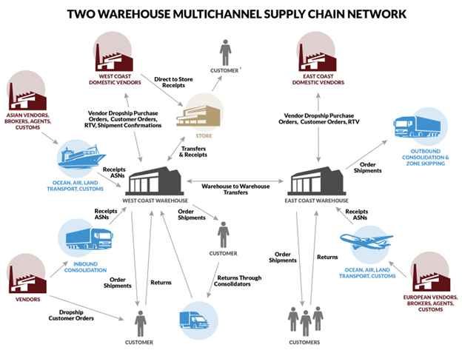

**Figure 5: E-commerce SCM**

(Source: https://www.fcbco.com)

Both item returns and last-mile conveyance can profit from enormous information and the Web of Things (IoT). A lot of data can be used to follow shipments and find potential risks, lowering the likelihood of delays (Aloqool *et al.* 2022). Due to the Web of Things' ability to monitor the condition of goods on the way, businesses can go to great lengths to avoid misfortune or harm. In addition, the Internet of Things can be used to provide constant movement tracking, assist customers in remaining educated, and provide significant information to associations. Supply chain management is the backbone of any e-commerce business. It aids in streamlining the process of taking your goods from point A to point B. new technologies can address issues with product returns and last-mile delivery (Pudjiastuti *et al.* 2020). Order fulfilment, delivery, and return processing can all be streamlined with the help of digital technologies and automation. The Internet of Things, big data, artificial intelligence, and analytics all have the potential to reduce risks, increase visibility, and improve decision-making. Businesses can use these technologies to cut costs and improve the efficiency of their supply chains, which increases their profitability and success.

# Conclusion

In conclusion, to better manage risk, the future supply chain will be able to deliver precisely what the customer wants, to a location of their choice, at a time that suits their needs. Innovations will also be used to manage issues with product returns and delivery over the last mile, as well as to control inverted streams and round-coordinated factors. Supply chains that are better able to meet the requirements of customers in the future will be built using all of these new technologies and procedures. These supply chains will be focused on customers and more effective.

# Reference list

**Journal**

Abdirad, M. and Krishnan, K., 2020. Customer satisfaction assessment of E-Supply chain quality in online shopping: a case study. *Preprints*.

Abdirad, M. and Krishnan, K., 2020. Customer satisfaction assessment of E-Supply chain quality in online shopping: a case study. *Preprints*.

Abdirad, M. and Krishnan, K., 2022. Examining the impact of E-supply chain on service quality and customer satisfaction: a case study. *International Journal of Quality and Service Sciences*, *14*(2), pp.274-290.

Abdirad, M. and Krishnan, K., 2022. Examining the impact of E-supply chain on service quality and customer satisfaction: a case study. *International Journal of Quality and Service Sciences*, *14*(2), pp.274-290.

Adel, H.M. and Younis, R.A.A., 2021. The interplay among blockchain technology adoption strategy, e-supply chain management diffusion, entrepreneurial orientation and human resources information system in banking. *International Journal of Emerging Markets*, (ahead-of-print).

Al Kurdi, B., Alshurideh, M. and Akour, I., 2022. THE IMPACT OF GREEN SUPPLY CHAIN PRACTICES AND E SUPPLY CHAIN IN ACHIEVING COMPETITIVE ADVANTAGE. *International Journal of Business Analytics and Security (IJBAS)*, *1*(1), pp.18-38.

Aloqool, A., Alharafsheh, M., Abdellatif, H., Alghasawneh, L. and Al-Gasawneh, J., 2022. The mediating role of customer relationship management between e-supply chain management and competitive advantage. *International Journal of Data and Network Science*, *6*(1), pp.263-272.

Aloqool, A., Alharafsheh, M., Abdellatif, H., Alghasawneh, L. and Al-Gasawneh, J., 2022. The mediating role of customer relationship management between e-supply chain management and competitive advantage. *International Journal of Data and Network Science*, *6*(1), pp.263-272.

Antoni, D. and Akbar, M., 2019. E-supply chain management value concept for the palm oil industry. *Jurnal Sistem Informasi*, *15*(2), pp.15-29.

Guergov, S., 2022. INVESTIGATING E-SUPPLY CHAIN ISSUES IN INTERNET OF MEDICAL THINGS (IOMT): EVIDENCE FROM THE HEALTHCARE. *International Journal of Computations, Information and Manufacturing (IJCIM)*, *2*(2).

Guergov, S., 2022. INVESTIGATING E-SUPPLY CHAIN ISSUES IN INTERNET OF MEDICAL THINGS (IOMT): EVIDENCE FROM THE HEALTHCARE. *International Journal of Computations, Information and Manufacturing (IJCIM)*, *2*(2).

Hamadneh, S., Alshurideh, M., Akour, I., Kurdi, B. and Joghe, S., 2023. Factors affecting e-supply chain management systems adoption in Jordan: An empirical study. *Uncertain Supply Chain Management*, *11*(2), pp.411-422.

Handojono, M., Alyona, C., Patty, A.C., Louth, F. and Dahoklory, I., 2022, December. Integrating E-Supply Chain Management for the Competitive Advantages of Early Stage Company. In *International Conference on Applied Science and Technology on Social Science 2022 (iCAST-SS 2022)* (pp. 591-595). Atlantis Press.

Jing, X., Guanxin, Y. and Panqian, D., 2020. Quality decision-making behaviour of bodies participating in the agri-Foods e-supply chain. *Sustainability*, *12*(5), p.1874.

Jing, X., Guanxin, Y. and Panqian, D., 2020. Quality decision-making behavior of bodies participating in the agri-Foods e-supply chain. *Sustainability*, *12*(5), p.1874.

Kumar, A., Garg, R. and Garg, D., 2019. An empirical study to identify and develop a constructive model of e-supply chain risks based on Indian mechanical manufacturing industries. *Management Science Letters*, *9*(2), pp.217-228.

Kumar, A., Garg, R. and Garg, D., 2020. Development of a Structural Model of Risk Factors Involved in E-Supply chain adoption in Indian Mechanical Industries. *International Journal of Supply and Operations Management*, *7*(3), pp.242-260.

Pudjiastuti, L., Indrawati, H.A., Arrum, D.A. and Pudjiastuti, L., 2020. Integrated E-Supply Chain Management Systems Services as a form of Acceleration of Development in Indonesia. *Int. J Sup. Chain. Mgt Vol*, *9*(3), p.426.

Rawat, R., 2022. A SYSTEMATIC REVIEW OF BLOCKCHAIN TECHNOLOGY USE IN E-SUPPLY CHAIN IN INTERNET OF MEDICAL THINGS (IOMT). *International Journal of Computations, Information and Manufacturing (IJCIM)*, *2*(2).

Rawat, R., 2022. A SYSTEMATIC REVIEW OF BLOCKCHAIN TECHNOLOGY USE IN E-SUPPLY CHAIN IN INTERNET OF MEDICAL THINGS (IOMT). *International Journal of Computations, Information and Manufacturing (IJCIM)*, *2*(2).

Subawa, S., Dwita, F. and Hafidzh, M.A., 2023. Analysis of Lean Manufacturing Implementation on E-Supply Chain Management Performance in Manufacturing Companies. *JEMSI (Jurnal Ekonomi, Manajemen, dan Akuntansi)*, *9*(2), pp.411-415.