INDIVIDUAL REPORT

(SUPPLY CHAIN MANAGEMENT OF M&S)

Table of Contents

1. Introduction 3

2. Overview of the chosen organisation 3

3. Critical analysis of a supply chain management function 3

4. The basic corporate social responsibilities and the implication in terms of benefits and challenges to supply chain managers 9

4. 1 Benefits of CSR to Supply chain managers 10

4.2 Challenges of CSR to supply chain managers 10

5. The use of the triple bottom line model to overcome some of the challenges 12

6. Conclusion and recommendation 14

Conclusion 14

Reference 16

# 

# 1. Introduction

This study is based on the critical analysis of the supply chain of one of the leading retail organisations of the UK that is Marks and Spencer. This study provides a brief overview of the organisation where the business goals and principles of the organisation will be included as well. The study will highlight the implementation of technology in the supply chain of Marks and Spencer. Marks and Spencer do not manufacture the products it sells in the retail stores, therefore the company is bound to maintain a strong supply chain. The role of the supply chain managers and the impact of the CSR activities of Marks and Spencer on its supply chain will be discussed in this study. In addition, this study will present a triple bottom line model, which helps the organisation to overcome the challenges associated with CSR in the supply chain. Furthermore, this study includes the potential recommendations that can be adopted by the organisation to strengthen its supply chain.

# 2. Overview of the chosen organisation

Marks and Spencers is a multinational company that deals in clothing materials, home decor, accessories and food items. The company is headquartered in England and was founded in the year 1884 by Michael Marks and Thomas Spencer (About us, 2023). The company has grown a lot since then and has established itself in the international market. The company is recognised as a high-street brand that has an impressive international presence in the market. The company is especially known for its high-quality clothing products that are both affordable and sustainable in terms of the environment.

The commitment of the company in terms of sustainability is not just limited to its own business operations and manufacturing activities but also extends to its supply chain. The company works with suppliers who ensure that they are capable of meeting the high demands of sustainable products in the market as well as helping the company to fulfil its social responsibilities as well. It is a well-known brand and has received recognition for its timeless designs of products. M&S operates across multiple nations in the world. The company has been recognised for its commitment towards sustainability as well as sustainable initiatives which enables the organisation to reduce its carbon footprint on the environment.

# 3. Critical analysis of a supply chain management function

M&S has a huge supply chain that is established on the foundation of a diverse supplier base. In order to maintain its diverse range of suppliers, the organisation has implemented a number of initiatives. One such initiative includes the implementation of the *Plan A* supplier program. According to this initiative, the company provides training and support to its supply chain in order to improve its performance in terms of sustainability.

With an increase in eco-conscious consumerism, M&S has been able to increase customer attraction which has contributed towards revenue collection of the organisation (Zhang *et al.*, 2020). It has also led to the increase in market share of the various product portfolio of the company.

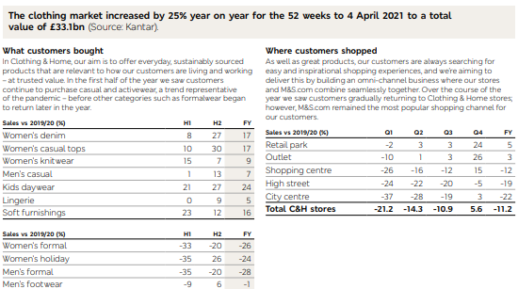

**Figure: Market content of M&S**

(Source: Strategic Report, 2022)

The above image shows the impact of supply chain activities as well as other business activities of the organisation on the increase in the market size of the company in terms of clothing.

The various supply chain functions of the organisation include

***Sustainability***: In order to incorporate sustainability in its business operations, the company has reinvigorated its sustainable approach in order to become net zero in terms of carbon emission by 2040 (Sustainability report, 2022). In response to the climate emergency situation, the company has reset Plan A initiative across all its operations. It has developed a clear road map in order to achieve the net zero goal of the organisation.

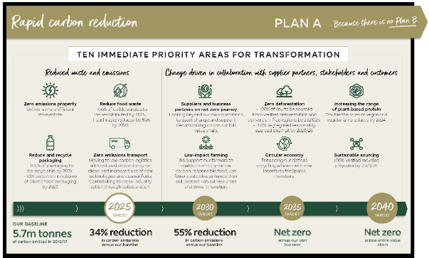

**Figure: Roadmap towards Net Zero**

(Source: Plan-a-our-planet, 2022)

The picture above shows the road map of chewing net zero. This will also contribute towards reducing emissions from Scope 1, Scope 2 and Scope 3 activities. The road map targets the activities of its multiple stakeholders which will enable the organisation to cut down on carbon emissions which will also enable the organisation to reduce its environmental footprint.

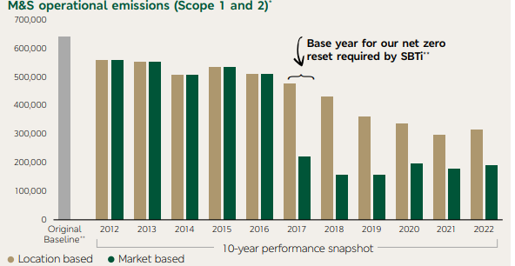

**Figure: GHG emissions of M&S**

(Source: Investor Report, 2022)

As shown in the above picture, the Scope 1 and 2 emissions of the organisation are generated from its own operations which include fuel and electricity. However, Scope 3 emissions include indirect emissions from the value chain of the organisations which account for 97% of the total carbon footprint of M&S. Hence, Plan A established by the organisation will enable it to keep a check on the emissions produced by the organisation from both its direct and indirect activities. This will enable the organisation to contribute towards its commitment towards becoming a net zero-emission business by 2040 (Raybould *et al.,* 2020).

***Digitalisation:*** The company has made huge investments in digital technology which enables it to improve the SCM functions of the organisation. The digital technology in which the company has invested includes artificial intelligence which enables the organisation to optimise its inventory levels as well as improves its accuracy in forecasting market trends and analysing customer behaviour (Le Thuy and Oe, 2020). The company has incorporated a wide range of digital tools and equipment in its business operations. The company has also invested in data science which enables it to stay one step ahead of its target audience. Due to these digital tools and Technologies, the company is capable of gathering real-time data which enables it to make effective decisions. This, in turn, allows the organisation to add to its brand identity in the market which leads to attracting top talent as well as customer engagement. The company also launched an app named Sparks which offers digital loyalty programs for the customers of the company. Rewards are given to the loyal customers of the organisation as well as the app also provides a personalised experience to its users. All these activities contribute to the digital experience of users enabling the company to attract loyal customers to the company.

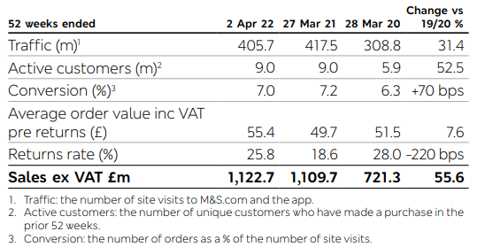

**Figure: Customer engagement on the online website of M&S**

(Source: Strategic Report, 2022)

The organisation has also made investments in placing products as well as conducting marketing activities on the online website of the organisation. This has enabled the organisation to attract a huge number of customer traffic. The company places its products on the online website of M&S while providing detailed information. This allows the customers to view the product offered by the organisation as well as make informed purchase decisions.

***Supply chain management:*** In order to keep track of the use of supply chain activities of the organisation, the company has invested in a supply chain tracking system which enables it to improve its trading activities, helps in improving the capacity of the organisation, enables the organisation to cut down on costs as well as improve its store operations as well. The various investments in the supply chain of the organisation have enabled it to create quicker and more efficient operations which have enabled the organisation to pave a way for establishing a modern automated network. The organisation also faced criticism from a few suppliers in terms of the payment practices of the company. It has been alleged that the company has engulfed itself in cash flow issues for both small-scale and medium-scale suppliers of the organisation. In addition to that, the critical analysis also highlights the fact that in order to continue its business operations, M&S also ensures that the supply chain activities are fair and trustworthy (McGrath *et al.*, 2021). It maintains transparency as well as takes accountability for its actions in order to improve the overall resilience of the organisation.

Moreover, in 2020, after the disruption of the supply chain across the globe, the company made significant efforts to restore the SC as well as established stronger relationships with them in order to become capable of dealing with saturations in the future.

***Resilience:*** Although the company has faced a number of supply chain disruptions starting from the collapse of Hanjin Shipping in 2016, the Covid-19 pandemic, the Brexit issue to the Russia-Ukraine war, M&S has successfully implemented several SC resilience measures which enabled it to overcome the challenges. The contingency plans to overcome the disruptive situation include diversification of suppliers and others. These resilience plans of the organisation have enabled it to effectively manage risks as well as overcome challenges. The company implemented its resilience plans on the vast range of business activities in order to keep continuing its operation during disruptive situations. The company also conducted risk-based Business Continuity assessments (Retzer, 2019). In order to have a clear idea of the sourcing offices as well as supplier arrangements in order to take significant measures to overcome the challenges.

***Transparency and accountability:*** M&S has a strong commitment towards transparency of its SCM functions. The company constantly updates its suppliers about the various initiatives taken by the organisation in order to fulfil its business objectives (McGrath *et al.*, 2021). It also informs the supplier and different stakeholders of the organisation about the range of measures the company takes from time to time in order to manage the visibility and feasibility of SC activities. However, there are certain concerns in terms of the usage of palm oil in the development of products by the company. Some of the stakeholders have even raised concerns about the lack of transparency in the use of palm oil. Therefore, to address the issue and take account of the actions, the company conducts audits regularly as well as informs its different stakeholders about the changes made by the organisation in terms of its business and collaboration from time to time.

***Evaluation of the impact of technology adoption on suppliers and/or customers supported with real-life examples***

Technology has had a significant impact on the overall business of the focus organisation. It has impacted the suppliers as well as customers in a significant manner. The implementation of a wide range of digital technology by M&S has allowed the organisation to improve its SCM activities. The organisation has implemented artificial intelligence (AI) in its SC inventory levels. This has enabled the company to reduce the lead time between orders for supplies to their delivery. This in turn allows the organisation to improve the forecasting to receive delivery of supplies and increases the efficiency of the SC operations of M&S. For example, M&S has partnered with Microsoft in order to implement its cloud-based platform called *Microsoft Dynamic 365* within the supply chain activities of the organisation (Microsoft, 2021). This helps the organisation in improving customer satisfaction which results in gaining loyal customers for the organisation. The technology also enables better collaboration of suppliers of the organisation. This also enables the organisation to have real-time visibility of the inventory levels. This can be further used by the organisation to improve its SC efficiency.

Another example of Technology adoption includes the implementation of Radio frequency identification (RFID) Technology by M&S. This technology allows the company to track inventory levels in real-time (Iftikhar *et al.*, 2020). However, it impacts the small suppliers of the organisation. The technology requires huge costs for implementation which add to the budget of the suppliers. The RFID Technology is also capable of reducing the lead time required for the effective implementation of SCM strategies. It improves the processes as well as enables collaboration between different levels of SC. This contributes to the smooth facilitation of various activities involved in the SCM. The activities include manufacturing of the supplies, transportation of supplies from the warehouses of the supply chain to the production units of M&S as well as other activities involved in SCM.

On the other hand, the company has made huge investments in digital technology which allows the company to improve customer satisfaction. The Technologies specifically include the implementation of mobile payment options as well as the usage of AI in terms of providing a personalised customer experience. M&S has incorporated AI on its online website. The AI uses a complex algorithm to identify the preferences as well as the most visited item on the website by a particular user. The AI analysis the information in order to make suggestions of products based on their previous searches to the particular customer on the page (Javed *et al.*, 2021). This provides a personalised experience to each of the customers of the company on the website which adds to the customer experience. In the same way, the mobile payment option enables the customer to make purchases by directly paying them through a mobile application instead of paying them in case. This makes the shopping experience of the customer much easier which makes them return to the company for future shopping.

# 4. The basic corporate social responsibilities and the implication in terms of benefits and challenges to supply chain managers

Marks and Spencer is one of the leading multinational retail companies, which has its headquarter in the UK. 98% of products are sold by Marks and Spencer under its own brand name, however, the company does not manufacture any products, therefore quite obviously the entire business of Marks and Spencer is heavily dependent on its suppliers (Marksandspencer, 2023). As a result, over 90% of Marks and Spencer’s environmental or social impact takes place within its supply chain. However, the rising global concern about environmental and social degradation has made it necessary for organisations to adopt effective CSR policies in the entire business model. Marks and Spencer is one such organisation that gives strong emphasis on its CSR activities. The company works for the upliftment of the society by doing charity and donations. Moreover, the company donates returned clothes as well as surplus clothes to the needy ones. The company cares for the health and overall well-being of people and it promotes the concept of a healthy lifestyle (Marksandspencer, 2023). Moreover, the company gives a special focus on sustainability. Therefore, the company gives high priority on waste management, sustainable sourcing and ethical trading. As Marks and Spencer heavily relies on its supply chain managers for business operations, the CSR policies of Marks and Spencer directly impact the supply chain managers. The impacts of CSR on the supply chain managers of Marks and Spencer are both beneficial and challenging at the same time.

M&S has made significant investments in technologies which are capable of incorporating Energy Efficiency in the business activities of the organisation. The company has invested in using LED lights in all the retail stores of M&S. The company has also used LED lighting in its clothing and home warehouses as well (Investor Report, 2021). This has enabled the organisation to not only reduce its carbon footprint but also has allowed the company to make its business activities more cost-efficient. Then corporation of LED lights into the details of the company will help the organisation contribute towards its target of achieving carbon neutrality and net zero emissions.

## 4. 1 Benefits of CSR to Supply chain managers

* Marks and Spencer donates surplus and returned clothes, and this is one of the prominent CSR policies of the company because this policy helps the company to have a good reputation. However, this policy of the company helps the supply chain managers from numerous angles. Firstly, it helps the managers in inventory management and reverse logistics. By donating surplus clothes, the company helps needy people, but at the same time, it prevents overstocking. The managers, thus always have adequate space in the inventory for new products.
* The company procures sustainable products and it gets into strategic partnership with the suppliers. This helps the managers to have a strong relationship with the suppliers. Moreover, this helps the managers to ensure an uninterrupted supply of products throughout the year, which further helps the company ensure that the needs and demands of the customer are met.
* The CSR policies of the company help the company to earn the support of the stakeholders. Consequently, the supply chain managers get the support of the stakeholders as well. The company has its business in over 60 counties, therefore, it is important for the managers to have the strong support of the stakeholders for international relationships.
* The managers get the support of consumers because the CSR policies of the company help to create a valued brand image of the company. Moreover, the brand reputation of the company in the market is quite high. This directly helps the managers in inventory management because the prediction of the managers regarding the demand for the products matches justly with the actual demand. This helps managers ensure that the inventories have adequate stock. At the same time, it is helpful for the company to prevent overstocking. Thus, there is always space for new stocks and the old stocks get cleared within the expected time.
* The company focuses on providing a wide range of healthy food products in the retail stores of the company. Moreover, the company focuses on sourcing fresh food items from local suppliers. This is indeed beneficial for the managers in the sense that it helps the managers to establish good relationships with the local suppliers.
* The company focuses on getting the support of local communities and quite obviously the managers get the support of local communities. The support of the local communities enables the managers to overcome transportation-related issues at the local level.
* The strong CSR policies of the company have attracted the attention of consumers across borders. This has helped the managers to get the support of consumers from all the countries.
* The company values sustainability and therefore the company has implemented advanced technologies like AI and ML so that the company can forecast product demands and have real-time information. The implementation of such technologies as AI and ML is indeed beneficial for managers because it helps the company managers to track the movements of tracks and all the goods. Real-time information has enhanced the effectiveness of the supply chain.
* The company cares for its people and provides required training to the employees. This is beneficial for the supply chain managers in the sense that it helps the managers to have skilled workers, who can effectively handle the advanced technologies, implemented in the supply chain.
* Moreover, the company provides necessary support to the employees and ensures that all the employees feel valued within the organisation. This helped the organisation to retain its valued employees. This too is beneficial for the managers because the skilled workers employed in the supply chain of the company are retained and work with full determination.

## 4.2 Challenges of CSR to supply chain managers

* The major challenge for the supply chain managers at Marks and Spencer is that Marks and Spencer have committed to sourcing sustainable raw materials. Therefore, Marks and Spencer have instructed the suppliers to connect with those suppliers who can ensure 100% sustainable raw materials. This is a challenging task for the supply chain managers at Marks and Spencer because the number of supplies that provide sustainable raw materials is limited. Moreover, there is an issue related to transparency. Therefore, the supply chain managers have to maintain a strong relationship with the suppliers. As a result, the managers cannot bargain on pricing because the number of suppliers is limited. Moreover, the supplier has the power to bargain and they often increase the price of raw materials.
* Due to the high bargaining power of the managers, the cost of sourcing materials becomes higher. This directly affects the operations cost of the company and the managers are unable to cope with the situation. Due to higher procurement costs, quite naturally the selling costs of products are set high. This becomes a subject of customer dissatisfaction and competitive disadvantage.
* The supply chain of Marks and Spencers is extremely complex because the company operates its business in over 60 counties and the supply chain managers have to take care of all the operations. However, modern technology like IoT and Ai has been helping the managers to monitor major movements of goods, at times due to technical glitches the managers face a hard time.
* Marks and Spencer have committed that by 2050 the company will be carbon neutral, therefore, the company has decided to incorporate green energy. In addition, the company has decided to reduce its carbon emission from logistics and transportation, therefore, the company has asked the supply chain managers to reduce the use of airlines for freight transportation. Freight transportation through railways and waterways is comparatively environmentally friendly. Therefore, for logistics within Europe, the managers focus on the railway, and logistics outside Europe are mostly done through waterways. This has helped the company to lower its carbon footprint significantly, however, the time of transportation has increased significantly. Transportation of goods via airlines takes less time, therefore, the supply chain was less complex, however, now it has been time-consuming and more complex. Due to this reason, the supply chain managers of this company have to struggle at times. Moreover, it leads to ineffective inventory management and customer discontent.
* Moreover, the supply chain managers do not get the opportunity to set the CSR policies, therefore the managers are not able to implement those policies that can on one hand reduce carbon emissions and on the other hand allow the supply chain to become more effective. As a result, managers have to accept the policies, which are imposed on them, rather than those that can add more value to the supply chain.

# 5. The use of the triple bottom line model to overcome some of the challenges

The triple bottom line model is basically a framework for evaluating the performance of an organisation on the basis of its sustainability. It evaluates the three basic dimensions of sustainability which include economic, environmental and social (Safdar *et al.,* 2020).

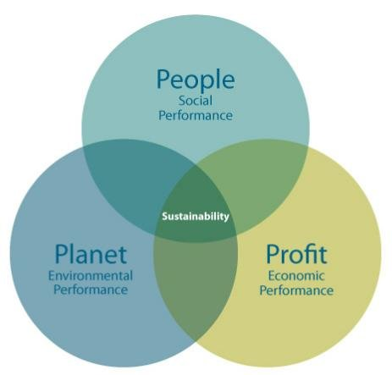

**Figure: TBL model**

(Source: Researchgate, 2020)

The above image is a pictorial representation of the TBL framework which is concerned with not just the returns of the company in terms of its finances but also the impact of the organisation and its business activities upon society as well as the environment.

Therefore, using the TBL model can allow the organisation as well as the supply chain managers of the organisation to overcome some of the aforementioned challenges associated with the CSR activities of M&S. The model provides a comprehensive Framework for evaluating the impact of the operations in terms of the 3 aspects of sustainability.

In order to address the issue of sustainable sourcing of products, SC managers of the organisation can identify opportunities for sustainable sourcing and align them with the Economic, social and environmental goals of the organisation. For example, M&S can prioritise Sourcing raw materials from suppliers who use organic methods of production or rely upon environmentally friendly methodology for producing the raw materials (Jayarathne *et al.*, 2021). The company can also work with local communities for sourcing supplies to develop its finished product. These factors will enable the organisation to evaluate the cost benefits of Sourcing supply from eco-friendly suppliers as well as contribute to the environment in a positive manner. Instead of the inventories from conventional suppliers, collaborating with eco-friendly SC enabled the organisation to contribute to the three aspects of sustainability. After identifying the sustainable SC, the SC managers can make use of the TBL model to set up clear goals and achievable targets. For instance, M&S can set up a goal of Sourcing a particular percentage of raw materials from sustainable suppliers over a specific period of time and then evaluating it with the previous business activities will enable the manager to monitor the performance of the company. It will also enable the manager to keep a track of the progress of the organisation in terms of Sourcing sustainable products as well as communicating with the stakeholders. This will open a lot of opportunities for the organisation to collaborate with green suppliers who are always on the lookout for getting into partnerships and making investments in eco-friendly businesses.

The TBL model can also be used by managers in order to identify opportunities for developing a partnership with suppliers, customers as well as stakeholders. This will enable the organisation to reduce the negative impact of its business operations on the environment. by developing products by making use of sustainable raw materials.

In the same way, the SC managers of M&S can address the issue of the increased cost of CSR activities by identifying opportunities of making use of energy-efficient equipment. This will enable the company to align its activities with the three main aspects of the TBL model as well as enable the company to implement cost-effective CSR measures. This will also enable the organisation to make use of the saved cost upon another initiative of CSR. M&S can also evaluate the cost of implementing new recycling programs in comparison to the long-term benefits of reducing waste production by the company. It will enable the managers of the company to align the business activities of the company with the environmental aspect of CSR. The TBL framework can be used by managers in order to monitor the performance of the organisation in terms of its CSR activities. Based on their in-depth understanding of the TBL model, the managers can develop reports of sustainability measures taken by the organisation as well as evaluate the overall reduction of carbon emissions. This will not only enable the organisation to keep track of its progress towards achieving its commitment to net zero emissions but also help the managers in identifying areas which require more effort.

# 6. Conclusion and recommendation

***Recommendation***

* M&S can emphasise investing in organising programs such as training programs and workshops in order to strengthen the engagement of the company with its suppliers. This will enable the company to leverage the resources of its suppliers in order to meet the sustainability standards and contribute toward the commitment of the company towards its social responsibilities. In addition to that, training programs will also help the company to build stronger relationships with suppliers by sharing knowledge assets which the suppliers can use to improve their business activities. The training programs will also have the company improve its compliance with the ethical guidelines as well as environmental standards established by the government in terms of the company operating in the retail industry.
* The company can expand its CSR initiatives in order to address the climate change crises as well as biodiversity losses (Yu, 2022). The company can take the sincere initiative to control its waste management programs. This will help the company to further align its operations of waste management and help the company identify areas for further development. Proper control of waste management and identification of opportunities for development will not only enable the company to reduce its environmental footprint but also help the company support restoration initiatives in terms of biodiversity conservation.

# Conclusion

From the above discussion, it can be concluded that Marks and Spencers conduct business activities using a wide range of product portfolios. Due to the expansion of the company into a number of international markets, it has collaborated with suppliers across the globe. Hence, the company has a complex supply chain which conducts a range of operations simultaneously. In this report, a critical analysis has been established in terms of the SCM functions of the organisation. It has also evaluated the impacts of incorporating different technological tools on the suppliers as well as the customers of the organisation. The report has also shed light on the CSR initiative taken by the organisation in order to contribute to the society and environment. The report highlights the benefits and challenges of CSR activities as well as discusses ways in which SC managers can make use of the TBL model to overcome the identified challenges.

# 

# Reference

Plan-a-our-planet, 2022. Available at:

<https://corporate.marksandspencer.com/sustainability/plan-a-our-planet>

Strategic Report, 2022. Available at: <https://corporate.marksandspencer.com/sites/marksandspencer/files/marks-spencer/investor/m-and-s-ar22-strategic-report.pdf>

Microsoft, 2021. Available at: <https://customers.microsoft.com/en-us/story/1422286642546612405-marks-and-spencer-retailers-microsoft365>

Researchgate, 2020. Available at: <https://www.researchgate.net/figure/Triple-Bottom-Line-3P-Formulation_fig1_323578157>

Investor Report, 2022. Available at: <https://corporate.marksandspencer.com/sites/marksandspencer/files/marks-spencer/investor/m-and-s-ar22-tcfd.pdf>

Sustainability report, 2022. Available at: <https://corporate.marksandspencer.com/sites/marksandspencer/files/marks-spencer/sustainabilty-at-M-S/sustainability-report-2022.pdf>

Marksandspencer, (2023). *STAY COOL & CHIC WITH LINEN.* Available at: <https://www.marksandspencer.in/> (Accessed on: 22.04.2023)

Yu, W., Hassan, A. And Adhikariparajuli, M., 2022. How Did Amazon Achieve CSR and Some Sustainable Development Goals (SDGs)—Climate Change, Circular Economy, Water Resources and Employee Rights during COVID-19? Journal of Risk and Financial Management, 15(8), p.364.

Raybould, B., Cheung, W.M., Connor, C. And Butcher, R., 2020. An investigation into UK government policy and legislation to renewable energy and greenhouse gas reduction commitments. Clean Technologies and Environmental Policy, 22, pp.371-387.

About us, 2023. Available at: <https://corporate.marksandspencer.com/about-us/our-history>

Zhang, Q., Cao, M., Zhang, F., Liu, J. And Li, X., 2020. Effects of corporate social responsibility on customer satisfaction and organizational attractiveness: A signaling perspective. Business ethics: A European review, 29(1), pp.20-34.

Le Thuy, L. And Oe, H., 2020. An Exploratory Discussion of a British Apparel Brand in Relation to New Markets: Developing Actionable Recommendations Based on Network, Relationship, and Collaboration Perspectives. Budapest International Research and Critics Institute (BIRCI-Journal): Humanities and Social Sciences, 3(3), pp.1660-1675.

McGrath, P., McCarthy, L., Marshall, D. And Rehme, J., 2021. Tools and technologies of transparency in sustainable global supply chains. California Management Review, 64(1), pp.67-89.

Wilshaw, R., Fowler, P. And Wallace, B., 2021. Working in Marks and Spencer's Food and Footwear Supply Chains.

Iftikhar, R., Pourzolfaghar, Z. And Helfert, M., 2020. Omnichannel value chain: mapping digital technologies for channel integration activities. In Advances in Information Systems Development: Information Systems Beyond 2020 28 (pp. 74-92). Springer International Publishing.

Retzer, K., 2019. Business Continuity.

Javed, U., Shaukat, K., Hameed, I.A., Iqbal, F., Alam, T.M. And Luo, S., 2021. A review of content-based and context-based recommendation systems. International Journal of Emerging Technologies in Learning (iJET), 16(3), pp.274-306.

Safdar, N., Khalid, R., Ahmed, W. and Imran, M., 2020. Reverse logistics network design of e-waste management under the triple bottom line approach. Journal of Cleaner Production, 272, p.122662.

Jayarathne, P.G.S.A., Sachithra, V. and Dewasiri, N.J., 2021. Sustainable practices through competitive capabilities in the apparel industry: Sri Lankan experience. FIIB Business Review, p.23197145211060398.