**THE ISSUE RELATING TO THE ROLE AND EFFECTIVENESS OF THE INTERNATIONAL LABOUR ORGANISATION**

**Abstract**

The Worldwide Work Association (ILO) is an association of the United Nations that attempts to progress social equality and guarantee fair working circumstances for all. Since its establishment in 1919, the ILO fundamentally affects worldwide work guidelines and works, including the advancement of fair work rehearses and the disposal of kid work, constrained work and abuse. In any case, the job and viability of the ILO have policymakers have been liable to discussion and examination. This examination plans to evaluate the viability of the ILO in advancing respectable work and civil rights and dissect approaches to reinforcing and upgrading its effect on worldwide work principles and practices. Information will be gathered through interviews, centre gatherings, and report investigation, and dissected utilizing topical examination. The consequences of this examination will be of extraordinary importance to strategy creators, work privileges activists and different partners keen on working circumstances and advancing social equality.

**TABLE OF CONTENTS**

Introduction 4

Background to a research Problem 4

Aims and Objectives 6

Research questions 6

Significance of the Research 7

The Effectiveness of the ILO in Promoting Decent Work 7

Role of the ILO in Addressing Emerging Issues 8

Challenges Facing the ILO in Addressing Emerging Issues 9

Research Methodology 10

Method Qualitative 10

Data collection: Secondary data 11

Data analysis: Thematic Analysis 12

Literature Review 13

Chapter Outline 15

Reference list 17

# Introduction

The Global Work Association (ILO) was laid out in 1919 as a specific organization of the Unified Countries. Its order is to advance civil rights, advance good working circumstances, and give a stage to the social discourse between labourers, bosses, and legislatures. Throughout the long term, the ILO plays had a basic impact in forming worldwide work guidelines and strategies, including the advancement of fair work rehearses and the destruction of youngster work, constrained work, and illegal exploitation.

The role and adequacy of the ILO have been likely to discuss and analysed throughout the long term. Some contend that the ILO misses the mark on its ability to uphold its choices and that its impact on work rehearses is restricted. Others fight that the ILO is too intensely impacted by states' and managers' inclinations and not adequately receptive to the necessities of labourers. The issue of the ILO's role and viability is especially applicable in the ongoing worldwide monetary environment, where the Coronavirus pandemic has uncovered critical holes in labour securities and featured the requirement for more grounded social well-being nets. As the world keeps on grappling with these challenges it is fundamental to evaluate the ILO's role in advancing decent work and social justice and analyse ways of strengthening and reinforcing its impact on global labour principles and practices.

# Background to a research problem

The Global Work Association (ILO) was established in 1919, this specific organization of the Unified Nations, is fully intent on advancing civil rights and advancing respectable working circumstances for labourers around the world (Adegbite and Adeleke, 2023). Throughout the last hundred years, the association plays had a vital impact in setting global work norms and advancing the freedoms of labourers all over the planet.



**(Figure 1: The international labour organisation)**

(Source: wikipedia/en/thumb/a/a7/International_Labour_Organization)

**In any case, regardless of its endeavours, the ILO faces a few moves that breakpoint its capacity to accomplish its objectives. These difficulties include:**

* **Restricted enrolment:** The ILO has 187-part states, yet not all nations are individuals. A few nations decide not to join the association, while others can't meet the enrolment necessities because of political or financial requirements.
* **Subsidizing limitations:** The ILO's spending plan is essentially supported by its part states, which restricts the association's capacity to attempt greater projects and drives. What's more, the association faces subsidizing difficulties, especially during seasons of a financial slump or emergencies.
* **Deficient execution of work guidelines:** Albeit the ILO sets worldwide work norms, numerous nations neglect to carry out them. This might be because of an absence of assets, political will, or the ability to uphold the norms.
* **Restricted requirement systems:** The ILO has restricted abilities to authorize its work norms. It depends on part of states to willfully conform to its guidelines, which can bring about lopsided implementation across various nations.
* **Developing nature of work:** The idea of work has changed essentially since the ILO's commencement in 1919. The ascent of the gig economy, mechanization, and new advancements has prompted new types of work that fall beyond conventional work norms.
* **Political difficulties:** The ILO works in a politically charged climate, with contending interests and needs among its part states. Political pressures can ruin the association's capacity to accomplish its objectives.

These difficulties add to the general adequacy of the ILO in accomplishing its objectives. The ILO's job and viability are thusly likely to discuss, with various partners maintaining various points of view on the association's accomplishments and limits (Aristodemou *et al.,* 2021). Some contend that the ILO plays an essential impact in advancing specialists' freedoms and working on working circumstances all over the planet. They highlight the association's endeavours to set global work guidelines, advance social exchange, and battle kid work, constrained work, and segregation. They contend that the association's restricted implementation components and political limitations have blocked its capacity to accomplish significant change. They additionally condemn the association for neglecting to adjust to the changing idea of work and for being too centred around customary business connections. The issue connecting with the job and viability of the Global Work Association is a perplexing and multi-layered one (Azis *et al.,* 2020). The difficulties confronting the ILO are critical and require progressing consideration and advancement to survive. While the association has accomplished a few remarkable triumphs in advancing labourers' privileges and working on working circumstances, there is still a lot of work to be finished to guarantee that all specialists all over the planet appreciate nice work and civil rights.

# Aims and Objectives

The research aim is to examine “What is the job and adequacy of the Global Work Association (ILO) in advancing and safeguarding labourers' privileges all over the planet”?

* To evaluate the viability of the ILO's endeavours to worldwide advance nice work and civil rights.
* To assess the ILO's ability to address arising difficulties in the realm of work, including mechanical advancement and globalization.
* To examine the effect of the ILO's shows and proposals on public work regulations and practices.
* To distinguish best practices and regions for development in the ILO's administration, financing, and dynamic cycles.
* To advance familiarity with the ILO's job and order among partners, including legislatures, businesses, labourers, and common society associations
* To assess the effect of ILO shows and suggestions on work guidelines and practices in part states.
* To break down the job of the ILO in advancing orientation fairness and engaging ladies in the work environment.

# Research questions

* What is the International Labor Organization's (ILO) history and mission?
* How successful has the ILO been in achieving its objectives and goals?
* What obstacles must the ILO overcome to carry out its mission, particularly in light of the current global situation?
* What is the ILO's role in advancing and safeguarding the rights of workers, and how has this role developed over time?
* What is the connection between the ILO and other international organizations like the World Trade Organization and the United Nations?
* How has the ILO responded to this crisis and how has the COVID-19 pandemic affected its work?
* What can we learn from examples of ILO programs and initiatives that have been successful?
* What impact does the ILO's work have on national and international labour standards and worker rights?
* The ILO's role in promoting social justice and decent work for all, what are some potential areas for future research?

# Significance of the research

## The Effectiveness of the ILO in Promoting Decent Work

The Global Work Association (ILO) is a Unified Countries specific organization that advances civil rights and fair work all over the planet. Nice work is characterized as useful work, turns out a fair revenue, social insurance, and freedoms, and gives open doors to self-improvement and social consideration. This paper looks at the adequacy of the ILO in advancing respectable work.

One of the manners in which the ILO advances nice work is by creating and advancing global work principles. These guidelines are created through a three-sided process including labourer and boss delegates and states. The ILO's Global Work Principles (ILS) cover many issues including the opportunity of affiliation, aggregate haggling, constrained work, youngster work, segregation, and government-managed retirement (Bakir, 2020). The ILS is a fundamental instrument for advancing good work, as it gives a system to nations to create and carry out strategies that safeguard labourers' freedoms and advance fair working circumstances.

Another way the ILO advances nice work is through specialized participation programs. These projects give specialized help to part nations in carrying out worldwide work norms, advancing social discourse, and fortifying work market establishments (Bentley *et al.,* 2021). The ILO has likewise assumed a significant part in advancing orientation uniformity in the realm of work through drives, for example, the Ladies at Work Century Drive, which expects to advance orientation correspondence in the realm of work. The ILO has likewise been dynamic in advancing social discourse, a fundamental component of fair work. Social discourse incorporates exchanges and meetings between managers, labourers, and state-run administrations on issues connected with work and business. The ILO advances social discourse through three-sided structures that give a stage for partners to participate in exchange and foster answers for business-related issues (Blustein *et al.,* 2020). The ILO has helped encourage social discourse in nations all over the planet, remembering struggle and post-struggle nations.

Be that as it may, regardless of his ILO endeavours to advance fair work, challenges still need to be tended to. The Coronavirus pandemic has featured the casual economy, traveller labourers, and the dubious idea of work for some specialists, including ladies. The ILO has answered these difficulties by creating strategic reactions and specialized help projects to assist nations with advancing good work concerning the pandemic.

All in all, the ILO plays had a significant impact in advancing good work through the turn of events and advancement of worldwide work norms, specialized participation programs, and the advancement of social discourse. Despite continuous difficulties, ILO's obligation to advance civil rights and fair work areas of strength stays.

## Role of the ILO in Addressing Emerging Issues

The Global Work Association (ILO) is a Unified Countries particular organization that advances civil rights and nice work all over the planet. As the universe of work develops quickly, the ILO assumes a key part in tackling arising issues and guaranteeing that specialists' privileges and needs are secured. This paper analyzes his ILO's role in resolving arising issues.

One of his arising issues at work is the ascent of the gig economy. The gig economy alludes to work markets described by fixed-term agreements or independent work, frequently empowered by computerized stages (Boniol *et al.,* 2019). The ILO perceives the difficulties and chances of the gig economy and has created rules to guarantee that labourers in this area are secure. ILO rules on the gig economy underscore the significance of social insurance, the right to aggregate haggling, and admittance to equity and debate goal systems.

One more arising point in the realm of work is robotization and digitization. These patterns are quickly changing the work market and the ILO perceives the need to guarantee that labourers are not abandoned. The ILO has created rules to advance the dependable utilization of computerized reasoning and guarantee that labourers' privileges are safeguarded concerning digitalization (Charalampous *et al.,* 2019). The ILO additionally focuses on the significance of upskilling and reskilling projects to guarantee labourers have the right stuff they need to prevail in the computerized economy.

The ILO has likewise assumed a significant part in tending to the difficulties of environmental change. Environmental change is significantly affecting the universe of work, particularly in regions like agribusiness, ranger service, and fisheries. The ILO has created rules on advancing fair work in the green economy. The rules stress the need to guarantee that specialists are not unfavourably impacted by the change to a low-carbon economy. All in all, the ILO plays a significant part to play in resolving arising issues in the realm of work. The ILO's obligation to advance civil rights and fair work is reflected in its endeavours to address arising difficulties like the gig economy, digitalization, and environmental change (Dewi and Hartana, 2023). ILO strategies and drives are fundamental devices to guarantee that specialists' freedoms and requirements are safeguarded in a quickly developing work market.

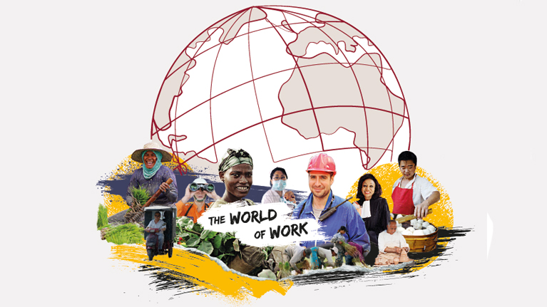

**(Figure 2: People in ILO)**

(Source: https://www.ilo.org/wcmsp5/groups/public/---dgreports/)

## Challenges Facing the ILO in Addressing Emerging Issues

"Although the International Labour Organization" (ILO) is effectively resolving arising issues in the realm of work, there are still a few difficulties the ILO faces in doing its order. This paper looks at a portion of the difficulties confronting the ILO in managing arising issues.

One of the fundamental difficulties of the ILO is the absence of systems to uphold its approaches and shows. The ILO has delivered rules and shows on arising subjects like the gig economy and digitalization, however, it depends on nations to carry out these actions. By and large, nations might not have the political will or assets to execute these strategies completely (Faulkner, 2020). Another test confronting the ILO is the quickly developing issues in the realm of work. The gig economy, digitization, and environmental change are continually developing and the ILO should be left on these issues. This requires a lot of assets and mastery that the ILO may not necessarily have in every case approach.

The ILO should consider the contending interests of labourers, bosses, and state-run administrations while managing arising issues. The interests of these gatherings can frequently be in struggle, and the ILO should deal with these pressures to guarantee that specialists' freedoms and necessities are safeguarded. In rundown, the ILO faces critical difficulties in resolving arising issues in the realm of work. These difficulties incorporate an absence of implementation systems, the fast development of new issues, and the exploration of contending interests (Faulkner, 2021). Notwithstanding these difficulties, the ILO stays focused on advancing civil rights and respectable work all over the planet.

# Research Methodology

## Method Qualitative

**Presentation:** The Global Work Association (ILO) is a particular organization of United Countries that works for civil rights and fair working circumstances for all. The reason for this subjective examination is to analyze the adequacy of the ILO in accomplishing its objectives.

**Technique:** This subjective examination joins interviews, centre gatherings, and report investigation to gather information. Members are chosen based on their association with the ILO or their involvement in specialists' privileges and working circumstances. Information is gathered from members utilizing a semi-organized interview guide, and meetings are recorded and interpreted for investigation. Centre gatherings will be directed at the people who have encountered work freedom infringement and have looked for help from the ILO. Centre-gathering conversations are taped and translated for examination (Giorgi *et al.,* 2020). A record investigation is done on significant ILO distributions, reports and records on labourers' freedoms and working circumstances. The investigation centres around the ILO's objectives, targets, techniques and results.

**Information investigation:** Information gathered from interviews, centre gatherings, and report investigation are examined utilizing topical examination. The information is coded by the examination question and coordinated specifically. Subjects are utilized to recognize examples and patterns in the information and make determinations about the viability of his ILO in accomplishing its targets.

**Moral Contemplations:** This study consents to moral rules for subjective examination. Informed assent is acquired from all members and her character is kept private. Members are educated that they reserve the option to end the review whenever. The information gathered will be dealt with safely and privately.

**Recognition:** This subjective review gives an understanding of the adequacy of his ILO in accomplishing its goals. The outcomes are significant to strategy producers, work freedom activists, and different partners keen on working circumstances and advancing civil rights.

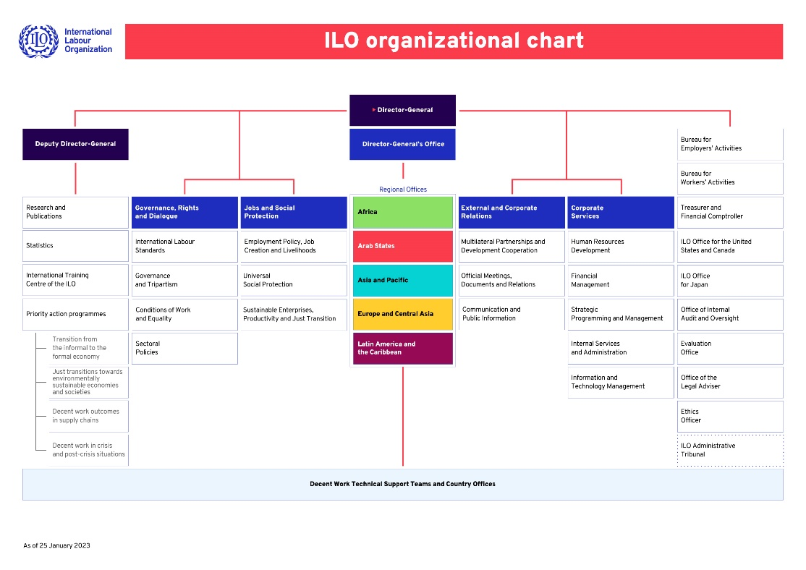

**(Figure 3: ILO organizational structure)**

(Source: https://www.ilo.org/wcmsp5/groups/public)

## Data collection: Secondary data

Work area research is an important technique for examining complex issues connected with the role and viability of the Worldwide Work Association (ILO). The optional examination includes an investigation of existing writing, information, and different sources instead of the assortment of essential information (International Labour Office, 2020. While leading work area research on the role and viability of the ILO, the accompanying advances can be taken.

**Recognize research questions:** Research questions ought to be engaged and explicit, for example, 'the historical backdrop of the ILO and how its role has advanced over the long haul'. or on the other hand "What are the fundamental difficulties of the ILO in advancing fair work and civil rights?"

**Search-related literature:** A thorough hunt of significant writing ought to be directed utilizing scholastic information bases like JSTOR and Google Researcher, and pertinent global associations like the actual ILO. Writing ought to be evaluated for significance and quality.

**Analyze the literature:** The writing ought to be efficiently investigated utilizing an organized way to deal with distinguishing key subjects, examples, and information holes. This examination should be acted in a way that guarantees exactness and legitimacy.

**Synthesize findings:** The consequences of the investigation ought to be incorporated into an intelligible story that tends to the exploration question. The story ought to expand on existing writing and give knowledge into his role and the viability of the ILO in advancing nice work and civil rights.

**Conclusion:** In light of the amalgamation of results, ends ought to be drawn concerning the role and adequacy of the ILO. Ends ought to be upheld by the proof introduced in the writing and give knowledge into the difficulties and valuable open doors confronting the ILO (Kawohl and Nordt, 2020). Generally speaking, work area research is a helpful method for looking at the role and viability of the ILO in advancing nice work and civil rights. By incorporating existing writing and information, this exploration can add to a more profound comprehension of the ILO's verifiable foundation, current difficulties, and future open doors.

## Data analysis: Thematic Analysis

The topical examination is a subjective exploration strategy used to recognize examples and subjects in information. This examination investigates the subject of the role and viability of the Global Work Association (ILO) through a topical investigation.

The ILO was laid out in 1919 as a feature of the Settlement of Versailles after The Second Great War. Its central goal is to advance civil rights and work on working circumstances all over the planet. In any case, there have been a few discussions about the role and viability of the ILO in doing its order (Leitão *et al.,* 2020). The main inquiry that rises out of the information is the ILO's part in setting global work norms. Through the reception of Shows and Suggestions, the ILO has been instrumental in creating and advancing worldwide work norms. In any case, there are worries that the absence of requirement systems for these guidelines sabotages their viability.

The subsequent subject is the ILO's role in advancing social exchange. The ILO assumes a significant part in advancing social exchange between labourers, bosses, and legislatures. Numerous nations have worked on the improvement of three-sided structures that give stages to discourse and collaboration (Malik, 2021). Nonetheless, ILO way to deal with social discourse has frequently been scrutinized for being hierarchical and coming up short on the comprehensiveness and importance to address labourers' inclinations.

A third subject is her ILO's role in tending to new difficulties. The ILO has been proactive in tending to new difficulties in the realm of work, like the gig economy and computerization (Musiała, 2021). We have created rules and proposals to address these difficulties and worked with discourse among partners. In any case, there are worries that the ILO isn't adequately deft to answer rapidly to quickly changing work economic situations.

In outline, the role and viability of the ILO is a complicated issue requiring cautious thought of different elements. Through this topical examination, he has recognized the main points of contention pertinent to his ILO's role in setting worldwide work guidelines, advancing social discourse, and tending to arise difficulties (Narayanamurthy and Narayanamurthy, 2021). While the ILO has made critical commitments to working on working circumstances all over the planet, there are likewise provokes that should be addressed to guarantee its proceeded with viability.

# Literature Review

As per the author Michael J. Hiscox *et al.,* 2020 In the article "The Worldwide Work Association's Effect on Worldwide Work Norms: An Observational Test", assess the adequacy of the Worldwide Work Association's (ILO) influence on worldwide work principles. Hiscox contends that the ILO emphatically affects work guidelines in part nations, especially in agricultural nations. The creator utilizes exact information to show that nations with more significant levels of ILO inclusion have better work norms. Hiscox additionally proposes that the ILO's adequacy is because of its capacity to construct associations with different associations, like non-administrative associations (NGOs) and other worldwide associations.

In the article, the author said writers Sway Elder and Paul Stubbs break down, 2021 "The ILO: 100 Years of Worldwide Social Strategy", the job of the ILO in forming worldwide social arrangements creators contend that the ILO has been a vital participant in forming worldwide social strategy, especially in the space of work freedoms. They propose that the ILO has had the option to impact worldwide strategy through its standard-setting exercises, specialized participation, and promotion endeavours. Elder and Stubbs likewise propose that the ILO's viability is because of its capacity to draw in various partners, including legislatures, managers, and labourers.

In "The Worldwide Work Association: Evaluating Its Effect on Globalization and Business Relations", writer Stephen McBride *et al.* 2021 analyze the job of the ILO in moulding globalization and business relations. McBride contends that the ILO has been a vital participant in advancing work freedoms and civil rights regards to globalization. The creator proposes that the ILO's viability is because of its capacity to advance social discourse and organizations between government, businesses, and labourers. McBride likewise recommends that the ILO's effect on globalization has been restricted by its dependence on intentional consistency and the absence of requirement instruments.

These writing surveys propose that the Worldwide Work Association decidedly affects worldwide work norms and social approaches. The ILO's viability is because of its capacity to construct organizations with various partners, participate in standard-setting exercises, and advance social exchange. Be that as it may, the ILO's effect on globalization and work relations has been restricted by its dependence on deliberate consistency and the absence of implementation instruments.

As per the author Obiora, 2023**,** The Global Work Association (ILO) was laid out in 1919 after The Second Great War to advance civil rights and work on working circumstances all over the planet. The ILO is the main three-sided association of the Assembled Countries. It unites agents of states, managers, and labourers to create and advance arrangements and projects that address workplace issues. The ILO was laid out as a feature of the Deal of Versailles that finished The Second Great War. The Show perceived the requirement for worldwide collaboration to work on working circumstances and advance civil rights. The ILO, the primary particular organization of the Unified Countries, has been focused on advancing labourers' freedoms and civil rights all over the planet. Over now is the right time, the ILO plays had a critical impact in setting work norms and social security strategies. The ILO has likewise been engaged with advancing nice work, including advancing social discourse, taking out youngsters and constrained work, safeguarding traveller labourers, and advancing orientation correspondence in the working environment.

One of the ILO's most significant accomplishments was the reception of the Philadelphia Statement in 1944. The Announcement perceived the need to accommodate financial and social advancement and underscored the significance of civil rights and individual nobility. Since its reception, the Statement has been directly crafted by the ILO. As of late, the ILO plays had a significant impact in advancing practical improvement through advancing fair work and advancing social security approaches. The ILO has additionally been associated with tending to the difficulties presented by globalization and the impacting universe of work.

In outline, the ILO has a long and recognized history of advancing civil rights and working on working circumstances all over the planet. The ILO is focused on creating work norms and social assurance approaches and plays had a significant impact in advancing good work and manageable turn of events. The ILO's three-sided structure has been basic to her ILO's outcome in uniting agents of state-run administrations, managers, and labourers to create and advance strategies and projects that address workplace issues.

According to the author Power, 2020**,** The Worldwide Work Association (ILO) is a Unified Countries particular organization with a three-sided design of delegates of legislatures, bosses, and labourers. The ILO has an exceptional design that recognizes it from other UN offices in that it unites these three gatherings to address work issues. The ILO's overseeing structure comprises a three-sided General Gathering, an Overseeing Body, and a Worldwide Work Office. The Overall Get together meets like clockwork and is made up of delegates of all Part States and agents of bosses and labourers. Overall Get Together is answerable for setting the ILO strategy, taking on worldwide work principles, and setting the ILO's financial plan. The Administering Body is the leading body of the ILO liable for regulating the exercises of the ILO until the following General Gathering. The Board is made up of 56 individuals, of whom 28 address the public authority, 14 managers, and 14 specialists. The Gathering is liable for regulating crafted by the Global Work Office, planning the ILO's program and financial plan, and cultivating social exchange between state-run administrations, bosses, and labourers.

The Worldwide Work Office (ILO) is the secretariat of the ILO and is liable for giving specialized help and guidance to legislatures, bosses and labourers on work issues. The Global Work Office is going by a Leader Chief designated by the Board. The Global Work Office is additionally liable for creating and advancing worldwide work principles, giving specialized help to the Part States and leading examination on work issues.

Notwithstanding its overseeing structure, the ILO has a decentralized design with neighbourhood and country workplaces all over the planet. These workplaces advance her ILO mission and give specialized help and counsel to the Part States. The Worldwide Work Association (ILO) is an interesting three-sided association that unites delegates of legislatures, bosses and labourers to address work issues. The ILO's overseeing structure comprises the Overall Gathering, the Administering Body, and the Worldwide Work Office, which together set the strategy for the association, set global work principles, and give specialized help and guidance to part states. The ILO's decentralized construction incorporates local and country workplaces all over the planet that work to propel the ILO's main goal and give specialized help and exhortation to part states.

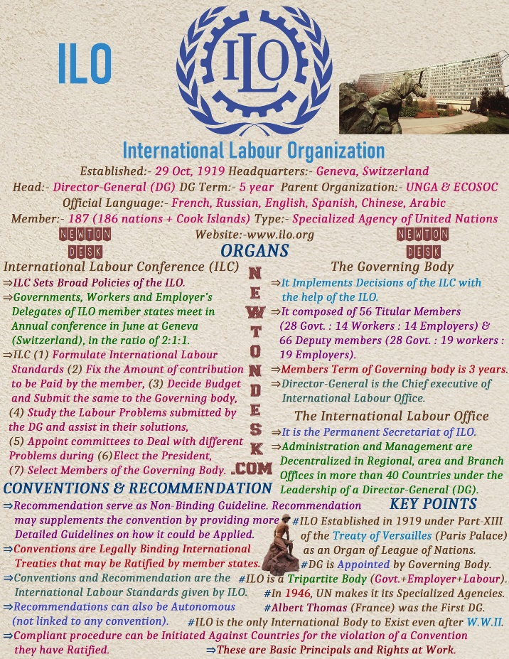

**(Figure 4: ILO in UK)**

(Source: 2020/02/ILO-International-Labour-Organization-of-united-nations.jpg)

## Chapter Outline

The Global Work Association (ILO) is a specific organization of the Unified Countries that intends to advance civil rights and nice working circumstances around the world. Notwithstanding its excellent goals, the ILO has been dependent upon the analysis regarding its job and viability in accomplishing its command. The issue connecting with the job and adequacy of the Worldwide Work Association is multi-layered. From one perspective, the ILO plays had a vital impact in advancing labourers' freedoms and civil rights through its shows and proposals. It has likewise been instrumental in uniting government, bosses, and labourers to foster approaches and systems for advancing good work.

The ILO's viability has been addressed, especially concerning its capacity to uphold its shows and proposals. Besides, a few pundits contend that the ILO is excessively regulatory and eases back to answer arising issues in the realm of work. Considering these issues, it is fundamental for the ILO to proceed to develop and adjust to the impacting universe of work. This incorporates tracking down ways of fortifying its authorization systems and working on its responsiveness to arising difficulties. It is likewise vital for the ILO to work all the more intimately with other UN offices and worldwide associations to guarantee that its targets are lined up with more extensive advancement objectives. At last, the outcome of the ILO will rely upon its capacity to stay applicable and compelling in advancing civil rights and respectable working circumstances for all.

# Reference list

Adegbite, A. and Adeleke, O., 2023. International Labour Organization and Employment Stability during the COVID-19 Pandemic: the Nigerian Situational Analysis. *Available at SSRN 4347618*.

Aristodemou, K., Buchhass, L. and Claringbould, D., 2021. The COVID-19 crisis in the EU: the resilience of healthcare systems, government responses and their socio-economic effects. *Eurasian Economic Review*, *11*, pp.251-281.

Azis, M.A., Zahidi, M.S. and Pradhan, D., 2020. Synergising International Labour Laws and Human Rights for Protection of Indonesian Migrant Workers. *Lampung Journal of International Law*, *2*(2), pp.109-120.

Bakir, A., 2020. Governing Body PFA ILO programme implementation 2018–19 Decent work results.

Bentley, T., Green, N., Tappin, D. and Haslam, R., 2021. State of science: the future of work–ergonomics and human factors contributions to the field. *Ergonomics*, *64*(4), pp.427-439.

Blustein, D.L., Duffy, R., Ferreira, J.A., Cohen-Scali, V., Cinamon, R.G. and Allan, B.A., 2020. Unemployment in the time of COVID-19: A research agenda. *Journal of Vocational Behavior*, *119*, p.103436.

Boniol, M., McIsaac, M., Xu, L., Wuliji, T., Diallo, K. and Campbell, J., 2019. *Gender equity in the health workforce: analysis of 104 countries* (No. WHO/HIS/HWF/Gender/WP1/2019.1). World Health Organization.

Charalampous, M., Grant, C.A., Tramontano, C. and Michailidis, E., 2019. Systematically reviewing remote e-workers’ well-being at work: A multidimensional approach. *European journal of work and organizational psychology*, *28*(1), pp.51-73.

Dewi, P.S. and Hartana, H., 2023. PERAN PENTING INTERNATIONAL LABOUR ORGANISATION DALAM MELINDUNGI BURUH MIGRAN INDONESIA DARI KEKERASAN. *Jurnal Gender dan Hak Asasi Manusia*, *1*(1), pp.10-17.

Faulkner, L., 2020. Update on building questions: headquarters building renovation project and ILO-owned premises in Abidjan.

Faulkner, L., 2021. -Appendix II-Director-General’s reply to the discussion of the Programme.

Giorgi, G., Lecca, L.I., Alessio, F., Finstad, G.L., Bondanini, G., Lulli, L.G., Arcangeli, G. and Mucci, N., 2020. COVID-19-related mental health effects in the workplace: a narrative review. *International journal of environmental research and public health*, *17*(21), p.7857.

International Labour Office, 2020. *Global employment trends for youth 2020: Technology and the future of jobs*. International Labour Organisation (ILO).

Kawohl, W. and Nordt, C., 2020. COVID-19, unemployment, and suicide. *The Lancet Psychiatry*, *7*(5), pp.389-390.

Leitão, J., Pereira, D. and Gonçalves, Â., 2019. Quality of work life and organizational performance: Workers’ feelings of contributing, or not, to the organization’s productivity. *International journal of environmental research and public health*, *16*(20), p.3803.

Malik, A., 2020. The Use of Labour Clauses in Free Trade Agreements.

Munck, R., 2021. Labour and globalisation: Complexity and transformation. *Tempo Social*, *33*, pp.253-266.

Musiała, A., 2021. A Workplace as the Central Institution of Labour Law. But Also an Administration Entity?. *Teka Komisji Prawniczej PAN Oddział w Lublinie*, *14*(2), pp.363-375.

Narayanamurthy, G. and Tortorella, G., 2021. Impact of COVID-19 outbreak on employee performance–moderating role of industry 4.0 base technologies. *International Journal of Production Economics*, *234*, p.108075.

Obiora, S.F., 2023. Dialectics on the Principle of Enforcement of Collective Agreements in Nigeria: A Reappraisal. *E-Journal of International and Comparative Labour Studies*, *11*(3).

Power, K., 2020. The COVID-19 pandemic has increased the care burden of women and families. *Sustainability: Science, Practice and Policy*, *16*(1), pp.67-73.

Pozzan, E. and Cattaneo, U., 2020. Women health workers: Working relentlessly in hospitals and at home. *International Labour Organisation*, *7*.

Rani, U., Kumar Dhir, R., Furrer, M., Gőbel, N., Moraiti, A. and Cooney, S., 2021. World employment and social outlook: the role of digital labour platforms in transforming the world of work. *Geneva: International Labour Organisation*.

Sima, V., Gheorghe, I.G., Subić, J. and Nancu, D., 2020. Influences of the industry 4.0 revolution on the human capital development and consumer behavior: A systematic review. *Sustainability*, *12*(10), p.4035.

Stannard, S., 2020. COVID-19 in the maritime setting: the challenges, regulations and the international response. *International Maritime Health*, *71*(2), pp.85-90.

Tien, N.H., Phu, P.P. and Chi, D.T.P., 2019. The role of international marketing in international business strategy. *International journal of research in marketing management and sales*, *1*(2), pp.134-138.

Tijani, H.I., 2019. The International Labour Organisation and its Bureau for Workers’ Activities (ACTRAV) in Africa on the Eve of the “Glorious” 1960s. *Comparativ*, *29*(4), pp.68-83.