**CREATIVE CHANGE AND INNOVATION**

# Executive Summary

This report is based on the importance and impacts of change and innovation in an organisation. Moreover, it also in understanding change management implemented in Unilever Company over the course of five years. On the other hand, the report provides an insight of the implementation of change management and the growth that can be taken into consideration by Unilever in the future.

Table of Contents

Executive Summary 2

Introduction 3

Overview of Unilever over the past five years 3

Analysis of Change Management 3

Maslow’s Hierarchy of Needs 5

Lewin’s Change Management Model 6

Bridges Transition Model 7

Analysis of Creativity, Innovation & Technological Advancement 8

Technological Advancements 8

Creativity and Innovations 9

Impacts of Change Management 10

Conclusions 11

References 12

# Introduction

Change management is a structural and systematic approach which deals with the transformation of transition of an organisation's objectives and goals. This report focuses on the implementation of creative change and innovations and the impacts of the process in Unilever while discussing the changes in the company over the past five years. Therefore, this report will explore the impacts of these changes in the organisation.

# Overview of Unilever over the past five years

Unilever is one of the largest consumer goods companies which provide products in three main divisions such as, home care, beauty, personal care, food and beverages. The company has developmental facilities all over the world in India, China, Netherlands, United States and United Kingdom (unilever.com, 2023). Over the years the company has acquired various brands such as Hellman's, Knorr while also launching self-developed brands such as Flora and Lipton. Collaboration helped the company to implement both external and internal expansion in a strategic manner. In the year 2018, the company reached revenue of €50,982 million whereas, over the course of five years, in 2022 the company’s turnover increased 14.5% (unilever.com, 2023). This has created a currency impact of 6.2% making the current assets of the company $20.184B which is an 11.55% increase from 2020.

Unilever has made several changes in the last year by implementing change in its organisational structure making it a more category focused business. Furthermore, the company has also divided the three main product lines into five by expanding to nutritional products and ice cream along with the previous divisions. Therefore, these massive changes helped the company grow in the ever changing market.

# Analysis of Change Management

Unilever is a multinational company it has undergone several massive organisational changes over the years, however, various components affected the changes in the company. The change management process of the company focuses on the changing preferences of the as the customers impact the extensive results of the business. As the consumer demands have changed to eco-friendly products which are sustainable the company has also implemented necessary changes in order to make products with organic resources. Unilever has also increased the sustainability of the products such as cosmetics products which are refillable. As per the view of Jevtić and Milovanović (2022), sustainable products are the focal point of innovative change management in Unilever. The company has also targeted to reduce plastic packaging by the year 2025 in order to make it further environmentally sustainable. Unilever has also made technological changes in the organisation by increasing the online brand image and enhancing e-commerce presence (cnbc.com, 2023). However, Unilever has used the “Five Levers of Change” in the management process for the analysing of the targeted customers as well as the implementing change. This has allowed the consumers to easily access the products and make easy purchases from home. On the other hand, the company has also implemented internal changes as a part of change management. In recent years the company has aimed to streamline the operations in order to increase sustainability of the products which led to consolidation of the personal care and food divisions.

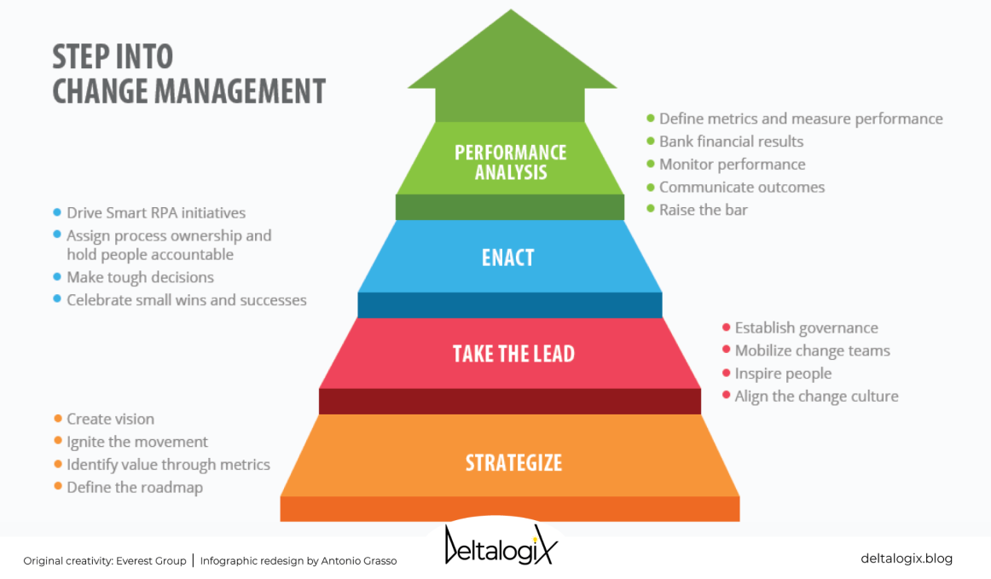

**Figure 1: Change Management**

(Source: Jevtić and Milovanović, 2022)

However, the company has also focused on the financial performance as it affects the overall profit of the company. As the organisation faced slow sales, in the year 2018 the company took strategic measures for the financial operations in order to spin off Unilever’s spreads (unilever.com, 2023). The company has implemented change in the organisational structure as well, due to the changes which were essential in the evolving leadership changes in the company. A major cultural transformation was implemented by the company initiative called “Connected 4 Growth”. This process helped in restructuring the entire company into small autonomous units. On the other hand, the company acquired personal care brands of Quala which is a Latin American company, this action helped Unilever to launch itself in the emerging markets (unilever.com, 2023). These strategic changes are necessary and effective for the company to increase sustainability and customer satisfaction.

## Maslow’s Hierarchy of Needs

Maslow's theory of needs can be used in order to analyse and understand the customer demands and make necessary changes accordingly. This theory states that the needs of human beings develop in a hierarchical manner from the basic needs to the more complicated needs. As stated by Abdelsalam *et al*. (2022), Maslow’s hierarchy of needs has five stages which are physiological needs, safety needs, belonging needs, self esteem and self actualisation needs. These five levels of needs have to be satisfied as these are interconnected and dependent on each other.

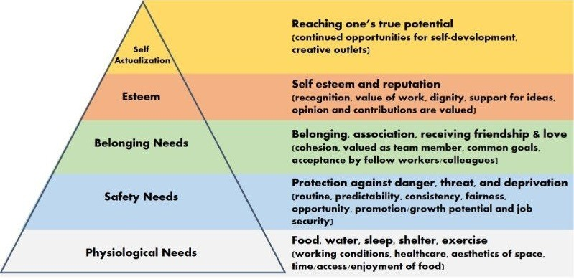

**Figure 2: Maslow’s Hierarchy of Needs**

(Source: Abdelsalam *et al*. 2022)

In this case the theories of change management can be explored in order to understand that leadership has influenced the creativity and effectiveness of innovative change management. Unilever functions through the commitment leadership which expresses diverse and sensitive responses in the cultural issues. This leadership style has made the company more approachable for the employees as well as customers as committed leaders put the efforts on the company's goals and values by pursuing the needs of the workers and customers.

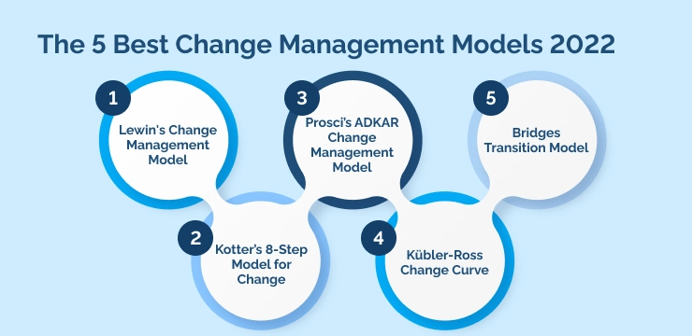

**Figure 3: Change Management Models**

(Source: Vrcelj and Karabašević 2022)

## Lewin’s Change Management Model

The change management model suggested by Kurt Lewin involves three major steps which are unfreezing, changing and refreezing. According to this theory the process of change has to be created from the initial perception that change is necessary, the next step is to carry forward the ideated process of change. Ultimately, solidifying the changes as the new norm of the company this step fulfils the change in the organisation. As per the view of Adam (2022), Lewin’s change management model helps in strategically implementing change in an organisation. In the unfreezing step of this model the management has to recognise the need for change as well as accepting the consequences of the implementation of this process. This step can be helpful for a multinational company such as Unilever.

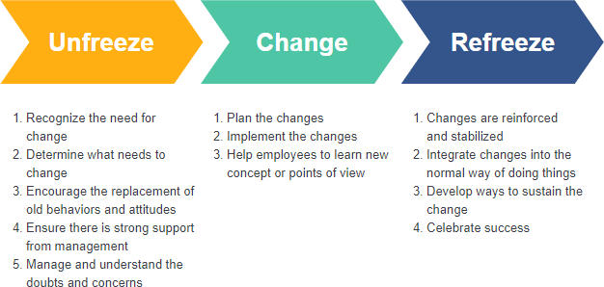

**Figure 4:** **Lewin’s Change Management Model**

(Source: Adam, 2022)

The consequences of the change management process include a training program for the employees in order to get accustomed to the changes, testing cost of the implemented changes on the customers. The second step of this process is the part where change is implemented and the process is applied in the live market. As stated by Vrcelj and Karabašević (2022), Lewin’s change management method is one of the most effective methods as it has a preoperational stage before enforcing the changes. Lastly the refreezing process of this method is useful stabilising the changes which are implemented in the company. Unilever could implement this process as this method is appropriate for larger organisations as the company could enhance sustainable living plan and portfolio transformation, this model is appropriate for the organisation.

## Bridges Transition Model

The Bridges transition model focuses on effectively managing the balance between the work and personal side of the implemented change. This model identifies the three stages or effects which change management has on an organisation as well as its employees. The first stage is identified in this model as the ending, neutral zone and the beginning stage (sergiocaredda.eu, 2023). According to this theory the employees more comfortable and adaptable towards the changes will easily transition to the third stage of this model. On the other hand, this model also helps in understanding and evaluating the impacts of the change in Unilever and its workers.

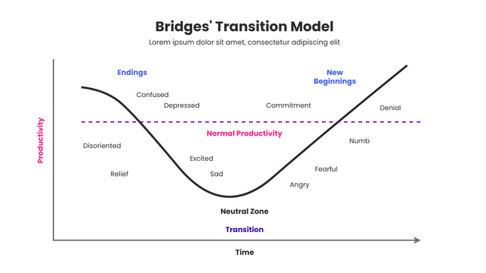

**Figure 5: Bridges Transition Model**

(Source: sergiocaredda.eu, 2023)

Moreover, this method can be useful for Unilever for analysing the impacts of the implemented change. This method the organisation will be able to evaluate whether the change is suitable for the workers and if there is further change necessary. The ending stage of this model is the first step which ends the ongoing process of operations. On the other hand, the next step of this model is the neutral zone; in this stage the changes are yet to be functional. As per the view of Cowen *et al*. (2022), Bridges model is most effective after the change has been implemented in a company. Lastly, the third stage of this model is the new beginning which understands the values and attribute of the change by fully accepting and normalising it in the organisation.

These models can be implemented for further change in Unilever as it is a company which focuses on evolving as the customer demand evolves. In the year 2018, Unilever has implemented change in the divisions of products of the company targeting to empower the long term strategic choices (nytimes.com, 2023). The company changed its headquarters to London for personal care, beauty and home care products in order to increase efficiency in the organisation. Similarly, the company decided to expand to two headquarters, these changes were necessary for the company to maintain its position in the market.

# Analysis of Creativity, Innovation & Technological Advancement

Unilever has implemented the change management process which has impacted the internal functions of the organisation as well as the external outcomes.

## Technological Advancements

Unilever is focusing on strengthening the internal functions and increasing efficiency with the use of disruptive technologies which influence the operational structure of the company. The organisation has introduced AI machine learning, big data, augmented reality and advanced cybersecurity systems with the use of cloud (unilever.com, 2023). The company has collected data on customer behaviour focusing on acquiring insights about the customer loyalty which has influenced sales. Unilever used e-commerce and B2B solutions in order to increase the communication with the customers. As the company implemented online shopping facilities for the customers with the help of online tools. Unilever has developed several strategic technological collaborations with the VTEX, UK's Foreign and Commonwealth and development office which has launched the “TRANSFORM” policy. This policy has helped in delivering £40 million (€48 million) in the funds of the company. This technological initiative will be extended till 2025 along with the collaboration with 15 Million influencer’s online (unilever.com, 2023). Additionally, the company has launched a partnership with the software firm SAP to create the TRANSFORM Support Hub. Unilever has also launched a new partnership with the World Economic Forum in 2022 which the company targets to expand in Latin America. These technological advancements have been useful for the sustainability of the organisation.

## Creativity and Innovations

Unilever foods innovation centre has created stock cubes which is the world's first zero salt range as traditionally salt is used to form the cube structure for holding the ingredients together. Moreover, these innovative solutions are effective in the advancement of the company as uniqueness and creativity help in attracting more customers (unilever.com, 2023). Furthermore, the company has reduced the amount of sodium in the salt merchandise making it more useful for the health conscious consumers. Unilever has launched the Knorr zero salt cubes after conducting virtual experiments in 2020. Additionally, the company has grown its plant based products as it is the current customer demand. Hellman’s vegan food products have been made available in 33 countries including UK, Canada, Spain, Sweden and Greece by Unilever. The company has also made biodegradable polymer based laundry products which do not harm the environment in order to increase sustainability.

Unilever has developed over 40 technologies for the cosmetics line Prestige Beauty which is growing at a faster rate due to its vegan ingredients. The beauty division has reached a turnover of €1 billion in 2021 (unilever.com, 2023). Over the course of five years the company has majorly brought changes in the products and increased the sustainability based on customer demand. In collaboration with the Dove products, Unilever has enforced organic ingredients in the skin and hair care products. These products were launched exclusively in the US in 2022 eventually dispersing all over the global market.

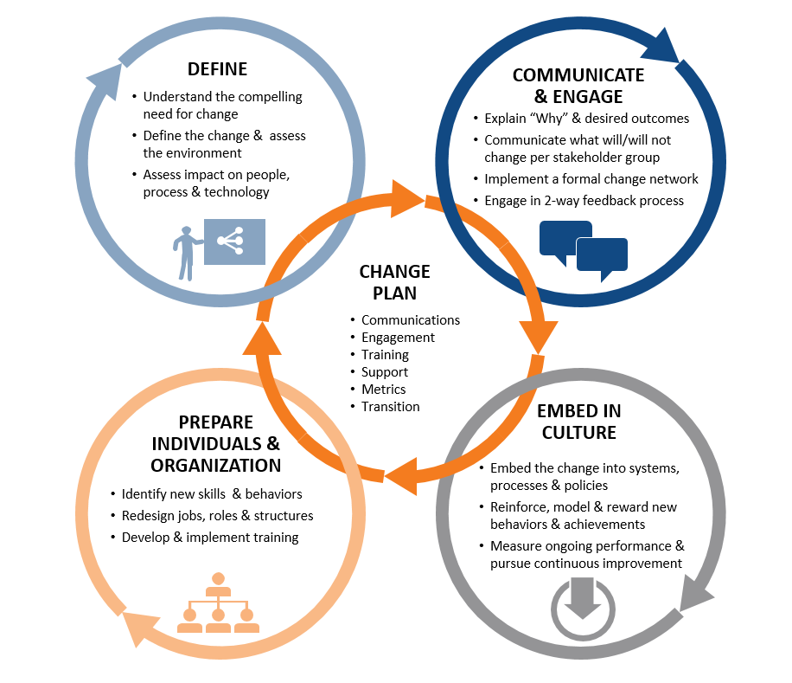

**Figure 6: Impacts of Change Management**

(Source: De Corso *et al.* 2022)

## Impacts of Change Management

Moreover, the company has been tactfully using collaborations and partnerships as a part of change management in the company. These partnerships have helped in the expansion of the business as well as the change management process of the company. As per the view of De Corso *et al.* (2022), the implementation of change management is a complicated process which is necessary for a company to grow in the market. As an impact of the change management this company has faced major changes in the market which has led to underlying sales growth accelerating 9.0% (unilever.com, 2023). Over the course of five years the turnover of the company has reached €60.1 billion which is a 14.5% increase from 2021. The company has focused on the carefully balanced growth of the product price in order to navigate the inflation of the market. The operating profit has also increased in the past two years slightly reaching €9.7 billion. However, the performance of the company was led by the underlying sales growth of the collaborative companies. The performance of the brands such as OMO, Rexona, Sunsilk, Hellman’s and Magnum made the sales growth reach 10.9% (unilever.com, 2023).

The underlying sales growth of Unilever rose up to 9.0% in the year 2022, led by the significant input cost of the inflation rate of the country. The change management has made these impacts by prioritising the needs of the consumers, as the products fit the needs of the customers more products are recommended through the word-of-mouth process. Moreover, the company has faced sequential growth in the eight quarters reaching 13.3% in the fourth quarter (forbes.com, 2023). The beauty and wellbeing sector of the company has also seen significant growth in the past five years as it has grown 7.8% in the year 2022. The beauty sector of the company faced this major change due to the increase of sustainable and eco friendly products. On the other hand, the personal care products have reached a steady growth of 11.8% in the past two years. Moreover, the Nutrition sector of Unilever has seen growth of 8.6% with the price increase of beverage and dressing products leading Unilever Food and Beverages to improve performance. However, the newer divisions of the company such as the Ice cream products have benefitted a 9.6% raise. These products have helped the growth of the products in the extensive market, as the emerging markets grew by 11.2% in South Asia in both volume and price (unilever.com, 2023). However, the company's sales have declined in the past two years due to the effects of the pandemic. Moreover, South East Asia has achieved a price growth of double digit in the inflationary environment. This has caused the branding and marketing related investments to grow by €0.5 billion.

The company has been able to cross a major milestone in the year 2022 as it reached its first and second tranches of €750 million. However, since July of 2022, the company has organised a more category based operating model which has included five business groups with a technology driven backbone. It has been stated by the company that 20% of the entire profit of the group is acquired from the improved and eco-friendly beauty products. The leading products in this growth have been the core skin care products which are demanded by the customers. As per the view of Rahate *et al*. (2022), advancements of a company depend on technological and innovative aids. Therefore, it can be determined from this report that the advancements of the company are due to the careful implication of the change management processes.

# Conclusions

It can be concluded from this report that Unilever has successfully implemented the change management process which has positively affected the growth of the company. This process has also helped in increasing financial growth of the organisation. As this method is a process which ensures changes are implemented in a secure manner, the drawbacks of these methods are minimal. Over the course of five years the company has been expanding the division of products and collaborating with major groups such as Dove, Hellman’s and Knorr, this has helped in the growth of the company. Unilever has shifted its headquarters to increase efficiency in the growing process. Therefore, it can be understood that the organisation has realised the changes which are necessary and made the changes effective. This report has discussed the theories of change management, leadership and customer demand in order to gain insight of the implication process. The theory of Maslow’s Hierarchy of Needs has been explored in this report to understand the importance of customer demand. On the other hand, Lewin’s change management theory has been discussed for understanding the importance of change management implementation. Lastly the theory of Bridges Transformation model was used in order to neutralise the changes and stabilise the environment of the organisation after the changes are implemented.

However, there are further changes which the company can devise in order to expand in the market even more. As the company has so far only implemented the strategies of change management based on the leadership factors and customer demand the company can implement better globalisation strategies and sustainability strategies. The globalisation strategy will be useful for the organisation as it is a method which ensures that through strategic planning the company can launch in the new markets. This method also focuses on matching the cultural and traditional demands of the host country. The strategies which can be used are transnational strategy and multi-domestic strategy. Similarly, the organisation can use sustainability methods like social sustainability methods and economic sustainability methods. Moreover, these strategies can be useful for the future changes which Unilever might face. Leadership methods can be implemented by Unilever as well, as this ensures that the internal organisational structure of the company is able to perform in a well organised manner. The strategies which were discussed in this report are the methods which will help Unilever in entering the global market. Therefore, it can be concluded that Unilever is a major example of successful change management and the positive impacts of it in the market.

# References

Abdelsalam, R., Al-Haddad, S. and Sharabati, A.A., (2022). RELATIONSHIP BETWEEN MASLOW’S HIERARCHY OF NEEDS AND MuMPRENEuRIAL INTENTIONS.

Adam, N.A., (2022). Employees’ Innovative Work Behavior and Change Management Phases in Government Institutions: The Mediating Role of Knowledge Sharing. Administrative Sciences, 12(1), p.28.

cnbc.com (2023), *Results 2018* Available at: https://www.cnbc.com/2019/01/31/unilever-q4-2018-results.html[Accessed on: 27/04/23]

Cowen, A.P., Rink, F., Cuypers, I.R., Grégoire, D.A. and Weller, I., (2022). Applying Coleman’s boat in management research: Opportunities and challenges in bridging macro and micro theory. Academy of Management Journal, 65(1), pp.1-10.

De Corso, E., Bellocchi, G., De Benedetto, M., Lombardo, N., Macchi, A., Malvezzi, L., Motta, G., Pagella, F., Vicini, C. and Passali, D., (2022). Biologics for severe uncontrolled chronic rhinosinusitis with nasal polyps: A change management approach. Consensus of the Joint Committee of Italian Society of Otorhinolaryngology on biologics in rhinology. Acta Otorhinolaryngologica Italica, 42(1), p.1.

forbes.com (2023), *Forbes* Available at:https://www.forbes.com/companies/unilever/[Accessed on: 27/04/23]

Jevtić, A. and Milovanović, G., (2023). Impact of digital marketing on sustainable business: Case of the Unilever company. Economics of Sustainable Development, 7(1), pp.15-28.

nytimes.com (2023), *unilever-headquarters* Available at:https://www.nytimes.com/2020/06/11/business/unilever-headquarters.html[Accessed on: 27/04/23]

Rahate, A., Walambe, R., Ramanna, S. and Kotecha, K., (2022). Multimodal co-learning: challenges, applications with datasets, recent advances and future directions. Information Fusion, 81, pp.203-239.

sergiocaredda.eu (2023), *models-bridges-transition* Available at:https://sergiocaredda.eu/organisation/tools/models-bridges-transition/#:~:text=The%20Bridge's%20Transition%20Model%20was,Making%20The%20Most%20Of%20Change[Accessed on: 27/04/23]

unilever.com (2023), *Company At A Glance* Available at: https://www.unilever.com/our-company/at-a-glance/ [Accessed on: 27/04/23]

unilever.com (2023), *extending-our-transform-initiative-with-new-partners-and-bigger-ambitions* Available at: https://www.unilever.com/news/news-search/2022/extending-our-transform-initiative-with-new-partners-and-bigger-ambitions/[Accessed on: 27/04/23]

unilever.com (2023), *Full Announcement* Available at: https://www.unilever.com/files/91ad891b-a5cd-4a79-823d-83b82b31615a/ir-q4-2022-full-announcement.pdf[Accessed on: 27/04/23]

unilever.com (2023), *Innovation Unilever* Available at:https://www.unilever.com/brands/innovation/#:~:text=We%20innovate%20for%20our%20consumers,for%20sustainability%20%2D%20for%20the%20planet[Accessed on: 27/04/23]

unilever.com (2023), *six-ways-were-creating-impact-with-our-innovations* Available at:https://www.unilever.com/news/news-search/2022/six-ways-were-creating-impact-with-our-innovations/#:~:text=At%20our%20Foods%20Innovation%20Centre,all%20the%20other%20ingredients%20together[Accessed on: 27/04/23]

unilever.com (2023), *strong-sales-growth-and-continued-progress-against-strategy* Available at: https://www.unilever.com/news/press-and-media/press-releases/2023/strong-sales-growth-and-continued-progress-against-strategy/[Accessed on: 27/04/23]

unilever.com (2023), *Unilever Announcement* Available at:https://www.unilever.com/Images/ir-q4-2018-full-announcement_tcm244-530374_en.pdf[Accessed on: 27/04/23]

unilever.com (2023), *unilever-announces-leadership-and-organisation-changes* Available at:https://www.unilever.com/news/press-and-media/press-releases/2019/unilever-announces-leadership-and-organisation-changes/[Accessed on: 27/04/23]

Vrcelj, N. and Karabašević, D., (2022). THE MOST INFLUENTIAL ORGANIZATIONAL CHANGE MANAGEMENT MODELS FROM 1950 TO 2020. Facta Universitatis, Series: Economics and Organization, pp.125-138.