**ENERGY AUDIT AND ENERGY ASSET MANAGEMENT**

**TABLE OF CONTENTS**

1. Introduction 3

2. GAP analysis and ISO50001 3

2.2 Current system 3

2.3 ISO50001 Requirement 4

3. Energy Management System 5

4. Opportunity identification 5

5. Significant Energy Use 6

6. Energy Performance Indicators 6

7. Audit Energy Management System 7

8. Training or Purchase identification 7

9. Government Financial Support 8

10. Conclusion 8

# **1. Introduction**

The energy process is used to define the commercial energy and regulation required to reduce energy consumption. In this report, a mining industrial sector has been chosen. This industrial sector belongs to the US sector. The Mining Sector is one of the best sectors for approaching the definition of energy consumption. However, the analysis and valuation will be dragging out the use of consultancy. The names of the mining sector and consultancy are "Peabody Energy" and "McKinsey & Company". In a very short way to define the regulating and management ability, there will be a short comparison between the company and the "ISO50001" regulation.

# **2. GAP analysis and ISO50001**

As the consultancy of "McKinsey & Company" in the following section, the most authentic regulation information is going to be dragged out by using the current system and business cultural aspects of "Peabody Energy".

## **2.2 Current system**

**Organisational Structure**

Peabody has consistently maintained that it is still permitted to be a personality bond for its mining activities despite this. The business asserts that Peabody Investments Corporation, a Peabody Energy subsidiary, which is the guarantor of the self-bond, satisfies the self-bonding criteria. On the other hand, documents show that "Peabody Investment Corporation's assets" are completely pledged as security for "Peabody Energy's debt" (Kontokosta *et al*. 2020). This seems to imply that this subsidiary cannot possibly fulfil the requirements for self-bonding outlined in 30 C.F.R. 800.23. If "Peabody Investment Corporation's" assets are committed to "Peabody Energy" as collateral, the subsidiary is just as unqualified in terms of finances as the parent.

**Culture**

"Peabody Energy" represents the biggest coal firm in the private sector in the world and a pioneer in clean coal technologies, sustainable mining, and energy access. In 25 nations across six continents, the firm provides metallurgical and thermal coal services to customers. Leading coal producer Peabody offers vital materials for the creation of steel and reasonably priced, dependable electricity (Hilorme *et al.* 2019). Everything we do is based on our dedication to sustainability, which also influences how people plan for the future. Seven fundamental principles serve as Peabody's compass: safety, customer focus, leadership, people, excellence, integrity, and sustainability.

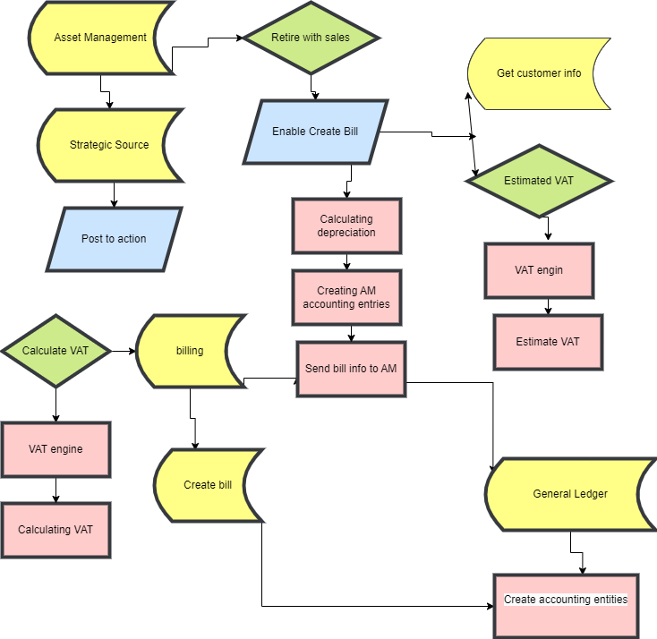

**Figure 1: Assets Management**

(Source: Self-created in Draw.io)

**Working Hours**

With a 13 per cent decrease in the worldwide safety rate, which amounts to 1.25 for 200,000 hours worked regarding employees and contractors, the firm achieved a new milestone for safety. Peabody reduced expenses by 5% and 24% across the "U.S." and "Australia," respectively.

**Equipment Specification**

In the case of "Equipment" and "Mining Supplies". The main things that "Peabody Energy" buys to support our mining operations include mining machinery and "replacement parts," "ammonium-nitrate," "diesel fuel," and "emulsion-based explosives," off-road tyres, "steel-related products," "lubricants," and "electricity” (Khatoon *et al.* 2019). This firm has numerous solid "strategic relationships" among the major product suppliers and doesn't think they were unduly reliant on any one of our particular providers.

**Operation and maintenance**

"Peabody" asserts that despite the company's obvious ineligibility for self-bonding, these states are continuing to rule that it does. Most recently, "Peabody" claimed that the State of Wyoming has once again backed the company's personality-bonding investments in its "North Antelope-Rochelle" & "Rawhide mining operations" there (Adedipe *et al.* 2020). The business claimed that the legislative body of "New Mexico" had given its self-bonding approval.

## **2.3 ISO50001 requirement**

The organisational culture must be more authenticated following "ISO50001" laws and regulations so that business preferences may discover more inventive approaches to reorganise the company. The comparison will be made to "McKinsey & Company" to pinpoint the difference.

The framework "ISO50001" has been provided to establish the distinction from "Peabody Energy" and is presented in the next section.

In the US, there are several words for "government," and "electrical," including "gas" organisations that provide "financial incentives" and energy efficiency programmes. However, historically speaking, "energy efficiency programmed" tends to concentrate on identifying "low-hanging fruit" and lacks tools for tracking energy savings, losing an opportunity to explain long-term benefits to "corporate management."

In the so-called "operational management system," time allocation and separate motive operations are also managed in addition to the major notice or working zones. "Peabody Energy" is something that must be accumulated (Adedipe, 2020). The "International Organisation" to Obtain "Standardisation" has created an "international standard" that includes specifications and usage guidelines. It aids companies in various sectors in creating an "energy Management System" that will utilise energy more efficiently.

# **3. Energy Management System**

The foundation of "Peabody's sustainability" strategy is respect and accountability for the environment and the communities in which we operate. The goal of "stewardship" of the natural environment is to make confident that coal production and land usage are beneficial to society. This includes things like effective land reclamation, energy efficiency, recycling, and water use management (Arjunan *et al.* 2020). Using energy conservation and other cutting-edge procedures, we will conserve energy and lessen the intensity of our activities' greenhouse gas emissions.

"Peabody," thinks that coal is a major source of inexpensive, trustworthy energy and that petroleum and other fossil fuels will keep regulating the world's energy balance. The business is aware that these fuels produce the emission of greenhouse gases, and the political, social, and regulatory environment in which they operate globally has grown to include concern over these emissions (Alam *et al.* 2019). Fossil fuels are an integral component of the energy mix and provide around 80% of the primary energy used by the planet. To produce new steel, coal is a crucial ingredient and serves a critical function in energy generation.

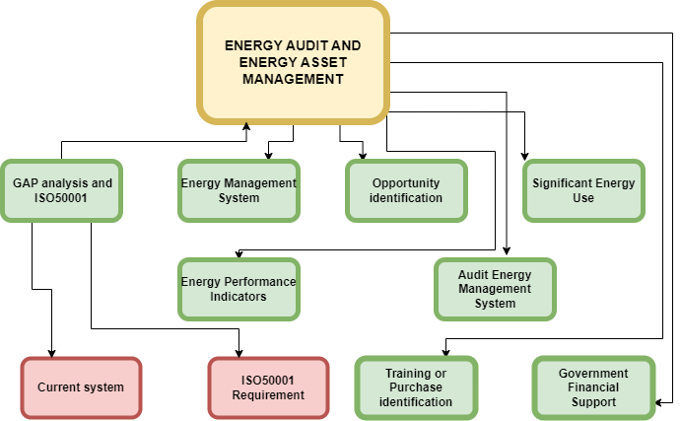

**Figure 2: Energy auditing flow chart**

(Source: Self-created in Draw.io)

# **4. Opportunity identification**

This "Peabody Energy '' has made a step in maintaining carbon emissions on the other hand the footprint which is played as the morale in development. As the consultancy is referred to, it went with better low-carbon technology. As per this, the following statements refer to the approach as the opportunity in maintaining carbon emissions.

* Utilising energy-saving technologies and other best practices to reduce emissions of greenhouse gas intensity at the company whenever possible.
* Funding research and important efforts for low-emissions collaborations and projects like those currently underway in China, Australia, and the United States.
* Assuming a leading position in the creation of national policy concerning the environment and energy.
* Interacting with authorities, academics, communities, and other interested parties to facilitate fruitful and knowledgeable discussions.
* Fostering understanding and support for the use of cutting-edge clean coal technology to end energy poverty, expand access to affordable power, and reduce emissions.

A welcome bonus that improves stream mitigation projects is the result of fairly regular out-of-bank brook flows that flood the floodplains (Teng *et al.* 2021). These flows turn the ground into wetlands conditions that serve to filter water, reduce erosion, as well as offering an environmental lift.

# **5. Significant Energy Use**

Peabody Energy said on the nineteenth of March 2009, that it has negotiated contracts for the long-term supply of a little over 90 million tonnes of coal. These arrangements allowed for the construction of the Bear Running Mine across the Sullivan Area of Indiana. By generating about 8 million tonnes of coal a year, Bear Run is predicted to be the largest operating surface mine of coal throughout the eastern United States. Two significant Midwest energy plants will first receive coal from the mine under contracts with a maximum duration of 17 years.

When combined, these partnerships are expected to bring in close to $6 billion in income. Peabody anticipates investing between $350 million and $400 million over a significant period of time in order to determine the mine's full capacity (Shafiee and Srensen, 2019). According to SER Chief Imprint Northam, Peabody Energy contributed $2 million to the Energy Advancement Centre, which Wyoming matched. A section of the office was expected to be used for studies concerning cutting-edge coal technology.

# **6. Energy Performance Indicators**

To comprehend and assess the influence of the six energy components, "energy performance indicators" have been extremely important. It is necessary to use additional relevant indicators that may quantitatively or qualitatively assess a building's performance because the elements affecting energy consumption do not truly reveal a building's energy consumption patterns. The term "building performance indicators" (EnPIs) refers to these metrics. According to ISO 5000 (2011), EnPls is an indication of energy intensity that is used to evaluate the performance and outcomes of energy management and efficiency initiatives.

**Objective**

The basic tenet of "Peabody Energy" is that humans have a big part to play in the world's energy mix. For both developed and developing nations, dependable, inexpensive energy is dependent on thermal goods. Their metallurgical coal produces the steel required for the construction of the fundamental infrastructure, support of industrialisation, and stimulation of urbanisation (Ahmad *et al.* 2021). Together, these goods support robust economies and higher standards of living. Their goal is to fulfil the "Peabody Energy" mission, and in our opinion, this goal can only be fruitful if significant action is taken in all areas of the environment, society, and governance.

# **7. Audit Energy Management System**

In this area of mining, it is commonly discovered that the top three operational expenses are energy, labour, and materials. Energy regularly ranks as the highest when comparing the cost predictability or potential cost savings in any of the previously mentioned aspects, making the responsibility of managing energy a key area for cost-cutting. Understanding how the fuel and energy are used towards "Peabody Energy" better will be possible with the aid of an energy audit, which will also help in locating potential waste sources and places for improvement.

The evaluation of energy use has provided a helpful direction for programs that are essential for production and utility operations, such as cutting energy costs, preventative maintenance, and quality control (Francisco *et al.* 2020). Such an audit plan will help to keep an eye on energy price variations, ensure the reliability and accessibility of the energy supply, selecting the proper energy mix together, identifying energy-saving technology, installing energy-saving equipment in retrofit situations, etc. In order to make conservation ideas a reality, energy audits frequently integrate technically feasible solutions with organizational and commercial mining problems.

An energy audit's primary objective is to identify ways to reduce operating costs or energy consumption per unit of output. Energy audits provide as a "benchmark" to track energy inside a company and as the basis for creating strategies for utilizing energy more efficiently across "Peabody Energy".

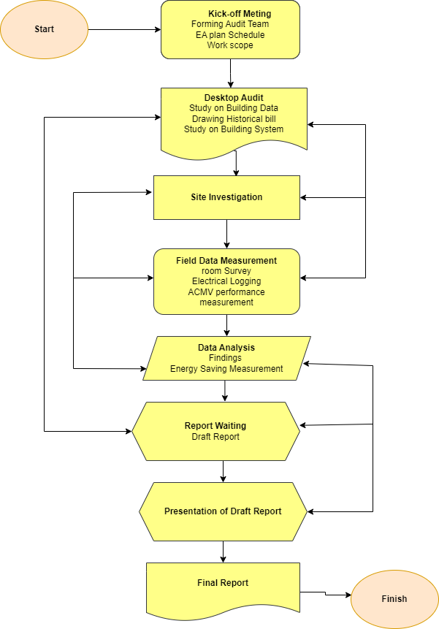

**Figure 3: Energy auditing Flow chart**

(Source: Self-created in Draw.io)

# **8. Training or Purchase identification**

To raise awareness and calculate savings, understanding energy costs is essential. In this industry, there might not be enough metres sufficient to determine all the energy utilised. Fuel and energy invoices will be helpful in such circumstances (Marinakis, 2020). Other sources of information on fuel and power costs and production-related statistics include the yearly balance statement of the firm.

The following uses should be made of energy invoices:

* They offer a record of the energy bought for a specific year, providing a baseline for future comparison.
* Energy bills may show potential savings when compared to production needs, air conditioning needs, space heating needs, etc.
* whenever power is bought using the maximum demand tariff.
* They can offer advice on potential areas for cost reduction.
* Invoices from subsequent years can be used to calculate the energy and money saved as a result of using energy conservation measures.

# **9. Government Financial Support**

"ISO50001" has an improved ability in terms of developing the organisation. Here, "Peabody Energy" should be accumulated to reduce the risk. In case of strength all over the financial condition, there needs to decrease in the vulnerability from the investment section. There need to be six more powerful targets to meet all policies.

# **10. Conclusion**

One of the finest industries for addressing the notion of energy consumption is mining. Our commitment to sustainability underpins everything we do and has an impact on how people make plans. Most recently, "Peabody" asserted that the Wyoming State has once more backed the business' personality-bonding efforts. An "international standard" including specifications and usage recommendations has been developed through an "International Organisation" to achieve "Standardisation". The industry is aware that these fuels emit greenhouse gases, and concern over these emissions has developed in the political, societal, and regulatory environments in which they operate on a worldwide scale. A strategy for an audit like this can help keep an eye on things like energy price variations, the dependability and accessibility of the supply of electricity, selecting the proper energy mix, identifying technologies that save electricity, installing energy-saving equipment during retrofits, etc.

**Reference List**

**Journal**

Adedipe, T., Shafiee, M. and Zio, E., 2020. Bayesian network modelling for the wind energy industry: An overview. *Reliability Engineering & System Safety*, *202*, p.107053.

Adedipe, T., Shafiee, M. and Zio, E., 2020. Bayesian network modelling for the wind energy industry: An overview. *Reliability Engineering & System Safety*, *202*, p.107053.

Ahmad, T., Zhang, D., Huang, C., Zhang, H., Dai, N., Song, Y. and Chen, H., 2021. Artificial intelligence in the sustainable energy industry: Status Quo, challenges and opportunities. *Journal of Cleaner Production*, *289*, p.125834.

Alam, M., Zou, P.X., Stewart, R.A., Bertone, E., Sahin, O., Buntine, C. and Marshall, C., 2019. The government championed strategies to overcome the barriers to public building energy efficiency retrofit projects. *Sustainable Cities and Society*, *44*, pp.56-69.

Arjunan, P., Poolla, K. and Miller, C., 2020. EnergyStar++: Towards more accurate and explanatory building energy benchmarking. *Applied Energy*, *276*, p.115413.

Francisco, A., Mohammadi, N. and Taylor, J.E., 2020. Smart city digital twin–enabled energy management: Toward real-time urban building energy benchmarking. *Journal of Management in Engineering*, *36*(2), p.04019045.

Hilorme, T., Zamazii, O., Judina, O., Korolenko, R. and Melnikova, Y., 2019. Formation of risk-mitigating strategies for the implementation of projects of energy-saving technologies. *Academy of Strategic Management Journal*, *18*(3), pp.1-6.

Khatoon, A., Verma, P., Southernwood, J., Massey, B. and Corcoran, P., 2019. Blockchain in energy efficiency: Potential applications and benefits. *Energies*, *12*(17), p.3317.

Kontokosta, C. E., Reina, V. J., & Bonczak, B. (2020). Energy cost burdens for low-income and minority households: Evidence from energy benchmarking and audit data in five US cities. *Journal of the American Planning Association*, *86*(1), 89-105.

Marinakis, V., 2020. Big data for energy management and energy-efficient buildings. *Energies*, *13*(7), p.1555.

Shafiee, M. and Sørensen, J.D., 2019. Maintenance optimization and inspection planning of wind energy assets: Models, methods and strategies. *Reliability Engineering & System Safety*, *192*, p.105993.

Teng, S.Y., Touš, M., Leong, W.D., How, B.S., Lam, H.L. and Máša, V., 2021. Recent advances on industrial data-driven energy savings: Digital twins and infrastructures. *Renewable and Sustainable Energy Reviews*, *135*, p.110208.