**GENDER INEQUALITY BASED ON HEALTH AND EDUCATION IN GLOUCESTERSHIRE**

**Table of Contents**

Analysis 3

Reference List 5

# Analysis

Gender inequality can be identified as a social issue whereas equal attention cannot be provided. Herein, the health and education can be considered as per the certain benchmark based on which the proper support can be provided. In the context of Gloucestershire, gender inequality concern is to be assessed which can affect the social feasibility as well (Jones and Comfort, 2020. Herein, the process of health based differentiation can be identified which through the possibility of making assessment of the health determinants can be marked based on the geographical and biological viewpoints. Herein, the viewpoint of making assessment of the inequality concern across South Gloucestershire, this would require to make the gender based assessment which can be beneficial for the health and education based development as well.

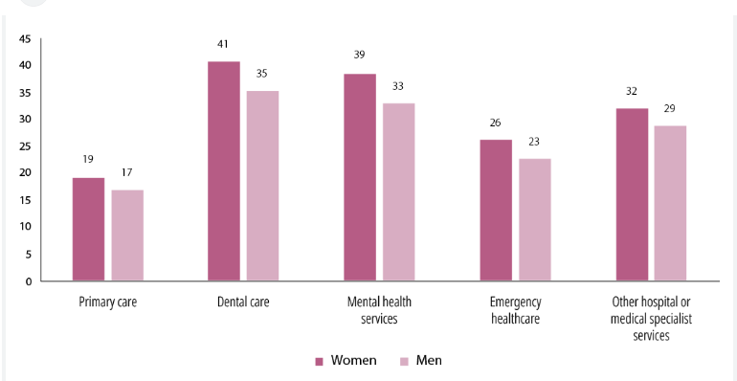

**Figure 1: Gender and intersecting inequalities relating to health care service**

(Source: Dph report 2020 beyond covid race health and inequality in gloucestershire, 2020)

In connection to the differentiation of the health care service, this would require to keep focus on the gender and intersecting inequalities aligning to the provided statistics. This can be identified that regarding the primary care providing process, the range of the woman is higher than the men in Gloucestershire (West *et al.* 2022). In the context of Gloucestershire, this needs to make an assessment of the public health assessment. Herein, the Gloucestershire county council focuses on the risk handling concern by providing the equal facilities to the communities by providing irrespective of operational support (England, N.H.S. and Improvement, N.H.S., 2019)

On the other hand regarding the academic learning based development, this would is required to make identification of significant gaps regarding the gender based assessment, Herein, the supportive learning environment is lacking which can affect the feasibility of the learning process and standard irrespective of the genders (Dph report 2020 beyond covid race health and inequality in gloucestershire, 2020). The procedure of making discrimination helps to keep providing the support which through the risk free measurements can be done which can accelerate the development of the health care service. Herein, the probable support regarding the research or the other repeated professions are required which can enhance the level of confidence of the different people (Nobles *et al.* 2022). In terms of reducing gender based discrimination, social consciousness has been developed which can help to keep acceleration of the learning values as well (Dph report 2020). This can help to keep up standerd the feasible development of own decision making. In relation to that the application of the co–education can be effective for the better learning practices and focusing on competency.

# Reference List

Dph report 2020 beyond covid race health and inequality in gloucestershire, 2020<https://www.gloucestershire.gov.uk/media/2102344/dph-report-2020-beyond-covid-race-health-and-inequality-in-gloucestershire.pdf>

England, N.H.S. and Improvement, N.H.S., 2019. Learning disability Mortality Review (LeDeR) programme: action from learning. *NHS England*.

Jones, P. and Comfort, D., 2020. A commentary on the localisation of the sustainable development goals. *Journal of Public Affairs*, *20*(1), p.e1943.

Nobles, J., Fox, C., Inman-Ward, A., Beasley, T., Redwood, S., Jago, R. and Foster, C., 2022. Navigating the river (s) of systems change: a multi-methods, qualitative evaluation exploring the implementation of a systems approach to physical activity in Gloucestershire, England. *BMJ open*, *12*(8), p.e063638.

West, A.R.C., Inman-Ward, A. and Beasley, T., 2022. Navigating the river (s) of systems change: a multi-methods, qualitative evaluation exploring the implementation of a systems approach to physical activity in Gloucestershire, England.