**ASSESSMENT 1**

**LOG9705 PROCUREMENT AND SUPPLY CHAINS**

**Executive Summary**

This report focuses on analysing ASDA’s procurement and supply chain management processes that also implicates on developing implication within product distribution. ASDA’s supply chain and procurement strategies are driven by local supplier empowerment and IPL logistics. ASDA gets on with things, making operational effectiveness possible due to application of its IPL procurement strategy. Company’s supply chain operations are governed by GSCOP facilitating effectiveness of supply chain and procurement activities. It also focuses on providing key recommendations that could help in developing procurement processes.

Table of Contents

1. Introduction 3

1.1 Background of ASDA 3

1.2 Brief Overview of ASDA’s approach to procurement and supply chain management 3

2. Analysis of Procurement and Supply strategy 5

2.1 Procurement Strategies 6

2.2 Supply Chain strategies and efficiency 8

2.3 ASDA’s success factor driven by supply chain and procurement 11

3. Recommendations for Improvement 14

3.1 Investment in digital improvement in distribution channels 14

3.2 Maintaining healthy relationships with the key suppliers 15

3.3 Enhancing supplier support by establishing feedback as an instrument 16

3.4 Application of green or sustainable procurement practices 17

3.5 Blockchain application in supply chain 17

3.6 Improved employee training 19

4. Conclusion 19

References 22

# 1. Introduction

## 1.1 Background of ASDA

Procurement and supply include functions of sourcing raw materials and supply policies that ensure the organisation’s sustainable spending regarding supply chain management. In this report, ASDA’s supply chain and procurement have been overviewed in terms of analysing its application. Furthermore, recommendations for potential improvement are also considered. ASDA offers its customers the best value considering their demands and marketing trends. The mission of ASDA is to be best-value retailer in Britain exceeding customer needs (ASDA, 2023).

The mission of the brand means that it encourages every individual to be honest and open. ASDA works collaboratively and creatively with one another, valuing input of everyone in organisation. ASDA operates with a core value of respect for every stakeholder involved in the business. Vision statement of retail brand is to make services and products more affordable for its customers (ASDA, 2023). The company with its effective supply chain and procurement practices has constantly been growing in UK's competitive retail sector.

## 1.2 Brief Overview of ASDA’s approach to procurement and supply chain management

In 2021, ASDA developed the commitment to enhance volume of the products that are sourced from UK-based suppliers. These products include items such as chicken and dairy goods that are for everyday use (Asda.com, 2023). Therefore the primary objective of the company is to source 100% of its product from British farms.

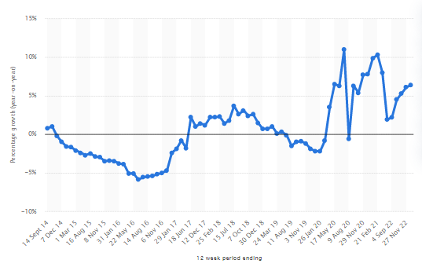

**Figure 1: Year-on-year sales growth of ASDA**

(Source: Statista.com, 2022)

ASDA’s collaboration with the effective supply chain practice has been crucial and the company has developed a commitment to effective suppliers. Using an effective supply chain and distribution chain, sales of Asda has increased by 6.4% in December 2022, which depicts distribution (Statista.com, 2023a). Asda’s transparent approach has made it possible to develop support for the local suppliers and procurement process has also developed distribution. ASDA experiences a constant sales growth supported by ILP strategies for procurement and supply chain procedures.

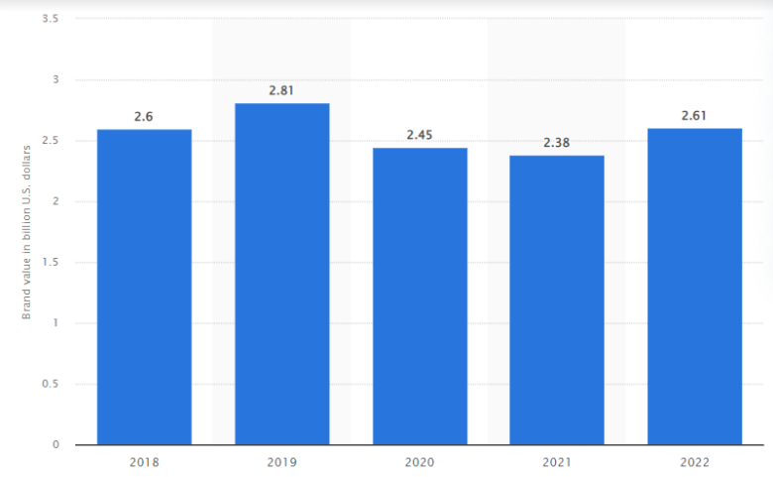

**Figure 2: Brand value of ASDA 2018-2022**

(Source: Statista, 2023b)

ASDA with procurement strategy of local suppliers' acquisition has attained significant growth in past five years. In 2022, ASDA was valued to be $2.61 billion which is almost similar to its five years ago sales of $2.59 billion in 2018 (Statista, 2023b). Moreover, brand value is referred to as amount contributed by brand to overall corporation value. ASDA operated with EDLP (everyday low price strategy) business model in its supply chain emphasising volume selling (ASDA, 2021). This benefits the business to attain an elaborated loyal customer base over its competitors in UK.

# 2. Analysis of Procurement and Supply strategy

ASDA pioneers a new supply chain collaboration way by permitting mutual suppliers to submit waste data aggregates, energy, and water to retailers at same time. The company works with collaboration platform 2degrees for collecting sustainability data (Henderson, 2020). Additionally, under agreement of 2 degrees by ASDA suppliers submit data once indicating data combination of Co-op and ASDA for effective supply chain management. According to Henderson (2020), Co-op and ASDA have benefited from 2degrees platform delivery. ASDA by allowing its suppliers to eliminate duplicate effort has engaged supply chains giving opportunity for efficiency driving. However, the company worked with a supplier advisory board and 2degrees for making requests simplest for suppliers, establishing supply chain effectiveness. As argued by Bhattacharya (2021), sustainability achievement in supply chain operations essentially needs to develop interlink between Industry 4.0 and circular economy. Therefore, indicating that supply chain sustainability of ASDA is significantly influenced by digitalisation and technology advancement of business operations.

## 2.1 Procurement Strategies

ASDA procurement is focused on involving both suppliers and customers to improve quality of supply chain practices. In 2021, ASDA made a commitment for increasing volume of products sourced from suppliers in UK comprising wheat, potatoes, and dairy (asda.com, 2023). Moreover, eggs, chicken, and potatoes came from farms in Britain to comply with CSR effectively. The company produced 100% of its own brand dairy like cheddar, cream, and milk along with 90% of British beef in 2021 (asda.com, 2023). The brand recognises need of its customers for purchasing local products that led to its transformation of procuring more products from local suppliers. In this context, it has been evaluated that ASDA collaborates with 300 local suppliers providing over 2000 product lines into retail brand’s stores (asda.com, 2023). Therefore, ASDA significantly applies local sourcing procurement strategy to improve its supply chain effectiveness.

Procurement strategies of businesses drive operational effectiveness and performance due to improved relationship and dependency between companies and suppliers. According to O'Sullivan (2019), breakdown of businesses are at operational disruption level like quality issues, poor performance of suppliers, customer demand, equipment malfunctioning and transportation delay. Furthermore, the supply chain disruptions also include increasing intensity of competitiveness, capacity or inventory issues, and human-centred issues. In this context, ASDA faced a significant issue of increased customer demand and transportation delay during COVID-19 pandemic, opening doors for improved procurement and supply chain strategies (asda.com, 2023). The restriction in cross-border transportation and procurement led to limitation of inventory and capacity of ASDA. Therefore, adoption of local supplier empowerment strategy by the brand is essential to cope up with pandemic environment business complexities.

Recent tangible situations have promoted management of supply chain to crucial importance for improved stakeholder engagement and operational performance. Covid-19 pandemic led to global financial crisis due to closure of businesses and lockdown of logistics operations (Rejeb *et al*. 2020). However, ASDA sustainably fought with implications of the pandemic by establishing local suppliers and procurement strategies. As argued by Mena *et al*. (2021), most of the global businesses in recent years have a chief procurement manager reporting to procurement team and broad impacting performance throughout company. Procurement is becoming an effective part of business for those seeking to establish as a benchmark have demonstrable ROI. ASDA to cope with complications of COVID-19 pandemic undertook an agreement of 2degrees which is collaboration with Co-op (asda.com, 2023). The developed relationship led to improved operational effectiveness gained by ASDA along with improved competitiveness in UK. The entire system of ASDA’s product retail business is managed and operated by IPL activities, eliminating requirements for specific product buyers.

The procurement strategy of ASDA ensures not only business profitability and growth but also provides extended product availability and low-priced merchandise accessibility to customers. ASDA sources products from global suppliers permitting IPL to establish long-term relationships with suppliers and farmers (asda.com, 2022). However, extensive dependency on IPL framework undertaken by the retail brand has resulted in disrupted local supplier procurement. This is because IPL extensively focuses on international and cross-border supply chain or procurement avoiding local supplier concerns. Therefore, indicating a need for revised and improved procurement and supply chain strategy adoption by ASDA to increase its competitiveness and revenue performance.

## 2.2 Supply Chain strategies and efficiency

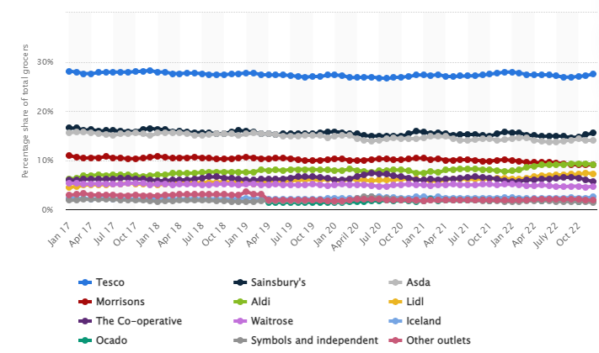

**Figure 3: Market share of ASDA**

(Source: Statista, 2023a)

The massive existing and increasing retail competition in UK imposed by giant retailers compel ASDA to undertake sustainable supply chain and procurement strategies. In 2022, ASDA captured third position in terms of retail market share in UK following Tesco and Sainsbury’s (Statista, 2023a). ASDA being one of the leading retailers has to extensively focus on its supply chain efficiency to cut down market competitiveness. Furthermore, the company helps local suppliers to decode effective relationship building ways with ASDA by running academies in Scotland and Northern Ireland for supplies in local authority's partnership. The business in these sessions offer expert advice and provide suppliers an inside look at ways to store work and depots. ASDA continues to expand its programme’s flexibility and reach with online learning materials and keeping local ranges optimisation (asda.com, 2023). Hence, indicating that ASDA emphasises local supplier empowerment to improve its competitiveness through effective supply chain and procurement strategies.

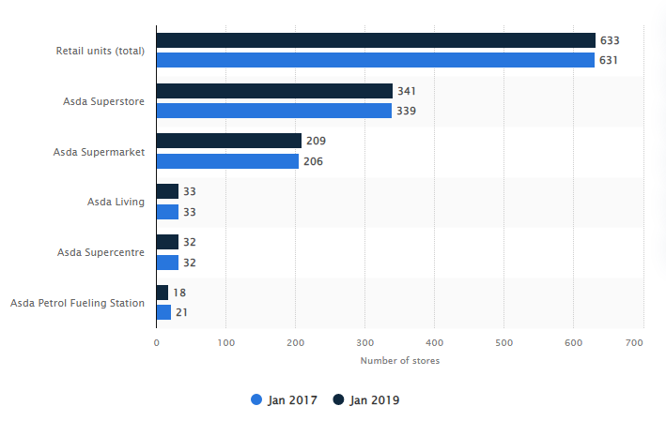

**Figure 4: Number of ASDA stores in UK**

(Source: Statista, 2022)

ASDA focuses on quantity value over profitability that has been driven by its low-priced products throughout its merchandise range. The retailing brand continues with 631 stores in UK, last record in 2017 out of which 339 are superstores (Statista, 2022). The business’s market share is in close competition with Sainsbury’s aiming to become a leading retail business in UK’s competitive retail industry. The company with a sustainable supply chain process acquires products from over 300 local suppliers in UK (asda.com, 2022). Moreover, the business also focuses on increasing product variety concerning local market procurement to improve its sustainability of both business operation and logical small-scale suppliers. As mentioned by Johnsen *et al*. (2017), global enterprises have been focusing short-term cost benefits through low-cost internal country sourcing with minimal regards for long-term global sustainability implications. ASDA in this respect emphasises low-priced product offering to its customers from both physical and online stores.

Effective procurement and supply chain activities play a critical role in improving market performance of global retailers by promoting effective stakeholders relationship establishment. Current business market disruptions like digital technologies, circular supply chain, and modern slavery evidently influences adoption of effective supply chain and procurement processes (Cherrafi *et al*. 2022). Application of digitised operations and blockchain in supply chain has also become significant recent trends. Similarly, as quoted by Grant *et al*. (2017), increasing carbon emissions through supply chain practices of retail sector in UK have resulted in need for sustainable and green procurement practices. Carbon emissions have been identified as significant recent issues faced by enterprises in supply chain management. For instance, in 2008 UK government recognised and abandoned individual carbon credit scheme under which individuals have an annual CO2 limit for energy and fuel usage (Grant *et al*. 2017). However, CO2 emissions can be exceeded by individuals taking credit in a market of secondary carbon-trading from those under limitation.

Numerous retail businesses source their grocery suppliers through bulk distributors or wholesalers. Large-scale retail establishments like ASDA handle supply of specialty or conventional items such as world foods, nature, and organic purchasing directly from manufacturers for selling them to retailers (ASDA, 2023). Supply effectiveness and strategies drive operational performance and effectiveness due to which establishing sustainable supply chain practice is essential for global companies. ASDA outsourced its application development to build and access skills in development techniques to HCL (asda.com, 2023). Moreover, the company has undertaken a three-year contract with HCL technologies firm concerning IT services to back its digital transformations using service development applications. Hence, it has been evaluated that ASDA collaborated on operational and strategic procurement to attain global retail market sustainability.

## 2.3 ASDA’s success factor driven by supply chain and procurement

The retail brand has a reputation of innovative product championing and getting them on shelves for its customers. ASDA aims to enhance number of available products in stores through *Range.Me* platform (asda.com, 2023). The platform helps procurement teams streamline submission by search filtration to find products and brands meeting exact needs. ASDA suppliers and buyers use “*Range.me*” to search for new products as a result of company’s aim to enhance number of innovative and new available products in stores. The retail brand quickly evolved and achieved majority success by being at forefront of every operational practice from food discounting to e-commerce experience. However, lack of visual hierarchy impacts market performance of ASDA as company’s website does not provide its own journey (Jones and Comfort, 2020). The retailing brand has interdependence on suppliers and customers for improving its supply chain activities.

The supply chain or logistics services of ASDA are an activity hub for its business operations influencing its procurement effectiveness. The retailer’s distribution activities include 42 operations globally comprising 3 clothing, 20 food depots, 2 imports, 5 dot.com fulfilments, 1 national station, and 9 ASCs centres (asda.com, 2022a). The company by attaining a diversified supply chain strategy by establishing local procurement strategies have been leading towards constantly increasing business success. In 2021, ASDA delivered 1.5 billion cases for Click and Collect needs in UK to manage over 12,500 colleagues working in distribution functions (asda.com, 2022a). Moreover, the effective control on procurement and empowerment of local suppliers strategies boosts success of ASDA in the UK and worldwide. The retailing brand to improve its supply chain undertook compliance with International Procurement & Logistics (IPL) in 2009 (asda.com, 2022a). Partnering of ASDA’s supply chain with role of IPL improved shopping experience of customers driving availability, great value, and quality of products.

ASDA’s nature programme provides medium and small-sized innovative suppliers access to self space easily and opportunity for working with ASDA in getting new/innovative products in shoppers hands. As stated by Doherty *et al*. (2019), incubator program of ASDA supports entrepreneurial and emerging brands like Psalt Rise partnership helps nurturing underrepresented talent within brand’s supply chain. This is achieved by the retailer through championing businesses black-owned. Nurture programs might see a rolling product launch calendar aligning different themes with delighting and surprising customer aims. Similarly, as mentioned by Zhao *et al*. (2020), ASDA selects suppliers to join programmes that might also have access to data. The programme helps them improve and develop their range along with an online suite. Additionally, the programme also provides end-to-end training for supply chain and a dedicated supportive team to facilitate company’s overall growth. ASDA considers its supplies as an important strategic partner that helps them establish effective procurement strategies.

IPL is raising ethical, environmental, and social standards in supply chain of ASDA. Moreover, IPL strategy of logistics also helps the retailing business to keep food affordable and tackle key issues like food waste and poverty. Supply chain of company is governed by Groceries Supply Code of Practice with a survey ranking ASDA as consistently following GSCOP by 94% of company’s suppliers (asda.com, 2022a). Thus, indicating that the company operates with an effective supply chain and procurement activities with strong strategic guidance.



**Figure 5: Modern Slavery Objectives 2021 of ASDA**

(Source: ASDA, 2022b)

Supply chain and procurement efficiency has enabled ASDA to attain a suitable competitive edge facilitating customer and other stakeholder engagement. According to Voss *et al*. (2019), ASDA complies with modern slavery act engagement concerning its supply chain process to improve its CSR efficiency and performance. This has benefited the company to increase its brand value and reputation leading to enhanced customer engagement, as well as, sales. Similarly as mentioned by Jones and Comfort (2021), modern slavery has become an evident issue for global retail businesses to manage. ASDA constantly enhances its workforce consistency to maintain ethical business operations along with business sustainability attainment. In 2021, ASDA analysed areas for improvement concerning elimination of risk for workforce provision (asda.com 2022b). The retail brand continues to work with a talent acquisition team, employment, labour, and GRI team to constantly improve its processes.

# 3. Recommendations for Improvement

**Figure 6: Recommendations**

(Source: Created by Author)

## 3.1 Investment in digital improvement in distribution channels

A Digital Adoption Platform (DAP) can be integrated with the supply chain which can also enhance the procurement processes. As per the opinion of Motaung and Sifolo (2023), digital procurement is based on digital technologies and automation which can reduce the time of task completion which is key in order to address supply chain issues. Furthermore, adopting digital platforms helps in developing resilience in the supply chain. Robotic processes of automation, analytics and AI can also be proposed to Asda to develop the procurement process in order to understand the implication of service delivery. In 2014, Asda launched IPL (International Procurement Limited) which eventually became its subsidiary, took the responsibility to develop value and quality of products by reducing the cost of the products sold by Asda (Asdasupplier.com, 2022). Thus, by provisioning discounts, Asda’s procurement system helped the customers of the company worldwide to gain savings. Using DAP can help in getting more relatable insights into the market that can help in getting a more detailed approach for developing the procurement process. Therefore, indicating that the procurement strategies have led to improved operational effectiveness in post-covid environment but not supported sales excellence.

## 3.2 Maintaining healthy relationships with the key suppliers

The procurement process is required to be composed of happy and satisfied suppliers that are crucial in terms of choosing the vendors considering suppliers' quality. It can be proposed to Asda to streamline procurement and maintain a healthy relationship with the suppliers. As per the views of Razak *et al.* (2021), retaining a good relationship with suppliers can increase goodwill and reputation that helps in assessing more sources of authentic supplies. Therefore, it is important for Asda to focus on procurement processes that involve suppliers by fulfilling their potential demands. Labour agencies for ASDA via IPL and GRI are needed to link ASDA on Sendex with complete SAQ.

Currently, Asda works with more than 300 local suppliers that address the company’s objective to source local products. More than 2000 product lines are provided by the dedicated suppliers of Asda (Asda.com, 2023). It is important for businesses to help to integrate the sourcing components by maintaining the transparency that is required to be developed. According to the opinion of Sönnichsen and Clement (2020), local sourcing of resources that are used in manufacturing is crucial in terms of developing support for local producers. Similarly, Asda develops implications for the local communities that help in developing sourcing processes. For instance, Asda’s Nurture programme helps in analysing small and medium suppliers to get in touch with Asda’s diverse product line by provisioning opportunities for businesses (Asda.com, 2023). Thus, the retailer has the continual approach to develop their implication by maintaining sustainable relationships with the suppliers.

## 3.3 Enhancing supplier support by establishing feedback as an instrument

Feedback in procurement process refers to the supplier feedback that enhances the communication with suppliers regarding established procurement procedures. As per the views of Allal-Chérif *et al.* (2021), feedback from the suppliers helps in understanding the market requirements and also improves the communication between the company and its suppliers. Therefore, it is important for the manufacturing function to focus on the manufacturing implication that is adhered to base on the feedback that is retrieved from the suppliers. It can be proposed to Asda implement supplier support which enhances operational coherence. In the context of Asda, more than 94% of the suppliers stated that Asda has been mostly consistent focusing on the key dealings that are developed by them (Asdasupplier.com, 2022). Therefore, it is pivotal for companies to develop implications within the integrated organisational system by contributing in manufacturing implications.

## 3.4 Application of green or sustainable procurement practices

Green or sustainable procurement is an effective way to improve supply chain or procurement activities as it ensures complete and efficiency usage of enterprise resources. As quoted by Vadakkepatt *et al*. (2021), sustainable retailing is considered to be an effective way for establishing market positioning and competitiveness. In this regard, ASDA focuses on procurement efficiency by application of local supplier acquisition. However, the brand has an opportunity of adopting e-procurement strategies to improve its accessibility to local UK suppliers. This might permit the business to increase its suppliers range and eliminate dependency on specific suppliers in local market. As opined by Deberdt and Le (2022), responsible sourcing has become a critical need for global businesses to attain effective competitiveness. Green procurement acts as an effective solution for mitigating the environment issues like extensive carbon emission. Carbon footprint of ASDA was 30,372,830 tCO2e in 2021 that was reduced by nearly 50% in 2022 (asda.com, 2023). This, therefore, indicates that by application of green or sustainable procurement, ASDA can improve its supply chain efficiency leading to improved customer retention.

## 3.5 Blockchain application in supply chain

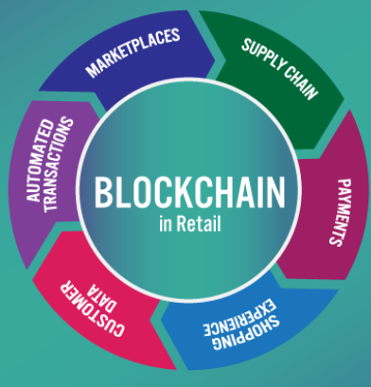

**Figure 7: Blockchain technology value in retail**

(Source: Guo *et al*. 2020)

Blockchain application enables retail businesses to offer operational process transparency to its stakeholders. Blockchain technology helps the enterprises to computerised business data leading to information recording efficiency. Additionally, blockchain also permits retail companies to improve flow of supply chain information due to centralised data storage (Guo *et al*. 2020). Centralisation of company data supports businesses to allocate all resources and enables their complete usage leading to improved operational efficiency. Blockchain also allows stakeholders to view the operational and strategic process of the business due to digitisation storage of business information (Sarkis *et al*. 2021). Thus, it can assist companies in improving organisational operations by enhancing precision rate successfully. Data digitisation opens doors for improved confidential data storage safety as layers of blockchain restrict its accessibility by general employees or individuals without special permits. Blockchain is also beneficial for protecting cyber attacks due to creation of various level protection valves that creates distraction for attackers restricting loss of confidential information of firms.

## 3.6 Improved employee training

Improving employee training is another sustainable method to boost operational effectiveness of procurement and supply chain procedures. Furthermore, employee training for technology application and usage might help retail firms to adopt operational digitisation (Maghazei *et al*. 2022). Process digitisation in recent years has become an effective way to attain market competitiveness by establishing operational automation and effective interaction with stakeholders. Employee training provides opportunity of capability and skill development to workforce offering increased employee satisfaction and motivation for improved performance (Razak *et al*. 2021). It can be stated that with assistance from proper guidance and strategic HR management, companies might be able to improve sustainability and progress by enhancing productivity level. This in turn might help the business to grow its market reputation and stakeholder inclusivity leading to improved operational effectiveness.

Moreover, employee training also helps businesses to identify inclusion of employees in supply chain procedure ensuring ethical business conduction. Employee training might also assure that global retail enterprises like ASDA establish transparent strategic relations with employees through improved training and learning processes. This implies that by improving its employee training, ASDA can facilitate its supply chain automation and efficiency.

# 4. Conclusion

The activities of developing shipping and warehousing for the company are crucial in order to distribute products to the customers. This report concluded by stating that Asda’s implementation of procurement helps in getting insights from the suppliers regarding supply chain and combining data management processes within the system. Increased industrial competitiveness in the retail industry of the UK has made it crucial for authorising local partnership that helps in getting effective information regarding supply chain procurement. Procurement is an effective function within the retail industry that helps in understanding the e-commerce operations that contribute to organisational operations and profitability. In that regard, maintaining a healthy relationship with the suppliers is important in conducting effective negotiations with suppliers. Asda has increased involvement with its core suppliers which is effective in terms of understanding the capabilities of the suppliers, understanding the market trends and enhancing implication of the resources.

Furthermore, this report focuses on analysing its procurement process which includes the logistics and business processes. Furthermore, key recommendations have been given by focusing on the marketing requirement that is further implicative in terms of developing the approach of handling the suppliers. Implementation of digital platforms in supply chain is also proposed in order to enhance the involvement of the suppliers considering their approach to provide industry insights.

ASDA has been focused on improving its procurement and supply chain processes to improve market stability and revenue profitability. It has been concluded that the retailing brand in recent years sustainably handles specialty or conventional items to increase its competitive market performance. Additionally, local market procurement strategy has enabled ASDA to improve its competitiveness and cope with cross-border procurement restrictions imposed by COVID-19 pandemic. The retail brand has been influenced by COVID-19 pandemic and cross-border procurement limitation resulting in adoption of local suppliers and increased involvement in business operations. It has also been concluded that ASDA effectively tackles the issue of modern slavery.

ASDA releases a modern slavery report every year to make its approaches of supporting health workforce and ethical operations transparent to its stakeholders. Moreover, it has been evaluated that the company using IPL control and management in procurement processes attains effective competitive edge in terms of improved stakeholder's engagement. Application of green or sustainable procurement practices has been recommended as an effective strategy through which ASDA might effectively improve its supply chain and procurement operations. Furthermore, application of blockchain in the supply chain can also support the company to increase operational transparency leading to increased stakeholder engagement.

# References

Allal-Chérif, O., Simón-Moya, V. and Ballester, A.C.C., (2021). Intelligent purchasing: How artificial intelligence can redefine the purchasing function. *Journal of Business Research, 124,* pp.69-76.

ASDA (2021). *ASDA business model. ASDA*. Available at: https://value-proposition-00.webself.net/asda#:~:text=Asda's%20business%20model%20consists%20of,and%20reduce%20the%20production%20costs. [Accessed on: 23rd April 2023]

ASDA (2022). *Modern Slavery Objectives 2021 Summary. ASDA*. Available at: https://corporate.asda.com/media-library/document/modern-slavery-statement-2022/_proxyDocument?id=00000180-89df-de24-adf1-dbdf94da0000#:~:text=Asda%20proudly%20became%20a%20member,now%20addressing%20the%20recommended%20actions. [Accessed on: 21st April 2023]

ASDA (2023). *About Asda. ASDA*. Available at: https://www.asda.jobs/about/#:~:text=Our%20mission%20means%20we%20encourage,on%20us%2C%20we%20have%20to. [Accessed on: 25th April 2023]

asda.com (2022a). *Company Facts. Logistics operations. ASDA.* Available at: https://corporate.asda.com/our-story/company-facts#:~:text=Asda%20Logistics%20Services%20is%20a,fulfilment%20centres%20and%20nine%20ASCs. [Accessed on: 21st April 2023]

asda.com (2022b). *Modern Slavery Statement 2022. ASDA.* Available at: https://corporate.asda.com/media-library/document/modern-slavery-statement-2022/_proxyDocument?id=00000180-89df-de24-adf1-dbdf94da0000#:~:text=Asda%20proudly%20became%20a%20member,now%20addressing%20the%20recommended%20actions. [Accessed on: 20th April 2023]

asda.com (2023). *Supplier Relations. ASDA*. Available at: https://www.asda.com/creating-change-for-better/better-business/supplier-relations#:~:text=Local%20Sourcing,product%20lines%20into%20our%20stores. [Accessed on: 22nd April 2023]

Asda.com. (2023). *Better Business.* Available at: https://www.asda.com/creating-change-for-better/better-business/supplier-relations [Accessed on: 12 April 2023]

Asdasupplier.com. (2022). *About Us.* Available at: https://www.asdasupplier.com/about-us#:~:text=IPL%20runs%20the%20whole%20produce,relationships%20with%20growers%20and%20suppliers. [Accessed on: 12 April 2023]

Bhattacharya, A., (2021). Achieving sustainability in supply chain operations in the interplay between circular economy and Industry 4.0. *Production Planning & Control*, pp.1-3.

Cherrafi, A., Chiarini, A., Belhadi, A., El Baz, J. and Benabdellah, A.C., (2022). Digital technologies and circular economy practices: vital enablers to support sustainable and resilient supply chain management in the post-COVID-19 era. *The TQM Journal*, *34*(7), pp.179-202.

Deberdt, R. and Le Billon, P., (2022). The green transition in context—cobalt responsible sourcing for battery manufacturing. *Society & Natural Resources*, *35*(7), pp.784-803.

Doherty, R., Ensor, J.E., Heron, T. and Prado Rios, P.A.D., (2019). Food systems resilience: towards an interdisciplinary research agenda. *Emerald Open Research*.

Grant, DB, Trautrims, A and Wong, CY. (2017). *Sustainable Logistics and Supply Chain Management: Principles and Practices for Sustainable Operations and Management*. 2nd edition, London, Kogan Page

Guo, S., Sun, X. and Lam, H.K., (2020). Applications of blockchain technology in sustainable fashion supply chains: Operational transparency and environmental efforts. *IEEE Transactions on Engineering Management*.

 Henderson, J., (2020). *Asda and Co-op to work together to drive supply chain efficiencies. Supply Chain*. Available at: https://supplychaindigital.com/digital-supply-chain/asda-and-co-op-work-together-drive-supply-chain-efficiencies [Accessed on: 24th April 2023]

Johnsen, T,E, Howard, M and Miemczyk, J. (2017). *Purchasing and Supply Chain Management: A Sustainability Perspective*, 2nd edition, Abingdon, Routledge.

Jones, P. and Comfort, D., (2020). A commentary on the United Kingdom's leading food retailers' resilience plans in the face of climate change. *Journal of Public Affairs*, *20*(2), p.e2047.

Jones, P. and Comfort, D., (2021). Leading Retailers in the UK and Modern Slavery Statements. *International Journal of Sales, Retailing and Marketing*, *10*(2), pp.18-26.

Maghazei, O., Lewis, M.A. and Netland, T.H., (2022). Emerging technologies and the use case: A multi‐year study of drone adoption. *Journal of Operations Management*, *68*(6-7), pp.560-591.

Mena, C, van Hoek R and Christopher, M. (2021) *Leading Procurement Strategy:Driving Value through the Supply Chain, 3rd ed*. London, Kogan Page.

Motaung, J.R. and Sifolo, P.P.S., (2023). Benefits and Barriers of Digital Procurement: Lessons from an Airport Company. Sustainability, 15(5), p.4610.

O'Sullivan, S. (2019). *Supply chain disruption: aligning business strategy and supply chain tactics,* London, Kogan Page.

Razak, G.M., Hendry, L.C. and Stevenson, M., (2021). Supply chain traceability: A review of the benefits and its relationship with supply chain resilience. Production Planning & Control, pp.1-21.

Rejeb, A., Rejeb, K. and Keogh, J.G., (2020). Covid-19 and the food chain? Impacts and future research trends. *LogForum*, *16*(4).

Sarkis, J., Kouhizadeh, M. and Zhu, Q.S., (2021). Digitalization and the greening of supply chains. *Industrial Management & Data Systems*, *121*(1), pp.65-85.

Sönnichsen, S.D. and Clement, J., (2020). Review of green and sustainable public procurement: Towards circular public procurement. Journal of cleaner production, 245, p.118901.

Statista (2022). *Number of Asda stores in the United Kingdom (UK) in January 2017 and on the 31st of January 2019, by size. Statista.* Available at: https://www.statista.com/statistics/300543/asda-number-of-stores-in-the-united-kingdom-uk/ [Accessed on: 22nd April 2023]

Statista (2023a). *Market share of grocery stores in Great Britain from January 2017 to December 2022. Statista*. Available at:https://www.statista.com/statistics/280208/grocery-market-share-in-the-united-kingdom-uk/ [Accessed on: 23rd April 2023]

Statista (2023b). *Brand value of ASDA worldwide from 2018 to 2022. Statista.*Available at: https://www.statista.com/statistics/1337838/asda-brand-value/ [Accessed on: 24th April 2023]

Statista.com. (2023). *Percentage change in sales at Asda in Great Britain compared to a year earlier from September 2014 to December 2022.* Available at: https://www.statista.com/statistics/386700/asda-sales-percentage-change-great-britain-uk/ [Accessed on: 12 April 2023]

Vadakkepatt, G.G., Winterich, K.P., Mittal, V., Zinn, W., Beitelspacher, L., Aloysius, J., Ginger, J. and Reilman, J., (2021). Sustainable retailing. *Journal of Retailing*, *97*(1), pp.62-80.

Voss, H., Davis, M., Sumner, M., Waite, L., Ras, I.A., Singhal, D.I.V.Y.A. and Jog, D., (2019). International supply chains: compliance and engagement with the Modern Slavery Act. *Journal of the British Academy*, *7*(s1), pp.61-76.

Zhao, G., Liu, S., Lopez, C., Chen, H., Lu, H., Mangla, S.K. and Elgueta, S., (2020). Risk analysis of the agri-food supply chain: A multi-method approach. *International Journal of Production Research*, *58*(16), pp.4851-4876.