INTERNATIONAL TOURISM (MONTENEGRO)

# 

**Table of Contents**

1. Introduction 2

2. Discussion of current development in Montenegro by critically assessing the theoretical concepts related to tourism destination development 2

3. Current offering for tourism in Montenegro and the challenges faced by the country in attracting tourist both with attracting tourists, both domestically and internationally. 4

4. Identification of the current positioning of Montenegro against similar destinations and critically examining trends for the future development of Montenegro 6

5. Conclusion 8

References: 10

Appendix: 13

# 1. Introduction

Tourism is an important industry that makes huge contributions to the economy of a country. Tourist spots attract visitors from across the world which adds to the revenue collection of a nation. Montenegro has had a similar experience in terms of tourism. With its pristine scenic beauty, picturesque medieval towns and historic buildings, the country has significant chances of increasing its tourism offerings. It has a beautiful coastline and at the same time rugged mountains that contribute to the experience of tourist visitors in the nation. This report discusses the developments of the country at present in terms of its tourism industry. It further established a critical discussion based on theoretical concepts of tourism and related destination development. It highlights the present offerings of the country to its tourists, as well as discusses the challenges faced by the country in terms of attracting both international and domestic visitors. In this report, identification has been made in terms of the existing position of the country in comparison to similar tourist destinations as well as establishes a critical examination of the trends for the upcoming development of Montenegro in the future.

# 2. Discussion of current development in Montenegro by critically assessing the theoretical concepts related to tourism destination development

With the slow recovery of Montenegro from the impact of Covid-19, the government of the country is making heavy investments in the tourism sector in order to fasten its growth. In 2020, the tourist attraction and arrival of international tourists fell by approximately 80% in comparison to 2019 (EBRD, 2023). Since tourism is capable of significantly contributing to the overall GDP of Montenegro, the government is making mighty efforts in the form of policy responses and tightening health safety protocols in terms of increasing tourist attraction in the tourist destinations in the country.

One of the most significant efforts made by the country is towards expanding its infrastructure in tourist spots. According to the report of the European Bank of Reconstruction and Development, the Montenegro government has invested more than €1.5 billion in developing infrastructure (EBRD, 2023). This will enable the country to support a growing number of tourists and the ability of the nation to host them properly. In addition to that, the completion of the Bar-Boljare Highway in 2021 which connects the Adriatic coast with the border of Serbia is one of the largest infrastructures by the government (IMF Technical Assistance Report, 2022). In this project, the government contributed €809 million among the rest of the finances were managed by International investors. The country is making extensive efforts and making investments in order to construct resorts, hotels and other tourist facilities in order to cater to the growing number of visitors and meet the demands of customers in the tourism sector. In terms of accommodation facilities, the government has invested around €800 million (IMIdaily, 2019).

The Destination Life Cycle framework is useful for establishing an understanding of the developments in terms of the tourism industry over a period of time (Paunović *et al.*, 2020). The theory basically refers to the fact that a tourist destination goes through several stages which include involvement, exploration, consolidation, stagnation and decline.

The tourism industry in Montenegro has been rapidly growing in the past few years. According to the National Tourism Organisation of Montenegro, in 2019, the country entertained over 2.5 million tourists (National Tourism Organisation, 2020). These advocate for the growth in tourism as compared to the previous year. The aforementioned figures and situation in terms of the tourism Industry suggest that the country is undergoing the development stage of the destination life cycle. The increase in tourism shows a strong trajectory towards the growth of the industry.

During this particular stage of development, tourist destinations mostly focus on improving the infrastructure and facilities in order to meet the needs of the customers of the industry. As a result of this, Montenegro has invested around €50 million in order to promote and preserve the cultural attraction sites in the country (Sciendo, 2021). These sites particularly include the old town of Kotor and Durmitor National Park. In addition to that, luxurious Hotels such as Aman Sveti Stefan and One&One Portonovi have been built along the coast of the country.

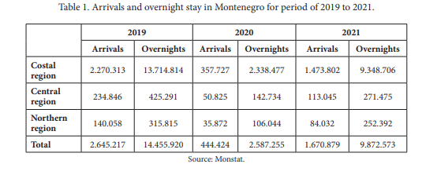

**Figure 1: Investments in overnight stays from 2019 to 2021**

(Source: Sciendo, 2021)

The country has also invested in overnight stays and accommodation facilities as shown in the above image. This will provide a luxurious experience to the tourists visiting the nation. It will enable the nation to add to the pleasure and relaxation experience of the tourist visiting the nation. The country has also developed ports and marinas which include the Port of Bar and the luxury Marina as well as made efforts into developing the residential infrastructure that is Porto Montenegro in Tivat (Porto Montenegro, 2022). Recently the country also made efforts into upgrading its international airports which are Podgorica and Tivat. This will allow the nation to handle a large volume of tourist influx. Hence the various efforts made by the government and the tourism industry in the country will enable it to attract a huge number of tourists and enable the country to provide excellent hospitality to them.

The focus country has also incorporated diversification in terms of tourism products. This includes the development of tourist sites to provide hiking and Kayaking experiences to its tourists and enhancing the cultural tourism of the nation by upgrading the historic sites which play an important role in attracting visitors to the country.

Furthermore, the sustainable Tourism development theory emphasises the importance of establishing an economic balance, supporting the environmental condition of the tourist spot as well as considering the social factors as well in terms of achieving sustainable development. Montenegro government has established a Sustainable Tourism Observatory which helps the government in gathering relevant data on the industry (Montenegrotravels, 2023). It also enables the tourism sector to analyse and support the development of the industry as well as the promotion of Sustainable practices in tourism. The data gathered by the observatory basically includes information collected from interviewing visitors, revenue collection of a tourist spot and others. It also enables the government to keep track of the carbon emission and waste management practices of the country which contributes towards the sustainability of the tourism industry in the nation.

# 3. Current offering for tourism in Montenegro and the challenges faced by the country in attracting tourist both with attracting tourists, both domestically and internationally.

*Tourism offerings in Montenegro*

Tourism is a crucial sector for a country and it contributes to the economic prosperity of the nation. Montenegro is regarded as an “undiscovered pearl” of the Adriatic Sea and it is situated in the South-East of Europe (Researchgate, 2023). Tourism contributes 22% of the GDP of the nation and helps to create opportunities for employment in the country (MDPI,2018). The country offers various tourist destinations starting from the mountain ranges to the Adriatic coastline. One of the most popular destinations in the country is Budva Beach and it offers various activities that attract more tourists. The country is also known for its UNESCO recognised World Heritage site Kotor a famous culturally based town surrounded by churches and heritage (Dookinternational, 2023).Although the country offers various tourist destinations, the main emphasis has been laid on coastal tourism as the country has a coastline of 293 km out of which 73 km is covered by beaches. The country adopts the ongoing market trend and thus instead of offering mass vacations, the country is inclined towards offering individual products for premium customers. Montenegro has a future in the tourism industry which helps to improve the revenue of the country which in return helps in the development of the lifestyles of the citizens. Montenegro focuses on the development of sustainable tourism that is intense to minimise the impact of the activity related to tourism on the environment. Sustainable Tourism also intends to minimise the negative impact on the culture of the local community in order to attain social and cultural sustainability (Novovic Buric *et al.*, 2022).The current tourism of Montenegro is dependent on the various countries like Russia, Serbia, and Ukraine surrounding the region. It has been noted that countries like Ukraine and Russia contribute almost 20% of all the tourists in Montenegro but the tourism sector of the country has been badly affected due to the outbreak of the war between Russia and Ukraine.

*Difficulties in attracting tourists both domestically and internationally*

In spite of the various famous tourist destinations in Montenegro, the country fails to attract both domestic and international tourists. The country has failed to achieve a competitive position in the international market due to the fact that the country laid emphasis on the summer months which are very few. It has been observed that the main reason for lagging behind in the tourism sector globally is the seasonal tourism that is the prevailing culture of the country. The majority of the accommodation facilities that the country offers are unregistered apartments and private homestays. To attract International tourists it is very important to offer unique accommodation facilities and other products that will comfort the premium tourist (Jaksic-Stojanovic *et al.*, 2019). The other issues that are prevailing in the coastal region such as illegal construction against sustainable development and the issues in managing the waste and inadequate facilities for transport in the region. The citizens of Montenegro have a low economic capacity and thus the consumption power is also low. That is the reason behind accommodating the tourist in the apartment as the citizens did not have the proper resources to build hotels to accommodate the tourist. To attract tourists globally it is necessary to promote tourism through various websites and integrate the travel agents to make a proper tour plan in the offered destination of the country.

To occupy a position in the Global European tourist market it is essential to open Airways for the airlines that are offering journeys at a low cost, the first company to offer a low-cost price for travelling in Montenegro Growas Wizz Airlines. Tivat and Podgorica airport in Montenegro offers air travel options at a low cost which opens the way for easy accessibility to the country. Although some hotels that offer high-class facilities have been built in the coastal area of the country, they make the smallest contribution to the accommodation purpose (Popović *et al*., 2021). To solve the problems related to accommodation it is necessary to build various hotels and resorts with the help of government intervention as it is necessary for the economic development of the country. It is also necessary to promote tourism and to become a tourist destination throughout the year instead of depending on seasonal tourism, particularly in the summer months. Improvement in the overall infrastructure of the country is necessary to attract tourists from both domestic and international.

# 4. Identification of the current positioning of Montenegro against similar destinations and critically examining trends for the future development of Montenegro

Montenegro has its own ornate beach and summer tourism that attracts many tourists worldwide. Being one of the famous tourist destinations, the penetration in the tourism market has major aspects in Montenegro and the revenue is increased per head of visitors in the various destinations in Montenegro (Jaksic *et al*., 2019). The geographic location of the place and pleasant weather conditions draw the attention of many tourists, especially in the summer. The business forecasting about the market and tourists' arrival need exponential smoothing with sessional effects in this case.

It is seen from the above figure that the percentage of the share of Montenegro in the tourism industry that holds one of the largest shares in the GDP is 9.8% (Gričar *et al*., 2021). It implies that Montenegro has a significant contribution to the tourism industry. The targeted market may be classified into 4 four major segments such as demographic, psychographic, geographic, and behavioural. In the demographic segment, the tourism business in Montenegro is open to all genders and all ages. People with a moderate monthly income can have ample opportunities in Montenegro to have the pleasure of nature. People with low income cannot afford the tourism facilities there, especially when they live in another country. Montenegro has their own cultural heritage. The major ethnic of the country is Montenegrin (45%). The Byzantine, Roman, and Ottoman are some of the major cultural segments there (Bulatović and Stranjančević, 2019).

The location named Podgorica has beautiful views of the mountain and as it is near the Albanian border the tourist may have the pleasure of the beautiful mountain sights for refreshment. The service development, especially in the e-tourism in the country, can provide a good level of tourism facilities to the tourist by which they can save a major segment of time in availing of many e-services.

The Marketing development of Montenegro is basically based on three major locations and they are Kosovo, the Albanian border, and the Balkans Area. The Macedonia, Greece and Roman Empire with their cultural heritage attract many tourists worldwide (Markus *et al*., 2019). The major diversifications in this area are Beach tourism, summer tourism, Sports, and sustainable tourism.

| **Market Penetration**   * Revenue Increment per visit * High Tourist Density in Summer * Sessional Tourists | **Service Development**   * New Location including Podgorica * New Services   **Tourists Likely to Visit**   * Revisit tourists * Local Tourists |
| --- | --- |
| **Market Development**   * Kosovo * Albanian Border (Jaksic *et al*., 2019) * Balkans | **Diversification**   * Beach Tourism * Summer Tourism * Sports * Sustainable Tourism |

**Table: Targeted Market Segment**

(Source: Self-developed)

It is seen from the above graphs that there is a significant number of tourists that come each year to Montenegro. The distribution of the graph from the year 2010 to 2014 was saturated in nature however, the number of visits to the city raised significantly from 2015 to 2019 where 2019 is the peak point of the graph and the overall income in the tourism sector in Montenegro in the year 2019 was $180 million dollars and ranked 10 among all other tourist destination in the world (DJURASEVİC *et al*., 2019). It shows that the country has a major point of earning from the tourism segment for overall development. It is seen that in the year 2020, the number of tourists per inhabitant was the lowest due to the pandemic globally and the country again raised its tourism business in the year 2021. There were massive financial losses during the time of pandemic and the country needed a significant amount of time for recovery. Moreover, the country recovers very fast and it implies that there is good potential in the tourism field of the country. The beautiful sights of nature and the old cultural heritage of the country are the key driving factors for which lots of tourists feel attracted to visit the country.

The future of the tourism industry relies on the sustainable development of the environment, encouragement of using renewable energy, and effective ICT (Information and Communication Technology). The recycling of effective waste management also is an important factor to consider. The adoption of Green Supply chain management (GSCM) is a good plan, however, there is always less number of eligible suppliers in the locality who can meet the satisfactory level of the supplies on time (Bulatović and Stranjančević, 2019). Renewable energy cannot meet the target level of output as per the demands. It is seen that the rate of unemployment in Montenegro is quite less as several tourism companies hire labour forces from other regions. Montenegro already receives aid from EU CARDS from the Government of Germany to give proper training to eligible candidates in the hotel and tourism industries (Delibasic *et al*., 2022). The marketing segments have extensive potential in the local aspects as well as at the international level too and with effective plans and strategies Montenegro can definitely step forward towards its goal in the tourism industry.

# 5. Conclusion

Montenegro has its own natural beauty and old cultural heritage throughout the country that attracts lots of tourists worldwide. The country’s development and GDP depend significantly on the tourism sector. The country has a serious vision in the tourism sector and development has increased significantly from the year 2015 significantly. There was a global loss during the time of the pandemic and it is seen that the country recovers from their loss with the fast nature of the development. The future of the development in the tourism sector depends on e-service (hotel bookings, taxi services, and city map services ) which may save time for tourists in availing of the services. The country sets up many institutions and already has aid from the Government of Germany in the development of Hotel & Tourism Institutions. Many people may get jobs in these sectors where unemployment is one of the major problems in Montenegro. The recycling, and adoption of GSCM in the existing supply chain may take time and cost-consuming and efficient plans may overcome the problems. Many hotels and tourism spots have already started using renewable energy resources (Solar PV) and it is also true that renewable energy resources cannot provide desired output as per the demands and the company needs to depend on conventional resources which emit carbon to the environment. The future of the tourism industry depends on the sustainable development of the environment.

# References:

Bulatović, I. And Stranjančević, A., 2019. Tourist satisfaction Montenegro: Destination management quality indicator. International Journal for Quality Research, 13(1), p.33.

Bulatović, I. And Stranjančević, A., 2019. Tourist satisfaction Montenegro: Destination management quality indicator. International Journal for Quality Research, 13(1), p.33.

Delibasic, M., Pupavac, J., Budic, H., Streimikis, J. And Shilina, M.G., 2022. Employment in the hotel industries of Croatia and Montenegro: Current state and outlook. Montenegrin Journal of Economics, 18(3), pp.23-34.

DJURASEVİC, S., ADZİC, S. And Stranjančević, A., 2019 Tourism Development Montenegro–Crucial Challenge Within The Structural Changes In Economy. GSI Journals Serie A: Advancements in Tourism Recreation and Sports Sciences, 2(1), pp.1-17.

Dookinternational, 2023.International, D. *Montenegro tourist attractions*, *10+ Top Montenegro Tourist Attractions, Places to Visit in Montenegro*. Available at: https://www.dookinternational.com/montenegro-tourist-attractions#:~:text=Tourists%20can%20find%20many%20things,to%20visit%20for%20nature%20lovers. (Accessed: April 19, 2023).

EBRD, (2023). Available at: <https://www.ebrd.com/publications/transition-report-202021-montenegro>

Gričar, S., Bojnec, Š., Karadžić, V. And Backović Vulić, T., 2021. Tourism-led economic growth in Montenegro and Slovenia. Economic Research-Ekonomska Istraživanja, 34(1), pp.3401-3420.

IMF Technical Assistance Report, (2022). Available at: <https://www.imf.org/en/Publications/CR/Issues/2022/06/08/Montenegro-Technical-Assistance-Report-Public-Investment-Management-Assessment-519043>

IMIDaily, (2019). Available at: <https://www.imidaily.com/editors-picks/three-more-hotels-slated-for-montenegro-cip-approval-in-coming-weeks/>

Jaksic-Stojanovic, A., Jankovic, M. And Seric, N., 2019. Montenegro as high-quality sports tourism destination-trends and perspectives. Sport Mont, 17(1), pp.93-95.

Jaksic-Stojanovic, A., Jankovic, M. And Seric, N., 2019. Montenegro as high-quality sports tourism destination-trends and perspectives. Sport Mont, 17(1), pp.93-95.

Markus, Z., Perovic, D., Pekovic, S. And Popovic, S., 2019. Assessing tourist revisit intention through the sports and recreational services offered. Business Systems Research: International journal of the Society for Advancing Innovation and Research in Economy, 10(2), pp.141-150.

MDPI,2018. Montenegro's Road to Sustainable Tourism Growth and Innovation Multidisciplinary Digital Publishing Institute. Available at: https://www.mdpi.com/2071-1050/10/12/4687 (Accessed: April 19, 2023).

Montenegrotravels, (2023). Available at: <https://www.montenegro.travel/en>

National Tourism Organisation, (2020). Available at: <https://go.montenegro.travel/en/home>

Novovic Buric, M., Jaksic Stojanovic, A., Lalevic Filipovic, A. And Kascelan, L., 2022. Research of attitudes toward implementation of green accounting in tourism Industry in Montenegro-practices, and challenges. Sustainability, 14(3), p.1725.

O'Neill, A. (2023) *Montenegro - Gross Domestic Product (GDP) 2008-2028*, *Statista*. Available at: https://www.statista.com/statistics/528667/gross-domestic-product-gdp-in-montenegro/ (Accessed: April 19, 2023).

Paunović, I., Dressler, M., Mamula Nikolić, T. And Popović Pantić, S., 2020. Developing a competitive and sustainable destination of the future: Clusters and predictors of successful national-level destination governance across destination life-cycle. Sustainability, 12(10), p.4066.

Popović, S.G., Dobričić, M. And Savić, S.V., 2021. Challenges of sustainable spatial development in the light of new international perspectives-The case of Montenegro. Land Use Policy, 105, p.105438.

Porto Montenegro, (2022) Available at: <https://www.portomontenegro.com/>

Researchgate,2023.Tourism policy in Montenegro - current situation and future challenges Available at: https://www.researchgate.net/publication/328743611_Tourism_Policy_in_Montenegro_-_Current_Situation_and_Future_Challenges (Accessed: April 19, 2023).

Sciendo, 2021. Available at: <https://sciendo.com/pdf/10.2478/eoik-2022-0017>

# Appendix:

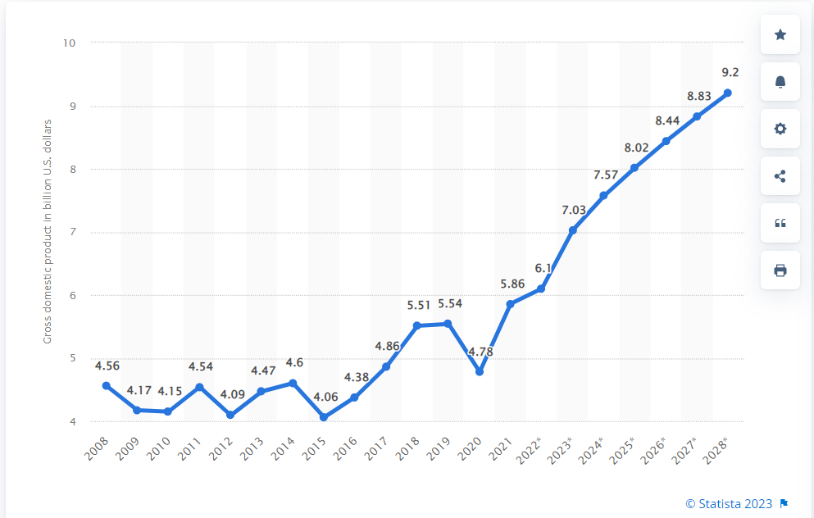

**Fig: GDP growth of Montenegro**

**(Source:Statista.com)**

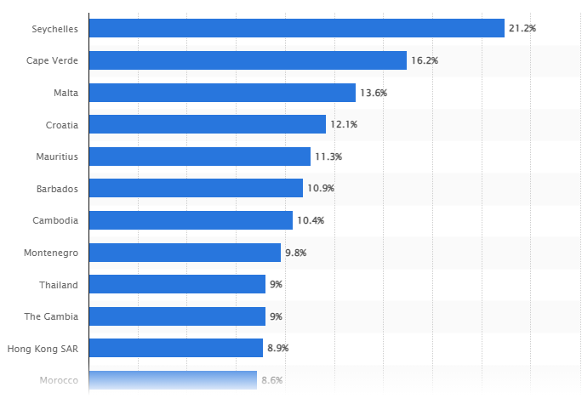

**Figure: Montenegro's share in the tourism industry and contribution in GDP**

**(Source: Statista.com)**

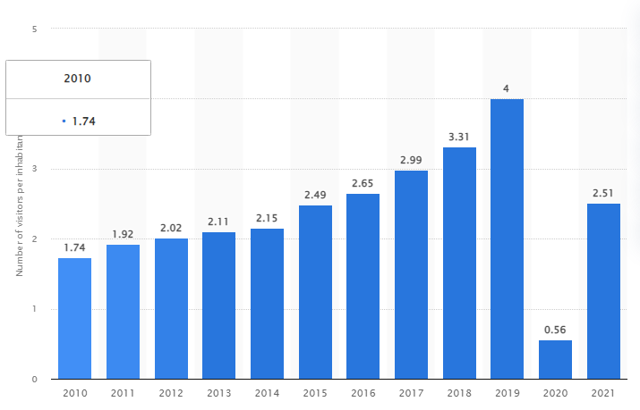

**Figure: Average number of visitors per inhabitant in Montenegro from 2010 to 2021**

**(Source: Statista.com)**