# Introduction:

* Overview of British Airways' Strategy
* Asian country's customer base.

The main purpose of the business is to satisfy the needs and demands of the customer but the business is not in such a position every time to satisfy all the customers. It may be an impediment for a business to meet all the requirements of the individual customer. It is important for an organisation to remember that the strategy of one size fits all do not work in business, as every individual does not have the same preference so a single product cannot satisfy everyone. Therefore companies adopt the strategy of market segmentation which helps them to divide the market into various segments and to develop products or to provide services according to the needs of the customers in those segmented areas. In this assignment, British Airways has been chosen and the customer market segmentation is based on the customer of Asian countries in this assignment the dynamic nature of the visitors that prefer British Airways for travel purposes will be demonstrated.

**Global customer segmentation**

* Target marketing
* Lifestyle and traits played an important factor.

Target marketing helps British Airways to identify the most profitable segment of the market.

Segmentation of a market helps the organisation to identify individuals who share the same characteristics or interests. It helps to get potential customers by dividing the broad range of customers into subgroups that have the same lifestyle and traits. When it comes to travelers few of them prefer to have high-quality service while others are more sensitive to prices, so it is essential for British Airways to segment their customers according to their preferences(Research gate,2023). The Airlines target those customers who are profitable and will help the growth of the organisation for the same reason they target the business class traveler who will generate more profit for them.

**Continued**

* Emphasis on geographical segmentation.
* Psychographic factors also need consideration.

The market is generally segmented into five groups they are geographic, demographic, psychographic, product related, and behavioral. British Airways segment their customer according to geographical factors and psychographic factors. They target the Asian market where individuals prefer to travel to countries having cold climates to enjoy vacations and they also target the psychographic factors of individuals in Asian countries, an individual who has a high standard of living will prefer to travel in business class.

**The customer journey in digital touch point**

* Access information through digital activities
* Offer innovative measures

It is important for any organisation to give the customer the best experience for that it is necessary to make the journey of the customer awesome. Customers are empowered by the technology to access their own needs and this gives the opportunity to the businesses to engage the customers in an innovative way (Vannucci and Pantano, 2020).In the Asian market, many companies are unable to recognise the digital touch points i.e. online advertisements, and online reviews, British Airways grab the opportunity by recognising the digital touch point of the Asian customers which helps the company to attract as many as customers and to gain profitability.

**Continued**

* Recognition of the customer journey
* Facilitates customer best experience through the user interface.

The customer journey in the digital touch point must be taken into account to evaluate the perspective of the customer and to understand their online behavior which helps the business to reach the customers and provide value-added information. Before arriving at a decision the customers access various information through applications of the company or the website available, British Airways facilities their customer's easy navigation on their website and it has been designed clearly and well responsive. Customers often want to interact with the representative to facilitate customer with this option British Airways provide a chat box tool that is very user-friendly and give the user the best live chat experience.

**Customer experience on digital touchpoints**

* Digital customer experience
* Various digital touch points.

To achieve a better customer experience it is necessary to evaluate the customer journey on the various digital touchpoints, in this point, 5 digital touchpoints will be evaluated to analyse the customer experience. The digital touchpoints are listed here:

Google's website is the most visited one throughout the world and it dominates the market of search engines. To get potential customers and to get their business noticed British Airways promote their business through Google advertising which helps them to expand their business.

Website of the British Airways will be considered an important digital touchpoint for any potential customer, so it is necessary for the company to make its website user-friendly so that easy so the customer can access information easily(Research gate,2023).

**Continued**

* Importance of live chat
* The necessity of social media
* Effectiveness of online reviews

Live chat is recognised as the most significant digital touchpoint for any business, and most customers prefer to have this experience to gather information British Airways need to implement the same properly.

Social media played a crucial role in the digital touchpoint as it helps the brand to connect with the customers at a personal level.

Online review is considered the most essential digital touch point as it has the effectiveness to change the customer decision.

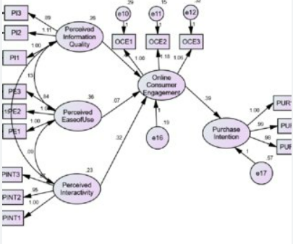

**Fig: Website engagement model**

**(Source: Research gate,2023)**

Speakers Note: Website engagement means the ability of an organisation through its brand value to attract customers, it determines that the users are getting valuable information through website browsing.

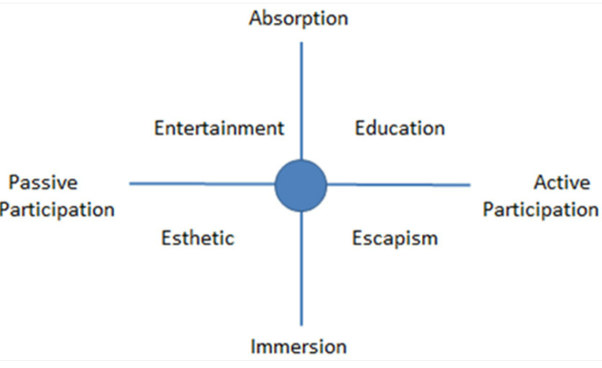

**Fig: Four Realms of Experience**

**(Source: Pine and Gilmore, 1999)**

Speaker Note: The author proposed the 4Es Educational, Esthetic, Escapist, and Entertainment for giving the customer a better experience.

**Role of social media digital touchpoint**

* Active participation in social media
* Need to build community

Digital touchpoint helps the organisation to create a community for potential customers which help them to improve their public image and help to boost brand loyalty. Social media is a vital digital touch point that helps the organisation to attract various potential customers. British Airways need to make its presence across various social media platform like Facebook, Twitter, and Instagram so that it can attract customer as much as possible. British Airways need to actively react to the various post and comments on the reviews and queries of the customer regarding their services. Lucrative discounts attract customers, so it is necessary for British Airways to promote discount coupons on tickets on their first journey with British Airways on social media platforms.

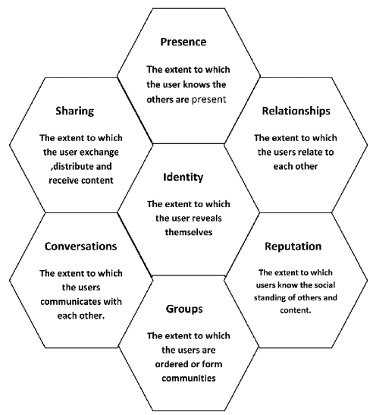

**Fig: Honey Comb Model**

**(Source: Kietzmann,*et al*.,2011)**

**Speaker Note:** The model is used to evaluate the forces behind the ecology of social media in which all users and marketers are operating.

**Strategy to enhance customer experience**

* Website flexibility
* Reliable information

For shaping the future customer experience strategy British Airways need to follow a few things that will be appropriate to engage the customer and enhance their digital experience. British Airways need to make its website flexible so that it has the ability to display the history of the customer and there should be consistency in the flow of information. British Airways should ensure that the information provided on its website is reliable and up to date. The website should be built in such a way that it can provide information according to the customer's digital touch points.

# Conclusion

* Digital touchpoints need to be evaluated properly
* Enhance customer experience through the chatbox

From the above discussion, it can be concluded that British Airways can attract global customers by evaluating the various digital touch point. Asian customers are the main segmented target of British Airways as many companies fail to recognise the digital touchpoint in Asia. The Company can enhance the customer experience by introducing the chat box in their app or website.

# 

# References:

Research gate,2023. (PDF) market segmentation, targeting, and positioning - Available at: https://www.researchgate.net/publication/319085560_Market_Segmentation_Targeting_and_Positioning (Accessed: April 21, 2023).

Research gate,2023.Consumer engagement towards travel websites and purchase intentions. Available at: https://www.researchgate.net/publication/338358167_Consumer_Engagement_Towards_Travel_Websites_and_Purchase_Intentions (Accessed: April 21, 2023).

Pine and Gilmore, 1999.Four experience realms. source: Pine and Gilmore [2]. - researchgate . Available at: https://www.researchgate.net/figure/Four-experience-realms-Source-Pine-and-Gilmore-2_fig1_343566633 (Accessed: April 21, 2023).

<https://www.researchgate.net/figure/Honey-Comb-Model-Source-Kietzmann-et-al-2011_fig1_333718942>

Vannucci, V. and Pantano, E., 2020. Digital or human touchpoints? Insights from consumer-facing in-store services. Information Technology & People, 33(1), pp.296-310.

Iftikhar, I., Yasmeen, B. and Ahmad, N., 2022. Honeycomb Framework: Examining the Social and Personal Drivers of Fake News Sharing on Social Media Platforms. Journal of Development and Social Sciences, 3(3), pp.01-16.

Chan, J.K.L. and Saikim, F.H., 2022. Exploring the ecotourism service experience framework using the dimensions of motivation, expectation and ecotourism experience. Tourism and Hospitality Research, 22(4), pp.425-443.