**ENGM 116**

**LEADERSHIP AND THE MANAGEMENT OF PROJECT RISK, QUALITY AND PEOPLE ASSIGNMENT 1 2023**

**Executive Summary**

This report has evaluated the importance of leadership and management for mitigating the project risks, quality and people. This report includes information regarding the effective leadership and management process to ensure a successful outcome. This report has evaluated the information regarding the effective leadership and teamwork policies. This report includes the relevant factors that impact the quality of the project process. Besides, this report includes information regarding the impact of the leadership style and management process. The information regarding the mitigation concepts has been evaluated in this report. Moreover, the project conditions of the Dyson Electric Car Project have been evaluated in this report as a case study. It has been evaluated that developing culturally-diversified and inclusive teams might help eliminate the issue of insufficient motivation faced by Dyson Electric Car Project.Moreover, to mitigate the issue of lack of quality equipment can be attained by developing preventive maintenance plan and using appropriate project management software.

Table of Contents

Introduction 3

1. Leadership and teamwork 3

1.1 Issues in managing people in projects 3

1.2 Importance of leadership to improve team performance 4

2. The factors that can impact on the quality of a project 5

2.1 Lack of effective planning 5

2.2 Lack of effective communication 6

2.3 Lack of management for stakeholders 6

2.4 Lack of accurate measurement 7

2.5 Lack of constant monitoring 7

2.6 Lack of insights 7

3. The impact of leadership style and team performance on quality issues in the Dyson Electric Car Project 8

3.1 Impact of leadership style on quality issues 8

3.2 Impact of team performance on quality issues 8

4. Mitigating concepts for quality issues of ‘Dyson Electric Car Project’ 9

4.1 Active participation of employees for the decision making process 9

4.2 Developing inclusive cross-cultural teams 9

4.3 Preventive maintenance plan and software adoption 9

Conclusion 10

References 11

# Introduction

The leadership and management of project risks and quality refer to the process of managing the projects in a systematic process to ensure accuracy and success. The mitigation of risk regarding the work process of the projects requires effective leadership and management to identify the issues and effective mitigation strategies. In order to maintain the quality of the projects the enhancement in the leadership and management need to be ensured. This is helpful to ensure the accuracy and quality of team works reading the projects. The leadership and management process are the essential part of a project as it helps to observe the total process of the projects.

# 1. Leadership and teamwork

## 1.1 Issues in managing people in projects

The management of people in projects includes multiple issues that can impact the quality of the project. The issues regarding the people management create risks regarding the work process of the projects. The team leaders of the project need to ensure the mitigation of the issues regarding people management to enhance the quality of the projects.

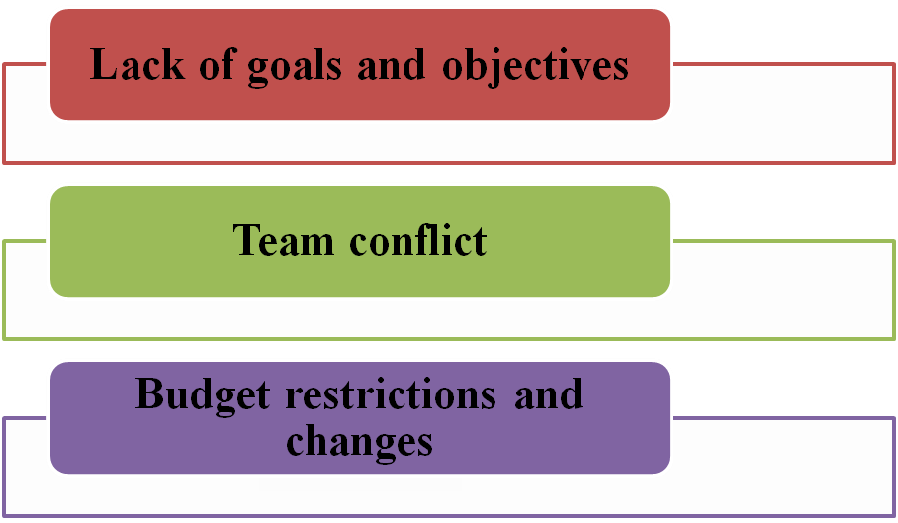

**Figure 1: Issues in managing people in projects**

(Source: Created by author)

***Lack of goals and objectives***

The management of people reading the projects requires the process of setting clear goals and objectives for the team members. According to the views of Wu *et al.* (2019), the team leaders need to set short time goals for the employees to encourage them into active participation for the project. This is helpful to enhance the organisational growth by enhancing the quality of the projects. According to the case study of Dyson Electric Car Project the people management for critical projects requires effective goal setting techniques to ensure the growth of the project (Dyson.com, 2023). This is helpful to encourage the work forces for more dedicated work towards the success of the projects.

***Team conflict***

The team conflict is the issues that impact the management regarding multiple tasks regarding the project. As mentioned by Todorova *et al.* (2022), team conflict creates issues regarding the management of multiple teams regarding the execution process of the projects. Conflicts among teams decrease the success rate of the project tasks which led to issues regarding the project outcome. Team conflict creates issues regarding the process of manufacturing by creating confusions among the team members. In accordance with the case scenario, team conflict regarding the project of electric cars creates issues regarding the manufacturing process due to lack of collaborative work process (Dyson.com, 2023). Team conflict impacts the quality of the car by reducing the accuracy rate of the essential parts such as converter, battery pack and charging station. Therefore, the leaders and managers of the project need to enhance the understanding among different teams.

***Budget restrictions and changes***

The critical projects such as car manufacturing require effective flow of financial resources to ensure the supply of resources and raw materials regarding the project. As mentioned by Schmidt and Eloy (2020), budget restriction and changes create issues regarding the distribution of financial resources for the supply of resources. The case study of Dyson Electric Car Project highlights that the budget restrictions regarding the projects create issues regarding the manufacturing and resources supply process. Budget restrictions and changes regarding the projects create delays in the productivity process. This is impactful for the process of attracting buyers and investors. For instance the Dyson Electric Car Project faces issues regarding the availability of buyers for the project (Dyson.com, 2023). This led to the unsuccessfulness of the project due to lack of investors and buyers for marketing.

## 1.2 Importance of leadership to improve team performance

***Effective support for the team members***

The leaders of the project teams play a vital role for the enhancement of team performance due to their capability to enhance the morality of the teams. In the views of Paais and Pattiruhu (2020), the team leaders are capable of bringing the best attributes for the team members to enhance the performance of the team. This is helpful to manage the team works accordingly by considering the requirements of the project. Furthermore, the leaders of the project teams are effective to improve the team performance that is essential to ensure the success rate of the projects. According to the case study, the leaders of the project regarding the Dyson electric car have helped the team members to enhance the manufacturing process by providing effective support. As commented by Wisittigars and Siengthai (2019), leadership is a vital factor for the maintenance of effective team work by identifying the drawbacks of the team members. Team leaders are able to observe the performance of the teams closely that helps them to identify the drawbacks of individual team members. This is helpful to enhance the team performance by providing effective feedback regarding the existing work process.

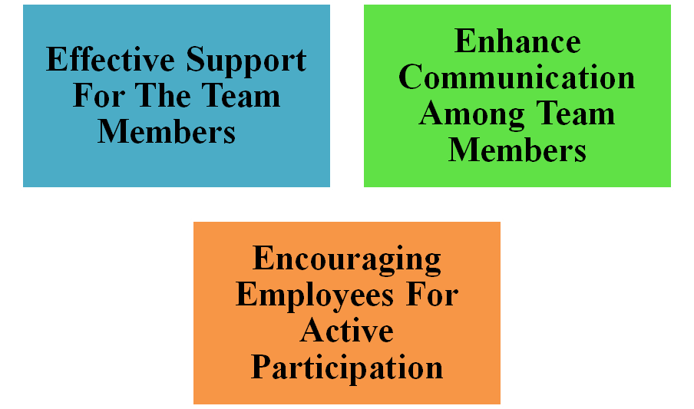

**Figure 2: Importance of leadership to improve team performance**

(Source: Created by author)

***Encouraging employees for active participation***

The shifting of work process for betterment of team performance requires effective leadership to ensure the enhancement of success rate of the teams. Aas and Paulsen (2019) have mentioned that, the leaders of the critical projects help to encourage the employees for active participation in the production process. On the other hand, the project leaders help to manage the critical situations regarding the projects by ensuring the implementation of substitute processes. For instance, the project leaders of Dyson electric cars have helped to mitigate the issues regarding the lack of buyers. The project leaders of the Dyson project have helped to ensure future betterment regarding the manufacturing of solid state batteries and other fundamental technologies (Dyson.com, 2023). Active participation of employees helps to enhance the team performance regarding the project of manufacturing electric cars.

***Enhance communication among team members***

The project leaders help to enhance the communication process among the team members that is essential to reduce confusions among employees. According to the views of Layton *et al.* (2020), the project leaders encourage the team members to discuss the issues to identify the effective mitigating process. This is helpful to enhance the understanding among the team members to ensure the success of the projects. Furthermore, the project leaders enhance the visibility among the team members that is effective to provide a clear goal regarding the project. Effective communication is helpful to enhance the project outcomes by considering the requirements of the investors and buyers.

# 2. The factors that can impact on the quality of a project

## 2.1 Lack of effective planning

The critical manufacturing project can get impacted due to lack of effective planning before starting the project. In the views of Meyers and VanGronigen (2019), the lack of effective planning before starting a manufacturing project creates issues regarding the information related to the requirements. Project planning is a vital thing to ensure the proper distribution of required resources regarding the project. For instance the lack of planning regarding the marketing of electric cars has created issues regarding the project of Dyson electric cars (Dyson.com, 2023). Besides, lack of effective planning creates issues regarding the assessment of effective information regarding the requirement of the project. Therefore, the project managers need to ensure effective planning for the projects.

## 2.2 Lack of effective communication

Effective communication is a vital factor to ensure understanding regarding the project requirements and goals among the team members and the managers. In the views of Izzulhaq and Simanjuntak (2022), lack of communication creates confusions regarding the requirements and goals of the project. The team members feel uncomfortable to share their issues regarding the tasks due to lack of communication among team members and the leaders. This impacts the work process of the projects by reducing the chances of mitigating issues. As per the case study, the lack of communication among the managers has created issues regarding the identification process of efficient buyers for Dyson electric cars (Dyson.com, 2023). The projects of manufacturing are critical and include multiple issues regarding the understanding and measurements. Lack of communication creates complexities regarding multiple tasks for the projects due to absence of understanding. Therefore, the team leaders and the managers need to enhance the communication process among the employees.

## 2.3 Lack of management for stakeholders

Management for stakeholders reading the projects is essential to ensure the effective supplies of required products and services. According to the views of Alshumaimeri and Alhumud (2021), project stakeholders play a vital role to ensure the success rate of the projects by providing required essentials regarding the projects. Besides, effective management for stakeholders is essential to enhance the benefits of the projects. Lack of management for stakeholders creates issues regarding the manufacturing process and the delivery process of the manufactured products. According to the case study the lack of stakeholders management have created issues regarding the marketing of electric cars of Dyson projects (Dyson.com, 2023). Besides, the issues regarding stakeholder management create issues regarding the outcome of the projects. The lack of the management process of stakeholders creates issues regarding the profitability structure of the projects. Lack of management for stakeholders creates issues regarding the work process of the projects as it reduces the satisfaction of the employees and investors. Stakeholders play a vital role for the executing process of the projects which requires effective management.

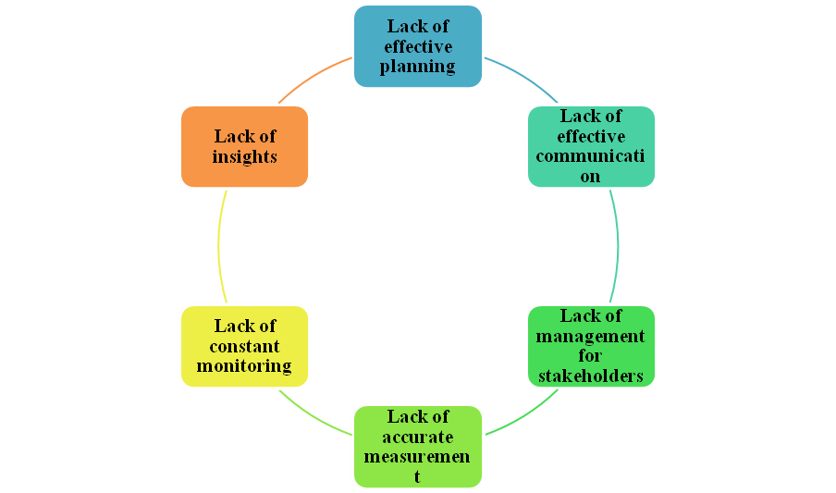

**Figure 3: Factors that can impact on the quality of a project**

(Source: Created by author)

## 2.4 Lack of accurate measurement

Lack of accurate measurement is a vital issue regarding the project of manufacturing as it creates issues regarding the flow of resources. As mentioned by Pennycook and Rand (2019), the lack of accurate measurement for projects creates confusion regarding the required raw materials and financial resources. The managers of the projects need to ensure the proper measurement of the project requirements to enhance the process of manufacturing. The lack of accurate measurement creates issues regarding the distribution of raw materials and resources among different departments of the organisation. For instance the Dyson car project got impacted due to the lack of measurements regarding the marketing of the electric cars. The lack of accurate measurement is essential to enhance the project outcome by ensuring the effective distribution of raw materials. According to the views of Melton *et al.* (2022), the lack of accurate measurement happens due to the lack of external information regarding the projects. This is impactful for the success rate of the projects due to lack of systematic process of using resources.

## 2.5 Lack of constant monitoring

Lack of constant monitoring for the projects impacts the growth of the process accordingly by considering the requirements. According to the views of Drigas *et al.* (2022), the lack of constant monitoring for the project process creates issues regarding the executions of the project. The lack of constant monitoring is helpful to assess information regarding the requirement of the projects. For instance, the lack of constant monitoring has created issues regarding the identification of effective investors for the Dyson car project. Therefore, the leaders of the project need to ensure constant monitoring to enhance the project outcome and the success rate of the projects.

## 2.6 Lack of insights

The lack of insights regarding the project impacts the planning process of the projects that is harmful for the success of the projects. In the views of Adam *et al.* (2022), the lack of insights for a project impacts the growth of the project outcome. Lack of insights creates confusions among the employees and the managers regarding the project. For instance the lack of insights regarding the Dyson car project has created issues regarding the investors (Dyson.com, 2023). Therefore the team leaders need to ensure the proper providence of insights regarding the project for the employees to keep up the up gradation process of the projects.

# 3. The impact of leadership style and team performance on quality issues in the Dyson Electric Car Project

## 3.1 Impact of leadership style on quality issues

***Democratic Leadership***

Democratic leadership is a kind of managerial process that helps to increase the participation of the employees regarding the decision making process. The organisational structure of Dyson is a flat organisational structure that includes less supervision and increasing involvement for decision making (Dyson.com, 2023). This clearly denotes that the Dyson electric car project has been conducted by using democratic leadership. According to the views of Barthold *et al.* (2022) democratic leadership is helpful to enhance the decision making process of the project. Democratic leadership process is helpful to enhance the decision making process regarding the project. Democratic leadership process is helpful to enhance the manufacturing process of electric cars by enhancing the active engagement of the employees.

***Coach-Style Leadership***

Coach-Style Leadership refers to the management process by assessing information regarding the drawbacks and strengths of the team members. The flat organisational structure of Dyson indicates the usage of coach style leadership (Dyson.com, 2023). This is helpful to manage the manufacturing process accordingly by considering the drawbacks and strengths of the team members. In the views of Moorfield (2022), the coaches' style leadership is helpful to plan the project execution process by considering the capabilities of the employees. This is helpful to enhance the project outcome with effective implementation.

## 3.2 Impact of team performance on quality issues

The team performance is an effective part of the project as it helps to enhance the quality of the manufacturing. In the views of Whang *et al.* (2023), team performance is responsible to enhance the project quality by ensuring the potentiality of the working process. Team performance refers to the performance of the team members. The project of Dyson electric car manufacturing includes effective teamwork that has provided huge success regarding the critical manufacturing of the electric cars (Dyson.com, 2023). This has helped to ensure the success rate of the project by ensuring the effective quality of the cars.

The team performance is effective to enhance the processing of the cars by ensuring the success of the manufacturing process. According to the views of Purwanto (2022), the team performance is the vital factor to enhance the manufacturing process of the electric cars. Team performance is helpful to ensure the effectiveness of the different parts of the cars such as traction battery pack, DC-DC Converter and electric motor (Dyson.com, 2023). This is helpful to ensure the marketing and profitability of the project products by proving quality.

# 4. Mitigating concepts for quality issues of ‘Dyson Electric Car Project’

The mitigating concepts for quality issues of Dyson electric car include implication of Coach-Style Leadership as it is helpful to analyse the drawbacks and strengths of the employees. According to the views of Atrizka and Pratama (2022), the coach style leadership is effective to manage the project process accordingly by considering the capabilities of the employees. This is helpful to enhance the project process of the Dyson car project in a systematic manner. The flat organisational structure of Dyson is helpful to manage the work process by implementing Coach-Style Leadership (Dyson.com, 2023). Besides, the Coach-Style Leadership is effective to enhance the quality of the manufactured electric cars by ensuring the active participation of the employees regarding the internal and external factors of the project.

## 4.1 Active participation of employees for the decision making process

Active participation of the work forces in the process of making decisions for the projects helps to enhance the quality of the projects. The active participation of the employees in the decision making process helps to identify the practical issues regarding the project process. According to the views of Bonga (2022), the active participation of the employees regarding the decision making process is effective to assess information regarding the requirements of the projects. On the other hand, the participation of the employees for the decision making process of the project is helpful to enhance the profitability of the project. Therefore the organisational leaders need to encourage the employees to participate in the decision making process.

## 4.2 Developing inclusive cross-cultural teams

The project significantly might face an issue of insufficient motivation that led to lack of buyer attraction and inappropriate marketing. According to Bajaj and Singh (2020), insufficient motivation is a critical issue that hampers performance of businesses concerning project planning and management. Development of inclusive and cross-cultural teams might be a suitable solution for eliminating insufficient motivation for quality issues concerning projects. As argued by Kaufhold *et al*. (2020), information overload often leads to reduced employee motivation due to excessive workload that can be eliminated by improving workplace inclusivity. Cultural diversity in an organisational environment helps develop innovative ideas providing easy solutions to complex and critical workplace issues. Employee motivation while working in a culturally-diversified environment tends to be more due to effective team collaboration and opportunity for learning new project aspects (Hussain *et al*. 2019). Therefore, developing inclusive teams permits businesses to establish equality leading to improved employee motivation.

## 4.3 Preventive maintenance plan and software adoption

Dyson Electric Car Project incorporated a significant issue of insufficient quality equipment which led to restricted demand and buyers in market despite effective car manufacturing. Maintenance plan for prevention of quality equipment shortages might be a suitable solution to influence market performance of new products launched in market like electric cars by Dyson. As mentioned by Bana *et al*. (2019), comprehensive analysis and competitor's evaluation are suitable ways to develop a preventive maintenance plan for eliminating lack of quality equipment. SAP S/4HANA Cloud and Six Sigma are some suitable software tools adopted for mitigating lack of quality equipment and improving project performance. As opined by Ferri *et al*. (2020), machine learning deployment using suitable software is another suitable solution to mitigate quality equipment lack issues. Thus, indicating that usage of appropriate project management software and predictive plan might help eliminate quality equipment.

# Conclusion

This report concludes that the successful execution of critical projects requires effective usage of leadership and management process. This report has evaluated the concept of teamwork and leadership process to enhance the project execution process. This report has concluded that the identification of the factors which impact on the quality of the projects helps to enhance the quality of the projects. The identification of the effect of leadership style and team performance on the quality of the projects is helpful to maintain the quality of the projects. This report includes information regarding the mitigation concepts for the projects to ensure the successful outcome of the projects.

# References

Aas, M. and Paulsen, J.M., (2019). National strategy for supporting school principal’s instructional leadership: A Scandinavian approach. *Journal of Educational Administration*.

Adam, O., Blay, M., Brunoni, A.R., Chang, H.A., Gomes, J.S., Javitt, D.C., Jung, D.U., Kantrowitz, J.T., Koops, S., Lindenmayer, J.P. and Palm, U., (2022). Efficacy of Transcranial Direct Current Stimulation to Improve Insight in Patients With Schizophrenia: A Systematic Review and Meta-analysis of Randomized Controlled Trials. *Schizophrenia Bulletin*, *48*(6), pp.1284-1294.

Alshumaimeri, Y.A. and Alhumud, A.M., (2021). EFL Students' Perceptions of the Effectiveness of Virtual Classrooms in Enhancing Communication Skills. *English Language Teaching*, *14*(11), pp.80-96.

Atrizka, D. and Pratama, I., (2022). The Influence of Organizational Leadership and Coaches on Indonesian Athletes' Adversity Quotient (Intelligence). *Revista de Psicología del Deporte (Journal of Sport Psychology)*, *31*(1), pp.88-97.

Bajaj, M. and Singh, A.K., (2020). Grid integrated renewable DG systems: A review of power quality challenges and state‐of‐the‐art mitigation techniques. *International Journal of Energy Research*, *44*(1), pp.26-69.

Bana, P.R., Panda, K.P., Naayagi, R.T., Siano, P. and Panda, G., (2019). Recently developed reduced switch multilevel inverter for renewable energy integration and drives application: topologies, comprehensive analysis and comparative evaluation. *IEEE access*, *7*, pp.54888-54909.

Barthold, C., Checchi, M., Imas, M. and Smolović Jones, O., (2022). Dissensual leadership: Rethinking democratic leadership with Jacques Rancière. *Organization*, *29*(4), pp.673-691.

BONGA, F.E.B., Eniekedou, F. and Charity, D.C.D., (2022). Influence of Mobilisation of Community Members on Effective Participation in Community Development Programme. *DYNAMIC JOURNAL OF EDUCATION, COMMUNITY SERVICE UNIT, IGNATIUS AJURU UNIVERSITY OF EDUCATION, RUMUOLUMENI, PORT HARCOURT, RIVERS STATE, NIGERIA.*

Drigas, A., Mitsea, E. and Skianis, C., (2022). Clinical Hypnosis & VR, Subconscious Restructuring-Brain Rewiring & the Entanglement with the 8 Pillars of Metacognition X 8 Layers of Consciousness X 8 Intelligences. *International Journal of Online & Biomedical Engineering*, *18*(1).

Dyson.com, (2023). Dyson Automotive update 10th October 2019. Available at: https://www.dyson.com/automotive[ Accessed on: 26.04.2023]

Ferri, F., Grifoni, P. and Guzzo, T., (2020). Online learning and emergency remote teaching: Opportunities and challenges in emergency situations. *Societies*, *10*(4), p.86.

Hussain, N., HAQUE, A.U. and Baloch, A., (2019). Management theories: The contribution of contemporary management theorists in tackling contemporary management challenges. *Yaşar Üniversitesi E-Dergisi*, *14*, pp.156-169.

Izzulhaq, B. and Simanjuntak, M.B., (2022). The Importance of Communication In The Family” Ali and The Queens of Queens”. *LITERACY: International Scientific Journals of Social, Education, Humanities*, *1*(2), pp.45-56.

Kaufhold, M.A., Rupp, N., Reuter, C. and Habdank, M., (2020). Mitigating information overload in social media during conflicts and crises: design and evaluation of a cross-platform alerting system. *Behaviour & Information Technology*, *39*(3), pp.319-342.

Layton, M.C., Ostermiller, S.J. and Kynaston, D.J., (2020). *Agile project management for dummies*. John Wiley & Sons.

Melton, F.S., Huntington, J., Grimm, R., Herring, J., Hall, M., Rollison, D., Erickson, T., Allen, R., Anderson, M., Fisher, J.B. and Kilic, A., (2022). OpenET: Filling a critical data gap in water management for the western United States. *JAWRA Journal of the American Water Resources Association*, *58*(6), pp.971-994.

Meyers, C.V. and VanGronigen, B.A., (2019). A lack of authentic school improvement plan development: Evidence of principal satisficing behavior. *Journal of Educational Administration*, *57*(3), pp.261-278.

Moorfield, J., (2022). Athlete perceptions of gendered expectations and coach competency.

Paais, M. and Pattiruhu, J.R., (2020). Effect of motivation, leadership, and organizational culture on satisfaction and employee performance. *The Journal of Asian Finance, Economics and Business*, *7*(8), pp.577-588.

Pennycook, G. and Rand, D.G., (2019). Lazy, not biased: Susceptibility to partisan fake news is better explained by lack of reasoning than by motivated reasoning. *Cognition*, *188*, pp.39-50.

Purwanto, A., (2022). Tourist satisfaction and performance of tourism industries: how the role of innovative work behaviour, organizational citizenship behaviour?. *Journal of Industrial Engineering & Management Research*.

Schmidt, I.B. and Eloy, L., (2020). Fire regime in the Brazilian Savanna: Recent changes, policy and management. *Flora*, *268*, p.151613.

Todorova, G., Goh, K.T. and Weingart, L.R., (2022). The effects of conflict type and conflict expression intensity on conflict management. *International Journal of Conflict Management*, *33*(2), pp.245-272.

Whang, S.E., Roh, Y., Song, H. and Lee, J.G., (2023). Data collection and quality challenges in deep learning: A data-centric ai perspective. *The VLDB Journal*, pp.1-23.

Wisittigars, B. and Siengthai, S., (2019). Crisis leadership competencies: the facility management sector in Thailand. *Facilities*.

Wu, G., Hu, Z. and Zheng, J., (2019). Role stress, job burnout, and job performance in construction project managers: the moderating role of career calling. *International journal of environmental research and public health*, *16*(13), p.2394.