**ANALYSIS AND FRAMEWORKS ASSESSMENT OF BONMARCHÉ'S STRATEGIC CAPABILITY, COMPETENCIES, AND COMPETITIVE POSITION**

**Table of Contents**

Introduction 3

Strategic capability 3

Bonmarché Competence 5

The Core Competence of Bonmarché 5

Bonmarché’s Competitive position 6

Porter five forces model 7

Bonmarché's financial performance and sustainability of its Strategy 8

Bonmarché’s financial performance 8

Bonmarché’s Strategy 9

Bonmarché’s Financial Performance 2018 - 2020 9

Timeline 9

Strategic Sustainability 10

Summary 10

Reference list 11

# Introduction

Bonmarché is a UK-based clothing retailer that specializes in clothing for women. With over 300 outlets nationwide, the business was established in 1982 and has since developed into a well-known brand in the UK. In addition to a large selection of clothes such as dresses, blouses, pants and coats, Bonmarché also sells jewellery, scarves and purses. The business caters to ladies who want to look smart and feel comfortable in their apparel and is well renowned for its reasonable costs and stylish designs. With helpful and educated employees who are always available to give advice and support, Bonmarché takes pride in providing a personalized shopping experience.

# Strategic capability

VRIO Framework can be used to analyze the strategic capability of Bonmarché. The capabilities are analyzed in terms of Value, Rarity, Inimitability, and Organization.

Value

The brand name, product selection, and customer base of Bonmarché are among its most valuable assets. Its target market recognises its brand identity, which has assisted it in building a strong customer base (Pacheco, 2023). Its product line comprises apparel, accessories, and footwear that are tailored to older women's particular requirements. Bonmarché has gained a competitive edge thanks to its specialized market.

Rarity

The customer base of Bonmarché is devoted, and the business has established a solid name in its specialized sector. Although other companies provide comparable goods, their product offerings are not necessarily unique. Additionally, the business has come up against more competition from internet sellers who may offer comparable goods for lower prices.

Inimitability

Bonmarché has built experience in meeting the demands of older women, and its brand name and consumer base are difficult to replicate (Akash, 2020). Although competitors may simply copy its product offers and marketing techniques, they are not always unique.

Organization

Bonmarché can effectively manage its activities because of a solid organizational structure. It has established a reputation for offering high-quality goods and helpful customer service, and it has a clear focus on its target market. However, the business has struggled to adjust to market developments including the rise in popularity of purchasing goods online.

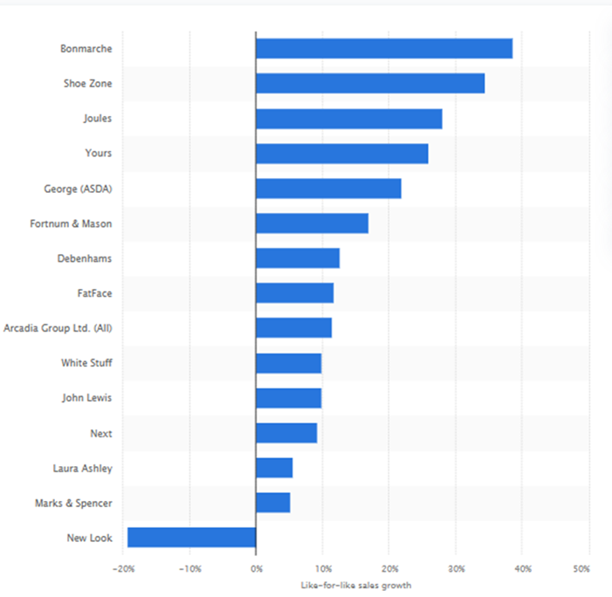

**Figure 1: Strategic Capability of Bonmarché**

(Source: https://www.statista.com/statistics/933613/fashion-retailers-growth-in-online-sales-united-kingdom-uk/)

Bonmarché has great strategic capabilities because of its devoted client base, well-known brand, and emphasis on a particular market. To be competitive, it will need to adjust to market developments, for example by enhancing its web presence and broadening its product offerings.

# Bonmarché Competence

A theoretical framework known as the Resource-Based View (RBV) is used to examine a firm's internal resources, skills, and capacity to develop a sustainable competitive advantage. Women's clothes business Bonmarché is established in the UK and has both physical stores and an online store. Following is an analysis of Bonmarché's skills in the context of RBV:

Human Resources

The employees of Bonmarché are knowledgeable and skilled in a variety of fields, including customer service, fashion, merchandising, and supply chain management. To improve the skills and expertise of its personnel, the company also funds training and development programmes for them.

Brand Reputation

In the UK market, Bonmarché has a solid reputation as a brand (Versteeg, 2021). The company's reputation for providing stylish, reasonably priced apparel for senior ladies has contributed to the development of devoted customers.

Supply chain management

A strong supply chain management system at Bonmarché enables the business to react rapidly to shifting market trends and consumer demand. The company also maintains tight relationships with suppliers to guarantee that it finds high-quality items at reasonable pricing.

IT Infrastructure

Bonmarché's highly developed IT infrastructure helps the company to effectively manage its business operations. Customers may explore and buy things from the company's online store while relaxing in their own homes.

Physical Stores

In the UK, Bonmarché has a network of physical stores. These shops have been thoughtfully positioned in busy places and are intended to provide customers with a pleasurable shopping experience.

## The Core competence of Bonmarché

According to the Resource-Based View (RBV) assessment of Bonmarché's competencies, the company has excellent brand recognition in the UK market and may be considered it's core competency. By providing reasonably priced, stylish apparel for adult ladies, Bonmarché has developed a devoted following that helps set the company apart from its rivals. Through efficient marketing tactics and a focus on customer happiness, a strong brand reputation has been developed over time. This primary competency has enabled Bonmarché to maintain a competitive edge in the UK market. Bonmarché may further develop its core competency and preserve long-term competitiveness by continuing to invest in its brand and upholding high levels of customer satisfaction.

# Bonmarché’s Competitive position

The product range at Bonmarché, which concentrates on reasonably priced and stylish apparel for ladies 50 and older, is one of its main advantages. Other shops frequently ignore this area of the market, giving Bonmarché a competitive edge (Wang, 2020). The company's product line consists of a mixture of formal and casual clothing, as well as footwear and accessories. In terms of pricing, Bonmarché portrays itself as a brand that offers value for the money by providing affordable prices that appeal to its target market. With the support of its pricing approach, the business has been able to remain competitive in the market and draw in budget-conscious customers.

Bonmarché places a high priority on providing its consumers with a pleasurable shopping experience. In-store changes, a variety of payment choices, and individualized styling assistance are all examples of this. Overall, Bonmarché's specialized product line, aggressive price policy, and emphasis on customer service give it a strong competitive position in the market. To be relevant in the quickly changing retail world, the firm must continue to innovate and adapt as it deals with growing competition from online retailers.

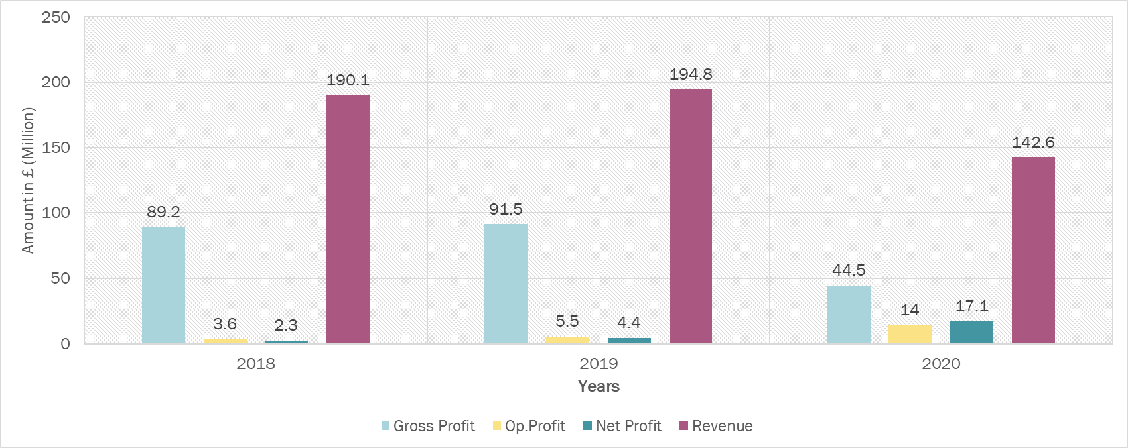

**Figure: Performance graph**

(Source: | Bonmarche Holdings plc Share Price - Investing.com)

## Porter's five forces model

According to Porter's five Forces model

Threats of New Entrants

Bonmarché faces a relatively low threat from new competitors due to several factors, such as the significant capital outlay needed to launch a clothes retail business, the need of developing good supplier connections, and the established customer base and name recognition that Bonmarché possesses.

Bargaining power of suppliers

Considering its size and position in the market, Bonmarché is in a position to negotiate favourably with its suppliers (Judd *et al.* 2021). As a result of its partnerships with a variety of suppliers, the corporation can utilize its purchasing power to get advantageous terms.

Bargaining power of buyers

Due to its concentration on a particular consumer demographic (women aged 50 and over) and its reasonable price policy, Bonmarché maintains a reasonably solid position in the clothes retail market, even though purchasers often have a high level of negotiating power.

Threat of substitutes

Substitutes offer a minor threat to Bonmarché, especially online retailers that provide a wider range of goods at reduced costs. However, the firm stands out from these alternatives because of its emphasis on its target market and individualized customer care.

Competitive rivalry

Bonmarché enjoys a reasonably solid competitive position in the very competitive clothes retail sector Due to its focused product line, aggressive pricing, and emphasis on customer service. To keep its position in the face of escalating competition from online retailers, the business must continue to innovate and adapt.

Bonmarché's excellent position across several components in Porter's Five Forces model is an indication of its competitive advantages (Atkinson *et al.* 2021). To preserve its position over time, the business must keep an eye on and adjust to changes in the competitive scene.

# Bonmarché’s financial performance and the sustainability of its strategy

## Bonmarché’s financial performance

**Best case scenario**

In Bonmarché's best-case scenario, the business would see high sales growth, improved profitability, and positive cash flow. The business effectively carries out its strategic initiatives to enhance its product line, grow its customers, and raise its profile. By effectively implementing cost-cutting strategies and enhancing operational effectiveness, Bonmarché raises margins and profits. The performance of the business is well received by investors, which raises the stock price.

**Worst case scenario**

In the worst-case scenario for Bonmarché, The company has diminishing revenues, rising expenses, and a negative cash flow. The business finds it difficult to compete with other merchants in the market and is unable to adapt to shifting consumer demands. To shift its inventory, Bonmarché is compelled to provide steep discounts, which lowers profits and increases losses. Stock prices decline as a result of investors losing faith in the firm.

**Status case scenario**

The business keeps performing at its existing level. The business has constant profitability, stable margins, and modest sales growth. Although Bonmarché can hold onto its market position and its present clientele, it does not significantly improve its product line or grow its customer base. Investors' responses to the company's performance are neutral, which leads to a steady stock price.

## Bonmarché’s Strategy

The goal of Bonmarché is to give customers an outstanding shopping experience both in-person and online. This involves ensuring that their merchandise is of the highest calibre, is reasonably priced, and that their personnel have received the necessary training to provide excellent customer service. To adapt its product lineup to the shifting requirements and tastes of its clients, the firm strives for ongoing innovation. This involves continuously updating its product lines and adding new categories to its product range.

Bonmarché works hard to retain a distinctive brand identity that appeals to its intended audience. This entails utilising its history and knowledge of the women's fashion industry, as well as being current with emerging trends and fashions. The corporation hopes to increase its market share by strengthening its online presence and retail reach. This includes expanding its physical shop network, e-commerce platform, and digital marketing skills (Koenig, and Poncet, 2019). The overall goals of Bonmarché's strategy are to provide a customer-centric approach, constant innovation, strong brand identification, and market expansion.

## Bonmarché’s Financial Performance 2018 - 2020

### Timeline

2018

Pre-tax deficits of £5.4 million were recorded by Bonmarché in 2018, which the company blamed on a fall in sales and rising shop closure expenses. To £186.1 million, the company's revenue decreased by 4.5%, while like-for-like sales dropped by 4.3% (Retail-week.com, 2023). With more online shops entering the market, Bonmarché encountered difficulties in the cutthroat UK retail sector, which negatively impacted company revenues. The firm kept making investments, such as creating additional locations and enhancing its online presence, but these actions were insufficient to counteract the fall in sales and resulting cost constraints.

2019

A modest gain over the year before, Bonmarché recorded a pre-tax profit of £2.0 million in 2019. Although the business's revenue continued to drop, dropping 3.9% to £179.2 million, its internet sales rose 28.5%. Additionally, Bonmarché used cost-cutting strategies that boosted its profit margins. The company continued to suffer difficulties in the UK retail industry due to a difficult business climate and escalating competition from internet retailers. Nevertheless, Bonmarché's initiatives to enhance its online visibility and cut expenses assisted in mitigating some of these difficulties and supporting its financial success.

2020

The financial performances of Bonmarché in 2020 were not made public since Peacocks bought the business after Bonmarché entered the administration as a result of the COVID-19 pandemic's effects on its operations. However, as was the case for many merchants, it is anticipated that the pandemic significantly hurt the company's revenue and profits (Retail-week.com, 2023). Although the Peacocks acquisition gave Bonmarché some stability, the continued difficulties in the UK retail industry and the uncertainties brought on by the pandemic continue to be very difficult for the business.

### Strategic Sustainability

The dedication of Bonmarché to sustainability is seen in its procurement practices, which place a priority on ethical and sustainable suppliers, as well as its initiatives to cut waste and increase energy efficiency across its operations (Retail-week.com, 2023). This not only helps the environment but also improves the brand's reputation and appeal to customers who are socially concerned. Bonmarché's investment in digital transformation and omnichannel commerce has helped it stay competitive in a world that is becoming more and more digital, and its customized customer service and loyalty programmes have helped it cultivate a strong customer base.

# Summary

In this study, the strategic capability of Bonmarché has been analyzed according to the VRIO framework. Bonmarché's Competence and Core competence of Bonmarché has been analyzed. Bonmarché’s Competitive position has also been analyzed and the Porter five forces model has been incorporated for the analysis. Bonmarché’s financial performance and the sustainability of its strategy have also been analyzed. The financial timeline and strategic sustainability have been evaluated.

# Reference list

**Journal**

Akash, S., 2020, September. Small and Medium Enterprises (SMEs) using E-brands and Multiple E-Marketing Channels to Dominate Global Ecommerce Industry. In 5. International EMI Entrepreneurship and Social Sciences Congress PROCEEDINGS E-BOOK (p. 58).

Atkinson, C., Beck, V., Brewis, J., Davies, A. and Duberley, J., 2021. Menopause and the workplace: New directions in HRM research and HR practice. Human Resource Management Journal, 31(1), pp.49-64.

Brewis, J., Atkinson, C., Beck, V., Davies, A. and Duberley, J., 2019. Menopause and the workplace.

Brown, S., Patterson, A. and Ashman, R., 2021. Raising the dead: on brands that go bump in the night. Journal of Marketing Management, 37(5-6), pp.417-436.

Judd, J., Kuruvilla, S. and Jackson, J.L., Security for Apparel Workers: Alternative Models.

Koenig, P. and Poncet, S., 2019. Social responsibility scandals and trade. World Development, 124, p.104640.

Pacheco, A., Pro–Environmental Efforts & its Impact on Competition.

Versteeg, L., 2021. Towards a better future?

Wang, C., 2020. Key Dimensions of Luxury Fashion Retail Atmospherics in the Chinese Market (Doctoral dissertation, The University of Manchester (United Kingdom)).

**Website**

Retail-week.com, 2023 “Bonmarché” Available At: <https://www.retail-week.com/prospect/bonmarche/strategy/18.supplierarticlelist?authent=1>

Retail-week.com, 2023 “Technology strategy at Bonmarché” Available At: https://www.retail-week.com/prospect/bonmarche/technology-strategy-at-bonmarche/7038601.supplierarticle