**INTERNAL AND EXTERNAL AUDIT OF GREEGS**

Table of Contents

1.0 Introduction 3

2.0 Analytical tools and frameworks 3

2.1 SWOT analysis 3

2.1.1 Strength 3

2.1.2 Weakness 4

2.1.3 Opportunities 4

2.1.4 Threats 4

2.2 Pestle analysis 5

2.2.1 Political 5

2.2.2 Economical 5

2.2.3 Social 5

2.2.4 Technological 5

2.2.5 Legal 5

2.2.6 Environmental 5

3.0 Financial Performance analysis 6

3.1 Income statement analysis 6

3.2 Balance sheet analysis 6

3.3 Cash flow statement analysis 6

4.0 When developing and implementing creative strategies to produce long-term economic value for Greegs Plc 7

5.0 Understanding the Need for, Importance of, Planning for, and Management of Financial Resources by International Firms 9

6.0 Conclusion 11

Reference list 12

Appendices 14

# 1.0 Introduction

A bakery-related food retail business with its headquarters in the UK is called Greggs plc. The business was established in 1939 and has expanded to become one of the top food retailers in the UK with more than 2,000 locations. In recent years, Greggs has concentrated on increasing the range of products it offers, streamlining its supply chain, and developing its digital capabilities. The objective of this research is to assess Greggs plc's strategy's financial performance and sustainability using analytical tools and procedures.

# 2.0 Analytical tools and frameworks

**Figure 1: SWOT analysis of the Greegs Plc**

(Source: In MS Word Self created)

## 2.1 SWOT analysis

### 2.1.1 Strength

* A well-known and reputable brand
* A large selection of reasonably priced goods that satisfy many tastes
* Effective distribution and supply networks Strong financial results and sales growth

### 2.1.2 Weakness

* Reliance on the UK market for financial support
* Minimal product diversity
* Vulnerability to changes in the price of commodities

### 2.1.3 Opportunities

* Entry into new markets abroad
* Introduction of novel goods, such as gluten-free and vegan choices
* Collaboration with grocery stores and internet food delivery services

### 2.1.4 Threats

* Rivalry with other chain bakeries and convenience businesses
* Consumer preference and lifestyle trends evolving
* Market volatility and economic ambiguity.

**Figure 2: PESTLE analysis of the Greegs Plc**

(Source: In MS Word Self created)

## 2.2 Pestle analysis

### 2.2.1 Political

Greggs works in a regulated food sector and is subject to a number of rules governing things like labeling and food safety. The operations and profitability of the corporation could be impacted by political unpredictability, alterations in governmental regulations, and taxes.

### 2.2.2 Economical

The financial success of Greggs could be impacted by economic issues like inflation, recession, and exchange rates. Changes in market trends and customer purchasing habits may also have an impact on the business.

### 2.2.3 Social

The business must take into account societal variables such evolving consumer tastes and lifestyles as well as the rising demand for nutritious food options.

### 2.2.4 Technological

Technology advancements like online ordering platforms and electronic payment methods can have an impact on Greggs' business processes.

### 2.2.5 Legal

Greggs is required to abide by a number of legal requirements, including intellectual property laws, data protection laws, and employment laws.

### 2.2.6 Environmental

As Greggs works to minimize its environmental imprint, environmental variables like climate change, sustainability, and waste management may have an impact on the company's operations and reputation.

# 3.0 Financial Performance analysis

## 3.1 Income statement analysis

An organization's revenues, costs, and net income for a given time period are displayed on the income statement. Revenue for Greggs reached £1,168.2 million in 2021, up 13.5% from the year before. As a result of better cost control, the company's gross profit margin grew from 60.5% in 2020 to 62.8% in 2021 (Gupta *et al.* 2020). By increasing from 5.1% in 2020 to 10.3% in 2021, Greggs' operating profit margin demonstrated an improvement in operational effectiveness. According to the examination of the financial statement, Greggs was able to enhance both its revenue and profitability in 2021.

## 3.2 Balance sheet analysis

The balance sheet displays the assets, liabilities, and equity of a business at a particular period. Greggs' total assets increased, mostly as a result of a rise in its property, plant, and equipment, from £452.7 million in 2020 to £527.9 million in 2021. Total liabilities for the corporation rose from £154.8 million in 2020 to £199.2 million in 2021, mainly as a result of an increase in borrowing (Strengers *et al.* 2019). Greggs' equity increased from £297.9 million in 2020 to £328.7 million in 2021, showing that its financial situation has improved. Overall, the review of the balance sheet reveals that Greggs was able to strengthen its financial situation in 2021.

## 3.3 Cash flow statement analysis

A company's cash inflows and outflows during a certain time period are displayed on the cash flow statement. The improvement in Greggs' cash generation can be seen in the company's net cash generated from operating activities, which rose from £103.7 million in 2020 to £151.1 million in 2021. Due principally to an increase in capital expenditure, the company's net cash utilized in investment activities increased from £48.3 million in 2020 to £71.2 million in 2021. Greggs' net cash utilized in financing activities grew, principally as a result of an increase in borrowings, from £55.4 million in 2020 to £75.1 million in 2021 (Gregg *et al.* 2021). Overall, the study of the cash flow statement reveals that Greggs was able to produce positive cash flow in 2021 from its operating activities. ***[Referred to appendix 1]***

# 4.0 When developing and implementing creative strategies to produce long-term economic value for Greegs Plc

To begin with, it's crucial to comprehend that innovation is a key component of generating long-term commercial value for any organization. However, developing and putting into action creative tactics is not without its difficulties and considerations. To successfully design and implement new ideas in the instance of Greegs Plc, a number of considerations must be made.

The need to strike a balance between immediate profitability and long-term sustainability is one of the main issues that businesses face. Organizations must constantly innovate and adjust to shifting market conditions if they want to be competitive (Robles *et al.* 2021). However, doing so frequently entails devoting funds to endeavors that might not immediately pay off. Managers must therefore thoroughly assess the potential risks and benefits connected with each decision.

Aligning innovation projects with the overall business strategy is another major difficulty. Finding opportunities that complement the company's competitive advantages and core strengths entails doing this. Resources might be wasted and opportunities lost if innovation activities are not in line with the business strategy.

The desire to foster an innovative culture within the organization presents another difficulty. This entails motivating staff members to be innovative and take chances while also offering the tools and assistance required to see new ideas through to completion. In companies with established cultures and methods of operation, this may be challenging.

When developing and putting into practice innovative ideas, businesses must also take into account a variety of options in addition to these difficulties. For instance, they must choose whether to concentrate on radical innovation, which entails establishing entirely new products or processes, or incremental innovation, which entails making little modifications to already-existing products or processes (Gregg *et al.* 2022). Additionally, they must choose whether to focus on internal innovation, which entails creating concepts internally, or external innovation, which entails collaborating with other businesses or acquiring new technology.

Overall, rigorous preparation, assessment, and decision-making are necessary for the successful creation and application of innovative solutions. The long-term objective of generating sustainable commercial value for the organization must be the focus of managers' attention while navigating the problems and decisions that may be presented.

Let start by making it clear that the work demands the critically examine the difficulties and decisions that firms encounter while developing and putting into practice novel strategies to generate long-term economic value. You will specifically apply pertinent ideas and theories from strategic planning, innovation, and value creation to the analysis of Greegs Plc.

Finding out what their target consumers' changing requirements and preferences are is one of the biggest problems that companies like Greegs Plc are currently facing. It can be challenging for businesses to keep up with changing consumer tastes and preferences and create goods and services that satisfy those needs (Gregg 2021). Greegs Plc may need to spend money on market research and consumer interaction efforts to overcome this obstacle and better understand what their customers want and need.

Creating and managing innovation: For businesses, creating and managing innovation in a sustainable manner is a major problem. While developing new goods and services can be costly and time-consuming, innovation is essential for promoting growth and adding value. Greegs Plc may need to set up procedures and organizational frameworks that encourage continuous innovation and experimentation while controlling costs and risks.

The ability to balance short-term and long-term aims is a third difficulty that Greegs Plc may encounter. Businesses need to think about how to build sustainable value over the long run in addition to making money in the short term (Dayton *et al*. 2021). This can entail making investments in R&D, sustainability programmes, and other initiatives that might not pay off right away but might support long-term development and success.

Managing organizational change: Businesses may find it difficult to implement innovative tactics because they frequently call for major organizational change (Gupta *et al.* 2020). Innovation initiatives may be slowed down or stopped in their tracks if employees reject changes to their jobs, procedures, and ways of doing things. Greegs Plc may need to spend money on change management initiatives to help staff members comprehend the need for change and experience support during it in order to get beyond this obstacle.

Maintaining competitive edge: In order to continue growing and succeeding, companies like Greegs Plc must continue to have a competitive advantage in their market. This can be difficult since rivals might steal innovative ideas or lower pricing. Greegs Plc may need to invest in continual innovation and distinction, forge close bonds with clients, and erect barriers to entry for rivals if they want to keep their competitive advantage.

In conclusion, Greegs Plc encounters a number of difficulties while coming up with and putting into practice creative corporate value-creation initiatives. These difficulties include determining client needs, creating and managing innovations, juggling short- and long-term objectives, controlling organizational change, and preserving competitive advantage. Greegs Plc can improve their chances of success in a cutthroat and quickly evolving business climate by being aware of and responding to these difficulties. ***[Referred to appendix 2]***

# 5.0 Understanding the Need for, Importance of, Planning for, and Management of Financial Resources by International Firms

In order to secure its long-term success, Greegs Plc, an international company, needs to have a thorough awareness of the necessity, significance, planning, and administration of finance. This entails locating and making use of the company's numerous financial resources.

For multinational companies like Greegs Plc, one of the main reasons finance is important is that it aids in controlling and reducing the financial risks associated with doing business abroad. For instance, changes in exchange rates, variations in tax rules, and political unrest in other locations can all have an effect on the company's financial health. In order to ensure the company's financial stability, Greegs Plc must have a well-planned and well-managed financial strategy that takes these aspects into account.

Finance additionally aids Greegs Plc in finding and seizing new business possibilities, funding R&D, and expanding its operations into new areas. Greegs Plc can make strategic investments that will benefit the company in the long run by having access to sufficient financial resources.

Greegs Plc must take into account a number of variables while planning and managing its finances, including its present financial situation, cash flow demands, and long-term financial objectives (Gupta *et al.* 2019). This entails creating a financial plan that complements the organization's overarching business strategy, estimating potential financial risks, and spotting development prospects.

Greegs Plc has a variety of funding options open to it, including debt financing, equity financing, and overseas financing. A useful option for businesses that want to grow but do not want to take on more debt is equity financing, which includes generating money by issuing new shares. On the other hand, debt financing entails raising money through loans or bonds, which can be a desirable choice for businesses with a reliable cash flow and a solid credit rating (Gupta *et al.* 2019). Last but not least, foreign investors or banks are used to raise money as part of international financing, which is a great alternative for businesses trying to grow into new markets.

Understanding the importance of finance for multinational companies like Greegs Plc is crucial. Any organization relies on its financial resources to function, and managing those resources presents special difficulties for multinational corporations (Gregg and Nafziger, 2020). These difficulties include managing cash flow across several nations and regions as well as coping with currency changes and intricate tax regulations. An international company like Greegs Plc must consequently have effective financial planning and management in order to succeed.

There are various choices to think about when it comes to the financial sources that Greegs Plc has access to. These cover debt and equity funding as well as numerous types of foreign financing. Debt financing involves borrowing money from lenders with the promise of repaying it with interest, whereas equity financing is selling shares of ownership in the company to investors (Gregg *et al.* 2020). Export credit organizations, international banks, and development finance organizations are a few examples of available international financing possibilities.

Greegs Plc's financial goals and objectives, risk tolerance, and overall business strategy should all be taken into account when creating a solid and persuasive financial strategy. Additionally, it is essential to take into account external issues like the state of the world economy, currency fluctuations, and regulatory changes that may impact the finance of the company.

# 6.0 Conclusion

From the discussion above the conclusion is made that it can be said that Greggs' financial performance study shows that the business had growth in 2021 in terms of revenue, profitability, and assets. The increase in operating profit margin and gross profit margin indicates that the business has been successful in reducing costs and enhancing operational efficiency. Equity and property, plant, and equipment have increased, which shows that the company's financial condition has improved. Additionally, the company's financial health is shown favorably by the positive cash flow produced by operating activities. Overall, according to the financial performance study, Greggs had a prosperous year in 2021. For businesses to create long-term economic value, innovation is essential, but it also has its own set of issues to take into account. Like other businesses, Greegs Plc has challenges figuring out how to meet shifting consumer wants, develop and manage innovation, balance short- and long-term goals, manage organizational change, and keep a competitive edge. Greegs Plc can increase its chances of success in a dynamic and competitive business environment by recognizing and addressing these difficulties. Planning, evaluating, and making decisions carefully are essential for the successful development and application of novel solutions that produce long-term commercial value for the organization.

# Reference list

**Journal**

Dayton, A., Gregg, A.G. and Nafziger, S., 2021. Shareholder Democracy under Autocracy: Voting Rights and Corporate Performance in Imperial Russia. *European Corporate Governance Institute–Finance Working Paper*, (773).

Gregg, A., Nathans, J., Phillips, J.M., Mankins, S. and Johnson, K., 2021. Creating Workflows for Oral History Transcription and Curation: A Case Study Involving Oral Histories in Satellite Meteorology. *Endnotes: The Journal of the New Members Round Table*, *10*(1), pp.13-20.

Gregg, A.G. and Nafziger, S., 2020. Financing nascent industry: Leverage, politics, and performance in Imperial Russia. *Politics, and Performance in Imperial Russia (March 8, 2020)*.

Gregg, B., 2021. Beyond due diligence: the human rights corporation. *Human Rights Review*, *22*(1), pp.65-89.

Gregg, H.R., Restubog, S.L., Dasborough, M., Xu, C., Deen, C.M. and He, Y., 2022. When disaster strikes! An interdisciplinary review of disasters and their organizational consequences. *Journal of management*, *48*(6), pp.1382-1429.

Gregg, S.P., Hartley, D., McAfee, M., Pitz, R., Teaff, J. and Clements, P., 2020, July. Patterns for Success in the Adoption and Execution of Feature‐based Product Line Engineering: A Report from Practitioners. In *INCOSE International Symposium* (Vol. 30, No. 1, pp. 465-482).

Gupta, R., Gregg, M. and Cherian, R., 2020. Developing a new framework to bring consistency and flexibility in evaluating actual building performance. *International journal of building pathology and adaptation*, *38*(1), pp.228-255.

Gupta, R., Gregg, M. and Panchal, R., 2019, September. Energy and Environmental performance of a green certified office building in the hot dry climate of India. In *IOP Conference Series: Earth and Environmental Science* (Vol. 329, No. 1, p. 012028). IOP Publishing.

Gupta, R., Gregg, M. and Salvati, A., 2020. Performance Evaluation Based Claims Process for Insuring Energy Performance of New Dwellings. In *Sustainable Ecological Engineering Design: Selected Proceedings from the International Conference of Sustainable Ecological Engineering Design for Society (SEEDS) 2019* (pp. 335-349). Springer International Publishing.

Gupta, R., Gregg, M., Manu, S., Vaidya, P. and Dixit, M., 2019. Customized performance evaluation approach for Indian green buildings. *Building Research & Information*, *47*(1), pp.56-74.

Robles-Granda, P., Lin, S., Wu, X., Martinez, G.J., Mattingly, S.M., Moskal, E., Striegel, A., Chawla, N.V., D'Mello, S., Gregg, J. and Nies, K., 2021. Jointly predicting job performance, personality, cognitive ability, affect, and well-being. *IEEE Computational Intelligence Magazine*, *16*(2), pp.46-61.

Strengers, Y., Kennedy, J., Arcari, P., Nicholls, L. and Gregg, M., 2019, May. Protection, productivity and pleasure in the smart home: Emerging expectations and gendered insights from Australian early adopters. In *Proceedings of the 2019 CHI conference on human factors in computing systems* (pp. 1-13).

# Appendices

**Appendix 1: Decomposition of ROE of Greegs Plc**

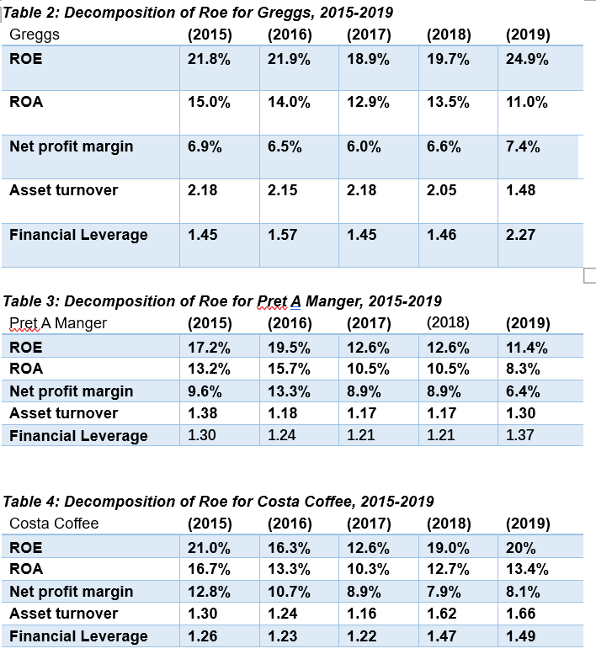

(Source: https://www.reuters.net)

**Appendix 2: Value discovery of Greegs Plc**

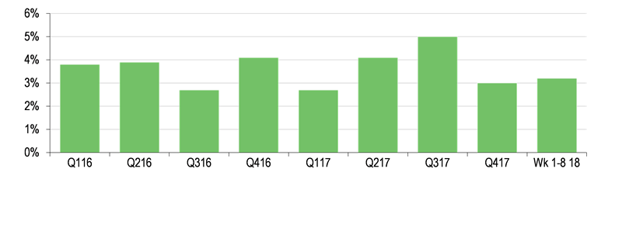

(Source: https://www.edisongroup.net)