**PRACTICE 2: DESIGN**

Table of Contents

Introduction 3

Key elements 3

Influenced key elements 3

Rose gold 3

Cubic Zirconium Stones 4

Proposed methodology 4

Project Artifact 4

The character of rose gold 4

Advantages of using Cubic Zirconia Stones 5

Final outcome 6

Conclusion 6

References 7

# Introduction

In my childhood, I loved nature a lot, such as butterflies, and the sky. One day, when I was playing in the field, I fell in love with a butterfly. Additionally, the Morpho butterfly is one of the most beautiful insects that I loved most. Morpho butterflies are colored metallic and these categorized butterflies have blue shades. Therefore, I loved this butterfly most due to its unique design. At present, I am working at a design company and I want to make earrings by applying Morpho Butterflies design. Therefore, this is totally my own story and I want to make this design for spreading the morpho butterfly’s design all over.

# Key elements

In this case, major key elements are involved with the morpho butterfly and I want to share the story of this butterfly. In a nutshell, it has been seen that people love this butterfly only for having iridescent dazzling wings. On the other hand, it has been seen that the Russian empire has one of the finest legacies and I appreciated their creativity. Additionally, the crown of Russian jewels is well known due to their creativity along with beauty. Therefore, these two are the most key elements that help me to attach to this. In other words, it has been seen that most countries implement this creativity actively. Thus, these major aspects support me in generating overall thoughts by creating designful earrings. In this case, my client asked me to make a gift for her upcoming events (Chen *et al.* 2019). At that time, I served my client's promises about creating this design. Additionally, my motivation is to fulfill the appropriate satisfaction to my clients. Therefore, I always want to show my creativity at work and also I would like to collect the client’s satisfaction review. The color combination of the butterfly is different and it also creates a unique style for this earring. I selected this butterfly due to its wing color which is very bright and the edge of the wings is a mixture of blue and black. It is able to create the reflection of light. It helps to catch the customer's minds and attract them as well.

# Influenced key elements

I select some major aspects such as design techniques, patterns and quantity of stone and I implement them into my work. These are the most essential aspects that enhance my product’s quality widely.

## Rose gold

This is one of the major elements that escalate the quality of products and rose gold is popular due to having some positive sides. These are normally involved with a pinkish hue and soft nature activities. In other words, Rose gold costs have existed between 14K to 15K. In other words, in the section comparing rose gold with normal gold, in most cases rose gold is won. In addition, 14K rose gold is slightly stronger than 18 K gold and this is the actual reason for winning the rose gold during the time sphere of comparison.

## Cubic Zirconium Stones

In order to make this jeweler, Cubic Zirconia Stones are one of the major items that are able to serve the blue color in the earrings. In support of these, this stone is affordable also and this stone can implement shine and sparkle in this design. In this case, generally, this stone is applied for making these elements efficiently.

# Proposed methodology

## Project Artifact

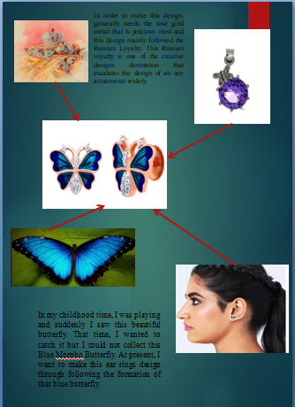

## The character of rose gold

Generally, I have examined lots of data related to finding the appropriate material for these earrings. Therefore, rose gold is one of the major items that throw a huge amount of advantages in earrings. I have chosen a little amount of rose gold for making this and I implemented these elements effectively. On the other hand, I have compared this rose gold with normal gold and I saw results that are good. It is light enough after implementing it with stones. Therefore, these earrings can not cause any trouble after wearing them by my client. Apart from that, this rose gold has the advantage regarding lightweight, that is satisfied my client appropriately (De Bellis *et al.* 2020). Therefore, in choosing this material, I have collected many outcomes from my clients. In this case, my client told me to make the design full of uniqueness. Thus, I applied my creativity in designing the earring borders.

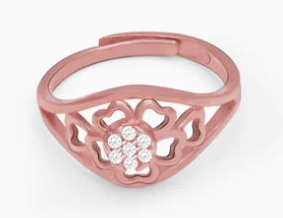

## Advantages of using Cubic Zirconia Stones

Another important component that I utilized in making the earring the same as the morpho butterfly's wings color. Additionally, I have faced some issues associated with discovering the appropriate color contrast-based stone as per my desired color. In support of these, rose gold is collected around 18KT and this stone is collected for making the gesture of earring the same as butterfly wings. Therefore, after creating this earring, I could not imagine my eyes. This stone actually gives the desired color and provides shiny activities also. At last, I checked this earring through my client. I asked her to wear this jeweler and she wore it. I just saw her ear and I appreciated that outfit accurately. Therefore, these are the methodology of completing my entire project regarding the blue sheds earning like butterfly wings.

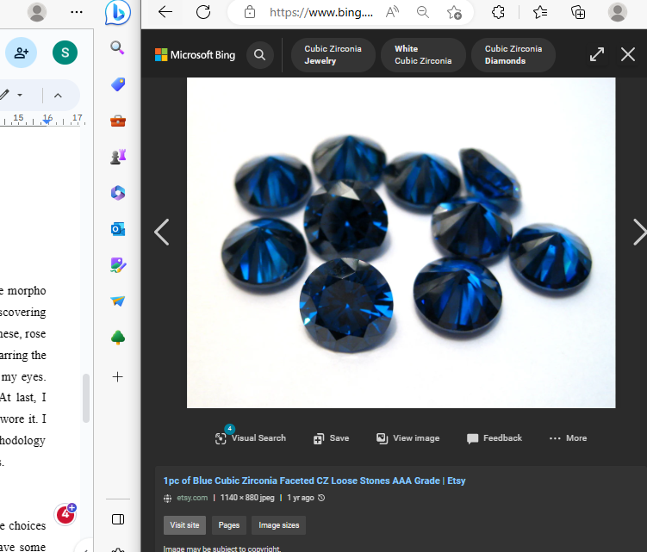

# Final outcome

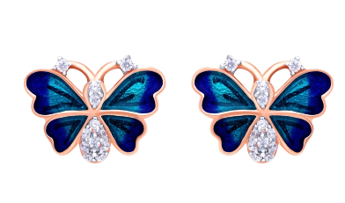

# Conclusion

From the above report, it can be said that the morpho butterfly is one of the unique choices for creating creative jeweler. The wings and overall structure of the butterfly have some extraordinary, beautiful side that attracts the individual. Accordingly, it has a marvelous color combination that creates an effective contrast with any kind of costume. Basically, the base of this earring is rose gold with zirconia stones. It is very feminine and sweet that will match any day and any type of outfit.

# References

Chen, Z., Fu, F., Yu, Y., Wang, H., Shang, Y. and Zhao, Y., 2019. Cardiomyocytes‐Actuated Morpho Butterfly Wings. Advanced Materials, 31(8), p.1805431.

De Bellis, I., Ni, B., Martella, D., Parmeggiani, C., Keller, P., Wiersma, D.S., Li, M.H. and Nocentini, S., 2020. Color modulation in morpho butterfly wings using liquid crystalline elastomers. Advanced Intelligent Systems, 2(9), p.2000035.