**PRACTICE 2: DESIGN**

Table of Contents

Introduction 3

Key Elements 3

Influenced key elements 3

Proposed methodology 4

Final outcome 6

Conclusion 7

References 8

# Introduction

All of us learned various kinds of fairytale stories in our childhood. A Witch and a Princess with golden hair was a popular fairy tale at that time. From, the first I heard it, “the story of Rapunzel” was able extremely amazed me. I was extensively encouraged by the movies Bryon Howards and Nathan Reno’s “Tangled” in 2010, which was directed by Disney. I have always thought that, whether I get a can chance I will apply this particular story in my job. I am initially knowledgeable about the story and its whole background, which could lead to me as a fashion student; I can properly applying various kinds of original and refreshing concepts from this study in my project. This is a story about Rapunzel, a princess with long magical hair. However, when Rapunzel was a baby, she was kidnapped by an old hag and further imprisoned in a tower.

# Key Elements

The primary factor that attached me is the main story character of this fairytale which is Rapunzel. In the story Rapunzel is a young woman in her teen phase, who is playful, brilliant, highly adventurous, and lively. The main things that inspired is from the story are each and every quality and her significance in the story. Along with that, it led me to bring out various kinds of inspiration and encouragement, mainly inspired by character qualities, for fulfilling the satisfaction of my client s my main motivation and goal. My client had asked me to develop a reception dress with some sustainable materials. I have always wanted to combine creative fashion with the creative elements from the “Tangled movie”. However, I have always felt that this is my best chance to get show ideas and skills. On the other hand, satisfying my custom demands for their reception dress.

# Influenced key elements

I choose to utilize various kinds of techniques, fabrics, and patterns for this cloth design which would majorly highlight positive traits and inspiration from the main character, particularly the witch and Rapunzel. Those key elements are discussed below

**Rapunzel's quality**

In the case of Rapunzel’s personality, she is a young and beautiful woman in her late teens. She is further kind, brilliant, joyful, highly adventurous, lively, and playful. For this generation; Rapunzel is a role model, as when it is necessary to show courage, she does not hesitate for defending both her people and herself (De Perthuis, 2020). Various kinds of individuals have claimed that Rapunzel is a role model for them, which further gave them a positive message. Her different kinds of characteristics have been massively influenced by my study and this project.

**The Golden Hair**

In the story told it has been said that the magical hair draws its overall strength from the golden bloom at the very beginning of the story. The main sickly corona queen, who is carrying the Rapunzel Healed using the golden flower. However, Rapunzel receives and flower cell that helps to recover the ills and helps to shimmer the hair.

**Witch**

The witch in the movie also known as Mother Other is a selfish, cunning, evil, and conceited character in the movie. She is further arrogant and selfish and only cares for her good looks and herself. She even agrees for giving up her own child daughter Cassandra for Rapunzel for her magical hair. Furthermore, her magical power and character significance are giving me lots of inspiration and encouragement.

# Proposed methodology

**Project artifact**

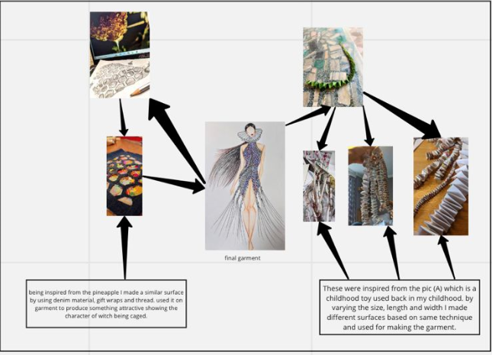

**Character and hair of Rapunzel**

The golden and long hair that is strong plays a crucial role in this fairy tale and further it is a vital highlight of this movie. The strength and power which Rapine’s hair grace is one of the factors in this movie that inspired me a lot. I had used various kinds of methods and techniques for hair braiding. During a particular lesson, I learned the braiding techniques for, using the coconut tree snake toy leaves. Furthermore, it stiffens and strengthens beside enhance the beauty of hair.

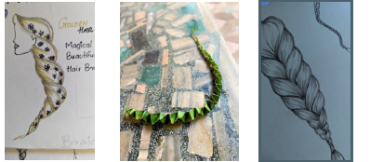

The methods we used for developing this hair could be tailored to any kind of structure and shoe such as swirling, twitching, and stretchable form. Furthermore, it can be used in different ways such as highlighting Rapunzel’s playful and peaceful personality and sewing those garments.

**Witch**

It is a massive important for preventing the overall propagation of evil traits. For this reason, I have used denim with hexagonal patterns for developing a surface. As this sequence would suggest the reflection of the evil nature of witches. In this project, I have obtained similar ideas here for reflecting the witch nature with the utilization of related sequences. Those sequences are confined within the hexagonal pattern, which would elaborate the horrible factors and aspects of the movie (Baker, 2022).

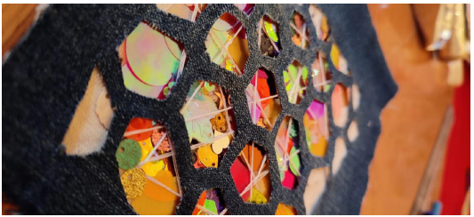

In the previously mentioned point, I have discussed and designed an outfit according to my client's demand and requirements using used or recycled materials for promoting sustainability within the fashion industry. On the other hand, I have used the present rap, vintage clothing, sequencing (X-rays), transient’s plastic sheets, and many more. The main technology employed in this case for developing a proper structure which would be served as the main point of this particular garment. The wave-like motion that moves forth and back is the most eye-catching in this project.

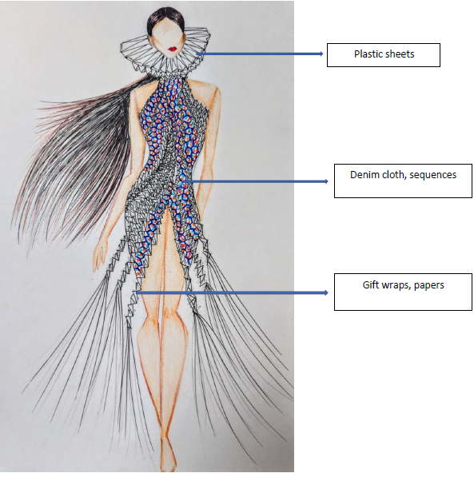

# Final outcome

The final outcome of this project after applying all the techniques and materials is shown below-

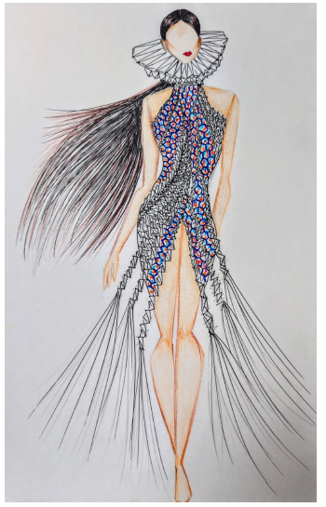

# Conclusion

During the study, I have come up with various kinds of ideas and plan for making something creative and innovative. After using the some of most relevant techniques and methods, finally I have successfully made this project. I have taken a massive number of inspiration and techniques from the movie “Tangled”. The main character Rapunzel is one of my primary motivators for creating this design. Their joyful and lively characteristics of her majorly encouraged me for getting various kinds of innovative and creative ideas.

# References

De Perthuis, K., 2020. Breaking the Idea of Clothes: Rei Kawakubo’s Fashion Manifesto. *Fashion Theory*, *24*(5), pp.659-677.

Baker, C., 2022. From Story-Based to Story-Interactive Experiences: Layers of Narrative Application in Theme Parks and Attractions. In *Global Perspectives on Strategic Storytelling in Destination Marketing* (pp. 74-93). IGI Global.