**Task C: Portfolio of teaching evidence**

**Teaching level:** Level 1: Pre-School (Kindergarten)

**Targeted Age Group:**

2 to 3 years group of children

**Teaching Location:** Private Nursery School

**Subject:** Science

**Teaching Philosophy:** Vygotsky's socio-cultural developmental theory of teaching is undertaken by creating the zone of proximal development (Eun, 2019). It is to be ensured that the learner is made independent at a certain stage but also given support.

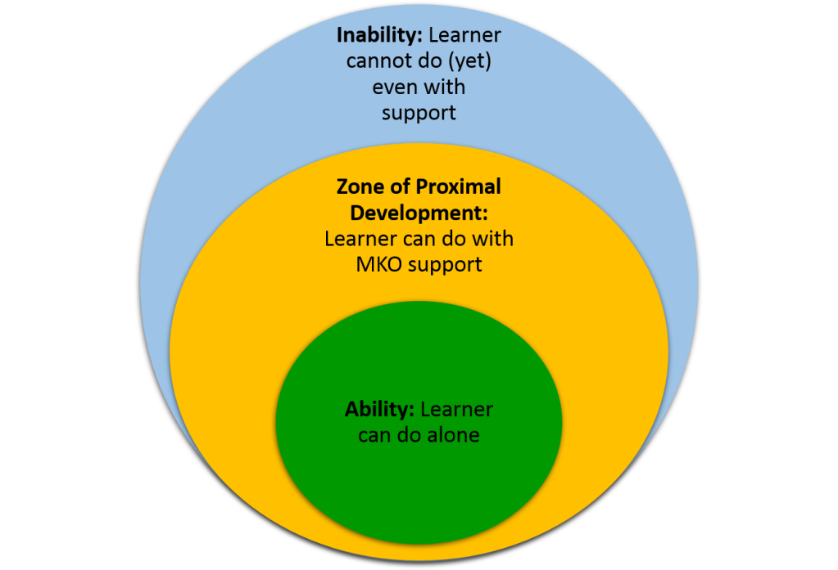

**Figure 1: Vygotsky learning model**

(Source: Self-created)

**Teaching goals:**

* To ensure equality and diversity in the classroom
* To provide a sense of being, becoming and belonging among the children
* To conduct the assessment feedback with parents for community support
* To arrange meetings on learner guidance and consultations
* To improve the social, cognitive, behavioural and emotional areas of the learners
* Development concerns, as with Early Learning Goals, will provide better starting points.

**Teaching regulations:**

UK EYFS will be considered based on classroom observation and the tests to be undertaken (Anderson, 2020). The exemption, if applied to any child will make the licence to be under stake. Any kind of physical punishment is restricted which will bring high-curriculum needs.

**Work schema**

|  |  |  |  |  |  |
| --- | --- | --- | --- | --- | --- |
| **Date/ Week** | **Learning Needs** | **Delivery models** | **Learning resources** | **Internal and external requirements** | **Learning area to focus** |
| Week 1 | To understand how the human body functions | Formative assessment | Books  Pictures | Inside the classroom, read books and take homework | To concentrate on the human body each part names |
| Week 2 | To learn the basic concepts of the human body | Summative assessment | Videos | Group work with assigning of 3 members in a team to watch a video | To understand how the human separate organs function |
| Week 3 | To perform activities to know about human body roles | Summative and formative assessment | Games  Placards  Drawings | Do games from team to play based on the subject for the test | To learn and perform the games from week 2 |

**Learning Plan for Student 1**

Name: Martha

Age: 2 years

Gender: Female

Any special condition: No

|  |  |  |  |  |  |  |
| --- | --- | --- | --- | --- | --- | --- |
| **Learning goal** | **Learning needs** | **Learning preferences** | **Individual goal** | **Curriculum needs** | **Learning style** | **Learning resources** |
| To understand the human body concepts from core | To score marks on the science subject | To improve on the cognitive skills of grabbing knowledge | To improve the attention capacity from class | To improve teamwork with other learners due to less mixing with others | Audio-visual aids are required to learn. A kinesthetic learner with 2-3 resources needed | Books  Audio clips  Homework |

**Learning Plan for Student 2**

Name: Ben

Age: 3

Gender: Male

Any special condition: No

|  |  |  |  |  |  |  |
| --- | --- | --- | --- | --- | --- | --- |
| **Learning goal** | **Learning needs** | **Learning preferences** | **Individual goal** | **Curriculum needs** | **Learning style** | **Learning resources** |
| To know how the human body elements will help in real-life | To give extra notes as a child is a slow learner | To follow class notes and learn from parents at home | To understand each line from the teacher and communicate effectively | To perform well on the learning readiness with each course module | The visual learner with need to only engage with books, presentations and the story materials | Books  Storybooks  Movies |

**Learning Plan for Student 3**

Name: Alicia

Age: 2

Gender: Female

Any special condition: Yes, Physical disability condition

|  |  |  |  |  |  |  |
| --- | --- | --- | --- | --- | --- | --- |
| **Learning goal** | **Learning needs** | **Learning preferences** | **Individual goal** | **Curriculum needs** | **Learning Style** | **Learning resources** |
| To understand the human body in depth in order to score well in exams | To get extra help from the teachers due to attendance issues in the class | To get help in sitting and walking in the classroom during the performance of any learning activity | To understand the content and bring physical mobility with learning into the classroom | To gain understanding and support from the teacher and students in learning | Kinesthetic style with sensory devices used to learn | Books  Music  Videos  Games |

**Learning Resource Design**

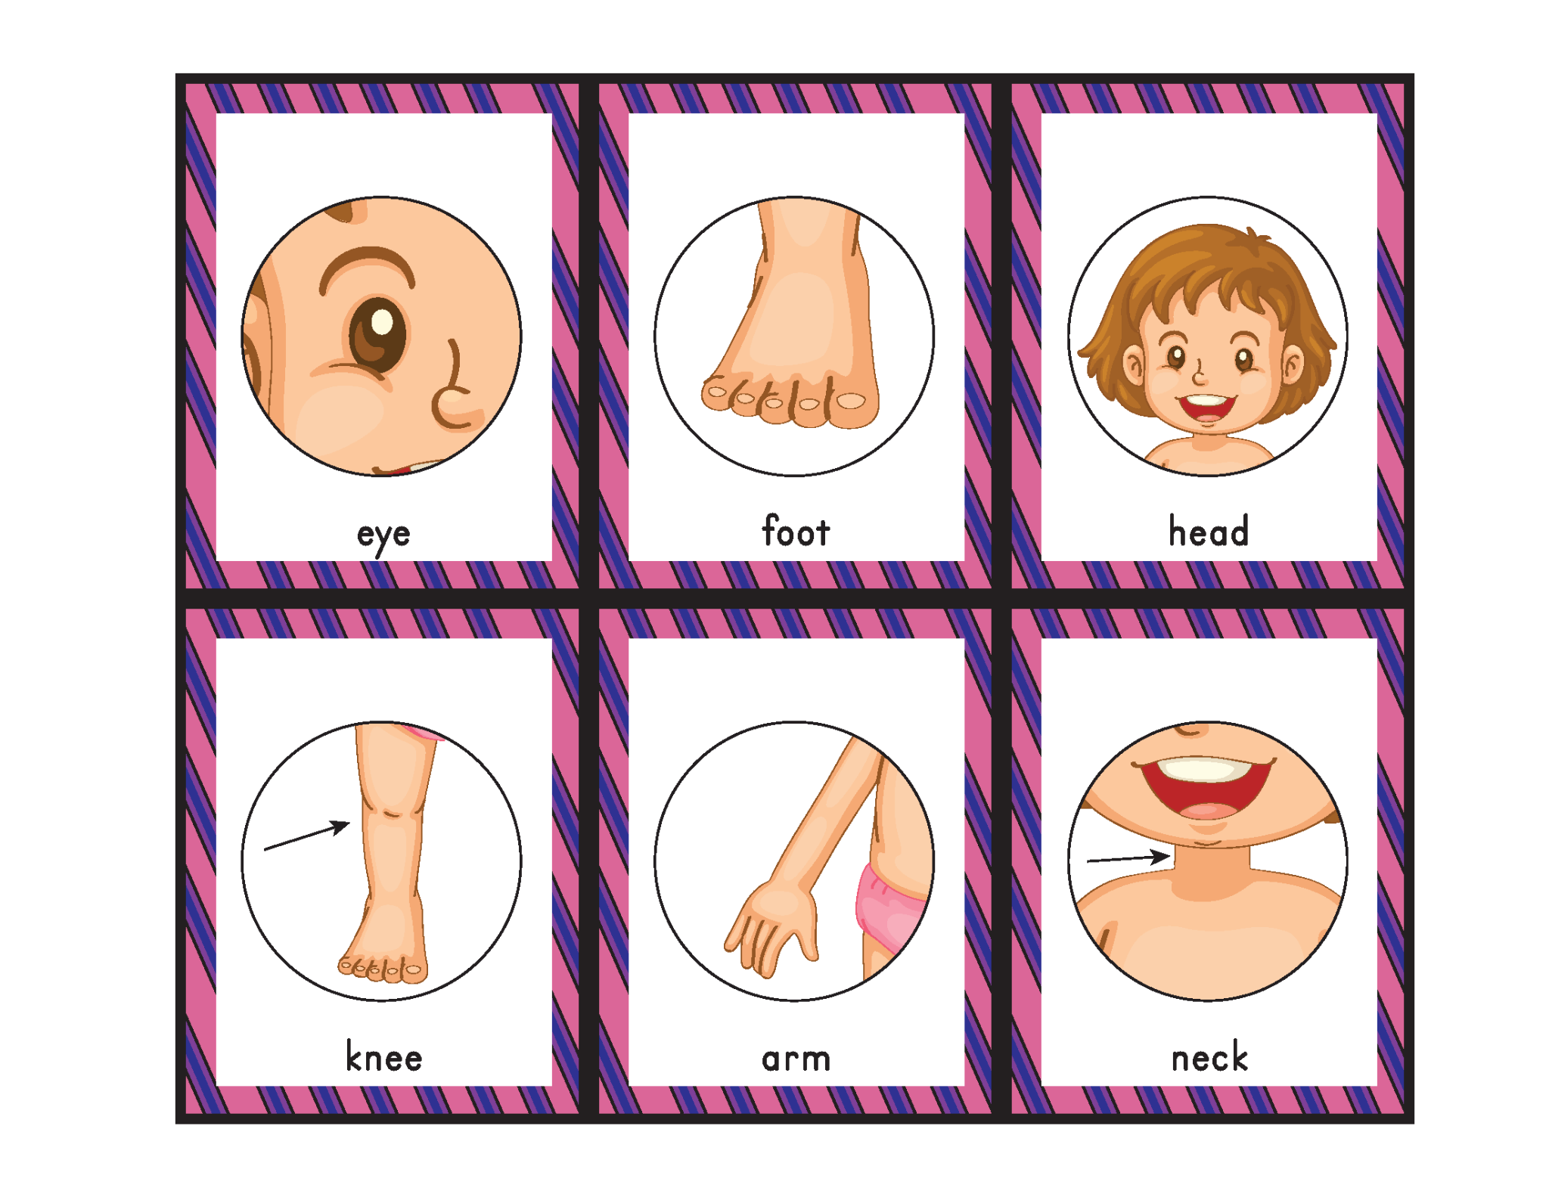

**Figure 2: Body Parts Bingo**

(Source: Gift of Curiosity, 2023)

**Learning Activity:**

Body Parts Bingo

**Resource Type:**

Game Placards and Assessment Sheet

**Resource Use:**

Use each of the design cards in the game, and make the learner apply them in the class activity

(Patton *et al*., 2023)**.** The learner will use them and place them matching the game when called out.

The assessment sheet will consist of questions like:

|  |
| --- |
| 1. With what, I can see my parents? 2. How can I walk to school every day? 3. How do you move to say ‘No’? 4. Where do we tie our collars? 5. Where can you wear your watch? 6. When we fall down, where do we get hurt in our legs? |

This makes the summative assessment carry 5 marks for each question answered. The total resource design is done based on the 6 x 5 = 30 marks in unit tests. The unit resource design will require the learners to respond to the questions in 15 minutes.

**Learning Assessment**

|  |  |  |  |  |  |  |  |  |  |  |  |  |  |  |  |  |  |  |  |  |  |  |  |  |  |  |  |  |  |  |  |  |  |  |  |  |  |  |  |  |  |  |  |  |  |  |  |  |  |  |  |  |  |  |  |  |  |  |  |  |  |  |  |  |  |  |
| --- | --- | --- | --- | --- | --- | --- | --- | --- | --- | --- | --- | --- | --- | --- | --- | --- | --- | --- | --- | --- | --- | --- | --- | --- | --- | --- | --- | --- | --- | --- | --- | --- | --- | --- | --- | --- | --- | --- | --- | --- | --- | --- | --- | --- | --- | --- | --- | --- | --- | --- | --- | --- | --- | --- | --- | --- | --- | --- | --- | --- | --- | --- | --- | --- | --- | --- |
| **Subject Domain:** Science  **Topic:** Human Body  **Total grades:** 50  **Minimum marks to pass:** 20   1. **Learning Motivation**  |  |  |  |  |  |  | | --- | --- | --- | --- | --- | --- | | * Interested to attend the class | 1 | 2 | 3 | 4 | 5 | | * Shows curiosity about the lessons | 1 | 2 | 3 | 4 | 5 | | * Family child perform homework on time | 1 | 2 | 3 | 4 | 5 |  1. **Learning Characteristics**  |  |  |  |  |  |  | | --- | --- | --- | --- | --- | --- | | * Learns about the human body features and concepts | 1 | 2 | 3 | 4 | 5 | | * Discuss with the teacher what is not understood | 1 | 2 | 3 | 4 | 5 | | * Want to attend the feedback session after class | 1 | 2 | 3 | 4 | 5 | | * Talk with friends after class about the topic | 1 | 2 | 3 | 4 | 5 |  1. **Student Behaviour**  |  |  |  |  |  |  | | --- | --- | --- | --- | --- | --- | | * Interested in learning science | 1 | 2 | 3 | 4 | 5 | | * Learns to understand the human body from own ideas | 1 | 2 | 3 | 4 | 5 | | * Draw the human body in a drawing book | 1 | 2 | 3 | 4 | 5 | | * Gives homework and silent in class | 1 | 2 | 3 | 4 | 5 | |

**Reference**

Anderson, B., 2020. The securitisation of values: early years leaders experiences of the implementation of the prevent strategy. *Ethics and Education*, *15*(4), pp.426-443.

Eun, B., 2019. The zone of proximal development as an overarching concept: A framework for synthesizing Vygotsky’s theories. *Educational Philosophy and Theory*, *51*(1), pp.18-30.

Patton, K.T., Bell, F., Thompson, T. and Williamson, P., 2023. *The Human Body in Health & Disease-E-Book*. Elsevier Health Sciences.