**UNDERSTANDING CUSTOMER**

**TABLE OF CONTENTS**

1. Definition of customer 3

2. Difference between customer and consumer 3

3. Importance of customer 5

4. Explanation of consumer behaviour with types 6

5. Role of IT to understand and facilitate customer 8

6. Conclusive 9

Reference List 10

# 1. Definition of customer

A customer is someone who buys some things from a vendor, seller or supplier. this person was called the buyer or the client and more over the purchaser. The person customer is responsible for bringing money also which has the responsibility to inflow the money (Szmigin and Piacentini, 2018). About the business, the customer is crucial to all internal business procedures. where the group are defined by age, race, ethnicity and gender.

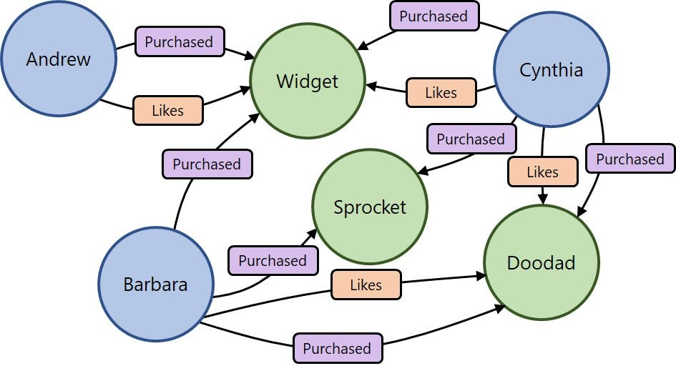

**Figure 1: Customer service**

(Sources: https://wwwmedium.com)

* "Customers" are the people and organisations that make purchases from other businesses.
* Some companies are always seeking ways to enhance their offerings as a way to better satisfy their clients. The "customer relationships" issue is what is referred to here.
* How businesses treat their "customers" can give them an advantage over competitors.
* Although "consumers" might also be clients, the term "consumer" is used to refer to anybody who uses or consumes market products and services.

# 2. Difference between customer and consumer

**Consumer**

The consumer is the person who used to consume the product or the service. This consumer word is an offence used in interchanging customer words. In eternity the person is denoted in organisation goods and service purchasing (Kotler et al. 2019). Although the knowledge of equipment is considered to consume the service. This stage of people is the last stage of people who are consuming the service.

**Trade Customer:** In addition to value and results to purchase goods and products are known as trade customers. This type of customer is found in "Wholesales", "Manufacture", "retailers" "Distribution" etc.

**Final customer:** The final customer is those who purchase goods for their use or to hand over to some other.

**Consumer**

According to the particular "Consumer Protection Agreement", 1986, the phenomenon excludes anybody who buys the item to enhance value or resell it for any kind of profit.

The usage of such goods or services, however, might be made to become "self-employed" or make money (Blythe and Martin, 2019). The word "consumer" refers to any user who uses the items with the buyer's permission but does not buy them. anybody responsible for the services is subject to it.

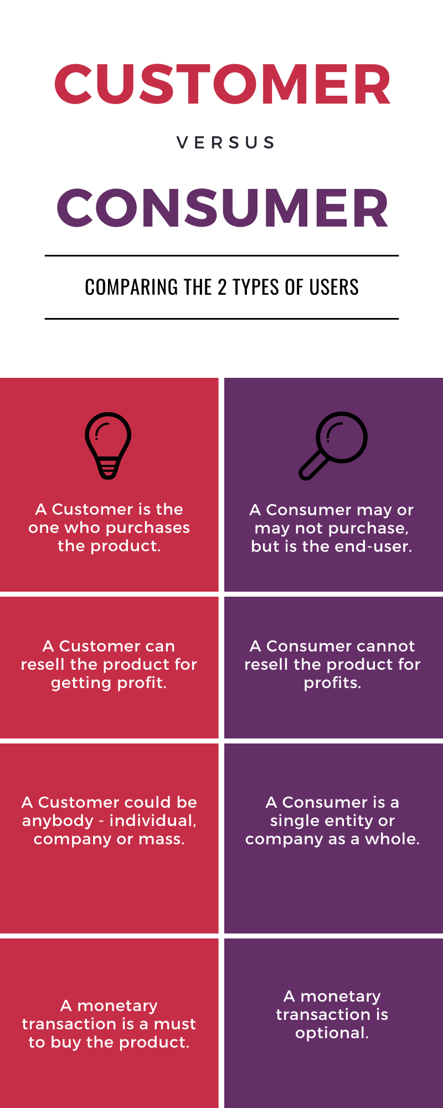

**Figure 2: Comparing**

(Source: https://www.smartkarrot.com)

**The fundamental key to the difference**

* The person who purchases a service or goods or the service from the vendor is known as the ``Customer”. and whether the person who consumed goods and services from the customer is known as a consumer.
* The end users who are consuming the goods at the very end section are defined as the consumed goods, which are frequent in used purchaser and client designation.
* Consumers can present the service or the purchase which has been interpreted with the very end sectional and in the definition of good consumed.

# 3. Importance of customer

Every point of business is developed with customers. Without the customer, there is not any firm which can get success. Customer satisfaction in any firm can be enjoyed in the long term way (Chartered Institute of Marketing, 2018). Customers belonging to the "travel industry" utilise the intangible concept of "service" to pick their preferred lodging or tourism provider. Even though customers usually find it difficult to describe what outstanding customer service hospitality is, they are aware of its existence.

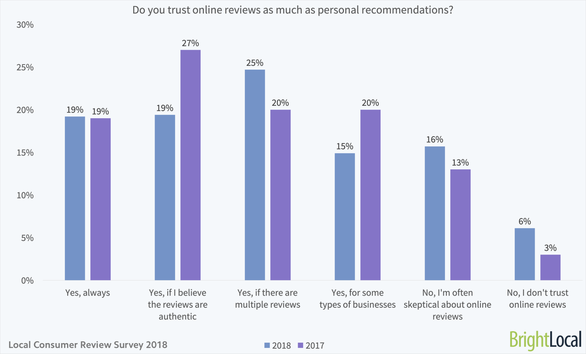

**Figure 3: Importance of customer**

(Source: https://www.answerdash.com)

It's also a disqualifying element to acquire "tourism" advancement, both as a method of meeting rising client demands and as an outcome of achieving financial success (Musumali, 2019). Reliable customer service gives customers the confidence they need to make purchases, which is especially important in a post-pandemic environment when information is always changing.

# 4. Explanation of consumer behaviour with types

“Consumer behaviour” is known as the study of consumers for strategies which are used in different sections. All the items are amenities. particularly emotional, mental and together in response to behaviour (Madeswaran, 2019).

Businesses must comprehend "consumer behaviour" to build effective marketing strategies that might influence customers' decision-making processes.

The four types of consumer behaviour have been described in the following section.,

“Complex buying behaviour”

“Habitual buying behaviour”

“Dissonance buying reduction behaviour”

"Variety-seeking behaviour"

**Complex buying behaviour**

Very frequently consumers are used to creating "complex buying behaviour" This thing is defined as the time of high gods and service orientation. In this action, the customers are more involved in choosing to buy the significant transaction. This is the main procedure in terms of investment.

As an example: At first, the automobile companies are reliable and very significant for purchase. whether the company carries high-level financial risk (Pearson *et al.* 2020). There is a lot of moderation consumption from close relatives in response to friends, in response to social position.

For inquisition, customer learning will be included in sophisticated purchasing behaviour. This time the first position will be for this person for being purchased. Where the attitude with final attitude behaviour in buying of decision making.

**Habitual buying behaviour**

At the time of playing the minimal involvement of making purchasing with claiming to exhibit buying behaviour. In this case, the consumer can only tell a few different variances across brands.

As the example:

Whenever a customer tries to purchase any energy drinks, then this person puts in a lot of effort or moreover time to find out the preferred flavour. Numerous items are included in this category. This group of goods includes chocolates, drinks, and cakes.

Among "shoppers," there is no brand steadfastness; they go ahead and get it. " To acquire such items, consumers need not conduct research or gather information.

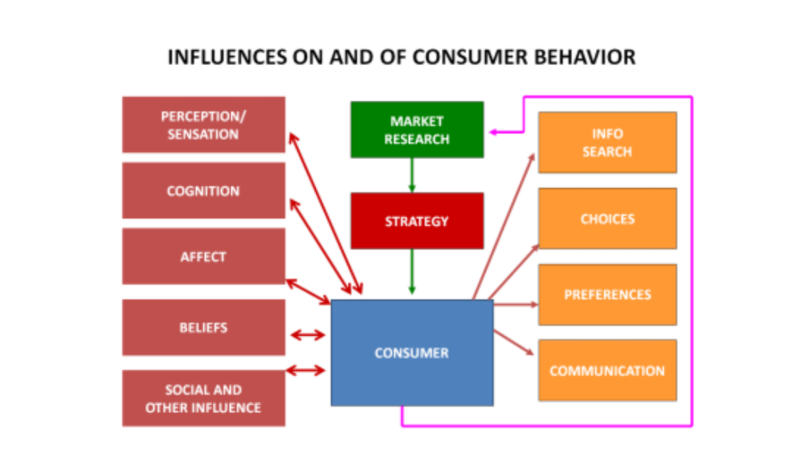

**Figure 4: Consumer behaviour influential area**

(Source: https://www.lapaas.com)

**Dissonance buying reduction behaviour**

Consumer engagement in "dissonance-reducing buying behaviour" is quite high. High pricing and "infrequent purchases" might be to blame for this. In addition, there are not many more options of the brand distinction for better noticeable. In this case, a customer purchases readily accessible goods.

The "Dissonance of reduction in customer engagement is known as the high quiet behaviour. wherever the price range is infrequent or high then the blame must stand for customer behaviour. In addition, there is not any brand with different types of options. In the case of a brand distinguishing the "Dissonance" has been founded. This kind of behaviour is rarely found in terms of accessible goods purchased.

Example: When purchasing a new folding table, a buyer quickly chooses the item after considering a handful of "brands" that are available and that can be brought while camping. The folding table's intended use, its characteristics, and its readily available "budget" should constitute the main deciding elements in this situation.

**Variety seeking behaviour**

without returning any kind of attention a customer finds satisfaction in the case of purchasing cookies from a selection brand. if this customer wants to test a new brand so the person can do it. This one called brand modification will ensue unintentionally frequently.

# 5. Role of IT to understand and facilitate customer

Since technology serves as a plethora of data-gathering tools, it holds the key to involving customers with agents and providing the context necessary to handle issues quickly. Clients now have options and may choose how they communicate thanks to technology. "CRM technology" has made it feasible to exchange information, engage with customers effectively, assess customer data, and customise responses.

**Communicate more quickly:** Most customers won't hold on to the phone for more than two minutes at a time, and 13% believe that no wait time is acceptable.

**Give more precise results:** In readily apparent automation also auto motive for customer service are integrated design. where the customer can answer where they rapidly reached.

**Cost-cutting:** According to the adage that time is a valuable resource, automation reduces costs by quickening client interactions and bringing down administrative expenditures. Any way the automation get enables customer service to represent the work more swiftly also effectively.

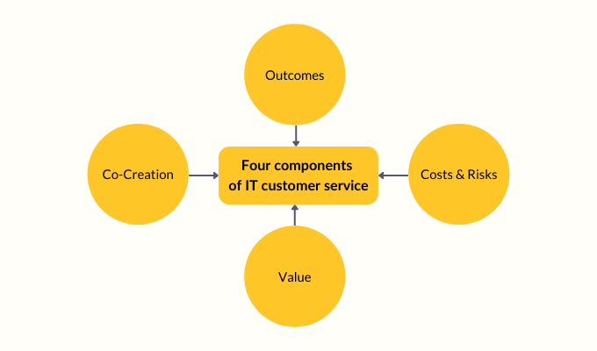

**Figure 5: IT in customer service**

(Source: https://www.2Fhiverhq.com)

Customer result increased: It is better for any client for satisfaction for more high retention which produces by automating. This answer is accessing purchases with different patterns with preferences.

In the following section, the example has been demonstrated,

**Staffing restaurant:** Typically, this group consists of the waitstaff, cooks, chefs, dishwashers, managers, and restaurant owners (Nick and Hague, 2018). Owners depend on kitchens or chefs to produce the food, who then need servers to deliver it to clients and dishwashers to keep the place clean.

**Marketing staff service:** A business could employ "marketing staff," which might include a "social media manager," a "copywriter," and a "graphic designer." The copywriter in addition "graphic designer" is used in the position of "social media manager" to create the material that is posted online.

**Retail service:** These internal consumers may include "cashiers," "inventory staff," and "management," depending on the needs of a store. The work of "cashiers" and "inventory staff" is essential to "management" to fill shelves and sell goods.

**The computer system in tourism**

Thanks to "computer systems" that allow communication across branches and locations, reservations, especially cross-location "company policies" may be more efficiently optimised. They are also used internally to maintain staff communication and give access to information that could improve the tourist experience (Strauss and Frost, 2014). For instance, a "single system" might be used to handle the needs of clients, "housekeeping information," before "reservation details".

# 6. Conclusive

At the point when clients and shoppers assume significant parts, it was acknowledged at the undertaker's decision that each client's dubious activity ought to be thought about. As a result, a lot of businesses keep a close eye on how customers interact with them to get feedback from customers on how to improve their products. A consumer is any user who consumes goods without the permission of the original purchaser. Even though it is normally challenging for clients to characterise extraordinary friendliness client assistance, they know about its presence. Furthermore, brand contrasts are more subtle and there are not many other options. Information can now be consolidated and shared thanks to the improvement of "CRM innovation." They are also used inside to grant access to information that could improve the visitor experience and keep track of staff correspondence.

# Reference List

**Journal**

Blythe, J. and Martin, J. (2019) *Essentials of Marketing* (7th ed). Pearson, Harlow

Chartered Institute of Marketing (2018). *Marketing glossary* I *CIM Marketing Expert.* [online) *Cim.co.uk.* Available at: https://marketingexpert.cim.co.uk/glossary/ (Accessed: 27 October 2022).

Kotler, P., Armstrong, G.. Harris, LC. and He, H.(2019) *Principles of Marketing.*am European Edition. Harlow: Pearson

Madeswaran. A, (2019) *Consumer* - *The Boss (Essentials on Consumer* *Behaviour and*

*Marketing Strategies)* Bangalore, Archers & Elevators Publishing House.

Musumali, B., (2019).An Analysis why customers are so Important and how marketers go about understanding their decisions, *Business and Marketing Research Journal,* pp. 230-246

Nick, H. and Hague, P. (2018) *828 Customer Experience: A practical guide to delivering exceptional CX.* Croydon: CPI Group (UK) Ltd. Strauss.J. and Frost, R. (2014). *E-marketing.* Boston: Pearson

Pearson, Harlow Whittington, R., Regner, P., Angwin, D., Johnson, G.and Scholes, K. (2020) *Exploring Strategy: Text and Cases.* Pearson UK.

Solomon, Michael R.(2020) *Consumer Behaviour: Buying, Having and Being* (13th Global Edition).

Szmigin,I. and Piacentini, M.(2018). Consumer behaviour. 2nd ed. Oxford: Oxford University Press.