**MARKETING DYNAMICS**

**ASSIGNMENT – POSTER**

**Table of Contents**

Introduction 3

Audit of “Internal and External” marketing environment 3

Internal marketing environment (SWOT) 3

External marketing environment (PESTLE) 4

Perceptual Map development/ Positioning Map of Sainsbury's 6

Target Market Segmentation 7

Customer persona development for targeted segment 9

Outline of Sainsbury's Marketing Mix 11

Skills required for the marketing department operation 13

Conclusion 14

References 15

# Introduction

Marketing dynamics are the key focus of the organisation that impacts the pricing strategy of the service or products by producing an effect on customers and manufacturers. The study has presented the key findings of the ***“Marketing dynamics”*** of Sainsbury's. Examination of the external and internal marketing environment of the organisation helps to identify the effectiveness of the organisation in the selected market. This study has developed a “Positioning Map” for demonstrating its relations with its competitors in the market of the UK. In addition, the target market of the organisation is described in this study with the use of the segmentation variables. The study has developed a marketing mix of Sainsbury's and a customer persona for organisational development. The creation of the research helps to understand the marketing dynamics of Sainsbury's which holds the largest market position in the UK.

# Audit of “Internal and External” marketing environment

## Internal marketing environment (SWOT)

|  |  |
| --- | --- |
| **Strengths** | **Weaknesses** |
| * Innovative marketing strategy by hiring social media influencers * Use of social media and online presence (Sainsburys.co.uk, 2023) * Higher customer satisfaction * Effective product segmentation * Stock exchange and wider market size | * Rising prices of products and services * Brand switching * Expensive products * Financial instability faced ***“£ 261 million”*** losses in 2022 (Statista.com, 2023). * The inability to international expansion |
| **Opportunities** | **Threats** |
| * Internal marketing * Marketing area development and growth in a rural area * Brand merged with ***Asda*** in 2018 (Sainsburys.co.uk, 2023). * Followed market trend | * The highly competitive global market * Threats of globalisation * Pandemic situation * Controversies and regulations of marketing countries |

**Table 1: SWOT analysis of Sainsbury's**

(Source: Self-developed)

**Analysis**

The SWOT table helps to identify the internal marketing environment of Sainsbury's where effective brand image and marketing strategy provides support for the growth of the organisation. Innovative marketing strategies are applied by the organisation where social media is used as the triggering aspect where ***“content marketing and social media influencers”*** are adopted (Fengyi, 2021). On the other hand, higher prices of the products limited the targeted customers of the organisation by ***“higher economic group”*** whereas positive feedback is examined for the quality of the products. In the year 2022, the revenue of Sainsbury's was identified as ***“$40.831 billion”*** which rose to ***7.44%*** from the year 2021 (Macrotrends.net, 2023). Therefore, positive growth in the revenue of the organisation is identified due to effective marketing opportunities such as support of mergers and following marketing trends. The examined threats such as the competitive marketplace, brand switching, globalisation, and pandemic threats can be managed with the opportunities of the organisation.

The image demonstrates the sales growth of Sainsbury due to internal marketing environment support.

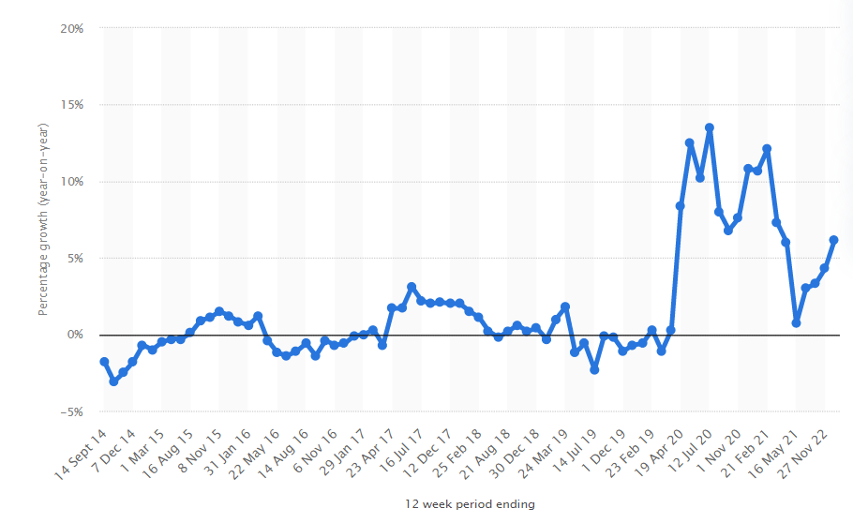

**Figure 1: Sales growth of Sainsbury's**

(Source: Statista.com, 2023)

## External marketing environment (PESTLE)

|  |  |  |
| --- | --- | --- |
| **Factors** | **Description** | **Impacts** |
| P (Political) | * Modern parliamentary democracy * Powerful and stable government * Low corruption level due to a stable political environment * Issues in Brexit Deal | Negative |
| E (Economic) | * The high growth of GDP is ***“4.1%”*** in the year 2022 (Ons.gov.uk, 2023). * Declined inflammation rate by 0.77% in the year 2020 (Cooper, 2020). * Reduction of the corporate tax rate by 17% (ns.gov.uk, 2023) * The lower unemployment rate is 4.8% (Ons.gov.uk, 2023). | Positive |
| S (Social) | * The higher population rate of “67 million” (Cooper, 2020) * Diversity in the population * Higher literacy rate up to 99% (Ons.gov.uk, 2023) | Positive |
| T (Technological) | * Advancements in technology * Application of IoT, AI and 5G networking * Higher investment of up to ***“15 billion dollars”*** in 2020 (Ons.gov.uk, 2023) | Positive |
| L (Legal) | * Supportive business regulation * ***“Equality Act 2010” and “Employment Act 1996”*** | Positive |
| E (Environmental) | * Rising awareness of sustainability * Eco-friendly strategy application and pollutants management | Positive |

**Table 2: PESTLE analysis**

(Source: Created by author)

**Analysis**

Analysis of the market in the UK helps to identify the external marketing environment of Sainsbury's. The above-described table demonstrates external environmental factors' impacts positively whereas political factors create complications for Sainsbury's. Examined political factors are showing political stability provides opportunities for business growth whereas “Brexit Issues” creates complications for the marketing of Sainsbury's (Cooper, 2020). In addition, GDP growth and decreased inflammation rate give positive impacts on the marketing opportunities of the organisation by enchantment of the sales rate. ***Sainsbury's Plc***, known as the second largest supermarket in the marketplace of the UK operates from ***15.2%*** of the market share (Sainsburys.co.uk, 2023). The identified external environment opportunities help in the rise of the sales of Sainsbury's as in 2021-22 the sales grew up to ***“6.2%”*** (Statista.com, 2023). However, the supportive external environment of the UK provides marketing opportunities where supportive legislation helps in the management of Sainsbury's.

The sustainability awareness of the country provides support for sustainable marketing development in this organisation. In the market of the UK, various opportunities are provided by the social factors where higher diversity is examined in the population of the country.

# Perceptual Map development/ Positioning Map of Sainsbury's

Market positioning is defined as the ability for influencing the perception of the brand relative to competitors. Examination of the marketing strategies of Sainsbury's helps to identify the effectiveness of the brand. In the UK market, the effective competitors of Sainsbury's are ***“Tesco Plc, Marks and Spencer, ASDA and Morrison”*** (Sainsburys.co.uk, 2023). The developed perception map of Sainsbury demonstrates a clear position of the brand in the targeted market area.

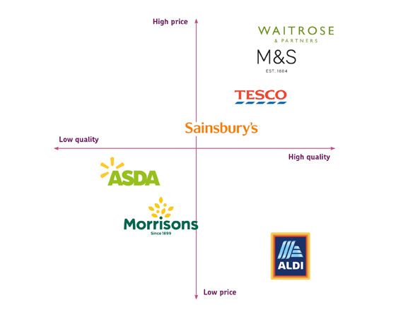

**Figure 3: Perceptual Map for market position of Sainsbury's**

(Source: Self-developed)

In the developed image two criteria for comparison of the brands in the UK market were examined such as ***“price and quality”***. Based on the position of Sainsbury's, it is present at a moderately high price with higher quality. In comparison, a higher position of “Marks and Spencer” is examined in the Map which makes the market competitive for Sainsbury's (Upadhyay *et al.* 2021). The brand has followed a ***“value for money”*** strategy in marketing where it has chosen SEO marketing, social media and Influencer marketing (Sainsburys.co.uk, 2023). On the other hand, in an analysis of the position of ***“ASDA and Morissions”*** a lower position in the Map is identified in comparison with Sainsbury's. Therefore, Sainsbury's established a significant market position which was identified with a comparison of the position of competitors in the perception map.

A sufficient market position gives opportunities for increasing revenue and sales along with competitive advantages for Sainsbury's. As per the view of Iyer *et al.* (2019), three factors are associated with a market position such as “products, business and competitors”. Therefore, an examination of the efficient position of Sainsbury's in the Perception map highlighted its innovative market strategies with the use of social media.

# Target Market Segmentation

|  |  |  |  |
| --- | --- | --- | --- |
| **Target Market** | **Marketing Segmentation** | **Targeting** | **Positioning strategy** |
| UK | Demographic | 15 to 80 years | High-quality high price |

Analysis

Market segmentation refers to a marketing strategy for the identification of the smallest group of people from the larger market area. ***“BTL and ATL techniques”*** are applied by Sainsbury's for selling products to segmented people. According to the view of Paruchuri (2019), ***“Demographic, psychographic, geographic, and behavioural”*** are four types of market segmentation applied by the organisation for target audience selection. Similarly, Sainsbury's has adopted ***“Demographic market segmentation”*** which created customers' persona based on their age, income, religion, gender and education. The organisation has selected ***“age and income”*** as the segmentation variables of the ***“Demographic market segmentation”.*** The targeted age group of the organisation is ***“15 to 80 years”*** and the innovative quality of the products develop it into the second-largest supermarket in the UK (Sainsburys.co.uk, 2023). Hence, selection of the demographic segmentation helps the organisation for identification of content and way of the marketing strategy development.

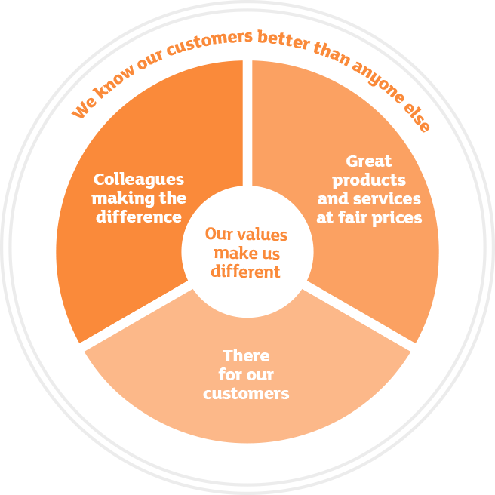

**Figure 4: Segmentation business strategy of Sainsbury's**

(Source: Sainsburys.co.uk, 2023)

Sainsbury's is currently targeting the “demographic” variables for the identification of the target customers for increasing competitive advantages in the UK market. In addition, the organisation has followed the segmentation strategy as it helps in the collection of the key information which makes the services cost-effective. In the year 2022, the stock price of Sainsbury's decreased by ***“-14.69%”*** which relates to the applied business strategies of the organisation (Statista.com, 2023). The application of “demographic” segmentation helps the organisation identify appropriate marketing strategies for engine customers for the developed sales rate of the organisation. In 2022, Sainsbury's operated with 1400 shops in the global aspect where a selection of ***“demographic segmentation”*** helps to identify appropriate information regarding the needs of the customers (Feng *et al.* 2019). Hence, the high-income group is included in the segmentation of the organisation as the high price of the products is seen in comparison with other organisations.

Premium pricing strategy is identified in the segmentation of Sainsbury's where its selected “marketing campaigns” for sharing information to the targeted customers about the quality of the products. The organisation followed ***“Live well with less”*** as the awareness strategy for ensuring effective customer behaviour in the segmented market (Sainsburys.co.uk, 2023). In addition, various social media sites are included by Sainsbury's such as ***“Linkedin, Instagram, Facebook, Twitter and Youtube”*** which helps it to reach the segmented market or to the demographic variables. Additionally, the “SEO strategy” has been followed by the organisation where “2,520,105 organic keywords” are identified as the marketing strategies (Sainsburys.co.uk, 2022). Therefore, the applied strategy helps the organisation to reach the segmented market area where “age and income” are the main focused area.

The main targeted customers under demographic segmentation are “family units” such as pregnant women where comfort is examined as the main aspect of product development. In addition, the organisation focuses on the improvement of the quality of the products and shares relevant information with the targeted market.

# Customer persona development for targeted segment

Development of the “Customer persona” included the target segmented area and identification of the target customers for Sainsbury's. The “Demographic Segmentation” is followed by Sainsbury's which helps the organisation to select customers based on the targeted market.

|  |  |  |
| --- | --- | --- |
| Mrs Emma | **Demographic and characteristics**  Age: 35  Income: “76,300 GBP per year”  Location: London, UK  Gender: Female  Interest: Sustainability and quality products | **Challenges**   * Lack of quality of the products * Old-trend products |
| **Background**  Job: Doctor  Family: Husband  Lifestyle: Sedentary | **Identifiers** **and buying behaviour**  Communication preference: By phone and Face-to-face in English  Social Media Platform: Facebook, Instagram and Twitter  Buying behaviour: Trending sustainable, high quality and premium pricing products | **Activity list**   * High-quality product delivery * Trending products opportunities * Premium pricing |
| **Goals**  Mitigation needs of the customer's  Increased satisfaction of the customers | |

**Table 3: Customer persona of Sainsbury's**

(Source: Self-developed)

The developed table of “customers persona” helps to examine buying behaviour of the customers along with their characteristics. The organisation has examined the demographic variables of the customers for identification of the targeted customers and mitigation needs of the customers. In the online purchasing persona four types of persona are applied such as ***“Competitive, Spontaneous, Humanistic, and Methodical”*** (Bueno *et al.* 2019). The targeted customers are identified between the age group of “15 to 80 years” and the above table has demonstrated an example persona for marketing of Sainsbury. Based on the targeted segmentation of the marketing, customers ' personas are developed for the management of the individual's needs. On the other side, Sainsbury followed the business strategy to satisfy the customers and provide support for effective purchasing experiences (Do and Vu, 2020). Additionally, the organisation has followed the ***“Influencer marketing and eCommerce strategies”*** for attracting customers in the digitalisation era.

On eCommerce websites, customers get opportunities for a select of the preferred and trending products. The organisation has used social media for content marketing where customers' persona helps in the development of demographic understanding regarding the needs of the customers. Sainsbury’s included marketing strategies for reaching the women such as mothers who are the targeted customers for the organisation.

# Outline of Sainsbury's Marketing Mix

The marketing mix is defined as the activities used by the organisation for the promotion of the brand by selling products. As per the view of Do and Vu (2020), the 7Ps of the marketing mix are ***“product, pricing, place, promotion, physical evidence, people, and processes”*** which helps to understand the business advertisement of the product. In addition, Sainsbury has followed the strategy of Marketing mix which is discussed in the below section.

***Product***

Sainsbury’s has applied 5 broad categories associated with separated product lines where “30,000 product lines” are included. The diversified product range is determined as “Fruits and vegetables, fish and meat, chilled, dairy, bakery, Beer, wine and spirits, healthy and Beauty, Baby, Household and pet care” (Sainsburys.co.uk, 2023). Therefore, a high differentiation is identified in the sold products of the organisation where the quality of the products is managed efficiently. In the competitive marketplace higher quality of the products provides advantages to Sainsbury’s and customers are willing to purchase products at a higher price.

***Pricing***

The identified current pricing strategy of Sainsbury’s is a “competitive based pricing strategy” due to a higher competitive market of the UK. On the other hand, in the competitive marketplace, it sells products at a higher price rather; superior quality of the products attracting customers. In the year 2022, the operating income of Sainsbury's was identified as ***“$1,579 million”*** which was possible with the “household and families” targeting strategies (Macrotrends.net, 2023). The organisation has applied a ***“price discrimination policy”*** for the identification of positioning of the products by delivery of fresh products in the local marketplace. The organisation is required to follow an affordable pricing strategy for engaging customers with the organisation.

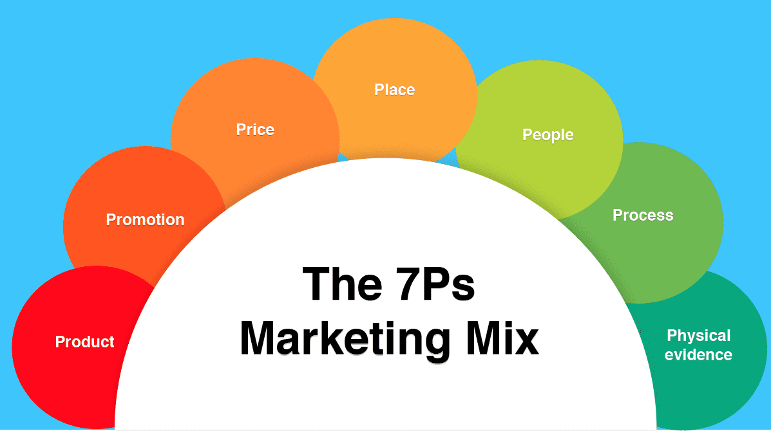

**Figure 5: Marketing Mix**

(Source: Naudé and Sutton-Brady, 2019)

***Place***

The organisation has followed two marketing channels such as online and physical stores for selling products. In the year 1922, Sainsbury's was founded in London as the largest retailer of groceries in the UK (Sainsburys.co.uk, 2023). The market dominance of Sainsbury's is identified in “Wolverhampton, Enfield, South-East London, Dartford, Redhill, Guildford, Swindon and Torquay”. Additionally, regional distribution channels are operated by the organisation in the identified distribution area. In The UK, up to “500 retailers” are identified for Sainsbury's and the ***“omnichannel distribution system”*** is followed by the organisation for successful management of the area of distribution and operation.

***Promotion***

The traditional and online modes of promotion are applied by Sainsbury's which helps it to reach the customers. ***“Social media advertising”*** is followed for attracting customers identified under the “demographic segmentation” (Siripipatthanakul and Chana, 2021). Besides this, various social media platforms are applied by Sainsbury's such as ***“YouTube, Facebook and Twitter”*** for promoting products of the organisation. On FaceBook number of followers of Sainsbury's is ***1.67 million***, on Twitter's total number of followers is ***593 thousand*** which helps the organisation effectively promote the products (Sainsburys.co.uk, 2023). Sainsbury's applied the “influencer marketing” strategy with the use of the social media platform where effective offers and quality-related information are shared.

***Physical evidence***

The packing and quality of the products are estimated as the physical evidence in the marketing strategies applied by Sainsbury's. High-quality services, information and transparency are examined in the online purchasing websites of Sainsbury's. In addition, sustainable and eco-friendly packaging strategies are applied by the organisation which established a positive marketing strategy.

***People***

Marketing is associated with the people such as stakeholders engaged with the marketing operations. The customers are the main targeted people and ***“demographic segmentation”*** is followed by Sainsbury’s for engaging with the customer’s needs. In addition, suppliers play an effective role as the people for the delivery of raw materials. In the global aspect, with over 60 countries Sainsbury’s operated with ***“2,200 sites”*** as the supply chain channels (Sainsburys.co.uk, 2022). Therefore, included people in those areas are playing efficient values for marketing strategies identified such as pricing.

***Processes***

In the marketing activities management of the manufacturing and delivery process are examined under this criteria. Sainsbury’s ensured the availability of the products for reaching the needs of the customers and in the digitalisation era it implemented an “online delivery process”. The customer's needs are identified with effective market research which helps to improve the quality of services under the delivery process. In 2022, up to ***“15 million”*** customers are identified for Sainsbury’s and innovative process adoption is required for need mitigation (Sainsburys.co.uk, 2022). Therefore, sustainability adopted by the organisation developed an innovative process under marketing.

# Skills required for the marketing department operation

Sainsbury’s has followed innovative and unique marketing strategies where successful marketing department handling operations are required. Collection of the customer's feedback helps the organisation to identify issues regarding marketing strategies. As per the view of Bueno *et al.* (2019), the application of the 4 Ps or 7 Ps of the marketing mix helps the organisation improve the marketing strategies and skills to reach the needs of the customers. On the other hand, ***“communication and innovation”*** are two required skills needed during operation management in the marketing department. Effective engagement with the workers in the marketing department is another innovative skill required for operational management. Sainsbury applied ***“omnichannel marketing”*** for the management of numerous marketing departments and outlets (Naudé and Sutton-Brady, 2019). Therefore, skills for handling “omnichannel marketing” are needed for the management of the marketing department.

The marketing operation managers and workers are required to ensure the success of the marketing operations. Innovation in customer service skills, project management and the ability for technological implementation is needed during marketing department operations.

# Conclusion

It can be concluded Sainsbury’s successfully operated the marketing operation measured with a successful discussion of the marketing dynamics. In addition, an effective international environment such as innovative marketing and social media marketing strategy raises opportunities for revenue development. It can be concluded that Sainsbury's applied the “competitive pricing strategy” along with its innovative quality of the products which ensures customers' preference for the brand. The findings regarding the external marketing environment of the UK supporting diverse social factors and technological advancement are examined. Therefore, the market in the UK provides opportunities for Sainsbury’s as a result it's become the second-largest supermarket in the UK.

The “high price high quality” strategy is followed by Sainsbury’s identified in the position Map which provides its competitive advantages. It can be concluded Sainsbury’ has applied “Demographic segmentation” which helps it to develop the customer's persona and reach the targeted customers. Besides this, Marketing Mix highlighted the focus of the organisation regarding online marketing strategy with effective product engagement. Therefore, the market dynamic of Sainsbury’s highlighted the innovative marketing strategies with high-quality products which provide competitive advantages.

# References

Bueno, E.V., Weber, T.B.B., Bomfim, E.L. and Kato, H.T., (2019). Measuring customer experience in service: A systematic review. *The Service Industries Journal*, [online]. 39(11-12), pp.779-798.

Cooper, R.J., (2020). Pestle and mortal: the demise of community pharmacy in the UK. *International Journal of Pharmacy Practice*, [online]. 28(3), pp.205-206.

Do, Q. and Vu, T., (2020). Understanding consumer satisfaction with railway transportation service: An application of 7Ps marketing mix. *Management Science Letters*, [online]. 10(6), pp.1341-1350.

Feng, L., Li, Y., Xu, F. and Deng, Q., (2019). Optimal pricing and trade-in policies in a dual-channel supply chain when considering market segmentation. *International Journal of Production Research*, [online]. 57(9), pp.2828-2846.

Fengyi, Z., (2021). The Analysis of Asda-Sainsbury’s Merger/Acquisition. *Journal of Finance Research*, [online]*.* 5(1), pp.1-6.

Iyer, P., Davari, A., Zolfagharian, M. and Paswan, A., (2019). Market orientation, positioning strategy and brand performance. *Industrial Marketing Management*, [online]. 81, pp.16-29.

Macrotrends.net (2023). Sainsbury Revenue 2010-2022. Available from: https://www.macrotrends.net/stocks/charts/JSAIY/j-sainsbury/revenue#:~:text=J%20Sainsbury%20annual%20revenue%20for,a%203.1%25%20increase%20from%202020. [Accessed 28 April 2023].

Naudé, P. and Sutton-Brady, C., (2019). Relationships and networks as examined in Industrial Marketing Management. *Industrial Marketing Management*, [online]*.* 79, pp.27-35.

Ons.gov.uk, (2023). UK. Available from: https://www.ons.gov.uk/ [Accessed 28 April 2023].

Paruchuri, H., (2019). Market segmentation, targeting, and positioning using machine learning. *Asian Journal of Applied Science and Engineering*, [online].8, pp.7-14.

Sainsburys.co.uk (2022). Business strategy. Available from: https://www.about.sainsburys.co.uk/about-us/our-business-strategy#:~:text=How%20are%20we%20achieving%20this,shopping%20and%20interacting%20with%20us. [Accessed 28 April 2023].

Sainsburys.co.uk (2023). About us. Available from: https://www.sainsburys.co.uk/ [Accessed 28 April 2023].

Siripipatthanakul, S. and Chana, P., (2021). Service Marketing Mix (7Ps) and Patient Satisfaction in Clinics: A Review Article. *International of Trend in Scientific Research and Development,* [online]*.* 5 (5), pp.842-850.

Statista.com, (2023). Percentage change in sales at Sainsbury's in Great Britain compared to a year earlier from September 2014 to December 2022*. Available from: https://www.statista.com/statistics/386729/sainsburys-sales-percentage-change-great-britain-uk/ [Accessed 28 April 2023].

Upadhyay, A., Kumar, A. and Akter, S., (2021). An analysis of UK retailers’ initiatives towards circular economy transition and policy-driven directions. *Clean Technologies and Environmental Policy*, [online] pp.1-9.