**ASSESSMENT 2: INDIVIDUAL ESSAY**

**Table of Contents**

Introduction 4

Task 1 4

Introduction 4

Meaning and Definition of motivation 4

Importance of Motivation 4

Theories of Motivation 5

Maslow's Hierarchy of needs 5

ERG Theory 6

McGregor Theory X and Theory Y 6

Herzberg's Two-factor theory 7

McClelland Acquired Needs Theory 7

Goal-setting theory 8

Reinforcement Theory 9

Equity Theory 9

Expectancy Theory 9

Conclusion 10

Recommendation 10

Task 2 10

Introduction 10

Meaning and Definition of leadership 10

Importance of Leadership in the Workplace 10

Leadership Theories 11

Trait theory 11

Lewin 3 style theory 13

Hersey Model 14

Situational theory 15

Fiedler Contingency Theory 16

Conclusion and Recommendation 16

Conclusion 16

Recommendation 16

Reference List 17

**Introduction**

Organisations that have an effective recruitment and selection strategy are likely to record better employee retention outcomes and talent development.

**Task 1**

**Introduction**

Amazon is a global organisation that mostly conducts e-commerce business along with digital streaming and cloud computing (Aboutamazon.com, 2023).

***Meaning and definition of motivation***

Motivation consists of the driving force that influences a person to exhibit goal-oriented behaviour (Simplypsychology.org, 2023).

***Importance of Motivation***

Employee motivation plays a crucial role in influencing the productivity and performance of the workforce in an organisation (Armstrong and Taylor, 2023).

***Theories of Motivation***

**Maslow's Hierarchy of needs**

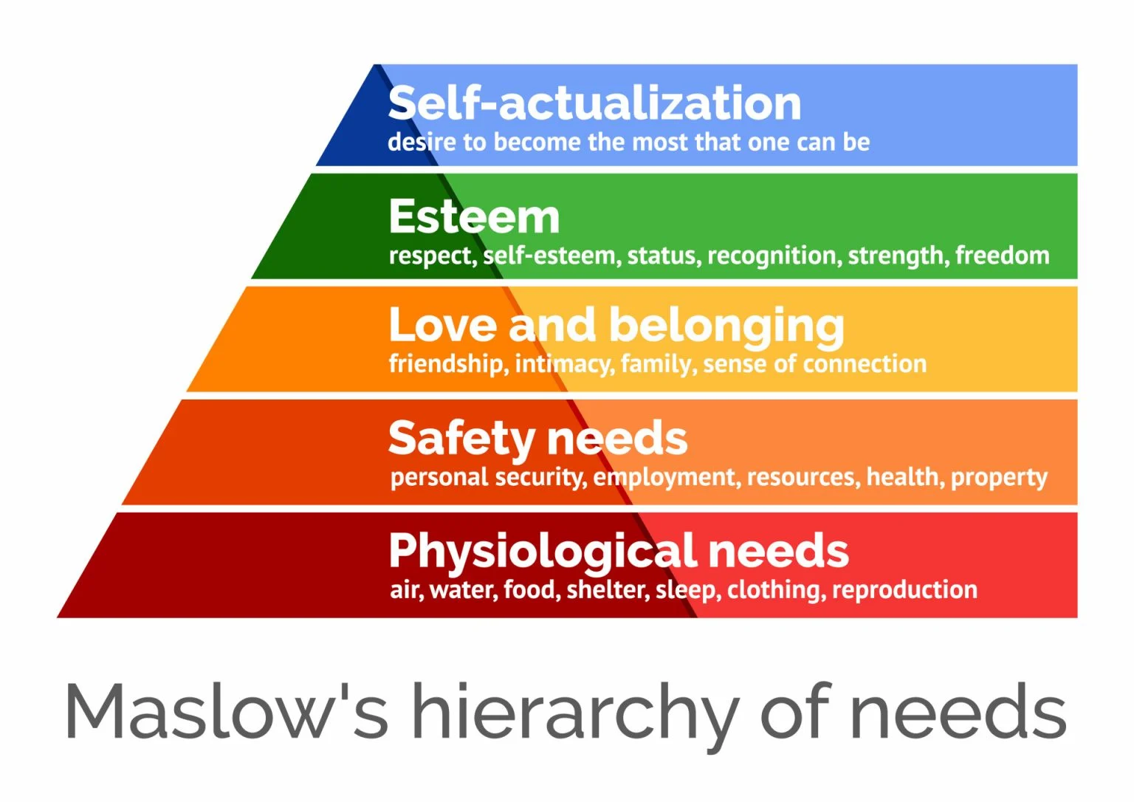

**Figure 1: Maslow's Hierarchy of needs**

(Source: Mcleod.org, 2023)

Maslow’s theory proposes the importance of 5 levels of motivation including “self-actualisation, esteem, love and belonging, safety needs, and physiological needs” (Mcleod.org, 2023). For instance, Amazon provides a safe workplace for its workers, which can attract talented people to apply for recruitment.

***ERG Theory***

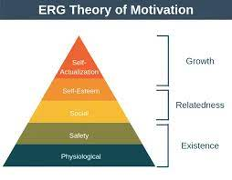

**Figure 2: ERG Theory**

(Source: Wang *et al.* 2021)

The theory explains that three elements named Existence, Relatedness, and Growth act as drivers of motivation for people (Wang *et al.* 2021). Amazon can apply the theory by providing development opportunities to employees, which can help recruitment by attracting individuals.

***McGregor Theory X and Theory Y***

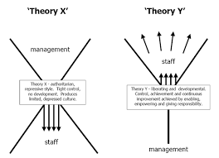

**Figure 3: McGregor Theory X and Theory Y**

(Source: Wangdi and Tobgay, 2022)

The theory explains that Theory X represents employees as being demotivated while Theory Y represents employees as being motivated (Wangdi and Tobgay, 2022). Amazon can utilise the theory by providing fair remuneration to employees to attract talented new recruits.

**Herzberg's Two-factor theory**

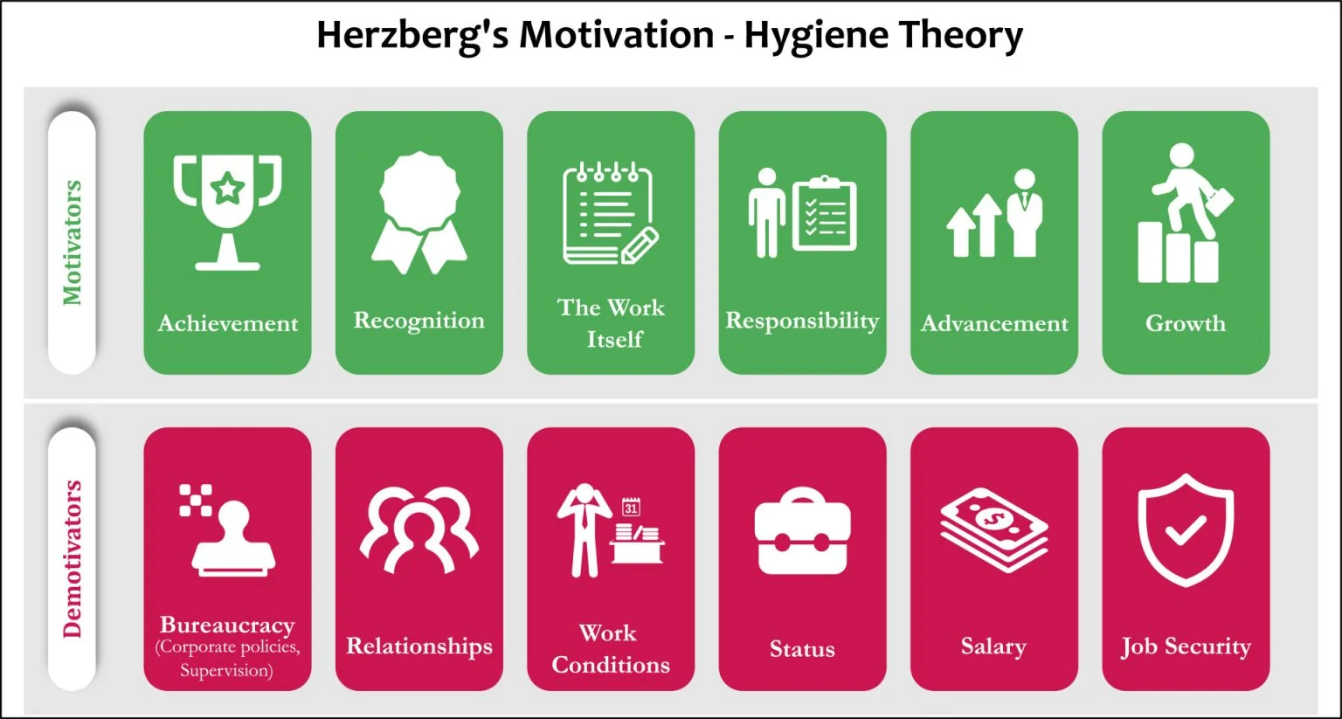

**Figure 4: Herzberg's Motivation Theory**

(Source: Nickerson, 2023)

Motivation factors include elements like the salary that motivate employees to work while hygiene factors are those that decrease motivation such as workplace conflicts (Nickerson, 2023). Accordingly, the company attracts both men and women for recruitment and selection by offering them equal pay.

***McClelland Acquired Needs Theory***

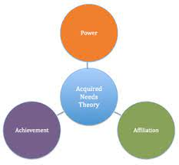

**Figure 5: McClelland Acquired Needs Theory**

(Source: Acquah *et al.* 2021)

The theory explains that Power, Need for Affiliation, and the Need for achievement serve as driving forces for individuals (Acquah *et al.* 2021). Amazon can benefit from the theory by providing rewards that can serve the need for achievement of its employees.

**Goal-setting theory**



**Figure 6: Goal setting theory**

(Source: Al Masaeid, 2020)

Accordingly, the goal-setting theory explains that challenging goals can help to motivate employees in companies (Al Masaeid, 2020). For instance, Amazon can set goals for the day-to-day work of its employees to motivate them.

***Reinforcement Theory***

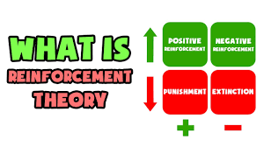

**Figure 7: Reinforcement Theory**

(Source: Grishin, 2021)

The theory explains that behaviour is a result of consequences of actions arising due to behaviour (Grishin, 2021). Therefore, Amazon can motivate employees by providing reinforcement in the form of rewards for good performance

***Equity Theory***

The theory explains that equitable treatment can help to motivate employees (Kollmann *et al.* 2020). Amazon can apply the theory by introducing distributive justice in the form of equal treatment.

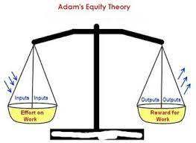

**Figure 8: Equity Theory**

(Source: Kollmann *et al.* 2020)

***Expectancy Theory***

The theory argues that expectations influence employee behaviour and motivation (Kollmann *et al.* 2020). Therefore, Amazon can improve motivation by providing rewards for favourable behaviour by employees like a good performance.



**Figure 9: Expectancy Theory**

(Source: Rehman *et al.* 2019)

***Conclusion***

The conclusion of the task is that motivation helps in improving the performance of employees.

***Recommendation***

**Provide regular rewards to high-performance employees**

Amazon can conduct regular monthly rewards and recognition to reward high-performance employees, which can motivate recruited employees to perform well.

**Task 2**

***Introduction***

Amazon has a 0% gender pay gap median within its UK operations (Assets.aboutamazon.com, 2022).

***Meaning and definition of leadership***

Mullins (2016) explains that business leaders play an important role in shaping the behaviour of employees by influencing their attitudes regarding their job and workplace.

***Importance of leadership in the workplace***

According to Leatherbarrow *et al.* (2014), the leadership in an organisation needs to provide adequate guidance and encouragement to employees.

***Leadership Theories***

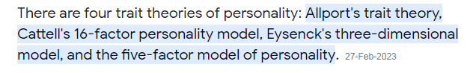

**Trait theory**

**Allport theory**

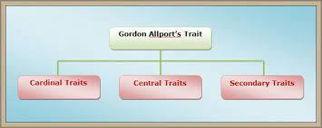

**Figure 10: Allport theory**

(Source: Ahmadi *et al.* 2023)

The theory proposes the importance of cardinal, central, and secondary traits that influence behaviour (Ahmadi *et al.* 2023). Accordingly, Amazon can apply the theory by developing central traits in leaders to improve leadership.

**Strength of the theory:** Provides Instant Results

**Weakness of the theory:** Does not provide leadership styles

**Cattell theory**

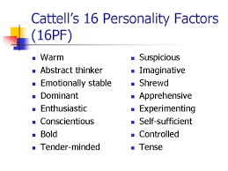

**Figure 11: Cattell's theory**

(Source: Alibaygi Sarhali. and Nickhahnoori, 2022)

The theory proposes that 16 types of personalities exist that have different strengths and weaknesses (Alibaygi Sarhali. and Nickhahnoori, 2022). Amazon can apply the theory by assessing the personality of its employees and having leaders adopt a suitable style for them.

**Strength:** Good for analysing personalities

**Weakness:** Does not provide leadership styles

**Eysenck theory**

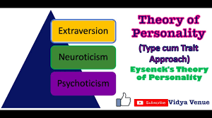

**Figure 12: Eysenck theory**

(Source: Dhelim *et al.* 2021)

The theory explains that introversion, normality, and emotional stability are three central traits among people (Dhelim *et al.* 2021). Amazon can apply the theory by pairing emotionally stable leaders with emotionally stable employees to improve performance.

**Strength**

The theory is strong for assessing the personality of employees and leaders in the workplace of Amazon.

**Weakness**

The theory is weak in terms of providing leadership input as it focuses mostly on the personality of people.

**Lewin 3 style theory**

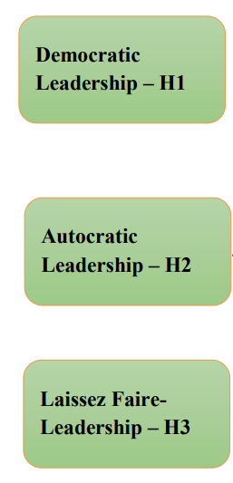

**Figure 13: Lewin’s leadership styles**

(Source: Hashim, 2021)

According to Hashim (2021), the 3 major styles of leadership include democratic, autocratic, and laissez-faire. Strong leaders are influenced to come for recruitment and selection at Amazon by providing them independence in their leadership role at Amazon.

**Strength of the theory**

It gives access to 3 distinct approaches to leadership that leaders can adopt to achieve higher effectiveness in their leadership responsibilities.

**Weakness of the theory**

The theory can be considered weak as it is difficult for leaders to smoothly change their leadership styles in different scenarios because of their natural tendencies and traits.

***Hersey Model***

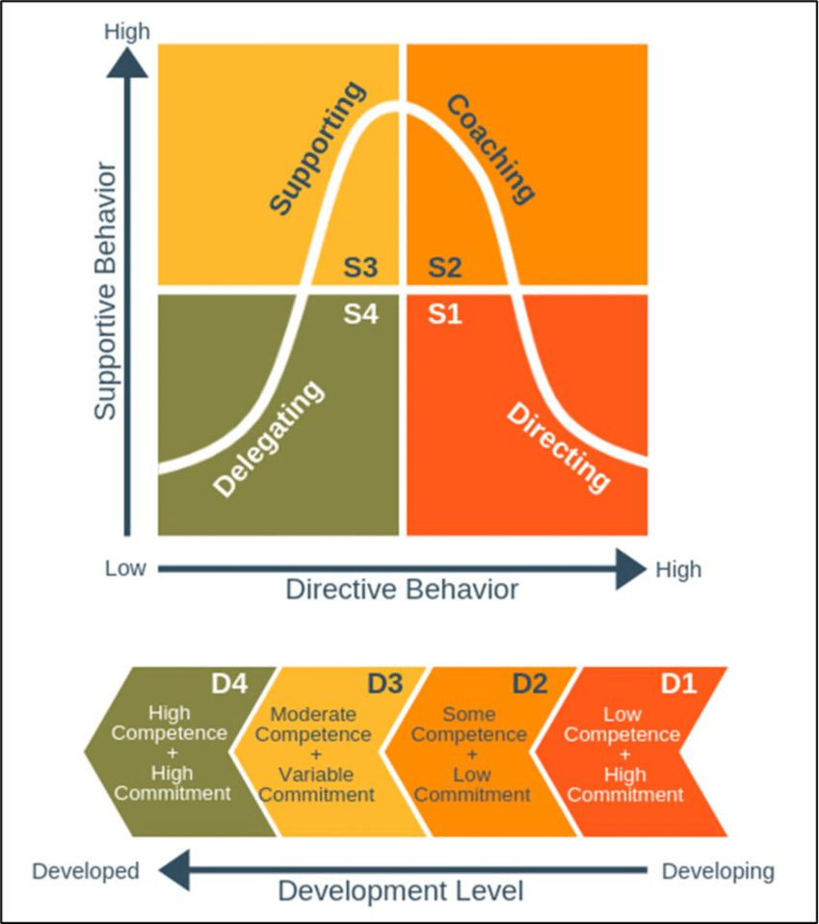

**Figure 14: Hersey Model**

(Source: Sbeih and Jones, 2021)

The theory proposes that workplace factors need to be considered in leadership to achieve effectiveness (Sbeih and Jones, 2021). Amazon can apply the model by considering the culture of offices to improve the leadership quality.

**Strength**

The theory is strong for improving the effectiveness of leaders at Amazon by considering cultural factors.

**Weakness**

The model can be considered weak in providing an approach to leadership to manage organisations.

**Situational theory**



**Figure 15: Situational Theory**

(Source: Sbeih and Jones, 2021)

The Situational theory of leadership explains that a single leadership style cannot be effective in different situations (Sbeih and Jones, 2021). It can be analysed that Amazon adopts a delegating style of leadership to enable employee development by providing employee independence.

**Strength of the theory**

The theory is strong as it helps leaders adopt a wide range of styles to achieve leadership effectiveness.

**Weakness of the theory**

The theory can be considered weak as leaders require training to properly implement all 4 styles of leadership.

***Fiedler Contingency theory***

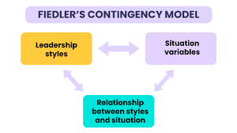

**Figure 16: Fiedler contingency theory**

(Source: Kundu and Mondal, 2019)

The theory explains that leaders need to fit their style of leadership according to the circumstances (Kundu and Mondal, 2019). Amazon leaders can apply the theory by adopting different leadership approaches in different scenarios at the workplace.

**Strength of the theory**

The theory is strong as it can help improve the leadership effectiveness at Amazon.

**Weakness of the theory**

The theory can be considered weak as it can result in higher tiredness among leaders due to extra work in adapting leadership styles.

**Conclusion and Recommendation**

***Conclusion***

It can be concluded that motivation and leadership are important parts of contemporary organisations.

***Recommendation***

**Adopt autocratic leadership for new recruits**

Amazon can utilise an autocratic leadership style to better manage its newer employees and avoid errors being made by new employees.

**Reference List**

Aboutamazon.com, (2023). *Employee Benefits*. Available at: https://www.aboutamazon.com/workplace/employee-benefits [Accessed on: 28.4.23]

Aboutamazon.com, (2023). *Leadership Principles*. Available at: https://www.aboutamazon.com/about-us/leadership-principles [Accessed on: 28.4.23]

Aboutamazon.com, (2023). *Who We Are*. Available at: https://www.aboutamazon.com/about-us [Accessed on: 28.4.23]

Acquah, A., Nsiah, T.K., Antie, E.N.A. and Otoo, B., (2021). Literature review on theories of motivation. *EPRA International Journal of Economic and Business Review*, 9(5), pp.25-29.

Ahmadi, M., Kavandi, S., Jahed, M. and Salehi, J., (2023). Review the personality theory of Mulla Sadra (from the perspective of Allport's trait personality theory). *Journal of Philosophical Investigations*.

Al Masaeid, T.F., (2020). Organisational Development Interventions to solve performance management challenges. *PalArch's Journal of Archaeology of Egypt/Egyptology*, 17(6), pp.7575-7586.

Alibaygi Sarhali, V. and Nickhahnoori, O., (2022). Interpretation and Analysis of Majnoon Personality Based on Cattell Theory. *Journal of Iranian Studie*s, 21(41), pp.389-428.

Armstrong, M., and Taylor, S. (2023). *Armstrong’s Handbook of Human Resource Management Practice: A Guide to the Theory and Practice of People Management*. 16th Edition. UK: Kogan Page.

Assets.aboutamazon.com, (2022). *Gender Pay Gap*. Available at: https://assets.aboutamazon.com/fd/58/ef6d02774640ab2fd0cfb0453cf6/uk-gender-pay-gap-results-2022-amazon.pdf [Accessed on: 28.4.23]

Dhelim, S., Chen, L.L., Aung, N., Zhang, W. and Ning, H., (2021). Big-Five, MPTI, Eysenck or HEXACO: The Ideal Personality Model for Personality-aware Recommendation Systems*. arXiv preprint arXiv*:2106.03060.

Grishin, N.V., (2021). Reinforcement theory and study of the impact of internet technologies on political participation of modern youth. *RUDN Journal of Political Science*, 23(1), pp.47-59.

Hashim, M.H.B., (2021). The Effect of Leadership Style on Co-Operative Success.

Kollmann, T., Stöckmann, C., Kensbock, J.M. and Peschl, A., (2020). What satisfies younger versus older employees, and why? An ageing perspective on equity theory to explain interactive effects of employee age, monetary rewards, and task contributions on job satisfaction. *Human Resource Management*, 59(1), pp.101-115.

Kundu, S. and Mondal, P., (2019). The luminance of contingency theory in revealing the leadership style of academic librarians. *Library Philosophy and Practice*, pp.1-11.

Leatherbarrow, C., Fletcher, J., Currie, D. (2014). *Introduction to Human Resource Management: A Guide to HR Practice*. 3rd Edition. CIPD: UK.

Mcleod, S., (2023). *Maslow’s Hierarchy Of Needs*. Available at: https://www.simplypsychology.org/maslow.html [Accessed on: 28.4.23]

Mullins, L. J. (2016). *Management and Organisational Behaviour*. 10th ed: Pearson UK.

Rehman, S., Sehar, S. and Afzal, M., (2019). Performance Appraisal; Application of Victor Vroom Expectancy Theory. *Saudi Journal of Nursing and Health Care*, 2(12), pp.431-434.

Sbeih, A. and Jones, A., (2021). THE IMPACT OF LEADERS’BEHAVIORS ON ORGANIZATIONAL PERFORMANCE AT GOVERNMENT ORGANIZATIONS IN DUBAI. *International Journal of Management* (IJM), 12(4).

Simplypsychology.org, (2023). *Motivation*. Available at: https://www.simplypsychology.org/theories/motivation-theories [Accessed on: 28.4.23]

Uslu, O., (2019). A general overview of leadership theories from a critical perspective.

Wang, T.C., Chen, W.T., Kang, Y.N., Lin, C.W., Cheng, C.Y., Suk, F.M., Chen, H.Y., Hsu, C.W., Fong, T.H. and Huang, W.C., (2021). Why do pre-clinical medical students learn ultrasound? Exploring learning motivation through ERG theory. *BMC medical education*, 21(1), pp.1-9.

Wangdi, T. and Tobgay, S., (2022). The impact of McGregor's theory X/Y on the level of job satisfaction of teachers and principals. *Shanlax International Journal of Management*, 9(3), pp.34-40.