ASSIGNMENT

(INFLUENCE OF CULTURAL FACTORS ON THE ACTIVITIES OF HUMAN RESOURCE MANAGEMENT IN FOREIGN SUBSIDIARIES)

# 

**Table of Contents**

Introduction 2

Background 2

Research aim 2

Research questions 2

The Rationale of the Research 2

Summary 3

Literature Review 3

Introduction 3

Influence of cultural factors on HRM Practices 3

Cultural Influence on the HRM Practices in the US 4

Cultural Influence on the HRM Practices in the UK 4

Cultural Influence on the HRM Practices in Japan 5

Literature gap 6

Theoretical framework 6

Summary 7

Findings and Discussion 8

Conclusion and Recommendation 11

References 13

# Introduction

## Background

The globalisation of businesses has established an interconnection between businesses all over the world and the technologies used by them. It has caused business organisations to expand and reach out to foreign markets. This not only has provided businesses to expand their business operations in a wider area of the market but has increased the availability of resources. Globalisation is a major reason behind the cultural exposure that is seen in the present world. Due to the expansion of trading activities into new markets, countries have been able to establish a connection with foreign cultures. This has significantly affected the behaviour of customers in the market and a major influence has been upon the HRM practices in foreign subsidiaries. The HRM practices including recruitment of employees, organising training programs, performance management, change management, benefits and compensation received by employees and others are usually affected by cultural factors in an organisation.

## Research aim

Identification of the influence of cultural factors (CF) on the HRM activities in the US and Japan in comparison to the UK. The research explores the influence of different CF with respect to the activities associated with HRM practices in countries including the US, the UK and Japan.

## Research questions

To identify ways in which globalisation changed HRM activities

To identify ways in which cultural factors have influenced leadership in foreign subsidiaries, specifically the UK, the US and Japan.

## The Rationale of the Research

The influence of CF on HRM activities is driven by multiple factors. Globalisation of businesses has increased the opportunities for organisations to conduct business operations capturing a wider market area. It has led to an increase in the aspect of competitiveness between business organisations due to the exposure of businesses in foreign markets. The increasing number of employees belonging to cross-cultural backgrounds has significant impacts on HRM practices as well. Furthermore, the US, Japan and the UK possess The largest market in terms of the global economy, the HRM practices in the respective nations play a major role in the business operations in the global market.

## Summary

Globalisation has got a huge transition in the leadership styles and procedures in business organisations. It has also brought about a number of changes in different activities associated with HRM practices. This particular research aims at Investigating the Impact and control of different factors associated with the culture upon the HRM practices of companies operating in different countries.

# Literature Review

## Introduction

This literature will discuss the various aspects of cultural factors that have the capability of establishing control and influencing HRM activities. It discusses the influence of culture on the HRM practices of organisations in countries such as the United Kingdom, the United States of America and Japan.

## Influence of cultural factors on HRM Practices

According to Aust *et al.* (2020), the expansion of business organisations into a variety of cultural contexts has led to the adaptation of HRM practices that are capable of meeting the needs of the employees within an organisation. The HRM practices are conducted in order to ensure that they are capable of catering to the preferences of both the internal and external stakeholders of business organisations. In cross-cultural teams, leaders need to establish clear communication with employees belonging to different cultural backgrounds. The leaders need to have effective communication skills that are capable of communicating the agenda of the organisation and providing effective guidance so that employees become capable of performing quality work. In the same way, lack of diversity and practices of inequality has a negative impact on the HRM practices which include employee relations and employee engagement within an organisation.

In case employees feel that they are not treated equally in the organisation based on their cultural background, race, sexual orientation and others, they become this interested in the activities of the organisation which has a direct impact on their relationship with the organisation (Hendri, 2019). It also has a huge negative influence on the engagement of the employees with the internal activities of the organisation. As a result of this, organisations pay great attention to the HRM practices within the organisation. Effective and proper HRM practices are capable of motivating employees. Employees who feel motivated at work are more likely to put in a lot of effort in terms of work performance. This in turn benefits the organisation by generating quality outcomes. This increases the business opportunities for the organisation and ensures that the organisation becomes capable of having a positive identity in the market.

## Cultural Influence on the HRM Practices in the US

Due to the huge diversity of the US, organisations in the country have a blend of cultural factors that shape the internal practices of the organisation including its HRM activities (Hong and Kim, 2019). The USA maintains an individualist culture that puts a lot of emphasis on the individual goes and achievements of people. This has a significant impact on the third process of individuals associated with the HRM of the organisation as well as shapes the HRM activities. Based on the individualistic reference in the US Society, business organisations focus on appraising the individual performance of employees. The performance metrics are focused on the individual performance of workers in an organisation and give recognition to a single employee instead of appreciating the collective work of a team. This indicates that HRM practices have had huge improvements in the individualism aspect of the US.

In accordance with Lizotte *et al.* (2020), organisations operating in the US or those which are originally based in the US give a lot of importance to equal opportunities and just decision-making activities. This influences the HRM practices as a result of which the human resource managers and other higher officials of the organisation vouch for hiring employees belonging to a variety of cultural backgrounds. Within the internal environment of the organisations, individuals involved with HRM activities make efforts to provide equal employment opportunities to individuals no matter their gender, race or cultural background. In fact, the Skills possessed by a potential candidate are preferred over their cultural factors during the recruitment process in an organisation. This indicates that the HRM practices in US organisations are influenced by the societal culture of the nation (England *et al.,* 2020). Therefore, organisations in the US give importance to the influence of culture which is reflected in the positive environment at the organisations.

## Cultural Influence on the HRM Practices in the UK

HRM is responsible for recruiting, training, and providing benefits to employees to ensure a positive environment in the workplace. It is a strategic approach for the successful running of the business operation various HRM policies are practised in the UK that are basically influenced by the national culture prevailing in the UK. HRM practices have specific characteristics influenced by the culture of the country in the UK equality culture is followed and both the main and women have given priority in the work culture of the organisation while in Japan the masculine culture is followed and the work culture is mostly influenced by the man (Islam, *et al*.,2022). In the UK individualist culture is followed and people are more self-oriented and focused on fulfilling their own goals, which influenced the HRM practice. The employees are being rewarded on the basis of individual performance and lay emphasis on individual bonuses, and promotions. The country that scores high in power distance increases inequality among the people as the power is distributed unequally, In UK power distance coal is low which refers that the culture in the country has equal distribution of power and the employees and the superiors both are involved in the decision-making process of the organisation and the employees are valued which helps to increase the productivity of the organisation(Armstrong and Taylor, 2023). Power distance influences the HRM practice like performance appraisal in high power distance countries performance appraisal is based on behavioural criteria rather than performance as the employees are obedient to their superiors. The managers who are responsible for the HRM department in an organisation recruit employees irrespective of their cultural background.

## Cultural Influence on the HRM Practices in Japan

The societal structure of Japan is extremely complex and over the past 125 years, the dynamism of Japanese culture has gone through several changes. At present, Japan has been successful in converting itself from a federal state into a modern and industrialised nation. Japan is an island country and ethnic homogeneity is prevalent in the country. The common Asian cultural traits such as authoritarianism, protocol, and group-centeredness are highly prevalent in the country. In Japan, having a job suggests that the employee will identify himself with a larger entity through which he will acquire pride and confidence. As per the observation of Jyoti and Sarthak (2019), in Japan, employees believe that their prestige is directly linked to the prestige of their employers and vice versa. The HRM practice is heavily influenced by the culture of the country and hierarchical order in the organisations is heartily accepted by the employees.

It has been argued by Morris *et al.* (2021) that in Japanese organisations different ranks, statuses, and designations are perfectly balanced and employees do not complain about the hierarchical order. Moreover, Japanese organisations value their people, and they observe the performance of the employees and give them promotions accordingly so that communication and interaction can be maintained. The Japanese language further reinforces the ranks and organisational positions at the workplace. Japanese employees address their senior managers and add honorifics at the endings of their language. Japanese HRM practices encourage employees to do things in the most possible manner. The commonly held belief among Japanese employees is that when they do things with great care and proper manners, possibilities of success is enhanced significantly. Moreover, in Japan female workforce shares 41% of the total employment of the country, this implies that the Japanese value women's emancipation and this reflects in the Japanese HRM practices as well.

## Literature gap

The above literature discusses the impact of cultural traits on the HRM activities of organisations in foreign subsidiaries. However, it fails to establish a link between the relationship of HRM practices followed by organisations in the US, the UK and Japan that are influenced by cultural factors which include diversity, cultural shocks, inequality, cultural beliefs of employees and other stakeholders among others. Hence, the scope for establishing future research has been identified in the literature which upon exploration will help in gathering deeper insights into the relationship between HRM practices in foreign subsidiaries.

## Theoretical framework

**Cultural intelligence theory:**

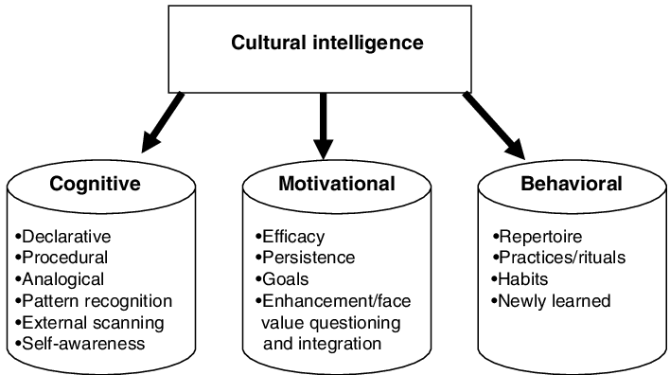

**Figure: Cultural Intelligence theory**

(Source: Researchgate, 2021)

This theory as depicted in the above image, suggests that individuals can develop intelligence in terms of culture by observing the behaviour of others belonging to different cultures (Stoermer *et al.*, 2021). In a globalised world, employees work in a setting that has individuals belonging to different cultural understandings. They have different cognitive abilities, physical abilities, emotional abilities as well as behaviours. These components are reflected in the behaviour and attitude of individuals which have a huge impact on their communication style, work performance and ability to understand others at the workplace. Hence, the development of cultural importance helps individuals to work in diverse team settings and at the same time deliver quality work. It enhances the ability of employees to communicate with their colleagues and the external stakeholders of the organisation. This in turn also leads to the development of positive relationships between the workers as well as enhances the relationship of employees with the stakeholders of the organisation. This benefits the organisation in terms of establishing an understanding of the demands and preferences of the client.

**Social Learning Theory:**

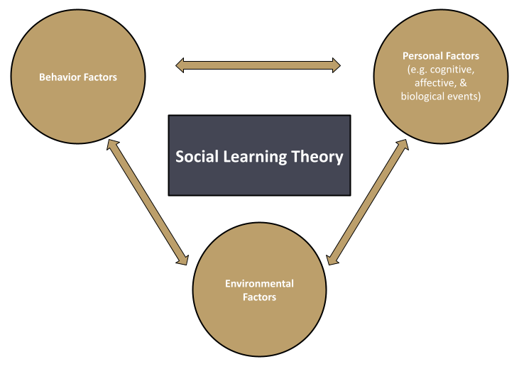

**Figure: Social learning theory**

(Source: Self-created)

This particular theory emphasises the fact that individuals learn from observing the behaviour and attitude of others. The behaviour of an individual is directly influenced by their cultural background and other cultural factors such as cultural stereotypes, cultural shocks and other associated elements of the culture (Gweon, 2021). Employees are potentially inclined to develop positive traits in case the organisation culture of an organisation is positive as well as their colleagues and managers maintain a positive attitude. In addition to that, a business organisation fostering a learning attitude will lead the employees to feel motivated to learn from their co-workers and those holding higher positions in the organisation. Hence according to this theory, demonstrating positive behaviour and outcomes within an organisation has a huge impact on the HRM activities of the organisation as well as impacts the employee relation and job satisfaction of the employees, positively.

## Summary

The literature review gives an insight into the influence of the culture on the HRM practice in various countries like the USA, the UK, and Japan. It describes that in a cross-cultural environment, effective communication is required to motivate the employees, and also evaluate individual behaviour on the basis of cultural intelligence and social learning theories.

# Findings and Discussion

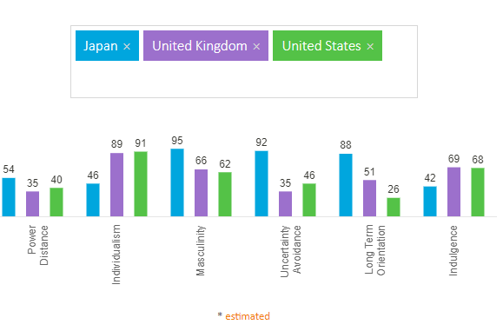

**Figure: Cultural comparison between the UK, US and Japan**

(Source: Hofstede, 2023)

***Power Distance-***

This particular dimension of the Hofstede comparison deals with the social belief that all individuals do not hold equal positions in society. It implies that individuals living in society develop different attitudes based on their position as an individual in society. It is influenced by the societal status of a person instead of the basic fact that everyone living in a society should be treated equally and should receive equal respect. Therefore, from the above image, it can be implied that the US has a relatively low power distance which stands at 35 than the UK and Japan. This implies that individuals, especially employees belonging to the US, have relatively low tolerance against powered inequalities In terms of organisational structure. On the other hand, Japan has the highest power distance in society which justify the gender inequality seen in Japanese organisations. Although globalisation has increased the awareness of employees all over the world in terms of the importance of equal opportunities for workers in an organisation, Japanese business organisations seem to be stubborn believers in inequality (Kitada and Harada, 2019). This particular attitude is an active promoter of the fact that male leaders hold more capabilities than female leaders. Hence, this particular attitude is reflected in the HRM activities of the business organisations in Japan. On the other hand, the UK has a moderate score in terms of power distance. This indicates that individuals are somewhat comfortable with the inequality of power in an organisation.

***Individualism***-

The dimension refers to the degree of interdependence maintained by individuals in a society. Both the US and the UK maintain a high level of individualism in their respective societies (Collier and Kay, 2020). This means that individuals are expected to be more self-dependent and prioritise their goals and aspirations. This preference of the masses in both countries has a huge impact on HRM activities such as the selection of candidates and recruitment of employees in organisations that prioritise hiring individuals who have more individual skills and achievements instead of focusing on teamwork capabilities and those who have higher tolerance in terms of cultural difference. In terms of training, employees as well, organisations in the US and UK focus on coaching and mentoring individual employees instead of a group of employees and support individual cultures of employees as well. On the other hand, Japan prioritises collectivism. Individuals belonging to the country have a more collectivistic approach to work than just prioritising their own careers and opportunities (Guo, 2022). As a result of this, the HRM practices in the country are also focused on building collective capabilities. Organisations also focus on building strong relationships among members in a group which in turn contributes to the collective goals of the organisation.

***Masculinity-***

The third dimension of the Hofstede model refers to the extent to which the society of a particular nation values masculine traits and focuses on achieving them. The masculine traits include assertiveness, competitiveness and achievements. This particular dimension prioritises the success of individuals and motivates individuals in society to compete with each other and work towards becoming winners in the competition. On the other hand, the feminine traits that basically include the quality of life and care for others are not admired in a society that has a higher dimension of masculinity. The society of the United Kingdom and the US maintain a somewhat equivalent level of masculinity (Warner *et al.*, 2022). Whereas, Japan puts a lot of emphasis on masculine traits of the society. This influences the HRM practices in Japan where this society does not quite admire the traditional feminine traits such as cooperation, modesty and societal harmony. The HRM practices are more inclined towards encouraging individuals to be competitive. Business organisations in Japan prioritise recruiting individuals based on their communication skills and teamwork. The HRM practices are designed in such a manner that individuals develop a competitive attitude among themselves. However, due to the mild collectivist attitude of the society in Japan, the HRM practices prioritise motivating individuals to collectively work towards achieving organisational goals as well as helping each other at the same time. The extreme workaholism attitude of Japanese society and the long working hours are clear indications of masculinity in society and the HRM practices.

***Uncertain avoidance***-

This dimension of the Hofstede model refers to the extent to which the individuals or the society as a whole in a country is in favour of taking risks and tolerating uncertain situations. A high level of uncertainty avoidance indicates that individuals who are members of a particular culture are less likely to get into unknown situations; in fact, they feel threatened by ambiguous situations (Colleoni *et al.,* 2022). As a result of this, they have a set of beliefs and follow a particular institution in order to avoid such situations in a broader aspect of society. Therefore, the significantly high score of Japan in terms of uncertainty avoidance indicates that the culture of the country is constantly threatened by unknown circumstances. The attribute is often reflected in the HRM practices of the organisations in the country. Hence, during recruitment procedures organisations look for predictability, conformity and stability in employees. The HR department of organisations emphasises organising training programs that focus on developing technical skills in employees. This approach indicates the conformity of the situation and compliance of the HR with the organisational standards. On the other hand, the HRM activities in the UK and the US maintain a fairly open attitude in terms of taking risks and incorporating adaptability in the organisation.

***Long-term orientation***-

This dimension of culture refers to the values which society carries from its past experiences in order to deal with the existing and future situations in society. This indicates that countries that have a high long-term orientation value the traditional cultural norms and respect the time-honoured traditions of the society. Japanese organisations have a relatively high level in terms of long-term orientation (Anyangwe *et al.*, 2022). This means that the society in Japan views the lives of individuals as a very momentary event and puts a lot of preference on the long-existing history of mankind. As a result of this, the country makes a relatively high investment in terms of R&D even during economically difficult times. This attitude is also reflected in the HRM activities of organisations based in Japan. These organisations emphasise developing long-term planning and focus on building loyalty among the stakeholders of the organisation. The organisation prioritises long-term goals and objectives while also focusing on developing a strong relationship with the employees which is not the case in terms of the UK and the US.

***Indulgence***-

This dimension deals with the ability and intent of individuals to control their natural desires and impulses. A society that instils the value of relatively weak control over individual desires is said to be indulgent (Firdaus, 2022). Whereas a society that maintains strong control over their individual aspirations and impulses is a more restrained society. The societies of the UK and the US score high on indulgence as compared to Japan. This attitude signifies that the HRM activities in the US and the UK are more flexible and maintain a greater scope of adaptation to new ideas. Employees are encouraged to be more expressive within the organisation. On the other hand, Japanese society has a relatively low indulgence. As a result of this, the HRM practices in Japanese organisations focus on avoiding rules and regulations and maintaining strict discipline. Employees in those organisations are less likely to express their opinions and maintain conformity to the organisation.

# Conclusion and Recommendation

***Recommendation***

Organisations in the UK can put more emphasis on prioritising the well-being of employees. It can encourage the workers in the organisation to develop a more collective attitude which will help in enhancing the skills of everyone involved in the organisation as a whole (Charalampous *et al.,* 2022). This will not only lower the score of masculinity dimension for the UK society but also help in uplifting the wellness of employees in the organisations. Organising employee programs within the organisation will help the employee identify ways in which they can take care of themselves which will ultimately reflect on the productivity of the employees.

Organisations in the US can invest in employee learning programs which will provide equal opportunity to everyone involved in the organisation to acquire skills and gain knowledge (Żywiołek *et al.,* 2022). This will enable better decision-making within the organisation and help in improving HRM practices. Investing in employee learning will not only enhance the capabilities of the employees in the organisation but also help the organisation as a whole to move forward and develop better outcomes in terms of catering to the needs of stakeholders. It will also help organisations to foster an attitude of respect and acceptance for employees belonging to different cultural backgrounds, belonging to different genders, religious beliefs and others. It will be able to establish an outlook that the organisation gives equal opportunities and maintains a fair attitude towards its employees which will ultimately add to the brand identity and value of the organisation in the market.

Japanese organisations can emphasise building a more relaxed environment at the workplace. The HRM department of an organisation can look for which organisation will be able to provide flexibility to the employees in terms of their job responsibilities. It can also encourage the employees to express their opinions and Express their emotions more openly. This will help the organisation identify areas which require further improvement for better organisational achievements.

***Conclusion***

From the above discussion it can be concluded that cultural attributes and behaviour have a huge impact on the activities and practices of the HRM departments in foreign subsidiaries. The research shed light on the fact that the HRM practices in the organisations of the United Kingdom are more liberal and flexible. The US also maintains a similar attitude towards its employees. Whereas, organisations in Japan prefer following the traditional belief and the HRM practices are more rules and regulation oriented.

# References

Anyangwe, T., Vanroose, A. and Fanta, A., 2022. Determinants of financial inclusion: does culture matter?. Cogent Economics & Finance, 10(1), p.2073656.

Armstrong, M. and Taylor, S., 2023. Armstrong's Handbook of Human Resource Management Practice: A Guide to the Theory and Practice of People Management. Kogan Page Publishers.

Aust, I., Matthews, B. and Muller-Camen, M., 2020. Common Good HRM: A paradigm shift in Sustainable HRM?. Human Resource Management Review, 30(3), p.100705.

Charalampous, M., Grant, C.A. and Tramontano, C., 2022. “It needs to be the right blend”: A qualitative exploration of remote e-workers’ experience and well-being at work. Employee Relations: The International Journal, 44(2), pp.335-355.

Colleoni, E., Romenti, S., Valentini, C., Badham, M., Choi, S.I., Kim, S. and Jin, Y., 2022. Does culture matter? Measuring cross-country perceptions of CSR communication campaigns about COVID-19. Sustainability, 14(2), p.889.

Collier, P. and Kay, J., 2020. Greed is dead: Politics after individualism. Penguin UK.

England, P., Levine, A. and Mishel, E., 2020. Progress toward gender equality in the United States has slowed or stalled. Proceedings of the National Academy of Sciences, 117(13), pp.6990-6997.

Firdaus, D.R.S., 2022. The unique communication pattern of Japanese and Indonesian families shaping specific character to their children. Jurnal Komunikasi Pembangunan, 20(01), pp.61-73.

Guo, Z., 2022, January. A Review of Social and Cultural Causes of Hikikomori: Collectivism in Japan. In 2021 International Conference on Public Art and Human Development (ICPAHD 2021) (pp. 727-731). Atlantis Press.

Gweon, H., 2021. Inferential social learning: Cognitive foundations of human social learning and teaching. Trends in Cognitive Sciences, 25(10), pp.896-910.

Hendri, N., 2019. The impact of organizational commitment on job performance.

Hofstede, 2023. Available at: <https://www.hofstede-insights.com/country-comparison/japan,the-uk,the-usa/>

Hong, G. and Kim, E., 2019. How to attract talented expatriates: The key role of sustainable HRM. Sustainability, 11(19), p.5373.

Islam, M.A., Mendy, J., Haque, A.A. and Rahman, M., 2022. Green human resource management practices and millennial employees' retention in small and medium enterprises: The moderating impact of creativity climate from a developing country perspective. Business Strategy & Development, 5(4), pp.335-349.

Jyoti, S. and Sarthak, S., 2019. Human resource management in Japan. Advances in Management, 12(1), pp.48-53.

Kitada, M. and Harada, J., 2019. Progress or regress on gender equality: The case study of selected transport STEM careers and their vocational education and training in Japan. Transportation research interdisciplinary perspectives, 1, p.100009.

Lizotte, M.K., Eichenberg, R.C. and Stoll, R.J., 2020. Citizen support for the pursuit of gender equality in US foreign policy. Journal of Human Rights, 19(3), pp.291-306.

Morris, J., Hassard, J., Delbridge, R. and Endo, T., 2021. Understanding managerial work in the modern Japanese firm: The influence of new organisational forms and changing human resource management practices. Economic and Industrial Democracy, 42(4), pp.1378-1406.

Researchgate, 2021. Available at: <https://www.researchgate.net/figure/Facets-of-cultural-intelligence-Earley-2002_fig3_5223211>

Stoermer, S., Davies, S. and Froese, F.J., 2021. The influence of expatriate cultural intelligence on organizational embeddedness and knowledge sharing: The moderating effects of host country context. Journal of International Business Studies, 52, pp.432-453.

Warner, T.D., Tober, T.L., Bridges, T. and Warner, D.F., 2022. To provide or protect? Masculinity, economic precarity, and protective gun ownership in the United States. Sociological perspectives, 65(1), pp.97-118.

Żywiołek, J., Tucmeanu, E.R., Tucmeanu, A.I., Isac, N. and Yousaf, Z., 2022. Nexus of transformational leadership, employee adaptiveness, knowledge sharing, and employee creativity. Sustainability, 14(18), p.11607.