**Module Title: Managing Across Cultures**

**Module Code: BUS5001**

**Student ID:**

**Table of Contents**

1. Introduction 3

2. Cross Cultural Management vs. International Management 3

2.1. Cross-Cultural Management 3

2.2. International Management 5

2.3. Differences between Cross Cultural Management and International Management 7

3. Understanding Cultural Differences in Cross-Cultural Management 9

3.1. Leadership and Motivation 9

3.2. Communications and Negotiating 11

3.3. Decision Making 13

3.4. Organisational Relationships 15

4. Conclusion 17

5. Reference List 18

# 1. Introduction

In the current epoch of globalisation, culture plays a pivotal and indispensable role in managing organisations. As organisations expand across borders and operate in multifarious and heterogeneous environments, managers must possess profound erudition and expertise requisite to steer through complex and intricate cultural variances. Despite being frequently used interchangeably, cross-cultural management and international management are two distinct concepts with disparate implications for managing global organisations (Chatzipanagiotou, Christodoulides and Veloutsou, 2019). Cross-cultural management involves managing individuals from distinct cultural backgrounds working together in a single setting. This encompasses the comprehension and admiration of cultural disparities while adapting management practices accordingly. Conversely, international management primarily focuses on managing organisations that operate across different countries and cultures and grappling with the myriad and dynamic challenges that arise from such operations.

Culture holds the utmost significance to the subjects of management and organisational behaviour, as it moulds individuals' beliefs, values, attitudes and conducts, hence, dictating their work ethics and interpersonal relationships. For an organisation to achieve its objectives, it is crucial to managing cultural differences effectively, whether it be to bolster productivity, improve employee engagement or expand into unfamiliar territories (Htun and Kim, 2021). Organisations operating in today's globalised world must possess the ability to continuously adapt to the ever-changing environment. One of the most formidable obstacles faced by managers is the management of cross-cultural teams (Tengimfene, 2020). The ability to comprehend and appreciate cultural disparities and modify management practices accordingly is of paramount significance to achieving success in today's business milieu.

# 2. Cross Cultural Management vs. International Management

## 2.1. Cross-Cultural Management

**Definition of Cross-Cultural Management**

Cross-cultural management pertains to the aptitude to proficiently administer and collaborate with individuals from varying cultures. It encompasses discerning and conforming to the exclusive attributes of diverse cultures, encompassing their communication manners, determination-making methods, and leadership approaches (Jain and Pareek, 2019). The management of cross-cultural diversities bears great significance in the contemporary globalised business milieu, where entities operate in multifarious environments and engage with people from varied cultural lineages.

**Importance of Cross-Cultural Management in Global Organisations**

Effective management across diverse cultures is indispensable for global organisations to accomplish their goals. It is a pivotal factor in establishing trust and collaboration, enhancing communication, and cultivating a positive work environment (Wales *et al.,* 2019). Managers can create strong connections with their employees and customers, leading to augmented productivity and profitability, by understanding and valuing the distinctions between cultures.

In the context of global organisations, effective management across cultures is critical for achieving success. Globalisation has caused increased diversity in the workplace, which can lead to cultural conflicts if not managed competently. In order to attain successful cross-cultural management, managers need to acknowledge and appreciate the distinct qualities of each culture, such as their methods of communication, decision-making, and leadership (Fisher, 2021). Neglecting to do so may result in a lack of understanding, misinterpretations, and disagreements that can hinder productivity and harm relationships within the organisation.

Cross-cultural management plays a substantial role in international business. When conducting business in different countries, managers must be capable of manoeuvring through intricate cultural disparities. This involves comprehending the customs and traditions of the local community, as well as cultural norms that may influence business practices. The effective management of cross-cultural affairs allows organisations to establish resilient connections with their global partners and customers, which in turn can lead to increased business prospects and revenue (Abdeldayem, Aldulaimi and Alazzawi, 2022).

**Key Features of Cross-Cultural Management**

Effective management of diverse societies entails a profound understanding of the distinct attributes intrinsic to each community. Various fundamental components of cross-cultural administration include the following:

* ***Conveyance:*** Proficient communication is indispensable for governing culturally diverse groups. Administrators ought to be capable of discerning and adjusting to an array of communication styles, encompassing both verbal and non-verbal.
* ***Guidance:*** Leadership approaches can differ across various cultures. Administrators must be able to identify and value these disparities and amend their style of leadership accordingly (Huhtala, Fadjukoff and Kroger, 2021).
* ***Decision-Making:*** Administrators are obliged to acknowledge that decision-making methodologies are not universal, and may be influenced by cultural variations. In light of this, it is incumbent upon them to recognise and adjust to these disparities by developing decision-making approaches that incorporate cultural conventions and values.
* ***Cultural Awareness:*** An adept comprehension of heterogeneous cultures is an imperative aspect of competent cross-cultural administration (Osborn and Karandikar, 2022). Leaders must possess the capacity to discriminate and appreciate the distinctive features of each society, encompassing their customs, traditions, and ethical principles.
* ***Flexibility:*** Successful cross-cultural management necessitates flexibility. Administrators must be capable of modifying their management practices to suit diverse cultural contexts and be open to learning from their experiences.

Cross-cultural management has become increasingly indispensable in today's globalised business milieu. Competent cross-cultural management necessitates a profound understanding of the distinctive attributes of diverse cultures, encompassing their communication methods, decision-making protocols, and leadership styles.

## 2.2. International Management

**Definition of International Management**

International management pertains to the procedure of administering commercial operations in various nations or regions. This involves supervising multifarious teams, traversing intricate legal and cultural disparities, and accommodating fluctuating market circumstances (Sharma *et al.,* 2020). To excel in international management, one must have a profound understanding of global business conventions, regulations about international trade, and cultural disparities. Additionally, one must have the competence to communicate effectively while overcoming language and cultural barriers.

**Importance of International Management in Global Organisations**

International management bears great importance to global organisations that operate across various countries and regions. It assumes a critical role in formulating global strategies, administering global teams, and fostering relationships with international associates and clients. By proficiently steering their international operations, organisations can capitalise on worldwide opportunities, ameliorate their competitive standing, and augment their profitability.

International management proves indispensable for triumph within global organisations. Globalisation has sparked amplified competition and market saturation, obliging organisations to expand into novel markets to maintain their competitiveness (Gallardo-Gallardo, Thunnissen and Scullion, 2020). International management empowers organisations to navigate labyrinthine legal and cultural disparities, create effectual global strategies, and foster robust relationships with international associates and clients.

International management also holds a vital role in international business. International managers must be able to navigate intricate business procedures in various countries, encompassing legal and regulatory prerequisites, cultural differences, and language barriers. Proficient international management can aid organisations to foster robust relationships with their international associates and clients, which may lead to amplified business opportunities and revenue (Shams *et al.,* 2021).

**Key Features of International Management**

Effective international management necessitates a profound comprehension of the exceptional qualities of diverse nations and regions. International management comprises several critical elements, including:

* ***Global Strategy:*** Devising a comprehensive global strategy is a crucial facet of international management (Peng, 2021). To accomplish this, managers must identify universal trends and prospects and contrive schemes that integrate local market conditions and cultural divergences.
* ***Multicultural Teams:*** Overseeing multifaceted teams is an imperative characteristic of international management. Managers must acknowledge and value cultural dissimilarities, and foster a favourable work environment that stimulates collaboration and productivity.
* ***Legal and Regulatory Compliance:*** Adherence to legal and regulatory mandates is indispensable for international management (Usmonov, 2021). Managers must manoeuvre intricate legal and regulatory frameworks in diverse countries and guarantee that their undertakings comply with local laws and regulations.
* ***Communication:*** Effective communication is pivotal for international management. Managers must have the capacity to communicate adequately across linguistic and cultural barriers and recognise and adjust to varied communication styles.
* ***Flexibility:*** Effective international management necessitates flexibility. Managers must have the capability to adapt their management methods to suit dissimilar cultural contexts and market circumstances and be prepared to learn from their experiences.

In the current globalised commercial landscape, attaining a triumphant outcome necessitates proficient international management. To achieve this end, one must have a comprehensive understanding of the distinctive characteristics of various nations and regions, skilfully navigate intricate legal and cultural differences, and strategies on a global scale, and cultivate strong relationships with international partners and clients.

## 2.3. Differences between Cross Cultural Management and International Management

Cross Cultural Management and International Management, while related in principle, differ in various respects. Among these distinctions are variations in their approaches to cultural disparities, the challenges of communication, and the cultivation of a global perspective.

**Cultural Differences and Their Impact on Management Practices**

Cross Cultural Management is a discipline that lays a greater emphasis on comprehending and administering the cultural disparities among individuals from diverse nations and regions (Liu, 2019). This includes grasping the cultural mores, principles and convictions, and modifying management methodologies to harmonise with these disparities. Cross Cultural Management acknowledges that cultural disparities can wield a momentous influence on management practices, encompassing communication modes, decision-making procedures, and organisational structures.

On the other hand, International Management assumes a more comprehensive approach towards cultural differences (Hendricks *et al.,* 2021). While it recognises the significance of cultural disparities, it lays more emphasis on managing global operations holistically. This encompasses managing transnational transactions, navigating legal and regulatory frameworks in different nations, and building relationships with international partners and customers.

**Cross-Cultural Communication Challenges**

Cross-cultural management places a paramount emphasis on efficaciously managing communication challenges that arise from cultural disparities. This encompasses comprehending and acclimating to distinct communication styles, dialects, and nonverbal cues. Cross-cultural management acknowledges that communication predicaments can result in misunderstandings, misinterpretations, and conflicts, hence it strongly prioritises the efficaciousness of intercultural communication (Jhaiyanuntana and Nomnian, 2020).

On the contrary, International Management prioritises the management of communication across borders. This involves regulating communication amidst divergent offices, branches, and subsidiaries in disparate countries, in addition to communication with international partners and patrons.

**Global Mindset and its Significance in Cross-Cultural Management**

A global outlook is a vital characteristic of both Cross Cultural Management and International Management. Nevertheless, the focal point of this perspective differs slightly in each method. In Cross Cultural Management, a global outlook entails cultivating a comprehension of distinct cultures and modifying managerial methods to suit these cultures (Szkudlarek *et al.,* 2020). This encompasses recognising and appreciating cultural variations and building the ability to function efficiently with individuals from distinct cultures.

On the other hand, in International Management, a global outlook entails a broader viewpoint on the administration of international operations (Aguilera and Grøgaard, 2019). This incorporates an understanding of global business trends and opportunities as well as the ability to navigate complex legal and regulatory frameworks in different nations. One of the key distinctions between Cross Cultural Management and International Management is the significance given to cultural variations. While both approaches acknowledge the importance of cultural differences, Cross-Cultural Management places a greater emphasis on comprehending and adapting to these differences. In contrast, International Management takes a more comprehensive approach to managing international operations as a whole.

Another critical contrast between the two methods is the emphasis placed on communication challenges. Cross Cultural Management places a strong emphasis on effective cross-cultural communication, while International Management places more emphasis on managing communication across borders (Jain and Pareek, 2019). Although Cross Cultural Management and International Management are interrelated concepts, several crucial differences distinguish the two approaches. These differences include the importance given to cultural differences, communication challenges, and the development of a global perspective. By comprehending these differences, managers can devise effective strategies for managing cross-cultural teams and international operations.

# 3. Understanding Cultural Differences in Cross-Cultural Management

## 3.1. Leadership and Motivation

Cross-cultural management entails comprehending and competently handling the disparities that arise from diverse cultural backgrounds, to foster cooperation, harmonious interaction, and superior performance. Leadership and motivation are two critical elements of cross-cultural management (Haque and Yamoah, 2021). Effective leadership plays a pivotal role in managing cross-cultural teams, while motivation strategies must be customised according to the cultural context to ensure optimal output. This section shall delve into the influence of cultural distinctions on leadership and motivation, and scrutinise the measures to stimulate motivation in cross-cultural teams.

**Impact of Cultural Differences on Leadership Style and Effectiveness**

Leadership style is fundamentally influenced by cultural norms and values, and its efficacy varies across different societies. In the United Kingdom, leadership is typically perceived as participative and inclusive, where leaders are expected to consult with their subordinates and actively seek their input. Conversely, in China, leadership is widely regarded as hierarchical, where leaders are required to exude a commanding and directive persona. Leaders must recognise the importance of cultural sensitivity and adapt their leadership style accordingly to maximise their effectiveness in diverse environments.

One can scrutinise the ***Hofstede Cultural Dimensions Model*** to fathom the influence of disparities in culture on leadership methodology and efficacy. This model outlines six cultural facets, encompassing power distance, individualism vs. collectivism, masculinity vs. femininity, uncertainty avoidance, long-term vs. short-term orientation, and indulgence vs. restraint (Jackson, 2020). The power distance component gauges the extent to which individuals in a given culture accept asymmetrical distribution of power, whereas individualism vs. collectivism measures the extent to which people recognise themselves as individuals or identify with their group. The remaining dimensions hold analogous implications for the leadership approach.

In cultures with a high power distance, such as China, leaders are typically expected to exhibit more authoritarian and directive behaviours. Conversely, in cultures with a low power distance, such as the UK, leaders are anticipated to display more participative and consultative behaviours. Similarly, in a collectivistic culture such as China, leaders are expected to prioritise group objectives over individual objectives, whereas, in an individualistic culture such as the UK, leaders are expected to focus more on individual accomplishments.

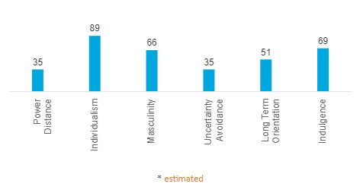

**Figure 1: Hofstede’s Cultural Dimension of the UK**

(Source: hofstede-insights.com, 2023)

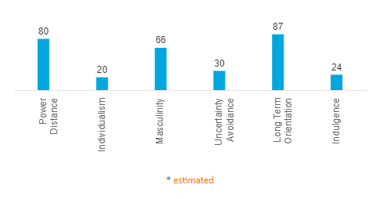

**Figure 2: Hofstede’s Cultural Dimension of China**

(Source: hofstede-insights.com, 2023)

**Cross-Cultural Motivation Strategies for High Performance**

Motivation stands as a crucial component of cross-cultural management, given that cultural disparities can significantly impact what inspires individuals and their reactions towards motivation-based strategies. In comprehending the influence of such cultural disparities on motivation, ***Maslow's Hierarchy of Needs*** can be examined. This framework proposes that individuals possess distinctive tiers of necessities, which consist of physiological requirements, safety-related necessities and a sense of belongingness, esteem-related prerequisites and self-actualisation imperatives (Hopper, 2020). In China, for instance, individuals may prioritise their sense of belongingness over their need for esteem, whereas in the United Kingdom, people may prioritise their need for esteem over their sense of belongingness. This has noteworthy implications for motivation strategies. In China, team-building activities and opportunities for social interaction could prove to be more efficacious in motivating employees, whereas, in the UK, recognition and praise could be more effective.

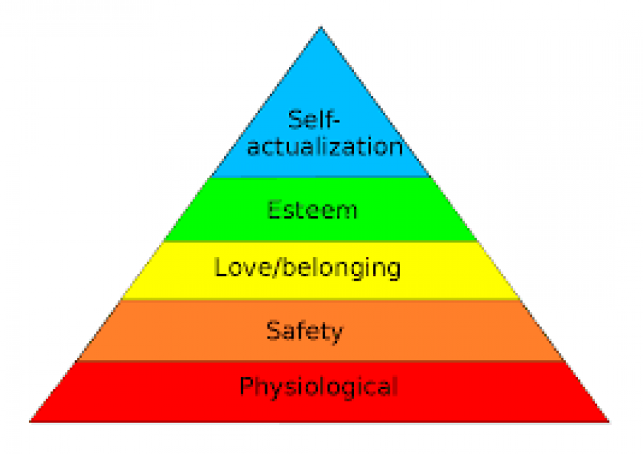

**Figure 3: Maslow’s Hierarchy of Needs**

(Source: ipc-mn.com, 2023)

Leaders must possess the ability to adjust their leadership and motivation techniques based on the cultural context to attain optimum performance in cross-cultural teams. This necessitates the adoption of a global mindset, which requires a disposition that is receptive and considerate of diverse cultural perspectives while being adaptable to specific cultural contexts.

## 3.2. Communications and Negotiating

Effective correspondence is an indispensable ingredient in the triumph of intercultural groups. Notwithstanding, disparities in culture frequently culminate in obstacles to communication that impede its effectiveness.

**Importance of Effective Communication in Cross-Cultural Teams**

Effective communication is an indispensable component in multicultural teams as it enables the establishment of connections, reinforcement of confidence and nurturing of comprehension. Communication facilitates the clarification of team members' expectations, sharing of innovative thoughts, and the resolution of disputes (Morrison-Smith and Ruiz, 2020). When team members communicate in varying dialects or originate from distinct cultural backgrounds, the need for efficient communication is even more critical.

**Communication Barriers and Strategies for Overcoming Them**

Communication obstacles can emerge from divergences in language, communication techniques, and social customs. For instance, some societies appreciate frank communication, while others prefer indirect communication. These variations can create misconceptions and misinterpretations. Group members must first acknowledge the existence of cultural distinctions and their impact on communication to overcome these hindrances. They must then modify their communication style to suit the team's requirements. Strategies to surmount communication barriers comprise:

* ***Active Listening:*** Active listening necessitates paying attention to others' statements, posing clarifying queries, and summarising what has been said (Clark *et al.,* 2019). Active listening assures that group members comprehend each other and can prevent misunderstandings.
* ***Non-Verbal Communication:*** Non-verbal communication can be equally significant as verbal communication in cross-cultural groups. Team members should acknowledge disparities in body language, facial expressions, and tone of voice, and utilise non-verbal hints to support their verbal communication.
* ***Use of Technology:*** Technology can aid in bridging communication barriers by providing translation services, video conferencing, and other collaborative tools (Inan *et al.,* 2020).

**Negotiating Styles in Different Cultures**

Cross-cultural negotiations can exhibit vastly different negotiating styles due to cultural discrepancies. Some cultures view negotiation as a competition, while others view it as a collaborative process. Effective cross-cultural negotiations demand understanding these differences. ***Anxiety and Uncertainty Theory*** suggests that negotiating with individuals from different cultures can lead to anxiety and uncertainty due to differences in communication styles, norms, and values (Bazrafshan and Bashir, 2020). Moreover, ***Face Negotiation Theory*** suggests that people from different cultures can have the motivation to maintain face-saving behaviour during negotiations, and it can impact their negotiating style (Communication Theory, 2014).

For example, negotiations in the UK may follow a direct and concise approach, with an emphasis on achieving an optimal outcome for both parties. However, in China, negotiations may follow an indirect approach, with a focus on cultivating relationships and preserving harmony. Chinese negotiators may be inclined to make concessions to evade losing face or to maintain a positive relationship with the opposing party. To be efficient in cross-cultural negotiations, comprehending the negotiating style of the other party is vital, and one must adjust their approach accordingly. Achieving this requires a profound knowledge of the cultural norms, values, and communication styles of the other party.

## 3.3. Decision Making

Cross-cultural dissimilarities can exert a momentous sway on the verdict-forming procedures of worldwide crews. To efficaciously administer intercultural teams, apprehending how cultural differences can affect decision-making is indispensable. This segment will scrutinise the repercussion of cultural discrepancies in the decision-forming procedures and deliver techniques for effective intercultural decision-forming.

**Cultural Differences and Their Impact on Decision-Making Processes**

Cultural variances possess the capacity to influence the decision-making process in diverse and multifaceted manners. To illustrate, in certain cultures, the decision-making process is characterised by an elevated degree of hierarchy, in which the ultimate decision is bestowed upon the person who holds the most authority. Conversely, in other cultures, the process is typified by a greater degree of collaboration, where the decisions are arrived at through the collective efforts of the group. Moreover, cultural differences can have an impact on the significance accorded to various factors during the decision-making process, including but not limited to individualism vis-à-vis collectivism, risk-taking, and time orientation (Wallenius, Alvinius and Larsson, 2020).

**Cross Cultural Decision Making Strategies for Effective Outcomes**

Effective cross-cultural decision-making is crucial and requires an in-depth understanding of cultural disparities and their influence on the decision-making process. One approach to comprehending such differences involves ***Trompenaars' Seven Dimensions of Culture Model***, which identifies seven cultural dimensions that can impact decision-making (Hannichenko, 2021). These dimensions are universalism versus particularism, individualism versus communitarianism, specific versus diffuse, neutral versus emotional, achievement versus ascription, sequential versus synchronic, and internal versus external control.

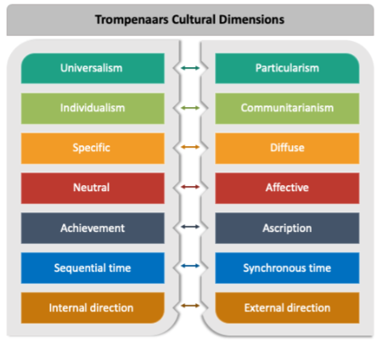

**Figure 4: Trompenaars Cultural Dimensions**

(Source: Created by Author)

Another method that can be used to understand cultural differences is the ***Lewis Model***, which classifies cultures into three groups: linear-active, multi-active, and reactive (Cross Culture, 2019). Each category has a distinct communication and decision-making approach. For instance, linear-active cultures like the UK prioritise punctuality and adherence to schedules, while multi-active cultures like China place a higher value on building relationships and may be more flexible with time.

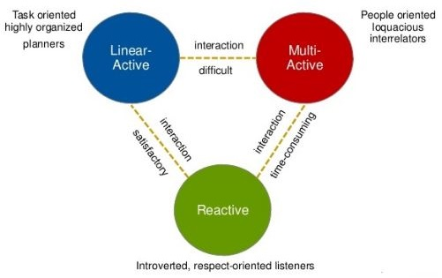

**Figure 5: Lewis Model**

(Source: Created by Author)

It is essential to establish clear communication channels and ensure that every team member has an equal opportunity to contribute to the decision-making process to achieve effective cross-cultural decision-making. Encouraging open communication and providing avenues for feedback and discussion can help overcome any cultural barriers, and ensure that each team member feels appreciated.

## 3.4. Organisational Relationships

Organisational relationships constitute a pivotal facet of cross-cultural management. The establishment and sustenance of these relationships are largely contingent upon the variances in cultural attributes, which have the potential to exert a significant impact on the effectiveness and triumph of cross-cultural teams.

**Cultural Differences and Their Impact on Organisational Relationships**

Culture exerts a significant influence on interpersonal interactions, particularly in an organisational context. Disparities in values, beliefs, and communication patterns in cross-cultural management can breed misunderstandings and strife in organisational relationships. For instance, certain cultures emphasise personal connections and confidence as a means of forging relationships, whereas others rely on formal accords and contracts (Gabel-Shemueli *et al.,* 2019). These disparities can impact how people approach negotiations, collaboration, and decision-making.

Disparities in power distance, individualism-collectivism, and uncertainty avoidance of ***Hofstede's model*** can also play a crucial role in organisational relationships. In high-power-distance cultures, employees may be disinclined to challenge their superiors, resulting in a dearth of inventiveness and novelty. Conversely, in individualistic cultures, workers may fixate more on their aims and interests, rather than the organisation's broader objectives. These disparities can create challenges in cultivating confidence and collaboration within cross-cultural teams.

**Strategies for Managing Cross-Cultural Relationships Effectively**

Cross-cultural relationships can be effectively managed by comprehending and valuing cultural dissimilarities. ***Edward T. Hall's High-Context and Low-Context Culture Theory*** is one model that can aid in this aspect (DONBAYEVA *et al.,* 2019). In high-context cultures, communication is implicit, nonverbal and shared experiences are crucial. Conversely, in low-context cultures, communication is explicit and direct. Recognizing these distinctions can assist managers in customizing their communication style according to the cultural setting, leading to more effective communication and stronger relationships.

The ***GLOBE project***'s study on cultural dimensions is another significant model. This model outlines nine cultural dimensions that can influence organisational relationships, including assertiveness, future orientation and performance orientation (Benson *et al.,* 2020). By understanding these dimensions, managers can adapt their leadership style and decision-making processes to the cultural setting, leading to more effective cross-cultural management.

Trust and personal connections must be established within cross-cultural teams. This can be accomplished by organizing team-building activities, social events, and other initiatives that encourage team members to build personal relationships. By building trust and relationships, cross-cultural teams can work together more effectively, resulting in better outcomes.

A case in point of managing cross-cultural relationships effectively is the partnership between a UK-based engineering firm and a Chinese manufacturing company. The UK firm recognised the importance of building trust and relationships with its Chinese partners. Hence, they dispatched a team to China to meet with the manufacturing company's leadership and tour their facilities. The UK team also invited the Chinese team to visit their facilities in the UK and participate in team-building activities. Through these initiatives, the two teams were able to establish personal connections and build trust, resulting in a successful partnership.

# 4. Conclusion

This report delves into the subject of cross-cultural management and its applicability to management and organisational behaviour concerns. The initial segment highlights the disparities between cross-cultural management and international management, underlining the need to grasp the cultural differences associated with governing global organisations. The latter section examines the primary concerns when it comes to understanding cultural differences that influence leadership and motivation, communication and negotiation, decision-making, and organisational relationships in managing cross-cultural teams. In sum, a thorough comprehension of cross-cultural management's fundamental concepts and strategies is essential to achieve the desired outcomes when managing a diverse group of individuals.

Effective management of global organisations is greatly impacted by cultural differences as it influences all aspects of organisational behaviour. Understanding these differences is made possible through the Hofstede Model and Maslow's Hierarchy of Needs which are valuable tools that shed light on how culture impacts leadership and motivation. Communication and negotiating styles are also shaped by cultural differences, as explained by the Anxiety and Uncertainty Theory and Face Negotiation Theory. Moreover, fruitful outcomes can be achieved by employing cross-cultural decision-making strategies and implementing effective strategies for managing cross-cultural relationships.

# 5. Reference List

Abdeldayem, M.M., Aldulaimi, S.H. and Alazzawi, A., (2022), March. Leadership Cultural Intelligence to Improve Decision Making Process in Cross-Cultural Work Atmosphere. In *2022 International Conference on Decision Aid Sciences and Applications (DASA)* (pp. 1182-1191). IEEE.

Aguilera, R.V. and Grøgaard, B., (2019). The dubious role of institutions in international business: A road forward. *Journal of International Business Studies*, *50*, pp.20-35.

Bazrafshan, M. and Bashir, H., (2020). Anxiety/Uncertainty Management in Intercultural Communication with Sunnis: a Narrative Study. *Socio-Cultural Strategy*, *9*(3), pp.35-70.

Benson, G.S., McIntosh, C.K., Salazar, M. and Vaziri, H., (2020). Cultural values and definitions of career success. *Human Resource Management Journal*, *30*(3), pp.392-421.

Chatzipanagiotou, K., Christodoulides, G. and Veloutsou, C., (2019). Managing the consumer-based brand equity process: A cross-cultural perspective. *International Business Review*, *28*(2), pp.328-343.

Clark, L.T., Watkins, L., Piña, I.L., Elmer, M., Akinboboye, O., Gorham, M., Jamerson, B., McCullough, C., Pierre, C., Polis, A.B. and Puckrein, G., (2019). Increasing diversity in clinical trials: overcoming critical barriers. *Current problems in cardiology*, *44*(5), pp.148-172.

Communication Theory, (2014). *Face-Negotiation Theory*. [online] Communication Theory. Available at: <https://www.communicationtheory.org/face-negotiation-theory/> [Accessed 28 Apr. 2023].

Cross Culture, (2019). *The Lewis Model – Dimensions of Behaviour | Cross Culture*. [online] Crossculture.com. Available at: <https://www.crossculture.com/the-lewis-model-dimensions-of-behaviour/> [Accessed 28 Apr. 2023].

DONBAYEVA, A.B., JAMASHEVA, J.R., SHYNYBEK, S.M. and UITANOVA, G.M., (2019). HIGH-CONTEXT AND LOW-CONTEXT CULTURES. In *Лучшая студенческая статья 2019* (pp. 182-186).

Fisher, D., (2021). Educational Leadership and the Impact of Societal Culture on Effective Practices. *Journal of Research in International Education*, *20*(2), pp.134-153.

Gabel-Shemueli, R., Westman, M., Chen, S. and Bahamonde, D., (2019). Does cultural intelligence increase work engagement? The role of idiocentrism-allocentrism and organizational culture in MNCs. *Cross Cultural & Strategic Management*, *26*(1), pp.46-66.

Gallardo-Gallardo, E., Thunnissen, M. and Scullion, H., (2020). Talent management: context matters. *The International Journal of Human Resource Management*, *31*(4), pp.457-473.

Hannichenko, T., (2021). Сross-cultural negotiations in English. The seven dimensions of culture.

Haque, A.U. and Yamoah, F.A., (2021). The role of ethical leadership in managing occupational stress to promote innovative work behaviour: A cross-cultural management perspective. *Sustainability*, *13*(17), p.9608.

Hendricks, A.J., Hsiao, J.L., Lowes, M.A. and Shi, V.Y., (2021). A comparison of international management guidelines for hidradenitis suppurativa. *Dermatology*, *237*(1), pp.81-96.

Hopper, E., (2020). Maslow’s hierarchy of needs explained. *ThoughtCo, ThoughtCo*, *24*, pp.1-3.

Htun, K.M.M. and Kim, S., (2021). Impact of organization development intervention on employee motivation, employee engagement, career success and job security towards employee turnover intentions in a telecommunication company in Myanmar. *International Journal of Innovative Science and Research Technology*, *6*(1), pp.840-852.

Huhtala, M., Fadjukoff, P. and Kroger, J., (2021). Managers as moral leaders: Moral identity processes in the context of work. *Journal of Business Ethics*, *172*, pp.639-652.

Inan, O.T., Tenaerts, P., Prindiville, S.A., Reynolds, H.R., Dizon, D.S., Cooper-Arnold, K., Turakhia, M., Pletcher, M.J., Preston, K.L., Krumholz, H.M. and Marlin, B.M., (2020). Digitizing clinical trials. *NPJ digital medicine*, *3*(1), p.101.

Jackson, T., (2020). The legacy of Geert Hofstede. *International Journal of Cross Cultural Management*, *20*(1), pp.3-6.

Jain, T. and Pareek, C., (2019). Managing cross-cultural diversity: issues and challenges. *Global Management Review*, *13*(2), pp.23-32.

Jhaiyanuntana, A. and Nomnian, S., (2020). Intercultural communication challenges and strategies for the Thai undergraduate hotel interns. *PASAA: Journal of Language Teaching and Learning in Thailand*, *59*, pp.204-235.

Liu, X., (2019). The role of enterprise risk management in sustainable decision-making: A cross-cultural comparison. *Sustainability*, *11*(10), p.2939.

Morrison-Smith, S. and Ruiz, J., (2020). Challenges and barriers in virtual teams: a literature review. *SN Applied Sciences*, *2*, pp.1-33.

Osborn, P.R. and Karandikar, S., (2022). Practice-based knowledge perspectives of cultural competence in social work. *Journal of Ethnic & Cultural Diversity in Social Work*, pp.1-13.

Peng, M.W., (2021). *Global strategy*. Cengage learning.

Shams, R., Vrontis, D., Belyaeva, Z., Ferraris, A. and Czinkota, M.R., (2021). Strategic agility in international business: A conceptual framework for “agile” multinationals. *Journal of International Management*, *27*(1), p.100737.

Sharma, P., Leung, T.Y., Kingshott, R.P., Davcik, N.S. and Cardinali, S., (2020). Managing uncertainty during a global pandemic: An international business perspective. *Journal of business research*, *116*, pp.188-192.

Szkudlarek, B., Osland, J.S., Nardon, L. and Zander, L., (2020). Communication and culture in international business–Moving the field forward. *Journal of World Business*, *55*(6), p.101126.

Tengimfene, A., (2020). Effectively managing in cross-cultural business environments of multinational companies (Doctoral dissertation, University of Pretoria).

Usmonov, M., (2021). International and National Legal Base in the Field Of Information Security. *Scienceweb academic papers collection*.

Wales, W., Gupta, V.K., Marino, L. and Shirokova, G., (2019). Entrepreneurial orientation: International, global and cross-cultural research. *International Small Business Journal*, *37*(2), pp.95-104.

Wallenius, C., Alvinius, A. and Larsson, G., (2020). Decision-making in a military staff context: A qualitative study on norms, challenges and difficulties. *Res Militaris*, *10*(1).