**THE IMPACT OF AI ON CUSTOMER EXPERIENCE AND RETENTION IN THE RETAIL INDUSTRY**

**Table of Contents**

1.0 Introduction 3

1.1 Introduction of the topic 3

1.2 Research question 3

2.0 Goal of the project and its benefits 3

2.1 Goal of project 3

2.2 Potential benefits 4

3.0 State of the art through literature review 5

4.0 Proposed methodology 7

4.1 Research design 7

4.2 Research sampling 7

4.3 Data collection and analysis 7

5.0 Project management (including risk assessment) 8

6.0 Ethical implications 12

7.0 Requirements and feasibility 13

7.1 Project requirements 13

7.2 Feasibility 13

8.0 Project plan 14

8.1 Identification of task with time bound 14

8.2 Gantt chart 15

9.0 References 16

10.0 Appendices 18

# 1.0 Introduction

## 1.1 Introduction of the topic

The proposal will give significant insights about the influence of artificial intelligence (AI) on customer experience and retention in the retail industry, as well as practical advice for retailers wanting to deploy AI technology. The aim and objective will discuss the segment of question for the problem to be found out and provide its solution to it. In addition to it, the benefit of this project is also connected with l;iterature reviews that prove woil;l be given to clarify the provided information onwards.

## 1.2 Research question

* How AI will improve customers' retail shopping experiences?
* How does the use of technologies related to AI in the retail industry affect customer trust and privacy concerns?
* What strategies can retailers use to address customer experience retention?

# 2.0 Goal of the project and its benefits

## 2.1 Goal of project

The primary goal of this project is to explore and assess the AI role on customer experience and retention in the retail business, with an emphasis on understanding how AI-powered solutions may be used to improve consumer engagement, loyalty, and satisfaction. The project's goal is to give retail firms with information and advice on how to successfully incorporate AI into their customer service and marketing strategies in order to enhance overall customer experience and customer retention rates.

**Objectives**

* To examine the AI role on customer experience and retention in the retail industry through the analysis of case studies and data.
* To identify the key drivers of customer experience and retention in the retail industry and understand how AI can be used to enhance these drivers.
* To provide recommendations for retail businesses on how to effectively integrate AI into their customer service and marketing strategies to improve overall customer experience and increase customer retention rates.
* To evaluate the potential risks and limitations of implementing AI in the retail industry and provide recommendations for mitigating these risks.
* To do primary analysis using Excel for analysis participant answers for utlizing information.

## 2.2 Potential benefits

Marin-Garcia, *et al.* (2022) has figured out that AI-powered chatbots integrated into e-commerce platforms can deliver faster and more personalised customer assistance, resulting in a better overall consumer experience. Chatbots may assist customers in swiftly locating information such as product details or shipment timeframes, as well as providing immediate responses to typical concerns (Marin-Garcia, *et al.* 2022). Chatbots can also help customers with personalised product recommendations based on their tastes and purchasing history, making their shopping experience more convenient and entertaining.

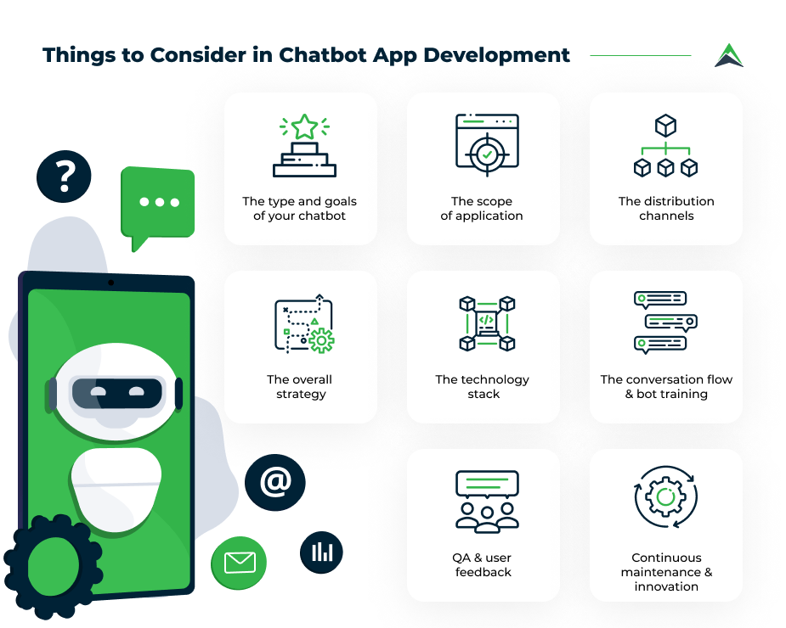

**Figure 1: Chatbot solution**

(Source: https://s3.easternpeak.com)

By providing great customer service, e-commerce businesses may increase client loyalty and retention. Chatbots can provide consistent, high-quality customer service, reducing client attrition. Chatbots may also gather customer feedback and provide follow-up assistance, building a positive relationship between the client and the business (Li, *et al.* 2023). It can manage a high volume of client enquiries and complaints with ease, decreasing the effort of human customer care employees and thus saving operational expenses. This can assist firms in allocating resources more efficiently and reducing the need for extra customer care personnel.

# 3.0 State of the art through literature review

According to Nicolescu, and Tudorache, (2022) utilization of AI in personalized customer service and after-sales support has a significant impact on customer experience, as seen in Figure. AI can also reduce customer wait times in call centres and post-sale services. Although AI is rapidly advancing, it should aid humans rather than replace them. Businesses must invest in and manage AI-driven processes to improve customer satisfaction throughout the customer journey, with mobile ordering being the most impactful change (Nicolescu, and Tudorache, 2022). AI get access to technologies such as big data analytics, and the recommendation systems, with conversational agents can enhance customer experience in various service industries.

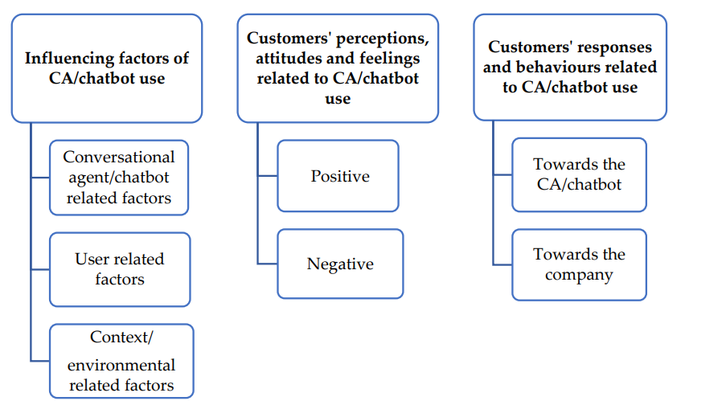

**Figure 2: Public experiences with AI and chat bot**

(Source: Nicolescu, and Tudorache, 2022)

Limna (2022) mentioned that the hospitality industry has the potential to improve customer experience and retention by providing personalized services, efficient customer support, optimized pricing, and proactive maintenance. AI can provide 24/7 customer support, reducing wait times and allowing customers to receive assistance at any time of day. It can help businesses to handle customer inquiries and complaints more efficiently, and can reduce the risk of customers becoming frustrated or abandoning their purchase due to long wait times (Limna, 2022). Chatbots may collect useful data about client preferences and behaviour, allowing e-commerce enterprises to enhance their marketing and sales tactics. They may monitor consumer interactions, such as commonly asked questions and purchase behaviours, and provide businesses with important data that can be utilised to improve marketing campaigns and product offers.

According to KUNAL, *et al* (2023) The results of the author showed that AI has an effective positive impact on customer service retention in the telecom industry. Authors have found that AI-based customer service solutions like IVR automation, automation with robotic processes, and machine learning can enhance customer satisfaction, reduce customer complaints, and improve customer loyalty. The authors also identified several factors that could influence the effectiveness of AI-based customer service in the telecom industry (KUNAL, *et al* 2023). These factors include the quality of AI algorithms and models used, the level of human oversight and intervention, and the degree of personalization and customization of AI-based solutions. On the other hand, customers who perceived AI-based customer service as impersonal, insensitive, and unhelpful were more likely to switch to another service provider.

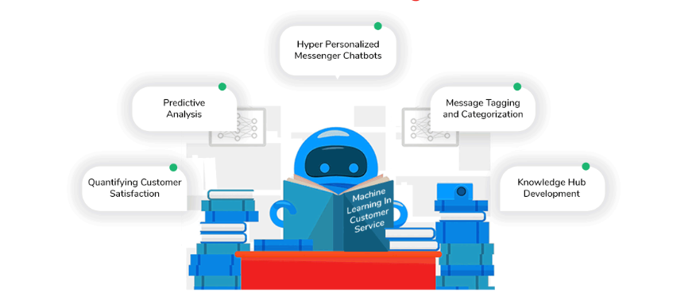

**Figure 3: Machine learning**

(Source: https://global-uploads.webflow.com)

# 4.0 Proposed methodology

## 4.1 Research design

Because this study will gather data from a particular moment in time, the research methodology will be ***cross-sectional and descriptive.*** To obtain primary data from customers of various retail businesses that employ AI technology to improve customer experience and retention, a survey questionnaire will be deployed (Chen, *et al.* 2021). To assess client happiness and retention, the survey will include multiple-choice questions and rating scales.

## 4.2 Research sampling

The study's target group will be ten consumers of retail businesses that apply AI technology in their operations. The sample will be chosen using a ***purposive quantitative approach***, with individuals chosen based on particular factors such as age, gender, and purchasing habits (Campbell, *et al.* 2020). The sample will consist of ten clients from various retail businesses that employ AI technology.

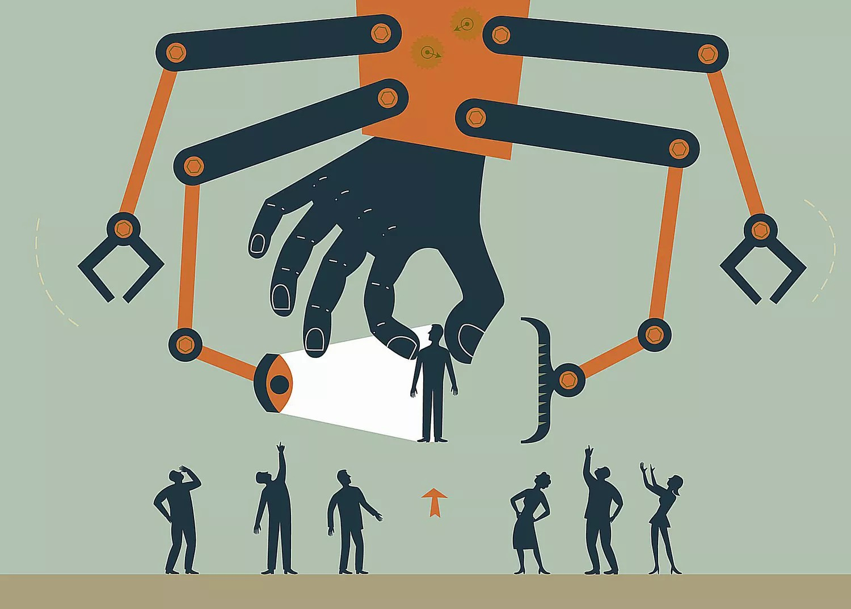

**Figure 4: Purposive quantitative sampling**

(Source: <https://www.thoughtco.com>)

## 4.3 Data collection and analysis

Customers will be given survey questionnaires at retail outlets and asked to respond to specific questions. The self-administered survey inquiry will take around 10-15 minutes to complete. Survey approaches will be used to distribute the questionnaire. The quantitative study will be analysed using the Excel programme (Marin-Garcia, *et al.* 2022). The graphical chart and their % evaluation can reveal connections between certain question responses. As a result, numerical representations will give useful information for shops adopting AI technology to improve their consumer experience and retention.

# 5.0 Project management (including risk assessment)

***Project Initiation:***

In this proposal identification of the objective can bring the several scope and finding out limitations of the project will inflow a greater area to connect with this project (Ford, and Lyneis, 2020). After that ***stakeholders*** will be found out to consider their involvement as they are the main resources for the budget and maintain all resources required for the project.

***Project Planning:***

After defining proposal goals and objectives ***work breakdown structure (WBS)*** will be created through proposal requirement elements (Marin-Garcia, *et al.* 2022). Elements then cover required tasks to be allocated within this time with each team member's roles and responsibility. Risk will be identified then for measuring controlling budget with ***communication plan and standard solution*** over these issues or risks. ***[Refer to Appendix 1]***

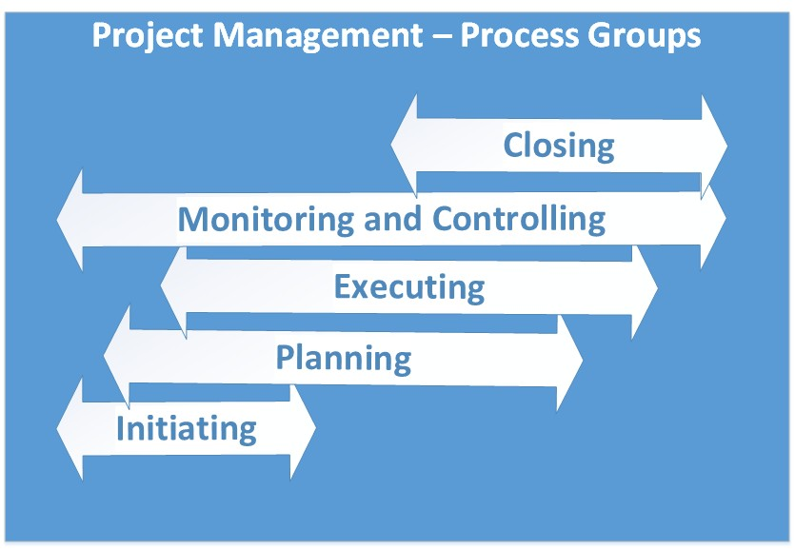

**Figure 5: Project management steps**

(Source: <https://codesteps.com>)

***Project Execution:***

Assigning each task to team members project progress can be figured out with approaching theory of adjustment too. Quality measurement process can solve quality standards process through project resources management effectively (Ford, and Lyneis, 2020). The team managers and organisers have to take care of all issues or conflicts that arise during project progress.

***Project Monitoring and Controlling:***

Project planning would be met while collecting participants' responses and collecting data about questions to identify potential issues and develop solutions on it (Ford, and Lyneis, 2020). Therefore, tracing project issues, planning of adjustment will also be needed.

***Project Closing:***

Next, conducting a final project review through a ***risk assessment process*** will help to obtain feedback from stakeholders about competing inbound and outsourcing tasks (Schmitt, 2023). Managing budget through allocating each resource will lead team members to a greater area to feel proud of.

|  |  |  |  |  |
| --- | --- | --- | --- | --- |
| **Risk Description** | **Impact** | **Likelihood** | **Severity** | **Mitigation Strategy** |
| Insufficient data quality | High | Medium | High | Implement data quality checks, perform regular data audits, and establish data governance processes to ensure that data is accurate and reliable. |
| Privacy of data and breaches of security | High | Low | High | Implement robust data privacy and security measures, including encryption, access controls, and regular security audits, to protect customer data. |
| AI algorithm bias | High | Medium | High | Establish guidelines for ethical AI development and testing, including identifying and mitigating algorithm bias. Use diverse and representative training data to reduce the risk of bias. |
| Poor user experience | High | Medium | High | Conduct user testing and incorporate feedback into AI development processes to improve user experience. Regularly monitor user feedback to identify and address issues quickly. |
| Resistance to AI adoption | High | Medium | High | Provide training and support to employees to build their AI skills and understanding (Schmitt, 2023). Communicate the benefits of AI to customers and build trust by being transparent about AI use. |
| Inadequate investment in AI | High | High | High | Develop a clear business case for AI investment, including expected ROI and impact on customer experience and retention (Yuen, *et al.* 2023). Establish a budget for AI development and implementation, and monitor ROI regularly to ensure that investment is justified. |
| Lack of integration with existing systems | High | Medium | High | Conduct a thorough assessment of existing systems and ensure that AI solutions can be integrated effectively (Schmitt, 2023). Establish clear integration requirements and conduct testing to ensure that data can be transferred seamlessly between systems. |

**Table 1: Risk Assessment**

(Source: Self-created)

# 6.0 Ethical implications

Retailers should be sure about using customer data transparently and ethically. AI systems must not infringe on the privacy of customers, and retailers must obtain customer consent before collecting and using their data (Yuen, *et al.* 2023). AI systems can unintentionally perpetuate or even amplify existing biases, leading to unfair treatment of customers. Retailers must ensure that their AI systems are designed to eliminate any biases in the data used to train them.

Customers must be informed when they are interacting with an AI system, and the system's limitations must be made clear. The use of AI systems should not be a way for retailers to avoid human responsibility (Schmitt, 2023). The use of AI in the retail industry can lead to the displacement of human workers. Retailers must consider the ethical implications of automating tasks that were previously performed by humans and ensure that they take steps to mitigate the impact on their employees. AI systems can be designed to manipulate customer behaviour, such as persuading them to buy more products or spend more time in the store (Schmitt, 2023). Retailers must ensure that their AI systems do not manipulate customers in unethical ways.

# 7.0 Requirements and feasibility

## 7.1 Project requirements

Here for this proposal of this topic, data collection tools must be employed, that is ***survey. Questionnaires*** must be well-designed and contain relevant questions to obtain meaningful insights (Christensen, *et al.* 2020). Not only that, excel software must be reliable and suitable for analyzing the data collected. After that, the 10 participants are highly needed within the given time 24 th April 2023.

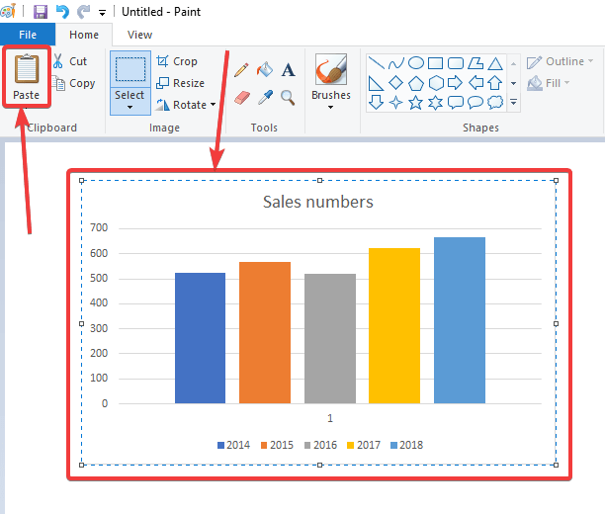

**Figure 6: Using Excel to process executed data**

(Source: <https://www.how2shout.com>)

## 7.2 Feasibility

For measuring feasibility the first step will be knowing the availability of 10 participants in various retails sectors. Consulting organizations will make the data collection and analysis process less time-consuming and feasible within the available time frame. So, the proposed project can be completed within a reasonable time (Dominique-Ferreira, *et al.* 2023). The survey can be conducted within a few weeks, and the data can be analyzed using excel within a few days.

# 8.0 Project plan

## 8.1 Identification of task with time bound

|  |  |  |  |  |
| --- | --- | --- | --- | --- |
| **Task Name** | **Duration** | **Start** | **Finish** | **Predecessors** |
| Research on AI in retail industry | 5 days | Thu 3/16/23 | Wed 3/22/23 |  |
| Identify customer experience & retention metrics | 4 days | Thu 3/23/23 | Tue 3/28/23 | 1 |
| Identify AI solutions for customer experience & retention | 3 days | Wed 3/29/23 | Fri 3/31/23 | 2 |
| Develop customer experience & retention metrics evaluation | 4 days | Mon 4/3/23 | Thu 4/6/23 | 3 |
| Evaluate impact of AI on customer experience & retention | 3 days | Fri 4/7/23 | Tue 4/11/23 | 4 |
| Develop final report on findings | 2 days | Wed 4/12/23 | Thu 4/13/23 | 5 |
| Review and revise report | 4 days | Fri 4/14/23 | Wed 4/19/23 | 6 |
| Finalize report and submit | 3 days | Thu 4/20/23 | Mon 4/24/23 | 7 |

**Table 2: Time Horizon**

(Source: Self-created)

According to the table, from Thu 3/16/23 - Wed 3/22/23 in the duration of 5 days research on AI significance must be done including its current state, trends, and potential use cases (Bulchand-Gidumal, 2022). Later, Identify Customer Experience & Retention Metrics will be accessed from Thu 3/23/23 to Tuesday 3/28/23, because identifying appropriate metrics is important for ensuring that the project is focused on the right areas and that the evaluation is comprehensive and accurate. Identification of the solution will be connected from Wed 3/29/23 to Fri 3/31/23 to make the project feasible (Schmitt, 2023). Next task will evolve with retention metrics from Mon 4/3/23 to Thu 4/6/23 through a plan that is important for ensuring that the evaluation is systematic and that the results are reliable and valid. Next, connecting evaluating solutions is projected or not from 4/7/23 to 4/11/23 for determining whether the AI solutions identified are effective in achieving the project goal (Jin, *et al.* 2023). Later developing final report results of the project to stakeholders and for informing future decisions. It will be done from 12th april to 13 th april 2023. Finally, reviewing the report will help it be completed on time and that stakeholders have access to the project findings and recommendations. In addition to it, finalising this proposal will be done 24 th April 2023 onwards.

## 8.2 Gantt chart



**Figure 7: Time frame**

(Source: self-created in MS project)

Depending on the tasks evaluated in the tabul;ar format is described here in the ***MS project*** software. All the tasks are taken within a specific time limit to clarify the next step for this proposal to take care with. Therefore, the whole project will bring success with deportation of topic information in a broad manner.

# 9.0 References

Bulchand-Gidumal, J., 2022. Impact of artificial intelligence in travel, tourism, and hospitality. In *Handbook of e-Tourism* (pp. 1943-1962). Cham: Springer International Publishing.

Campbell, S., Greenwood, M., Prior, S., Shearer, T., Walkem, K., Young, S., Bywaters, D. and Walker, K., 2020. Purposive sampling: complex or simple? Research case examples. *Journal of research in Nursing*, *25*(8), pp.652-661.

Chen, J.S., Le, T.T.Y. and Florence, D., 2021. Usability and responsiveness of artificial intelligence chatbot on online customer experience in e-retailing. *International Journal of Retail & Distribution Management*, *49*(11), pp.1512-1531.

Christensen, A.P., Golino, H. and Silvia, P.J., 2020. A psychometric network perspective on the validity and validation of personality trait questionnaires. *European Journal of Personality*, *34*(6), pp.1095-1108.

Dominique-Ferreira, S., Gomes, H., Brito, P.Q. and Prentice, C., 2023. Exploring the Role of Emotional Intelligence and Artificial Intelligence on Luxury Value and Customer-Based Outcomes. In *Perspectives and Trends in Education and Technology: Selected Papers from ICITED 2022* (pp. 543-554). Singapore: Springer Nature Singapore.

Ford, D.N. and Lyneis, J.M., 2020. System dynamics applied to project management: a survey, assessment, and directions for future research. *System Dynamics: Theory and Applications*, pp.285-314.

International Journal of Computing Sciences Research. Advance online publication.

Jin, Y.H., Ueltschy Murfield, M.L. and Bock, D.E., 2023. Do as you say, or I will: Retail signal congruency in buy‐online‐pickup‐in‐store and negative word‐of‐mouth. *Journal of Business Logistics*, *44*(1), pp.37-60.

KUNAL, K., RAMPRAKASH, K., ARUN, C.J. and XAVIER, M., 2023. A BEHAVIOURAL STUDY ON THE IMPACT OF ARTIFICIAL INTELLIGENCE ON CUSTOMER SERVICES RETENTION IN TELECOM INDUSTRY. Russian Law Journal, 11(5s).

Li, L., Lin, J., Luo, W. and Luo, X.R., 2023. INVESTIGATING THE EFFECT OF ARTIFICIAL INTELLIGENCE ON CUSTOMER RELATIONSHIP MANAGEMENT PERFORMANCE IN E-COMMERCE ENTERPRISES. *Journal of Electronic Commerce Research*, *24*(1), pp.68-83.

Limna, P. (2022). Artificial Intelligence (AI) in the hospitality industry: A review article.

Marin-Garcia, A., Gil-Saura, I. and Ruiz-Molina, M.E., 2022. Do innovation and sustainability influence customer satisfaction in retail? A question of gender. *Economic Research-Ekonomska Istraživanja*, *35*(1), pp.546-563.

Nicolescu, L. and Tudorache, M.T., 2022. Human-Computer Interaction in Customer Service: The Experience with AI Chatbots—A Systematic Literature Review. *Electronics*, *11*(10), p.1579.

Schmitt, M., 2023. Big Data Analytics in the Metaverse: Business Value Creation with Artificial Intelligence and Data-Driven Decision Making. *Available at SSRN 4385347*.

Yuen, K.F., Ng, W.H. and Wang, X., 2023. Switching intention in the online crowdsourced delivery environment: The influence of a platform's technological characteristics and relational bonding strategies. *Technology in Society*, *72*, p.102167.

# 10.0 Appendices

**Appendix 1: Strategies for improvement**

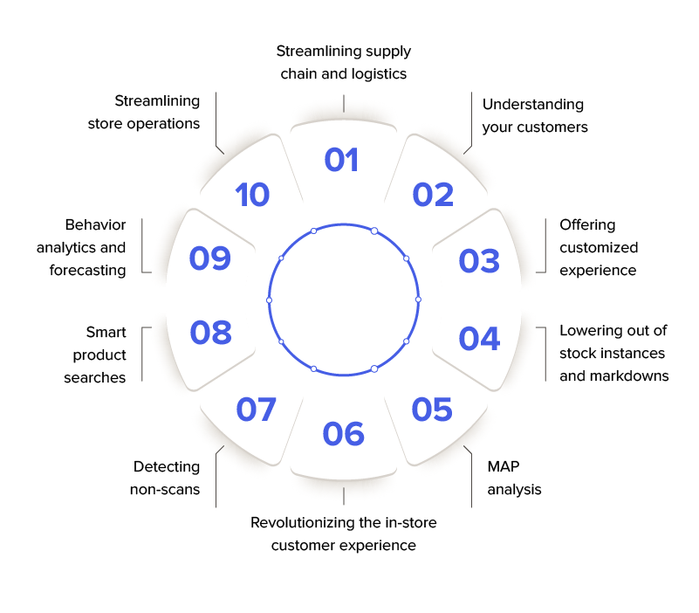

(Source: Self-created)