**UNDERSTANDING INTERNATIONAL BUSINESS OF TESCO PLC.**

**Executive summary**

The proposed report evaluates existing market conditions of Tesco in order to evaluate its market expansion consideration. The current operations of the company have been linked with one of the popular theories of internationalisation which is The Uppsala model. A further evaluation has been made on the markets Tesco can expand into in the future. It is found that the company had operations in the USA and Japan; and was forced to retract from the countries due to reasons. Thus, an evaluation of the environment of these countries has been made to understand current conditions of the situation. Based on the evaluation a possible market entry solution has also been presented as recommendations. For USA Tesco has been suggested licensing strategy while for Japan, a joint-venture is expected to be best-suited.

**Table of Contents**

1. Introduction 4

2. Theory of Internationalisation 4

2.1 Theory of internationalisation 4

2.2 Context of foreign market operation of Tesco 5

3.Potential Markets and Suitable Entry Modes 7

3.1 PESTLE of USA 7

3.2 PESTLE of Japan 9

3.3 Justification of the choices 11

3.4 Suitable entry mode 12

4. Conclusion 13

Reference list 14

Appendices 18

Appendix 1: USA federal tax rate over the years 18

Appendix 2: US GDP rate increase 19

Appendix 3: IT sector development of USA 20

Appendix 4: Japan corporate tax rate over the years 21

# 1. Introduction

Internationalisation or globalisation of business is the consideration of expansion of flow of services, goods, people, capital and ideas outside national borders for better profit generation. The companies subjecting themselves to globalisation and outside national borders are known as multinational companies or MNCs. Tesco is a retail company having its origin in the UK. Currently, the company operates in 12 countries altogether, with about 4,752 global stores as of the global market of 2022 (Globaldata.com, 2023). An expansion evaluation of the company will be considered in this report with targets being the USA and Japan. The country already had operations in these counties, however had left recently due to market conditions. Thus, a re-entry in these markets can be evaluated while concerning current market conditions. The context of the report is to evaluate USA and Japan markets and rationalise modes of re-entry in the markets for Tesco.

# 2. Theory of Internationalisation

## 2.1 Theory of internationalisation

The Uppsala model is a theoretical model based on the steps of internationalisation of a firm. The core application of this model is to evaluate the process through which companies intensify their activities and investments in foreign markets. The model elaborates the steps a firm should take as a part of a sequential approach to increment their internationalisation expansion practices. The model has successfully distinguished between different modes of entering into an international market. The successive stages evaluated in the model represent steps of higher degrees of international involvement and market commitment a company should endure (Hult *et al*. 2020). The four gradual stages of the model include No regular export actions (sporadic export), Independent representative-based export, foreign sales subsidiary establishment, and Establishment of foreign production.

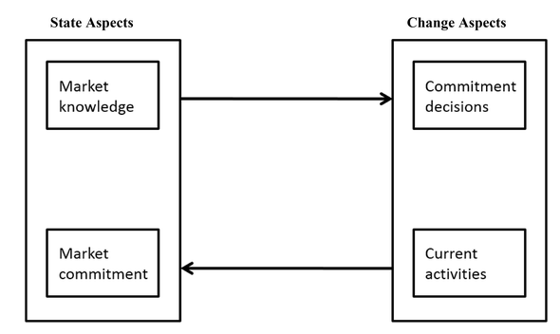

**Figure 1: Steps in Uppsala model**

(Source: Inspired by Hult *et al*. 2020)

These four stages however, do not account for regular export activities and deals with knowing a market with the process of experiential learning. Thus, the companies can utilise and use the resources in a better way. The model also concerns exploring the market through independent agents which is a preferred and suitable way of most firms entering new markets (Arvidsson and Arvidsson, 2019). Moreover, the model reflects upon four main aspects of internationalisation of a firm. A company first gathers ***market knowledge***; makes commitment decisions, and engages in ***suitable activities*** that lead them to a full market commitment. However, like most of the internationalisation models it too has its advantages and drawbacks.

The main advantages of the model are that it deals with the indirect product exporting by the help of external merchants or export agents. It also evaluates low-cost entry methods which are the quickest way to entering a new market. The establishment of foreign sales subsidiaries can help increase customer base and increase sales in a much quicker manner and also help maintain the cultural factors in the environment. One of the main drawbacks of evaluation through this model is that occasional export of goods can divert the customer's interests (Kim *et al*. 2020). Lack of knowledge of phases of export can hamper intra-organisational learning processes and can create halts in organisational growth. The model does not acknowledge any human resource development programs which are crucial for development of any organisation from an operational level. Thus, this model is somewhat inappropriate to apply to relatively small firms having existing psychic distance.

## 2.2 Context of foreign market operation of Tesco

Tesco Plc had its primary existence in the UK. Only in the 1990’s did the company start expanding internationally. It started its international expansion strategy by first targeting local EU countries. The company ventured into central Europe first and then the company targeted Asia and the US. Despite significant chances of global expansion, the company faced challenges regarding diversity in customer demands, variability of cultures and declining sales in different markets. One of the challenges was the price differences of local and global brands (Zim and Zahan, 2019). As per The Uppsala model, the company had gathered significant market knowledge and made commitment decisions according to it. However, in their active involvement the company had not acquainted themselves with the changes in the market with time. Thus, despite having a significant market commitment, the company faced challenges and were retrieved from several countries.

In an expansion process to different countries, the main thing to consider is the external environmental distance of the two countries. This accounts for economic distance, political distance, cultural distance and technological distance (Krummel, 2022). For expanding in countries like Indonesia Tesco adapted to equity or FDI investment related models such as Joint ventures and wholly owned subsidiary considerations. Thus, Greenfield and acquisitions are the process of entry of Tesco in Indonesia. This was useful as the company had been able to gain sufficient market knowledge and openness restrictions of FDI investments in some foreign countries such as this. This knowledge helped them to co-create operations along with companies of Indonesia.

However, Tesco failed to develop a competitive market analysis of China in their internationalisation in the market. As per the second stage of Uppsala model, the company failed to make suitable commitment decisions in spite of a proper market analysis (Woohyoung *et al.* 2020). The study suggests that the Chinese local market of RT-Mart was more successful than Tesco in factors like product delivery, location, employee services and brand recognition. This only proves the fact established in the Uppsala model that change aspects such as commitment decisions should not be made before proper evaluation of the primary state aspect, which is market knowledge.

On the contrary, Tesco has been able to fully internationalise in several countries using strategies that are aligned with the Uppsala model’s four stages. For example, in south Asian countries like India, Tesco has been dynamically operating based on a proper evaluation and expansion strategy in the market. Kar *et al.* (2021) suggests that the rapid expansion of retail due to urbanisation in India, has presented Tesco a less competitive market. In policy reformation during the period of 2014-19 in India, presented Tesco a better opportunity. The World bank acknowledged India’s retail reform measure guaranteed the stopping of Tesco in the market and made commitment decisions as per Uppsala model. The reforming of GDP in the country also helped in Tesco’s decision making as well.

# 3.Potential Markets and Suitable Entry Modes

## 3.1 PESTLE of USA

|  |  |  |
| --- | --- | --- |
| **Elements** | **Analysis** | **Effect** |
| **Political** | * Corporate tax rate of the federal government has dropped to 21% since 2014 from being 35% and stayed the same since then (Tradingeconomics.com, 2023). * Government shows support for businesses by lowering the federal tax rate. | Better business support.  Positive |
| **Economic** | * Except for a sudden decline in 2010, the GDP rate of the country has been rising. * US GDP in 2021 was about $23,315.08 billion (Macrotrends.net, 2023). * This was a 10.71% increase from the previous year * Greater GDP means better investments | Better business investment.  Positive |
| **Social** | * Population has been steadily increasing and is currently at 339,996,563 in 2023. * It is a 0.5% increase from 2022 (Macrotrends.net, (2023). * As per World bank data, per capita income is about 70,480 PPP dollars as last seen in 2021 (Datacommons.org, 2023). | More customers.  Positive |
| **Technological** | * The IT industry revenue is expected to reach $440.20 by the end of 2023 (Statista.com, 2023). * A further annual growth of 6.25% is expected by 2027. | Better innovation.  Positive |
| **Legal** | Business formation in USA and the common entry types include:   * Sole proprietorship * Limited Partnership * General Partnership * Corporation * Limited Liability Limited Partnership (LLLP) * Limited Liability Company (LLC) * Non-profit Corporation * Both internal and foreign business is protected by Federal Integrated Business Framework (FIBF) (Gsa.gov, 2023). | Lots of options for entry. Positive |
| **Environmental** | * Environmental guidelines for businesses are governed by Resource Conservation and Recovery Act (RCRA) (Law.cornell.edu, (2023). * Carbon emission reduction rate is 7% since 1990 being 13.2 trillion pounds in 2020 (Epa.gov, (2023). | Proper EV guideline, pressure for carbon emission reduction. Positive |

**Table 1: PESTLE analysis of USA**

**(**Source: self-developed)

Tesco already had established a market in the USA. However, left the market in 2013, the company had about 208 stores in the market at its operational peak. However due to the company’s own small store format, improper customer research, food packaging related concerns and poor store locations, Tesco was forced to exit (Castusglobal.com, 2022). Due to the conditions the company also lost about $1.6 billion USD in the market as well. However, the current conditions have changed significantly as the tax rate has dropped increasing support for the businesses by the government.

***[Referred to appendix 1]***

The federal tax rate reducing to 21% from 35% since 2014 will provide a better revenue generation consideration with lowering of expenses (Tradingeconomics.com, 2023). Lowering of expenses may slowly recover the revenue lost in the market previously and the company can ensure better operational investments. Economically the growth of GDP of the country will mean better government support of revenue towards the businesses (Macrotrends.net, 2023). This at one hand might increase completion and on the other hand generate a revenue stream for Tesco as well.

***[Referred to appendix 2]***

Socially the increase of population will provide more customers to target for the company. The increase in their per capita income will ensure better spending habits of their customers, for their goods. The increase in IT statistics means better technological availability in the market. Local considerations for technological availability can reduce costs for the company as well.

***[Referred to appendix 3]***

Legally, the company can afford a lot of market entry types to enter either individually or through collaborations, whichever option is best suited as per market analysis. Environmentally, the company has to strictly follow Resource Conservation and Recovery Act (RCRA) and keep the carbon and GHG emission rate at a minimum. Being a third-party retailer, the company have to consider green product exchange to account for standardised environmental guidelines of the USA.

## 3.2 PESTLE of Japan

|  |  |  |
| --- | --- | --- |
| **Elements** | **Analysis** | **Effect** |
| **Political** | * Corporate tax rate of the country has dropped to 30.86 % since 2016. * A further drop was seen to 30.62% in 2019 and has stayed the same since then (Tradingeconomics.com, 2023). | Better business support.  Positive |
| **Economic** | * The GDP growth rate of the country was 1.6% in 2021 (Macrotrends.net, 2023). * It was about a 6.6% increase from 2020. * Increase in GDP means better investments. | Better business opportunity. Positive |
| **Social** | * The current unemployment rate is at 2.8% since 2020 (Macrotrends.net, 2023). * The current population has seen a decline of 0.53% from 2022. * The current per capita income rate is 44,570 PPP dollars as per recent World Bank data Datacommons.org, (2023). | Low employment opportunity, low income and population decline means less customers. Negative |
| **Technological** | * The software industry accounted for about 16.7 trillion Japanese yen as of 2020 (Statista.com, 2023). * Statistics also show that vulnerability to cybercrimes has increased over the years. | Both positive and negative effects |
| **Legal** | Business supportive laws and regulations in Japan are largely digitally accounted for. Japan supports legal business frameworks related to:   * E-commerce regulations * Data protection * Norms of cybersecurity * Digital business tax templates * Digital employment laws and may others | Large digital business supportive law framework. Positive for digital business |
| **Environmental** | * The Ministry of Environment plays a crucial role in Japan’s environmental regulation protection.   The company regulate several field-based population protection laws such as:   * Air Pollution Control Act * The Water Pollution Control Law * Soil Contamination Countermeasures Law * Environmental Quality Standard for Noise * Vibration Regulation Law * The Offensive Odour Control Law (Env.go.jp, 2023). | Strict environmental protection consideration. Negative |

**Table 1: PESTLE analysis of Japan**

**(**Source: self-developed)

Similar to the American market, Tesco also had a business established in Japan which the company left in 2011. The reason for Tesco leaving Japan was due to the high cost of operations in the country and due to the difficulty of meeting customers’ demands. The problem with costs however can be rethought as the tax rate of the country has dropped from a sheer 38% to 30% within the last years (Tradingeconomics.com, 2023). However, the cost is still high in respect to the tax rate seen in America.

***[Referred to appendix 4]***

The economic condition is also slowly at a rise making the investment consideration of the company more suitable. However, the company might still face social problems as the products might not suit the difficult and culturally-conservative needs of the Japanese individuals. On the other hand, a possibility of population decline may not increase the development of new reputation in the market as it already retreated from the market being subjected to less customer satisfaction.

Technologically, Japan is significantly improving their investments in IT, especially in the software industry. However along with technological improvement, vulnerability to cybercrimes also has increased. This can act as a negative aspect if Tesco does not invest enough in digital security providence in their operations. The company has to strictly follow the country based digital governance laws and act according to its requirements to ensure a positive impact on the business (Env.go.jp, 2023). In the case of abiding by environmental laws, Japan also has a strict set up of different environmental element protection-based laws. Operating on Japanese soil would mean strict abidance of these laws and investments on that concern.

## 3.3 Justification of the choices

The main reason Tesco failed in America previously is that the company was not able to adapt to the bulk-buying culture of an average American citizen. Tesco opened their small Fresh & Easy stores mostly concentrating on the eastern US. I this context, most Americans have a habit of bulk-buying from large places concerning 2 to 3 weeks of supplies. Tesco re-entering America and competing with others have to ensure large store placements with sufficient items for sale in bulk. USA has significantly large store retail competitors such as Walmart, Amazon, Alibaba, Target and such others (Lingyu *et al.* 2019). Government provides support for retail industry operations in the country. Due to the support of the e-commerce retail industry sales statistics in the USA have been constantly increasing. The market has insured from 3 trillion to 6.6 trillion US dollars in between the time of 2000 and 2021. This statistic is expected to reach 6.6 trillion by 2026 (Statista.com, 2023). This is a great opportunity for Tesco to invest in the US market again and ensure customer satisfaction.

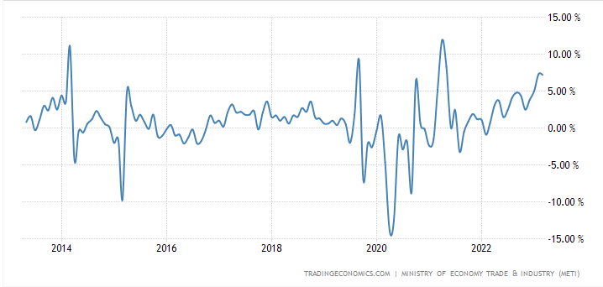

**Figure 6: Japan’s retail market fluctuation over the years**

(Source: Tradingeconomics.com, 2023)

The primary concern of Tesco entering into the Japanese market was its previous success in South Asian markets such as Thailand. Tesco faced success in Thailand and decided to expand to Japan, as at that time it was the world's second largest retail market (Poapongsakorn *et al.* 2019). However, the company was forced to retreat due to high cost and non-fulfilment of Japanese customer demands. Since that time the retail sales statistics of Japan has been fluctuating and has increased since 2020. From last year the sales have increased about 7.3% (Tradingeconomics.com, 2023). An additional 7.2% increase is expected by the next year as well. The main opportunity however, lies with the country not hosting many large global players such as Amazon or Walmart. The main competitors are Uniqlo, Shimamura and others who are mostly local players. Tesco has an opportunity here to become a significant part of the market. But for that the company has to largely adapt to its culture.

## 3.4 Suitable entry mode

As discussed earlier, Tesco had failed in the USA due to its small markets and unavailability of bulk products as per customer requirements. This problem can be solved by Tesco by taking a ***licensing*** approach as mode of entry in the USA. Thus, other existing companies in the USA can be targeted to use their property in order to sell products of this company. With a licensing approach, Tesco can use other existing properties for their sales operations. This way the company can use existing large spaces to their advantage and sell a variety and bulk of products having such spaces (Tien and Ngoc, 2019). Tesco has to only pay a small amount of fee in order to use the properties. This could be an opportunity for Tesco as a small investment and high return scenario. Tesco can also get profit as licensing generally takes care of several manufacturing and marketing costs occurring in the foreign market. This can reduce the operating cost of Tesco in the USA making the business more convenient.

For the mode of entry in the Japanese market, Tesco have to correct their mistake of not adapting to the cultures. Only then, the company might be able to compete with the local players. Best market entry strategy in this case could be a ***joint-venture*** with the local players. A joint-venture will consist of Tesco and other local retail companies jointly operating in Japan. The control of the new company in the foreign market would be in the hands of both of the existing companies and both will decide operations as per their shares in the venture (Paul and Rosado-Serrano, 2019). This will be significantly beneficial for Tesco in the Japanese market as, from the local company; Tesco will be able to get a significant amount of cultural data which the company can later use to their research advantage. Simultaneously, the cost of the operations can be shared between the two players. This means Tesco can also reduce the costs of their operations which was one of the main reasons the company bailed from the market previously.

# 4. Conclusion

The proposed report suggests that Tesco has been operating as a global business expanding to over 12 countries. However, due to reasons, the company had to bail out from certain highly opportunistic countries such as the USA and Japan. As per the main focus of the report the market entry considerations of two countries have been taken and USA and Japan have again been selected for a possible re-entry. Environmental evaluation of the USA market is identified with significant opportunity. Tesco can correct its mistake with licensing as its mode of entry and ensure a bigger operational area with lower costs. Some dilemmas have been found in case of entry in Japan regarding cultural adaptation and high costs. Both can be solved by a joint venture consideration with a local retail operator in the market.

# Reference list

Arvidsson, H. and Arvidsson, R., (2019). The Uppsala Model of internationalisation and beyond. *International Journal of Finance and Administration, 42(2)*, pp.221-239.

Castusglobal.com, (2022). *International Expansion: Why Tesco Missed the Mark in the U.S.* *Market* *[online]*. Available at: https://www.castusglobal.com/insights/international-expansion-why-tesco-missed-the-mark-in-the-u-s-market#:~:text=At%20its%20peak%2C%20the%20company,it%20sold%20its%20remaining%20stores. [Accessed on: 25 April, 2023]

Datacommons.org, (2023). *GNI per capita* *[online]*. Available at: https://datacommons.org/place?utm_medium=explore&dcid=country/JPN&mprop=amount&popt=EconomicActivity&cpv=activitySource,GrossNationalIncome&hl=en [Accessed on: 25 April, 2023]

Datacommons.org, (2023). *GNI per capita.* *[online]*. Available at: https://datacommons.org/place/country/USA?utm_medium=explore&mprop=amount&popt=EconomicActivity&cpv=activitySource%2CGrossNationalIncome&hl=en [Accessed on: 25 April, 2023]

Env.go.jp, (2023). *Japan's regulations and environmental law* *[online]*. Available at: https://www.env.go.jp/en/coop/pollution.html#:~:text=It%20was%20enacted%20in%201976,taking%20 measures%20 for%20 traffic%20 vibration.[Accessed on: 25 April, 2023]

Epa.gov, (2023). *Climate Change Indicators: U.S. Greenhouse Gas Emissions* *[online]*. Available at: https://www.epa.gov/climate-indicators/climate-change-indicators-us-greenhouse-gas-emissions#:~:text=Data%20%7C%20Technical%20Documentation-,Key%20Points,2005%20(see%20Figure%201). [Accessed on: 25 April, 2023]

Globaldata.com, (2023). *Number of Tesco Stores Globally (FY2016 – FY2022) [online]*. Available at: https://www.globaldata.com/data-insights/retail-amp-wholesale/number-of-tesco-stores-globally/ [Accessed on: 25 April, 2023]

Gsa.gov, (2023). *Mission Support Business Standards* *[online]*. Available at: https://ussm.gsa.gov/fibf/ [Accessed on: 25 April, 2023]

Hult, G.T.M., Gonzalez-Perez, M.A. and Lagerström, K., (2020). The theoretical evolution and use of the Uppsala Model of internationalization in the international business ecosystem. *Journal of International Business Studies, 51*, pp.38-49.

Kar, S.K., Bansal, R. and Mishra, S., (2021). Tesco: Entry and Expansion Strategy in India. *Emerging Economies Cases Journal, 3(2)*, pp.65-76.

Kim, H., Wu, J., Schuler, D.A. and Hoskisson, R.E., (2020). Chinese multinationals’ fast internationalization: Financial performance advantage in one region, disadvantage in another. *Journal of International Business Studies, 51*, pp.1076-1106.

Krummel, D., (2022). Expansion in the Retail Sector—Market Entry Strategies in Consideration of Formal and Informal Institutions: A Tesco Case Study. *Open Access Library Journal, 9(2),* pp.1-19.

Law.cornell.edu, (2023). *Environmental law* *[online]*. Available at:https://www.law.cornell.edu/wex/environmental_law#:~:text=Major%20Federal%20Laws&text=Resource%20Conservation%20and%20Recovery%20Act,areas%20which%20are%20already%20polluted. [Accessed on: 25 April, 2023]

Lingyu, M., Lauren, C. and Zhijie, D., (2019), May. Strategic development of fresh e-commerce with respect to new retail. In 2019 IEEE 16th International Conference on Networking, Sensing and Control (ICNSC) (pp. 373-378). IEEE.

Macrotrends.net, (2023). *Japan GDP 1960-2023.* *[online]*. Available at: https://www.macrotrends.net/countries/JPN/japan/gdp-gross-domestic-product [Accessed on: 25 April, 2023]

Macrotrends.net, (2023). *Japan Unemployment Rate* *[online]*. Available at: 1991-2023https://www.macrotrends.net/countries/JPN/japan/unemployment-rate [Accessed on: 25 April, 2023]

Macrotrends.net, (2023). *U.S. GDP 1960-2023* *[online]*. Available at: https://www.macrotrends.net/countries/USA/united-states/gdp-gross-domestic-product [Accessed on: 25 April, 2023]

Macrotrends.net, (2023). *U.S. Population 1950-2023* *[online]*. Available at: https://www.macrotrends.net/countries/USA/united-states/population [Accessed on: 25 April, 2023]

Paul, J. and Rosado-Serrano, A., (2019). Gradual internationalization vs born-global/international new venture models: A review and research agenda. *International Marketing Review, 36(6)*, pp.830-858.

Poapongsakorn, N., Chokesomritpol, P. and Pantakua, K., (2019). Development of food value chains in Thailand. *Eiichi Kusano*, p.8.

Statista.com, (2023). IT industry in Japan - statistics and facts. *[online]*. Available at: https://www.statista.com/topics/7755/it-industry-in-japan/#topicOverview [Accessed on: 25 April, 2023]

Statista.com, (2023). *IT Services - United States* *[online]*. Available at: https://www.statista.com/outlook/tmo/it-services/united-states#revenue [Accessed on: 25 April, 2023]

Statista.com, (2023). *Retail market in the United States - statistics & facts*. *[online]*. Available at: https://www.statista.com/topics/6928/retail-market-in-the-united-states/#topicOverview [Accessed on: 25 April, 2023]

Tien, N.H. and Ngoc, N.M., (2019). Comparative Analysis of Advantages and disadvantages of the Modes of Entrying the International Market. *International journal of advanced research in engineering and management, 5(7)*, pp.29-36.

Tradingeconomics.com, (2023). *[online]*. Available at: https://tradingeconomics.com/japan/corporate-tax-rate?continent=g20/forecast#:~:text=Corporate%20Tax%20Rate%20in%20Japan,according%20to%20our%20econometric%20models. [Accessed on: 25 April, 2023]

Tradingeconomics.com, (2023). *Japan Retail Sales* *[online]*. Available at: https://tradingeconomics.com/japan/retail-sales-annual [Accessed on: 25 April, 2023]

Tradingeconomics.com, (2023). *United States Federal Corporate Tax Rate [online]*. Available at: https://tradingeconomics.com/united-states/corporate-tax-rate [Accessed on: 25 April, 2023]

Woohyoung, K., Kim, H. and Hwang, J., (2020). Transnational corporation’s failure in China: Focus on Tesco. *Sustainability, 12(17)*, p.7170.

Zim, Z.S. and Zahan, M., (2019). Local versus global brands: The internationalization process in Food and Beverage Industry. *The Business and Management Review, 10(5)*, pp.58-66.

# Appendices

## Appendix 1: USA federal tax rate over the years

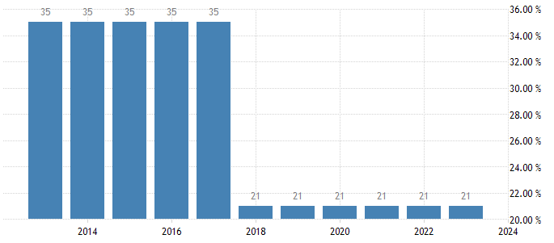

(Source: Tradingeconomics.com, 2023)

## Appendix 2: US GDP rate increase

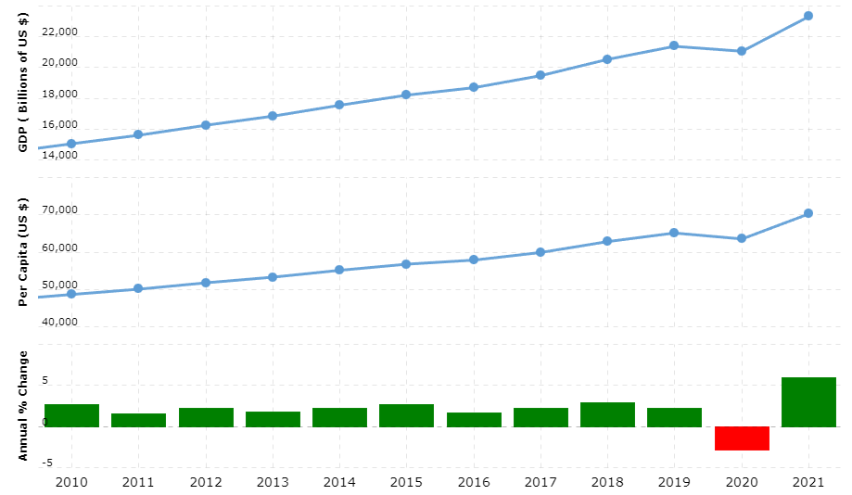

(Source: Macrotrends.net, 2023)

## Appendix 3: IT sector development of USA

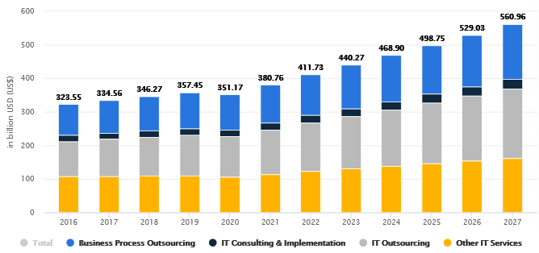

(Source: Statista.com, 2023)

## Appendix 4: Japan corporate tax rate over the years

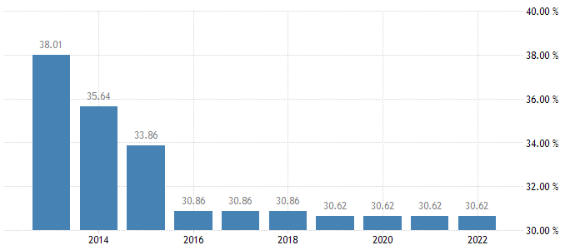

(Source: Tradingeconomics.com, 2023)