BPP Business School Coursework Cover Sheet

Please use this document as the cover sheet of for the 1st page of your assessment.

Please complete the below table – the grey columns

|  |  |
| --- | --- |
| Module Name |  |
| Student Reference Number (SRN) |  |
| Assessment Title |  |

Please complete the yellow sections in the below declaration :

Declaration of Original Work:

I hereby declare that I have read and understood BPP’s regulations on plagiarism and that this is my original work, researched, undertaken, completed and submitted in accordance with the requirements of BPP School of Business and Technology.

The word count, excluding contents table, bibliography and appendices, is words.

Student Reference Number:

Date:

By submitting this coursework you agree to all rules and regulations of BPP regarding assessments and awards for programmes.

Please note that by submitting this assessment you are declaring that you are fit to sit this assessment.

BPP University reserves the right to use all submitted work for educational purposes and may request that work be published for a wider audience.

**MSc Management**

*Data Driven Decisions for Business*

SUMMATIVE Coursework Assessment Brief

Submission mode: **Turnitin online access**

**Table of Contents**

Introduction and the Plan of Project 2

Evaluation of Information along with the Commentary 5

Charting of Data and its Commentary 10

Conclusion and Suggestions 12

Reference List 14

Appendices 15

Appendix 1: Issues within data set of BIJ 15

Appendix 2: Benchmark comparisons of activities 15

# Introduction and the Plan of Project

There has been the utilization of the statistical cycle acquired by investigation as the framework in the case of the advancement and creation of the issues of statistics. A variety of models are present that are being proposed by the removal of a few noted variations within the similar atmosphere. Cycles acquired by PPDAC are being utilized in the case of the description of five steps of statistical investigation. There has been the involvement of ***“Problem”, “Plan”, “Data”, “Conclusion”*** and ***“Analysis”.*** At the standard which is primary in nature, there can be the description of these particular processes in this context.

The issue refers to negotiation, refining acquired by the issue in association with the issue of familiarization and deconstruction. Planning refers to the detection of distinct information that has been required for sorting out an issue and recording the evaluation of the information. The collection acquired by data refers to cleaning along with a record of plenty of information. The analysis refers to the manipulation, organization, and interpretation of the information for detection of distinct patterns by which appropriate evidence is acquired so that the issue can be addressed. The conclusion highlights the proof that is detected in the case of the phase of analysis that interconnects to the beginning issue in the matter of bestowing an appropriate response (Farrell and Robertson, 2019).

Usage of Data Science continues to expand the business along with the life possessed by civic since there is a responsibility for the adoption of youths within their responsibilities of orientation of data. A comprehensive substructure for the knowledge of information is adopted that refers to the cycle of PPDAC. There is an illustration of the process of sorting out different issues on the distinct values on the basis of datasets of real-world. This assists in the explanation of the rationale in the matter of qualifications of latest datasets which is served by authorities of qualifications of Scotland.

A variety of attendees of workshops who get the invitation to share their experiences and data for the development of knowledge of the data. Considering the cycle of PPDAC assists in sorting out the issues of ***“Plan”, “Data”, “Analysis”, “Problem”,*** and ***“Conclusion”.*** A few different refinements which require being performed to regard cycles possessed by investigation from outlook acquired by data science. This may be performed by utilizing the instance of ***CRISP-DM,*** the core problem mentions the modeling of data science that is used and has a relation with the forecasting target for modeling within cycle possessed by data science.

Troubles in attestation of modeling, as well as, the segregation in the middle of casual along within visionary models are absent from ***PPDAC cycle.*** There is an association of it with the forecasting problems as the target in the matter of aim of modeling. There is a collection of datasets throughout the ***PPDAC Cycle*** that possess a variety of techniques of a collection which may emerge. This is due to the fact that data is gathered through sensors, from private devices along with information from transactions (Hariri *et al.* 2019).

There can be a scraping of data from distinct web pages by utilizing GPS, which is going to gather a variety of data by the side of geographic data. These segregated sorts of information may be multivariate, as well as, framed badly. A synopsis of distinct tools which are considered as statistical in nature is utilized within different schools. However, schools in Germany are yet there with ***GeoGebra***, and ***graphing calculators*** are used.

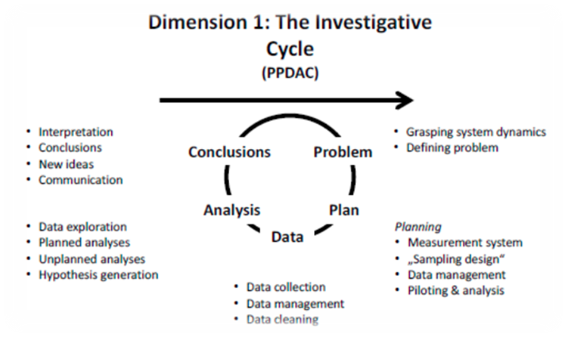

**Figure 1: Dimension 1 possessed by Cycle of PPDAC**

(Source: Hariri *et al.* 2019)

**Troubles with Remedies in the matter of Quality possessed by Data**

**Troubles**

**Reserving Information -** Reserving information refers to being analyzed as a vital issue which a variety of companies face recently. The major reason by the side of this particular aspect mentions the image of wider data for organizations (Bahrami and Shokouhyar, 2022). It points out the regular operations of the business possessed by the organizations. This detail is essential within the matter of being reserved for the welfare of the firm within the coming days. Information is preserved in the *hard drives* and difficulty exists in carrying them.

**Absence of Rectification of Data-** There is an absence of upgradation acquired by application software in a variety of organizations for utilization (Johnson *et al.* 2022). There is the utility of numerous applications that lack of upgradation is inefficient for providing the great benefit for the recent financial inevitabilities.

**Duplicates in Data-** Due to division of the particular data there is the existence of the high chance of the information that is not authenticated. There is an existence of a greater chance in the matter of enough initiation of this specific information into particular business. Therefore, it is understood that duplicate datasets are acquired in numerous places through the particular individual by which trouble is created within the matter possessed by business.

**Resolution**

**Virtual storage of information-** As per the recent advancement of specific technology, there is an existence of virtual storage of information. In the setting of reference, it is analyzed that there must be the storage of necessary information through the enterprise upon systems possessed by ***cloud computing*** (Huang *et al.* 2023)Information is stored by this specific system virtually in the absence of utility of gadgets that is tangible.

**Valuable Staff-** There is an efficiency of valuable staff in creating better results than those who do not possess skills. Widely, it is asserted that there is a capability of more valuable staff in possessing the proper dataset than the individuals who have the absence of the perfect efficiencies (Aburumman *et al.* 2020). For this, it is noticed that appropriate information is possessed by valuable staff.

Troubles observed in specific datasets acquired by **BIJ International**

There is a repetition of particular segments of market and is regarded as the primary specific problem in dataset acquired through **BIJ International**

A particular accessory item that is repeated through the enterprise is regarded as another trouble in a particular dataset. In these datasets, there is a notification that information is repeatedly associated with the item hairband double times. Aside from this, individual trouble is noticed while interpreting data within the graphic manner.

Issue observed in the specific dataset mentions the subsistence of the particular alphabet within numerics. In particular data, there is an existence of little alphabets within a volume of sales possessed through items

Other issue that is pointed out within the particular dataset has been the existence acquired through the data of 2030. From the Excel sheet, information is acquired by the upcoming year. This results in the difficulty of acquisition of the particular data by interpretation, as well as, graph preparation from the similar one

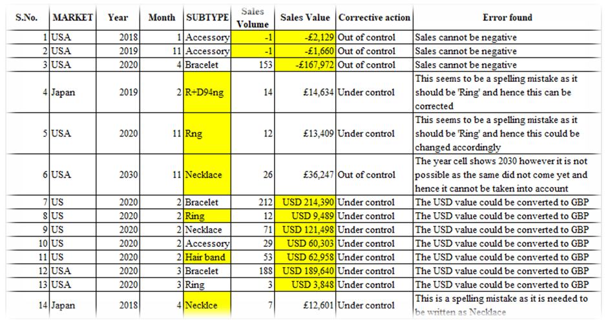

**Table 1: Issue in the Dataset of BIJ**

(Source: Made by Self)

# Evaluation of Information along with the Commentary

The activities of the enterprise are pointed out in the view of the value of sales, as well as, volume possessed by aggregate sales in below table. Presentation of the particular volume of sales is existed by the total acquired through volumes within dataset in the case of specific time. Greenthal et al. (2022) have performed the calculation by adding a volume of sales with the matter of particular records.

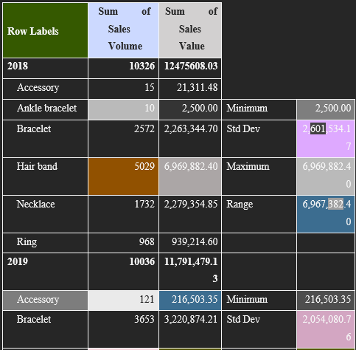

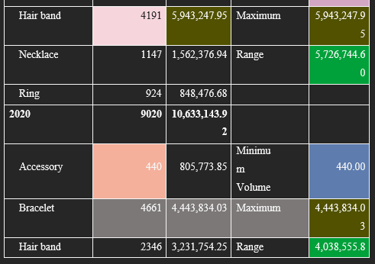

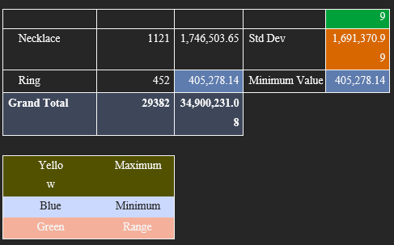

**Table 2: Category Range, Maximum, Minimum and Std Dev on yearly basis**

(Source: Made by self)

As per the Second Table, a reflection is made on maximum value, range, standard deviation, and minimum value within 2018, 19 along with 20 within specific cases of overall classification with whole markets. In this above table, there has been the depiction of all the values related to the values of sales and the volumes possessed by sales. It has been understood from this particular table that there has been a presence of different values of all the accessories within different years. Those years include 2018, 19 along with 2020 and it has been analyzed that the sales of different items are different in the case of entire items listed above. It has been understood that 2018 has maximum sales that that of 2019 along with 2020. Hence, there has been a requirement for progress in the case of the company.

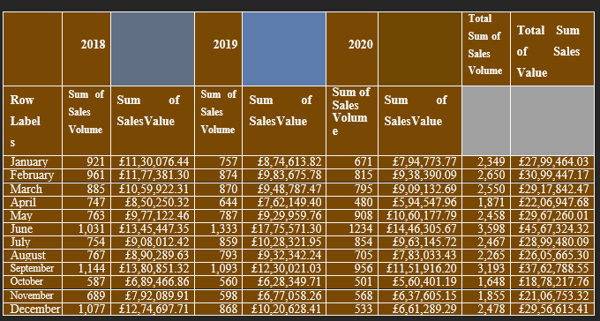

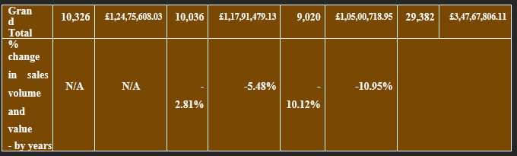

**Table 3: Table A- Analysis of Data along with Trend**

(Source: Made by self)

There has been an outline of volumes of sales, as well as, value acquired through enterprise upon the entire analysis period within 2018, 19 along with 20 on monthly basis in Table A. Proof is present in declining direction through dependence upon the particular table. In the view of value of sales in 2019, there was a downfall of 5.48% than 2018. Whereas a proof was present possessed by specific revenue later referred to the pitfall possessed by 10.95%. Aside from this, it was noticed that a heavy sale occurred in the period of June-September within the matter of the enterprise than different months. In the case of the specific table provided above, it has been understood that there has been a presence of huge differences within the sales of all items possessed by different items in distinct months. It has been understood from the above scenario that in the month of June along with December, there has been a presence of a great sales. In addition to that, there has been the calculation of the percentage within the volume, as well as, the values possessed by sales as well. In all the cases, negative percentages have been acquired in this context.

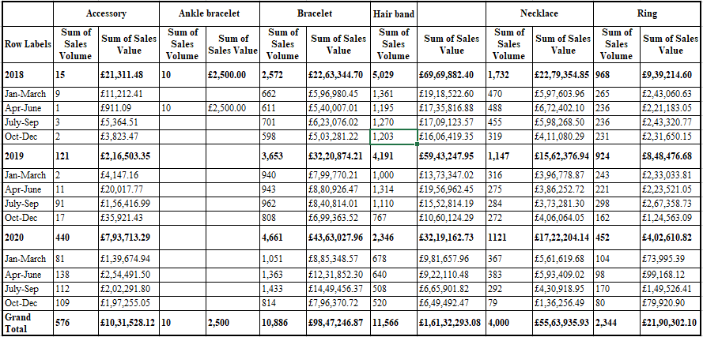

**Table 4: Table B - Benchmark comparisons of performances**

(Source: Created by self)

There is the consideration of Table B within the case possessed by volume of sales acquired through accessories expanded significantly of 15 units in 2018 to the 440 units in 2020. The development acquired through the revenue was supported through this from particular segment as well. Nevertheless, in the view of Ankle Bracelets, sale acquired by 10 pieces in 2018 was present. Aside from this, value of sales, as well as, volume acquired by bracelets proved to be strong development upon the period. Highest sales are seen through sales while quarter is possessed by July to the September. High pitfall was witnessed through hair bands, as well as, it attained “2,346 units” in the 2020 and it had been “5,029 units” in 2018. It may be detected that similar downfall in the view of necklace, as well as, sales of rings. In the year 2018, the sum possessed by the values of sales is less than that of 2019 along with 2020. In the case of 2020, it is greatest and in the matter of sum of the values acquired through sales, the highest position is of 2018. This has been pointed out from the above table. This description refers to the calculation of Accessory, however, in the case of Ankle Bracelet, sales was occurred in 2018 only. In the same manner, within the matter of all other items manufactured by the firm, most sales were occurred in 2018.

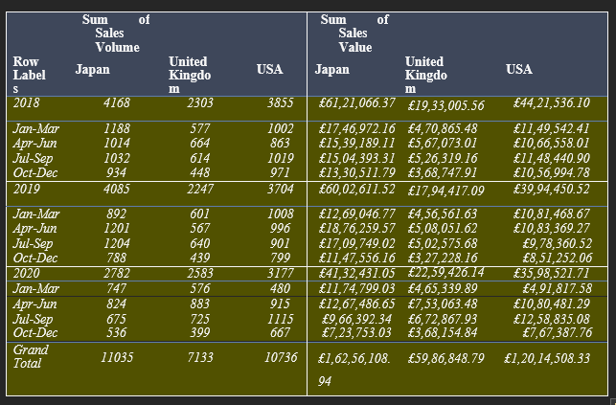

**Table 5: Table C - Benchmark comparisons of sales volume and value between markets by quarter, by year and across the whole analysis period**

(Source: Made by self)

By viewing Table C, it is pointed out that within UK, a capability was present in creating sales acquired by 2,303 units through the firm in 2018. Contrastingly, a decrease was present in sales to the 2,247 units. Nonetheless, within the case of markets possessed by Japan along with USA, a high downfall in sales was acquired through the enterprise. From the above depiction within the Table above, there has been an analysis of the fact the company has marketed in USA the most. Thus, a good impact possessed through campaigns acquired through marketing may be seen within the matter possessed by sales of enterprise. It is understood that BIJ has to make fruitful strategies to expand in other two above-mentioned countries.

# Charting of Data and its Commentary

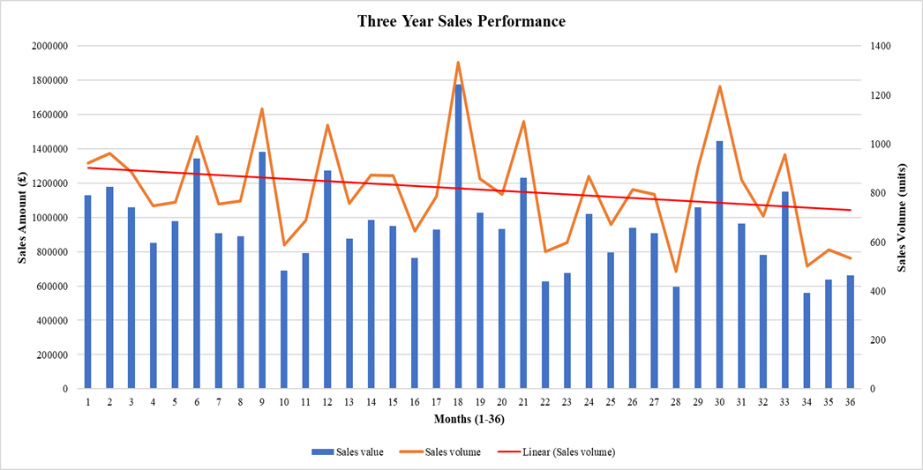

**Chart A: Comparison of sales value trends across markets**

**(**Source: Made by self)

From the chart presented above, trends of value are elucidated in the case of the past three years of the enterprise. The hike of sales possessed by BIJ has been attained within 18th month within the previous history of 36 the month of the firm. Contrastingly, the firm is portraying the minimal volume of sales within 34th month according to trends of value. A status of downfall in the firm within sales is obtained from the scenario discussed above.

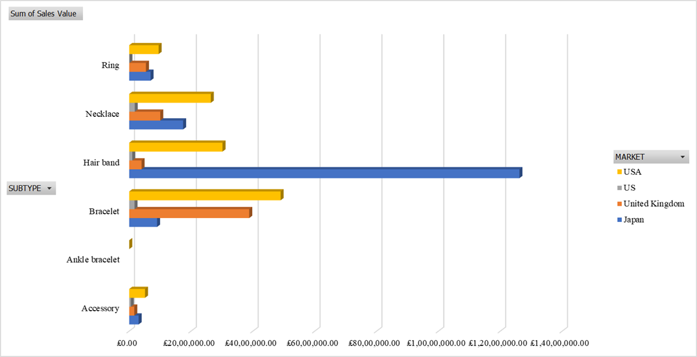

**Chart B: Categorized performance comparisons between markets**

**(**Source: Created by self)

From the above-presented chart B, there can be a detection of the greatest value within sales in a specific item, hairband. Within the segment of the bracelet, there is a possession of the segment gained by value within the USA. In addition to that, hair bands, ring, accessory along with necklace has attained a position within categories of the brand. There is the segment of gathering high revenue within the UK that has been accompanied by rings, accessories, hairbands, and necklaces within the classification of segregated items.

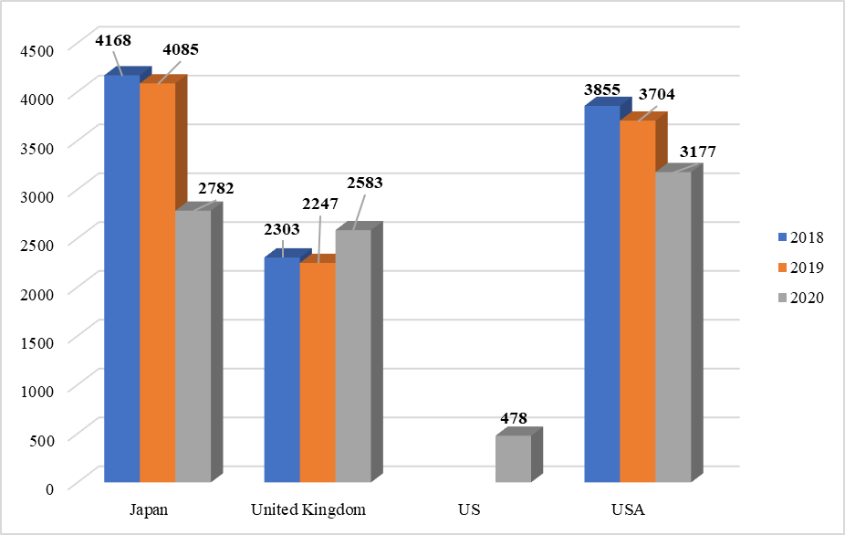

**Chart C: Impact of the marketing campaign in the UK market with comparison**

**(**Source: Made by self)

It is depicted in above Chart C, there may be the observance of pitfalls within particular market of UK in 2019, as well as, 20. Sales of 2247 units within 2019 may be notified and within 20, sales of 2583 units have been seen. There can be the observance of consistent pitfalls within Japanese Market from conditions that are similar. There is a necessity for detection of strategies within the market of the USA. Benefit can be gained in the matter of BIJ for the expansion of volume of sales within these markets that are affected.

# Conclusion and Suggestions

**Conclusion**

A presence of the high degree of the information is observed in this particular paper in the view of a variety of accessories yielded with the help of BIJ currently. In the view of this, it can be notified that the firm possesses an entrance in a variety of metropolitan countries within the matter of the increase within the same type of businesses. Nevertheless, a variety of facets are present that have been essential for taking into consideration with the help of the manager. There is a necessity in the matter of management possessed by the business and for doing this, there is the generation of tables along with graphics that must be present than aggregate volume possessed by sales.

● A necessity is existed for considering the alteration through BIJ in taste and desires acquired through the customers in the matter of customization possessed by jewelry

● A necessity is present of guarantee through the firm of manufacturing items possessed of quality that is much higher

● An execution of the campaign that is focussed is required of marketing through the enterprise in distinct markets that it possesses due to the effectiveness of the enterprise in the market of UK

# Reference List

Aburumman, O., Salleh, A., Omar, K. and Abadi, M., 2020. The impact of human resource management practices and career satisfaction on employee’s turnover intention. Management Science Letters, 10(3), pp.641-652.

Bahrami, M. and Shokouhyar, S., 2022. The role of big data analytics capabilities in bolstering supply chain resilience and firm performance: a dynamic capability view. Information Technology & People, 35(5), pp.1621-1651.

Farrell, K. and Robertson, J., 2019, October. Interdisciplinary data education: Teaching primary and secondary learners how to be data citizens. In *Proceedings of the 14th workshop in primary and secondary computing education* (pp. 1-2).

Greenthal, E., Marx, K., Grossman, E.R., Ruffin, M., Lucas, S.A. and Benjamin-Neelon, S.E., 2022. Incentives and penalties tied to sales volume in contracts between beverage companies and public universities in the United States. *Journal of American College Health*, pp.1-10.

Hariri, R.H., Fredericks, E.M. and Bowers, K.M., 2019. Uncertainty in big data analytics: survey, opportunities, and challenges. Journal of Big Data, 6(1), pp.1-16.

Huang, Y., Li, Y.J. and Cai, Z., 2023. Security and privacy in metaverse: A comprehensive survey. Big Data Mining and Analytics, 6(2), pp.234-247.

Johnson, P.C., Laurell, C., Ots, M. and Sandström, C., 2022. Digital innovation and the effects of artificial intelligence on firms’ research and development–Automation or augmentation, exploration or exploitation?. Technological Forecasting and Social Change, 179, p.121636.

# Appendices

## Appendix 1: Issues within data set of BIJ

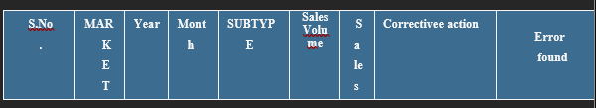

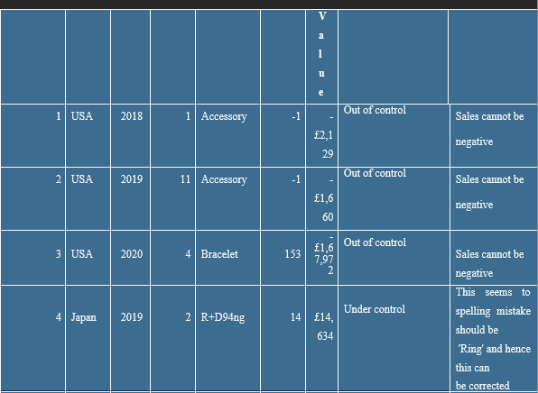

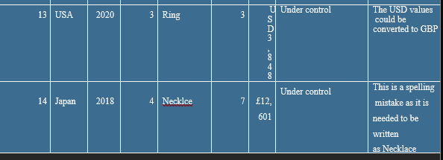

## Appendix 2: Benchmark comparisons of activities

