**LITERATURE REVIEW ON CONTEMPORARY ISSUES:**

**RELATIONSHIP WITH UNEMPLOYMENT AND LACK OF TRAINING**

**Table of Contents**

Introduction 3

Methods 4

Results 5

Discussion 7

Conclusion 8

References 9

# Introduction

The contemporary issues that are considered to be maintained with the currently affecting procedure are still not solved yet. The issues of unemployment that are taken are granted to be the cause for the suffering that financial hardship impacts among communities, families, and relationships are affected. The topic of ***contemporary issues on Unemployment*** is chosen, where ***“Relationship with Unemployment and Lack of training”*** is mainly focused. This topic is chosen as contemporary issues of unemployment have been raised in recent days worldwide. Lack of training causes unemployment because many such young youths are unemployed due to lack of training. The reason for unemployment is the lack of training due to the requirement of finding new employment (Pratap *et al*., 2021). The high rate of unemployment in educated youth is also due to lack of sufficient unemployment and getting any jobs. This made unemployment due to lack of training where a large number of suitable graduates are unemployed due to their commensurate for their degrees.

The research aims to focus on the Contemporary Issues of Unemployment. This topic is chosen as it is very important in the program area to get employment as soon as anyone completed their course for the sake of getting employed. Numerous people are unemployed as per the lack of any skills adapted and learned.

The research will cover Methods of the research and results of the findings that are considered as the objective to be found out. The concept is something that is conceived in the mind with the abstract for considering generic ideas for the generalized phenomenon used as particular instances.

Research Objective

* To identify the impact on the employment process due to lack of training
* To explain the purpose of the main problem or causes of modern Unemployment
* To analyze training process development and the requirement of relevant infrastructure to overcome the unemployment issue
* To examine the relationship between Unemployment and lack of training.

Research Question

* What is the impact of the unemployment process due to lack of training?
* What is the main problem or cause that arises due to modern Unemployment?
* Why training process development is required for overcoming the unemployment issues?
* How the relationship between unemployment and lack of training needs to be examined?

# Methods

***Keywords used***

The keywords used in the research based on the questions asked are: ***Unemployment, Lack of Training and Proper education.***

***Search strategy***

The search strategy for the research is to find out the relevant keywords in determining the relevant articles from different search platforms. Keywords such as *Unemployment AND Poverty* are used in searching the article from ***Google Scholar.*** Platform like ***Sci-hub*** is also used in searching relevant articles by using keywords such as *Lack of training AND Knowledge development* to understand and gather relevant information for the training material to be used for the sake of the research (Abdullah *et al*., 2020). The contemporary issue for unemployment and the lack of training or doing any skilled course have led to unemployment is the main fact for the study. The way the article is gathered are miley and through reading about their relevance with the topic (Ngbongha and Akaa, 2020). By using the keywords *Proper education AND learning* the way the article is searched are maintained through proper researching and implementation of the study. The search strategy followed in the research is by using the keywords the articles are extracted and information is sampled to implement in the research (Eisenberg-Guyot *et al*., 2020). During the search process the article that is used before 2018 is excluded and the article that is used after 2018 is included in the research.

***Choice of Databases***

The choice of databases is from secondary data collection methods used as per the result that is extracted. Thematic analysis for the research will be followed next. The database selection thus made from the advanced procedure where every data that is collected is done sampling of clustered methods. Mostly the databases are chosen, it might be considered as the type or amount of data that the researcher has taken to be implemented in the research (Schmidpeter and Winter-Ebmer, 2021). Different types of databases are designed to be handled by the types of data and workloads to be used for choosing and suited for importance. The data is collected as per secondary purposes where every feature of the data is extracted by the means of journal and online articles used in the research. There is various information about unemployment where it is taken as the most serious issue to be reduced. Thus the data regarding facts of unemployment and training that would give employment to graduate youth and most of the data or articles chosen are from this area.

***Inclusion/Exclusion Criteria***

The inclusion/exclusion criteria used in the research for the methods is the secondary data that is used to extract relevant books, journals or online articles. The journals that are published before 2018 are totally excluded and the journals that are published after 2018 are included. The inclusion of the topic or study that is related to und employment and training. The topic or study regarding unemployment and training is considered and included in the research. Any other other irrelevant topic or study that is not related to unemployment is excluded and not included in the research.

***Data Extraction***

The data collected by various means is the way of collecting the secondary data to be used for finding thematic analysis. It is the process of retrieving and collection of data by the disparate types used as per from various sources and from various search platforms. The way the data is used is designed to be collected as per the structures and semi-structures sources where the extraction of the data is done and sampled by clustered sampling methods (Onwuzu *et al*., 2023). The process to extract the data is by the means of qualitative or quantitative approach and the tools that are used are of helping the thresher in collecting or generating the tools. This is used for the relevance ikn gathering the data in regardless of the organizations that is used for the ability to leverage and collect data limited to manual processing.

# Results

***Theme 1: Impact on the employment process due to lack of training***

Unemployment is a variation from the present rate as due to this issue the economic rate of the world is decreasing. There are various reasons available behind this issue and all reasons are very serious reasons for all over the world. The current employees are not fully trained or skilled and this is the main reason behind the increasing unemployment rate (Merino *et al.,* 2019). There are different people present in this world who are not fully skilled, however, due to this they don’t have any kind of employment and this situation is increasing the poverty rate in different countries.

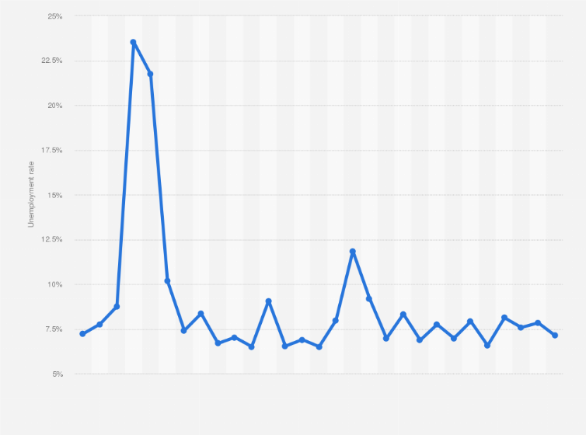

**Figure 1: Impact of unemployment on present day**

**(Source: Satista.com, 2022)**

***Theme 2: The purpose of the main problem or causes of modern Unemployment.***

There are different reasons that are the reason behind modern Unemployment. However, the main reason behind this issue is the increasing population rate. There are many countries in which the population is rapidly increasing and due to this, the Unemployment rate of those countries is also increasing. Seasonal occupation is also the reason behind Unemployment such as agriculture. For example, there are many people who are farmers and their main occupation is agriculture as this occupation is seasonal occupation when the season is not good for agriculture then the people are doing is Unemployed. In small countries, a lack of skills is also the reason behind this Unemployment. The Unemployment issue is present in both urban and rulers areas which is the worst part of this issue.

**Theme 3: Training process development and the requirement of relevant infrastructure to overcome the unemployment issue**

The Unemployment issue is a very serious problem for the youth generation as they are the future of this world and due to this issue they are unable to prove themselves (Brunello and Wruck 2020). To overcome this issue there is a need for relevant infrastructure which provides the proper training to the youth generation so that they can increase the employment rate of the world.

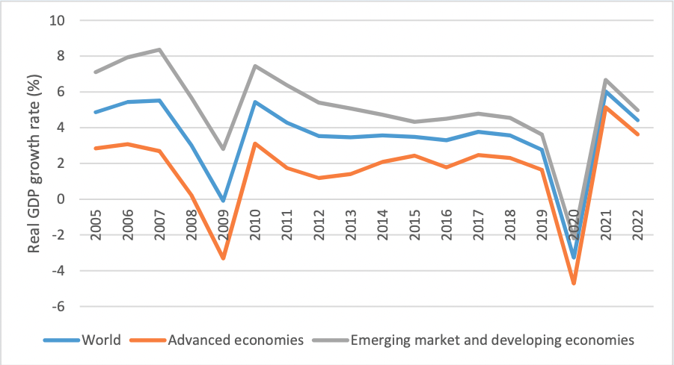

**Figure 2: Unemployment payment rate in the Youth Generation**

**(Source: Weforum.org, 2023)**

**Theme 4: The relationship between Unemployment and lack of training**

Training is a very important factor for employment as in this modern world there are different new job roles open for the youth generation. For employment purposes training is required and due to the lack of training the unemployment rate in different countries is increasing. In this world, there are a number of youths who have captivity however due to lack of training they are not employed.

# Discussion

Based on the result it is concluded that the main reason behind the increasing rate of unemployment is the lack of training and infrastructure. In different regions of the world, this issue is present which also affects the economic rate of the world. There are different youth generations who are not employed due to a lack of training. In this modern world, the competition level among the employees, and without proper training they are unable to gain employment. The unemployment rate of the different countries also increases the poverty rate of those countries which affects the GDP of the world. Instead of this lack of training reason, there are different or more causes which are the reason behind the increasing unemployment (Marques and Hoerisch 2019). The population is also the reason behind this as due to this reason job opportunities are not present according to the population rate. In different countries, there are many seasonal occupations that also increase unemployment as in the off-season the people are not employed which is a problematic situation for the world. In this modern world, there are different innovative job opportunities available, however, these jobs require the proper skills and training and the lack of these factors in the employees is the reason behind this unemployment issue. The relation between unemployment and training is very clear as due to lack of training among the youth generation the unemployment issue is rapidly increasing all over the world. This issue can be solved with the help of a popper training development process and relevant infrastructure theses are the two important factors by which this issue can be solved. It is very important that the youth generation of the world go through the proper training development process so that they can employ themself.

# Conclusion

The way the research is granted is the focus on the research methods and the Literature Review to be performing in regards with the contemporary issues of relationship with unemployment and training. The research aims and objectives are being highlighted in the research and the reason for choosing the topic and the purpose of doing this research is being discussed. Keywords used in the research with search strategy, inclusion/exclusion criteria and data extraction is also included. The data collection methods with the needs for the collection of data is also being discussed in Thai research. Findings and Analysis of the results regarding unemployment and lack of training is discussed with making proper discussion of the results.

# References

Abdullah, A., Cudjoe, E. and Manful, E., 2020. Creating a better kinship environment for children in Ghana: Lessons from young people with informal kinship care experience. *Child & Family Social Work*, *25*, pp.207-214. https://onlinelibrary.wiley.com/doi/abs/10.1111/cfs.12764

Brunello, G. and Wruuck, P., 2020. EIB Working Papers 2020/03-Employer provided training in Europe: Determinants and obstacles (Volume 2020/3). European Investment Bank. Available at:<http://hnpublisher.com/ojs/index.php/HNJSS/article/download/62/90>

Eisenberg-Guyot, J., Peckham, T., Andrea, S.B., Oddo, V., Seixas, N. and Hajat, A., 2020. Life-course trajectories of employment quality and health in the US: A multichannel sequence analysis. *Social Science & Medicine*, *264*, p.113327. https://www.nber.org/papers/w31120

Marques, P. and Hoerisch, F., 2019. Promoting workplace‐based training to fight youth unemployment in three EU countries: Different strategies, different results?. International Journal of Social Welfare, 28(4), pp.380-393. Available at;<https://onlinelibrary.wiley.com/doi/abs/10.1111/ijsw.12381>

Merino, M.D., Privado, J. and Arnaiz, R., 2019. Is there any relationship between unemployment in young graduates and psychological resources? An empirical research from the conservation of resources theory. Revista de Psicología del Trabajo y de las Organizaciones, 35(1), pp.1-8. Available at; <https://www.redalyc.org/journal/2313/231360290001/231360290001.pdf>

Ngbongha, I.O. and Akaa, I., 2020. Entrepreneurial Skill needs of Agricultural Education Graduates in Vocational Training for Combating Unemployment in FC T, Nigeria. *Asian Journal of Social Science and Management Technology*, *2*(3), pp.121-127. http://www.ajssmt.com/Papers/23121127.pdf

Onwuzu, K.C., Nnamani, E. and Okonkwo, A.O., 2023. MENTORING AND UNEMPLOYMENT IN THE SOUTH EAST OF NIGERIA. *European Journal of Marketing and Mangement Sciences*, *6*(1). https://aspjournals.org/Journals/index.php/ejmms/article/view/257

Pratap, P., Dickson, A., Love, M., Zanoni, J., Donato, C., Flynn, M.A. and Schulte, P.A., 2021. Public health impacts of underemployment and unemployment in the United States: Exploring perceptions, gaps and opportunities. International journal of environmental research and public health, 18(19), p.10021. https://www.mdpi.com/1283270

Satista.com (2022) India: Covid-19 impact on unemployment 2022, Statista. Available at: https://www.statista.com/statistics/1111487/coronavirus-impact-on-unemployment-rate/ (Accessed: May 5, 2023).

Schmidpeter, B. and Winter-Ebmer, R., 2021. Automation, unemployment, and the role of labor market training. *European Economic Review*, *137*, p.103808. https://www.sciencedirect.com/science/article/pii/S0014292121001549

Weforum.org (2023) The pandemic has damaged youth employment: Here's how we can help, World Economic Forum. Available at: https://www.weforum.org/agenda/2021/07/pandemic-damaged-youth-employment/ (Accessed: May 5, 2023).