**CRITICAL EVALUATION OF ECONOMIC, FINANCIAL, AND SOCIAL FEASIBILITY CONCEPTS, TECHNIQUES, AND METHODS IN INTERNATIONAL FINANCIAL AND CONTRACTUAL MANAGEMENT IN THE UNITED KINGDOM: A COMPREHENSIVE STUDY**

Table of Contents

Introduction 4

Pre-Project Analysis 5

Economic, financial, and social project appraisal and possibility concepts, procedures and strategies 5

Role of Contracts in dispute resolution 6

Stakeholder Analysis 6

Market Analysis 7

Risk Assessment 7

Resource Assessment 7

Partner Examination 8

Project Execution 8

Project Monitoring and Control 8

Contract Management 8

Resource Management 9

Stakeholder Management 9

Quality Management 9

Communication Administration 10

Change Management 10

Procurement Management 10

Performance Reporting 11

Knowledge Management 11

Post Project Analysis 11

Evaluation Criteria 12

Evaluation Methods 12

Evaluation of Extend Results 12

Recognizable proof of Lessons Learned 13

Contract Debate Determination 13

Overall Quality of Presentation 14

Individual Critical Evaluation 17

Feasibility Concepts, Techniques, and Methods Used in the Pre-Project Phase 17

Effectiveness of Feasibility Concepts, Techniques, and Methods in the Pre-Project Phase 18

Feasibility Concepts, Techniques, and Methods Used in the Project Execution Phase 18

Effectiveness of Feasibility Concepts, Techniques, and Methods in the Project Execution Stage 18

Feasibility Concepts, Techniques, and Methods Used in the Post-Project Phase 19

Effectiveness of Feasibility Concepts, Techniques, and Methods in the Post-Project Stage 19

Conclusion 21

Reference 23

# **Introduction**

The project in question includes universal monetary and legally binding administration for the United Kingdom, which may be a basic perspective of the country's financial development and advancement. The project's significance is reflected in its objective, which is to supply a system for viable administration of monetary and legally binding commitments related to worldwide exchanges including UK organizations.

The venture points to upgrading the UK's financial position within the worldwide commercial centre by giving a platform for the effective administration of universal monetary and legally binding commitments. The project's drivers incorporate the got to streamline international financial exchanges, diminish related dangers, and advance straightforwardness and responsibility within the administration of legally binding commitments.

The project's esteem is reflected in the potential benefits it offers to the supporting organization, other key partners, and the broader UK economy. These benefits incorporate expanded benefits, diminished exchange costs, made strides get to universal markets, and upgraded notoriety within the worldwide trade community.

The project's foundation too incorporates a wide layout of the universal political, financial, and social situations in which it was conceived. This incorporates variables such as globalization, expanding competition, mechanical progressions, and changing buyer inclinations, among others. The venture is planned to assist UK organizations adjust to these changing situations by providing a system for the successful administration of their worldwide money-related and legally binding commitments.

Moreover, the project's destinations and drivers were identified and examined. The essential objective of the project was to set up a modern seaward wind cultivate to create power for the UK advertise, contributing to the country's renewable vitality targets. The extent pointed to accomplish this by developing and introducing a wind cultivate with a total capacity of 900 MW. The venture was too expected to give business openings and stimulate financial development within the locale. In addition, the project's esteem was too talked about. The extension had an estimated value of £3.5 billion, making it one of the biggest framework ventures within the UK.

# **Pre-Project Analysis**

## **Economic, financial, and social project appraisal and possibility concepts, procedures and strategies**

As stated by Christophers, (2019) during the pre-project stage, it is basic to conduct a comprehensive investigation of the financial, monetary, and social achievability of the venture. The financial examination includes surveying the monetary practicality of the venture, counting the anticipated returns on the venture, and the general financial effect of the venture. According to Kyere, and Ausloos, (2021) money-related evaluation includes analysing the money streams of the venture and evaluating its monetary practicality based on its costs and incomes. Social evaluation includes surveying the effect of the venture on the more extensive society and partners (Davis, and Rhodes, 2020).

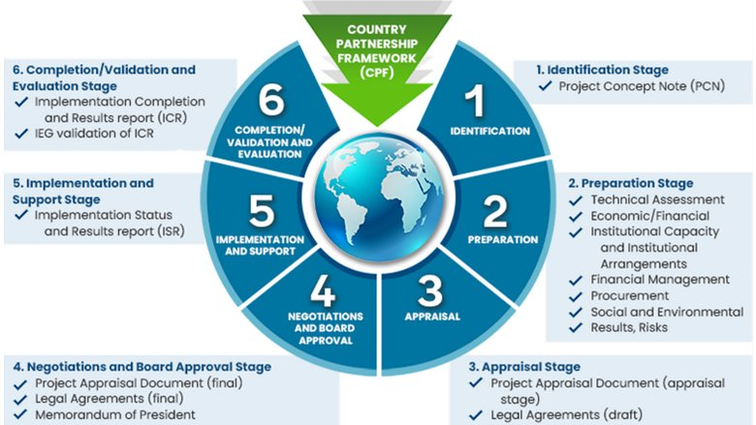

**Figure 1: World Bank cycle plan**

(Source: worldbank.scene7.com, 2023)

To conduct an exhaustive examination, different strategies and strategies can be utilized, such as cost-benefit examination, affectability investigation, and situation examination. The cost-benefit examination includes distinguishing and evaluating the costs and benefits of the extension to decide whether the extension is financially practical (Davis, and Rhodes, 2020).

## **Role of Contracts in dispute resolution**

During the pre-project stage, it is essential to set up clear contracts and understandings between the parties included in the project. Contracts can give a system for overseeing debate and settling clashes that will emerge amid the project's execution. According to Davis, and Rhodes, (2020) clear and well-drafted contracts can offer assistance dodge errors and debate, and guarantee that the venture is executed as arranged.

As per Hamledari, and Fischer, (2021) contracts can incorporate clauses that indicate the debate determination components that will be utilized in cases of debate, such as intercession, intervention, or case. It is fundamental to guarantee that the contracts are drafted in a way that's enforceable under UK law which provides adequate security for all parties included in the venture (Hamledari, and Fischer, 2021). Contracts ought to moreover be frequently surveyed and upgraded to ensure that they reflect any changes within the venture or outside components that will affect the project's execution (Hamledari, and Fischer, 2021).

## **Stakeholder Analysis**

According to Funck, and Karlsson, (2020) during the pre-project stage, it is vital to distinguish and analyse all partners who may be affected by the extent. This incorporates inner partners such as workers and outside partners such as customers, providers, and administrative bodies. Partner investigation makes a difference to guarantee that the project meets the desires and expectations of all partners and can help identify potential dangers and openings (Funck, and Karlsson, 2020).

## **Market Analysis**

As per Song, and Zhou, (2020) showcase examination includes surveying the request and supply conditions within the showcase in which the extension will be executed. This incorporates analysing the current advertising patterns, recognizing potential competitors, and surveying the potential advertising measure. According to Song, and Zhou, (2020) the advertising investigation makes a difference to guarantee that the extension is adjusted with the showcase request and can offer assistance distinguish potential openings and dangers (Song, and Zhou, 2020).

## **Risk Assessment**

As Stated by Gereffi, (2020) hazard evaluation includes distinguishing potential dangers that will affect the project's execution. This includes analysing outside dangers such as changes in financial conditions or administrative environment and internal risks such as extended administration dangers or specialized dangers. According to Gereffi, (2020) chance appraisal makes a difference to guarantee that suitable hazard administration strategies are put in put to mitigate potential dangers.

## **Resource Assessment**

Resource assessment includes recognizing the assets required for the project's execution (Gereffi, 2020). This incorporates surveying the accessibility of monetary assets, human assets, and specialized assets. Asset appraisal makes a difference to guarantee that the venture has satisfactory assets to meet its goals and can help identify potential asset limitations that will affect the project's execution (Filimonau, Todorova, Mzembe, Sauer, and Yankholmes, 2020).

# **Partner Examination**

During the pre-project stage, it is imperative to conduct a comprehensive stakeholder examination to recognize all partners who may be affected by the extent (Filimonau, Todorova, Mzembe, Sauer, and Yankholmes, 2020). This includes inner partners such as representatives and outside partners such as clients, providers, and administrative bodies. Partner examination makes a difference to guarantee that the extend meets the requirements and desires of all partners and can offer assistance distinguish potential dangers and openings (Filimonau, Todorova, Mzembe, Sauer, and Yankholmes, 2020). The investigation can moreover advise the project's communication and engagement procedures with stakeholders.

# **Project Execution**

## **Project Monitoring and Control**

During the execution stage, it is vital to screen and control the project's advance to guarantee that it is on track to meet its destinations (Abad-Segura, González-Zamar, López-Meneses, and Vázquez-Cano, 2020). This incorporates following key execution pointers such as plan, budget, and quality, and taking remedial activities if fundamental (Abad-Segura, González-Zamar, López-Meneses, and Vázquez-Cano, 2020). Viable venture observing and control can offer assistance to guarantee that the extent is conveyed on time, inside a budget, and to the specified quality benchmarks.

## **Contract Management**

Contracts play a basic part in the execution stage of the venture. This incorporates overseeing the contracts with merchants, providers, and other partners included within the venture (Abad-Segura, González-Zamar, López-Meneses, and Vázquez-Cano, 2020). Compelling contract administration makes a difference to guarantee that the extension is executed in agreement with the terms and conditions of the contracts and can offer assistance to relieve potential debate. As per Lerner, and Nanda, (2020) this may include creating a contract administration arrangement, following contract deliverables, and guaranteeing compliance with lawful and administrative prerequisites.

## **Resource Management**

A study by Lerner, and Nanda, (2020) shows resource management is a vital perspective of extended execution. This includes overseeing the project's assets such as money-related assets, human assets, and specialized assets to guarantee that they are viably distributed and utilized (Lerner, and Nanda, 2020). Viable asset administration can offer assistance to guarantee that the venture is conveyed on time, within budget, and to the specified quality benchmarks.

## **Stakeholder Management**

As given by Vickerman, (2021) stakeholder management is a progressing handle all through the extended execution stage. This includes locking in with partners and overseeing their desires to guarantee that the venture meets their needs and necessities (Vickerman, 2021). Successful partner administration can offer assistance to construct positive connections with partners and mitigate potential clashes or issues which will emerge amid the project's execution.

## **Quality Management**

Quality administration is a vital perspective of project execution. This includes guaranteeing that the project's deliverables meet the desired quality guidelines (Alabdullah, Ahmed, E and Nor, 2020). Successful quality administration can offer assistance to ensure that the extension is executed in understanding with the project arrangement and can offer assistance to play down the chance of blunders or surrenders that will affect the project's results (Alabdullah, Ahmed, and Nor, 2020). This may include creating a quality administration arrangement, conducting quality assessments and reviews, and executing remedial activities if fundamental.

## **Communication Administration**

Communication administration is basic during the venture execution stage (Jallow, Renukappa, and Suresh, 2021). This includes creating and executing a communication arrangement to guarantee that extended data is viably shared with partners. This may incorporate customary status reports, advance overhauls, and partner gatherings. Stated bu Jallow, Renukappa, and Suresh, (2021) compelling communication administration can offer assistance to construct positive connections with partners and guarantee that the extension is executed in agreement with their desires.

## **Change Management**

Change management may be a basic viewpoint of venture execution. According to Jallow, Renukappa, and Suresh, (2021) this includes overseeing changes to the extended scope, plan, budget, or other viewpoints of the venture arrangement. Successful alter administration can offer assistance to guarantee that changes are legitimately documented, reviewed, and affirmed and that they do not adversely affect the project's targets or outcomes. This may include creating a alter administration arrangement, conducting impact assessments, and actualizing alter-control forms.

## **Procurement Management**

According to Burton, Kumar, and Pandey, (2020) obtainment administration is a vital viewpoint of extended execution, especially for ventures that require the acquisition of products or administrations from outside vendors or providers. This includes managing the acquirement preparation, from distinguishing acquirement to selecting merchants and arranging contracts. Viable obtainment administration can offer assistance to guarantee that the project's acquirement needs are met conveniently and cost-effectively (Burton, Kumar, and Pandey, 2020).

## **Performance Reporting**

Execution detailing includes following and detailing the project's advance to partners (Burton, Kumar, and Pandey, 2020). This incorporates giving standard overhauls on venture status, key execution pointers, and dangers and issues. Compelling execution announcing can offer assistance to construct belief with partners and guarantee that the extension is executed in understanding with their desires.

## **Knowledge Management**

Information administration includes capturing and sharing knowledge gained amid the venture execution stage. This incorporates reporting lessons learned, best hones, and other information that can be utilized to move forward in future ventures. Successful information administration can offer assistance to guarantee that the organization benefits from the project's outcomes and can help to progress future extended execution.

# **Post Project Analysis**

Post-project analysis, too known as an extended assessment, may be a pivotal stage of venture administration. This stage includes evaluating the project's results and recognizing ranges for enhancement. The taking after subheadings gives a diagram of key angles of the post-project stage within the setting of the case ponder on Worldwide Budgetary and Contractual Management for the United Kingdom:

## **Evaluation Criteria**

Assessment criteria allude to the standards or benchmarks against which the project's results will be evaluated (Lippert, Perthes, and und Politik-SWP-Deutsches, 2020). Within the case of the Worldwide Monetary and Legally Binding Administration for the United Kingdom, assessment criteria may incorporate budgetary execution, partner fulfilment, and extend goals. According to Lippert, Perthes, and und Politik-SWP-Deutsches, (2020) clear assessment criteria ought to be set up sometime recently before the venture starts to guarantee that the project's results can be viably surveyed.

## **Evaluation Methods**

Evaluation strategies allude to the procedures or devices utilized to survey the project's results (Elsayed, Nasreen, and Tiwari, 2020). Within the case of the Worldwide Monetary and Legally Binding Administration for the United Kingdom, assessment strategies may incorporate monetary examination, overviews, and interviews. According to Elsayed, Nasreen, and Tiwari, (2020) the choice of fitting assessment strategies is basic to guarantee that the project's results are viably evaluated and that important experiences can be picked up.

## **Evaluation of Extend Results**

According to Enderwick, and Buckley, (2020) appraisal of venture results includes assessing the extent to which the project's destinations were accomplished. Within the case of universally Money related and Legally binding Administration for the United Kingdom, extended results may incorporate progressed monetary execution, enhanced stakeholder fulfilment, and fruitful contract administration (Enderwick, and Buckley, 2020). The appraisal of extended results ought to be based on the set-up assessment criteria and ought to be bolstered by suitable assessment strategies.

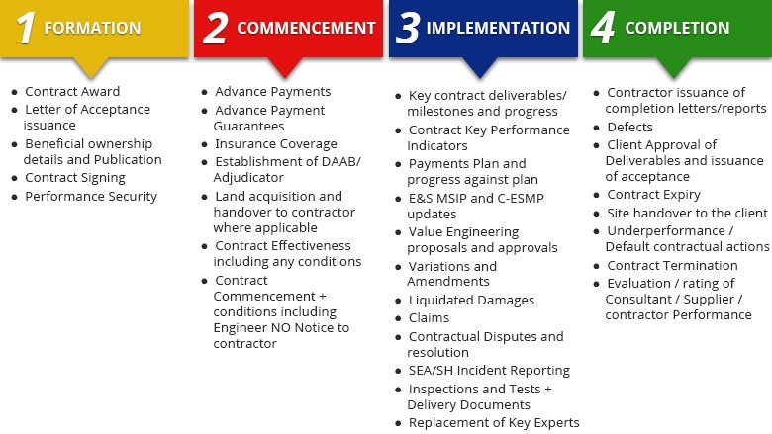

**Figure 2: Management Module**

(Source: worldbank.scene7.com, 2023)

## **Recognizable proof of Lessons Learned**

According to Napier, and Stadler, (2020) distinguishing proof of lessons learned involves documenting key experiences picked up from the venture and identifying areas for enhancement. Within the case of Universal Budgetary and Legally Binding Administration for the United Kingdom, lessons learned may incorporate best hones for monetary administration, procedures for viable contract administration, and zones for enhancement in partner engagement (Napier, and Stadler, 2020). The recognizable proof of lessons learned is basic to guarantee that the organization can benefit from the project's results and can make strides in future extended execution.

## **Contract Debate Determination**

According to Tao, Chen, and Pan, (2019) contract debate determination is an imperative thought within the post-project phase, especially for ventures that include legally binding agreements with outside parties. Within the case of Worldwide Budgetary and Legally Binding Administration for the United Kingdom, contract debate determination may include the appraisal of any debate that emerged amid the extent and the identification of strategies for settling these debates in the future. As per Tao, Chen and Pan, (2019) viable contract dispute resolution can offer assistance in playing down the effect of debate on project outcomes and can offer assistance to construct positive connections with external parties.

In conclusion, the post-project stage may be a basic angle of project management that includes the appraisal of extended outcomes and the recognizable proof of zones for change (Tao, Chen, and Pan, 2019). Within the setting of a Worldwide Budgetary and Legally binding Administration for the United Kingdom, key angles of the post-project stage incorporate the foundation of clear assessment criteria, the choice of suitable assessment strategies, the evaluation of venture results, the recognizable proof of lessons learned, and contract debate determination. By viably overseeing the post-project stage, organizations can guarantee that they advantage of the project's results and can progress future extended execution. In addition, Frost (2020) the post-project stage may moreover include other key activities, such as the planning of a last project report, the completion of budgetary reviews, and the closure of venture accounts. These exercises are basic to guarantee that the project's results are viably communicated to partners and that all financial and legally binding commitments are met (Frost, 2020). Moreover, the post-project stage may include the advancement of a project document or information base, which can be used to illuminate future venture arranging and execution. Overall, viable post-project administration is basic for maximizing the esteem of venture speculations and guaranteeing long-term organizational victory.

# **Overall Quality of Presentation**

The Overall Quality of Presentation could be a basic viewpoint of any written work, and it is especially vital within the setting of the case study on International Financial and Contractual Management for the United Kingdom (Abbas, Pienkowski, and Rogoff, K. 2019). To attain tall marks for this angle of the task, it is critical to consider the extent of variables, counting dialect, structure, and visual helps.

One of the most vital contemplations when it comes to introduction is dialect. It is basic to utilize a clear and brief dialect that's effortlessly caught on by the peruse. This implies dodging specialized language and acronyms wherever conceivable and clarifying any terms or concepts which will be new to the peruse (Abbas, Pienkowski and Rogoff, 2019). In expansion, it is imperative to utilize great sentence structure, language structure, and accentuation to guarantee that the work is easy to peruse and get it.

Another key thought is structure. The work ought to be well-organized, with a coherent flow of thoughts and clear topical passages. This could offer assistance to guarantee that the peruse can effectively take after the contention and get the key focuses being made. It is additionally imperative to utilize headings and subheadings to break up the content and offer assistance to the peruse exploring the archive (Abbas, Pienkowski, and Rogoff, 2019).

Visual aids are another vital perspective of introduction. Tables and figures can be utilized to support the content and upgrade the general clarity of the work. They ought to be clearly labelled and referenced in the content, and their reason and importance ought to be clarified to the peruse. Moreover, it is vital to guarantee that the visual bits of help are simple to examine and understand, with clear textual styles, suitable colours, and suitable labelling.

Generally, consideration of detail is key when it comes to the Generally Quality of the Introduction of the action (Abbas, Pienkowski, and Rogoff, 2019). This implies taking the time to edit and alter the work carefully, and guaranteeing that it is free from blunders and presents a clean and proficient appearance. It is additionally important to consider the requirements and desires of the expected gathering of people and to tailor the introduction style and dialect to meet their needs.

Within the setting of the case considering Worldwide Budgetary and Legally Binding Administration for the United Kingdom, the Generally Quality of Presentation is especially vital (Farhan, Jasim, and Hameed). The subject matter is complex and specialized, and the planning group of onlookers is likely to have a run of diverse foundations and levels of ability. As a result, it is vital to use clear and brief dialects, maintain a strategic distance from specialized language, and clarify any new terms or concepts.

As per Farhan, Jasim, and Hameed, the structure of the work ought to too be carefully considered. The case thinks about covers a run of distinctive subjects, counting venture possibility, contract administration, and post-project examination. Each of these points ought to be tended to in a partitioned area or chapter, with clear headings and subheadings to assist the peruse explore the report.

According to Farhan, Jasim, and Hameed visual help can moreover help display the data clearly and briefly. For case, tables can be utilized to show monetary information, while diagrams and flowcharts can be utilized to demonstrate project management forms. These visual aids should be clearly labelled and referenced in the content, and their reason and centrality ought to be clarified to the peruse.

Finally, the General Quality of the Introduction ought to reflect the high standards of professionalism and consideration of detail anticipated within the field of universal monetary and legally binding administration (Evenett, 2019). This implies taking the time to edit and alter the work carefully, and guaranteeing that it presents a clean and proficient appearance. By taking after these rules, the author can guarantee that their work meets the highest standards of introduction and successfully communicates the key concepts and concepts related to Worldwide Budgetary and Legally Binding Administration for the United Kingdom (Evenett, 2019).

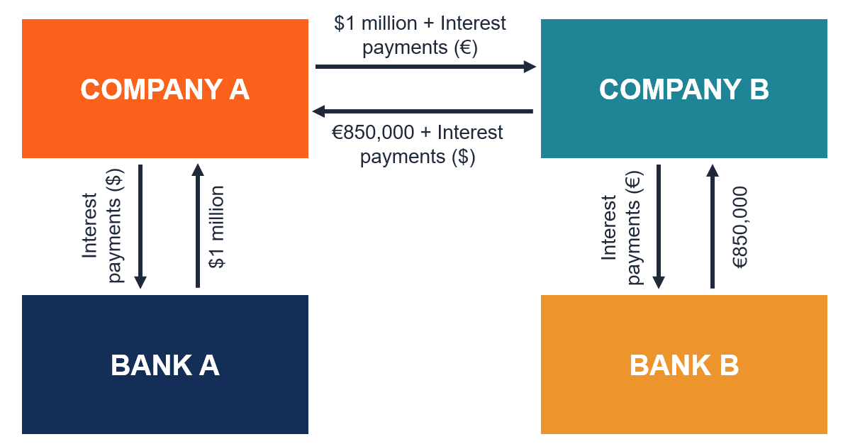

**Figure 3: Currency Swap**

(Source: cdn.corporatefinanceinstitute.com, 2023)

# **Individual Critical Evaluation**

The victory of any venture to a great extent depends on the decision-making preparation and the utilization of suitable possibility concepts, procedures, and strategies amid the project's lifecycle. According to Evenett, (2019) this basic assessment will evaluate the viability of financial, financial, and social possibility concepts, strategies, and strategies in helping decision-making sometime recently, amid, and after the venture for Universal Money related and Legally binding Administration for the United Kingdom (Evenett, 2019).

## **Feasibility Concepts, Techniques, and Methods Used in the Pre-Project Phase**

The pre-project stage includes the starting arranging and appraisal of the project's possibility (Evenett, 2019). During this stage, the possibility concepts, methods, and methods are utilized to help decision-making. For illustration, a cost-benefit investigation (CBA) was utilized to survey the money-related achievability of the Worldwide Budgetary and Legally Binding Administration extension (Cohen, 2020). The CBA included assessing the project's potential benefits and costs and comparing them to decide whether the extension was practical or not. According to Cohen, (2020) a hazard examination was conducted to recognize potential dangers and decide how to moderate them. The chance investigation gave a clear understanding of the dangers related to the venture, permitting the venture group to create suitable procedures to oversee them (Cohen, 2020).

## **Effectiveness of Feasibility Concepts, Techniques, and Methods in the Pre-Project Phase**

The utilization of achievability concepts, procedures, and strategies within the pre-project stage was successful in helping decision-making (Tinsley, R., 2022). The CBA has given a clear understanding of the monetary possibility of the venture and empowered the extended group to decide whether the venture was financially practical or not. Also, the hazard investigation was compelling in distinguishing potential dangers and creating methodologies to relieve them, lessening the project's overall risk (Tinsley, 2022).

## **Feasibility Concepts, Techniques, and Methods Used in the Project Execution Phase**

According to Tinsley, (2022) during the extended execution stage, achievability concepts, methods, and methods are utilized to track the project's advance and guarantee it remains on track. For case, Earned Esteem Administration (EVM) was utilized to track the project's advance against its budget and plan. EVM includes comparing the project's genuine advance to its arranged advance and budget, permitting the extended group to recognize any deviations and take remedial action (Tinsley, 2022).

## **Effectiveness of Feasibility Concepts, Techniques, and Methods in the Project Execution Stage**

The utilization of possibility concepts, methods, and strategies amid the extended execution stage was compelling in following the project's advance and ensuring it remained on track (Urbański, Haque, and Oino, 2019). EVM was a compelling procedure in following the project's advance against its budget and plan, permitting the extended group to identify deviations and take remedial action to keep the extension on track (Urbański, Haque, and Oino, 2019).

## **Feasibility Concepts, Techniques, and Methods Used in the Post-Project Phase**

According to Urbański, Haque, and Oino, (2019) the post-project stage includes assessing the project's victory and recognizing any lessons learned. Amid this stage, possibility concepts, methods, and strategies are utilized to evaluate the project's victory and distinguish opportunities for enhancement. For illustration, a Cost-Effectiveness Analysis (CEA) was utilized to assess the project's victory by comparing the project's costs to its benefits (Urbański, Haque, and Oino, 2019). CEA includes calculating the project's cost-effectiveness ratio, which decides the project's productivity and viability.

## **Effectiveness of Feasibility Concepts, Techniques, and Methods in the Post-Project Stage**

According to Desmond, (2019) the utilization of achievability concepts, methods, and strategies amid the post-project stage was compelling in assessing the project's victory and distinguishing openings for change. CEA gave a clear understanding of the project's cost-effectiveness, empowering the extended group to decide whether the project's benefits defended its costs. Furthermore, lessons learned were recognized, permitting the venture group to actualize advancements in future ventures (Desmond, 2019).

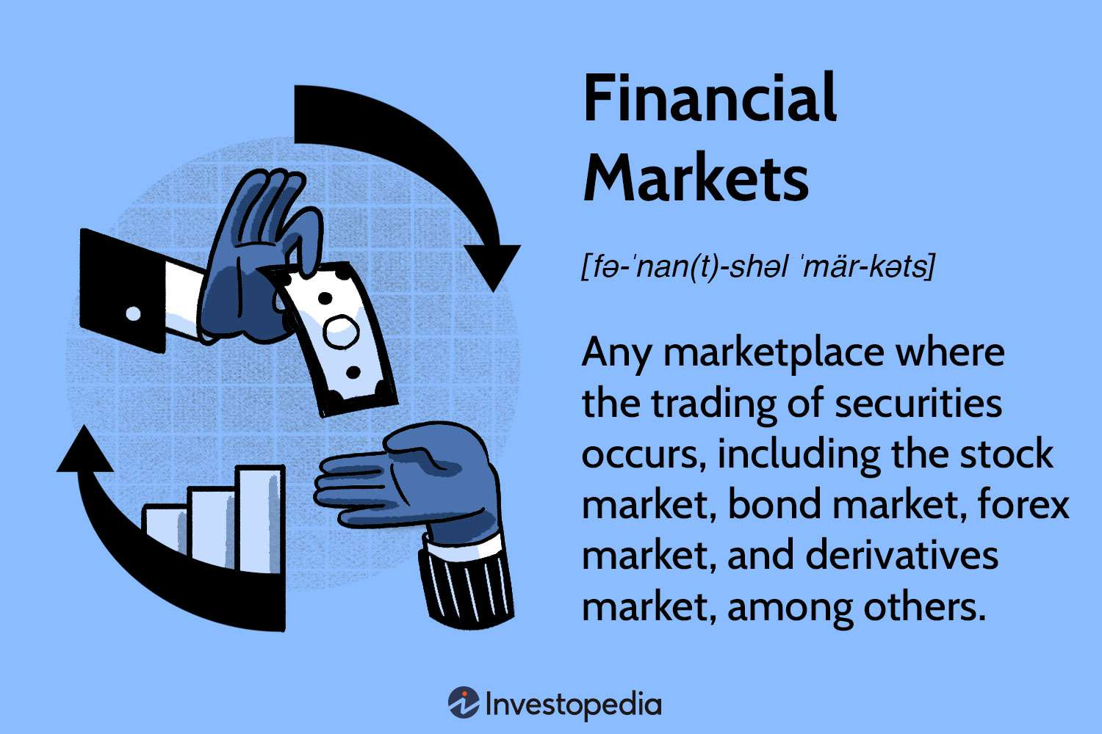

**Figure 4: Financial Market**

(Source: www.investopedia.com, 2023)

Moreover, sensitivity investigation and scenario planning are two other imperative strategies utilized during the pre-project stage. Affectability investigation makes a difference in recognizing the factors that have the greatest effect on the venture results. By modifying the values of these factors, it is conceivable to decide the potential impact on the generally extended execution (Desmond, 2019). On the other hand, situation arranging includes the advancement of different conceivable scenarios to assess how the extension would perform beneath distinctive circumstances. This strategy makes a difference in distinguishing potential risks and vulnerabilities and allows the project team to create possible plans to relieve their effect.

During the extended execution stage, the extended group must regularly screen and control the venture to guarantee that it is advancing as planned (Borlaug, Salisbury, Gerdes, and Muratori, 2020). The utilization of earned value management (EVM) could be a commonly utilized strategy for venture observing and control. EVM compares the arranged budget and plans with the real uses and advances to decide whether the extension is on track or not. This method gives an early warning framework for venture deviations and empowers the venture group to require remedial activities (Borlaug, Salisbury, Gerdes, and Muratori, 2020).

Another imperative perspective of extended execution is contract management. Contracts play a significant part in the venture execution stage, and their successful administration can essentially affect the project's victory. The contract administration handle includes exercises such as contract negotiations, contract organization, and debate determination (Borlaug, Salisbury, Gerdes, and Muratori, 2020). The extended group must guarantee that the contracts are legitimately arranged, executed, and managed to avoid any debate which will emerge amid the extension.

# **Conclusion**

In conclusion, the evaluation of financial, monetary, and social achievability concepts, strategies, and strategies is significant for compelling choice-making in universal budgetary and legally binding administration ventures within the United Kingdom. The pre-project stage plays a basic part in deciding the achievability and reasonability of the extend through showcase examination, partner examination, and hazard appraisal. This stage includes the utilize of different strategies, counting advertisements inquiries, overviews, and monetary modelling, to evaluate the potential costs, benefits, dangers, and returns related to the venture.

During the venture execution stage, it is significant to screen the project's advance, oversee the budget, and guarantee compliance with legally binding commitments. The utilization of execution markers and venture administration devices can help in the following advance, recognizing potential issues, and executing remedial measures to guarantee the project's victory.

The post-project stage includes assessing the project's results against the starting targets, counting budgetary execution, social and natural impacts, and partner fulfilment. This stage can include the utilization of different strategies, counting cost-benefit investigation, social return on speculation, and affecting the appraisal, to survey the project's general viability.

In terms of future hone, it is suggested that organizations lock-in in the careful pre-project investigation to guarantee the project's achievability and practicality. This includes conducting an advertising examination, evaluating the project's potential dangers and benefits, and locking in with partners to ensure their needs and desires are met. Amid extend execution, it is fundamental to prioritize venture administration and viable communication to guarantee the extend remains on track and inside budget. At last, within the post-project stage, organizations ought to lock in exhaustive evaluation and affect evaluation to memorize from their encounters and illuminate future choice-making.

# **Reference**

Abad-Segura, E., González-Zamar, M.D., López-Meneses, E. and Vázquez-Cano, E., 2020. Financial technology: review of trends, approaches and management. *Mathematics*, *8*(6), p.951.

Abbas, S.A., Pienkowski, A. and Rogoff, K. eds., 2019. *Sovereign debt: A guide for economists and practitioners*. Oxford University Press.

Alabdullah, T.T.Y., Ahmed, E.R. and Nor, M.I., 2020. The world declining economy and coronavirus pandemic: Systems should be continued. *Russian Journal of Agricultural and Socio-Economic Sciences*, *102*(6), pp.89-96.

Borlaug, B., Salisbury, S., Gerdes, M. and Muratori, M., 2020. Levelized cost of charging electric vehicles in the United States. *Joule*, *4*(7), pp.1470-1485.

Burton, B., Kumar, S. and Pandey, N., 2020. Twenty-five years of The European Journal of Finance (EJF): a retrospective analysis. *The European Journal of Finance*, *26*(18), pp.1817-1841.

cdn.corporatefinanceinstitute.com,2023, company profile, Available at: (https://cdn.corporatefinanceinstitute.com/assets/currency-swap-contract.png), [Accessed on: 10th may 2023]

Christophers, B., 2019. The rentierization of the United Kingdom economy. *Environment and Planning A: Economy and Space*, p.0308518X19873007.

Cohen, M.J., 2020. Does the COVID-19 outbreak mark the onset of a sustainable consumption transition?. *Sustainability: Science, Practice and Policy*, *16*(1), pp.1-3.

Davis, G. and Rhodes, R.A., 2020. From hierarchy to contracts and back again: reforming the Australian public service. In *Institutions on the Edge?* (pp. 74-98). Routledge.

Desmond, M., 2019. In order to understand the brutality of American capitalism, you have to start on the plantation. *New York Times*, *14*.

Elsayed, A.H., Nasreen, S. and Tiwari, A.K., 2020. Time-varying co-movements between energy market and global financial markets: Implication for portfolio diversification and hedging strategies. *Energy Economics*, *90*, p.104847.

Enderwick, P. and Buckley, P.J., 2020. Rising regionalization: will the post-COVID-19 world see a retreat from globalization?. *Transnational Corporations Journal*, *27*(2).

Evenett, S.J., 2019. Protectionism, state discrimination, and international business since the onset of the Global Financial Crisis. *Journal of International Business Policy*, *2*, pp.9-36.

Farhan, M.M., Jasim, M.R. and Hameed, A.J., The Role of Political Stability in the Development of Accounting.

Filimonau, V., Todorova, E., Mzembe, A., Sauer, L. and Yankholmes, A., 2020. A comparative study of food waste management in full service restaurants of the United Kingdom and the Netherlands. *Journal of Cleaner Production*, *258*, p.120775.

Frost, J., 2020. The economic forces driving fintech adoption across countries. *The technological revolution in financial services: how banks, fintechs, and customers win together*, *838*, pp.70-89.

Funck, E.K. and Karlsson, T.S., 2020. Twenty‐five years of studying new public management in public administration: Accomplishments and limitations. *Financial Accountability & Management*, *36*(4), pp.347-375.

Gereffi, G., 2020. What does the COVID-19 pandemic teach us about global value chains? The case of medical supplies. *Journal of International Business Policy*, *3*, pp.287-301.

Hamledari, H. and Fischer, M., 2021. Construction payment automation using blockchain-enabled smart contracts and robotic reality capture technologies. *Automation in Construction*, *132*, p.103926.

Jallow, H., Renukappa, S. and Suresh, S., 2021. The impact of COVID-19 outbreak on United Kingdom infrastructure sector. *Smart and Sustainable Built Environment*, *10*(4), pp.581-593.

Kyere, M. and Ausloos, M., 2021. Corporate governance and firms financial performance in the United Kingdom. *International Journal of Finance & Economics*, *26*(2), pp.1871-1885.

Lerner, J. and Nanda, R., 2020. Venture capital's role in financing innovation: What we know and how much we still need to learn. *Journal of Economic Perspectives*, *34*(3), pp.237-61.

Lippert, B., Perthes, V. and und Politik-SWP-Deutsches, S.W., 2020. Strategic rivalry between United States and China: Causes, tragectories, and implications for Europe.

Napier, C.J. and Stadler, C., 2020. The real effects of a new accounting standard: the case of IFRS 15 Revenue from Contracts with Customers. *Accounting and Business Research*, *50*(5), pp.474-503.

Song, L. and Zhou, Y., 2020. The COVID‐19 pandemic and its impact on the global economy: what does it take to turn crisis into opportunity?. *China & World Economy*, *28*(4), pp.1-25.

Tao, S., Chen, S. and Pan, Z., 2019. Current status, challenges, and policy suggestions for coalbed methane industry development in China: A review. *Energy Science & Engineering*, *7*(4), pp.1059-1074.

Tinsley, R., 2022. *Advanced Project Financing Structuring Risk*. Euromoney Institutional Investor PLC.

Urbański, M., Haque, A.U. and Oino, I., 2019. The moderating role of risk management in project planning and project success: Evidence from construction businesses of Pakistan and the UK. *Engineering Management in Production and Services*, *11*(1), pp.23-35.

Vickerman, R., 2021. Will Covid-19 put the public back in public transport? A UK perspective. *Transport Policy*, *103*, pp.95-102.

worldbank.scene7.com ,2023, company profile, Available at: (https://worldbank.scene7.com/is/image/worldbankprod/Project-cycle-graphic?wid=780&hei=439&qlt=85,0&resMode=sharp), [Accessed on: 10th may 2023]

worldbank.scene7.com ,2023, company profile, Available at: (https://worldbank.scene7.com/is/image/worldbankprod/step-tracking-contract-implementation-stages-780x439?wid=780&hei=439&qlt=85,0&resMode=sharp), [Accessed on: 10th may 2023]

www.investopedia.com,2023, company profile, Available at: (https://www.investopedia.com/thmb/uLMH2s_hQum8jn5dt2FWeWGHbA0=/1500x0/filters:no_upscale():max_bytes(150000):strip_icc()/financial-market-Final-4459a12ee9f34aa98410afddd075c9c7.jpg), [Accessed on: 10th may 2023]