**MGT9706M STRATEGY IN CONTEXT**

**STRATEGIC ANALYSIS OF GOOGLE INC**

**Executive summary**

The proposed report is the critical evaluation of Google’s case study. The case study itself concerns Google’s revolutionary business model regarding its ad-based income and the challenges faced by the company in this process. The report considers a systematic evaluation of the context, situation, solution and recommendations regarding specific business tactics.

**Table of Contents**

1. Introduction 3

2. Discussion 3

2.1 Context 3

2.2 Situation 6

2.3 Problem 11

2.4 Solution 13

3. Recommendations and Conclusion 14

Reference list 16

Appendices 19

Appendix 1: Annual performance evaluation 19

# 1. Introduction

Strategic analysis is the evaluation of an organisation’s business environment in relation to its operations. The proposed study evaluates the strategic positioning and context of Google Inc.’s performance based on the environment. Google is a multinational technology company established in 1998 in the USA. Currently, the company is one of the world’s largest technical support server companies accountable globally (About.google, 2023). The evaluation of this multinational organisation has been conducted in four main parts. The evaluation includes finding the positive and negative aspects of Google’s strategic contexts, the current situation of Google’s performance and competitive positioning. A further account of the company’s portfolio-related internal problems and respective solutions have aslo been taken, addressing change management. Based on the current understanding of all such elements, a further recommendation has been made for further improvement of Google.

# 2. Discussion

## 2.1 Context

The key elements of Google’s operational strategy can be evaluated through the strategy diamond model developed by James Fredrickson and Donald Hambrick in 2005. The key elements of the strategy diamond include ***economic logic, staging, arenas, vehicles and differentiators.***

|  |  |
| --- | --- |
| **Variables** | **Strategy** |
| ***Economic logic*** | Low cost through relocation and scope-based advantage |
| ***Staging*** | Prioritising a sequence of initiatives |
| ***Arenas*** | * ***Product categories:*** Media and software; and clothing and accessories. * ***Market segments:*** All ages, all social classes, students, employees and professionals * ***Geographic distribution:*** Global * ***Core technologies:*** PageRank, MapReduce, Google file Systems, and Bigtable * ***The values creation stages:*** Respect for the users, respecting opportunities and respecting each other |
| ***Vehicles*** | Motorola Mobility, Nest, DoubleClick, Looker, Fitbit and over 250 others. |
| ***Differentiators*** | * ***Image:*** Most preferred search engine * ***Customisation:*** Unique and built-to-order * ***Price:*** Value-based and market-oriented pricing * ***Product reliability:*** Highly reliable |

**Table 1: Strategic Diamond of Google**

(Source: self-developed)

***Economic logic*** accounts for how the results and returns will be obtained by Google. Based on the economic conditions there are four ways a company can obtain returns. The processes include:

* Low cost through scale advantage
* Low cost through relocation and scope-based advantage
* Premium pricing through unmatchable services and
* Premium pricing due to product feature priority.

The strategy Google adapts is a ***low-cost through relocation and scope-based advantage*** strategy. Across the core suite of Google’s software products, the company largely gives a free service while accounting for only small fees regarding some additional software products (case study). For example, the company provides free services regarding some elements of Google’s dashboard such as docs and mail. While additionally, to use their cloud services users have to purchase plans that are up to $300. The plans also provide more than 20 additional free products for customers to use (Cloud.google.com, 2023). These products have a significant scope of demand globally and are generally acquired at a lower price, if not free of cost. This is a positive aspect of their economic logic-based strategy.

***Staging*** in Google accounts for the company’s speed and sequence of moves. A company in its staging strategy can either consider the ***speed of expansion*** or ***prioritise a sequence of initiatives***. At the time of a product launch by Google, the company prioritises the usage of the product before considering monetisation of the products (Savolainen, 2021). Then the company is able to consider the best possible customer experience. This customer and product prioritising strategy of Google can be considered as a ***prioritisation of a sequence of initiatives***. The positive side of this strategy is that the company is able to satisfy the customers. However, this is not a strategy that can be used in competitive revenue generation as it primarily accounts for the customers and not the competition.

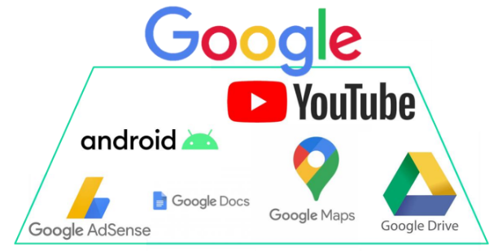

**Figure 1: Core technologies used in Google**

(Source: Case-study)

Evaluation of ***Arenas*** in a company accounts for their ***product categories, market segments, geographic distribution, core technologies and the value creation stages.*** The product categories of Google include two main product genres, Media and software; and clothing and accessories (Support.google.com, 2023). Google’s demographic market segmentation includes the inclusion of all age groups from children to retired individuals who are interested and communicate through media. As per occupations, they can be students, employees and all professionals. Google’s psychographic segmentation includes all social classes. Geographically, the services of the company are distributed globally and in both urban and rural environments. The global reach of Google is still unmatched by its competitors. The core technologies Google uses include ***PageRank, MapReduce, Google File Systems, and Bigtable*** (Wang *et al*. 2020). The value creation stages of the company include three main considerations; respect for the users, respecting opportunities and respecting each other. Thus, Google have been able to maintain a large customer base worldwide. Having such a large and variable arena of operations is a positive aspect of Google’s strategy as the company is able to have more exposure to the customers.

***Vehicles*** account for internal development and consideration of acquisition and merging such as joint ventures, licensing, franchising and acquisitions. Google, as a large multinational company strategises with acquiring and merging with new companies while integrating their operations into theirs. Till date, they have merged with 256 companies globally and their main private and public ownerships include ***Motorola Mobility, Nest, DoubleClick, Looker, and*** many others.

The ***differentiator*** of a company is the recognition of their uniqueness. This includes ***image, customisation, price, styling and product reliability.*** Considering public image, Google is the most preferred search engine with global accountability (Khan *et al.* 2021). Google's product customisation is taken with unique and built-to-order activities. The pricing strategy that the company uses is a value-based and market-oriented pricing strategy acknowledging both customer satisfaction and market competition. Lastly, the products are highly reliable and preferred largely by a global audience.

## 2.2 Situation

**Porter’s five forces**

|  |  |
| --- | --- |
| **Variables** | **Impact** |
| **Competitors in the industry** | High |
| **Potential new entrants in the industry** | Low |
| **Power of suppliers** | Low |
| **Power of buyers** | High |
| **Threats of substitutes** | Moderate |

**Table 2: Porter’s five forces and their effects on Google**

(Source: self-developed)

***Competitors in the industry*** pose potential threats to market acquisition. The more number and power the competitors have, the fewer the chances of market acquisition by a company. Google’s main operations in the market have a significant number of competitors. The competitors of Google include ***Amazon, Facebook, Apple, Microsoft, Bing, Yahoo, and Firefox*** which have global accountability (George and George, 2023). Other than local country-based competitors such as ***Baidu in China*** also provides Google regional competition.

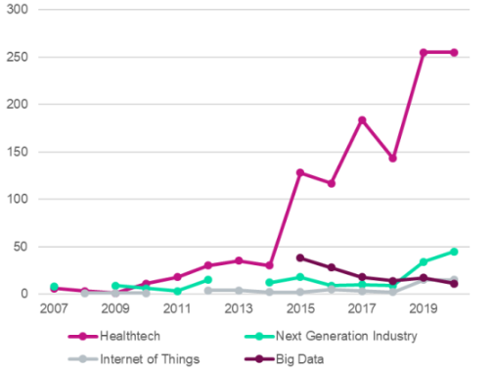

**Figure 2: the priority to healthcare tech over the years**

(Source: case-study)

Amazon competes with Google in more than search but in healthcare too. The growth in healthcare segment as seen in figure 2 compels them to do so.

***Potential new entrants in the industry*** can also devaluate the existing market operation of the company. An increase in potential new entries in the market can give the existing market competition and can reduce the share of revenue generation. Thus, a higher number of potential new entrants in the market poses a threat to the existing company. However, new entrants in the global market regarding such operations are not seen. The company has only significant competition from the large global companies.

***The power of suppliers*** of a company determines the company’s capabilities of dealing with its primary supply chain sources. The suppliers having more power can indirectly control products, services and operations of a company having a high impact. The main suppliers of Google are its customers having use the search engine, from which Google can gain knowledge of developing a better performance (Brickley *et al.* 2019). Other than that, the merger companies and acquisitions also provide the company with information. These suppliers, however, do not have much control over Google’s ultimate decisions regarding product and service delivery. Ireland (2021), finds out5 additionally that Google’s technology and hardware suppliers also do not have significant power over the company as Google currently is the topmost player in its field.

**The power of buyers** of a company shows how much a customer has control over the company’s decision-making. Google primarily accounts for satisfying their customers with new products before having the accountability of monetary gain. An example can be seen in the case study regarding the facing of multiple customer threats for their data-driven ad model integration (Case study). Thus, the voice of the customers plays a key role in the decision-making of the company and therefore the customers have significant power over the company.

***Threats of substitutes*** occur when similar services enter the market and take over the entirety or a large part of the market. Globally, there is a significant amount of search engine-based similar service providers such as Mozilla, Yahoo, Microsoft, Ask and others. However, despite the number of substitute products being high, the threat of substitutes is low due to the quality of Google’s products and services.

**SWOT analysis**

|  |  |
| --- | --- |
| **Strengths**   * World’s biggest search engine * Significant revenue generated through ads. (Case study) * Huge data accessibility through Chrome * Huge customer base and preferability | **Weaknesses**   * Amazon as the biggest competitor (Case study) * Google ads taking significant space * Less infrastructure on offline activities |
| **Threats**   * The aggressive move of Facebook in Google’s advertising territory * Customer threats regarding growing ads * Voice search threatening to erase on-screen ads (Case study) * Derailing of Google’s data source buy regulations (Case study) | **Opportunities**   * Moving of google drive to the B2B market * Pixel phones and laptops still have importance (Case study) * Still being the top search engine in the market with the largest database and research capability. |

**Table 3: SWOT analysis of Google’s current situation**

(Source: self-developed)

Google is the most preferred search engine with the largest database is the company’s main strength of market strength. With the search engine, Google is able to involve algorithms that are accountable for the largest detection of customer preferences. Google uses this strength to involve a data-driven advertisement delivery. This is the process of analysing customer preferences and delivering similar ads to them.

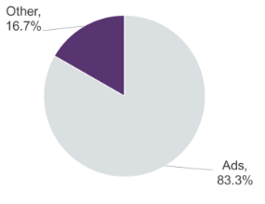

**Figure 3: Percentage of Google’s revenue generated through Ads**

(Source: Case study)

This process is the largest revenue generator for the company. Approx 83.3% of the total revenue of Google is generated through data-driven ads, as seen in the above figure (Case study). This is also possible due to the ads reaching a huge number of customers. As mobile phones, PCs and laptops still have importance in the market, Google can have significant opportunities for operation and ad-based income. Other than that, the company also has the opportunity regarding their cloud services and drive accessibility largely moving to the B2B market (Beverungen *et al.* 2022). This can increase the revenue generation of the company in a significant manner.

However, the company has a significant number of competitions in the market regarding the operations of Amazon, Facebook and the major search engine service providers. On top of that, Google ads, which contribute the most to the company’s revenue, is also their weakness regarding the fact that there are too many of them. As the number of Google ads is increasing, so are the customer complaints about them, which is already considered a significant threat to the company’s operations. The ghost ads that Google puts on social media sites are the biggest turnoffs of the company in recent years (Gordon *et al.* 2021). Other than that, the recent data protection and circulation regulations mostly adopted by the UN prevent several areas of operations for Google deeming them unethical, which can provide future threats to the company. Lastly, the increase in voice search market since 2019, and the domination of the market by Apple, Amazon and Microsoft have reduced the space for Google’s advertising creating threats to the company in the future (Case study). However, despite such a competitive business environment, Google still stands as a market dominator in its field due to its intense preference and significant market revenue.

**Annual performance evaluation**

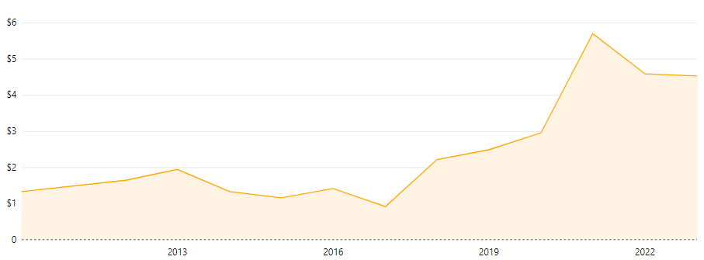

**Figure 4: EPS of Google over the years**

(Source: Companiesmarketcap.com, 2023)

The Anual performance evaluation of Google is considered with a three-year comparison analysis of 2020 to 2022. In 2020, the total investment revenue has been seen at 182,527 million $ (Abc.xyz, 2020). This constantly increased and reached 282,836 million $ in 2022. However, as seen in Figure 4, the operating income and margin fluctuated in the years from 28% in 2020 to 31% in 2021 and then reduced to 26% in 2022 (Companiesmarketcap.com, 2023). The reason could be the increase in operating or non-operating costs or both (Bhatt, 2021). A further decrease in income from Google services can also be seen with 52,873 million $ in 2020 dropping to 21,101 million $ (Sec.gov, 2023). A similar drop can aslo be seen in Google Cloud service-based income as well. This only indicates a drop in the use of Google’s services over the years.

***[Referred to appendix 1]***

## 2.3 Problem

The problem discussed in the case study is the current revolutionised business model of Google while assessing that the process can be evolved further. The problem, in this case, is evaluated through the AFI strategy framework. The framework holds three stages of evaluation; ***Analysis, Formulation and Implementation*** (Kašparová, 2022). Through this framework not only current problems are evaluated, but possible solutions and implementations of the problems can also be accounted for.

|  |  |
| --- | --- |
| **Elements** | **Remark** |
| ***Analysis*** | * Reduction of on-screen ads due to voice-search practices. * Aggressive movement of Facebook towards Google ads * Amazon’s activeness as the biggest competitor * Data regulations creating data accessibility and evaluation problems |
| ***Formulation*** | * Aggressive investment in Google ads. |
| ***Implementation*** | * The constant increase of investments in Google ads. |

**Table 4: AFI Framework for Google**

(Source: Self-developed)

***Analysis*** in the AFI framework accounts for the evaluation of the current problems. The case study identifies the main problems of Google with the company’s data-driven model facing threats. The threats included a reduction of on-screen ads due to voice-search practices and the aggressive movement of Facebook towards Google ads. Amazon’s activeness as the biggest competitor and data regulations creates data accessibility and evaluation problems which are also potential problems seen (Case study). These arising problems have provoked three main risks in the company. Firstly, several ***growth regulatory risks*** have been seen as the US conducted several FTC and DOJ investigations on the company. From the EU, the company has faced record fines in the last few years regarding antitrust violations. Secondly, their earnings have been downgrading from initial predictions. Their earnings per share were reduced to $10.12 from an estimation of $12.42 in 2019 (Thestreet.com, 2019). Lastly, the employees have also started to become sceptical about the company’s further growth.

***Formulation*** is the process of plan creation for necessary action to mitigate the perceived challenges and problems. The strategy formulation for voice search domination can be considered with Google's own voice search process implementation with advanced algorithm-based result generation. However, in this case, the visual ads completely lose their value as the services are not at all compatible with one another (Case study). In case of competition with Amazon and Facebook in the territory of ads, the company has to be more aggressive to stay in the competition. The company has a significant amount of capital amounting to approx $1.560 Trillion in 2023 (Companiesmarketcap.com, (2023). Such capital should be used for large investments in their most valued revenue generation area - Google ads.

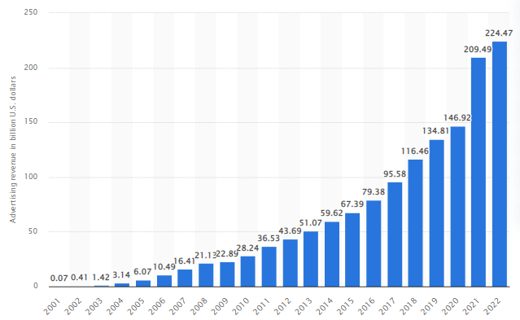

**Figure 5: Revenue investments in Ads by Google**

(Source: Statista.com, 2023)

***Implementation*** is the process ofexercising the execution of the plan formulation. The problems and challenges faced by the company only have engaged Google in investing more and more revenue in their advertising field. From 2001 to 2022, their advertising revenue has seen a constant rise from 0.07 billion US dollars to 224.47 billion US dollars (Statista.com, 2023). The investment in the most valuable revenue generator asset is expected to be the right strategy for Google.

## 2.4 Solution

The solution for Google’s future performance and prospects of revolutionising the industry can be evaluated through the Scenario planning framework. The steps of scenario planning include the identification of critical triggers even in uncertainty, developing multiple scenarios and building a response strategy (Rounsevell *et al.* 2021). The detailed planning is as follows:

|  |  |  |
| --- | --- | --- |
| **Steps** | **Scenario #1** | **Scenario #2** |
| **Main issue** | Reduction of space for Google Ads (Case study) | Increase of competitive stance by Amazon and Facebook (Case study) |
| **Time horizon** | 5 years | 5 years |
| **External factors** | Increase in voice search | Online advertising share increase |
| **Internal factors** | Increase R&D investment and develop a competitive area of advertising | Increase R&D investment and develop a competitive e-entertainment market |
| **Definitive assumptions** | * New ways of online advertisements may not be found * New platforms for advertisements may not be found. * Customers may lose interest due to increased advertisements. | * Amazon and Facebook may surpass Google in advertising. * Entertainment services of the competitors may increase in revenue more aggressively. * New innovations by competitors may induce new attractive features while increasing competition. |
| **Developing perspective** | * More investment in innovation has to be made. * More investment in advertising has to be considered * Customer preference and feedback on new products and services have to be acquired. | * Competitor analysis of the market should be considered * New entertainment and professional services have to be incorporated into the system |
| **Maintenance** | * Annual reports have to account for an increase in revenue from advertising * New technology regarding ad detection should be considered with AI and Ml implementation | * AI and Ml should be incorporated in market and competition analysis. * The large customer segment should be maintained by providing both entertainment, learning and corporate services. |

**Table 5: Scenario planning framework of Google**

(Source: Self-developed)

# 3. Recommendations and Conclusion

Based on the problems and evaluations made on Google a few improvement solutions can be given adjacent to the aspect of the problems. The main problem discussed in the case study is regarding the downfall of Google ads. The best possible solution, in this case, would be to improve the ***click-through rates*** (CTR) of the ads. For this, Google has to implement extensive AI and ML technology to target the right keywords, narrow down and segment the target audience and keep the ads skimmable. Special offers can also be presented through the ads, to make them attractive. Putting the main keywords in the display path helps in ensuring the right targeting process. Lastly, appealing to the emotions of the audience can generate more CTR for the company.

Concluding upon the discussion, the case study can be considered specific to Google’s ad-related problems and increased competition in the field. Current context evaluation shows Google using a “Low cost through relocation and scope-based advantage”, three-stage value creation and value-based pricing strategies. The situational analysis shows Google has significant competition in the market regarding Facebook, Amazon and other search-engine service provider competitors. Having significant competitors and their financial performance has also been fluctuating in the current scenario. Concerning the solution to the problem, more investment in advertisements and improving the advertisements through AI and ML have been accounted for the company.

# Reference list

Abc.xyz, (2020). *Alphabet Announces Fourth Quarter and Fiscal Year 2020 Results [Online]*. Available at: https://abc.xyz/investor/static/pdf/2020Q4_alphabet_earnings_release.pdf [Accessed on: 15 May 2023]

About.google, (2023). *From the garage to the Googleplex [Online]*. Available at:https://about.google/our-story/#:~:text=They%20called%20this%20search%20engine,it%20universally%20accessible%20and%20useful.%E2%80%9D [Accessed on: 15 May, 2023]

Beverungen, D., Hess, T., Köster, A. and Lehrer, C., 2022. From private digital platforms to public data spaces: implications for the digital transformation. *Electronic Markets, 32(2)*, pp.493-501.

Bhatt, A.R., (2021). CP (Cost-Profit) Analysis of Unlevered and High Levered Companies in India-A Select Study. *The Management Accountant Journal, 56(6)*, pp.86-89.

Brickley, D., Burgess, M. and Noy, N., (2019), May. Google Dataset Search: Building a search engine for datasets in an open Web ecosystem. In *The World Wide Web Conference* (pp. 1365-1375).

Cloud.google.com, (2023). *Google Cloud pricing* *[Online]*. Available at: https://cloud.google.com/pricing [Accessed on: 15 May, 2023]

Companiesmarketcap.com, (2023). *EPS history for Alphabet (Google) from 2010 to 2023 [Online]*. Available at: https://companiesmarketcap.com/alphabet-google/eps/#:~:text=According%20to%20Alphabet%20(Google)',EPS%20that%20were%20of%20%245.70. [Accessed on: 15 May 2023]

Companiesmarketcap.com, (2023). *Market capitalization of Alphabet (Google) (GOOG)* *[Online]*. Available at: https://companiesmarketcap.com/alphabet-google/marketcap/ [Accessed on: 15 May 2023]

George, A.S. and George, A.H., (2023). A review of ChatGPT AI's impact on several business sectors. *Partners Universal International Innovation Journal, 1(1)*, pp.9-23.

Gordon, B.R., Jerath, K., Katona, Z., Narayanan, S., Shin, J. and Wilbur, K.C., 2021. Inefficiencies in digital advertising markets. *Journal of Marketing, 85(1)*, pp.7-25.

Ideland, M., (2021). Google and the end of the teacher? How a figuration of the teacher is produced through an ed-tech discourse. *Learning, Media and Technology, 46(1)*, pp.33-46.

Kašparová, P., (2022). New Approaches to the Application of Business Intelligence in the Strategic Management Process. *ACC Journal*.

Khan, S.M., Liu, X., Nath, S., Korot, E., Faes, L., Wagner, S.K., Keane, P.A., Sebire, N.J., Burton, M.J. and Denniston, A.K., (2021). A global review of publicly available datasets for ophthalmological imaging: barriers to access, usability, and generalisability. *The Lancet Digital Health, 3(1)*, pp.e51-e66.

Rounsevell, M.D., Arneth, A., Brown, C., Cheung, W.W., Gimenez, O., Holman, I., Leadley, P., Luján, C., Mahevas, S., Marechaux, I. and Pélissier, R., (2021). Identifying uncertainties in scenarios and models of socio-ecological systems in support of decision-making. *One Earth, 4(7),* pp.967-985.

Savolainen, I., (2021). Comparing external data monetization of two analytics products–case study in the telecommunications industry.

Sec.gov, (2023). *Alphabet Announces Fourth Quarter and Fiscal Year 2022 Results* *[Online]*. Available at: https://www.sec.gov/Archives/edgar/data/1652044/000165204423000013/googexhibit991q42022.htm [Accessed on: 15 May 2023]

Statista.com, (2023). *Advertising revenue of Google from 2001 to 2022* *[Online]*. Available at: https://www.statista.com/statistics/266249/advertising-revenue-of-google/#:~:text=Google%3A%20annual%20advertising%20revenue%202001%2D2022&text=In%202022%2C%20Google's%20ad%20revenue%20amounted%20to%20224.47%20billion%20U.S.%20dollars [Accessed on: 15 May 2023]

Support.google.com, (2023). *Google product category [google_product_category] [Online]*. Available at: https://support.google.com/merchants/answer/6324436?hl=en [Accessed on: 15 May 2023]

Thestreet.com, (2019). *Google's 3 Biggest Challenges for 2020* *[Online]*. Available at:https://www.thestreet.com/investing/google-alphabet-3-biggest-challenges-in-2020 [Accessed on: 15 May 2023]

Wang, J., Yang, Y., Wang, T., Sherratt, R.S. and Zhang, J., (2020). Big data service architecture: a survey. *Journal of Internet Technology, 21(2)*, pp.393-405.

# Appendices

## Appendix 1: Annual performance evaluation

|  |  |  |  |
| --- | --- | --- | --- |
| **Element** | **2020 (**Abc.xyz, (2020) | **2021 (**Sec.gov, (2023) | **2022 (**Sec.gov, (2023) |
| Revenues | 182,527 million $ | 257,637 million $ | 282,836 million $ |
| Operating income | 15,651 million $ | 78,714 million $ | 74,842 million $ |
| Operating margin | 28 % | 31 % | 26 % |
| Other income (expense),net | 15,227 million $ | 76,033 million $ | 59,972 million $ |
| Google Services | 52,873 million $ | 25,993 million $ | 21,101 million $ |
| Google Cloud | 3,831 million $ | 890 million $ | 480 million $ |
| Other Bets | 1,136 million $ | 1,450 million $ | 1,631 million $ |
| Corporate costs, unallocated | 1,036 million $ | 1,768 million $ | 830 million $ |
| **Total income from operations** | **15,651 million $** | **21,885 million $** | **18,160 million $** |

(Source: self-developed)