**LSC UOS BA IN BUSINESS**

**HOW CORPORATE SOCIAL RESPONSIBILITY (CSR) AFFECTS CUSTOMER LOYALTY: A CASE OF THE UK RETAIL INDUSTRY**

**Abstract**

The proceeded report format is a proposal for a considered primary research topic. The topic of evaluation chosen in this case is the process through which CSR practices of the UK retail industry affect customer satisfaction and loyalty. The background information shows mandatory CSR implementation in the retail sector with the problem statement stating that young individuals have more effects of such concern. The aims and objectives set are meant to determine the positive relationship established between the variables. The literature review presents a broad aspect of evaluation regarding the relationship and its effectiveness. The proposal for methodology is considered for a future primary quantitative method through the conducting of a survey including 51 individuals by simple random sampling.

Table of Contents

1. Introduction 4

2. Aims and Objectives 7

3. Literature Review 7

4: Research methods 13

4.1 Research Design 13

4.2 Data collection and analysis 15

5. Reference List 17

6. Appendices 20

Appendix 1: Survey Questionnaire 20

Appendix 2: Research timeline 23

**List of figures**

Figure 1.1: UK retailer’s CSR-based performance ethics by age group 4

Figure 1.2: UK Food Retailers' Concerns for Sustainability 5

Figure 3.1: Conceptual Framework of CSR in the UK Food Industry 8

Figure 3.2: Relationship between Customer satisfaction, trust and loyalty with CSR 9

Figure 3.3: perceived value as a mediating factor between CSR and customer loyalty 10

Figure 3.4: The Carroll's Pyramid of CSR 11

Figure 3.3: Conceptual map 12

Figure 4.1: Sounder’s research onion 13

# 1. Introduction

***“Background of the study”***

The proposed study has focussed on evaluating specifically CSR policies of the UK retail industry and how they affect customer loyalty. "Corporate social responsibility" or CSR is a business model or strategy implemented by companies to ensure social accountability of the company, its operations and its stakeholders. However, a focused discussion on customers as stakeholders will be the pinpoint of the study.

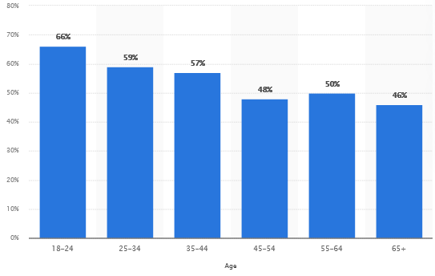

#### Figure 1.1: UK retailer’s CSR-based performance ethics by age group

(Source: Statista.com, 2023)

CSR and its implementation in the UK have been introduced much later than the other first-world countries. The first CSR considerations started in the Uk in the early 2000s. The UK and the European Commission adopted CSR policies starting in 2001 and 2002 (Core.ac.uk, (2023). During these years the European Union Commission released a compendium of Member State initiatives. This was the first form of CSR based on an awareness-raising campaign. The implementation of CSR in UK retail, however, has been seen as a much later concern. The start of this has been seen with Deloitte publishing a “Global Powers of Retailing” report in 2006 where concerns about retail industry risk factors regarding social unrest were taken into account (Rahdari*et al.* 2020). Since then both the government and the private retail companies have started incorporating CSR-related frameworks into the system. This introduced performance ethics in UK retail industry. However recent statistics such as performance ethics mostly benefited the young to young adult individuals and less influenced the elders (Statista.com, 2023). This indicated that the Implemented CSR largely affected the younger age group than the elders.

***Rationale and problem statement***

The main problem of discussion in this study will be the effect of CSR in the consideration on customer loyalty generation, specific to the UK retail industry. As discussed earlier, CSR is a guideline or framework for companies in performing their social responsibilities while improving in corporate fields. As the prime priority of a business is to account for customer satisfaction, thus CSR is one of the most essential aspects of business development and social accountability. One of the main reasons for implementing CSR is to attract investors while showcasing social awareness and good risk management considerations (Metzker*et al.* 2021). Thus the ultimate goal of the companies here is to be involved in sustainable development.

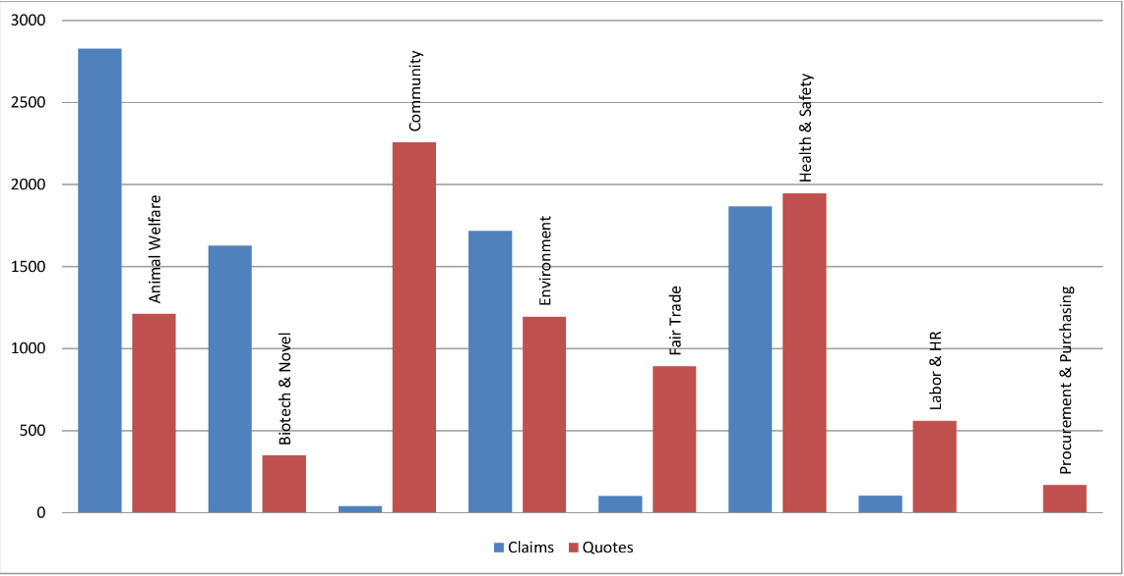

#### Figure 1.2: UK Food Retailers' Concerns for Sustainability

(Source: Semanticscholar.org, 2023)

In current times, as the consideration of customer accountability is increasing, so is the concern of implementing CSR in practices. The most CSR implementation in current times has been seen in UK food retailers. The CSR of food retailers mainly included “***animal welfare”, “biotechnology”, “environmental concerns”, “fair trade”, “health and safety”, “HR and labour”***. All this is connected with customer satisfaction directly or indirectly (Semanticscholar.org, 2023). Currently, all large UK retailers from Deloitte to Amazon, all implement CSR activities to provide the business with an ethical background and account for social responsibilities. However, a need for research is still considerable in order to understand how implementing CSR has a relation to customer satisfaction of retail companies and how directly CSR implementation and customer loyalty are related to each other. Thus a detailed source-based research has been taken under consideration.

***Significance of the Topic of Research***

The evaluation of the research topic is significant as CSR policy implementation and customer loyalty generation have been linked with each other in many previous studies. CSR practices are expected to evaluate the stakeholders of the companies in order to understand them in a better manner. Thus the retail companies can account for better engagement towards their stakeholders. On the other hand, CSR implementation can create a pierced value regarding the customers leading to a consideration of customer satisfaction (Sun, *et al*. 2020). Further better customer satisfaction can encourage customer loyalty generation. This pathway has to be evaluated thoroughly in the aspect of the retail industry of the UK. Thus, the conductance of such study can be subjectively signified.

***Value of the research***

Other than the subjective significance, the study also will also have a professional and personal significance, providing value to the reason for conductance. Professionally, the topic evaluation will bring forth several internal and external variables of the UK retail industry that are responsible for the relationship in between implemented CSR policies and customer loyalty generation. Therefore, a better critical viewpoint can be achieved on specified industry and country-based concerns regarding the matter. Personally, the research will help in the development of knowledge regarding the matter both theoretically and practically while also accounting for personal competence development.

# 2. Aims and Objectives

***“Research Aim and Objectives”***

***Aim***: The main aim is to critically evaluate how CSR in the UK retail industry affects customer loyalty in operations.

***Objectives***

* To understand the relationship in between customer loyalty generation and CSR practices.
* To evaluate the values and goals concerned in CSR policy implementation in the UK retail industry for customer satisfaction
* To discuss how CSR policies have affected UK retail industry Customer loyalty and recommend possible further improvements

***Research Question***

Based on the primary objectives, the primary research question concerns:

***Q1:*** How implemented CSR policies in the UK retail industry have affected customer loyalty generation and how can they be further modified for better result generation?

# 3. “Literature Review”

A literature review is the process of critically evaluating existing information as a secondary source. Through the literature review section, detailed previously researched information will be critically discussed regarding the effect and relationship between CSR and customer loyalty. This will provide a framework for the actual study to improve upon.

***Reason of CSR practices adhered to by the UK Retail Industry***

The UK retail industry is one of the biggestproviders to the GDP of the country. Government statistics suggest that as per 2020 readings, the retail industry comprises “*5****.2% of the UK’s gross domestic product*** and ***provides to 9.3% of the total employment***” considered (Ons.gov.uk, 2023). This reason alone is sufficient for the industry to implement ethical CSR in industry operations. The main practices adhered to by the UK retail industry in CSR policy implementation is the consideration of economic, social and corporate sustainability. According to Benghezal and Izadi (2022), CSR in sustainability concerns two main characteristics to be assured of, ***stakeholder engagement*** and an ***increase in financial performance***. In the case of stakeholder engagement, big good retail companies in the UK such as Tesco, Asda, Sainsbury’s and Morrisons can be exemplified using such concerns. The study finds their CSR implementation has elements such as ***fuel saving, GHG emissions, revenue saving and employment creation***. The financial performance enhancement consideration of such companies regarding CSR applications includes ***gross profit increase, taxation control, increase in dividend per share and operational profits***.

Alternatively, another CSR-related practice adhered to by the large UK retail operator’s concerns environmental sustainability. As per the study of Williams and Murphy (2023), the retail industries learn from each other and create a concern for the environment in their CSR for sustainable accountability. They primarily follow the consideration of UN sustainable development goals (SDGs) and ensure the best practices through their CSR framework. Thus they present their sustainably accountable operations towards the “World Commission on Environment and Development”. They consider providing value to their CSR practices through environmental accountability and sense making.

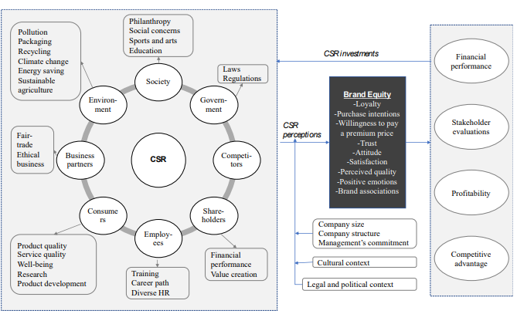

#### Figure 3.1: Conceptual Framework of CSR in the UK Food Industry

(Source: Tosun and Köylüoğlu (2020)

However, not all the retail operations in the UK are equally accountable in their CSR policy implementation. Food retail sectors, such as Tesco, Asda and Morrison’s are better accountable for their CSR practices than others. As exemplified by Tosun and Köylüoğlu (2020), the food retailers of the UK implement CSR from a managerial perspective and adapt them mainly to improve the marketing performance of the companies. They use the customer-based brand equity modelling process to both accounts for the customers and ensure organisational performance improvement. Thus, they become accountable for reasoning with both the customers and company improvement. Food retailers such as Tesco and Asda are largely concerned with such practices.

***Relationship between CSR Policy, customer satisfaction and loyalty generation***

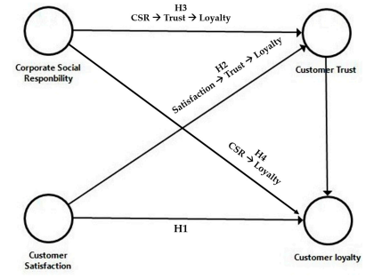

#### Figure 3.2: Relationship between Customer satisfaction, trust and loyalty with CSR

**(Source:** Leclercq-Machado *et al.* 2022)

Researchers find it evident that CSR policy creation and implementation have a direct linkage with customerloyalty and satisfaction generation. In this context, the findings of Leclercq-Machado *et al.* (2022) suggests that ***customer trust*** acts as a middle factor in between customer loyalty generation and corporate social responsibility. When CSR policies have been created concerning the mitigation of customer concerns, their implementation creates trust for the operations from the end of the customers. Due to the fact that customer trust and loyalty go hadn in hand, thus the development of customer trust also develops customer loyalty. This proves that progressive CSR implementation has a direct relationship with customer loyalty generation.

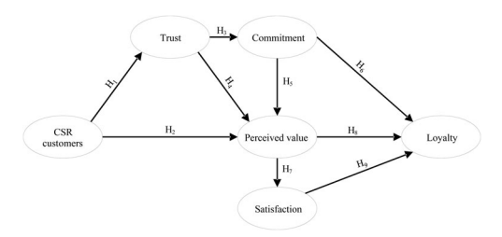

#### Figure 3.3: perceived value as a mediating factor between CSR and customer loyalty

(Source: Servera-Francés and Piqueras-Tomás, 2019)

Contrary to the above evaluation, ***customer-perceived value*** can also be considered as a mediating factor between CSR policy implementation and customer loyalty. Servera-Francés and Piqueras-Tomás (2019), suggest that the development of trust in the customers has to be measured by customers' perceived value by the company. Only through the consideration of customers' perceived value, can the company truly evaluate their customers and act in accordance with their demands. The perceived value as a margin of measurement accounts for both- level of trust generation and the level of commitment of the customers, which acts as indicators. Thus, loyalty generation is the result of perceived value measurement and not the result of customer trust and commitment.

As a further alternative consideration, the ***co-creation*** consideration of the companies can also act as a bridge between CSR policies and customer loyalty. Co-creation is the process where a business involves outsiders for the ideation and development of a particular process. Sun *et al.* (2020) argue that co-creation is only helpful in customer accountability when the company involves the opinion of the customers in the operational development. This indicates that if the retail industries are willing to involve the suggestion of their customers in the operations made for the customers, then the companies will be able to become much more positively accountable for customer loyalty generation. With co-creation acting as a mediator in relationship development, CSR practices can be improved much more effectively. For example, ***Unilever*** has been seen developing a co-creation operation with their ***Open -innovation platform launched in 2010*** (Scozzese and Granata, 2019). Through this, they present specific challenges to the public and improve upon their CSR from the responses given. Thus CSR practices and customer satisfaction and loyalty generation are directly linked with one another.

***Theoretical Underpinning***

***The Carroll's Pyramid of CSR***

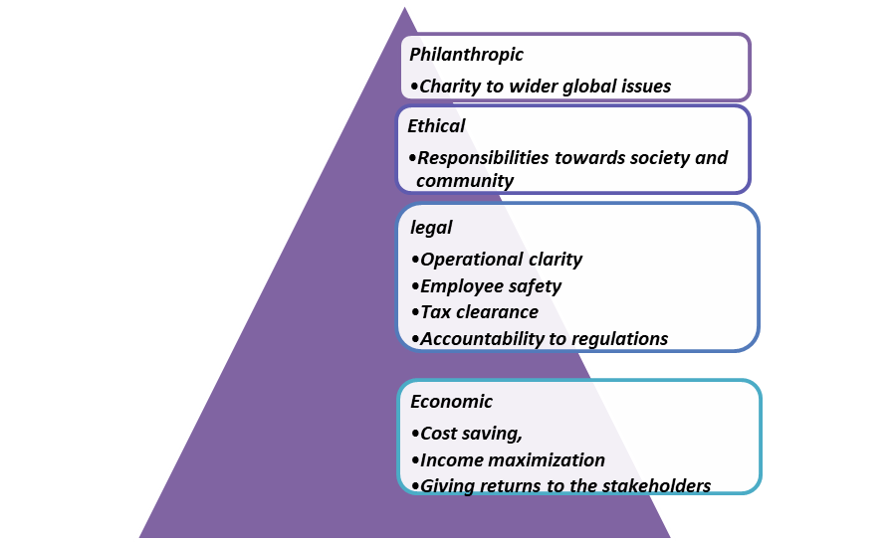

#### Figure 3.4: The Carroll's Pyramid of CSR

(Source: Self-developed)

Carroll's Pyramid of CSR was proposed by Archie Carroll and provides a four-part evaluation of how a completely accountable CSR policy should be represented. Carroll also prioritised the four parts in different degrees creating a representation of a pyramid structure. The pyramid represents an organisation’s hierarchy of responsibilities. The responsibilities from the least important to the most important include “***economic”, “legal”, “ethical” and “philanthropic responsibilities”***. The economic responsibilities include ***cost saving, income maximisation and giving returns to the stakeholders***. The legal responsibilities are ***operational clarity, employee safety, tax clearance and accountability to regulations***. Ethical responsibilities include ***responsibilities towards society and community*** and finally, philanthropic responsibilities concern ***charity to wider global issues*** (Lee *et al.* 2019). With the inclusion of all these can a company be able to establish a holistic CSR practice.

The proposed theory is immensely important in finding out all the variables accountable for developing a competent CSR policy. This can help in understanding the requirements of the UK retail industry in addressing their CSR policies to become more accountable in customer loyalty generation. The variables evaluated in the theory can be related to the study to find the exact variables establishing a relationship between UK retail industry CSR policies and customer loyalty generation in the UK.

***Conceptual map***

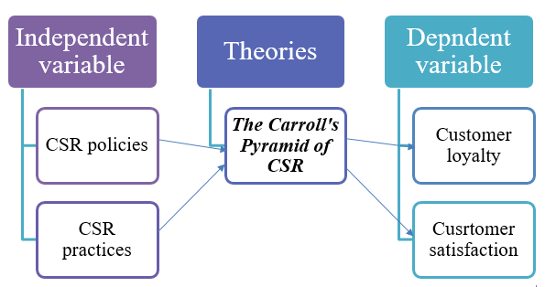

#### Figure 3.3: Conceptual map

(Source: self-developed)

***Literature Gap***

The proposed literature though will be accountable with a wide range of variable-based discussions and theories and still may have gaps regarding time shortage and word count. Until a complete critical evaluation is made, it is not possible to determine the exact drawbacks. However, subjectively, as the research will be contained with an evaluation of only the UK retail sector and CSR policies, Other broad area-based discussions such as sustainability reports and other country and industry-based evaluations will be restricted and therefore limited.

# 4: Research methods

## 4.1 Research Design

***Research Onion***

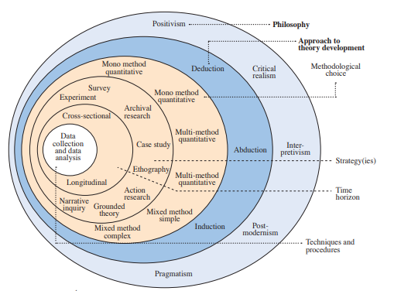

#### Figure 4.1: Sounder’s research onion

(Source: Melnikovas, 2018)

Research onion is the graphical representation of all the parts associated with a complete methodological representation. The outermost layers of the onion represent broader aspects such as philosophy, strategy and approach while the inner layers represent specific accountability such as method of data collection and interpretation. A complete consideration of layers of the methodology will be evaluated through philosophy, strategy, approach, data collection method, sampling technique and data evaluation method respectively.

***Philosophy of the Research***

Research philosophy can be considered as a brief of the way, in which the entire direction of the research will be headed. Based on different types of research the philosophy can also be of different types of which include r***ealism, pragmatism, interpretivism and positivism*** (Mason *et al.* 2022)***.*** The proposed topic will follow a ***positivist*** research philosophy. The reason for such philosophy selection is due to the fact that positivist philosophy follows a large structure and sample evaluation-based consideration where a statement is primarily considered true and the research is done to prove that statement through the mainly quantitative method. The topic that will be under evaluation will pursue that CS responsibilities has a relationship with customer loyalty as a true statement. Further, the degree and direction of the relationship have to be evaluated which can be done best with a qualitative evaluation and thus, positivism can be considered as a choice of philosophy.

***The Design and Strategy of the Research***

Research design is the specified framework chosen by a researcher conducting a study. Based on the nature of the research, it can also be of four main types: ***Experimental, semi-experimental, correlational and descriptive*** (Muraina and Adeleke, 2021)***.*** Research strategy is also an additional consideration to research design and according to the nature of the data which can be either ***qualitative or quantitative*** in nature. In this research, a detailed evaluation of LR and data analysis will be conducted critically discussing the variables to understand the qualitative nature of the said relationship. For this reason, a ***descriptive design*** will be chosen along with a ***qualitative strategy*** approach. Choosing such will ensure a statistics-based evaluation process of the relationships while having a critical evaluation of the facts.

***The Approach of the Research***

A research approach is a formal procedure of selecting, analysing and interpreting data. Thus, based on the nature and direction of the evaluation of the data, a research approach can be of mainly three types, ***inductive, abductive and deductive*** (Upmeier *et al*. 2021). In this research, a quantitative heading of data methodology will already be preferred. For the evaluation of the relationship between customer loyalty and CSR, a statistical analysis of variables will be ensured through a proposed qualitative method. The relationship between the dependent variable, customer loyalty and the independent variable CSR policies can undergo a correlational analysis for a statistical evaluation of the relationship. An ***inductive approach*** will ensure the proposed data collection and evaluation finalising this as a possible approach for this research.

## 4.2 Data collection and analysis

***“Data collection method”***

The data collection method can vary according to the structure of the research and the nature of the data being collected. Based on the data source and approach, the data collection method can be of four types, ***primarily qualitative, primarily qualitatives secondary qualitative and secondary quantitative*** (Braun *et al.* 2021). In this research, a primary qualitative method will be ensured to understand the statistical relationship between CSR policy and customer loyalty. Therefore the best specs would be the conduct of a ***survey*** and its qualitative evaluation. A survey concerning retail company employees with close-ended questions will ensure a controlled response for the development of the statistical evaluation. 10 close-ended questions will be subjected to the employees to answer the survey.

***[Referred to Appendix 1]***

***Sampling Criteria, technique and Size***

Sampling indicates the biases of selection observations from a large number of the same. Based on the degree of selectiveness the process can be either ***probability sampling or non-probability sampling***. In this case, an unbiased selection of organisational employees is needed for the survey response and therefore a ***simple random sampling*** will be the best approach (Bhardwaj, 2019). For a detailed approach, a total of 51 sample participants will be selected from a primary selection of retail industry employees through random selection. This could present an unbiased and large sample-based evaluation needed for ethically accountable research.

***Data evaluation method***

Data evaluation will also depend on the nature of the data and its collection method. A qualitative approach will be taken and a survey will be conducted, thus a statistical evaluation of the survey will ensure a complete evaluation process. In this case, the data gathered from the survey will be numerically introduced in statistical software and similar numerical results will be generated for the interpretation of the numerical data in a critical manner by using excel. Evaluation methods such as correlation and regression analysis will be done as they have vastly used approaches in data interpretation

***Reliability and validity determination***

When a data measurement results in the same under the same conditions and with the same variables, it is considered reliable. When the data measures what it is expected to measure, it is considered valid (Sürücü and MASLAKÇI, 2020). In this case, the formation of the questionnaire will be formed in such a manner that unbiased unawares can be obtained under different conditions. This will assure the reliability of the research. On the other hand, as the data will be manipulation free, the measurements are expected to finalise that there is a relationship between CSR policy and perceived customer loyalty. Thus, the data will aslo be valid as well.

***Ethical Consideration***

Ethical consideration in primary research ensures the maintenance of ethical boundaries while subjecting regular individuals as primary sources of information. Unethical proceedings with data such as insignificant disclosures can bring future conflicts revalidating the research. Thus, the primary data collection and evaluation process will follow the "Data Protection Act 2018" to ensure accountability of a complete ethical consideration and data protection (Legislation.gov.uk, 2023). This will help the research ensure ethical sharing and maintenance of confidentiality of sensitive information.

***Study Limitations***

The study though will be conducted critically, will still have its limitations regarding venturing into broad areas of discussion regarding CSR implementation. Another aspect is that such a topic would be better suited for evaluation through a mixed method of evaluation regarding both primary and secondary sources. However, conducting only primary research will limit its area of discussion.

***Research Timeline***

***[Referred to Appendix 2]***

# 5. Reference List

Benghezal, D. and Izadi, J., (2022). Exploring the impact of CSR strategy in food retail sector firms.

Bhardwaj, P., (2019). Types of sampling in research.*Journal of the Practice of Cardiovascular Sciences, 5(3)*, p.157.

Braun, V., Clarke, V., Boulton, E., Davey, L. and McEvoy, C., (2021).The online survey as a qualitative research tool.*International journal of social research methodology, 24(6),* pp.641-654.

Core.ac.uk, (2023).*A Contextual Review of CSR Policy and Law in the UK [online]*. Available at: https://core.ac.uk/download/pdf/1593174.pdf [Accessed on: 15 May 2023]

Leclercq-Machado, L., Alvarez-Risco, A., Esquerre-Botton, S., Almanza-Cruz, C., de las Mercedes Anderson-Seminario, M., Del-Aguila-Arcentales, S. and Yáñez, J.A., (2022).Effect of Corporate social responsibility on consumer satisfaction and consumer loyalty of private banking companies in Peru.*Sustainability, 14(15)*, p.9078.

Lee, S.S., Kim, Y. and Roh, T., (2019). Modified pyramid of CSR for corporate image and customer loyalty: Focusing on the moderating role of the CSR experience. *Sustainability, 11(17)*, p.4745.

Legislation.gov.uk, (2023).*Data Protection Act 2018[online]*. Available at:https://www.legislation.gov.uk/ukpga/2018/12/contents/enacted [Accessed on: 15 May 2023]

Mason, P., Augustyn, M.M. and Seakhoa-King, A., (2022).Research Philosophy.In Encyclopedia of Tourism Management and Marketing (pp. 684-687).*Edward Elgar Publishing.*

Melnikovas, A., (2018). Towards an explicit research methodology: Adapting research onion model for futures studies. *Journal of futures Studies, 23(2)*, pp.29-44.

Metzker, Z., Maroušek, J., Hlawiczka, R., Belás, J. and Khan, K.A., (2021). The Perception of the Market and Operational Area of Business by Service Sector and Tourism Companies in terms of CSR implementation.*Journal of Tourism and Services*.

Muraina, I.O. and Adeleke, I.A., (2021). Researchers’ Artificial Intelligence Expert System Rule-Based Decision Making Using Visirule.*International Journal of Progressive Sciences and Technologies (IJPSAT), 28(1)*, pp.351-358.

Ons.gov.uk, (2023).*Retail industry in Great Britain[online]*. Available at: https://www.ons.gov.uk/economy/nationalaccounts/balanceofpayments/articles/economictrendsintheretailsectorgreatbritain/1989to2021#:~:text=2.-,Retail%20industry%20in%20Great%20Britain,all%20UK%20employees%20in%202019. [Accessed on: 15 May 2023]

Rahdari, A., Sheehy, B., Khan, H.Z., Braendle, U., Rexhepi, G. and Sepasi, S., 2020. Exploring global retailers' corporate social responsibility performance.*Heliyon, 6(8)*, p.e04644.

Scozzese, G. and Granata, G., (2019). The action of e-Branding and Content marketing to improve consumer relationships.*European Scientific Journal, 15(1 (January 2019))*, pp.58-72.

Semanticscholar.org, (2023).*Comparing UK food retailers corporate social responsibility strategies[online]*. Available at: https://www.semanticscholar.org/paper/Comparing-UK-food-retailers-corporate-social-Souza-Monteiro-Hooker/4bfb65c157174dff5dafb23683ccd03b8b7e9c6b [Accessed on: 15 May 2023]

Servera-Francés, D. and Piqueras-Tomás, L., (2019). The effects of corporate social responsibility on consumer loyalty through consumer perceived value. *Economic research-Ekonomskaistraživanja, 32(1)*, pp.66-84.

Statista.com, (2023).*Share of consumers more likely to buy from a retailer or brand that has strong ethical and sustainable credentials in the United Kingdom (UK) in 2022, by age.[online]*. Available at: https://www.statista.com/statistics/1296905/uk-ethical-retailer-preference/ [Accessed on: 15 May 2023]

Sun, H., Rabbani, M.R., Ahmad, N., Sial, M.S., Cheng, G., Zia-Ud-Din, M. and Fu, Q., (2020). CSR, co-creation and green consumer loyalty: Are green banking initiatives important? A moderated mediation approach from an emerging economy.*Sustainability, 12(24)*, p.10688.

Sun, H., Rabbani, M.R., Ahmad, N., Sial, M.S., Cheng, G., Zia-Ud-Din, M. and Fu, Q., (2020). CSR, co-creation and green consumer loyalty: Are green banking initiatives important? A moderated mediation approach from an emerging economy.*Sustainability, 12(24)*, p.10688.

Sürücü, L. and MASLAKÇI, A., (2020). Validity and reliability in quantitative research.*Business & Management Studies: An International Journal, 8(3)*, pp.2694-2726.

Tosun, P. and Köylüoğlu, S., (2020). Corporate social responsibility in the food industry from a marketing perspective.*In Academic Studies in Administrative Sciences* (p. 77).Livre de Lyon.

UpmeierzuBelzen, A., Engelschalt, P. and Krüger, D., (2021).Modeling as scientific reasoning—The role of abductive reasoning for Modeling competence.*Education Sciences, 11(9)*, p.495.

Williams, S. and Murphy, D.F., (2023). Learning from each other: UK global businesses, SMEs, CSR and the Sustainable Development Goals (SDGs).*Sustainability, 15(5)*, p.4151.

# 6. Appendices

## Appendix 1: Survey Questionnaire

1. What is your age?

* 18-25
* 26-35
* 36-45
* 46-55
* 56-65

2. What is your gender?

* Male
* Female
* Others

3. What is your job role in your organisation?

* Employee
* Management
* Others

4. Do you agree that the CSR policies of the company account for the customers?

* Strongly Agree
* Agree
* Neutral
* Disagree
* Strongly Disagree

5. Do you agree that the firm is prioritised over the customers In the company's CSR policies?

* Strongly Agree
* Agree
* Neutral
* Disagree
* Strongly Disagree

6. Do you agree that Customer satisfaction related to customer demand increase due to CSR?

* Strongly Agree
* Agree
* Neutral
* Disagree
* Strongly Disagree

7. Do you agree that increased customer satisfaction brings operational clarity to the company?

* Strongly Agree
* Agree
* Neutral
* Disagree
* Strongly Disagree

8. Do you agree that Customer satisfaction develops customer trust?

* Strongly Agree
* Agree
* Neutral
* Disagree
* Strongly Disagree

9. Do you agree that Customer trust and customer loyalty are positively related to CSR?

* Strongly Agree
* Agree
* Neutral
* Disagree
* Strongly Disagree

10. Do you agree that the CSR of your company is more committed to the Loyal customers?

* Strongly Agree
* Agree
* Neutral
* Disagree
* Strongly Disagree

## Appendix 2: Research timeline

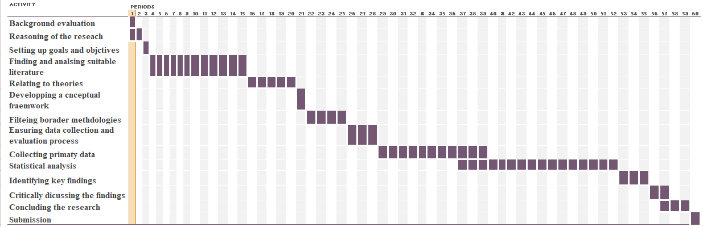

(Source: Self-developed)