**Principles of Marketing MS40041**

**Assessment 2 – Individual Report**

Table of Contents

1.0 Introduction 3

2.0 Developing the market strategy 3

3.0 Discussing the marketing mix 4

4.0 Discussion of customer-driven strategy 6

5.0 Conclusion 9

References 10

# 1.0 Introduction

This report discusses the UK-based retail organisation Tesco. It discusses the implementation of a marketing plan as well as its conception through the implementation of different marketing strategies. The first section of the report develops the market strategy towards an efficient long-term group, which is secured by the use of Ansoff’s Matrix model. This is followed by a discussion of the marketing mix of the organisation which utilises the 4Ps Marketing Mix model. The report, based on the findings, will then develop the customer-driven strategy by using the STP analysis for segmentation, targeting and positioning. The brand perceptual map will also be shown in this under the positioning part. This leads the report to summarise the findings towards the conclusion. The main objective of the plan will be to increase customer engagement by 20% through social media and other digital channels.

# 2.0 Developing the market strategy

Ansoff’s Matrix was developed by Igor Ansoff to present four distinct growth strategies that a firm can use towards growing its market direction. This can be discussed in the context of Tesco by applying the four individual growth strategies in an individual capacity. This will be shown below as follows.

**Market Development:** Under this strategy, the firm aims to develop the market by introducing an existing product in its portfolio to an entirely new market. Market development is comparatively limited for Tesco as well, due to the more global competitiveness expressed by its immediate rivals like Aldi and Lidl. The competitiveness of these European companies in the UK retail market has dislodged the traditional Big Four hierarchy of UK supermarket retailers, which also included Tesco (Bedford, 2023). Tesco’s market development strategy is therefore less essential for resolving its issues than the market penetration strategy, which will be discussed below as well.

**Diversification:** Under the diversification strategy, the firm develops and introduces a new product in a new, untested market. Therefore, this is the riskiest strategy available for implementation for any firm, including Tesco. Owing to the foothold of the firm in the retail sector, this diversification strategy is not recommended entirely as it presents high risk and forces the firm to take a new direction entirely. However, Tesco can diversify by exporting its internal digital technologies and systems used in business processes. Its rivals, such as Ocado, already follow this strategy (Iddenden, 2022). Therefore, the same is feasible for Tesco if considered from a diversification perspective. Market diversification in this way can be followed in a structured format with incremental changes and decisions made towards diversification of the company’s operations and offerings. This will ensure that customer feedback has a chance to be incorporated while developing the diversification strategy, thereby increasing the value proposition of the entire diversification strategy as a whole.

**Market Penetration:** Under market penetration, the firm increases the existing market share of its product by expanding its sales in the existing market. As the safest strategy in the Ansoff Matrix, this strategy requires comparatively less investment of resources and is also less risk-intensive compared to strategies like diversification. Market penetration can be secured by increasing the promotional content and advertising based on the Tesco brand. This can be successful to a greater degree when incorporating digital social media-based marketing platforms such as Instagram (Jamil et al., 2022). Market penetration can aim for localised growth in rural and urban regions according to different areas of relevance for Tesco; the STP analysis below will further discuss how Tesco can engage its market penetration for performance.

**Product Development:** Under product development, the firm develops a new product that can be launched in the existing market. This strategy aims to satisfy latent or new desires in consumers or respond proactively to new consumer trends by launching a product that meets their needs and desires. Tesco can develop in-house products that can be sold as a cheaper replacement to branded products with a higher price tag yet similar features. Other firms have followed a similar approach, such as Aldi’s range of cream products being a best-seller and out-selling rival brand Elizabeth Arden's similar product (Hunt, 2018). This instance shows it is also possible for Tesco to do the same, where it can engage with its suppliers and other partners to develop such products for cheaper and sell them to customers. This will directly satisfy the value-conscious customers whose consumer power has been limited as a result of the ongoing spread of inflation in the UK economy (Smith, 2023).

# 3.0 Discussing the marketing mix

The marketing mix framework was popularised through the ideology espoused by Niel Borden. In the case of Tesco plc, the elements within the marketing mix framework can be elaborated in the below manner (Menon and Menon, 2017).

**Price:** Before the holiday season announced itself, Tesco plc decided to create a new price lock on thousands of products until Easter 2023. This allows them to accept a low pricing given the competition on the rise from the market, and the growing issues with consumer cost of living. Therefore, popular branded products including own branded staples, cupboard essentials, and other teatime favourites reach households. There are even other health and beauty products that are also locked at a lower price alongside the above products. The products feature bestsellers including Braided Plaice Fillets, McCain Home Chips, and Nescafe-based items. The average change in the price is £1.40 which is to help the daily grocery shoppers by pushing them to stick to their budgets (Tescoplc.com, 2023). They are thus dissuaded from overspending on leisure-based retail items. Some of the consumers, who might still find the daily items expensive, can be pushed towards exclusive Clubcard deals. These club cards help the consumers to get facilitated with better discount offers, and seasonal changes in prices regularly (Tescoplc.com, 2023).

**Product:** Aside from its normal groceries, household goods, and other products. Refining the same quality, Tesco plc has recently decided to launch a program known as ‘Tesco Red Door’. This approach is to tackle disruptive innovation that invites other innovators from start-up organisations with integral ideas of product development. For instance, as the popularity of vegan foods grows, a start-up with better product developing capacities might give birth not just to the product. It might also increase the level of characteristics associated with the product which includes better dietary provisioning to support digestion, the versatility of the dish, alternate ingredient-based compositions, and consumption that can be done in small quantities (Tescoplc.com, 2023). Such products are likely to be more than welcome to Tesco plc, because they want to tackle the competitions surrounding them in the form of Marks and Spencers, Morrissons, and others. As these organisations have already begun to find innovative product ideas, to ensure they get ahead in terms of consumer confidence inducement that is capitalised over a period.

**Promotion:** An alteration in the promotion strategy undergone by Tesco plc occurred through their two-pronged marketing scheme. That not only improved slumping sales, but reverted increased dependence on online strategies to spending on TV and print media marketing. This was to hammer home among daily household shoppers the price cuts, thereby driving customer loyalty through additional couponing. Tuning back to the traditional form of marketing, allows Tesco plc to show their customers the approach of personalised form of product management. Whereby, the product features are optimised as per customer requirements, and without asking for too much to be spent from the wallets (Vizard, 2014). Only smartphones will be used for a more personalised form of promoting, as a medium for digital media. The users will be encouraged to undertake smooth transactions, in which they might be able to use their debit and credit cards as well. Product improvement suggestions can also be made by filling out the feedback forms.

**Place:** Tesco plc has decided to shift its business to more rural-based regions of the UK, which allows them to buy time from the growing competition and market-related upheavals. For instance, the company decided to target regions of Lincolnshire, Cambridgeshire, and Surrey, where commercial customers have to travel a long distance for shopping. This is mitigated by Tesco plc, even if there are some competitors have already begun to shift their attention. However, if the above product-based market strategizing is applied by Tesco plc, they can likely generate back their lost revenue and poor performance that was experienced in the last few months (Tescoplc.com, 2023). The main challenge will still rest on the targeted customers, including types of customers who daily flock to the stores, and the customers Tesco plc would prefer to exclusively shop in their stores.

# 4.0 Discussion of customer-driven strategy

The customer-driven strategy for Tesco will be discussed across the individual segments of segmentation, targeting, positioning and differentiation. This will include the broader discussion of segmentation values such as behaviours and psychographic qualities among consumers, as well as the inclusion of a perceptual map within the positioning segment.

**Segmentation:** Geographically, Tesco can target the majority of customers that are found across the rural and urban markets. This will primarily concern the cost-sensitive consumers who want to buy value-oriented products that satisfy their lifestyle needs without emphasizing brand value and subsequently higher prices. Therefore, cost-effectiveness is a quality best associated with the millennial age group of consumers in the 28-42 age bracket (The Drum, 2017). This ensures that the family-based earners and household units as a whole are included in the segmentation process (The Drum, 2017). Demographically, this can include both male and female consumers as the division of labour in households can lead to different individuals taking charge of domestic grocery purchasing needs (Wunsch, 2022). Psychographic and behavioural qualities may indicate a propensity for buying lower-priced products, such as products on a discount as it appeals to the fiscal sensitives of the consumer. Their personality and values will be entirely budget-conscious, as driven by the need to engage with discount supermarket chains like Tesco (Davey, 2022). The products purchased will be for daily or regular use, as Tesco sells such products as food and vegetables as well as other essential conveniences among other retail items (Davey, 2022). Therefore, customer retention can be used to increase the life cycle potential for each consumer through strategies such as loyalty membership and price-based discounts and offers as an incentive for membership (Davey, 2022).

**Targeting:** The targeting criterion considers the company's value proposition to its target group of buyers segmented in the segmentation analysis. Therefore, the success of targeting relies on the alignment of the value proposition with the expected values and needs of the consumers. A closer alignment and greater satisfaction of customers here leads to direct improvement in the competitive business performance of the company, particularly given the approaches used by its rivals (Sjödin et al., 2020). Therefore, the targeting approach ensures marketing and sales channels of the firm are reachable to consumers. This includes digital outreach through e-commerce storefront and digital marketing channels as well, for consumers inclined to purchase with the company digitally (Sarkar, 2021). Brand benefits must be exemplified through differentiation led by marketing activities; digital marketing through influencer strategies will increase engagement across targeted segments online. Ultimately, targeting aims to increase the conversion of marketing leads into sales leads, and therefore satisfy more customers and increase the firm's market share at the same time (West, Ford and Ibrahim, 2015). Tesco can use its network of various physical store units and compound it by the factor of digital marketing and sales performance. This will lead to more effective targeting strategies driven by the use of a hybrid retail strategy that incorporates online and offline features as well as channel performance (Norouzi and Albadvi, 2016).

**Positioning:** The positioning of the Tesco brand against its rivals can be expressed by developing a perceptual map for the four biggest brands including Tesco. This ensures a subjective association of quality and price is measured for each brand (Shirai, 2015). Therefore, the report will draw from the market research on brand performance for Tesco, Sainsbury’s, Asda and Morrisons as their market performance has been the strongest, making them effective competitors for a company of Tesco’s size. Recent figures from April 2023 show Tesco at 27% market share followed by Sainsbury’s at 14.9% market share (Bedford, 2023). This is further followed by the company Asda and Aldi at 14% and 10.1% (Bedford, 2023). Therefore, other companies like Morrisons and Lidl are not considered in the perceptual map as their market share is in single digits i.e. 8.7% and 7.6%, considerably below the double-digit performance of the top four companies including Tesco (Bedford, 2023).

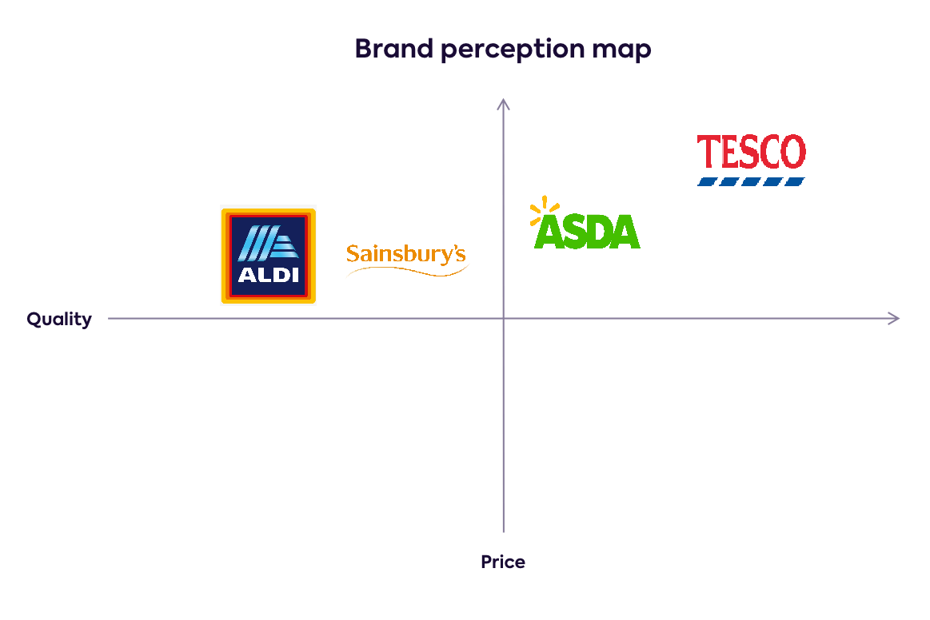

**Figure 1: “Brand Perceptual Map for Tesco”**

(Source: self-created)

**Differentiation:** The positioning analysis shows Tesco retains a market leader despite its customer-centric issues. This is ultimately due to the brand value, loyalty and equity retained by the firm on its past performances (Kotler and Armstrong, 2021). This has given the Tesco brand resilience against market disruption such as the growth of brands like Aldi and Lidl in the contemporary British supermarket sector. Therefore, Tesco drives market differentiation based on its targeted programmes for loyalty and membership-based rewards. It is also able to satisfy more customers due to the large footprint of sales channels it has across the UK.

# 5.0 Conclusion

The report has discussed the different areas of organisational performance by Tesco, particularly within a marketing context. The growth analysis showed that Tesco has the opportunity for diversified market growth opportunities, which will help the company meet customer needs and therefore satisfy them as well. This is recommended to Tesco through the growth strategies of market penetration and product development. Furthermore, the 4PS analysis and STP analysis together developed insight into consumer behaviour and market engagement relative to the Tesco brand. The findings were expanded through references to market developments, such as Tesco's retention of effective market share in a double-digit capacity alongside only 3 market competitors whereas the others have a single-digit market share. Therefore, Tesco only needs to account for the three rivals of Sainsbury's, Asda and Aldi to retain its effective market performance and engagement through the satisfaction of customers. This will ensure it increases engagement to meet the goal of the marketing objective outlined in the report.

# References

Bedford, E. (2023). *Market share of grocery stores in Great Britain from January 2017 to December 2022*. [online] Statista. Available at: https://www.statista.com/statistics/280208/grocery-market-share-in-the-united-kingdom-uk/ [Accessed 12 May 2023].

Davey, J. (2022). Loyalty pays off for Tesco as Britons feel the pinch. *Reuters*. [online] 23 Feb. Available at: https://www.reuters.com/business/retail-consumer/loyalty-pays-off-tesco-britons-feel-pinch-2022-02-23/ [Accessed 12 May 2023].

Hunt , A. (2018). *Aldi re-release their sell-out £3.99 Miracle Cream which rivals Elizabeth Arden’s Eight Hour Cream*. [online] Woman and Home Magazine. Available at: https://www.womanandhome.com/beauty/aldi-miracle-cream-elizabeth-arden-eight-hour-cream-245652/ [Accessed 12 May 2023].

Iddenden, G. (2022). *Ocado reveals ‘game-changing’ new tech -*. [online] Latest Retail Technology News From Across The Globe - Charged. Available at: https://www.chargedretail.co.uk/2022/01/26/ocado-reveals-game-changing-ocado-smart-platform/ [Accessed 12 May 2023].

Jamil, K., Dunnan, L., Gul, R.F., Shehzad, M.U., Gillani, S.H.M. and Awan, F.H. (2022). Role of Social Media Marketing Activities in Influencing Customer Intentions: A Perspective of a New Emerging Era. *Frontiers in Psychology*, [online] 12, pp.1–12. doi:https://doi.org/10.3389/fpsyg.2021.808525.

Kotler, P. and Armstrong, G. (2021). *Principles of Marketing*. 18th ed. Harlow: Pearson Education Limited.

Menon, A. and Menon, A. (2017). Enviropreneurial Marketing Strategy: The Emergence of Corporate Environmentalism as Market Strategy. *Journal of Marketing*, 61(1), p.51.

Norouzi, A. and Albadvi, A. (2016). A hybrid model for customer portfolio analysis in retailing. *Management Research Review*, [online] 39(6), pp.630–654. doi:https://doi.org/10.1108/mrr-04-2014-0082.

Sarkar, M. (2021). *Analyzing business model of TESCO - The Strategy Story*. [online] TheStrategyStory. Available at: https://thestrategystory.com/2021/06/10/tesco-business-model/ [Accessed 12 May 2023].

Shirai, M. (2015). Impact of ‘High Quality, Low Price’ Appeal on Consumer Evaluations. *Journal of Promotion Management*, [online] 21(6), pp.776–797. doi:https://doi.org/10.1080/10496491.2015.1088922.

Sjödin, D., Parida, V., Jovanovic, M. and Visnjic, I. (2020). Value Creation and Value Capture Alignment in Business Model Innovation: A Process View on Outcome‐Based Business Models. *Journal of Product Innovation Management*, [online] 37(2), pp.158–183. doi:https://doi.org/10.1111/jpim.12516.

Smith, E. (2023). *UK inflation rate surprises again with March figure holding above 10%*. [online] CNBC. Available at: https://www.cnbc.com/2023/04/19/uk-inflation-rate-surprises-again-with-march-figure-holding-above-10percent.html [Accessed 12 May 2023].

Tescoplc.com (2023). *Tesco is keeping low prices low, with over a thousand everyday products price locked until Easter 2023*. [online] www.tescoplc.com. Available at: https://www.tescoplc.com/tesco-is-keeping-low-prices-low-with-over-a-thousand-everyday-products-price-locked-until-easter-2023/ [Accessed 12 May 2023].

Tescoplc.com (2023). *Tesco launches Jack’s to celebrate 100 years of great value*. [online] www.tescoplc.com. Available at: https://www.tescoplc.com/tesco-launches-jacks-to-celebrate-100-years-of-great-value/ [Accessed 12 May 2023].

Tescoplc.com (2023). *Tesco launches the ‘Tesco Red Door’; invites innovators to share ideas*. [online] www.tescoplc.com. Available at: https://www.tescoplc.com/tesco-launches-the-tesco-red-door-invites-innovators-to-share-ideas/ [Accessed 12 May 2023].

The Drum (2017). *Which brands do millennials like best?* [online] The Drum. Available at: https://www.thedrum.com/opinion/2017/07/31/which-brands-do-millennials-best [Accessed 12 May 2023].

Vizard, S. (2014). *Tesco steps up marketing to get across price message*. [online] Marketing Week. Available at: https://www.marketingweek.com/tesco-steps-up-marketing-to-get-across-price-message/ [Accessed 12 May 2023].

West, D.C., Ford, J. and Ibrahim, E. (2015). *Strategic Marketing: Creating Competitive Advantage*. 3rd ed. Oxford: Oxford University Press.

Wunsch, N.-G. (2022). *United Kingdom: usual grocery shoppers by gender 2020*. [online] Statista. Available at: https://www.statista.com/statistics/1256034/share-of-uk-consumers-who-usually-shop-for-food-by-gender/ [Accessed 12 May 2023].