**RESEARCH PROPOSAL**

**WORD COUNT: 3,020 words**

**BA Business**

**Research Methodologies**

**RM Assignment**

**Abstract**

This research proposal focuses on providing insights regarding the impact of gender discrimination on employee’s performance in the UK. Accordingly, a definite research background has been provided, alongside a problem statement and a rationale for this statement. Based on rationale, the core research question and related research objectives have been generated. The literature review section involves an analysis of the key concepts related to this study, mainly based on the first three research objectives. In terms of methodology, an interpretivism philosophy has been selected, followed by an inductive approach and case study-based strategy. For data collection and analysis, a secondary qualitative method and thematic analysis method have been selected respectively. Reliability and validity aspects related to this study have been described as well. Furthermore, core ethical considerations and limitations of this research has also been underlined.

**Table of Contents**

Proposed Title 4

1. Introduction 4

1.1 Research Background 4

1.2 Problem Statement 5

1.3 Research Rationale 5

1.4 Research Questions 6

1.5 Research Aim and Objectives 6

2. Literature review 7

2.1 Factors influencing Employee Satisfaction in UK Businesses 7

2.2 Leading factors of gender discrimination across UK businesses 9

2.3 Challenges of Gender Discrimination in UK Businesses 10

3. Research Methodology 12

3.1 Research design 12

3.2 Data Collection and Analysis 13

3.3 Reliability and validity 14

3.4 Research ethics 14

3.5 Limitations 14

3.6 Timespan 15

Reference list 16

# Proposed Title

The impact of gender discrimination on employees’ performance in the UK.

# 1. Introduction

## 1.1 Research Background

The issues of gender discrimination are largely prominent in the UK, with such mainly observable across various business workplaces. Women are highly subject to disproportionate policies in terms of economic and social aspects. In particular, a notable degree of discrimination is readily observable across education and employment, indicated by a significant national gender pay gap still persistent across respective regions. According to a recent survey, around 23% of the UK populace regarded gender inequality as one of the most serious types of gender inequality (Phipps, 2023). Furthermore, it has been determined that women are much less likely to get full-time employment, around 45%, in comparison to me, being around 61%. Gender discrimination is persistent in the parliament as well, with women comprising only one-third of the parliament members.

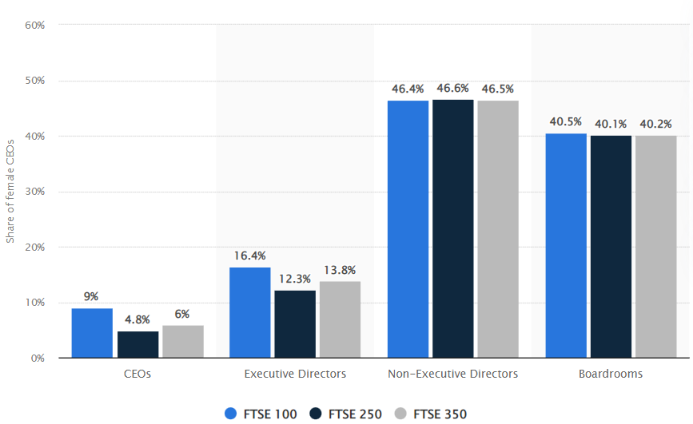

**Figure 1.1: Share of female lead positions in UK-based FTSE companies**

(Source: Clark, 2023)

Cases of gender discrimination are largely observable across respective households in the UK. For instance, in comparison to 49% of the men, 85% of the women are cooking and doing daily housework (Phipps, 2023). In FTSE companies in the UK, gender discrimination is widely prevalent. According to recent reports, only around 9% of the companies listed under the FTSE 100 had a female CEO in 2022 (Clark, 2023). This percentage is further lower in the case of FTSE 300 and FTSE 250 companies in the UK, around 6% and 4.8% respectively. Similar cases of the gender gap are observable within the Executive Board, Non-executive Board and Boardrooms of respective FTSE companies in the UK. Furthermore, in 2022, the overall gender pay gap based on hourly earnings was determined to be 14.9% (Clark, 2022). Accordingly, it can be determined that the pay gap has decreased slightly as compared to the previous year.

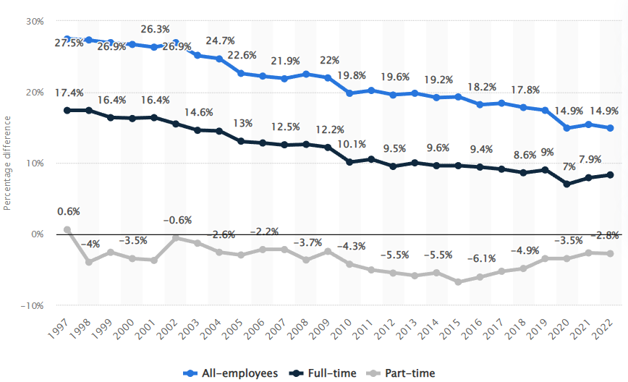

**Figure 1.2: Gender pay gap in the UK**

(Source: Clark, 2023)

## 1.2 Problem Statement

Gender inequality is determined as the leading cause of poor employee satisfaction across UK businesses.

## 1.3 Research Rationale

In terms of the background information provided, gender-based discrimination is a major issue across workplaces in the UK. Accordingly, a recent poll carried out across various UK businesses has resulted in 8.2 million employees agreeing to cases of discrimination faced across respective business workplaces (SME Loans, 2023). Contrary to the discrimination against women that has been reported above, this recent poll has indicated men are more likely to become victims of gender discrimination as compared to women. In this regard, gender discrimination has been observed across various grounds. For instance, 28.7% of the individuals faced with gender discrimination have reported that promotional opportunities were overlooked based on gender grounds (SME Loans, 2023). Furthermore, this survey also revealed that around 23.4% of the respondents agree with cases of unfair dismissal on grounds of gender.

Instances of unfair dismissal and providing poor promotional opportunities can be determined as some key factors that led to employee dissatisfaction across UK-based organisations. According to Mwesigwa *et al.* (2020), unfair dismissal and irregular salary payments are considered as one the major components of poor administration that lead to employee dissatisfaction and low organisational commitment. Therefore, gender discrimination based on unfair dismissal practices leads to a significant decline in the overall. Furthermore, the study by Alrawahi *et al.* (2020) states that limited job opportunities provided by an employer is a leading factor for employee dissatisfaction. Hence, it can also be stated that gender inequality based on promotional opportunities would lead to low employee satisfaction levels across UK businesses. In this context, this study aims to explore the various factors that influence employee satisfaction and provide appropriate recommendations to promote proper gender equality across UK-based business workplaces.

## 1.4 Research Questions

What is the key impact of gender discrimination towards employee satisfaction across respective UK businesses?

## 1.5 Research Aim and Objectives

The aim of this research is to determine the impact of gender discrimination on employee satisfaction across UK businesses. Accordingly, the following objectives can be formulated:

* To determine the key factors that influence employee performance in UK businesses
* To identify the leading cause of gender discrimination across UK workplaces
* To determine the key challenges faced by UK employers while promoting gender equality and maintaining employee satisfaction in the workplace
* To recommend effective strategies that can be adopted by UK businesses for improving employee satisfaction through the promotion of gender equality

# 2. Literature Review

## 2.1 Factors influencing Employee Satisfaction in UK Businesses

The impact on overall employee satisfaction and performance across UK business ideas is largely dependent on factors involving the level of employee motivation, management styles and work environment. According to the research conducted by Olusadum and Anulika (2018), motivation is termed as the core reasoning behind an individual’s actions and thereby, influences the individual to act in a particular manner. In this context, it can be detected that motivation is a leading determinant of the overall dedication level observed among employees within an organisation. The most common motivational factors based on any organisation are defined through the human relationships’ philosophy based on management. Accordingly, the kind of management style undertaken determines the overall stimuli being provided to the workforce (Olusadum and Anulika, 2018). The response of an employee towards the organisation would be largely based on the stimuli obtained from the management style. Therefore, it can be determined that the management style of an organisation also has a significant impact on employee satisfaction.

In terms of work environment, the kind of leadership style undertaken and the overall workplace culture of an organisation places a significant impact on employee satisfaction. According to Saputra and Mahaputra (2022), a leader facilitates motivation among employees through participation within company ownership. This in turn has been stated to have a positive influence on overall employee loyalty. The aforementioned study also underlines the definite relationship between job satisfaction and leadership style. In this regard, a leader providing proper compensation would place a major positive influence on an employee's overall job satisfaction (Sudiardhita *et al.* 2018). Furthermore, the impact of leadership style is also largely observable upon employee commitment and motivation, with such placing a positive impact on employee satisfaction and performance as well.

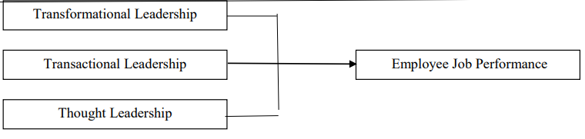

**Figure 2.1: Impact of leadership style on employee performance**

(Source: Wen *et al.* 2019)

The impact of various other factors on employee satisfaction across UK businesses can be identified from multiple studies. Besides employee motivation and leadership style, rewarding strategy and training and skill development programs have been determined as key factors that influence employee satisfaction. As per the views of Nagarajah *et al.* (2021), a high degree of positive correlation has been found between human resource management practice and organisational performance. In this context, training and development have been considered one of the key HRM practices that places a positive impact on the knowledge and skill levels of employees. This in turn significantly improves the overall work performance of respective employees (Niati *et al.* 2021). Furthermore, this study states the importance of training and skill development programs as a definite way of bridging skills among employees. Therefore, through higher performance, employees are motivated at work and this directly leads to improvement in work satisfaction.

Reward and recognition, another key factor influencing employee satisfaction, is determined as essential towards ensuring improved employee commitment and performance. A reward is defined as the compensation employees expect from businesses for performing their respective work (Akgunduz *et al.* 2020). Accordingly, rewards are categorised into multiple types, including financial, non-financial and psychological rewards. Broadly, rewards are essentially divided into two main types, intrinsic and extrinsic. Herein, extrinsic rewards are mainly defined as tangible benefits that employees obtain from their respective companies (Akgunduz *et al.* 2020). Primary examples of extrinsic rewards include pay promotions, club memberships, holiday provisions, bonuses and honorary titles. Furthermore, extrinsic rewards are also related to social rewards that can help in the establishment of effective relationships between employees and supervisors.

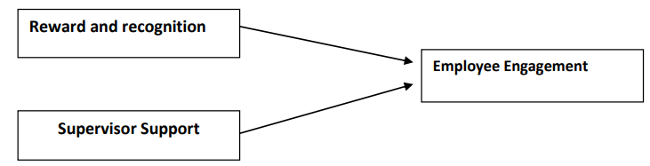

**Figure 2.2: Relationship between reward and recognition, supervisor support and employee engagement**

(Source: Baqir *et al.* 2020)

Intrinsic rewards, on the contrary, refer to rewards that are entirely based on the personal interest and tasks of individual employees. Intrinsic rewards are not considered a part of job obligation and are mainly provided in forms of self-esteem, involvement, job satisfaction, recognition and creativity (Manzoor *et al.* 2021). In this context, it can be determined that employee engagement and satisfaction can be readily provided through improved recognition and motivation levels. The study by Baqir *et al.* (2020) states that both aspects of reward and recognition have a positive influence on the overall level of employee engagement observable within the workplace. Additionally, supervisor support is determined as another major factor that improves employee engagement. Therefore, rewarding and recognition schemes undertaken across UK businesses would improve overall satisfaction levels across respective workplaces.

## 2.2 Leading Factors of Gender Discrimination across UK businesses

A wide range of factors can be identified that have led to significant gaps in terms of gender equality across UK-based workplaces, involving various cultural, societal, educational and economic factors. In this regard, poor availability of flexible working options has been determined as one of the major causes of such gender gap. Additionally, women are perceived as the core providers of various forms of unpaid caring responsibilities (Ogando *et al.* 2022). This perception is the primary cause of inequality based on gender pay gap across different UK companies. Furthermore, factors based on occupational segregation and undervaluing of women’s work have also been determined as major factors that lead to workplace gender discrimination. In response to such issues, businesses across the UK are readily undertaking various steps to ensure gender gap is effectively mitigated. However, reports suggest that lack of female representation within executive director positions is still a major issue within UK businesses (Smith and Parrotta, 2018). Accordingly, this is mainly observable across FTSE companies based in the UK.

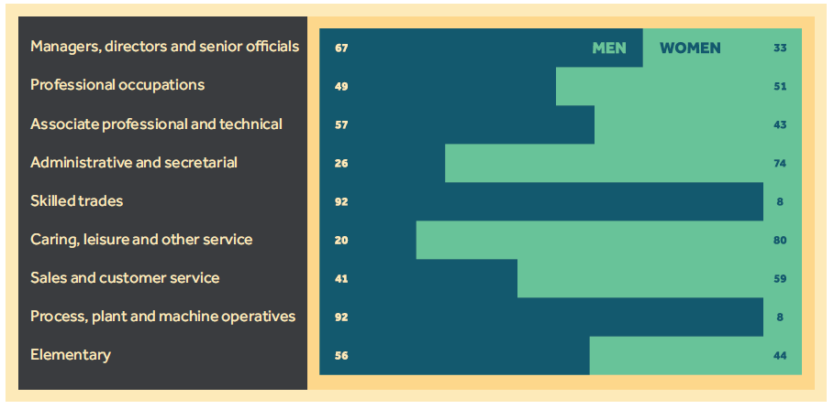

**Figure 2.3: Occupational segregation in the UK**

(Source: Gains and Sanders, 2020)

## 2.3 Challenges of Gender Discrimination in UK Businesses

A wide range of challenges are faced across different UK businesses based on gender discrimination. A prominent example can be provided through the total percentage of UK businesses being run by women. In this regard, reports show that only 29% of small businesses in the UK are run by women, with such being only 4% in the trades (Smith, 2022). Furthermore, a survey conducted on more than 800 women business owners in the UK has revealed that gender bias and inequality have been the major impacting factor towards business growth and success. Further reports have suggested that around 32% of the total female entrepreneurs in the UK have been faced with issues based on sexism as a company owner. Additionally, 19% of women owners have been reported to have faced unequal access to opportunities for business growth and overall success (Simply Business, 2023). Overall, around 91% of the total number of business owners in the UK have stated challenges based on gender bias and inequality across respective industries.

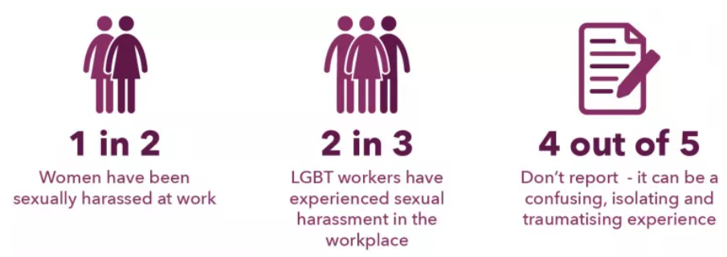

**Figure 2.4: Prevalence of sexual harassment in UK businesses**

(Source: TUC, 2023)

Various reports from UK-based business workplaces have suggested that persistence of the gender pay gap is notably high. Accordingly, a wide range of cases based on women being faced with repeated sexual harassment across respective workplaces have been identified as well (TUC, 2023). Furthermore, discrimination on grounds of pregnancy and maternity have also been identified as severe problems, alongside some recent high-profile claims. Both men and women are subject to sexual harassment within an UK workplace, with women being significantly more likely to become a victim. In 2017, around 11% of mothers reported poor treatment across respective workplaces, thereby leading such individuals to leave the jobs. Similar cases of discrimination are observable in recent years as well. For instance, the gender pay gap in 2022 was determined to be at 8.3%, an increase from 7.75% in previous year (CIPD, 2023). Additionally, cases of unfair dismissal and compulsory redundancy were also reported across respective UK businesses.

# 3. Research Methodology

## 3.1 Research design

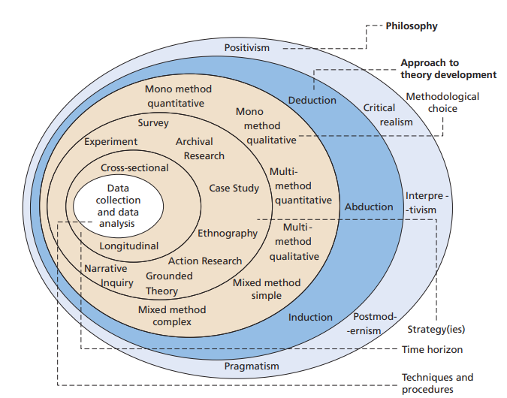

**Figure 3.1: Research onion**

(Source: Saunders *et al.* 2019)

In this research, the research onion theoretical framework would be followed for presenting the research methodology. According to Saunders *et al.* (2019), research onion helps researchers to develop an effective research methodology by providing detailed descriptions of the key layers to be considered while designing a methodology. In this regard, the upper layers of the research onion comprise research philosophy and research approach. Research philosophy is defined as the overall beliefs and values that are followed by researchers while developing a particular research study. Research philosophy can be broadly classified into four types, including realism, positivism, pragmatism and positivism. In this research study, an interpretivism research philosophy would be followed. According to Alharahsheh and Pius (2019), interpretivism philosophy helps in providing an in-depth understanding of key aspects that influence a particular phenomenon through collection and interpretation of secondary data. Therefore, it can be stated that an interpretivism research philosophy would be suitable for determining the key factors that influence employee satisfaction across UK businesses.

Research approach is defined as the overall approach to theory development undertaken within a research study. In this regard, the research approach is categorised into inductive, abductive and deductive types. An inductive research approach is undertaken for developing a new theory or interpretation based on known premises. Accordingly, an inductive approach is mainly used for providing generalised conclusions from particular instances. In this research study, an inductive approach would be used. As per Woiceshyn and Daellenbach (2018), inductive approach is deemed essential for advancing knowledge and helps in effectively answering research questions. Therefore, it can be said that an inductive research approach would be suitable for determining the leading cause of gender discrimination across UK workplaces.

Research strategy is defined as the exact direction of research provided via undertaking certain methods. The most commonly used research strategies include case studies, experiments, actions research, grounded theory, survey and cross-sectional studies. Case studies are used to make a set that enables the development of a particular set of interpretations. For this research purpose, case studies would be used as the preferred research strategy. According to Hanson and Glăveanu (2018), case studies have been determined to be useful in elaborating the key reasoning behind the occurrence of a particular phenomenon, while considering multiple variables into account. Therefore, it has been determined that using case studies would facilitate identification of the key challenges that are faced across UK businesses in terms of gender discrimination.

## 3.2 Data Collection and Analysis

Data collection refers to the strategy undertaken for collecting the requisite data for a provided research study. In this regard, data collection can be categorised into primary and secondary methods, based on data sources. In terms of data type, data collection method varies between quantitative and qualitative methods. In view of the requirements for this research, the preferred method of data collection would be secondary qualitative. As per the views of Lester *et al.* (2020), qualitative data has been deemed useful for bringing meaning to a particular data set. Accordingly, qualitative data facilitates interpretations to be provided from a wide range of sources, including observations, images and conversational data. Hence, it can be stated that qualitative data would be useful for determining the various factors that influence employee satisfaction in UK businesses.

Data analysis involves consideration of the key techniques to be used for extracting the requested information from the collected data. In this regard, the data analysis strategy undertaken is entirely dependent on the kind of data collection strategy selected. For this study, selection of secondary qualitative data collection methods entails the fact that a thematic data analysis strategy would be most appropriate. As per Maguire and Delahunt (2017), the thematic analysis method is not bound to any form of theoretical or epistemological view. This allows a highly flexible approach to be undertaken within the data analysis process, with being highly beneficial across diverse learning and teaching fields. In this context, it can be stated that thematic analysis would be useful for this research in providing effective recommendations for improving employee satisfaction in UK businesses via promotion of gender equality.

## 3.3 Reliability and validity

Research reliability is defined as whether the results of a particular research can be accurately reproduced through using the same defined methods in the future. In this regard, a research reliability measures the effectiveness of the methodology used to generate the key research outcomes (Olabode *et al.* 2019). In this research, appropriate research philosophy, approach and strategy would be undertaken for delivering the requisite research results. On the contrary, research validity for a secondary research defines the extent to which a particular experiment answers the research questions. In this study, an inductive approach and case study-based strategy has been deemed to be appropriate in effectively answering the research question, thereby maintaining high research validity.

## 3.4 Research ethics

In this research, careful consideration would be given to avoidance of any form of plagiarism within the writeup, thereby helping in maintaining a high research authenticity. The research also complies with the terms set under “Copyright, Designs and Patents Act 1988 (c. 48)”. Additionally, this research avoids usage of any personalised data that relates to identifiable living persons. The research is also in line with the original consent that was obtained from participants across different research journals. Proper acknowledgement of data sources would also be maintained via providing relevant references and citations. Furthermore, this research avoids usage of obsolete data by only sourcing data from journals published on or after 2018, thereby allowing further research authenticity to be maintained.

## 3.5 Limitations

The key limitations of this research involve constraints based on time and budget. These constraints prevented collection and analysis of primary and quantitative data. Additionally, lack of primary quantitative data has led to poor triangulation of data being maintained, thus declining overall research reliability. Furthermore, a major limitation of using secondary data involves lack of information specific to the research subject, thereby leading to poor research results being generated.

## 3.6 Timespan

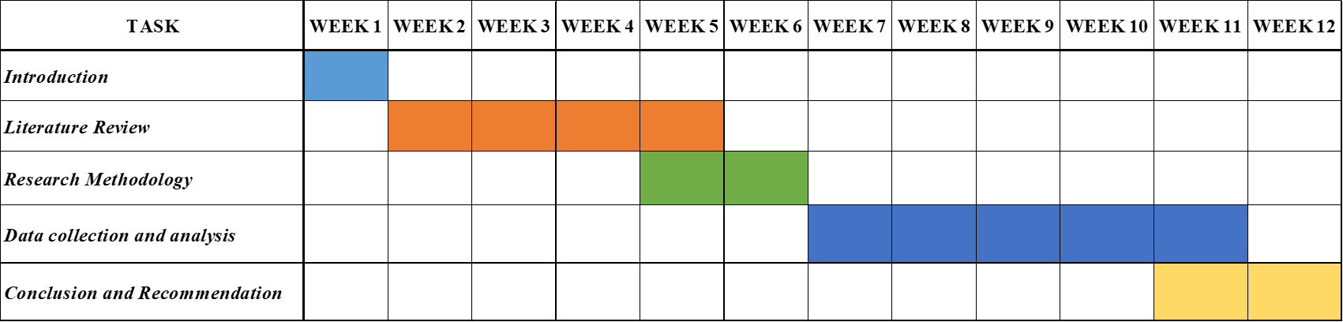

**Figure 3.2: Research timespan**

(Source: Self-created)

# Reference list

Akgunduz, Y., Adan Gök, Ö. and Alkan, C., (2020). The effects of rewards and proactive personality on turnover intentions and meaning of work in hotel businesses. *Tourism and Hospitality Research*, *20*(2), pp.170-183.

Alharahsheh, H.H. and Pius, A., (2020). A review of key paradigms: Positivism VS interpretivism. *Global Academic Journal of Humanities and Social Sciences*, *2*(3), pp.39-43.

Alrawahi, S., Sellgren, S.F., Altouby, S., Alwahaibi, N. and Brommels, M., (2020). The application of Herzberg's two-factor theory of motivation to job satisfaction in clinical laboratories in Omani hospitals. *Heliyon*, *6*(9), p.e04829.

Baqir, M., Hussain, S., Waseem, R. and Islam, K.A., (2020). Impact of reward and recognition, supervisor support on employee engagement. *American International Journal of Business and Management Studies*, *2*(3), pp.8-21.

CIPD, (2023). *Gender equality at work*. Available at: https://www.cipd.org/uk/views-and-insights/cipd-viewpoint/gender-equality-work/ [Accessed on: 23 May 2023]

Clark, D., (2022). *Gender pay gap for median gross hourly earnings in the United Kingdom from 1997 to 2022*. Available at: https://www.statista.com/statistics/280710/uk-gender-pay-gap/ [Accessed on: 24 May 2023]

Clark, D., (2023). *Share of female held leadership positions in FTSE companies in the United Kingdom in 2022*. Available at: https://www.statista.com/statistics/685195/share-of-female-ceo-positions-in-ftse-companies-uk/ [Accessed on: 24 May 2023]

Gains, F. and Sanders, A., (2020). *Gender and occupational segregation in Greater Manchester.* Available at: https://blog.policy.manchester.ac.uk/posts/2020/01/gender-and-occupational-segregation-in-greater-manchester/ [Accessed on: 24 May 2023]

Hanson, M.H. and Glăveanu, V.P., (2020). The importance of case studies and the evolving systems. In *Handbook of research methods on creativity*. Edward Elgar Publishing.

Lester, J.N., Cho, Y. and Lochmiller, C.R., (2020). Learning to do qualitative data analysis: A starting point. *Human Resource Development Review*, *19*(1), pp.94-106.

Maguire, M. and Delahunt, B., (2017). Doing a thematic analysis: A practical, step-by-step guide for learning and teaching scholars. *All Ireland Journal of Higher Education*, *9*(3), pp.3351-33514.

Manzoor, F., Wei, L. and Asif, M., (2021). Intrinsic rewards and employee's performance with the mediating mechanism of employee's motivation. *Frontiers in psychology*, *12*, p.563070.

Mwesigwa, R., Tusiime, I. and Ssekiziyivu, B., (2020). Leadership styles, job satisfaction and organizational commitment among academic staff in public universities. *Journal of Management Development*, *39*(2), pp.253-268.

Nagarajah, S., Medawala, P. and Rathnayake, S., (2021). An Empirical Study of the Factors Affecting Employees’ Performance at ABC Group of Companies Proceedings of the 5 th CIPM International Research Symposium on HRM 2021. Chartered Institute of Personnel Management of Sri Lanka. ISSN: 2513-2733 An Empiri. July. *no. July. https://doi. org/10.13140/RG*, *2*(14476.44169).

Niati, D.R., Siregar, Z.M.E. and Prayoga, Y., (2021). The effect of training on work performance and career development: the role of motivation as intervening variable. *Budapest International Research and Critics Institute (BIRCI-Journal): Humanities and Social Sciences*, *4*(2), pp.2385-2393.

Ogando, A.C., Rogan, M. and Moussié, R., (2022). Impacts of the COVID‐19 pandemic and unpaid care work on informal workers' livelihoods. *International Labour Review*, *161*(2), pp.171-194.

Olabode, S.O., Olateju, O.I. and Bakare, A.A., (2019). An assessment of the reliability of secondary data in management science research. *International Journal of Business and Management Review*, *7*(3), pp.27-43.

Olusadum, N.J. and Anulika, N.J., (2018). Impact of Motivation on Employee Performance: A Study of Alvan Ikoku Federal College of Education. *sigma*, *1*(1), pp.53-65.

Phipps, C., (2021). *Why we should still be concerned about gender inequality in the UK*. Available at: https://blogs.lse.ac.uk/socialbusinesshub/2021/11/15/why-we-should-still-be-concerned-about-gender-inequality-in-the-uk/ [Accessed on: 23 May 2023]

Saputra, F. and Mahaputra, M.R., (2022). Effect of job satisfaction, employee loyalty and employee commitment on leadership style (human resource literature study). *Dinasti International Journal of Management Science*, *3*(4), pp.762-772.

Saunders, M., Thornhill, A. and Lewis, P. (2019). *Methods for Business Students (8th edition)*. Pearson Education: London.

Simply Business, (2023). *Our report into the main challenges faced by women business owners*. Available at: https://get.simplybusiness.co.uk/empowering-women-in-business/#lp-pom-block-619 [Accessed on: 25 May 2023]

SME Loans, (2023). *MEN More Likely Than Women To Feel Discriminated At Work On The Grounds Of Gender*. Available at: https://www.smeloans.co.uk/blog/gender-discrimination-in-the-workplace/ [Accessed on: 25 May 2023]

Smith, C., (2022). *Report into gender bias and inequality affecting women business owners*. Available at: https://www.simplybusiness.co.uk/knowledge/articles/2022/03/report-into-gender-bias-and-inequality-in-business/ [Accessed on: 23 May 2023]

Smith, N. and Parrotta, P., (2018). Why so few women on boards of directors? Empirical evidence from Danish companies in 1998–2010. *Journal of Business Ethics*, *147*, pp.445-467.

Sudiardhita, K.I., Mukhtar, S., Hartono, B., Sariwulan, T. and Nikensari, S.I., (2018). The effect of compensation, motivation of employee and work satisfaction to employee performance Pt. Bank Xyz (Persero) Tbk. *Academy of Strategic Management Journal*, *17*(4), pp.1-14.

TUC, (2023). *Sexual harassment has no place in the workplace*. Available at: https://www.tuc.org.uk/campaigns/sexual-harassment-has-no-place-workplace-thisisnotworking [Accessed on: 25 May 2023]

Wen, T.B., Ho, T.C., Kelana, B.W.Y., Othman, R. and Syed, O.R., (2019). Leadership styles in influencing employees’ job performances. *International Journal of Academic Research in Business and Social Sciences*, *9*(9), pp.55-65.

Woiceshyn, J. and Daellenbach, U., (2018). Evaluating inductive vs deductive research in management studies: Implications for authors, editors, and reviewers. *Qualitative Research in Organizations and Management: An International Journal*, *13*(2), pp.183-195.