**HUMAN SERVICES**

Table of Contents

Introduction 3

Discussion 3

Conclusion 10

Reference List 11

Appendices 15

# Introduction

Human services are dedicated towards the objective of meeting human needs focusing on preventing and remediation of issues. In this context, practitioners use distinctive approaches towards maintaining workplace effectiveness and integrity. Therefore, the essay focuses on the human services sector of Australia while delving into the direct practice approaches of practitioners for understanding its evolution and impact. Hence, its affiliation with the diversity of the services sector was also ascertained. Concerning this prospect, proper recommendations were constructed in terms of supporting the relevance of the practice in future scenarios. Thus, the essay contextualises the significance of the direct practice approach in the Australian service sector.

# Discussion

Direct Practice by professionals in the service sector is associated with engaging in one-on-one contact with people at the micro level. As stated by Allan (2020), it is important for businesses to provide support to their practitioners regarding the availability of resources for gaining better business profits as a whole. Hence, in terms of professionals in the Australian services sector, mainly engage in a problem-solving process while considering the guiding principles of social diversity and promoting social and economic justice. The purpose of the direct practice approach in the Australian services sector is to maintain transparency while collaboratively employing innovative hiring methods.

The human services sector in Australia is a sub-sector of the services industry where the employment rate was recorded at 77.73% in 2020 ***[Refer to Appendix 1].*** Concerning this prospect, the direct practice approach of professionals in the human services sector of Australia allows them to focus on providing assistance to vulnerable groups within the society without limiting themselves in terms of social reach. The main purpose of these practices is to keep social work consistent within the human services sector while empowering change in context to associated clients. According to Kim et al. (2021), professionals focusing on the direct practice approach are more focused on alleviating any concerns regarding substance abuse, counselling, therapies and so on. This is one of the major reasons for the need for one-on-one interactions to understand the requirements of each client and fulfilling them appropriately.

Concerning this prospect, by using direct practices, professionals in the Australian human services sector work towards ensuring the mental safety of vulnerable groups. They are also responsible for hiring volunteers who can carry out social work in an effective manner by assessing and helping a client through their life’s challenges (Friedman, 2021). Therefore, it can be determined that it is the responsibility of social practitioners to directly contact vulnerable groups through the use of their direct practice approach while promoting diversity.

The human services sector plays a vital role in Australia in regard to safeguarding its population concerning health, education as well as community services. The practitioners within this industry often refer to the prospect of service user diversity which helps to prevent any kind of discrimination within the framework of social work. According to Marsiglia, Kulis & Lechuga-Peña (2021), user diversity in the human services sector often provides better suggestions in terms of resolving challenges such as the ageing population, increased adoption of technologies and so on. In this context, practitioners in the Australian human services sector also look after employment in healthcare and social assistance. This provides them with insights into the number of professionals available to provide services to vulnerable groups.

The direct practice approach of practitioners reflects a positive impact on the human services sector by focusing on creating employment opportunities and hiring them through direct contact to have a better grasp of their abilities in the practical field. In this instance, the healthcare and social assistance segment employed 2,112,600 with a future growth forecast of 15.8%. Female employees have the largest share within the sector amounting to 76.2% with the average age being 41 ***[Refer to Appendix 2]***. This indicates that the human services sector in Australia has employed proficient practitioners who assisted in looking after vulnerable groups.

In regard to user diversity, the appointment of practitioners and volunteers from different walks of life has allowed the sector to become diverse. This helped to incorporate new insights into caring for vulnerable groups in Australia without compromising the quality of healthcare. In this context, the Department of Human Services (DHS) in Australia is the governing body which reflects the profitability of the sector. DHS administers three acts covering hearing, income and health programme support for the welfare of the Australian people. Hence, its revenue amounted to 5.3 billion Australian dollars in 2020 ***[Refer to Appendix 3].*** Concerning this prospect, human service practitioners need to reflect on their direct practice approach which also allows them to have a collaborative impact on the welfare of Australian people. This also contributes towards the growth of the sector in meaningful ways.

On the other hand, Human service providers often work with people hailing from different cultures and traditions and it is essential for them to be respectful to each. Therefore, their direct approach towards improving the welfare prospects allows them to understand cultural norms first-hand which prepares them for handling client issues better. According to Moro et al. (2022), collaboration in the human services sector provides greater benefits to the eventual growth of business prospects as a whole while maintaining social welfare. Therefore, in terms of the direct service approach, it allows practitioners or social workers to work at ground-level with clients and assist in connecting them with the resources and services which they require in consideration to maintaining their welfare. Thus, this provides better opportunities in terms of clientele collaboration which has a positive impact on the reinforcement of the human service sector in Australia.

In consideration of the direct human services practice approach, the government of Australia has focused on improving expenditure in terms of providing practitioners with the necessary amount of resources to guide better business practices as a whole. According to Curley et al. (2021), it is important for the government of a country to invest in welfare activities for improving the position of vulnerable groups. In this context, government spending on welfare activities in Australia amounted to 195.7 billion dollars in 2020 ***[Refer to Appendix 4].*** Concerning this prospect, this allows human service practitioners to increasingly focus on their direct practice approach to improving service quality.

In consideration of the direct practice approach in human services, mainly assists in increasing the affinity of clientele with professional practitioners. According to Cano (2020), it is important for human service practitioners to focus on assessing the requirements of their clientele before strategizing about resolutions. Hence, direct practitioners are more involved and draw on a clear working pattern to meet client needs. Direct social workers also have the opportunity to build a catalogue of potential options for their clients to find the best possible solution to their issues. They are also helpful towards people who are suffering from mental issues by connecting them with healthcare professionals who can take care of their health.

On the other hand, the direct practice approach also involves tailoring an approach in terms of assessing the needs of the client for adhering to their unique perspectives. According to Bracons (2019), it is important for direct practitioners to focus on improving the accessibility of their clients without compromising upon the quality of service. This helps direct social care workers in Australia to care for vulnerable groups efficiently while guiding them towards better opportunities for welfare treatment. Hence, it can be determined that the growth of the human services sector in Australia is mostly dependent on the number of skilled professionals present within the segment who can guide better process optimisation as a whole.

In this context, the direct practice approach also involves screening the client to determine their eligibility regarding various services and programmes as well as providing case management. Hence, by adhering to a direct practice approach in the contemporary scenario, human service professionals are able to gain a deeper understanding of the requirements of their clientele and provide them with the necessary resources to thrive in terms of their welfare.

However, in terms of future relevance, it is difficult to pinpoint the relevancy of this approach due to the rapidly evolving and changing market dynamics. As per Gallant et al. (2020), market dynamics determine the demand and supply curves which must be taken into consideration by policymakers. In this prospect, it can be said that future market dynamics can shift drastically when a direct practice approach of human services may not be as technically viable as of now. This can be attributed towards increasing demand, enhanced adoption of technologies and more.

Hence, it can be said that the future of this practice is uncertain due to the need for human service practitioners to come in direct contact with their clientele. This process may be streamlined in the future through the use of technologies. This implies that though the existing system may not be entirely relevant in the future, its improved variants may drive future market trends in the Australian human services sector.

The primary goal of the direct practice approach is to lay emphasis on the strength perspective while focusing on families, groups and individuals (Bostock et al., 2019). This indicates that the direct practice approach is an increasingly time-consuming process when compared with other human service approaches. Hence, professionals in the Australian human services sector need to focus on optimising operations for gaining better perspectives while linking diversity progress in terms of welfare activities.

Australia is also determined to play its part in maintaining the sustainability of human welfare by serving the long-term direction for international development. In this context, the country is providing an additional 900 million dollars in ODA to the Pacific for supporting the Pacific family's development and resilience (DFAT, 2023). The commitment of Australia towards developing its reserves to support human welfare is evident in its human services sector which allows the provision of better opportunities for persons to interact with different communities and cultures. Hence, the presence of cultural diversity within the sector provides a greater significance in terms of providing better prospects as a whole.

The direct practice approach in the Australian human service sector must focus on reinforcing accessibility to resources for both practitioners and clientele. This can help to resolve welfare disruptions at an increased pace and support a large number of people. As per Tufford (2021), by aligning business operations towards maintaining peaceful harmony among communities, welfare can be supported thoughtfully. Therefore, it can be determined that Australia's human service sector is brimming with opportunities for voluntary social work, employment and so on. This aspect further reinforces the cusp of the country's sector in the context of providing the necessary welfare perspectives for resolving any difficulties as a whole. Thus, this also contributes towards the formation of a reinforced and better welfare collaboration programme in the sector.

The Australian Government is recommended to suggest more developmental programmes for improving the current state of welfare activities within the human services sector. This can also contribute towards generating more dedicated strategies towards resolving particular issue segments. As per Keeney et al. (2022), personalised welfare strategies are most common in direct practice as practitioners are in direct contact with the client. Hence, practitioners must focus on guiding better business trends by effectively referring to the needs and requirements of their clients for optimising the process of welfare. Therefore, increased support from the government can boost the resources of the human services sector in Australia by investing in more skilled labour to gain more effective welfare results as a whole.

On another note, direct practice approach practitioners in the sector need to adhere towards the use of emerging technologies. This can help human service professionals in Australia to look after more clients on a regular basis while streamlining the process of interaction. As per Dybicz & Hall (2021), the use of technologies to monitor welfare progress and optimise plans can improve the integrity of welfare activities as a whole. This can contribute towards gaining specific welfare benefits for afflicted individuals. It can also improve and reinforce welfare activities without compromising the quality of services offered.

In this context, the human services sector in Australia can also focus on organising volunteers who are at the forefront of operations concerning direct practices. This can help the sector's volunteers to efficiently cater to the needs of their clients while consistently improving upon their practices to reach more vulnerable groups. This can assist the sector in gaining more proficient workers who can evaluate the needs and requirements of their clients. As per Kim et al. (2021), the growth of welfare activities within the human services sector can be attributed towards the evolutionary practices with the implementation of modern technologies.

Concerning this prospect, the human services sector of Australia is also recommended to lean further into telehealth. This can help professionals to directly contact a large number of clients rapidly which can tremendously save time and contribute towards the better distribution of welfare activities. Therefore, by offering flexibility and support for care services, professionals will be able to effectively fulfil the requirements of their clients through their direct practice approach. Hence, this approach must also be refined in terms of implementing collaborative strategies which can assist in the traditional growth of welfare ideals.

In this instance, establishing a clear line of communication and asserting commitment towards welfare equality can allow professionals in the human services sector of Australia to reinforce their activities. This can also provide them with improved quality of life changes and support vulnerable groups through personal assistance. Therefore, this can also contribute towards the growth of direct practice approaches in the human service sector of Australia. Thus, in this manner, by referring to these potential suggestions, the operations in the sector can be refined appropriately.

# Conclusion

It can be concluded that a direct practice approach in Australian human services is quite viable in the contemporary scenario. However, due to the rapidly changing market dynamics, this approach needs to be aligned with future technologies for staying relevant in the long term. Concerning this prospect, the Department of Human Services and the government in Australia need to provide the sector with the necessary funding and support for additional resources. Hence, this will assist in reinforcing the current state of operations within the sector while improving the ability of direct practice approaches of practitioners to effectively resolve the issues of their clientele.

# 

# Reference List

AIHW, (2021). *Welfare expenditure* <https://www.aihw.gov.au/reports/australias-welfare/welfare-expenditure>

Allan, J. (2020). Maintaining the partnerships between educators and practitioners. In *Fieldwork in the Human Services* (pp. 145-159). Routledge. <https://www.taylorfrancis.com/chapters/edit/10.4324/9781003115625-14/maintaining-partnerships-educators-practitioners-june-allan>

Bostock, L., Patrizo, L., Godfrey, T., & Forrester, D. (2019). What is the impact of supervision on direct practice with families?. *Children and Youth Services Review*, *105*, 104428. <https://uobrep.openrepository.com/bitstream/handle/10547/623388/Bostock+et+al_2019_Impact+of+supervision+on+direct+practice_CYSR.pdf?sequence=2>

Bracons, H. (2019). Culture, diversity, interculturality and cultural competence: knowledge and importance of the concepts in social work perspective. *IJNE: International Journal of New Education*, (3), 62-67. <https://dialnet.unirioja.es/servlet/articulo?codigo=7454939>

Cano, M. (2020). Diversity and inclusion in social service organizations: Implications for community partnerships and social work education. *Journal of Social Work Education*, *56*(1), 105-114. <https://www.tandfonline.com/doi/abs/10.1080/10437797.2019.1656577>

Curley, C., Levine Daniel, J., Walk, M., & Harrison, N. (2021). Competition and collaboration in the nonprofit sector: Identifying the potential for cognitive dissonance. *Administration & Society*, *53*(8), 1293-1311. <https://scholarworks.iupui.edu/bitstream/handle/1805/25339/Curley2021Competition.pdf?sequence=3&isAllowed=y>

Dfat, (2023). *Australia’s development program* <https://www.dfat.gov.au/development/australias-development-program>

Dybicz, P., & Hall, J. C. (2021). An introduction to the postmodern paradigm via contrast to the modern paradigm: Relevance for direct social work practice. *Social Sciences & Humanities Open*, *4*(1), 100206. <https://www.sciencedirect.com/science/article/pii/S2590291121001029>

Friedman, C. (2021). The impact of direct support professional turnover on the health and safety of people with intellectual and developmental disabilities. *Inclusion*, *9*(1), 63-73. <https://meridian.allenpress.com/inclusion/article-abstract/9/1/63/461592/The-Impact-of-Direct-Support-Professional-Turnover>

Gallant, J., Kroft, K., Lange, F., & Notowidigdo, M. J. (2020). *Temporary unemployment and labor market dynamics during the COVID-19 recession* (No. w27924). National Bureau of Economic Research. <https://www.nber.org/system/files/working_papers/w27924/w27924.pdf>

Keeney, A. J., Lee, A., Jayyousi, S., Young, J. A., Guarino, J., & Turner, K. B. (2022). Social Work Students’ Self-Efficacy Toward Direct Practice Skills in Field Education Using Virtual Simulations and Scripted Role Plays. *Advances in Social Work*, *22*(2), 303-317. <https://journals.iupui.edu/index.php/advancesinsocialwork/article/view/24929>

Kim, S. S., Kim, J., Badu-Baiden, F., Giroux, M., & Choi, Y. (2021). Preference for robot service or human service in hotels? Impacts of the COVID-19 pandemic. *International Journal of Hospitality Management*, *93*, 102795. <https://www.ncbi.nlm.nih.gov/pmc/articles/PMC9998175/>

LMI, (2022). *Health Care and Social Assistance* <https://labourmarketinsights.gov.au/industries/industry-details?industryCode=Q>

Marsiglia, F. F., Kulis, S. S., & Lechuga-Peña, S. (2021). *Diversity, oppression, and change: Culturally grounded social work*. Oxford University Press, USA. <https://books.google.co.in/books?hl=en&lr=&id=PvwTEAAAQBAJ&oi=fnd&pg=PP1&dq=social+work+and+diversity&ots=_nf9gXxRWT&sig=yGFDGBvhBxKMFUFWbR3gws6eXxM&redir_esc=y#v=onepage&q=social%20work%20and%20diversity&f=false>

Moro, M. F., Kola, L., Fadahunsi, O., Jah, E. M., Kofie, H., Samba, D., ... & Gureje, O. (2022). Quality of care and respect of human rights in mental health services in four West African countries: collaboration between the mental health leadership and advocacy programme and the World Health Organization QualityRights initiative. *BJPsych open*, *8*(1), e31. <https://www.cambridge.org/core/services/aop-cambridge-core/content/view/0609B57F549497992AC4085BC311BBDE/S2056472421010802a.pdf/quality_of_care_and_respect_of_human_rights_in_mental_health_services_in_four_west_african_countries_collaboration_between_the_mental_health_leadership_and_advocacy_programme_and_the_world_health_organization_qualityrights_initiative.pdf>

Statista, (2022). *Income of the Department of Human Services (DHS) in Australia from financial years 2014 to 2020* <https://www.statista.com/statistics/705255/australia-department-of-human-services-income/>

Trading Economics, (2023). *Employment in Services Sector* <https://tradingeconomics.com/australia/employment-in-services-percent-of-total-employment-wb-data.html>

Tufford, L. (2021). Impact of adding mindfulness practices to a bachelor of social work direct practice course. *Contemporary Educational Research Journal*, *11*(2), 29-42. <https://d1wqtxts1xzle7.cloudfront.net/68857734/7421-libre.pdf?1629762938=&response-content-disposition=inline%3B+filename%3DImpact_of_adding_mindfulness_practices_t.pdf&Expires=1684841199&Signature=OUUlQLb8l~X2zk~MpzptWw8GKTf3us1bEYtex468traoK0iF66p34-KzP9NkPcZkQ9Oq52IirxFKXCRlbiyyz8pdD3TYYzpWAvUNufcGAMGQcP-pGQ73619d4R3GwEDtAnchGcOMvZY4Alcir02~sE~sqzRZLFLNX7Qzww-0fHzs3Lys6XKyREhk7mNAQNzhFpb482cOe62lBL7PaQzGkNR6clk~buaYm9MKn9unagm2fXSLn7D2oh9qJwOJetMcYuyrf9Qom4gKnwmBfpdE~e3XL1eODr8eqD0JeZLom~ui6m7k6-zEju2T2sOTo0j8H0nOG4ZoHDGxucF6ElNO2Q__&Key-Pair-Id=APKAJLOHF5GGSLRBV4ZA>

# Appendices

**Appendix 1: Employment in Services Sector of Australia**

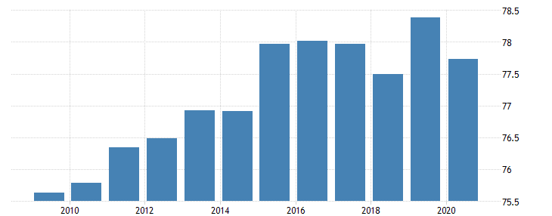

(Source: Trading Economics, 2023)

**Appendix 2: Overview of Social Healthcare Workforce in Australia**

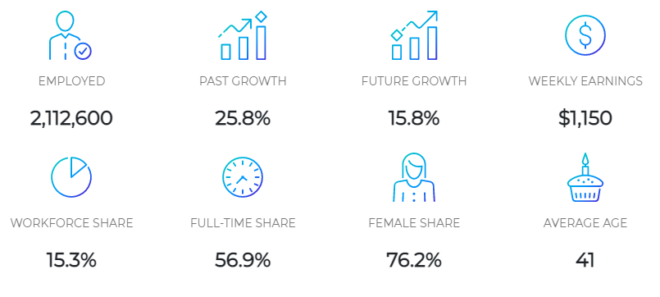

(Source: LMI, 2022)

**Appendix 3: Income of the Department of Human Services (DHS) in Australia**

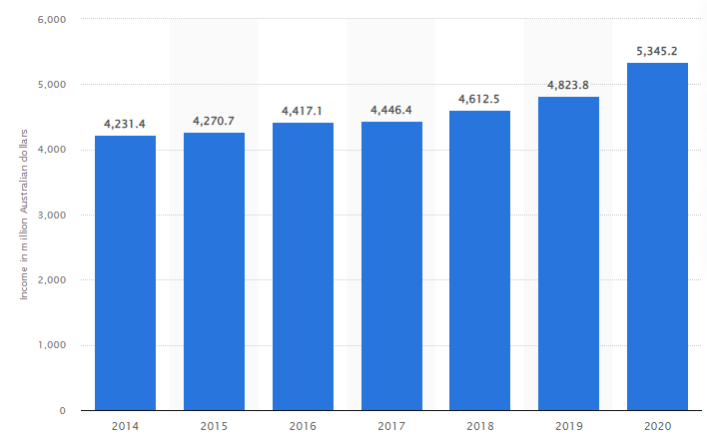

(Source: Statista, 2022)

**Appendix 4: Government Welfare Expenditure Australia**

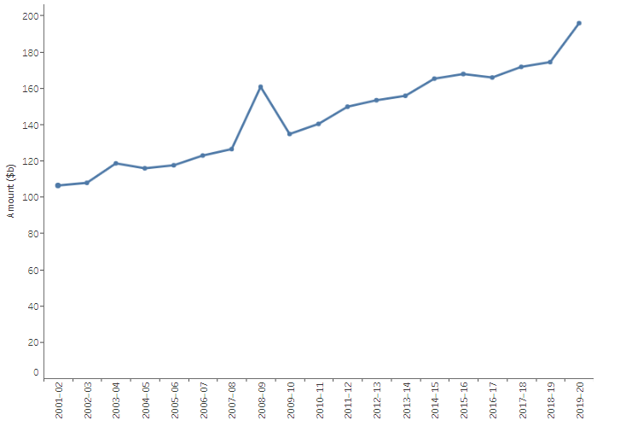

(Source: AIHW, 2021)