**PEOPLE MANAGEMENT AND ORGANISATIONS**

**Table of Contents**

1

Introduction 2

Leadership effectiveness with reference to leader and follower characteristics 2

Potential environmental factors that could affect leadership 8

Conclusion 10

Appendices 15

# 

# Introduction

Organisational leadership is a strategic approach used in achieving the goals of the organisation. In this process, leaders provide guidance and motivation to the employees in order to successfully complete the organisational goals. Based on the structure and culture of the organisation leadership styles can vary; this helps to create understanding environment, motivation and better communication in the organisation. In this case, the effectiveness of the leadership styles is evaluated based on the characteristics of the leaders and the followers. The essay also discusses the factors of employee engagement and motivation in the development of leadership in the company.

# Leadership effectiveness with reference to leader and follower characteristics

The leader’s ability to manage the employees and influence them in order to fulfil the requirements of the stakeholders is factors which influence the effectiveness of the leadership style. There are specific skills which are required for the effective leadership management in an organisation such as inner values, innovation, inspiration and communication. As suggested by Keykha *et al*. (2022), effective leadership allows the organisation to function seamlessly and improves the decision making process in the internal system of the business. Moreover, the key characteristics which are required for successful leadership are communication skills, integrity, self-awareness, accountability, transparency, decision making and creativity. It is necessary that a leader is unbiased in the cultural differences of the employees and maintains business integrity in the workplace. Integrity is an essential quality for leaders as it is necessary to retain the respect of the employees and to promote the image of the organisation. The general moral code of the organisation and the ethical beliefs of the business can be showcased by the leaders to create ethical goals for the employees. On the other hand, positivity is also one of the key qualities which a leader has to obtain for the improvement of employee morale in the organisation.

A positive approach influences the employees to work towards the organisational goal even in a critical situation. This also improves the morale of the organisation and positively influences the employees to mitigate the challenges. As per the view of James and Bennett (2022), leadership skills and characteristics build the foundation of an organisation’s extensive work environment. Therefore, it is necessary that the leaders of an organisation create an impactful presence which influences the employees to increase the quality of the work. There are six common styles of leadership based on the characteristics of the leaders. The six styles are known as transformational, delegative, transactional, authoritative, participative and servant leadership. Transformational leadership emphasises on promoting positive change in the internal functions of an organisation. Transformational leadership has been implemented by Walmart in order to increase the productivity of the employees (corporate.walmart.com, 2023). This leadership style is effective for organisations which are prioritising change management in the organisation. On the other hand, delegative leadership which is also referred to as the laissez-faire style is one of the least intrusive styles. This form of leadership requires that the employees are allowed the freedom to take decisions without the involvement of the leaders.

Moreover, this form strictly avoided micromanaging the employees and allows the workers to utilise the creativity of the individuals. As commented by Saputra and Mahaputra (2022), leadership styles influence multiple factors in an organisation including the job satisfaction, loyalty of the employees and engagement of the employees. Furthermore, authoritative leadership relies on the understanding and relationship between each employee and the authorities. On the other hand, the CEO of Tesco Ken Murphy has effectively implemented responsible leadership strategies and increased the ROI rate of the organisation which amounted to 60.2 billion in the year 2022 (tescoplc.com, 2023). This form focuses on guidance, motivation and feedback methods for encouraging the employees to accomplish the goals of the organisation. However, there are theories which can be implemented for increasing the effectiveness of the leadership in an organisation such as the contingency theory of leadership.

***Contingency Theory of Leadership***

The contingency theory of leadership suggests that the effectiveness of a specific leadership style depends on the situational requirements of the workplace. According to this theory, in order to maximise the likelihood of success it is necessary to evaluate the situation and implement the effective leadership style accordingly. As stated by Amghar (2022), the contingency theory of leadership emphasises on the adaptiveness of the workplace and its employees. The Fiedler’s model of contingency theory suggests that there are three variables in the effective incorporation of leadership in an organisation. On the other hand, Tesla has set an example by following a divisional and flexible leadership style (ir.tesla.com, 2023). The variables are leadership styles, situational variables and relationship between styles and situational requirements. Moreover, the theory suggests that successful leadership styles might not be as effective if one of the variables change. As per the view of Al Rusheidi and Supian (2022), in order to successfully incorporate leadership style in an organisation it is essential to evaluate all the critical factors which might cause the leadership style to demotivate the employees. Therefore, taking the contingency theory into consideration can be effective in the selection process of the required leadership style.

Vision is also one of the key qualities which a leader has to hold for the effective improvement of the organisation. Envisioning and predicting the future challenges which the organisation might face, helps the leaders to provide long term goals for the organisation. As suggested by Webb *et al*. (2022), leadership of an organisation requires the leaders to provide the employees with the tools, equipment and training necessary for garnering better results of the tasks. The leadership style Therefore, it is necessary for the leaders to understand the areas in which the employees are lacking in order to provide guidance accordingly. Furthermore, the leaders are also required to incorporate creative solutions to the challenges faced in a workplace as it consists of a diverse range of employees. Apple’s software application head Rodger Rosner has increased the number of employees to 137,000 with steady revenue of $260 billion in the year 2019 (hbr.org, 2023). It is necessary to understand the needs and demographics of the employees which can help in the implementation of specific leadership characteristics. Theories of human needs and demographics can be useful in this case for the implementation of effective leadership.

***Maslow’s Hierarchy of Needs***

Maslow’s hierarchy focuses on the hierarchical needs of human beings which require fulfilment for the satisfaction of the individuals. There are five dimensions of this theory such as physiological, safety, love or belonging, self esteem and self-actualisation needs. As per the view of Anuyah *et al.* (2023), the five stage model helps in the understanding of the requirements which are interrelated for the satisfaction of the employees. The first basic need of the theory focuses on the physiological needs of the individuals such as the basic environmental requirements such as food, water and shelter.

The lack of these basic requirements affects the employees and it is a leader's responsibility to ensure that the workers have the essential needs in the work culture of the organisation. On the other hand, the need for safety is also a major factor as the employees cannot function in an unsafe environment. As commented by Vithayaporn *et al.* (2022), Maslow’s hierarchy helps in understanding the needs of the employees which is one of the primary requirements of the implementation of organisational leadership. According to this theory the need for love and belonging is also required as a work environment which lacks inclusivity will also lack in providing morale to the workers. It is necessary that the leadership of the organisation is being respectful towards each employee while also receiving respect from the workers. As commented by Omodan (2022), implementing the hierarchy of needs enhances the retention of employees as it incorporates the idea of responsible and considerate authorities of the organisation. Lastly, it is essential to fulfil the need of self actualisation of the employees which ensures that morality, creativity and spontaneity is maintained in the workplace. The needs of this theory are interrelated as the inability to meet one need would affect the other dimensions of need.

It is effective for the implementation of leadership to lead by building examples to inspire the employees. The behaviours showcased by the leadership affects the behavioural culture in the organisation. However, there are challenges of the implementation process which can be mitigated by positive leadership practices in an organisation. As suggested by Kouzes and Posner (2023), the challenges faced by the leadership in the implementation of specific styles in the organisation includes providing inspiration for the employees, developing the individuals and leading the organisational change management. Leading change in an organisation affects the systematic process of business functions in the company thus, it is essential that the changes are implemented gradually based on the adaptation capabilities of the organisation. As commented by Stejerne *et al.* (2022), the strategic implementation of leadership allows the employees to feel less pressured about the goals set by the authorities. On the other hand, the leadership of an organisation often faces challenges regarding the amount of supervision which is required for the effective implementation of the method. Micromanaging the workers often backfire as the innovative traits of the employees are hindered in the process.

The leaders of an organisation have to ensure that the employees are allowed to work freely without hampering the free will of an individual. Furthermore, the organisations often face challenges due to the internal conflict in the workplace. These conflicts require intervention of the leadership and mitigation of the conflicts by providing fair solutions for both parties. As per the view of Willis (2019), various factors affect the effective leadership in the organisation such as the lack of financial investments required for the implementation process of leadership. The financial investments include the costs of strategically incorporating leadership practices in the workplace. On the other hand, UK based retail company Walmart has enforced a People Development Program for increasing the team function in the organisation (careers.walmart.com, 2023). Leadership practices which can be helpful are the relationship enhancement practices such as mentorship programs, inclusivity programs, real time feedback and publicised central goals of an organisation. The mentorship programs can be effective for building the relationship between authorities of an organisation and the employees. As suggested by Shalka *et al*. (2019), mentorship development is an essential part of successfully implemented leadership in an organisation as it inspires the employees to follow the goals set by the leader. On the other hand, the developmental challenges of leadership include changes in consumer behaviour and lack of internal communication in the workplace.

The importance of communication in the development of leadership practices is majorly affected by the organisational structure of the workplace. The most commonly used leadership communication is the relay information process. This method focuses on communicating the cultural core values of an organisation as well as the mission and vision of the company. Sharing the values of the organisation increases the relatability of the employees and enforces team function in the workplace. A shared vision allows mitigation of workplace conflict and defines the relationship between the employees and leaders. As commented by Susiloningsih *et al.* (2022), organisational communication affects the extensive performance of the organisation and affects the implementation of leadership as it is based on communication. It is necessary that a leader is able to convey the requirements which need fulfilment and the employees are able to communicate the basic needs for the achievement of desired results. Therefore, it is also essential for the leaders to acquire the characteristics of a listener which allows them to gather feedback from the employees. Gathering the feedback of the employees will also allow the leadership of the organisation to improve the areas of leadership to make it more customised for the organisational structure of the company. The extensive improvement of organisational communication also allows the leaders to motivate the employees. In this case, the theory of Herzberg’s Two-factor Theory can be implied for understanding the key takeaways of motivation in an organisation.

***Herzberg’s two-factor Theory***

The Herzberg theory is a concept which is used in the management of human resources and organisational behaviour. According to this theory the two factors which motivate the employees can be divided into two dimensions such as job satisfaction and job dissatisfaction. The theory suggests that these two main factors work in a cycle for the incorporation of motivation in the workplace. As per the view of Mo *et al*. (2023), the Herzberg theory indicates the job satisfaction as the hygiene factors which include security of the job, payment procedures, fairness and conditions of work. Therefore, it can be gathered that the salary and financial benefits affect the employee’s motivation. It has been shown in studies that 78% of the businesses in the UK are affected by the active and regular encouragement from the leaders (Rains, 2020). These factors can be effectively utilised by the leaders in the improvement of the motivational environment in the workplace. On the other hand, the job policy, work environment and company administration each affect the employee’s satisfaction and motivation. As commented by Ahmadi *et al*. (2023), motivational leadership helps in increasing the motivation for employees to work towards a central goal and motivational leaders evoke the best qualities of the employees to achieve required results. Furthermore, the theory of Hertzberg suggests that extrinsic factors such as achievement, recognition of the accomplishments and rewards increase motivation for the employees.

There are followership qualities that affect the leadership in an organisation such as the high degree of self worth, personal competency, personal aspirations and integrity of the individuals. As per the view of Oc *et al*. (2023), the followers affect the extensive performance of the implemented styles of leadership. The ability to accept the leaders and following the instructions of the leaders are two of the primary qualities which followers have to showcase for the effective implementation of the leadership styles.

The theory can be effective for the incorporation of effective leadership in an organisation as it helps in gaining insight of the factors affecting motivation for the employees. On the other hand, the leadership of an organisation also has to prioritise factors which increase employee engagement in the organisation. As commented by Susanto *et al*. (2023), factors which increase employee engagement are also factors which help the leaders to make the employees enthusiastic about the performance of the organisation. The optimistic approach of the leaders helps in influencing the employees to promote collaborative approaches which align with the organisation’s central goals. The example of Tesla, the UK based retail company can be showcased in this case as it has implemented comprehensive medical coverage for the employees to increase engagement (tesla.com, 2023). The team function in an organisation can be increased as the individual workers are engaging with the organisation and other workers. As stated by Nakinaalwa (2023), promoting engaging leadership practices can be achieved by the leaders by organising group activities and business seminars, training and trips. Therefore, these practices allow the organisation to increase the extensive collaboration and team function also improving the performance and efficiency of the workers.

The stakeholders of an organisation also affect the leadership process in the company as the leadership practices need to align with the requirements of the stakeholders. The expectations of the stakeholders have to be met through the identification of the critical factors for the implementation of the leadership practices in the organisation. As per the view of Nuhu *et al*. (2023), as the strategic direction of the organisational goals is maintained by the stakeholders of the company it is necessary to ensure the common goals of the leadership aligns with the stakeholders. Moreover, the steps include identifying the stakeholders, understanding and evaluating the needs of the stakeholders, categorising and approaching the stakeholders strategically. The CEO of the fast fashion brand H&M, Helena Helmersson has set an example in the leadership of organisations by following inspiration, delegation of tasks, feedback and motivation for the improvement of the organisation (about.hm.com, 2023). It is also necessary to understand that the management of the potential conflicts between the stakeholders is also the responsibility of the leadership.

The implementation of leadership weaknesses can be a great challenge in the effectiveness of the process. The lack of trust in the employees and excessive connectivity can cause potential damage to the internal structure of the organisation and decrease the efficiency of the process. As commented by Spain and Woodruff (2023), failing to set clear organisational goals can misguide the employees and cause incompetence in the workplace. Therefore, it is essential that the organisational culture is critically evaluated prior to the selection of a specific leadership method. The practices of enhancing the leadership qualities can be increased by the leaders through training programs. On the other hand, specific strategies can be adapted by the leaders for the mitigation of the above mentioned challenges and hardships faced in the implementation process.

Strategically evaluating the organisational behaviour and the personality traits of the employees is one of the most effective strategies for the implementation of leadership practices. The example of the CEO of Harrods, a luxury departmental store in London can be used in this case to understand the role of an impactful leader in an organisation. The CEO of Harrods Michael Ward has significantly developed the business by encouraging positive behaviour in the organisation and managed to create a revenue increase of $1.3 billion (forbes.com, 2019). The company increased its extensive performance through the effective leadership styles.

# Potential environmental factors that could affect leadership

Institutional factors that have impacted the overall implication of leadership approaches, it has been important in developing internal and external implications of managing employees. Environmental factors impact on external approach of leadership by determining target influence within leadership assessments. According to the opinion of Sunarsi *et al.* (2020), success of organisations often depends on leadership assessments and managing employees with effective regulations. Economic and social differences and instability in operational approach are considered two key factors that can impact organisational implications within factors. Potential factor in leadership has been important in developing perceived development that has enhanced conditions.

Economic conditions have been different in different regions promoting changes in factors which has also been required to assess regional changes. Economic instability of employees has been focused on analysing important leadership perspectives which can also cause issues. As per the opinion of Shukla *et al.* (2022), leaders and followers are also important to ensure an interrelation that has been important to ensure a more transparent approach in analysing balance in organisational issues. For instance, companies such as Amazon and Accenture have decided to develop aspect of laying off employees which has caused them economic issues. Mainly, it has been an imminent outcome of social and economic imbalance that has occurred due to uncertainty in their leadership. Hence, it has been important for leaders to develop effective aspects of employee enhancement and also take care of needs of the employees. Therefore, In disrupting environment, this has been important in analysing environments that have been crucial in understanding implications in market opinions that is important in developing industrial enhancement.

Perceived condition of employees in a leadership environment is important is effective in analysing employee assessments which also implicates a crucial assessment in follower-leader relationships. Organisational leadership is important in dedicating implications within developing aspects which have been crucial to showcasing followers' dedication to work and their commitment to follow the leaders. As per the opinion of Mugge *et al.* (2020), it is important to understand implications that have been organisation is essential in determining activity of leaders. Therefore, leadership approach can also face an issue of employee perception is integral character is not shown by the leader who are engaged in developing a business perspective. In addition to that, leadership aspects are also important in developing influences in developing an integrated approach in operational approach.

Instability in operation is also an evident issue that is key in managing dependence on employees in managing implications in determining approach developing opportunities. Therefore, it has been important for leaders to understand the level of implication of leadership principles that is essential in developing opportunities is also important to develop implications. Hence, a transparent leadership approach can be developed to address the issue of instability in organisational operations. For example, famous Germany-based automation company Volkswagen has been an example of a failure in leadership approach that has been important in managing employees. Hence, this is important in meeting developments from the leaders.

# Conclusion

It can be derived from the essay that the leadership style of an organisation affects the extensive performance of the company in the specific industry. The essay focuses on the factors of employee engagement, communication and discusses various theories of analysing the needs of the employees. The various factors such as characteristics of the leaders and the followers which affect the effectiveness of the leadership styles were discussed in the essay. Therefore, it can be concluded that irrespective of the challenges of implementation of the process, effective leadership can increase the fundamental growth of the organisation.

**References**

About.hm.com (2023), *H&M Way* Available at:https://about.hm.com/content/dam/hmgroup/groupsite/documents/en/hm-way/HM%20Way_en.pdf [Accessed on: 29.05.23]

Ahmadi, A., Ali, H. and Anwar, K., (2023). The Influence of Education, Knowledge and Motivation (Literature Review). Dinasti International Journal of Management Science, 4(3), pp.388-402.

Al Rusheidi, A.S.A. and Supian, K., (2022). The mediating effects of lean leadership on the influence of lean management and gemba practices towards sustainability performance of national bank of Oman. International Journal of Accounting, 7(40), pp.184-195.

Amghar, A., (2022). Revisiting the Contingency Theories of Leadership: Key Features, Meanings and Lessons (No. 9310). EasyChair.

Anuyah, O., Badillo-Urquiola, K. and Metoyer, R., (2023), April. Characterizing the Technology Needs of Vulnerable Populations for Participation in Research and Design by Adopting Maslow’s Hierarchy of Needs. In Proceedings of the 2023 CHI Conference on Human Factors in Computing Systems (pp. 1-20).

Careers.walmart.com (2023), *People-development-program* Available at:https://careers.walmart.com/people-development-program [Accessed on: 29.05.23]

Corporate.walmart.com (2023), *Leadership* Available at:https://corporate.walmart.com/about/leadership [Accessed on: 29.05.23]

Hbr.org (2023), *How-apple-is-organized-for-innovation* Available at:https://hbr.org/2020/11/how-apple-is-organized-for-innovation [Accessed on: 29.05.23]

Ir.tesla.com (2023), *Corporate Governance* Available at:https://ir.tesla.com/corporate [Accessed on: 29.05.23]

James, A.H. and Bennett, C.L., (2022). Effective nurse leadership in times of crisis. Nursing Management, 29(4).

Keykha, A., Rahmani, P. and Ezati, M., (2022). Identifying the Competencies of School Principals for Effective Leadership in Schools. School Administration, 10(3), pp.110-132.

Kouzes, J.M. and Posner, B.Z., (2023). The leadership challenge: How to make extraordinary things happen in organizations. John Wiley & Sons.

Lorelei, M., (2019), *life-changing-lessons-we-can-learn-from-michael-ward-harrods* Available at:https://www.forbes.com/sites/loreleimarfil/2019/10/01/life-changing-lessons-we-can-learn-from-michael-ward-harrods/ [Accessed on: 29.05.23]

Mo, Q., Zeng, J. and Lin, J., (2023). An empirical study on employment behavior of college students in the post-epidemic era based on Herzberg's two-factor theory. Highlights in Business, Economics and Management, 12, pp.173-179.

Mugge, P., Abbu, H., Michaelis, T.L., Kwiatkowski, A. and Gudergan, G., (2020). Patterns of digitization: A practical guide to digital transformation. Research-Technology Management, 63(2), pp.27-35.

Nakinaalwa, P., (2023). Public service motivation, employee engagement and task performance among public sector employees of Mpigi District Local Government (Doctoral dissertation, Makerere University).

Nuhu, S., Munuo, N. and Mngumi, L., (2023). Governance challenges of regularisation of informal settlements in peri-urban Tanzania: perspectives from local stakeholders. International Journal of Urban Sustainable Development, 15(1), pp.35-47.

Oc, B., Chintakananda, K., Bashshur, M.R. and Day, D.V., (2023). The study of followers in leadership research: A systematic and critical review. The Leadership Quarterly, p.101674.

Omodan, B.I., (2022). Analysis of ‘hierarchy of needs’ as a strategy to enhance academics retention in South African universities. Academic Journal of Interdisciplinary Studies, 11(3), pp.366-376.

Rains, A., (2020), *How-leaders-can-improve-employee-engagement* Available at:https://www.forbes.com/sites/forbesbusinessdevelopmentcouncil/2020/09/11/how-leaders-can-improve-employee-engagement---even-during-challenging-times/ [Accessed on: 29.05.23]

Saputra, F. and Mahaputra, M.R., (2022). Effect of job satisfaction, employee loyalty and employee commitment on leadership style (human resource literature study). Dinasti International Journal of Management Science, 3(4), pp.762-772.

Shalka, T.R., Corcoran, C.S. and Magee, B.T., (2019). Mentors that matter: International student leadership development and mentor roles. Journal of International Students, 9(1), pp.97-110.

Shukla, B., Sufi, T., Joshi, M. and Sujatha, R., (2022). Leadership challenges for Indian hospitality industry during COVID-19 pandemic. Journal of Hospitality and Tourism Insights.

Spain, E. and Woodruff, T., (2023). The Applied Strategic Leadership Process: Setting Direction in a VUCA World. Journal of Character and Leadership Development, 10(1), pp.47-57.

Stjerne, I.S., Wenzel, M. and Svejenova, S., (2022). Commitment to grand challenges in fluid forms of organizing: The role of narratives’ temporality. In Organizing for societal grand challenges. Emerald Publishing Limited.

Sunarsi, D., Rohaeni, N., Wulansari, R., Andriani, J., Muslimat, A., Rialmi, Z., Kustini, E., Kristianti, L.S., Rostikawati, D., Effendy, A.A. and Purwanto, A., (2020). Effect of e-leadership style, organizational commitment and service quality towards indonesian school performance. Syst. Rev. Pharm, 11, pp.472-481.

Susanto, P.C., Agusinta, L., Setyawati, A. and Panjaitan, A.R.P., (2023). Determinant Organization Commitment and Development Organization: Analysis Servant Leadership, Transformational Leadership, Transactional Leadership. Formosa Journal of Multidisciplinary Research, 2(3), pp.541-558.

Susiloningsih, E., Hendrajaya, H., Luturmas, Y., Akbar, M. and Suroso, A., (2023). The Analysis Effect of Organizational Communication and Self Development Program on Teacher Performance. Journal on Education, 5(4), pp.14181-14186.

Tescoplc.com (2023), *Financial-performance* Available at:https://www.tescoplc.com/investors/reports-results-and-presentations/financial-performance/five-year-record/ [Accessed on: 29.05.23]

Tesla.com (2023), *Impact* Available at:https://www.tesla.com/en_eu/impact/people#:~:text=Tesla%20employees%20enjoy%20comprehensive%20medical,them%20do%20their%20best%20work. [Accessed on: 29.05.23]

Vithayaporn, S., Katekaew, R., Vorapanya, C. and Sanpetpanich, S., (2022). Antecedents and Consequences of Organizational Learning Climates: A Meta-Analysis Using Maslow’s Hierarchy of Needs Theory. ABAC ODI JOURNAL Vision. Action. Outcome, 9(2), pp.38-58.

Webb, S.A., Bruyere, B., Halladay, M. and Walker, S., (2022). A framework for conceptualizing leadership in conservation. Oryx, pp.1-7.

Willis, P., (2019). From knowing to doing: Reflexivity, leadership and public relations. Public Relations Review, 45(3), p.101780.

# Appendices

**Appendix 1: The Contingency Theory**

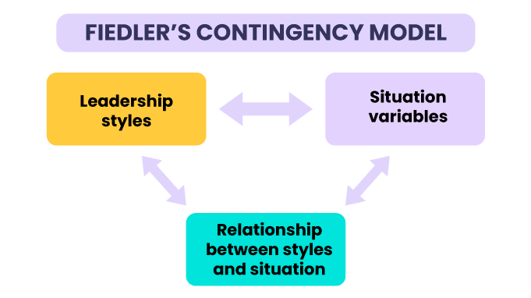

**Appendix 2: Maslow’s Hierarchy of Needs**

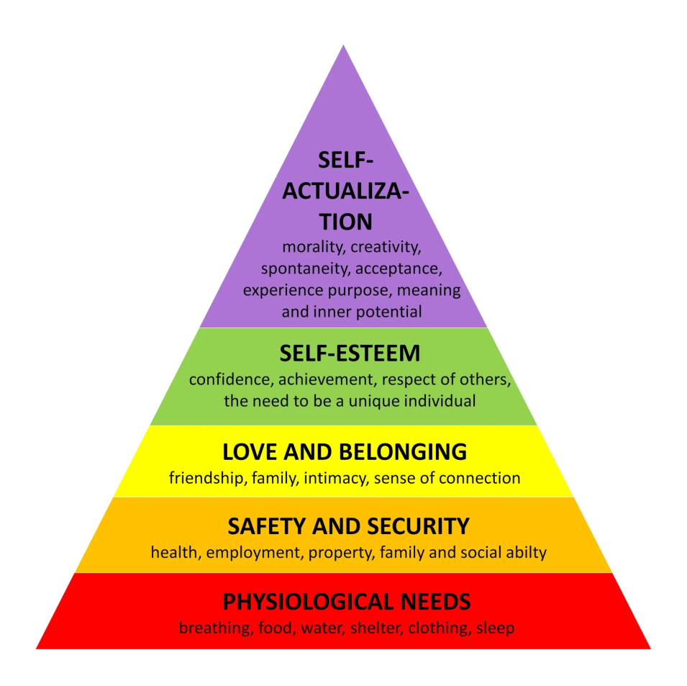

**Appendix 3: Herzberg's Two-factor Theory**

