|  |
| --- |
| https://lh4.googleusercontent.com/j-O-W-qRUpPNlYz1YOKXvk96kB20lOxFKKnI0S7wPanisfapC6qSbsszm6bk_gVU_Pl2NcO-o7tR39B-9F-fUqD7UTu08YNwce-CCG9tRWuobD8NMNV9iL8qJQvVXLQ7DnbU3cdeGqR7SIBAcwnXhTIeaNZVXJ6PynyFYpD_8AzV80ZkCMA2FVsE8qVwkUIAvdbvn1WBFg |
| https://lh4.googleusercontent.com/Uma9BNkdB4a9zjGCvlQE4-9AQ_0N4SW_x_AKAa9rf7iW1n8aZVf3fReq1MRPmL2TQxX3xLjkdxW-ZxFVBZuJUX9_ZaERn2rez2ePMCeWid7BVRFNg6tIrBeRspxftBcaX8mCpyphYfmpi3OAEF5-K-TfIgYtQVWwkdKbd1x3Z-HBI2k31J2L-tOHq7P8__PAX6Sbjt65oQ |
| https://lh3.googleusercontent.com/8O-66cL8kuvfMP1_ZGRTNlO1IDS2NTCe5fd2tPMPxLoEudtZU0fAFcFhiIXxTOJWMnTLXmqelvb9KNfJa4ljl8ZKR_1nI3szQNNR7R1dywndoFp5JbyTrTgEIdtcjgi5gkZljnQ0efqWmOgo_3JILqsnVP1LoTfOsOd0iqkhWvn3jp5yvMyW23eyRug2WVlY9suA8fp_gw |
| https://lh6.googleusercontent.com/i6tIRIQItteKKd0TqOkzS9lWRQE_XZkfQ1Xa3vy3V3ySW5q_rkkdf27cAWPvbeeLboFnVg7quXSx63LT9eQk0TkaMtm1x_1Zp2N2K3g3yJvGqT8ozylmGFPcnjB89boyzvk4kDjdACd7_itpl7_Copabyj3_Fg5x-clOtohDsOT05euv3u9q3A2qjEk8vHyvV_4T0GzHDA **DATA VISUALISATION AND INTERPRETATION** |
| https://lh3.googleusercontent.com/rDqNW4NsesPYNr9Ft47pppo_t8QcYWfpebLa58zCkKKpfuRPYNZH7cTmMN_aN7tOZ8YpJ2sC80U3qn2nkrhDUuZjKRNc-QbFyDZnxL-fiPrKq7FZEOETCH4Fcy_6APvM5QVGTI3aiekfjPI2neDOV9gChRA5G7TiJyyHhHNivwde_hdvGXbiXvYTY6ANcGV_6yQ8TISIDg |
| https://lh5.googleusercontent.com/aJUNs1e5J3OIojJazRT8I-mC2GThCTxWRxr3luqG94vzS1ZCexadoCfHbt6USQJ9AErOwZRpYVGi6UnOQAPY3o7-XaoS2_5pWvCFA2EzKW7oAHnMjh1jiW8HBkXaSaFt-YaZWH5qTLEnjymBACIzSHE9osXjngNY7ciS5MGKwQcv-D5T5tZrLltkJCymtZSIg4M0R9m-Eg |
| https://lh3.googleusercontent.com/gIMR_n25I-64BSymBnWq2JjWlxY3qr3MfG5Ic1hRinLZf-RtX3JCbzUKNRROQmE74WOoNGMRZLariqWL6RF1fuFrUirZZS6x8d8HX1roXxpmr142st7VBccoBXpY3-3YBki1GBCnRZ6tmHBbvGNsX-ikiZb2nYNVdXve5sqST3hrHrzuLE_Fod-dzT1CrnSptTkHunmOIg 1500  https://lh5.googleusercontent.com/UhNVF6LsvdesxR1VDN7vTpEO6DlzaupQ8BeO26PlwWmywzkG6CSmaCUj5rCPTSOstDMYltqrYrYiO6ulN9q2YrjigedsWrG5dfd1BzX0_R5377yysUaNF_yYDwlht4mk-D3c2Jpvw981sc-qKnG_wXSWVzqd2n2CmjJjcKChzRzzR4yzdk5X1HETh4RGu2vUeLqRyjUIZQ |

**DATA VISUALISATION AND INTERPRETATION**

Table of Contents

Introduction 4

Discussion 4

Assessment of Data Visualisation Method in the Context of Email Usage 4

Effectiveness of Data Visualisation Choices 7

Findings from data visualisation 7

Conclusion 9

References 11

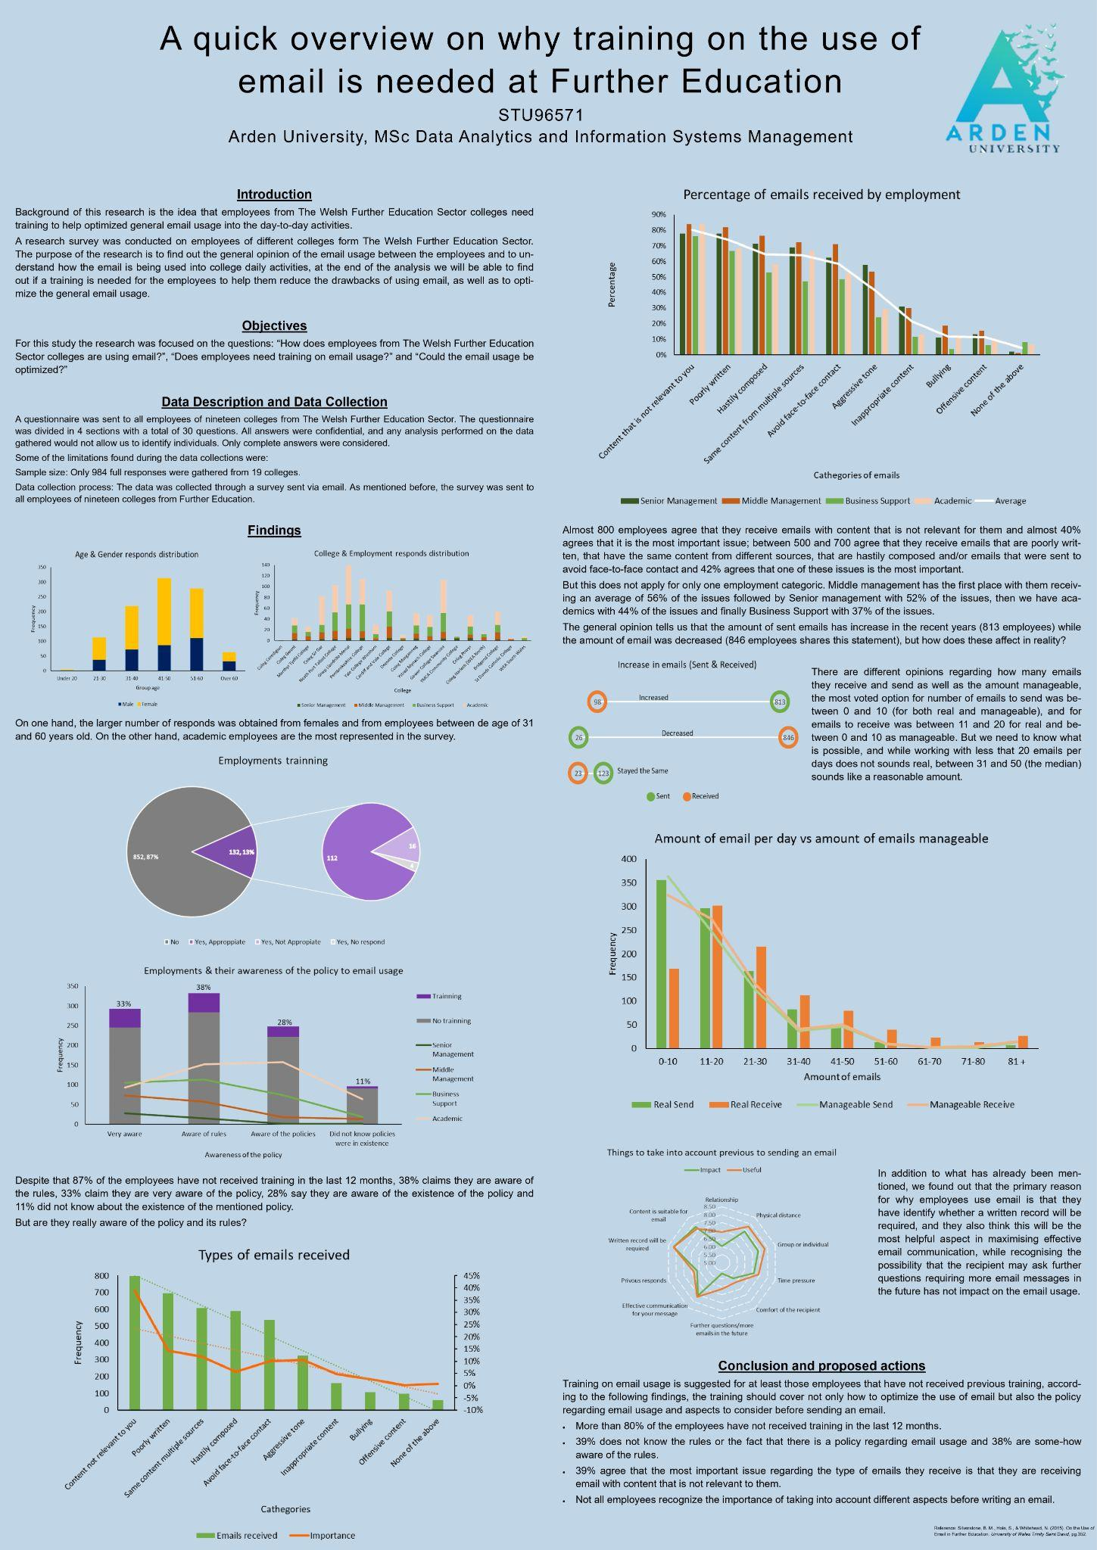

**Figure 1: Data Visualisation on the use of email is required in further education**

(Source: Poster)

# Introduction

The purpose of this report is to evaluate the data visualisation methods in terms of data presentation in a particular context. Data visualisation consists of a graphical representation of information that presents data as a graphic or image. Hence, it is more convenient to find patterns and recognise tough concepts. Common data visualisation methods are useful to bring in the advantages of data-driven decision-making. There are multiple advantages of data visualisation technologies such as it supports individuals' view, interact with and better recognise information. In this report, data visualisation on email usage for further education has been analysed with the assessment of data visualisation and its effectiveness in the Welsh Further Education Sector colleges. The correct visualisation can bring all to the same area, regardless of their experience whether complex or simple. The methods used in further education for data communication with the use of email have been evaluated to find the reason why training on email usage is required in further education.

# Discussion

## Assessment of Data Visualisation Method in the Context of Email Usage

Data visualisation helps in representing data and information in a graphical form. As commented by He *et al*. (2019), data visualisation tools like graphs and charts offer an accessible path to view and recognise patterns, outliers and trends in information. Colours and patterns easily draw human attraction for which data visualisation becomes successful to discover data with presentable outcomes. According to the data visualisation given in Figure 1, it can be found that the findings of collected data have been presented in data visualisation methods such as Bar graphs and Pie Charts. Data visualisation is a component of multiple business intelligence instruments and solutions to advanced analytics. On the other hand, Nusrat *et al.* (2019) argued that data visualisation supports businesses in making sense of all the data, or information, created today. In addition, data visualisation on further use of email drives a positive impact on the organisation.

Strong visualisation of data is necessary to analyse data and decision-making on the basis of collected data. In the given context in the poster, the study was focused on how The Welsh Further Education Sector college employees are using email. Hence, the researchers used a questionnaire to collect data from all workers of nineteen colleges in The Welsh Further Education Sector. The result in a visualised form lets researchers see and understand relationships and patterns easily and quickly. However, Rahman *et al*. (2020) cited that visualising data allows individuals to spot emerging trends that might proceed with just a spreadsheet or table of raw numerical data. On the other hand, specialised training is not needed for interpreting what is presented in the images, activating the usual knowledge in most cases.

Employees who use email tend to save the overwhelming weight of messages they get. As stated by Kim *et al*. (2021), email storage and retrieval have been found by researchers as two of the key uses of this visual communication technology. However, it is important to use email in further education. Furthermore, focusing on data communication insights helps evaluate the data visualisation methods in terms of data presentation in the context of email usage in the Further Education sector. Here are some individual data visualisations represented in different forms:

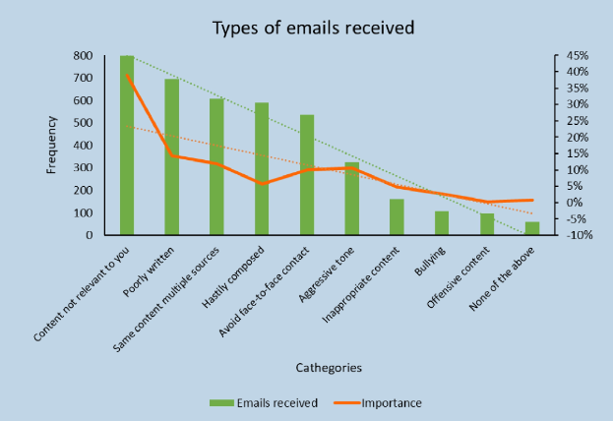

**Figure 2: A Bar Graph indicating the types of emails received**

(Source: Poster)

The above figure displays a bar graph that creates a visual form of the number of emails received in the data collection process. This data visualisation form simplifies data comparison on importance and email received. However, as argued by Lowe and Matthee (2020), it does not display the interconnections between the key factors like received email and importance.

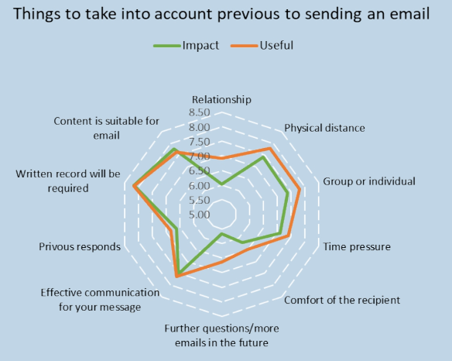

**Figure 3: A Radial Chart indicating the things taken into account before sending an email**

(Source: Poster)

The above figure displays a radial chart that shows the data on various things required to take into account before sending an email. This radial diagram covers the pattern of email taken into consideration with the comparison of multiple data sets on impacts over time (Waldner *et al*. 2019). On the other hand, it is identified that this data visualisation form only works for variable data on the impact of email usage allocated for a data axis.

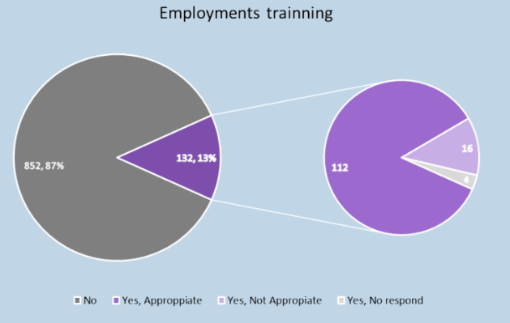

**Figure 4: Pie Charts representing the number of employees training**

(Source: Poster)

The above figure shows pie charts that show the data collected on employment training. These pie charts cover the data visually as a fractional segment of overall employment training that allows people to see the data comparison at a glance. However, the series of data for comparing multiple sets lacks in this pie chart for which it only displays a single data set on employment training.

## Effectiveness of Data Visualisation Choices

Besides, visualisation communication becomes interested in the proposal of discovering the opportunities and email archives they offer for the visual explorer of patterns. Hence, most of the research done on data visualisation techniques through email comes under four key categories such as:

* Contact-based Visualisations
* Temporal Visualisations
* Social-network visualisations
* Thread-based visualisations

Most tools used for data visualisation can connect data sources such as relational datasets. However, Menges *et al.* (2020) claimed that collected data, which may be stored in the cloud on-premises, has been retrieved to generate the graphical form of data, also known as Data Visualisation. Users choose the best technique for presenting the information from different options and some instruments offer display suggestions based on data type presented automatically.

Graphical tools such as pie charts and bars are useful to generate visual data collected from the responses to the questionnaire. Business analysts have to assess and choose the best data visualisation instrument for communicating the major data finding to decision-makers with high visual and effective storytelling methods. However, as claimed by Andrienko *et al*. (2020), the end objective of clear data communication insights is essential for decision-makers when assessing data visualisation tools for a project. Therefore, accurate data measurement in visualisation tools assesses the effectiveness of data visualisation in email.

## Findings from data visualisation

The results generated from the research on why training on email usage is required at Welsh Further Education provide a graphical representation by curating data which is easier to recognize. All the generated graphs included in the poster are part of the findings on email usage in the Welsh Further Education Sectors colleges.

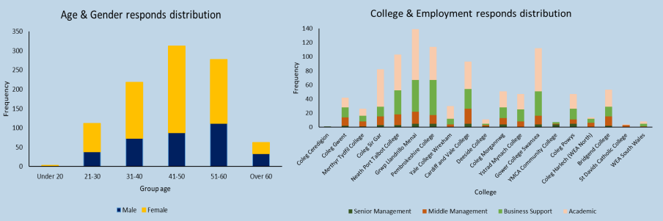

**Figure 5: Responses on Age, Gender, College and Employment**

(Source: Poster)

The above figure consists of two individual bar graphs that show the responses on College and Employment, and Age and Gender individually. According to the above data visualisation through a bar graph, it can be found that the age group of 41-50 are the largest users of email in the further education sector. The over-60 age group has a minimum frequency of email usage. However, the most represented employment responses come from academic employees in the survey for which they require email usage in Further Education.

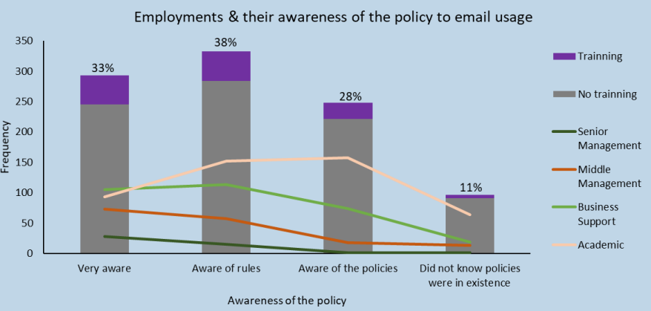

**Figure 6: Employment and their awareness of the email usage policy**

(Source: Poster)

The above data visualisation through a line bar graph represents the interconnection between email usage frequency and policy awareness of employees in the Further Education sector. However, Dwyer *et al*. (2020) claimed that edge routing approaches in bar graphs provide a stable layout in data visualization. 38% of employees claim that they are aware of the email usage policy among 87% of employees have not gotten training in the last year. On the other hand, 28% of employees are aware of the policy's existence and the rest of them did not know about the email usage policy.

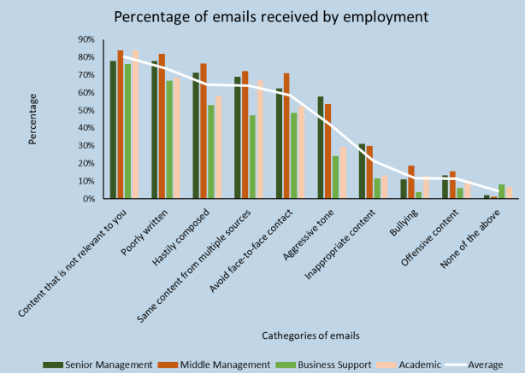

**Figure 7: Received Email Percentage**

(Source: Poster)

The above figure shows a detailed bar graph on the percentage of emails received by employment. According to the above bar graph, it can be found that 40% of employees agree that they get mail with relevant content and 800 employees receive irrelevant content mail. As stated by Satriadi *et al.* (2021), bar graphs show every data while distributing frequency. However, middle management led the position receiving 56% of the issues followed by senior management with an average of 52% issues. Hence, the general opinion helps in getting the amount of sent emails has grown recently and most of those emails are not relevant to the employees.

# Conclusion

It can be concluded that data visualisation is useful for data representation in a graphical format. According to the data visualisations given in the poster, various data on employment and email usage have been shown in the pie chart, bar graph and radial chart format. It can be found that strong data visualisation is essential for analysing data as well as decision-making based on the collected data. The results displayed in the bar graphs and pie charts are the visualised forms that allow individuals to see and recognise patterns and connections easily. The bar graph simplifies comparisons of data on considerable factors, whereas the radial diagram covered the pattern of data with the differentiation of multiple data. Moreover, pie charts are useful to represent a fractional part of overall data that lets people view the overall data comparison. Selecting the best data technique to present data from various options evaluates the effectiveness of data visualisation.

# References

Andrienko, G., Andrienko, N., Drucker, S., Fekete, J. D., Fisher, D., Idreos, S., ... and Sharaf, M. (2020, March). Big data visualisation and analytics: Future research challenges and emerging applications. In *BigVis 2020-3rd International Workshop on Big Data Visual Exploration and Analytics*. Available from: https://inria.hal.science/hal-02568845/document [Accessed 26th May 2023]

Dwyer, T., Cordeil, M., Czauderna, T., Haghighi, P.D., Ens, B., Goodwin, S., Jenny, B., Marriott, K. and Wybrow, M., (2020). The data visualisation and immersive analytics research lab at Monash University. *Visual Informatics*, *4*(4), pp.41-49. Available from: https://www.sciencedirect.com/science/article/pii/S2468502X2030067X [Accessed 26th May 2023]

He, J., Chen, H., Chen, Y, Tang, X, en zou Y. (2019). Diverse visualisation techniques and methods of moving-object-trajectory data: A review. *ISPRS International Journal of Geo-Information*, *8*(2), p.63. Available from: https://www.mdpi.com/2220-9964/8/2/63/pdf [Accessed 26th May 2023]

Kim, J. Y., Calvo, R. A., Enfield, N. J., and Yacef, K. (2021, October).A Systematic Review on Dyadic Conversation Visualisations.In *Companion Publication of the 2021 International Conference on Multimodal Interaction* (pp. 137-147). Available from: https://dl.acm.org/doi/abs/10.1145/3461615.3485396 [Accessed 26th May 2023]

Lensen, A., Xue, B., and Zhang, M. (2020).Genetic programming for evolving a front of interpretable models for data visualisation.*IEEE transactions on cybernetics*, *51*(11), pp.5468-5482. Available from: https://arxiv.org/pdf/2001.09578 [Accessed 26th May 2023]

Lowe, J., and Matthee, M. (2020). Requirements of data visualisation tools to analyse big data: A structured literature review. In *Responsible Design, Implementation and Use of Information and Communication Technology: 19th IFIP WG 6.11 Conference on e-Business, e-Services, and e-Society, I3E 2020, Skukuza, South Africa, April 6–8, 2020, Proceedings, Part I 19* (pp. 469-480). Springer International Publishing. Available from: https://link.springer.com/chapter/10.1007/978-3-030-44999-5_39 [Accessed 26th May 2023]

Menges, R., Kramer, S., Hill, S., Nisslmueller, M., Kumar, C., and Staab, S. (2020, June). A visualization tool for eye tracking data analysis in the web.In *ACM Symposium on Eye Tracking Research and Applications* (pp. 1-5). Available from: https://www.researchgate.net/profile/Marius-Nisslmueller/publication/341905102_A_Visualization_Tool_for_Eye_Tracking_Data_Analysis_in_the_Web/links/ [Accessed 26th May 2023]

Nusrat, S., Harbig, T., and Gehlenborg, N. (2019, June).Tasks, techniques, and tools for genomic data visualisation.In *Computer Graphics Forum* (Vol. 38, No. 3, pp. 781-805). Available from: https://onlinelibrary.wiley.com/doi/pdfdirect/10.1111/cgf.13727 [Accessed 26th May 2023]

Rahman, Y., Asish, S. M., Fisher, N. P., Bruce, E. C., Kulshreshth, A. K., and Borst, C. W. (2020, March). Exploring eye gaze visualisation techniques for identifying distracted students in educational VR.In *2020 IEEE Conference on Virtual Reality and 3D User Interfaces (VR)* (pp. 868-877).IEEE. Available from: https://par.nsf.gov/servlets/purl/10168890 [Accessed 26th May 2023]

Satriadi, K.A., Ens, B., Czauderna, T., Cordeil, M. and Jenny, B., 2021, May. Quantitative data visualisation on virtual globes. In *Proceedings of the 2021 CHI Conference on Human Factors in Computing Systems* (pp. 1-14). Available from: https://www.researchgate.net/profile/Kadek-Satriadi-2/publication/348706131_Quantitative_Data_Visualisation_on_Virtual_Globes/links/600c1275a6fdccdcb873728a/Quantitative-Data-Visualisation-on-Virtual-Globes.pdf [Accessed 26th May 2023]

Waldner, M., Diehl, A., Gračanin, D., Splechta, R., Delrieux, C., and Matković, K. (2019).A comparison of radial and linear charts for visualising daily patterns.*IEEE transactions on Visualisation and computer graphics*, *26*(1), pp.1033-1042. Available from: https://ieeexplore.ieee.org/abstract/document/8807238/ [Accessed 26th May 2023]