**WOMEN PILOTS IN THE AVIATION INDUSTRY**

Table of Contents

1. Introduction 3

1.1 Background and Rationale of the Research 3

1.2 Aim and Objectives of the Research 3

1.2.1 Aim 3

1.2.2 Objectives 3

1.3 Research Questions 4

1.4 Theoretical Model 4

1.4.1 Gender role theory 4

1.4.2 Stereotype threat 4

1.4.3 Intersectionality 4

1.5 Proposed research structure 5

2. Literature Review 6

2.1 Introduction 6

2.2 Investigation of the process involved in the pilot training of the women 6

2.3 Identification of the major challenges faced by the women during their training 6

2.4 Perspectives of the Men towards the pilot training of Women 7

2.5 Identification of the gender stereotypes and gender-based biases within the aviation Industry 7

2.6 Literature Gap 8

2.7 Conceptual Framework 8

2.8 Summary 9

3. Methodology 10

3.1 Research Philosophy 10

3.2 Research Paradigm 10

3.3 Sampling strategy 11

3.4 Research Data Collection 11

3.5 Data Analysis 12

3.6 Ethical consideration 12

4. Contingency plan 13

4.1 Factors affecting the lifecycle of research 13

4.2 Gantt Chart 13

4.3 Contingency plan 14

5. Conclusion 15

6. References 16

# 1. Introduction

## 1.1 Background and Rationale of the Research

Pilot training programs consist of rigorous physical activities and skill development procedures that are essential for developing an individual to become a professional pilot. In the aviation industry, gender equality has been promoted significantly which has led to an increasing number of women being invited to join pilot training programs. However, due to the complexity of the training activities, women face challenges significant challenges during their training period as well as pursuing a career in the industry. According to the International Federation of Airline Pilots (IFALPA), there were 185,143 pilots across the globe of which only 9,746 were women. Women pilots in the whole aviation industry make up only 5.26% and only 1.42% of women are captains (IFALPA Report, 2021). This portrays the level of implementation of diversity and inclusivity in the industry. The training program consists of both theoretical and physical components that are necessary for the comprehensive development of an individual to become a pilot.

## 1.2 Aim and Objectives of the Research

### 1.2.1 Aim

To investigate pilot training procedures for women and the difficulties faced by them during training along with highlighting the perspective of men

### 1.2.2 Objectives

* To investigate the procedures involved in pilot training for women pilots.
* To identify challenges faced by women during pilot training procedures in terms of both physical activities.
* To explore the perspective of men in the aviation industry regarding pilot training for women
* To identify gender stereotypes and gender-based biases prevalent in the aviation industry.

## 1.3 Research Questions

What are the training procedures involved in women pilots in the aviation industry?

What are the challenges faced by women during pilot training procedures in terms of both physical activities?

How do men perceive pilot training for women in the aviation industry?

Why do women pilots deal with stereotypes in the aviation industry?

## 1.4 Theoretical Model

### 1.4.1 Gender role theory

Gender roles in society or in a particular environment are a result of the expectations possessed by individuals present there. Gender roles are decided on the basis of the sex of an individual and the societal beliefs which influence the behaviour of an individual belonging to a certain gender (Ferla and Graham, 2019). This theory also highlights the contribution of the difficulties faced by women during pilot training due to the stereotypes and gender biases present in the industry.

### 1.4.2 Stereotype threat

It is the situational predicament that leads to individuals experiencing negative stereotypes associated with a particular social group (Liu *et al.,* 2021). In the aviation industry, women pilots may face stereotypes due to their belonging to a particular gender and misjudge on the basis of that. This may negatively impact their performance as well as their self-confidence in the industry.

### 1.4.3 Intersectionality

This particular theory emphasize is on the presence of individuals belonging to different gender, race and other characteristics of Social Identity (Couto *et al.*, 2019). In case these identities intersect in an industry, it leads to the individuals present in the industry experiencing unique challenges and difficulties. In the aviation industry as well, that theory acknowledges the intersecting factors that cause a significant disbalance in the power dynamics during pilot training.

## 1.5 Proposed research structure

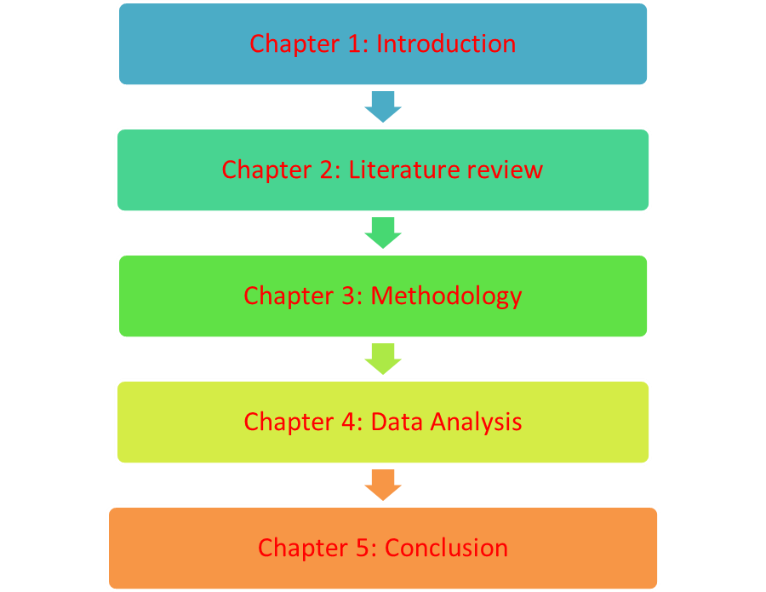

**Figure 1: Research Structure**

(Source: Self-created)

# 2. Literature Review

## 2.1 Introduction

The concerned section of the literature review reflects the various information in terms of secondary data that has been made by the researchers within their own work. In this respect, it can be stated that the previously made research papers are analysed over here. Apart from that, a literature gap has been identified here in terms of indicating the loophole that is present within the literature review. After that, a conceptual framework has been made in order to reflect the contents in a graphical presentation over here.

## 2.2 Investigation of the process involved in the pilot training of the women

According to Smith (2023), the process of pilot training for women is the same as that for males. In this respect, both the male and female candidates are required to invest about £700,000 to £13,000 in terms of receiving the pilot training. The amount varies from institute to institute all across the UK. Apart from that, the minimum and maximum age limit for enrolling in the pilot training programs are 18 and 21 respectively for both males and females subsequently. This indicates that the training of the pilots starts at a very young age within the UK. Whereas on the other hand, CAE is providing a standard level of scholarship for women who are eager to obtain training in pilots to pursue their careers within the aviation industry *Inspiring Women to fly* (2022). The decision was made in July 2022 wherein the women segment was provided with the scholarship programs in terms of getting the training of pilots. The training is to be provided in collaboration with the easyJet at a minimum charge to support the women in their careers. With respect to this, it can be stated that the UK government has major support for the growth and development of pilot training for women who are interested in the aviation industry at the present time.

## 2.3 Identification of the major challenges faced by the women during their training

As per the *Challenges faced by women pilots (*2023), female pilots are observed to have more challenges during the tenure of their training as compared to that of the other pilots. The major reason is ascertained to be the lack of female coaches within the UK in terms of providing training to the women pilots. Apparently, the women pilots are having a major issue in terms of psychological burden towards their achievements. This indicates that women pilots in the UK are having major challenges in terms of their pilot training programs as a result of which they are not able to perform better in their respective fields. Whereas, on the other hand, the training that is provided to the pilots are same for both the male and female candidates and is not being treated in a different manner. The trainers of the pilots are also observed to be treating all the candidates in the same manner on the basis of the qualities that they are having within themselves. This indicates the fair and the systematic training aspects that are provided to the pilots throughout their duration of the same. Moreover, the rules and regulations are also the same for all the gender groups in the UK.

## 2.4 Perspectives of the Men towards the pilot training of Women

According to Norman (2021), the perspectives of men are not in favour of the women pilots from the ancient time. At the present time also their men are having a point of view that the women pilots are not proficient enough in the aviation industry towards their career. In simple words, it can be stated that according to the point of view of the men the women are not able to deliver a better result in the aviation industry as compared to them. For this reason, there is less scope for the women in this particular field. Moreover, according to Yanıkoğlu (2020), the women gender group are considered to be the face of the aviation industry at the present time. There is a wide increment in the number of female pilots as compared to the men's gender groups at the present time. Apart from this, the women are also able to deliver a better results as compared to the male pilots within the aviation industry at the present time. For this reason, there is an increment in the number of female pilots as compared to that of the past few decades. This indicates that the scope of the pilot is increasing for the women gender groups as compared to that of the men and they are also supporting this particular change within the society.

## 2.5 Identification of the gender stereotypes and gender-based biases within the aviation Industry

According to Ferla (2019), there is a lack of female role models within the aviation industry for which there is a lack of role model for which the women gender groups are not having an adequate level of support and passion towards the aviation industry. Apart from that lack of support is also restricting the women gender groups towards having a career within the aviation industry. This indicates that there is a presence of gender stereotypes within the society that is having a negative impact on the growth of the aviation sector in terms of accommodating the female gender group. Whereas, on the other hand at the present time there is a huge change within the society towards accepting the women gender group within the aviation industry. The core reason behind this aspect is just that the women at the present time are more confident about their careers and choices as compared to what they were having in the past few decades.

## 2.6 Literature Gap

Literature reviews are interpreted in order to ascertain the loophole that is existing within a particular literature review. In accordance with this, it can be ascertained that the concerned literature review is also having a loophole in terms of the consideration of the articles and journals. In a broader sense, it can be stated that the concerned literature review is having a minimum of information as a limited number of resources has been evaluated over here due to lack of time. In terms of evaluating the gap in the literature, the upcoming research will be acquiring a broader piece of information.

## 2.7 Conceptual Framework

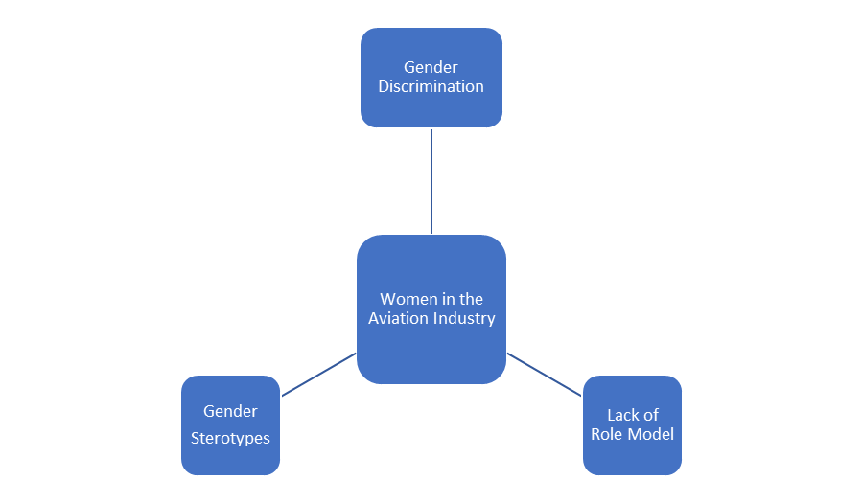

**Figure 2: Conceptual Framework**

(Source: Self-created)

## 2.8 Summary

The literature review has covered a wide range of information in terms of analysing the various articles and journals from different segments. Moreover, a literature gap has also been identified that is to be mitigated in the upcoming research paper. Apart from this, a conceptual framework has also been made in order to indicate dependent and independent variables present within the literature.

# 3. Methodology

## 3.1 Research Philosophy

The research philosophy is considered to be the set of beliefs that determines the overall strategy that is followed throughout a particular research paper (Alharahsheh, 2020). As per this, it can be indicated that the research philosophy is an assumption that is to be made for particular research. With respect to this, for the concerned research, the positivist research philosophy is to be proposed here for consideration. The main perspective of using this particular philosophy is just that it covers a wide piece of information in a short period of time and also without any issues. Apparently, for this particular research, it will provide a wide piece of information in a short period of time. It will also make the data collection process much easier for the researchers.

## 3.2 Research Paradigm

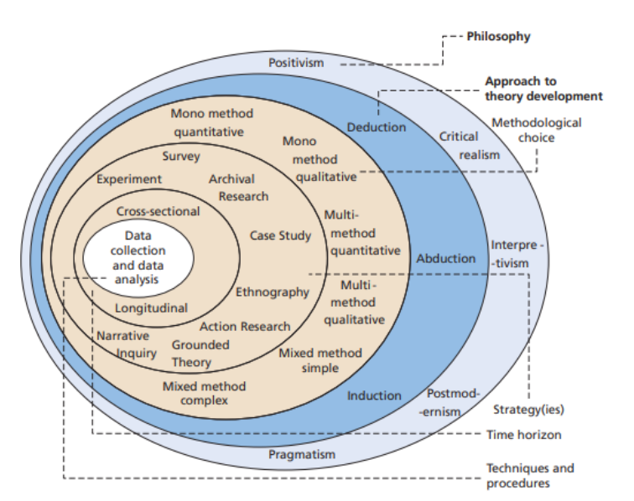

**Figure No 3: Saunders Research Onion**

(Source: Saunders *et al.,* 2007)

In terms of the consideration of the research paradigm, it can be stated that the Saunders research Onion is to be followed in the research in order to identify the different tools and techniques that will be used in the process of the data collection. As per the figure indicated above that is figure No 3 indicates the different layers of the Saunders Research Onion that is to be interpreted within the proposed paper of the research. The Saunders Research Onion is the simplest form of a research paradigm that reflects the major tools and tools involved in the research. The main strategy for choosing this paradigm is to reflect the different methodological tools in a simple format.

## 3.3 Sampling strategy

The random sampling strategy is to be used in order to conduct the primary research over here. Apparently, the sample size that is to be chosen here is about 3 women pilots from the aviation industry. The reason behind choosing the sample from the aviation industry is to ensure that a clear reflection is made in terms of acquiring the data for the research. Moreover, a small sample size has been ascertained in order to make the process of data collection relatively simple and easier for an individual. With respect to this, it can be stated that it will be easier to conduct the interview with such a minimum number of respondents.

## 3.4 Research Data Collection

The primary data collection process is to be proposed for the concerned research paper by means of considering the principle aim and objectives of the same. The main perspective of using the primary source of data in the research is to deliver an accurate result towards the same. The primary data is associated with analysing the present scenario of a particular phenomenon (Fainshmidt, 2020). As a result of this, the concerned research will also be able to deal with the present reflection of the challenges that are faced by women pilots within the aviation industry.

## 3.5 Data Analysis

In order to provide the required data for the research qualitative data are to be used for indicating the results that have been made in terms of conducting the interview for the research. The qualitative method of data analysis involves the interpretation of the non-numerical values that are being generated within a particular primary data (Toyon, 2023). Apart from this, it also helps towards making an easy comparison towards the different aspects that are involved within a particular research paper. Considering this, it can be stated that for the concerned research, the qualitative data will help towards delivering accurate numerical data and an easy comparison towards the different perspectives involved within the same.

## 3.6 Ethical consideration

The research is proposed to maintain some of the major ethical principles right from the beginning towards the end of the same. With respect to this, it can be stated that full consent is to be taken from the participants in order to take the interview from them. In simple words, it can be stated that none of the candidates will be forced to participate in the interview research. Moreover, the candidates will not be having any restrictions towards answering the questions of the interview. This indicates that the research will be having an adequate strategy towards the autonomy of the respondents that are participating in the interview. Apart from this, the research will also be maintaining an adequate level of privacy towards the personal data of the research. For this purpose, the research will be conducted in terms of following the Data Protection Act (2028) in order to maintain a standard level of safety standards for the personal pieces of information of the respondents (Li, 2021). As per this, it can be stated that the research will be conducted in terms of maintaining a wide range of ethical principles which delivers an adequate level of safety and security towards the participants that are responding to the interview.

# 4. Contingency plan

## 4.1 Factors affecting the lifecycle of research

The major factor that is having a chance to affect the lifecycle of the project is the nature of the study that an individual is having within themselves. Different people are having different perspectives about a particular topic. Apparently, it is complicated to deal with the variation in the point of view of different people. With respect to this, it can be stated that the nature of the study that an individual is following creates an issue towards the lifecycle of the concerned research paper. Moreover, the inaccessibility of the data can also affect the lifecycle of a project. In simple words, it can be stated that there is a higher chance that the researcher will not be able to acquire the required piece of data in order to interpret the entire research paper. Considering this, it can be stated that not having an adequate access to the data sets can also affect the lifecycle of the concerned research paper.

## 4.2 Gantt Chart

|  |  |  |  |  |  |  |
| --- | --- | --- | --- | --- | --- | --- |
| **Weeks/ Tasks** | **Week: 1** | **Week: 2** | **Week: 3** | **Week: 4** | **Week: 5** | **Week: 6** |
| **Introduction** |  |  |  |  |  |  |
| **Literature Review** |  |  |  |  |  |  |
| **Methodology** |  |  |  |  |  |  |
| **Data Findings** |  |  |  |  |  |  |
| **Conclusion** |  |  |  |  |  |  |
| **Submission** |  |  |  |  |  |  |

**Table No 1: Gantt Chart**

(Source: Created by self)

## 4.3 Contingency plan

In order to mitigate the issues identified above it can be ascertained that the process of the data collection is extended for about two weeks in the research. The main reason behind this aspect is just to deliver a better dataset in terms of the data collection methods. The research is associated with conducting primary research by means of interviews. In this respect, it can be stated that the time taken for the data collection will be for two weeks in order to understand the point of view of the participants more accurately for deploying an in-depth understanding of the research.

# 5. Conclusion

The proposal has indicated all the necessary aspects that are proposed to be interpreted within the research paper about the women pilots within the aviation industry at the present time. With respect to this, first of all, an introduction has been made in terms of identifying the rationale behind conducting the research. The introduction has also drawn the principle aim and objectives of the research that is setting the goal to be achieved by the same. Moving forward, a literature review has been made that reflects the perspectives that have been drawn by some of the researchers within their own research papers. After that, the various tools and techniques have been identified in terms of the research methodology that is proposed to be used for acquiring the datasets for the research. In this section of the proposal, the major ethical considerations have also been evaluated that will be followed throughout the entire research paper. Further, in the last the contingency plan has been made that has reflected the major factors that may affect the lifecycle of the entire research. Apart from that, a Gantt chart has also been drawn in order to indicate a tabular presentation of the time that will be taken to complete the research paper.

# 6. References

Alharahsheh, H.H. and Pius, A., 2020. A review of key paradigms: Positivism VS interpretivism. Global Academic Journal of Humanities and Social Sciences, 2(3), pp.39-43.

Challenges faced by women pilots - ISA+21: International society of ... Available at: https://isa21.org/wp-content/uploads/2020/07/Challenges_Faced_by_Women_Pilots.pdf (Accessed: 29 May 2023).

Couto, M.T., Oliveira, E.D., Separavich, M.A.A. and Luiz, O.D.C., 2019. The feminist perspective of intersectionality in the field of public health: a narrative review of the theoretical-methodological literature. Salud colectiva, 15, p.e1994.

Fainshmidt, S., Witt, M.A., Aguilera, R.V. and Verbeke, A., 2020. The contributions of qualitative comparative analysis (QCA) to international business research. Journal of International Business Studies, 51, pp.455-466.

Ferla, M. and Graham, A., 2019. Women slowly taking off: An investigation into female underrepresentation in commercial aviation. Research in Transportation Business & Management, 31, p.100378.

Ferla, M. and Graham, A., 2019. Women slowly taking off: An investigation into female underrepresentation in commercial aviation. Research in Transportation Business & Management, 31, p.100378.

IFALPA Report, 2021. Available at: https://www.aerosociety.com/news/achieving-flight-training-gender-diversity/#:~:text=According%20to%20the%20International%20Federation,1.42%25

Inspiring women to fly: Cae Launches 2022 women in flight program with EasyJet (no date) CAE. Available at: https://www.cae.com/news-events/press-releases/inspiring-women-to-fly-cae-launches-2022-women-in-flight-program-with-easyjet/ (Accessed: 29 May 2023).

Li, Q., Wen, Z., Wu, Z., Hu, S., Wang, N., Li, Y., Liu, X. and He, B., 2021. A survey on federated learning systems: vision, hype and reality for data privacy and protection. IEEE Transactions on Knowledge and Data Engineering.

Liu, S., Liu, P., Wang, M. and Zhang, B., 2021. Effectiveness of stereotype threat interventions: A meta-analytic review. Journal of Applied Psychology, 106(6), p.921.

Norman, J.E., Lawton, J., Stock, S.J., Siassakos, D., Norrie, J., Hallowell, N., Chowdhry, S., Hart, R.I., Odd, D., Brewin, J. and Culshaw, L., 2021. Qualitative research. In Feasibility and design of a trial regarding the optimal mode of delivery for preterm birth: the CASSAVA multiple methods study. NIHR Journals Library.

Saunders, M., Lewis, P.H.I.L.I.P. and Thornhill, A.D.R.I.A.N., 2007. Research methods. Business Students 4th edition Pearson Education Limited, England, 6(3), pp.1-268.

Smith, W. by J. How to become a pilot in the UK, Prospects.ac.uk. Available at: https://www.prospects.ac.uk/jobs-and-work-experience/job-sectors/transport-and-logistics/how-to-become-a-pilot-in-the-uk (Accessed: 29 May 2023).

Toyon, M.A.S., 2023. Introduction to research: Mastering the basics.

Yanıkoğlu, Ö., Kılıç, S. and Küçükönal, H., 2020. Gender in the cockpit: Challenges faced by female airline pilots. Journal of Air Transport Management, 86, p.101823.