**DATA-DRIVEN DECISIONS FOR BUSINESS**

Table of Contents

Task 1: Introduction 2

Purpose of the report 2

Overall Project Plan 2

Key performance indicators 2

Task 2: Data quality issues along with the remedies 3

Generic Data problems along with the solutions 3

Problems identified in the BIJ datasets 4

Task 3: Data analysis and commentary 5

Data and trends in sales volume and value by month, by year and across the whole analysis period 5

Benchmark comparisons of category performance covering sales volume and value by quarter, by year and across the whole analysis period, 5

Benchmark comparisons of sales volume and value between markets by quarter, 6

Task 4: Data Charting and Commentary 7

Comparison of sales value trends across markets over time 7

Category performance comparisons between markets 8

Impact of the marketing campaign in the UK market itself, and in comparison, with other markets. 9

Task 5: Conclusions and recommendations 10

Conclusion 10

Recommendations 10

References 11

Appendices 12

Appendix No: 1 12

Appendix No: 2 13

Appendix No: 3 14

Appendix No: 4 15

Appendix No: 5 17

Appendix No: 6 17

Appendix No: 7 17

# Task 1: Introduction

## Purpose of the report

The data-driven decisions help in the overall analysis and interpretation of the raw datasets of an organization in terms of taking the most appropriate decisions from the same. With respect to this, the main purpose of the report is to analyse the impact of the marketing campaign on the sales performance within the UK market segment. In this context, first of all, some of the major KPIs of BIJ Internationals will be identified that help in identifying the aggregate level of the production of the same. Followed by this, the data issues will be identified over here that are present within the raw dataset of the company.

## Overall Project Plan

The overall project plan consists of having generic data problems along with solutions that help corrections of the same. After that, the issues in the dataset of the BIJ international will be ascertained over here. Moreover, various tabular presentations will be made in terms of analysing the datasets of the company. In addition to this, the different kinds of charts will be interpreted to have a clear understanding of each of the segments. Further, in the last the conclusion and the recommendation will be made over here in terms of delivering the effectiveness of the campaign.

## Key performance indicators

The key performance indicators of BIJ Internationals are as follows:

* Sales Volume- The sales volume is considered to be one of the basic KPIs of any business in terms of the aggregate turnover of the same (Cristea, 2021). Mostly for any organization a higher sales volume determines a higher level of turnover of the same. For this reason, it is necessary that an organization focus towards increasing the sales volume of a business. In this context, for BIJ Internationals also the sales volume acts as a major KPI towards the measurement of the aggregate turnover of the same.
* Profit Margin- The profit margin reflects the overall amount of income that is generated by an organization over a particular accounting period (Nguyen, 2020). The higher level of profit margin indicates a higher income level of the same making the business more successful and developed. The profit margin is the aggregate level of a sum that is generated by the means of deducting the various cost of expenditure from the revenue of the business. Apparently, for BIJ Internationals also the profit margin acts as an important KPI in terms of determining the business turnover of the same.
* Consumer Demand- The demand for products and services from the customers also acts as a KPI in terms of understanding the turnover of the same (Helmold, 2020). In this respect, it can be stated that the higher the demand for the product and services the higher it reflects the growth rate of the same. With respect to this, BIJ Internationals also consider consumer demand as one of its main KPIs in terms of understanding the business turnover of the same.

# Task 2: Data quality issues along with the remedies

## Generic Data problems along with the solutions

***Problems***

* Data duplication- The duplication of datasets has become a huge issue at the present time (Carlini, 2021). This issue occurs when particular datasets are being downloaded from a certain place. During the time of storing datasets, it has been observed that the actual data are not been downloaded which causes an issue for taking the most appropriate decisions from the same.
* Inadequate data literary skill- An inadequate level of literacy or technical skills can also act as a major issue in terms of generic data (Bergdahl, 2020). With respect to this, in case an individual is not having an adequate level of skill in terms of generic data then he or she will not be able to work with the concerned datasets adequately.
* Storage of the datasets- Data storage causes a huge issue in terms of managing the confidential data of any organization (Tabrizchi, 2020). There is a higher chance of data breach while storing a confidential set of data. In addition to this, storage of the datasets within the hard drives can also have chances of the loss of the entire datasets apparently causing huge damage to a particular organization.

***Solutions***

* Development of adequate level of skill- An adequate level of development of technical skills is necessary to be present within an individual to work with a wide range of datasets (Persaud, 2021). In this respect, it can be stated it is necessary that an individual his or her skills in terms of working with a wider range of data and take the most appropriate decisions from the same without any obstacles.
* Virtual storage of the datasets- The virtual storage system has become quite necessary at the present time. It helps in storing the data in a virtual format in terms of maintaining safety and security. The cloud computing system is one of the most famous strategies for saving data in a virtual format that resolves the issue of storage of data.

## Problems identified in the BIJ datasets

There are basically two types of issues identified within the datasets of BIJ Internationals. They are as follows:

* Out of Control- The datasets of BIJ Internationals are having some major problems that are out of control. As per Appendix no 1, it has been observed that there are some data of the organization wherein the aggregate level of the sales volume is in a negative balance. Whereas, the valuation of the sales can not be made in a negative balance. In addition to this, there is also data for the year 2030 as it has not arrived yet. With respect to this, it can be stated that these are some of the issues that can not be controlled or managed while interrupting.
* Under Control- There are also some data issues that can be changed or managed while interrupting within the Excel sheet. As per Appendix no 1 there are some spelling mistakes within the name of the accessories that are being sold by the company. In addition to this, it has also been observed that there is an issue in terms of the currency symbol of the amount. These are some of the basic issues that can be controlled or managed while interrupting the datasets.

Appendix no 2 reflects the corrected data of BIJ Internationals. A manual correction has been done within the datasets in order to utilise the same in the data analysis. The corrections have been made only over the under-control data that is the spelling and the year mistake.

# Task 3: Data analysis and commentary

## Data and trends in sales volume and value by month, by year and across the whole analysis period

The tabular presentation presented in Table no 3 determines the trend in the aggregate sales volume in terms of the months and year all across the concerned analysis period over here. In this respect, the datasets of BIJ Internationals have been segregated within the concerned months as well as the years reflecting the overall sales performance of the same. It can clearly be observed here that the year 2018 has observed the highest level of sales performance. Whereas, on the other hand, the year 2020 has observed the least sales volume as compared to the other years. Moreover, in the year 2018, the highest sales were made in the first three months. In the year, 2019 the highest sales were made between the fourth to the sixth month of the same. Further, in the year 2020 also the same scenario was observed in terms of generating revenue from the same.

## Benchmark comparisons of category performance covering sales volume and value by quarter, by year and across the whole analysis period,

As per appendix no 4 provided within the report a benchmark comparison is made in terms of each category of women's accessories that are being sold in each of the quarters of the three concerned financial years over here. For the bracelets, it has been observed that the highest number of bracelets were being sold in the year 2020 in the maximum sales were made in the month of July-Sep. On the other hand, the least sales were made in the year 2018. Similarly, in the case of hairbands, the maximum amount of sales was made in the year 2018. A similar scenario has also been observed in the case of the necklace wherein the highest sales were made in the year 2018 and the lowest in the very next financial year of the same. Further, the product ring has also observed similar segregation in terms of the highest and lowest sales volume of the same in which the year 2018 has observed the maximum level of the sales volume of the same.

## Benchmark comparisons of sales volume and value between markets by quarter,

**by year and across the whole analysis period**

Appendix no 5 of the concerned report indicates the benchmark comparison of the sales volume in terms of the market by the quarter over the entire period of analysis. In this tabular presentation, the sales volume of each of the products has been ascertained by the means of segregating them towards the quarter months and the countries. Herein the total sales value, as well as the volume of the same, has been segregated in terms of having a clear understanding of the volume of each of the countries. It can clearly be observed over here that the overall sales volume of Japan is higher over here as compared to the other countries. Further, the lowest level of sales is being generated by the country United Kingdom.

# Task 4: Data Charting and Commentary

## Comparison of sales value trends across markets over time

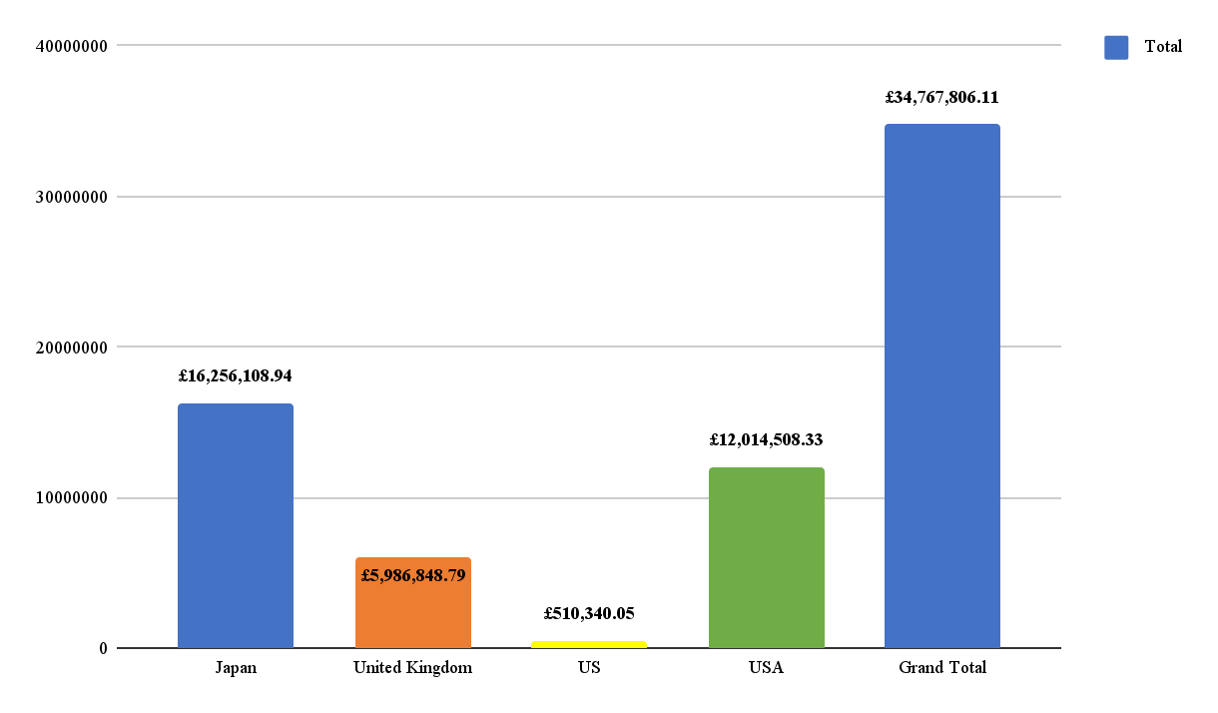

**Figure No 1:**

(Source: created by Self)

The figure presented above determines the comparison in the trend in the overall sales volume across the different market segments over different times. It can clearly be observed here that Japan is having the highest level of sales volume as compared to the other countries. In addition to this, the trend indicates that the UK is having the least volume of sales throughout the entire time period.

## Category performance comparisons between markets

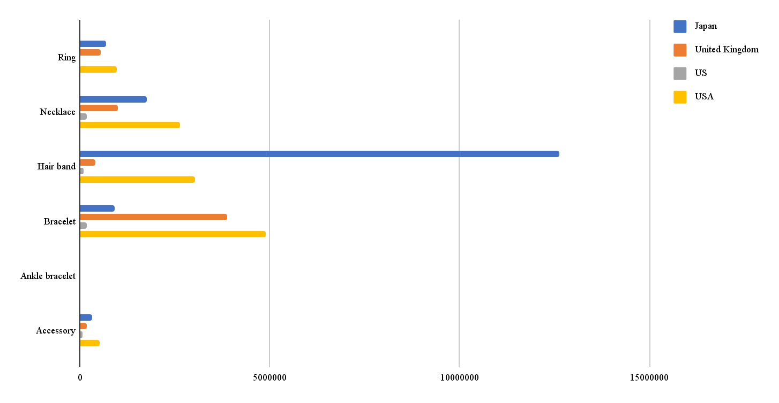

**Figure No 2:**

(Source: created by Self)

The figure presented above that is figure number 2 indicates the graphical presentation of the various women's accessories that are being sold by BIJ Internationals in the concerned countries over the three financial years. Considering this, it can clearly be observed here that the product "hairband" is having a maximum sales volume in all the countries. Whereas, on the other hand, ankle bracelets are having the least sales volume in all the countries over the concerned financial years.

## Impact of the marketing campaign in the UK market itself, and in comparison, with other markets.

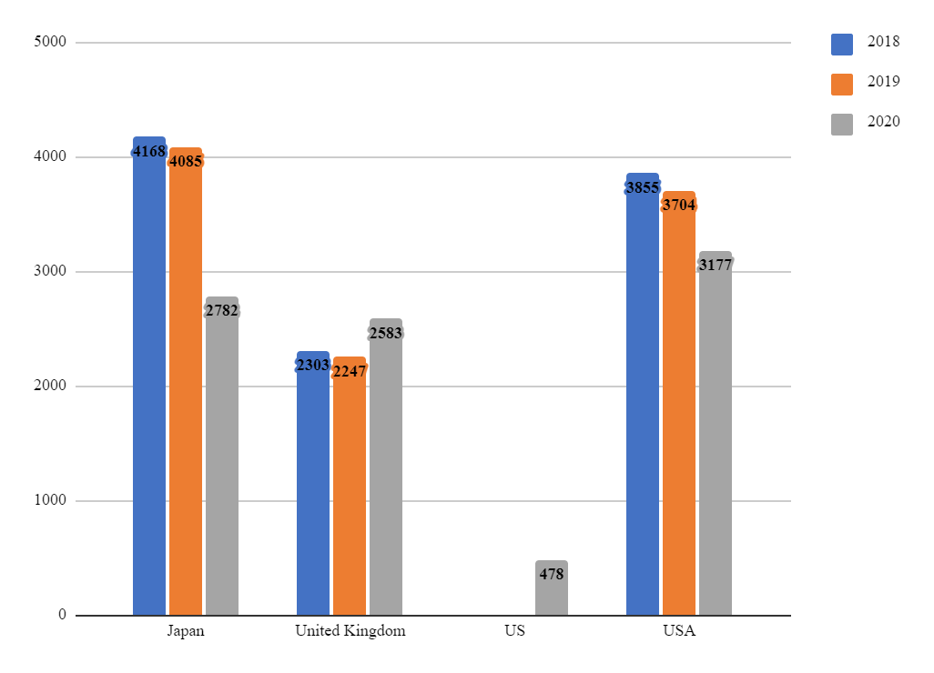

**Figure No 3:**

(Source: created by Self)

From the above figure, that is figure no 3 the graphical presentation of the impact of the marketing campaign can be ascertained within the UK market segment in terms of the comparison with the all the other countries. Apparently, it can be identified over here that the sales performance of the Japan is considered to be the best over here. Further, the overall performance of the campaign within the UK market segment is not so good enough as compared to that of the USA. In this context, it can be stated that Japan is in the first position, the USA is in the second position, and the UK is in the third position in terms of the sales volume generated by the same.

# Task 5: Conclusions and recommendations

## Conclusion

The report has covered a wide range of information in terms of data driven decisions that can be taken by an organization. With respect to this, it can be stated that BIJ Internationals has provided a wide range of data in terms of the different women accessories products that are being sold in the different countries after conducting the campaign. As per the business performance of the BIJ Internationals, it has been observed that the country Japan has observed a highest level of sales in tems of all the products that are being sold by them. In addition to this, it can be stated that the campaign was not having a slight improvement in terms of the sales performance of the UK market segment.

## Recommendations

The following recomendations can be made over here in terms of evaluating the datasets provided by the BIJ Internationals:

* There was a huge issue in terms of evaluating the datasets of the company. In this respect, it can be stated that the company needs to acquire and provide a better datasets that will not be having any issues within the same.
* It has been observed that after the campaign also the overall sales volume of the UK was not at the highest level over here. In this respect, it can be recommended over here that the in order to further enhance the business within the UK market segment BIJ Internationals needs to further enhance their business strategies by the means of considering the requirement of the customers that are belonging towards the UK.

# References

Bergdahl, N., Nouri, J. and Fors, U., 2020. Disengagement, engagement and digital skills in technology-enhanced learning. *Education and information technologies*, *25*, pp.957-983.

Carlini, N., Tramer, F., Wallace, E., Jagielski, M., Herbert-Voss, A., Lee, K., Roberts, A., Brown, T.B., Song, D., Erlingsson, U. and Oprea, A., 2021, August. Extracting Training Data from Large Language Models. In *USENIX Security Symposium* (Vol. 6).

Cristea, C. and Cristea, M., 2021. KPIs for operational performance assessment in flexible packaging industry. *Sustainability*, *13*(6), p.3498.

Helmold, M. and Helmold, M., 2020. *Total revenue management (trm)* (pp. 1-12). Springer International Publishing.

*Information Technology & People*, *34*(1), pp.178-203.Nguyen, T.N.L. and Nguyen, V.C., 2020. The determinants of profitability in listed enterprises: a study from Vietnamese stock exchange. *The Journal of Asian Finance, Economics and Business*, *7*(1), pp.47-58.

Persaud, A., 2021. Key competencies for big data analytics professions: A multimethod study.

Tabrizchi, H. and Kuchaki Rafsanjani, M., 2020. A survey on security challenges in cloud computing: issues, threats, and solutions. *The journal of supercomputing*, *76*(12), pp.9493-9532.

# Appendices

## Appendix No: 1

|  |  |  |  |  |  |  |  |  |
| --- | --- | --- | --- | --- | --- | --- | --- | --- |
| **S.No.** | **MARKET** | **Year** | **Month** | **SUBTYPE** | **Sales Volume** | **Sales Value** | **Corrective action** | **Error found** |
| 1 | USA | 2018 | 1 | Accessory | -1 | -£2,129 | Out of control | Sales cannot be negative |
| 2 | USA | 2019 | 11 | Accessory | -1 | -£1,660 | Out of control | Sales cannot be negative |
| 3 | USA | 2020 | 4 | Bracelet | 153 | -£167,972 | Out of control | Sales cannot be negative |
| 4 | Japan | 2019 | 2 | R+D94ng | 14 | £14,634 | Under control | This seems to be a spelling mistake as it should be 'Ring' and hence this can be corrected |
| 5 | USA | 2020 | 11 | Rng | 12 | £13,409 | Under control | This seems to be a spelling mistake as it should be 'Ring' and hence this could be changed accordingly |
| 6 | USA | 2030 | 11 | Necklace | 26 | £36,247 | Out of control | The year cell shows 2030 however it is not possible as the same did not come yet and hence it cannot be taken into account |
| 7 | US | 2020 | 2 | Bracelet | 212 | USD 214,390 | Under control | The USD value could be converted to GBP |
| 8 | US | 2020 | 2 | Ring | 12 | USD 9,489 | Under control | The USD value could be converted to GBP |
| 9 | US | 2020 | 2 | Necklace | 71 | USD 121,498 | Under control | The USD value could be converted to GBP |
| 10 | US | 2020 | 2 | Accessory | 29 | USD 60,303 | Under control | The USD value could be converted to GBP |
| 11 | US | 2020 | 2 | Hair band | 53 | USD 62,958 | Under control | The USD value could be converted to GBP |
| 12 | USA | 2020 | 3 | Bracelet | 188 | USD 189,640 | Under control | The USD value could be converted to GBP |
| 13 | USA | 2020 | 3 | Ring | 3 | USD 3,848 | Under control | The USD value could be converted to GBP |
| 14 | Japan | 2018 | 4 | Necklce | 7 | £12,601 | Under control | This is a spelling mistake as it is needed to be written as Necklace |

## Appendix No: 2

|  |  |  |  |  |  |  |  |  |
| --- | --- | --- | --- | --- | --- | --- | --- | --- |
|  | Column Labels |  |  |  |  |  |  |  |
|  | 2018 |  | 2019 |  | 2020 |  | Total Sum of Sales Volume | Total Sum of Sales Value |
| Row Labels | Sum of Sales Volume | Sum of Sales Value | Sum of Sales Volume | Sum of Sales Value | Sum of Sales Volume | Sum of Sales Value |  |  |
| 1-3 | 2767 | £3,367,380.05 | 2501 | £2,807,077.07 | 2281 | £2,642,296.55 | 7549 | £8,816,753.67 |
| 4-6 | 2541 | £3,172,820.13 | 2764 | £3,467,680.46 | 2622 | £3,101,031.42 | 7927 | £9,741,532.01 |
| 7-9 | 2665 | £3,179,153.37 | 2745 | £3,190,685.22 | 2515 | £2,898,095.35 | 7925 | £9,267,933.94 |
| 10-12 | 2353 | £2,756,254.48 | 2026 | £2,326,036.38 | 1602 | £1,859,295.63 | 5981 | £6,941,586.49 |
| Grand Total | 10326 | £12,475,608.03 | 10036 | £11,791,479.13 | 9020 | £10,500,718.95 | 29382 | £34,767,806.11 |

## Appendix No: 3

|  |  |  |  |  |  |  |  |  |  |  |  |  |
| --- | --- | --- | --- | --- | --- | --- | --- | --- | --- | --- | --- | --- |
|  | Column Labels |  |  |  |  |  |  |  |  |  |  |  |
|  | Accessory |  | Ankle bracelet |  | Bracelet |  | Hair band |  | Necklace |  | Ring |  |
| Row Labels | Sum of Sales Volume | Sum of Sales Value | Sum of Sales Volume | Sum of Sales Value | Sum of Sales Volume | Sum of Sales Value | Sum of Sales Volume | Sum of Sales Value | Sum of Sales Volume | Sum of Sales Value | Sum of Sales Volume | Sum of Sales Value |
| 2018 | 15 | £21,311.48 | 10 | £2,500.00 | 2572 | £2,263,344.70 | 5029 | £6,969,882.40 | 1732 | £2,279,354.85 | 968 | £939,214.60 |
| Jan-March | 9 | £11,212.41 |  |  | 662 | £596,980.45 | 1361 | £1,918,522.60 | 470 | £597,603.96 | 265 | £243,060.63 |
| Apr-June | 1 | £911.09 | 10 | £2,500.00 | 611 | £540,007.01 | 1195 | £1,735,816.88 | 488 | £672,402.10 | 236 | £221,183.05 |
| July-Sep | 3 | £5,364.51 |  |  | 701 | £623,076.02 | 1270 | £1,709,123.57 | 455 | £598,268.50 | 236 | £243,320.77 |
| Oct-Dec | 2 | £3,823.47 |  |  | 598 | £503,281.22 | 1203 | £1,606,419.35 | 319 | £411,080.29 | 231 | £231,650.15 |
| 2019 | 121 | £216,503.35 |  |  | 3653 | £3,220,874.21 | 4191 | £5,943,247.95 | 1147 | £1,562,376.94 | 924 | £848,476.68 |
| Jan-March | 2 | £4,147.16 |  |  | 940 | £799,770.21 | 1000 | £1,373,347.02 | 316 | £396,778.87 | 243 | £233,033.81 |
| Apr-June | 11 | £20,017.77 |  |  | 943 | £880,926.47 | 1314 | £1,956,962.45 | 275 | £386,252.72 | 221 | £223,521.05 |
| July-Sep | 91 | £156,416.99 |  |  | 962 | £840,814.01 | 1110 | £1,552,814.19 | 284 | £373,281.30 | 298 | £267,358.73 |
| Oct-Dec | 17 | £35,921.43 |  |  | 808 | £699,363.52 | 767 | £1,060,124.29 | 272 | £406,064.05 | 162 | £124,563.09 |
| 2020 | 440 | £793,713.29 |  |  | 4661 | £4,363,027.96 | 2346 | £3,219,162.73 | 1121 | £1,722,204.14 | 452 | £402,610.82 |
| Jan-March | 81 | £139,674.94 |  |  | 1051 | £885,348.57 | 678 | £981,657.96 | 367 | £561,619.68 | 104 | £73,995.39 |
| Apr-June | 138 | £254,491.50 |  |  | 1363 | £1,231,852.30 | 640 | £922,110.48 | 383 | £593,409.02 | 98 | £99,168.12 |
| July-Sep | 112 | £202,291.80 |  |  | 1433 | £1,449,456.37 | 508 | £665,901.82 | 292 | £430,918.95 | 170 | £149,526.41 |
| Oct-Dec | 109 | £197,255.05 |  |  | 814 | £796,370.72 | 520 | £649,492.47 | 79 | £136,256.49 | 80 | £79,920.90 |
| Grand Total | 576 | £1,031,528.12 | 10 | 2500 | 10886 | £9,847,246.87 | 11566 | £16,132,293.08 | 4000 | £5,563,935.93 | 2344 | £2,190,302.10 |

## Appendix No: 4

|  |  |  |  |  |  |  |  |  |
| --- | --- | --- | --- | --- | --- | --- | --- | --- |
|  | Column Labels |  |  |  |  |  |  |  |
|  | Sum of Sales Volume |  |  |  | Sum of Sales Value |  |  |  |
| Row Labels | Japan | United Kingdom | US | USA | Japan | United Kingdom | US | USA |
| 2018 | 4168 | 2303 |  | 3855 | £6,121,066.37 | £1,933,005.56 |  | £4,421,536.10 |
| 1-3 | 1188 | 577 |  | 1002 | £1,746,972.16 | £470,865.48 |  | £1,149,542.41 |
| 4-6 | 1014 | 664 |  | 863 | £1,539,189.11 | £567,073.01 |  | £1,066,558.01 |
| 7-9 | 1032 | 614 |  | 1019 | £1,504,393.31 | £526,319.16 |  | £1,148,440.90 |
| 10-12 | 934 | 448 |  | 971 | £1,330,511.79 | £368,747.91 |  | £1,056,994.78 |
| 2019 | 4085 | 2247 |  | 3704 | £6,002,611.52 | £1,794,417.09 |  | £3,994,450.52 |
| 1-3 | 892 | 601 |  | 1008 | £1,269,046.77 | £456,561.63 |  | £1,081,468.67 |
| 4-6 | 1201 | 567 |  | 996 | £1,876,259.57 | £508,051.62 |  | £1,083,369.27 |
| 7-9 | 1204 | 640 |  | 901 | £1,709,749.02 | £502,575.68 |  | £978,360.52 |
| 10-12 | 788 | 439 |  | 799 | £1,147,556.16 | £327,228.16 |  | £851,252.06 |
| 2020 | 2782 | 2583 | 478 | 3177 | £4,132,431.05 | £2,259,426.14 | £510,340.05 | £3,598,521.71 |
| 1-3 | 747 | 576 | 478 | 480 | £1,174,799.03 | £465,339.89 | £510,340.05 | £491,817.58 |
| 4-6 | 824 | 883 |  | 915 | £1,267,486.65 | £753,063.48 |  | £1,080,481.29 |
| 7-9 | 675 | 725 |  | 1115 | £966,392.34 | £672,867.93 |  | £1,258,835.08 |
| 10-12 | 536 | 399 |  | 667 | £723,753.03 | £368,154.84 |  | £767,387.76 |
| Grand Total | 11035 | 7133 | 478 | 10736 | £16,256,108.94 | £5,986,848.79 | £510,340.05 | £12,014,508.33 |

## Appendix No: 5

|  |  |
| --- | --- |
| Row Labels | Sum of Sales Value |
| Japan | £16,256,108.94 |
| United Kingdom | £5,986,848.79 |
| US | £510,340.05 |
| USA | £12,014,508.33 |
| Grand Total | 34767806.11 |

## Appendix No: 6

|  |  |  |  |  |
| --- | --- | --- | --- | --- |
| Sum of Sales Value | Column Labels |  |  |  |
| Row Labels | Japan | United Kingdom | US | USA |
| Accessory | £305,179.89 | £163,317.66 | £52,346.77 | £510,683.80 |
| Ankle bracelet |  |  |  | £2,500.00 |
| Bracelet | £901,162.74 | £3,880,093.78 | £171,512.14 | £4,894,478.20 |
| Hair band | £12,616,479.58 | £399,147.79 | £99,986.64 | £3,016,679.07 |
| Necklace | £1,743,502.63 | £1,003,450.93 | £178,903.42 | £2,638,078.95 |
| Ring | £689,784.10 | £540,838.63 | £7,591.07 | £952,088.30 |

## Appendix No: 7

|  |  |  |  |
| --- | --- | --- | --- |
| Sum of Sales Volume | Column Labels |  |  |
| Row Labels | 2018 | 2019 | 2020 |
| Japan | 4168 | 4085 | 2782 |
| United Kingdom | 2303 | 2247 | 2583 |
| US |  |  | 478 |
| USA | 3855 | 3704 | 3177 |