**ECONOMIES FOR BUSINESS**

# 

**Table of Contents**

Introduction 2

Task 1: 2

Task 2: 4

Conclusion 7

Reference list 8

# Introduction

In the process of taking a specific event from the year 2021-2023, that has created a better impact on the UK economy, the effectiveness of the Ukraine and Russia war can be mentioned. The war has put further pressure on the prices, particularly of food and energy creating a greater impact on the entire economy of the country. It has been observed that UK prices have already been squeezed by the shortage of labour because of the effects of Brexit and the covid-19 pandemic. In regard to this, the report is giving focus on the identification of the Impact of this event on the economy of the UK. In addition to this, a comparison is going to be done by using the Circular Flow diagram model between the UK and another country to analyse the outcome in a better way.

# Task 1:

One of the major impacts of this word is seen as slowing down the base of economic growth in the UK specifically at a time when the country was actually struggling to recover from the impact of pandemic distress. Due to the disruption of the two major trade routes Ukraine and Russia and at the same time the subsequent sanction which is imposed on Russia by different other economies created a significant impact on the global supply chain (Ngoc *et al.*, 2022). This has resulted in a surge in oil prices while pushing up the inflation rate in an effective way. In addition to this, one of the biggest and most common impacts of this particular war can be seen in widening the demand-supply imbalances in the UK. This scenario has been fueled by erratic rainfall along with the supply shocks that have happened because of Russia's invasion of Ukraine.

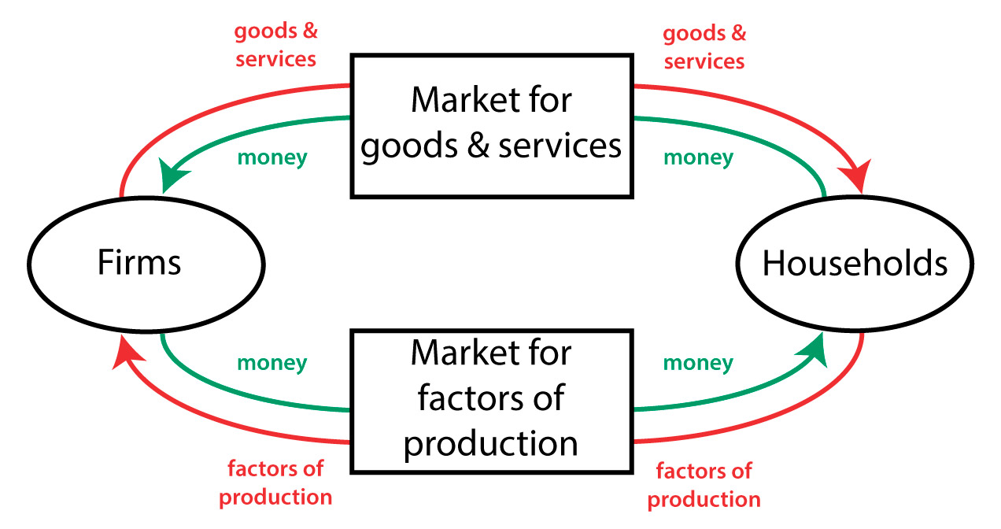

**Figure 1: Circular Flow Diagram Model**

(Source: Chaudhary and Vrat 2020)

Using the circular flow diagram model it has been easy to represent the flow of money and of goods and services in the overall economy after the UK and Russian war in the perfect way. It has been observed that in the market for services and goods it is the household that purchases goods or services from a significant firm that is responsible to generate a flow of money to those firms (Bianchini *et al.*, 2019). After the impact of this particular global event, significant pressure has been seen in the Global supply chain. The shortage of materials and staff along with the delay in the transportation system has been able to create a huge negative impact on the overall economy. It has become really difficult and challenging for the mentioned country to deal with the spike in the demand for the product particularly for construction materials and consumer goods. Besides this, the conflict in Ukraine has been responsible for adding to the food supply chain pressure in terms of the rising cost of energy, animal feed and fertilisers.

The information highlights that the UK Government has acknowledged the fact that the likelihood of the increasing food price due to the disruption in the trade and the supply of raw materials and fertiliser issue, has been responsible for increasing the price of food (Jagtap *et al*., 2022). Besides, the demand has seen to increase in competition with the food availability in the supply which has also brought significant outcomes. According to the circular flow diagram, the money flows back to the household depending on the fact that firms purchase the factors of production from the households. In the case of the UK, it has been observed that energy prices were seen to be increasing and gas prices were also exposed to volatility that has impacted the consumers to purchase the products with the increased price (Bagchi and Paul 2023). This particular factor has also been responsible for creating a major threat to the overall economy of the UK in the process of impacting the circular economy motion.

The negative impact has been felt largely in the supply chain once again where it can be seen that the organisations are scrambling in the process of mitigating the disruptions to their business. The difficulties can also be observed in storing goods, raw materials, and funds along with keeping the flow of information to the supply chain (Ben Hassen and El Bilali 2022). Additionally, the conflict in Ukraine has also been responsible to reinforce the imperative, specifically for most organisations to enjoy more resilient supply chains. On the other hand, the rapid inflation of the price has instigated different organisations across the globe to explore various alternative sources. This positive approach is not because of finding cheaper materials but at the same time bringing surety to the proper supply of the materials.

Data reveals that another positive impact of this global disruption is that the government along with different businesses, is no longer seen to be dependent on traditional suppliers (Zakeri *et al.*, 2022). The changes have also been seen in their approaches where diversifying partners or finding alternative sourcing modes got the primary importance. In addition to this, the capitalisation of the new opportunities has seen to be prioritised. With the help of this, the entrepreneurs got the opportunity in the process of filling the gaps created by the volatility. This has helped them to create a completely new business model and at the same time potentially improve the overall format of doing business in the UK (Siddi, 2023). In the process of dealing with the labour shortage, it has been seen that the country is depending on investment in digital technology and automation. This is again considered to be one of the greatest positive approaches that has come with the help of technological advancement to make the overall economy quite stronger.

Additionally, accepting the new normal has also provided a significant opportunity for organisations, which can be regarded as one of the crucial positive impacts of this global phenomenon. The ability of companies to adopt sustaining growth in these uncertain times has been able to develop best-class agile competencies (Lim *et al*., 2022). This has been beneficial for all the organisations in the mentioned country to deal with different challenges that have impacted the positive growth of the economy. Furthermore, it can also be quite useful for them to flourish their business well in future.

# Task 2:

The Ukraine and Russia war triggered a massive disturbance towards the global economy, especially in the energy as well as food market which directly created a negative impact towards the supply chain and rising prices at an uncertain level. The circular economy provides details about the market which gives incentives for reusing the product other than creeping in and extracting new resources. The war between Ukraine and Russia has created a huge impact towards the circular economy as well. It reveals that the circular economy has designed negative impacts towards the various economic activities which cause damage towards human health and natural resources as well. The World Bank has reported that the embarking of investment towards the circular economy and many countries have invested in the last scale towards the circular economy (Heshmati and Rashidghalam, 2021). Due to the effects of the Ukraine and Russia Wars, the circular economy creates a huge impact and various negatives which directly affect investment and practices.

The rise of the Ukraine and Russia war creates a huge effect on the UK, as the UK has less exposure towards the direct trade effects of Russian evasion of Ukraine than those European countries. Although indirect as well as long-term effects have been implemented towards the trade with the UK it directly affects the economy of the UK as well. The increase of the pressure of inflation worldwide contributes to hikes in prices of various food and energy supplies in the UK (www.chathamhouse.org, 2023). The UK is facing issues due to Brexit as well as the Covid-19 pandemic, which creates huge concerns towards the worker shortage and food supply chain management across borders. The Government of the UK has expanded its challenges with the food suppliers by connecting with the worldwide supply chain and continuing together proper food and energy respectively. However, due to the rise of the conflict between Ukraine and Russia war states, the country increased food and energy shortage. In the longer term post-war effects are going to implement trading relationships with the European countries which directly affects the UK Nation, as the process defines the position of Ukraine with regards to the European territories which encourages revisiting its relations with the UK. Understanding the economic prospectus in the UK due to the rise of War the GDP growth will be closest to zero at the end of 2023 which creates risk factors for recession (www.instituteforgovernment.org.uk, 2023). The energy supply towards the European countries is done by Russia due to the war environment. The power supply is going to reduce which indirectly affects the UK, as the supply chain for power is also connected with the European territories. Various research and studies claim that the UK announced at the mid-end of February the initial set of sanctions on Russia where various business targets at the Russian Bank and expansion in the financial market of Russia. This activity helps to gain the power to exclude the Russian Bank from the financial system and includes direct opportunity on clearing the payment through the UK by accessing the power to ban Russian state and private companies from raising funds in the UK and trading debt. Due to the rise of the war, the European Union has banned all oil importing from Russia which directly creates an economic disruption in the UK, recession, tepid growth and a forecast of degradation in the economy by 3.2% is analysed. All these negative effects directly create disposable income in the UK with the rise of inflation which affects the circular economy in the UK.

The Ukraine and Russia war create a lead increase in energy prices and high inflation In many Western countries, and an increase in the cost of living is seen in the African country. Cost of living increases: almost 1000 workers marched to the Union building in Pretoria which is located in South Africa to the seats of government calling to decrease the price and cost of living. as the annual inflation rate for August 2022 has increased by 20.52% which is one of the highest hikes since 2005 seen by the population of Africa (www.e-ir.info, 2023). Most of the food crops and oils are imported to Ukraine and Russia through which the economic balance is stabilised for the country although due to the war between the two countries creates a disruption towards the supply chain of various communities in Africa which includes wheat and Sunflower oil and crude oils.

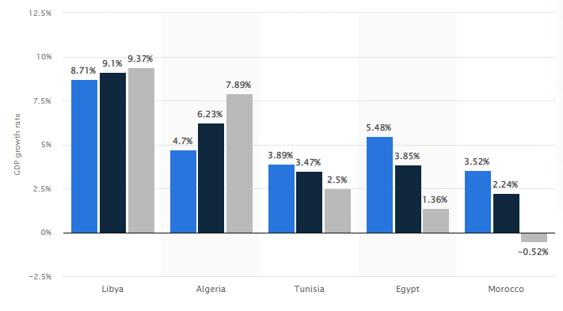

**Figure 2: Graphical representation of the impact of the Russia-Ukraine war on the GDP of Africa in 2022**

(Source: www.statista.com, 2023)

According to the reports representing NATO, the Russia and Ukraine war had direct effects towards African countries where the challenges increased towards the series of existing in the economy and the debt rising. Reports are established that almost 20 million metric tons of wheat and corn are been exported to Ukraine which is reportedly stopped due to the war conflict arising between Russia and Ukraine (www.carnegieendowment.org, 2023). These scenarios directly affect the economic aspects of the country.

Comparing the economic impact on both the UK and Africa, the common aspect is the inflation rate. Compared to the UK, Africa is facing more issues in the development of the economy and a circular economy cannot participate due to the rise of debt in the country and the business issues which rises due to the war between Russia and Ukraine. The circular flow model provides an economic description which elaborates on the relationship between business, household and government. The effects which are gathered from the African country is on the import system which is one of the major businesses done between the Ukraine country creating a huge hamper to the economy of the country through which rises in the cost of living for the people of Africa. The UK also faces various issues wear energy from the channel increases due to the energy price rise inflation which creates an impact towards the food supply for the country due to the rise of the war.

# Conclusion

Summarising all of the information that has been provided, greater knowledge can be obtained about the overall scenario of the UK economy after the immediate impact of the Ukraine Russian war. The impact largely felt in the supply chain as well as in the shortage of labour in a negative as well as in a positive way has brought a massive change in the process of doing business that can influence the economy in a better way. The study has been able to use a circular flow diagram in the process of analysing the outcome that has threatened the economy of the mentioned country after this global phenomenon. Additionally, a proper comparison has been done between the two countries which has been beneficial to know about the outcomes in a much better way.

# 

# Reference list

Bagchi, B. and Paul, B., 2023. Effects of Crude Oil Price Shocks on Stock Markets and Currency Exchange Rates in the Context of Russia-Ukraine Conflict: Evidence from G7 Countries. *Journal of Risk and Financial Management*, *16*(2), p.64.

Ben Hassen, T. and El Bilali, H., 2022. Impacts of the Russia-Ukraine war on global food security: towards more sustainable and resilient food systems?. *Foods*, *11*(15), p.2301.

Bianchini, A., Rossi, J. and Pellegrini, M., 2019. Overcoming the main barriers of circular economy implementation through a new visualization tool for circular business models. *Sustainability*, *11*(23), p.6614.

Chaudhary, K. and Vrat, P., 2020. Circular economy model of gold recovery from cell phones using system dynamics approach: a case study of India. *Environment, Development and Sustainability*, *22*, pp.173-200.

Heshmati, A. and Rashidghalam, M., 2021. Assessment of the urban circular economy in Sweden. Journal of Cleaner Production, 310, p.127475. Available at: <https://www.sciencedirect.com/science/article/pii/S0959652621016942>

Jagtap, S., Trollman, H., Trollman, F., Garcia-Garcia, G., Parra-López, C., Duong, L., Martindale, W., Munekata, P.E., Lorenzo, J.M., Hdaifeh, A. and Hassoun, A., 2022. The Russia-Ukraine conflict: Its implications for the global food supply chains. *Foods*, *11*(14), p.2098.

Lim, W.M., Chin, M.W.C., Ee, Y.S., Fung, C.Y., Giang, C.S., Heng, K.S., Kong, M.L.F., Lim, A.S.S., Lim, B.C.Y., Lim, R.T.H. and Lim, T.Y., 2022. What is at stake in a war? A prospective evaluation of the Ukraine and Russia conflict for business and society. *Global Business and Organizational Excellence*, *41*(6), pp.23-36.

Ngoc, N.M., Viet, D.T., Tien, N.H., Hiep, P.M., Anh, N.T., Anh, L.D.H., Truong, N.T., Anh, N.S.T., Trung, L.Q. and Dung, V.T.P., 2022. Russia-Ukraine war and risks to global supply chains. *International Journal of Mechanical Engineering*, *7*(6), pp.633-640.

Siddi, M., 2023. Europe’s Energy Dilemma: War and the Green Transition. *Current History*, *122*(842), pp.83-88.

www.carnegieendowment.org, 2023. Available at: <https://carnegieendowment.org/2022/04/19/how-imf-and-world-bank-can-support-african-economies-hit-hard-by-russia-s-invasion-of-ukraine-pub-86931>

www.chathamhouse.org, 2023. Available at: <https://www.chathamhouse.org/2022/09/uk-trade-and-war-ukraine>

www.e-ir.info, 2023. Available at: <https://www.e-ir.info/2022/12/20/the-russo-ukrainian-wars-impact-africa-and-a-neo-cold-war/#:~:text=The%20Russo%2DUkrainian%20war%20has,living%20in%20several%20African%20countries>.

www.instituteforgovernment.org.uk, 2023. Available at: <https://www.instituteforgovernment.org.uk/article/explainer/russia-ukraine-war-how-could-it-affect-uk-economy#:~:text=In%20this%20scenario%2C%20UK%20GDP,significant%20risk%20of%20a%20recession.&text=There%20are%20many%20possible%20scenarios,is%20reduced%20but%20not%20eliminated>

www.obr.uk, 2023. Available at: <https://obr.uk/box/how-does-the-russian-invasion-of-ukraine-affect-the-uk-economy/>

www.statista.com, 2023. Available at: <https://www.statista.com/statistics/1322439/impact-of-the-russia-ukraine-war-on-gdp-growth-rate-in-north-africa-by-country/>

Zakeri, B., Paulavets, K., Barreto-Gomez, L., Echeverri, L.G., Pachauri, S., Boza-Kiss, B., Zimm, C., Rogelj, J., Creutzig, F., Ürge-Vorsatz, D. and Victor, D.G., 2022. Pandemic, War, and Global Energy Transitions. *Energies*, *15*(17), p.6114.