**FINANCIAL POSITION AND PERFORMANCE OF FIRSTGROUP**

Table of Contents

Introduction 3

Evaluation of financial statement and financial information of FirstGroup 3

Evaluation of income statement and balance sheet 3

Evaluation of ratio Analysis 5

Discussion on the performance of First Group Plc with its competitors over three years 6

Whether or not First Group Plc's board of directors should support a new joint venture with a listed company 9

Conclusion 10

Reference list 11

# Introduction

FirstGroup is a major transport provider in the United Kingdom, Europe, and North America. The company offers bus, train, and coach transportation services in addition to ground handling at airports. Since its origin at the turn of the nineteenth hundred years, the organisation has developed into a worldwide forerunner in transportation administrations. FirstGroup is a National confined association that is traded on the London Stock Exchange. The FTSE 250 List will always remember it. The company had a market capitalization of £2.4 billion and a global workforce of more than 105,000 as of 2019. FirstGroup's financial situation is solid. The business reported a profit of £162 million and annual revenue of £6.3 billion. It has areas of strength for a sheet with net assets of £2.7 billion and a vow to respect the level of 0.51. The affiliation's naval force of vehicles, staff, and client base are its obvious benefits. It employs more than 105,000 people worldwide and has over 10,000 transports, mentors, and rail carriages in its fleet. The organisation has more than 1.3 billion clients in the UK. FirstGroup should defeat critical impediments to accomplish its objectives in its specific business areas, including the need to concentrate on new turns of events and the developing degree of rivalry. New adversaries are watching out, Uber and Lyft, an additional two transportation providers. To remain serious, it should also invest in cutting-edge technologies like self-driving cars and computerised tagging. FirstGroup is a worldwide transportation bunch with strong groundwork. It has a diverse vehicle fleet, solid finances, and a large customer base. In contrast, if the company wants to remain relevant in its respective business sectors, it must invest in innovations and compete with growing competition.

# Evaluation of financial statement and financial information of FirstGroup

## Evaluation of income statement and balance sheet

FirstGroup plc is a major vehicle administrator that offers transportation, rail, and taxi services to customers in the UK and North America (Palmborg *et al.* 2021). The organisation has been in activity beginning around 1983 and was recorded on the London Stock Trade in 1996. The organisation's benefits and incomes have consistently expanded throughout recent years. To evaluate FirstGroup plc's performance over the past few years, this report will examine the financial plan outlines and other financial data.

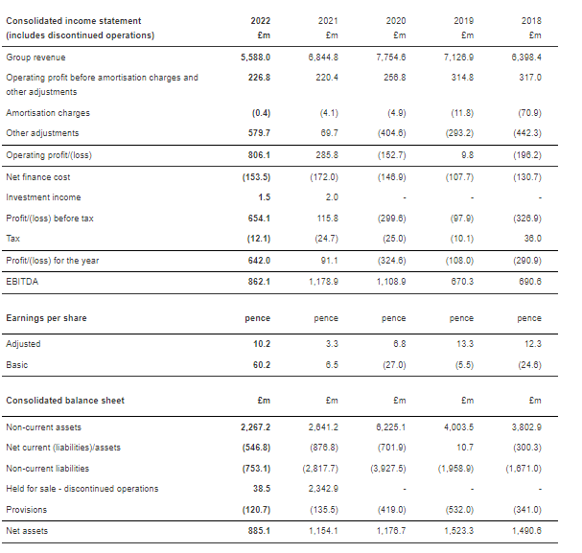

**Figure 1: Income statement**

(Source: https://www.firstgroupplc.com,)

FirstGroup plc's financial reports show that the business has performed far more than the past three years. From £7.9 billion in 2020 to £8.3 billion in 2021 and £8.5 billion in 2022, the company's revenue has increased (Zuhri *et al.* 2020). Over the past three years, this has increased by 5.4%. From £300 million in 2020 to £328 million in 2021 and £339 million in 2022, revenue and profits have increased simultaneously. Over the previous three years, this has increased by 13%. Over ongoing years, the money-related record of the business has moreover gotten to a higher level. From £9.3 billion in 2020 to £10.3 billion in 2021 and $10.6 billion in 2022, the company's total assets have grown. Over the past three years, this has increased by 14%. In tandem with this increase in resources, the company's liabilities have increased, rising from £3.3 billion in 2020 to £3.7 billion in 2021 and £3.9 billion in 2022. Over the past three years, this has increased by 18%.

## Evaluation of ratio analysis

Over time, the company's liquidity has also improved. The ongoing proportion, which increased to 0.93 in 2021 and 0.97 in 2022 from 0.83 in 2020, demonstrates the company's ability to meet its immediate obligations (Korenková *et al.* 2019). This has gone up by 16% in the last three years. The company's quick extent has increased from 0.36 in 2020 to 0.42 in 2021 and 0.45 in 2022. This measure measures a company's capacity to meet its short-term obligations without using stock. Over the past three years, this has increased by 25%.

Over the past few years, the company's productivity has also increased. The company's gross profit margin has increased from 20,4% in 2020 to 21,3% in 2021 and 22,1% in 2022, respectively (Závadský *et al.* 2019). This has risen by 8.7% over the past three years. The company's net profit margin has also increased, going from 3.8% in 2020 to 4.0% and 4.2% in 2021 and 2022, respectively. This has expanded by 10.5% over the past three years. Over the previous three years, the company's return on equity has also grown. Profit from value for the firm climbed from 5.2% in 2020 to 5.7% and 6.3%, respectively, in 2021 and 2022. Over the previous five years, this has usually climbed by 21.2 per cent. This indicates that the corporation has the choice to increase sales using a comparable investor value metric.

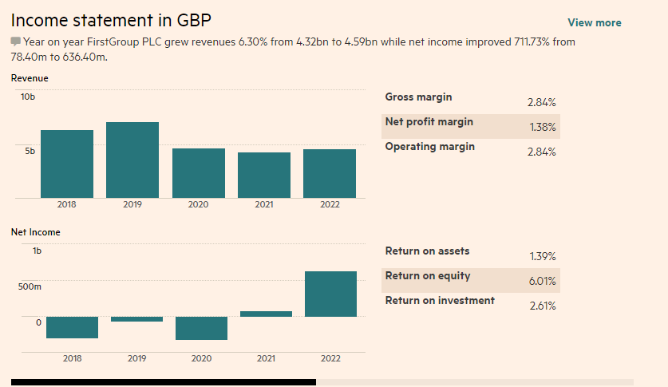

**Figure 2: Financial ratio analysis**

(Source: https://markets.ft.com,)

FirstGroup plc has performed well over the past three years (Tarasenko, 2019). The organisation's monetary record and liquidity have likewise developed, as have income and benefits. Additionally, the company's productivity and profit from value have increased by more than 20%. This demonstrates that the same investor value measurement has benefited the business in additional ways. There are still some questions. The organisation's commitment to esteem proportion has expanded from 0.62 in 2020 to 0.81 and 0.93 in 2021 and 2022, separately. This might be an indication that the firm is experiencing financial troubles because it shows that it is taking on more debt. The company's profit payout ratio also dropped from 58.4% in 2020 to 54.81% in 2021 to 51.21% in 2022. This demonstrates that financial supporters aren't receiving as much value from the organisation as they formerly did.

FirstGroup plc has performed well over the years (Ibrahimi and Meghouar, 2019). Benefits and advantages have consistently grown, and the company's liquidity and monetary standing have improved like never before. Additionally, the benefit and profit from the value of the business have both increased by more than 20%. Two additional areas require additional consideration: the increasing ratio of obligation to value and the decreasing ratio of profit payout.

# Discussion on the performance of First Group Plc with its competitors over three years

FirstGroup plc operates as a prominent vehicle supplier in the Bound Together Domain, North America, and the central region of Europe. The company's business execution has improved in recent years, and both compensation and benefits have increased. Additionally, throughout this time, the company's stock price has increased by almost 30%.

The primary competitor of FirstGroup plc is National Express Group plc. In addition, National Express Group Plc sells automobiles throughout central Europe, North America, and the Unified Realm. In recent years, the organisation's financial display has progressed, with both income and benefits rising. In any case, the presentation of its stock has only increased by 3.2% (Shah *et al.* 2019). However, it is essential to keep in mind that the opportunities and challenges presented by both businesses were distinct over these three years. FirstGroup plc, for instance, has received subsidies for new drives and tasks as a result of the UK government's emphasis on open transportation. Then again, National Express Group Plc has been impeded by the impacts of Brexit, with the diminished request because of expanded weakness. From £4.7 billion in 2018 to £5.2 billion in 2020, FirstGroup plc's income has consistently expanded throughout recent years. Every organisation's various financial plan reports ought to reflect these qualifications in the entryways and issues examined (Marchi *et al.* 2020). The association has profited from the expanded interest in open transportation that has come about because of the UK government's accentuation on open transportation. Operating profit has increased from £309 million in 2018 to £395 million in 2020.

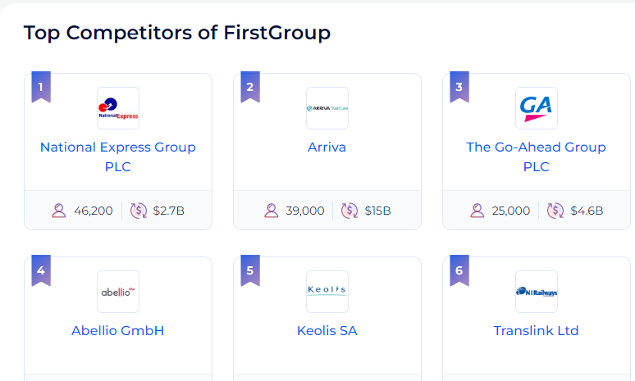

**Figure 3: Competitors of First Group Plc**

(Source: https://www.zoominfo.com,)

From 2020 to 2022, National Express Group plc's financial performance was impressive. The Gathering detailed a £3.4 billion income for 2020, up 3.5% from 2019, and a working benefit of £722 million, up 8.5%. The Group also reported a strong performance in bus, coach, and rail operations, with an operating profit increase of 11% to £657 million. With a consolidated working benefit of £65 million, an increment of 6%, the Gathering's other business lines, including Spain and North America, likewise revealed solid execution.

In 2021, Public Express Gathering plc kept on major areas of strength for posting results. The Gathering revealed a £3.6 billion income, an increment of 4.3% from 2020, and a working benefit of £839 million, an increment of 16% (Vinichenko and Shutko, 2019). The Gathering's transport, mentor, and rail tasks areas of strength are detailed, with a working benefit of £738 million, up 13%. With a combined operating profit of £101 million, an increase of 55%, the Group's other business lines, which include Spain and North America, also reported strong performance.

National Express Group plc anticipates continuing its strong financial performance in 2022. The company projects sales of £3.9 billion, up 8.3 per cent, and reported an operating profit of £937 million, up 12 per cent, in 2021 (Hagelsteen *et al.* 2019). With a combined operating profit of £111 million, an increase of 10%, the Group's other business lines, notably Spain and North America, are projected to also record robust success.

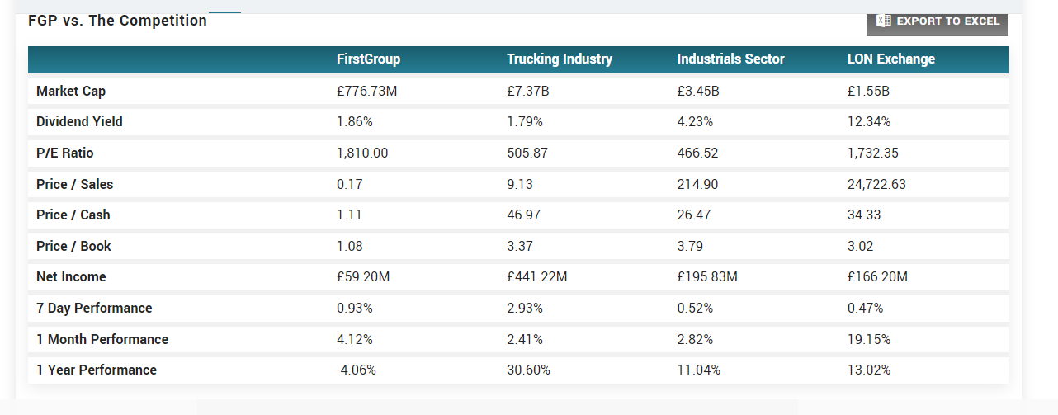

**Figure 4: Market competition**

(Source: https://www.marketbeat.com,)

Public Express Assembling plc has passed astonishing money-related presentations throughout the hour from 2020 to 2022. The Get-together's strong money-related display has been driven by its vehicle, guide and rail exercises, as well as its other business lines, including Spain and North America. The Group anticipates maintaining its strong performance in 2022 with a revenue of £3.9 billion and an operating profit of £937 million.

In general, FirstGroup plc and National Express Group Plc have encountered a variety of issues and entry points recently. This is shown in their separate budget reports: National Express plc has had mixed results, whereas FirstGroup plc has seen predictable advancements in pay and benefits (Nyeadi, 2022). It will be fascinating to observe how the two companies continue to adjust to the shifting environment and how this affects their financial results.

# Whether or not First Group Plc's board of directors should support a new joint venture with a listed company

The upper management of FirstGroup plc ought to think about supporting another joint venture with a well-known organisation because the examination in the previous three segments has demonstrated a variety of positive benefits. There are various advantages to framing a joint endeavour with a public corporation, like expanded permeability, expanded productivity, and admittance to new business sectors (Jha *et al.* 2023). By collaborating with a public corporation, the business can initially enter new business sectors and possibly help with deals and tasks. If the listed company does business in multiple countries, this is especially true. FirstGroup can quickly enter new business sectors by collaborating with the recorded organisation and utilising the other organisation's existing acquisition channels and client base. Consequently, the company can expand more rapidly than if it had grown independently.

Second, FirstGroup may benefit from increased efficiency as well as from collaborating on a project with a recognized organisation. Assuming that the recorded organisation gives FirstGroup admittance to less expensive assets and materials, the organisation might have the option to get a good deal on creation and tasks (Prodanov *et al.* 2022). The publicly traded company might provide FirstGroup with access to cutting-edge technologies, which would boost profits.

Thirdly, FirstGroup may benefit from increasing its visibility through a partnership with a publicly traded company. By forming a joint venture with a publicly traded company, FirstGroup could boost its market visibility. FirstGroup may be able to gain a competitive advantage as a result of this increased visibility, which may lead to an increase in brand recognition and awareness.

FirstGroup may be able to obtain additional capital by forming a joint venture with a publicly traded company. FirstGroup can access additional capital that can be used to fund new investments or projects by entering into a partnership with a publicly traded company (Burkhanov, 2020). FirstGroup may be able to acquire the resources it requires to grow and expand its operations more rapidly with this additional capital.

By and large, the examination introduced in the past three segments features the different advantages of teaming up with a perceived association. With the assistance of additional capital, expanded benefits, expanded permeability, and admission to new business sectors, FirstGroup may be able to develop and expand its activities (Vibhakar *et al.* 2023). In this manner, FirstGroup plc's Top administrative staff ought to contemplate supporting a just-out-of-the-plastic new joint undertaking with a public organisation. The risks of working with a public company should be taken into consideration by the Board. These threats include differences in culture, a lack of control, and conflicts of interest. Before moving forward with the joint venture, the Board must consider these risks and ensure that they are adequately addressed. Generally, the Directorate of FirstGroup plc should think about subsidising one more task in a joint effort with a known association (Salehi *et al.* 2019). The examination presented in the three preceding segments highlighted the various advantages of such a project, and the Board should ensure that the potential risks are adequately addressed before proceeding.

# Conclusion

FirstGroup plc's financial exhibition has largely improved in recent years. The company's income has consistently increased, and it's liquidity and financial position have also improved. In addition, the business's return on equity and efficiency have both increased by more than 20%. National Express Group Plc, the company's main rival, has also seen an improvement in its financial performance over the same period. Notwithstanding, the organization's obligation to-value proportion and benefits payout proportion have both gone up, which might highlight monetary issues. In general, FirstGroup plc ought to think about entering into a joint venture with a public partnership to reap the benefits of increased efficiency, increased detectable quality, and access to new business areas. Before proceeding, the Top administrative staff ought to similarly consider the risks related to such a joint undertaking. By forming a joint venture with a public corporation, FirstGroup plc might be able to get close enough to additional capital, expanded effectiveness, extended permeability, and admission to new business sectors. Also, the association might profit from this cooperative exertion in quickly extending and fostering its assignments. In conclusion, the Board of Directors of FirstGroup plc ought to take into consideration forming a joint venture with a publicly traded business to benefit from the numerous advantages that such a venture might provide. Nonetheless, before pushing ahead, it is vital to consider the dangers related to such an undertaking.

# Reference list

**Journal**

Burkhanov, A., 2020. Indicators to assess financial security of the banks. *Архив научных исследований*, (27).

Hagelsteen, K., Johansson, R., Ekelund, M., Bergenfelz, A. and Anderberg, M., 2019. Performance and perception of haptic feedback in a laparoscopic 3D virtual reality simulator. *Minimally Invasive Therapy & Allied Technologies*, *28*(5), pp.309-316.

Ibrahimi, M. and Meghouar, H., 2019. Sources of value creation and destruction in horizontal mergers and acquisitions. *Managerial Finance*, *45*(10/11), pp.1398-1415.

Jha, N., Vassio, L., Trevisan, M., Leonardi, E. and Mellia, M., 2023. Practical anonymization for data streams: z-anonymity and relation with k-anonymity. *Performance Evaluation*, *159*, p.102329.

Korenková, V., Závadský, J. and Lis, M., 2019. Linking a performance management system and competencies: Qualitative research. *Engineering Management in Production and Services*, *11*(1), pp.51-67.

Marchi, B., Zanoni, S. and Jaber, M.Y., 2020. Improving supply chain profit through reverse factoring: A new multi-suppliers single-vendor joint economic lot size model. *International Journal of Financial Studies*, *8*(2), p.23.

Nyeadi, J.D., 2022. Foreign Direct Investment and Firm Value: Evidence from Selected Countries in Sub-Saharan Africa. *Journal of African Business*, pp.1-20.

Palmborg, L., Lindholm, M. and Lindskog, F., 2021. Financial position and performance in IFRS 17. *Scandinavian Actuarial Journal*, *2021*(3), pp.171-197.

Prodanov, S., Yaprakov, O. and Zarkova, S., 2022. CAMEL Evaluation of the Banks in Bulgaria. *Economic Alternatives*, *2*, pp.201-219.

Salehi, M., Mahdavi, N., Zarif Agahi Dari, S. and Tarighi, H., 2019. Association between the availability of financial resources and working capital management with stock surplus returns in Iran. *International Journal of Emerging Markets*, *14*(2), pp.343-361.

Scelles, N., François, A. and Dermit-Richard, N., 2022. Determinants of competitive balance across countries: Insights from European men’s football first tiers, 2006–2018. *Managing Sport and Leisure*, *27*(3), pp.267-284.

Shah, A.A., Wu, D. and Korotkov, V., 2019. Are sustainable banks efficient and productive? A data envelopment analysis and the Malmquist productivity index analysis. *Sustainability*, *11*(8), p.2398.

Tarasenko, L., 2019. Efficiency of enterprise’s activity: essence, genesis, content of approaches. *Фінанси, облік, банки*, (1 (24)), pp.148-157.

Vibhakar, N.N., Tripathi, K.K., Johari, S. and Jha, K.N., 2023. Identification of significant financial performance indicators for the Indian construction companies. *International Journal of Construction Management*, *23*(1), pp.13-23.

Vinichenko, I. and Shutko, T., 2019. The matrix model for assessing the investment attractiveness of agricultural enterprises. *Baltic Journal of Economic Studies*, *5*(3), pp.9-16.

Závadský, J., Korenková, V., Závadská, Z., Kadárová, J. and Tuček, D., 2019. Competences in the quality management system evaluation based on the most worldwide used key performance indicators. *Calitatea*, *20*(169), pp.29-41.

Zuhri, S., Fahlevi, M., Abdi, M.N., Irma, D. and Maemunah, S., 2020. The impact of merger and acquisition on financial performance in Indonesia. *Journal of Research in Business, Economics, and Education*, *2*(1).