**MANAGING SUPPLY CHAINS IN RESTAURANT AND BAR OPERATIONS**

**Table of Contents**

Introduction 3

Utilisation of the supply chain and purchasing within restaurant and bar operations 3

Evaluation of the term purchasing, supply chain, and competitive advantage 4

How restaurant and bar operations can use supply chain and purchasing to enhance their competitive advantage 5

Conclusion 6

List of references 7

Appendices 8

# Introduction

Managing the supply chain process in restaurant and bar operations is referred to as a critical aspect for enabling these businesses to operate effectively and efficiently. However, a well–developed supply chain ensures businesses enhance quality, reduce costs, and influence customer satisfaction levels. The provided assignment hence develops to understand the significant component of the supply chain and its associated major implications to ensure bar owners and restaurants effectively manage their operations. Concerning this, the essay evolves to discuss the concept of the supply chain, purchasing, and competitive advantage and presents a correlation between each of them.

# Utilisation of the supply chain and purchasing within restaurant and bar operations

The application of the “supply chain management process” refers to the process of delivering products or goods from raw materials to their consumers in the global market. As per the opinion of Tan and Sidhu (2022), restaurants or hospitality organisations focus on managing their supply chain management processes such as ingredient sourcing, distribution, manufacturing as well as assembly, inventory management and delivery and return. In this context, the bar or restaurant focuses on managing its purchasing process by controlling the various steps. In turn, the steps are outlining policies, identifying the demands of the consumers in the competitive market, deciding on vendors and monitoring and receiving and managing the storage process. As per the view of Hastig and Sodhi (2020), organisations also focus on developing their supply chain process which helps to develop collaboration with the suppliers in the competitive market. In turn, the supply chain process comprises the optimisation of the flow of the money, information, and products across the supply chain from raw materials sourcing. Moreover, bars or restaurants focus on managing their supply chain operations like product development plans, distribution, finance, and consumer service. Presently, restaurants focus on using advanced technologies such as AI or Blockchain technology in terms of managing their distribution and warehouse management processes. As per the opinion of Sony *et al.* (2021), the application of the TQM model allows the organisations to produce quality products and services in terms of meeting the needs of the consumers in the global market. TQM allows the bar or restaurant to maintain its ongoing process to detect and eliminate errors which increases productivity. Thus, it can be stated that bar and restaurants focus on controlling their Supply chain and purchasing operations by following the TQM which attract consumers in the competitive market.

# Evaluation of the term purchasing, supply chain, and competitive advantage

Competitive advantage signifies the strategic advantage that corporations pose over their competitors belonging to a similar industry. As suggested by Singh *et al.* (2019), this in return ensures businesses acquire superior performance and profitability. Moreover, the competitive advantage of the organisation may emerge from its unique processes, resources, or capabilities that ensure it can generate services or goods faster, better, or cheaper than its competitors.

One of the significant ways with the help of which businesses can generate a competitive advantage is through strategic purchasing. As opined byBals*et al.* (2019), the concept of "purchasing" comprises acquiring services and goods from suppliers who can offer high-quality products at the possible lowest cost structure. Furthermore, the purchasing strategy of the company must be aligned with its entire business goals and strategy to enable it to source the relevant services or materials from the appropriate suppliers.

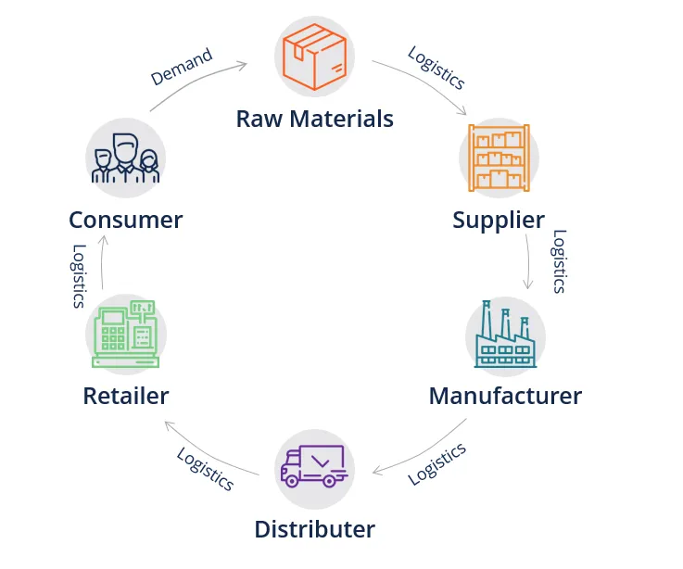

**Figure 1: The supply chain management**

(Source:Cole *et al*. 2019)

The term "supply chain" implies the network of processes and organisations included in the manufacturing, distribution, and delivery of services and goods from suppliers to customers. However, the supply chain plays a major part relative to the business's potentiality to deliver its services or products effectively and efficiently and hereby leads to acquiring a competitive advantage. As recognised by Cole *et al*. (2019), effective supply chain management comprises the optimisation of the flow of money, information, and goods across the supply chain from raw materials sourcing to delivering finished items to customers. Furthermore, organisations can generate this by utilising modern technologies including supply chain software which in return helps business to monitor supplier performance, track inventory levels, and subsequently manage logistics (Min *et al.* 2019).

It can be exclaimed that purchasing, supply chain, and competitive advantage are interrelated terms that play a crucial role in the success of the business. Companies that effectively manage their purchasing strategies and supply chain to generate competitive advantage are most likely to succeed in the existing highly competitive business scenario (Singh *et al.*2019).

# How restaurant and bar operations can use supply chain and purchasing to enhance their competitive advantage

The supply chain is an important aspect for restaurants and bars in terms of operating their business successfully. As per the view of Hong *et al.* (2019), an effective supply chain of companies increases business progress positively. In this context, restaurants and bars use raw materials procurement for making the final products positively. Similarly, it helps restaurants in collecting raw materials from suppliers at a given time. In turn, positive communication with the suppliers helps the restaurants and bars in accessing the raw materials at the proper time. Besides, the accession of raw materials at the proper time helps restaurants in making the final products for the customers. On the other hand, the restaurants make planning for raw material procurement by communicating with the suppliers properly. In turn, the proper SCM process can reduce the overall cost of the restaurants which can help them to earn a high amount of profits. In addition, the proper purchasing technique helps restaurants and bars in maintaining hygiene in the food-making process. Furthermore, the purchasing ability creates opportunities for restaurants to buy ingredients based on the customer's choice. Therefore, it can be said that restaurants and bars use the SCM process and purchasing technique effectively in order to satisfy the customers properly.

The restaurants and bars identify the areas that are required for developing the SCM process through purchasing techniques. The restaurants utilise high transparency in the SCM process to increase the business value positively. As per the opinion of Hellani *et al*. (2021), Supply chain transparency helps in scanning the bar codes of final products. In this context, the scanning process of final products helps restaurants in providing the final menu to the customers at a given time. The process of providing a menu to the customers helps in improving the competitive advantage in the market. Moreover, restaurants reduce the cost of products by purchasing ingredients in bulk. It helps restaurants in gaining more profit which creates opportunities in achieving a competitive position in the market. On the other hand, TQM is an effective theory for developing the SCM process of companies (Sharma, S. and Modgil, 2020). In turn, the application of this theory can create creates opportunities for restaurants in making food products for customers timely that enhance their brand image. Thus, it can be said that the high brand image of customers through purchasing and SCM process helps in achieving a competitive advantage in the international market.

# Conclusion

Thus, it can be concluded that effective supply chain management implies significant for the success of restaurant and bar operations. By incorporating effective strategies such as demand forecasting, lean inventory management and vendor management, restaurant, and bar owners can enhance quality, decrease expenses and fulfill customer preferences. Moreover, it is regarded vital to stay up to date with the latest technologies and trends in supply chain management to enable these businesses to remain successful and competitive in the long term.

# List of references

Bals, L., Schulze, H., Kelly, S. and Stek, K., (2019). Purchasing and supply management (PSM) competencies: Current and future requirements. *Journal of purchasing and supply management*, *25*(5), p.100572.

Cole, R., Stevenson, M. and Aitken, J., (2019). Blockchain technology: implications for operations and supply chain management. *Supply Chain Management: An International Journal*, *24*(4), pp.469-483.

Hastig, G.M. and Sodhi, M.S., (2020). Blockchain for supply chain traceability: Business requirements and critical success factors. *Production and Operations Management*, *29*(4), pp.935-954.

Hellani, H., Sliman, L., Samhat, A.E. and Exposito, E., (2021). On blockchain integration with supply chain: overview on data transparency. *Logistics*, *5*(3), p.46.

Hong, J., Liao, Y., Zhang, Y. and Yu, Z., (2019). The effect of supply chain quality management practices and capabilities on operational and innovation performance: Evidence from Chinese manufacturers. *International Journal of Production Economics*, *212*, pp.227-235.

Min, S., Zacharia, Z.G. and Smith, C.D., (2019). Defining supply chain management: in the past, present, and future. *Journal of business logistics*, *40*(1), pp.44-55.

Sharma, S. and Modgil, S., (2020). TQM, SCM and operational performance: an empirical study of Indian pharmaceutical industry. *Business Process Management Journal*, *26*(1), pp.331-370.

Singh, S.K., Chen, J., Del Giudice, M. and El-Kassar, A.N., (2019). Environmental ethics, environmental performance, and competitive advantage: Role of environmental training. *Technological Forecasting and Social Change*, *146*, pp.203-211.

Sony, M., Antony, J., Douglas, J.A. and McDermott, O., (2021). Motivations, barriers and readiness factors for Quality 4.0 implementation: an exploratory study. *The TQM Journal*, *33*(6), pp.1502-1515.

Tan, W.C. and Sidhu, M.S., (2022). Review of RFID and IoT integration in supply chain management. *Operations Research Perspectives*, p.100229.

# Appendices

***Purchase process***

