**PES7052: SUSTAINABLE CITIES – ASSESSMENT DOCUMENT**

**ESSAY – PART A**

**Table of Contents**

2. The gendered city 3

Introduction 3

Ways of experience of the “gendered” city 3

The difference in girls' and women's experiences from boys and men in relation to leisure 4

Conclusion 8

Reference List 10

# 2. The gendered city

## Introduction

The Gendered City implies the concept that determines how gender shapes the use, experience, and design of urban space. However, the term reflects the ways in which public and city spaces are often developed to privilege the experiences and requirements of men over those of women and other marginalised genders. This in return can lead to a range of issues comprising exclusion from public life, unequal access to public resources, and gender-associated violence. Hence, by understanding and dealing with the gendered dimensions concerning urban spaces, better equitable and inclusive cities can be created that help to serve the experiences and requirements of their residents. The provided essay evolves to mainly focus on the difference between girls' and women's experiences from boys and men in accordance with leisure aspects. Furthermore, adequate examples are included in the paper to effectively fulfill the core purpose of the essay.

## Ways of experience of the “gendered” city

Historically, the field of urban planning has been dominated by men. Towns are uniform and gender-inclusive "because thought male desires and requirements remained ubiquitous" as a result of this prejudice. The effects of previous prejudice might unwittingly be perpetuated by gender-inclusive legislation, regulations, and programmes. They might be based on masculine behaviours and ignore elements of women's journeys that might be different from what happens to men (Mbala, 2022). Female varied, integrated identities whether ethnic, social, or religious have a bearing on their own experiences in Kinshasa, which furthers this separation. Women are unlikely to have a homogeneous gendered experience in cities like Kinshasa. Therefore, depending on such distinctions, communities are constructed and experienced inside the framework of social order.

Although they continue to fight for it, women in Kinshasa, Congo, have not yet gained a spot of complete parity with males. Even though females have certain rights under the law and are acknowledged to play a significant part in the community by the Mobutu dictatorship, their chances are nonetheless constrained by social mores and the law. Planning, architecture, and strategy makers' discriminatory beliefs and rejection of female demands are to blame for the current situation of women who reside in metropolitan areas. Having been passed down by decades of urban planners, managers have a gender-insensitive viewpoint. Safety constitutes a single of the initial advantages of gendered cities that springs to thoughts.

Gender discrimination is an extremely serious concern in a lot of towns due to poorly lit avenues, isolated train terminals, barren regions, and congested transportation, which increases the likelihood of acts of violence and sexual harassment towards women. Because they sometimes exclusively have entry to poorly compensated exporting operations and unorganised trade, women generally usually make less than males. They frequently bear more responsibility as a result of an absence of offerings, including being forced to travel longer to access reliable water or using underground toilets deemed inappropriate for women while expecting or cycling.

Women experience a comparable right to sectors, jobs, secure transportation, and healthcare in gendered cities, which also benefit from a more diverse population of workers and higher value for money. Women in gendered cities have expertise in making financial choices that are advantageous to the entire family. Studies demonstrated that once women have control throughout the home finances or possession of their savings, they decide on choices a component of eventually, assist the whole family, with the value of bringing their kids to institutions of learning or establishing petite enterprises (Christensen and Jokar Arsanjani, 2020). The rationale underlying most microfinancing projects is that this strategy encourages households to make more durable and long-term financial choices.

Improved community backing may come from gender-equal participation in cities wherein female residents are satisfied that their demands are being met (Muhaya *et al.* 2022). Women, for instance, frequently take the requirements of kids into account when gaining possession of assets, thereby assisting the city meet kids' requirements in addition. A neighbourhood would be losing out on expertise, duration, and ability if women were excluded economically. These are all important assets. A society may boost its general competitive edge by exploiting the abilities of the female population.

## The difference in girls' and women's experiences from boys and men in relation to leisure

Leisure activities signify to be an essential portion of an individual's life offering opportunities for recreation, socialisation, and relaxation. Moreover, the leisure experience can significantly vary based on gender, with girls and women experiencing unique barriers and challenges that limit their access to leisure opportunities. As understood by McGroarty *et al.* (2020), over the years, leisure time activities have been extensively studied and hereby it is well identified that there exist gender differences in the context of experiences, types of activities, and participation rates. As opined by Lyttelton *et al.* (2020), historically, girls and women have faced several issues concerning participation in leisure activities, including cultural norms, societal expectations, lack of resources, access, and safety concerns. In context to this, the significant city "gendered" experience difference between girls and women and that of boys and men with a major focus on leisure aspects.

As identified by Codina and Pestana (2019), research has indicated that men are more likely to participate in outdoor and sports activities, while women prefer various indoor activities such as arts, socialising, and reading. Moreover, this specific gendered pattern of leisure engagement can be observed in Kinshasa as well. For instance, men in Kinshasa were more preferable to participate in outdoor leisure activities such as running, basketball, and football, whereas women like indoor activities such as watching television, sewing, and cooking (Suka and Alenda-Demoutiez, 2022). Furthermore, these gendered patterns of leisure engagement are shaped partly by cultural norms and societal expectations that dictate what is considered relevant leisure activities for women and men.

As highlighted by Ravensbergen *et al.* (2019), one of the most crucial barriers to girls and women's participation in leisure activities is the cultural expectations and social norms that restrict their access and mobility to public spaces. Girls and women in several cultures are expected to prioritise their household responsibilities and family over their leisure activities. As judged by Lane *et al.* (2019), this expectation in return limits their ability to participate in recreational and social activities outside the home including cultural events, and going to gyms or parks. In Kinshasa, for instance, women are generally expected to prioritise their duties at home and also care for their children and thereby leaving them with little free time to participate in any leisure activities (Suka and Alenda-Demoutiez, 2022). However, girls and women usually experience additional safety concerns while participating in leisure activities in public spaces. Gender related violence, for instance, sexual assault and harassment is referred to as a crucial threat to their well-being and safety. As per the report published by the United Nations Entity for Gender Equality and the Empowerment of Women, girls, and women remain at higher violence risk while accessing public scenarios such as recreational areas and parks (World Health Organization, 2021). Additionally, the fear of harassment and violence can further create barriers to girls' and women's mobility and thereby prevent them from leisure access opportunities. In contrast to this, boys and men tend to have greater access to leisure activities and public space as they are less likely to experience restrictions relative to their mobility and are generally less vulnerable to gender associated violence. As exclaimed by Codina and Pestana, (2019), boys in context to several cultures are motivated to participate in physical activities such as sports which are mainly considered unfeminine or inappropriate for girls. This gendered expectation can cause limitations to girls' opportunities to participate in physical leisure activities and subsequently to create their confidence and physical skills.

The socioeconomic position of women and girls is referred to as a crucial element that influences their access to leisure options. As presented by Ravensbergen *et al.* (2019), women and girls often have limited access to recreational amenities including sports facilities, swimming pools, and cultural venues in low-income communities. Additionally, they might not have the money to pay for extracurricular expenses like admission fees or equipment rentals. As identified by Suka and Alenda-Demoutiez, (2022), for instance, a Kinshasa study discovered that low-income women's access to leisure activities was constrained by a lack of funds. In addition, the opportunities for leisure time for women and girls may be constrained by their caregiving obligations. As preferred by McGroarty *et al.* (2020), considering how frequently women are needed to care for children, the elderly, and other family members may not have much free time for leisure pursuits. For instance, a study carried out in India discovered that women's caring obligations restricted their involvement in leisure activities, especially those that required them to travel a great distance (Yerkes *et al.* 2020). In contrast, men and boys typically have more free time and less responsibility for caring for others, which allows them to engage in leisure activities more regularly. As highlighted by Lane *et al. (*2019), furthermore, boys are frequently encouraged to pursue leisure pursuits that foster independence, such as taking part in outdoor activities or traveling, whereas girls may be expected to give priority to household duties.

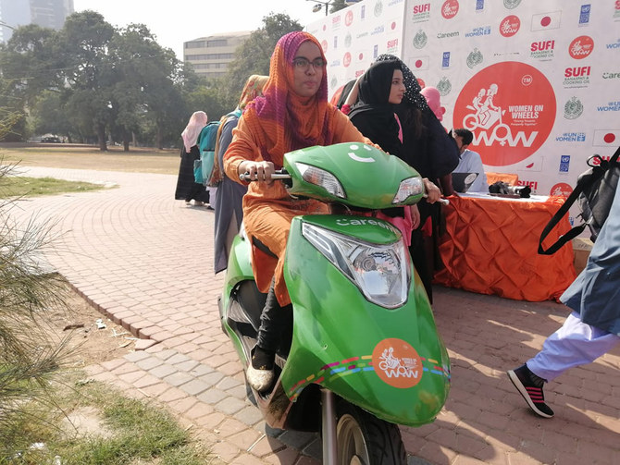

**Figure 1: Women on Wheels progra**m

(Source: Faiz *et al*. 2020)

As visualised by Su *et al.* (2020), it is crucial to develop policies and programs that give women's and girls' access to leisure activities a top priority in order to alleviate these gender disparities in leisure possibilities. For instance, as recognised by Faiz *et al*. (2020), programs like Women on Wheels, which was introduced in Pakistan in 2016, seek to boost the mobility and accessibility of women by giving those bicycles and providing them with road safety education. Similar to this, programs that offer free or inexpensive leisure activities to women and girls can aid in addressing the financial barriers that prevent them from making use of leisure opportunities.

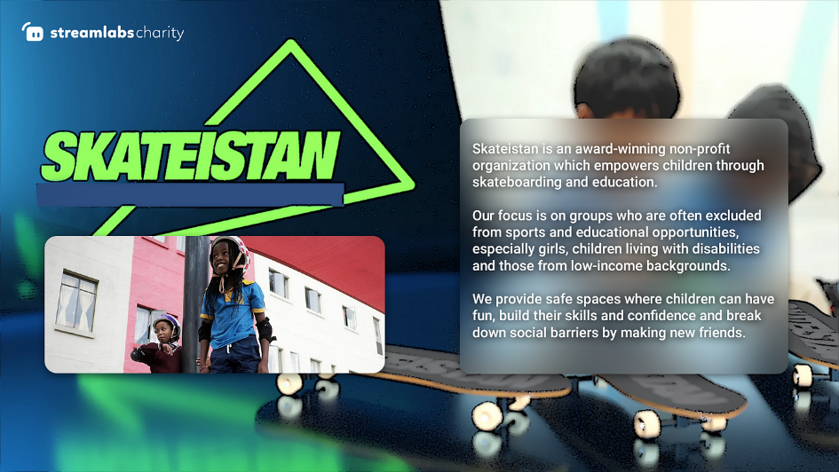

**Figure 2: Skateistan program to dispel gender stereotypes**

(Source: Hayhurst *et al.* 2021)

In context to this, it is regarded as critical to question and change the cultural and social assumptions that prevent women and girls from participating in leisure activities. This can be accomplished through community related initiatives that support gender equality and dispel gender stereotypes. For instance, a program called Skateistan uses skateboarding as a way to empower girls and dispel gender stereotypes. As commented by Hayhurst *et al.* (2021), this program Skateistan especially runs in Afghanistan, Cambodia, and South Africa. Besides, the program also offers girls a welcoming, safe environment where they may participate in physical activities and grow in confidence and leadership.

Hence, it can be exclaimed that societal norms, safety concerns, socioeconomic status, cultural expectations, and caregiving obligations all play a significant role in how women and girls enjoy leisure in comparison to men and boys. As referred by Havronska *et al.* (2021), these obstacles restrict their access to leisure activities and may be harmful to their physical and mental wellbeing, social relationships, and general well-being. As undertaken by Su *et al. (*2020), it is crucial to develop policies and initiatives that prioritise women and girls' access to leisure activities, combat gender norms and stereotypes, and advance gender equality in order to resolve these inequalities. By doing this, more equal and inclusive environments can be developed for everyone to enjoy themselves.

## Conclusion

Thus, it can be concluded that the term a gendered city in accordance with leisure is a multifaceted and complex challenge that poses crucial implications for urban planning and design. However, gendered expectations and norms usually shape the path that individuals experience and interact with urban spaces, causing the development of gendered leisure spaces. Historically leisure places such as beaches, sports facilities, and parks have been developed with a male-centric ideology, resulting in the marginalisation of women including other marginalised groups. Furthermore, recent efforts have been demonstrated to develop more diverse and inclusive leisure spaces that evolve based on the preferences and requirements of every individual irrespective of gender.

Hence, developing gender inclusive and neutral leisure spaces is significant for promoting social equity and also ensuring that every individual can fully engage and benefit from urban living standards. This specifically needs an understanding commitment and dealing with the diverse experiences and needs of varied communities and individuals and actively working towards acquiring a more equitable and just urban landscape.

# Reference List

Christensen, M. and Jokar Arsanjani, J., 2020. Stimulating implementation of sustainable development goals and conservation action: predicting future land use/cover change in Virunga National Park, Congo. Sustainability, 12(4), p.1570.

Codina, N. and Pestana, J.V., (2019). Time matters differently in leisure experience for men and women: Leisure dedication and time perspective. *International Journal of environmental research and public health*, *16*(14), p.2513.

Faiz, K., Woodcock, A., McDonagh, D. and Iqbal, S., (2020). Applying a systemic approach to gender transport poverty: Pakistan in context. *FormAkademisk*, *13*(4), pp.1-1.

Havronska, T., Krasnolobova, I., Bortniak, V., Bondar, D. and Boiko, A., (2021). The Role of Public Authorities in Combating Gender-Based Violence. *Cuestiones Políticas*, *39*(71).

Hayhurst, L.M., Thorpe, H. and Chawansky, M., (2021). *Sport, gender, and development: Intersections, innovations and future trajectories*. Emerald Group Publishing.

Lane, A.R., Hackney, A.C., Smith-Ryan, A., Kucera, K., Registar-Mihalik, J. and Ondrak, K., (2019). Prevalence of low energy availability in competitively trained male endurance athletes. *Medicina*, *55*(10), p.665.

Lyttelton, T., Zang, E. and Musick, K., (2020). Gender differences in telecommuting and implications for inequality at home and work. *Available at SSRN 3645561*.

Mbala, M.S., 2022. An ethical exploration of the effects of the increased commercialization of ethnomedicine products on the environment: the case of the city province of Kinshasa Democratic Republic of Congo (Doctoral dissertation).

McGroarty, N.K., Brown, S.M. and Mulcahey, M.K., (2020). Sport-related concussion in female athletes: A systematic review. *Orthopaedic journal of sports medicine*, *8*(7), p.2325967120932306.

Muhaya, V.N., Chuma, G.B., Kavimba, J.K., Cirezi, N.C., Mugumaarhahama, Y., Fadiala, R.M., Kanene, C.M., Kabasele, A.Y.Y., Mushagalusa, G.N. and Karume, K., 2022. Uncontrolled urbanization and expected unclogging of Congolese cities: Case of Bukavu city, Eastern DR Congo. Environmental Challenges, 8, p.100555.

Ravensbergen, L., Buliung, R. and Laliberté, N., (2019). Toward feminist geographies of cycling. *Geography compass*, *13*(7), p.e12461.

Su, W., Han, X., Yu, H., Wu, Y. and Potenza, M.N., (2020). Do men become addicted to internet gaming and women to social media? A meta-analysis examining gender-related differences in specific internet addiction. *Computers in Human Behavior*, *113*, p.106480.

Suka, C.D. and Alenda-Demoutiez, J., (2022). Being vulnerable in a vulnerable activity: women market gardeners of Kinshasa. *Canadian Journal of Development Studies/Revue canadienne d'études du développement*, *43*(4), pp.593-610.

World Health Organization, (2021). Addressing violence against women in health and multisectoral policies: a global status report.

Yerkes, M.A., Roeters, A. and Baxter, J., (2020). Gender differences in the quality of leisure: A cross-national comparison. *Community, Work & Family*, *23*(4), pp.367-384.