|  |  |
| --- | --- |
| Use Case Name | Online Assessment System |
| Domain | General |
| Complexity | Complex |

Table of Contents

1. Business Objective 3

2. Functionality 3

3. Services for Candidate and Admin 4

4. Scope and Limitations 4

5. Design Considerations / Assumptions: 5

6. UI Screens / Pages 6

a. Index Page/Login Page 6

b. Registration by a new user (user type “candidate”) 13

c. Home Page for Candidate and further flow for the Candidate 17

d. Home Page for an Admin 29

e. View list of all candidates – report 30

f. View list of all tests taken – report 32

7. Application Flow 33

# Business Objective

The **Online Assessment System** provides a facility to a candidate to take up online assessments. It also allows the administrator of the system to view relevant reports about candidates and the tests that they have attempted.

So, this system should support two types of users -> “**candidate**” and the “**admin**”

Below are the functionalities that **candidate** is enabled with:

* Registration
* Login & Logout
* Home page
* Take Tests
* View Success/Failure result

Below are the functionalities that admin is enabled with:

* Login & Logout
* View list of all Candidates
* View list of all tests taken by candidates

# Functionality

The Online Assessment System will provide a facility to the candidate to take up an online assessment and to the admin to view relevant reports.

1. There can be two types of users 🡪 “candidate” and the “admin”
2. **Candidate:**
   1. Will first register into the assessment portal by providing details like first name, last name, email id and password.
   2. Once registered successfully, the candidate can login using his/her credentials (email id & password).
   3. Once logged in, the candidate can take up any tests available (Tests are MCQ based tests).
   4. Once the test is completed and if the candidate secures marks >= minimum marks prescribed for that test, then a success message/page is shown to the candidate else failure message/page is shown.
3. **Admin:**
   1. No registration is needed. A static list of admins is maintained with appropriate details. Email ID and password details are used by the admins to login into the Application.
   2. Admins once logged in, will have access to view 2 reports:
      1. List of all registered candidates.
      2. List of all candidates who have taken up tests along with the test and marks details.
4. Tests offered to the candidates upon successful registration and login:
   1. The application offers 2 MCQ based tests -> “Spring” and “Hibernate”.
   2. Every Test has 5 questions which is a Multiple-choice Question (MCQ) (single selection) based questions.
   3. Each question carries 10 marks. There are no partial or negative marks.
   4. Min. passing marks is 30 (out of possible 50)

# Services for Candidate and Admin

The services provided to the candidate is to register, login, take up tests and logout the services provided to the admin are to login, view 2 available reports and logout.

# Scope and Limitations

Online Assessment System at present offers only 2 assessments/tests which is MCQ based assessment/test. There are fixed set of questions and options available for every test. There is no option at present to add/delete/modify any questions.

The static list of Admin details is maintained in the application and at present there are only 2 reports available to them.

# Design Considerations / Assumptions:

1. You can store the data in Http Session or Cache or in-memory database
2. The candidate must register into the application as per the registration page requirements and then login and further continue to attempt an assessment/test.
3. A static list of 2 Admins are maintained in the application with the below details:

|  |  |  |  |  |
| --- | --- | --- | --- | --- |
| **Email** | **Password** | **First Name** | **Last Name** | **User Type** |
| [roger@gmail.com](mailto:roger@gmail.com) | wipro@123 | Roger | Kutcher | admin |
| [steve@gmail.com](mailto:steve@gmail.com) | wipro@123 | Steve | Martin | admin |

In the above data, the ‘email id’ and ‘Password’ forms the credentials and is used by the admins to login to the application.

1. [http://host:port/contextroot/{path}](http://host:port/contextroot/%7bpath%7d)

In the above URL**,** *contextroot* isthe Context root of the application. You can use any value for **contextroot** in your local environment during development but **do not hardcode** it in the application source code, as the system will replace it with the dynamically generated name as context root and deploy in the application server to validate the functional test cases using selenium web driver API. In case if you are not using the context root (say for example**, Dot Net core** and **NodeJS applications** may **not** really **have the context root**), it will be replaced with blank.

For example:

Java: <http://localhost:8080/OnlineAssessment/index.html>

NodeJS: <http://localhost:3000/index.html>

Dot Net: <http://localhost:5001/index.html>

1. Do not refer any third-party libraries (CSS/JS libraries) directly from internet in the code, instead download them and use as local reference.
2. **Variable Identifier** of HTML should be id/name for input types, id for <div> and **anchor text** for <a> tags. It should be followed strictly.
3. Do not hard code port number and context root anywhere in the code

# UI Screens / Pages

**Please read the below points carefully before you start the development of the use case.**

Each page should have the following:

* Title of the page
* All the input elements to capture the user input
* Buttons/Links for any action like submit, cancel etc.,
* **All the HTML elements should have id or name attribute**
* **Element id or name should be unique and is case sensitive. If you do not follow this and use different names, the automated functional test cases will fail.**
* Success or Error message to be displayed should be wrapped in a <div> tag with the documented id/name. Please note the div id name is case sensitive.
* Please use the success / error messages documented as is(be careful with **upper case** and **lower case),** otherwise the **automated functional test cases** will **fail.**
* **Please use the** **design considerations / assumptions section** **to configure the master data like user credentials, default admin users etc., without which the functional tests will fail.**
* The colours that appear in the sample screen-shots of the views below are only indicative. You can choose to ignore using background colours for pages as it is **Optional** and in no way effects the functionality or evaluation of the application.

## Index Page/Login Page

This page allows the user to login into the Online Assessment System. Candidates (if already registered) or Admins should be able to login into the application by providing all the data in the mandatory fields. An error message should be displayed when the mandatory field is missing. On successful login, take the user to appropriate page.

Sample index page looks like below:

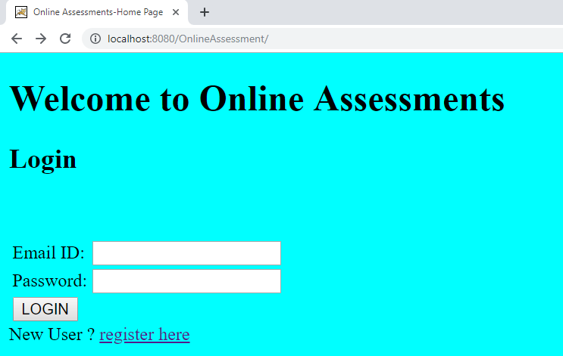

If mandatory fields are left empty and the user tries to login, it should show the default browser validation message (HTML5 feature) like below:

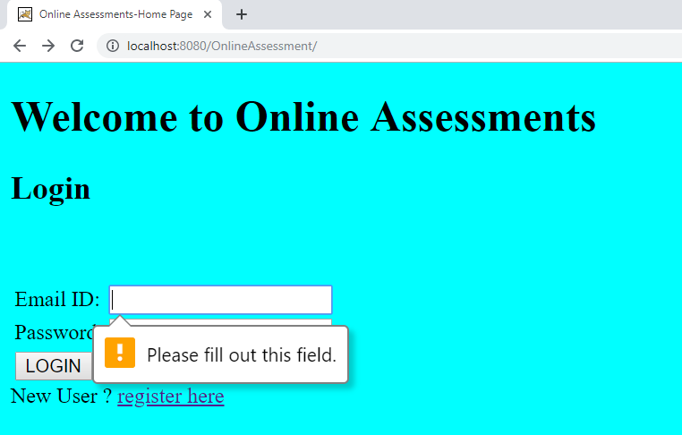

A sample valid “Admin” login would be like below:

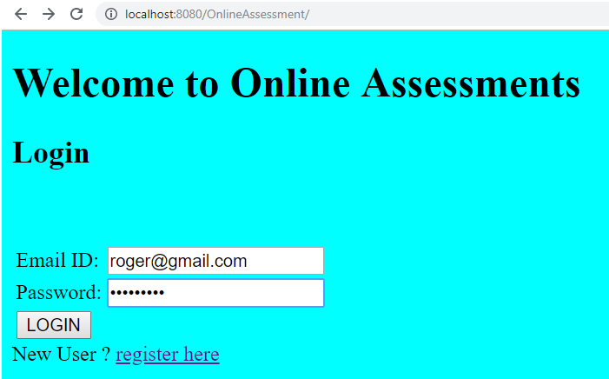

Upon successful “Admin” login, he/she sees the “Select Reports” page as below (Details of this page, its title and contents will be discussed later)

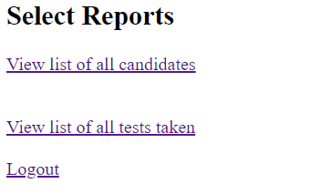

A sample valid login for a ‘candidate’ would be like below:

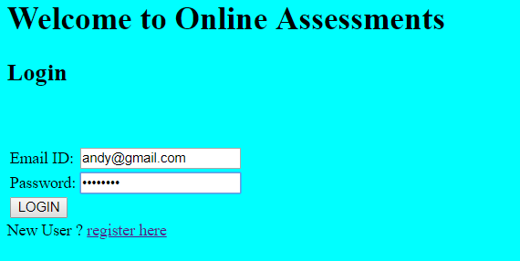

Upon successful “candidate” login, he/she sees the “Select Tests” page as below (Details of this page, its title and contents will be discussed later)

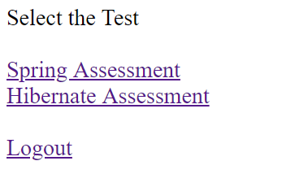

Home Page/Index page Details:

|  |  |  |  |  |  |
| --- | --- | --- | --- | --- | --- |
| **Field / Page attribute** | **HTML Element Type** | **Required** | **Identifier** | **Validation Message** | **Remarks** |
| URL | [*http://host:port/contextroot*](http://host:port/contextroot) or <http://host:port/contextroot/index.html> | | | | |
| Title of the page | Online Assessment - Home Page | | | | |
| Email ID | Label |  |  |  |  |
| Email ID | email | Yes | id=”email” | Use HTML5 built-in “required” validation to mark this input as mandatory | Use input type=”email” |
| Password | Label |  |  |  |  |
| Password | password | Yes | id=”password” | Use HTML5 built-in “required” validation to mark this input as mandatory | Use input type=”password” |
| LOGIN | submit | Yes | id=”login” |  | Click on the button should validate the provided credentials and on successful validation the page should navigate to relevant page, based on whether the user was a “candidate” or an “admin”. If the user is a ‘candidate’, then it should go to the “Select Tests” page or if the user is an admin, it should go to the “Select Reports” page (As sample screens above this table)  On unsuccessful validation of login,   1. If the Email ID is wrong, then a “Invalid User Page” will be displayed. (Details are discussed after this table) 2. If the password is wrong, then a “Password Error Page” will be displayed (Details are discussed after this table) |
| New User ? | Label/text |  |  |  |  |
| register here | Hyperlink/anchor | Yes | Hyperlink text should be: **register here**  For ex:  <a href=””>register here</a> | | Click on this, should take the user to registration page. |

An unsuccessful login with wrong Email ID would be:

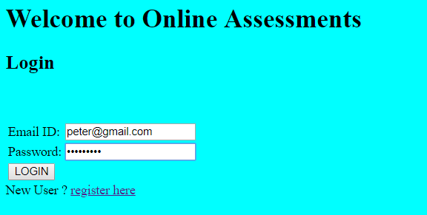

Would show “Invalid User Page” with the details below:

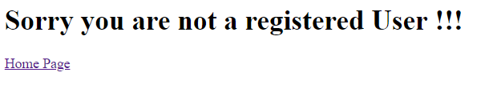

Details of the above “Invalid User Page”:

|  |  |  |  |  |  |
| --- | --- | --- | --- | --- | --- |
| **Field / Page attribute** | **HTML Element Type** | **Required** | **Identifier** | **Validation Message** | **Remarks** |
| URL | <http://host:port/contextroot/login/do> | | | | |
| Title of the page | Invalid User Page | | | | |
| Message | H1 | Yes | id=”msg” |  | H1 value should be “Sorry you are not a registered User !!! |
| Home Page | HyperLink/Anchor | Yes | Hyperlink text should be: **Home Page**  For ex:  <a href=””>Home Page </a> | | Click on this, should take the user to index page. |

A sample invalid Login with wrong password:

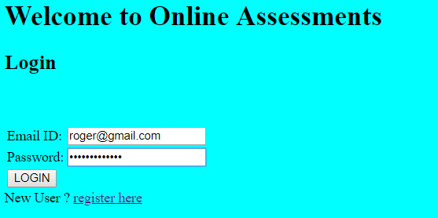

Would show “Password Error Page” with the details below:



Details of the above “Password Error Page”:

|  |  |  |  |  |  |
| --- | --- | --- | --- | --- | --- |
| **Field / Page attribute** | **HTML Element Type** | **Required** | **Identifier** | **Validation Message** | **Remarks** |
| URL | <http://host:port/contextroot/login/do> | | | | |
| Title of the page | Password Error Page | | | | |
| Message | H1 | Yes | id=”msg” |  | Sorry your Password is Wrong !!! Login again !!! |
| login again | HyperLink/Anchor | Yes | Hyperlink text should be: **login again**  For ex:  <a href=””>login again </a> | | Click on this, should take the user to index page. |

## Registration by a new user (user type “candidate”)

Only ‘candidates’ must register into the application (Not admins, as a static admin list as discussed earlier is already maintained within the application). A new candidate can register into the application by choosing the “register here” hyperlink in the index page. When the user clicks on the “register here” link, the registration page opens where the candidate can register by providing the details. Registration page shows a “form” with appropriate labels and inputs.

**Sample registration page:**

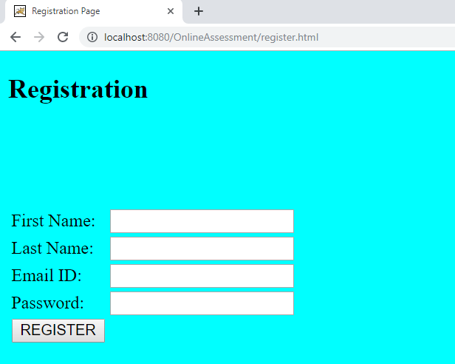

If the user tries to enter non-alphabetic characters into firstname / lastname, the default browser validation method should be displayed.

Sample:

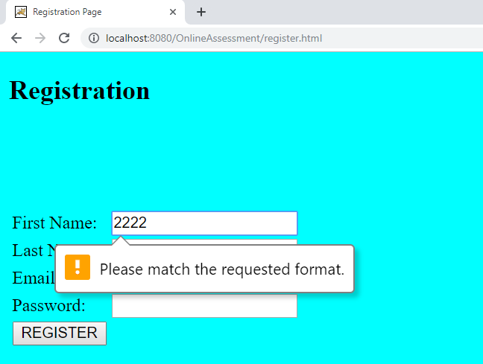

Email should be in an email format, if not, the default browser validation message should be displayed.

Sample:

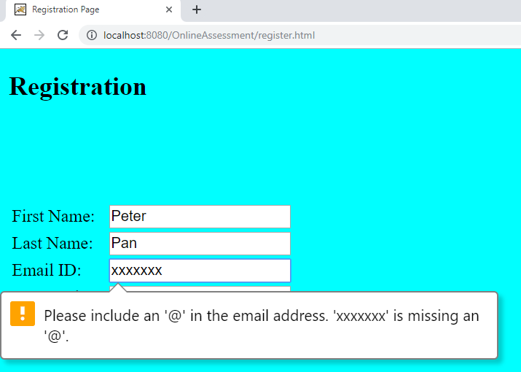

The password’s minimum length should be 8 characters, if not, the browser’s default validation should be displayed.

Sample:

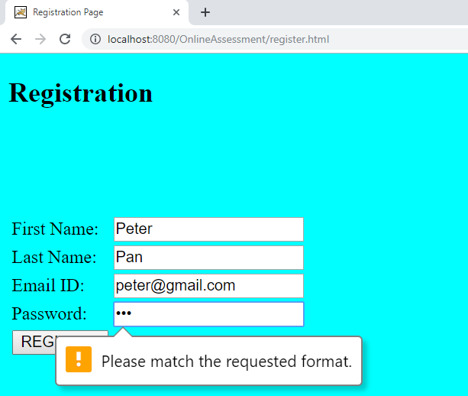

|  |  |  |  |  |  |
| --- | --- | --- | --- | --- | --- |
| **Field / Page attribute** | **HTML Element Type** | **Required** | **Identifier** | **Validation Message** | **Remarks** |
| URL | <http://host:port/contextroot/register.html> | | | | |
| Title of the page | Registration Page | | | | |
| First Name | Label |  |  |  |  |
| firstname | Text | Yes | id=”firstname” |  | Mandatory and should allow 1 or more alphabets only |
| Last Name | Label |  |  |  |  |
| lastname | Text | Yes | id=”lastname” |  | Mandatory and should allow 1 or more alphabets only |
| Email ID | Label |  |  |  |  |
| email | Email | Yes | Id=”email” |  | Use input type=”email” |
| Password | Label |  |  |  |  |
| password | Password |  | id=”password” |  | Min. length for a password should be 8 |
| REGISTER | Submit | Yes | id=”register” |  | On successful registration, display the **confirmation page** |

Sample confirmation page:

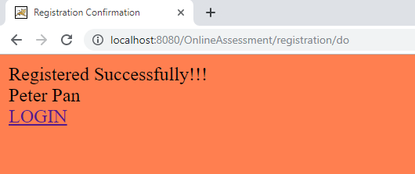

|  |  |  |  |  |  |
| --- | --- | --- | --- | --- | --- |
| **Field / Page attribute** | **HTML Element Type** | **Required** | **Identifier** | **Validation Message** | **Remarks** |
| URL | <http://host:port/contextroot/registration/do> | | | | |
| Title of the page | Registration Confirmation | | | | |
| Registered Successfully!!! | Ordinary text inside the body | Yes |  |  |  |
| Firstname lastname | Ordinary text inside the body | Yes |  |  | The firstname and the lastname of the registered candidate. |
| LOGIN | Anchor/hyperlink | Yes | Hyperlink text is: LOGIN |  | Click on this hyperlink should take you to the index page (login page) |

## Home Page for Candidate and further flow for the Candidate

Upon successful registration, the candidate will now have to login with his/her email id and password as the credentials, upon successful login validation, the candidate will land onto the main home page of the candidate.



|  |  |  |  |  |  |
| --- | --- | --- | --- | --- | --- |
| **Field / Page attribute** | **HTML Element Type** | **Required** | **Identifier** | **Validation Message** | **Remarks** |
| URL | <http://host:port/contextroot/login/do> | | | | |
| Title of the page | Select Tests | | | | |
| Select the Test | div | Yes | Id=”msg” |  | To show the text “Select the Test” |
| Spring Assessment | Anchor/Hyperlink | Yes | Hyperlink text is: Spring Assessment |  | Click on the ‘Spring Assessment’ hyperlink should take the user to springAssessment.html |
| Hibernate Assessment | Anchor/Hyperlink | Yes | Hyperlink text is: Hibernate Assessment |  | Click on the ‘Hibernate Assessment’ hyperlink should take the user to hibernateAssessment.html |
| Logout | Anchor/Hyperlink | Yes | Hyperlink text is:  Logout |  | Should clean/invalidate the session and logout and should take the user back to the index page/home page |

Click on the ‘Spring Assessment’ link should take the user to springAssessment.html.

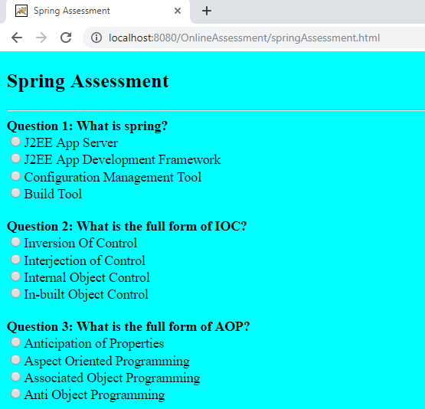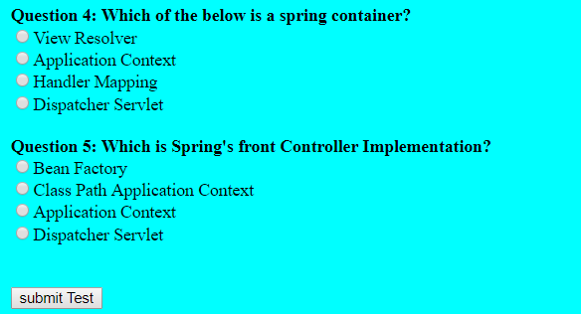

|  |  |  |  |  |  |
| --- | --- | --- | --- | --- | --- |
| **Field / Page attribute** | **HTML Element Type** | **Required** | **Identifier** | **Validation Message** | **Remarks** |
| URL | [http://host:port/contextroot/springAssessment.html](http://host:port/contextroot/login/do) | | | | |
| Title of the page | Spring Assessment | | | | |
| Question 1: What is spring? | Label | Yes |  |  |  |
| J2EE App Server | radio | Yes | id="Q1-Opt1" name="Question1"  value="J2EE App Server" |  |  |
| J2EE App Development Framework | radio | Yes | id="Q1-Opt2" name="Question1"  value="J2EE App Development Framework" |  |  |
| Configuration Management Tool | radio | Yes | id="Q1-Opt3" name="Question1"  value="Configuration Management Tool” |  |  |
| Build Tool | radio | Yes | id="Q1-Opt4" name="Question1"  value="Build Tool" |  |  |
| Question 2: What is the full form of IOC? | Label | Yes |  |  |  |
| Inversion Of Control | radio | Yes | id="Q2-Opt1" name="Question2"  value="Inversion Of Control" |  |  |
| Interjection of Control | radio | Yes | id="Q2-Opt2" name="Question2"  value="Interjection of Control" |  |  |
| Internal Object Control | radio | Yes | id="Q2-Opt3" name="Question2"  value="Internal Object Control" |  |  |
| In-built Object Control | radio | Yes | id="Q2-Opt4" name="Question2"  value="In-built Object Control" |  |  |
| Question 3: What is the full form of AOP? | Label | Yes |  |  |  |
| Anticipation of Properties | radio | Yes | id="Q3-Opt1" name="Question3"  value="Anticipation of Properties" |  |  |
| Aspect Oriented Programming | radio | Yes | id="Q3-Opt2" name="Question3"  value="Aspect Oriented Programming" |  |  |
| Associated Object Programming | radio | Yes | id="Q3-Opt3" name="Question3"  value="Associated Object Programming" |  |  |
| Anti Object Programming | radio | Yes | id="Q3-Opt4" name="Question3"  value="Anti Object Programming" |  |  |
| Question 4: Which of the below is a spring container? | Label | Yes |  |  |  |
| View Resolver | radio | Yes | id="Q4-Opt1" name="Question4"  value="View Resolver" |  |  |
| Application Context | radio | Yes | id="Q4-Opt2" name="Question4"  value="Application Context" |  |  |
| Handler Mapping | radio | Yes | id="Q4-Opt3" name="Question4"  value="Handler Mapping" |  |  |
| Dispatcher Servlet | radio | Yes | id="Q4-Opt4" name="Question4"  value="Dispatcher Servlet" |  |  |
| Question 5: Which is Spring's front Controller Implementation? | Label | Yes |  |  |  |
| Bean Factory | radio | Yes | id="Q5-Opt1" name="Question5"  value="Bean Factory” |  |  |
| Class Path Application Context | radio | Yes | id="Q5-Opt2" name="Question5"  value="Class Path Application Context" |  |  |
| Application Context | radio | Yes | id="Q5-Opt3" name="Question5"  value="Application Context" |  |  |
| Dispatcher Servlet | radio | Yes | id="Q5-Opt4" name="Question5"  value="Dispatcher Servlet" |  |  |
| Submitspring | Submit | Yes | id=”submitspring” | Click on this submit button should submit the form to evaluate the assessment based on correct and incorrect options selected for every question and based on that if score is >=30, display the success or failure message in the result page as displayed below. | |

If the candidate scores marks >=30 then the success page should display the following message.

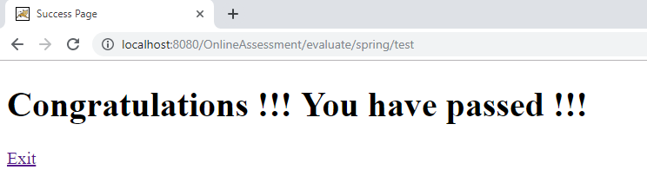

If the candidate does not clear the assessment (< 30 marks), then the failure page should display the following message.

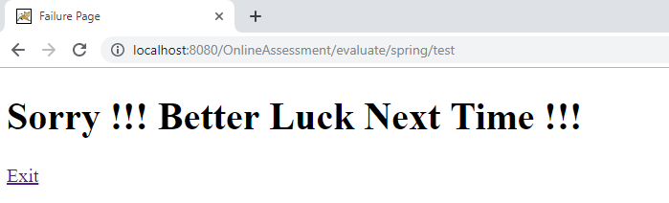

The success page details are:

|  |  |  |  |  |  |
| --- | --- | --- | --- | --- | --- |
| **Field / Page attribute** | **HTML Element Type** | **Required** | **Identifier** |  | **Remarks** |
| URL | [*http://host:port/contextroot*/](http://localhost:8080/onlinebanking/)evaluate/spring/test | | | | |
| Title of the page | Success Page | | | | |
| Success / Failure message | H1 | Yes | Id=”msg” | Success Message should be:  Congratulations !!! You have passed !!! | |
| Exit | Anchor / hyperlink | Yes | Hyperlink text should be: Exit  For ex:  <a href=””>Exit</a> | Click on it should take you back to index page | |

Failure Page

|  |  |  |  |  |  |
| --- | --- | --- | --- | --- | --- |
| **Field / Page attribute** | **HTML Element Type** | **Required** | **Identifier** |  | **Remarks** |
| URL | [*http://host:port/contextroot*/](http://localhost:8080/onlinebanking/)evaluate/spring/test | | | | |
| Title of the page | Failure Page | | | | |
| Success / Failure message | H1 | Yes | Id=”msg” | Failure Message should be:  Sorry !!! Better Luck Next Time !!! | |
| Exit | Anchor / hyperlink | Yes | Hyperlink text should be: Exit  For ex:  <a href=””>Exit</a> | Click on it should take you back to index page | |

Similarly, when the user clicks on the ‘Hibernate Assessment’ link should take the user to hibernateAssessment.html.

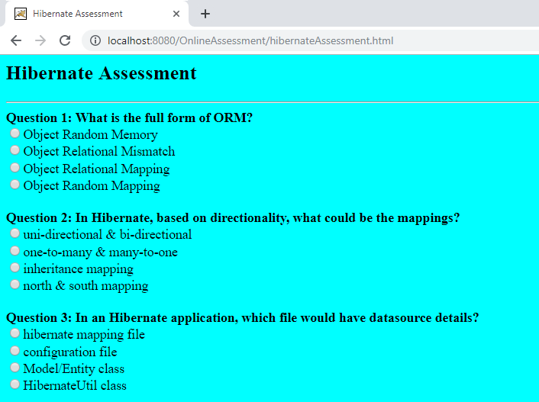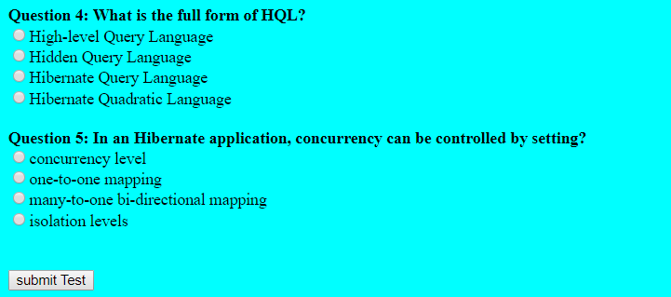

|  |  |  |  |  |  |
| --- | --- | --- | --- | --- | --- |
| **Field / Page attribute** | **HTML Element Type** | **Required** | **Identifier** | **Validation Message** | **Remarks** |
| URL | <http://host:port/contextroot/hibernateAssessment.html> | | | | |
| Title of the page | Hibernate Assessment | | | | |
| Question 1: What is the full form of ORM? | Label | Yes |  |  |  |
| Object Random Memory | radio | Yes | id="Q1-Opt1" name="Question1"  value="Object Random Memory" |  |  |
| Object Relational Mismatch | radio | Yes | id="Q1-Opt2" name="Question1"  value="Object Relational Mismatch" |  |  |
| Object Relational Mapping | radio | Yes | id="Q1-Opt3" name="Question1"  value="Object Relational Mapping" |  |  |
| Object Random Mapping | radio | Yes | id="Q1-Opt4" name="Question1"  value="Object Random Mapping" |  |  |
| Question 2: In Hibernate, based on directionality, what could be the mappings? | Label | Yes |  |  |  |
| uni-directional & bi-directional | radio | Yes | id="Q2-Opt1" name="Question2"  value="uni-directional & bi-directional" |  |  |
| one-to-many & many-to-one | radio | Yes | id="Q2-Opt2" name="Question2"  value="one-to-many & many-to-one" |  |  |
| inheritance mapping | radio | Yes | id="Q2-Opt3" name="Question2"  value="inheritance mapping" |  |  |
| north & south mapping | radio | Yes | id="Q2-Opt4" name="Question2"  value="north & south mapping" |  |  |
| Question 3: In an Hibernate application, which file would have datasource details? | Label | Yes |  |  |  |
| hibernate mapping file | radio | Yes | id="Q3-Opt1" name="Question3"  value="hibernate mapping file" |  |  |
| configuration file | radio | Yes | id="Q3-Opt2" name="Question3" |  |  |
| Model/Entity class | radio | Yes | id="Q3-Opt3" name="Question3"  value="Model/Entity class" |  |  |
| HibernateUtil class | radio | Yes | id="Q3-Opt4" name="Question3"  value="HibernateUtil class" |  |  |
| Question 4: What is the full form of HQL? | Label | Yes |  |  |  |
| High-level Query Language | radio | Yes | id="Q4-Opt1" name="Question4"  value="High-level Query Language" |  |  |
| Hidden Query Language | radio | Yes | id="Q4-Opt2" name="Question4"  value="Hidden Query Language" |  |  |
| Hibernate Query Language | radio | Yes | id="Q4-Opt3" name="Question4"  value="Hibernate Query Language" |  |  |
| Hibernate Quadratic Language | radio | Yes | id="Q4-Opt4" name="Question4"  value="Hibernate Quadratic Language" |  |  |
| Question 5: In an Hibernate application, concurrency can be controlled by setting? | Label | Yes |  |  |  |
| concurrency level | radio | Yes | id="Q5-Opt1" name="Question5"  value="concurrency level" |  |  |
| one-to-one mapping | radio | Yes | id="Q5-Opt2" name="Question5"  value="one-to-one mapping" |  |  |
| many-to-one bi-directional mapping | radio | Yes | id="Q5-Opt3" name="Question5"  value="many-to-one bi-directional mapping" |  |  |
| isolation levels | radio | Yes | id="Q5-Opt4" name="Question5"  value="isolation levels" |  |  |
| Submithibernate | Submit | Yes | id="submithibernate" | Click on this submit button should submit the form to evaluate the assessment based on correct and incorrect options selected for every question and based on that if score is >=30, display the success or failure message in the result page as displayed below. | |

If the candidate scores marks >=30 then display “Success Page” with the below message:

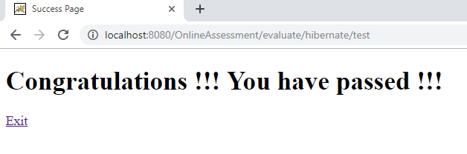

If the candidate does not clear the assessment (< 30 marks), then display “Failure Page” with the below message:

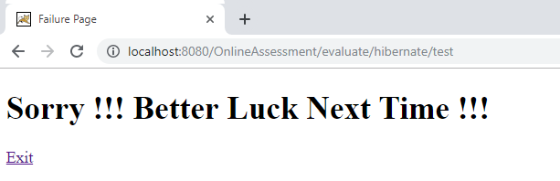

The success page details are:

|  |  |  |  |  |  |
| --- | --- | --- | --- | --- | --- |
| **Field / Page attribute** | **HTML Element Type** | **Required** | **Identifier** |  | **Remarks** |
| URL | [*http://host:port/contextroot*/](http://localhost:8080/onlinebanking/)evaluate/hibernate/test | | | | |
| Title of the page | Success Page | | | | |
| Success / Failure message | H1 | Yes | Id=”msg” | Success Message should be:  Congratulations !!! You have passed !!! | |
| Exit | Anchor / hyperlink | Yes | Hyperlink text should be: Exit  For ex:  <a href=””>Exit</a> | Click on it should take you back to index page | |

Failure Page

|  |  |  |  |  |  |
| --- | --- | --- | --- | --- | --- |
| **Field / Page attribute** | **HTML Element Type** | **Required** | **Identifier** |  | **Remarks** |
| URL | [*http://host:port/contextroot*/](http://localhost:8080/onlinebanking/)evaluate/hibernate/test | | | | |
| Title of the page | Failure Page | | | | |
| Success / Failure message | H1 | Yes | Id=”msg” | Failure Message should be:  Sorry !!! Better Luck Next Time !!! | |
| Exit | Anchor / hyperlink | Yes | Hyperlink text should be: Exit  For ex:  <a href=””>Exit</a> | Click on it should take you back to index page | |

Correct Options for the Spring and the Hibernate Assessments are as follows:

**Spring Assessment – Correct Options**

|  |  |  |  |
| --- | --- | --- | --- |
| Questions | Question | Correct Option | Correct Option Number/id |
| Question 1: | What is spring? | J2EE App Development Framework | Q1-Opt2 |
| Question 2: | What is the full form of IOC? | Inversion Of Control | Q2-Opt1 |
| Question 3: | What is the full form of AOP? | Aspect Oriented Programming | Q3-Opt2 |
| Question 4: | Which of the below is a spring container? | Application Context | Q4-Opt2 |
| Question 5: | Which is Spring's front Controller Implementation? | Dispatcher Servlet | Q5-Opt4 |

**Hibernate Assessment – Correct Options**

|  |  |  |  |
| --- | --- | --- | --- |
| Questions | Question | Correct Option | Correct Option Number/id |
| Question 1: | What is the full form of ORM? | Object Relational Mapping | Q1-Opt3 |
| Question 2: | In Hibernate, based on directionality, what could be the mappings? | uni-directional & bi-directional | Q2-Opt1 |
| Question 3: | In an Hibernate application, which file would have datasource details? | configuration file | Q3-Opt2 |
| Question 4: | What is the full form of HQL? | Hibernate Query Language | Q4-Opt3 |
| Question 5: | In an Hibernate application, concurrency can be controlled by setting? | isolation levels | Q5-Opt4 |

**Important Note:** When the user takes a test, the current date should be captured and saved as well, and the format should be DD-MM-YYYY HH:MM:SS. The result also be saved either as “Passed” or “Failed” (These will be useful later while generating reports).

## Home Page for an Admin

When an “admin” user successfully logs in, display the home page of the admin user, to select the reports.



|  |  |  |  |  |  |
| --- | --- | --- | --- | --- | --- |
| **Field / Page attribute** | **HTML Element Type** | **Required** | **Identifier** |  | **Remarks** |
| URL | [*http://host:port/contextroot*/](http://localhost:8080/onlinebanking/)login/do | | | | |
| Title of the page | Select Reports | | | | |
| Select Reports | H2 | Yes | Id=”msg” |  | To display text “Select Reports” |
| View list of all candidates | Anchor/ hyperlink | Yes | Hyperlink text should be: ***View list of all candidates*** |  | Be careful about the uppercase and lower case of the hyperlink text. Maintain exactly as mentioned.  Click on this link should take the user to “All User Details Page” |
| View list of all tests taken | Anchor/ hyperlink | Yes | Hyperlink text should be: ***View list of all tests taken*** |  | Be careful about the uppercase and lower case of the hyperlink text. Maintain exactly as mentioned.  Click on this link should take the user to “All Tests Details Page” |
| Logout | Anchor/ hyperlink | Yes | Hyperlink text should be: Logout |  | Be careful about the uppercase and lower case of the hyperlink text. Maintain exactly as mentioned |

## View list of all candidates – report

When the “admin” user clicks on the “View list of all candidates” link, the All User Details Page should be shown. The users should include admin users as well and should be sorted based on first name, ascending order.

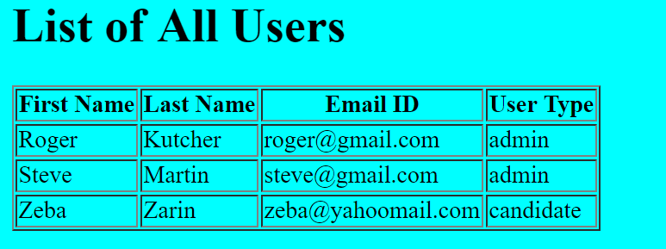

If a “candidate” type of user is also registered, then the above table will contain information of the “candidate” type of user as well.

|  |  |  |  |  |  |
| --- | --- | --- | --- | --- | --- |
| **Field / Page attribute** | **HTML Element Type** | **Required** | **Identifier** |  | **Remarks** |
| URL | [*http://host:port/contextroot*/users/all](http://host:port/contextroot/users/all) | | | | |
| Title of the page | All User Details | | | | |
| List of All Users | Label / Text | Header Text | | | |
| Table data to be displayed in ascending order of first names. | | | | | |
| First Name | Column Header Text | | | | |
| Last Name | Column Header Text | | | | |
| Email ID | Column Header Text | | | | |
| User Type | Column Header Text | | | | |
| First Name | span | Yes | Id=”firstName1” for row 1  Id=”firstName2” for row 2 etc. | |  |
| Last Name | span | Yes | Id=”lastName1” for row 1  Id=”lastName2” for row 2 etc. | |  |
| Email Id | Span | Yes | Id=”email1” for row 1  Id=”email2” for row 2 etc. | |  |
| User Type | span | Yes | Id=”userType1” for row 1  Id=”userType2” for row 2 etc. | |  |

## View list of all tests taken – report

When the “admin” user clicks on the “View list of all tests taken” link, the All Tests Details Page should be shown. The results should be sorted based on test date, ascending order. The details of the page are:

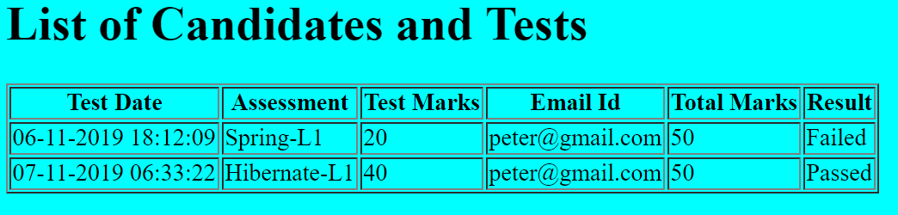

|  |  |  |  |  |  |
| --- | --- | --- | --- | --- | --- |
| **Field / Page attribute** | **HTML Element Type** | **Required** | **Identifier** |  | **Remarks** |
| URL | [*http://host:port/contextroot*/tests/all](http://host:port/contextroot/tests/all) | | | | |
| Title of the page | All Tests Details | | | | |
| List of Candidates and Tests | Label / Text | Header Text | | | |
| Table data to be displayed in ascending order of Test Date | | | | | |
| Test Date | Column Header Text | | | | |
| Assessment | Column Header Text | | | | |
| Test Marks | Column Header Text | | | | |
| Email ID | Column Header Text | | | | |
| Total Marks | Column Header Text | | | | |
| Test Date | span | Yes | Id=”testDate1” for row 1  Id= “testDate2” for row 2 etc. | | Format should be DD-MM-YYYY HH:MM:SS |
| Assessment | span | Yes | Id=”assessment1” for row 1  Id=”assessment2” for row 2 etc. | |  |
| Test Marks | span | Yes | Id=”marks1” for row 1  Id=”marks2” for row 2 etc. | |  |
| Email ID | span | Yes | Id=”email1” for row 1  Id=”email2” for row 2 etc. | |  |
| Total Marks | span | Yes | Id=”totalMarks1” for row 1  Id=”totalMarks 2” for row 2 etc. | |  |
| Result | span | Yes | Id=”result1” for row 1  Id=”result2” for row 2 etc. | |  |

# Application Flow

|  |  |  |
| --- | --- | --- |
| **Current Page** | **Action** | **Next / Landing Page** |
| Login by Candidate | Submit - Success | Home Page of Candidate |
| Login by Candidate | Submit – Failure | Display appropriate Error Page with an option to go back to the Login page |
| Login by Admin | Submit – Success | Home Page of Admin |
| Login by Admin | Submit – Failure | Display appropriate Error Page with an option to go back to the Login Page |
| Registration by Candidate | Registration – Success | Display appr. Success message along with a link to go back to the Login page |
| Home Page of Candidate | Select Spring Assessment | Spring Assessment Page |
| Spring Assessment Page | Submit – Success (passed) | Success Page with an option to Exit and go back to home page |
| Spring Assessment Page | Submit – Failure (failed) | Failure Page with an option to Exit and go back to home page |
| Home Page of Candidate | Select Hibernate Assessment | Hibernate Assessment Page |
| Hibernate Assessment Page | Submit – Success (passed) | Success Page with an option to Exit and go back to home page |
| Hibernate Assessment Page | Submit – Failure (failed) | Failure Page with an option to Exit and go back to home page |
| Home page of admin | Select – All users link | All users Details page |
| Home page of admin | Select – All Tests link | All test Details page |