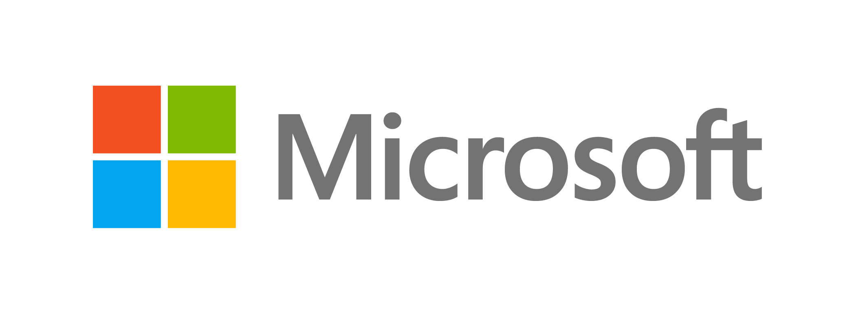Published September 2015

IT Showcase Productivity Guide

Using Windows 10  
Client Hyper-V

Summary: Client Hyper-V is the virtualization technology built into Windows 10 and Windows 8.x. It is the same virtualization technology previously available only in Windows Server. Client Hyper-V enables you to run more than one 32‑bit or 64‑bit x86 operating system at the same time on the same host computer. But instead of working directly with the computer’s hardware, the operating systems run inside a virtual machine (VM). Hyper-V enables developers and IT professionals to easily maintain multiple test environments. It also provides a simple mechanism to quickly switch between these environments quickly.

# Topics in this guide include:

Practical applications for Client Hyper-V

Hardware requirements

Enabling Client Hyper-V

For more information

Tools

What is not included in Client Hyper-V?

Limitations of Client Hyper-V

# Practical applications for Client Hyper-V

As a developer or IT professional, consider using Client Hyper-V for the following scenarios:

* Build a test lab infrastructure on your desktop or laptop. After creating virtual machines and testing them on the desktop or laptop, move the VMs to a Windows Server production environment.
* Test an application with different operating systems. For example, you might have an application that you need to test in Windows 10, Windows 8.x, Windows 7, and Windows XP. You can create four VMs with these OS versions on your desktop or laptop. You then can run your tests (except for scale/performance tests) on the Client Hyper-V computer instead of in a production environment or dedicated testing lab.
* Export (or simply copy) a VM from your production environment, import it to your desktop or laptop with Client Hyper-V (you will need to adjust settings), and do the required troubleshooting. Then export the VM (with adjustments) back to the production environment.
* Using VM networking, create a multicomputer environment for testing, development, and demonstration that does not affect the production network.
* Take a snapshot of a VM while it’s running. A snapshot saves everything about the virtual machine, enabling you to go back to a previous point in time in the life of a VM. This is a great tool when you are trying to debug tricky problems.
* Mount and boot a Windows operating system using Windows To Go virtual hard disks (VHDs) from a USB drive as a virtual machine.

## Interaction with Windows Update

A computer running Client Hyper-V can take advantage of Windows Update, so you do not need to set up additional maintenance processes.

## Wireless network adapters and sleep states

Client Hyper-V works with wireless network adapters and is compatible with sleep states. For example, if you are running Client Hyper-V on a laptop and you close the lid, the VMs that are running will shift to a saved state. You can resume the VMs when the computer wakes.

# Hardware requirements

Hyper-V supports creation of both 32-bit and 64-bit operating systems in VMs. To be a Client Hyper-V host system your computer must:

* Be running a 64-bit version of Windows 10 or Windows 8.x Professional or Enterprise Editions.
* Have a CPU that supports Second Level Address Translation (SLAT), a feature present in the current generation of 64-bit processors by Intel and AMD. To determine whether your CPU supports SLAT, go to <http://social.technet.microsoft.com/wiki/contents/articles/1401.aspx>.
* Have 4 gigabytes (GB) of RAM. The Hyper-V dynamic memory allows memory needed by the VM to be allocated and deallocated dynamically (you specify a minimum and maximum), and it shares unused memory between VMs. You can run a few VMs on a computer that has 4 GB of RAM. The number of VMs that you can run will depend on the RAM size and required performance.

Microsoft IT recommends testing the CPU for NX and SSE2. You can use the Sysinternals Coreinfo tool to test for both.

For more information, go to <http://technet.microsoft.com/en-us/sysinternals/cc835722>. Because BIOS support for virtualization is required, before you enable Client Hyper-V, ensure that your computer has the latest BIOS version. For information on checking and changing the virtualization support settings of your system BIOS, check with your computer manufacturer, and visit <http://social.technet.microsoft.com/wiki/contents/articles/3190.aspx>.

For storage, you can add multiple hard disks to the IDE or SCSI controllers available in the VM. You can use virtual hard disks (.vhd or .vhdx files) or actual disks that you pass directly through to the VM. VHDs can also reside on a remote file server, which makes it easy to maintain and share a common set of predefined VHDs across a team.

The Hyper-V Live Storage Move capability helps your VMs to be fairly independent of the underlying storage. With Live Storage Move, you can move the VM’s storage from one local drive to another, to a USB drive, or to a remote file share without needing to stop your VM. This is very handy for fast deployments if you need a VM quickly. You can start a VM from a VM library maintained on a file share, and then move the VM’s storage to your local drive.

# 

# Enabling Client Hyper-V

You can enable Client Hyper-V in Windows 10 or Windows 8.x in three ways: from Control Panel, in the Windows PowerShell command-line interface, or from the command prompt.

## Use Control Panel

1. Go to **Start > Settings**.
2. In the search box, enter **programs**, and then select **Programs and Features**.

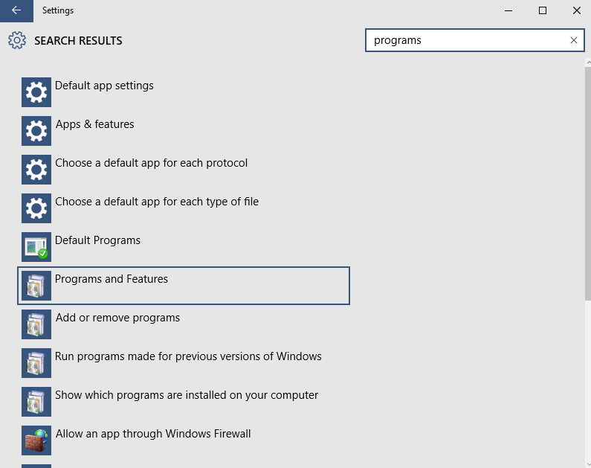

1. Select **Turn Windows features on or off**.

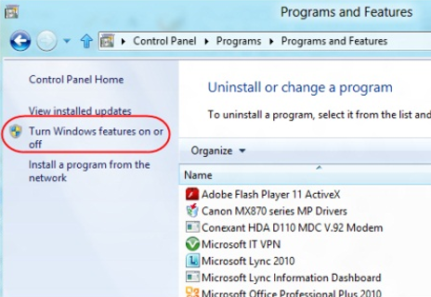

1. In the **Windows Features** dialog box, select the check boxes for the Hyper-V items that you want to install, and then select **OK**.

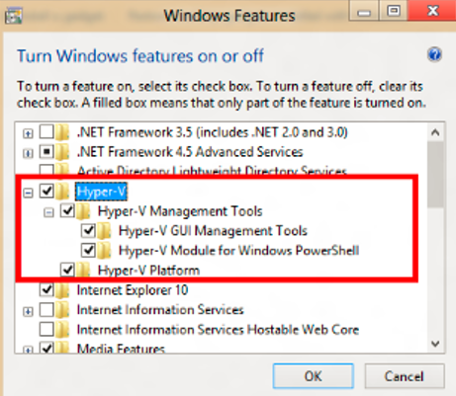

Windows searches for and installs the required files.

1. Select **Close**.

## Use Windows PowerShell

At the Windows PowerShell prompt (using administrator credentials), enter the following:

enable-WindowsOptionalFeature -Online -FeatureName Microsoft-Hyper-V -All

## Use the Windows command prompt

At the Windows command prompt (using administrator credentials), enter the following:

dism /online /enable-feature /featurename:Microsoft-Hyper-V -All

NOTE: You must restart your computer to complete the Hyper-V installation. Depending on your computer *manufacturer*, you may have to pause a few seconds before restarting, for the required changes to take effect. If you use a *laptop*, you may have to remove the battery before restarting. After restarting the computer, you can use Hyper-V Manager or Windows PowerShell to create and manage VMs. You can also use VM Console to connect to VMs remotely.

For more information on configuring Hyper-V, go to:

<http://technet.microsoft.com/en-us/library/hh846766.aspx>.

# 

# Tools

VM management and other tools created for Server Hyper-V, such as VMM P2V or Sysinternals Disk2vhd tools, will also work in Client Hyper-V. Disk2vhd is available at <http://technet.microsoft.com/en-us/sysinternals/ee656415.aspx>.

For any Hyper-V virtual switch extensions and Windows PowerShell scripts for managing VMs that you develop and test on Client Hyper-V, you can move them to Server Hyper-V.

NOTE: *Bluetooth network interface cards (NICs) do not appear as Ethernet NICs and are not usable by Client Hyper-V VMs.*

## Hyper-V Manager

Enabling Client Hyper-V also installs Hyper-V Manager. You can use Hyper-V Manager to create and manage your virtual machines. You can also use it to enable an external network virtual switch so that a VM can connect to an external (physical) network connection.

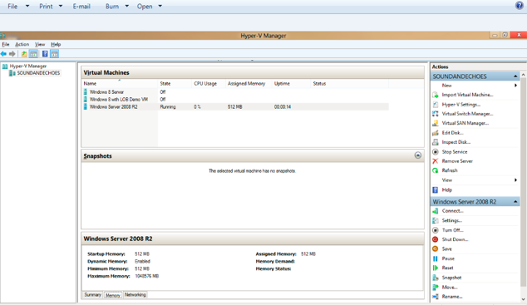

For more information about the Hyper-V Manager user interface, go to <http://technet.microsoft.com/library/cc770494.aspx>.

## Using Windows PowerShell

The Windows PowerShell scripts for managing VMs that you create using Client Hyper-V are fully compatible with Windows Server 8 Hyper-V. For example, assuming you have the .xml files for these VMs already available on your computer, network share, or USB storage, enter the following Windows PowerShell command to start them all for you on your Client Hyper-V computer:

dir *.xml | import-vm | start-vm

For more information about Hyper-V Windows PowerShell cmdlets, go to <http://technet.microsoft.com/library/hh848559.aspx>.

## Using Hyper-V with Remote FX

If you have used Hyper-V before and are accustomed to using Remote FX to interact with VMs, note that the new version of Remote Desktop Protocol (RDP) includes support for the following:

* USB redirection (To enable in RDP, go toShow Options > Local Resources Tab > More.)
* Multipoint touch to a Windows VM if you are using a touch-enabled device
* Bidirectional audio
* Host folder sharing
* Host printer sharing
* Smart-card authentication

## VM Console and Remote Desktop Connection

Windows provides two mechanisms to peek into the VM: the VM Console and Remote Desktop Connection. The VM console (also known as VMConnect) is a console view of the VM. It provides a single monitor view of the VM with resolution up to 1600 x 1200 in 32-bit color. This console provides you with the ability to view the VM’s booting process.

For a richer experience, you can connect to the VM using Remote Desktop Connection. With Remote Desktop Connection, the VM takes advantage of capabilities present on your physical PC. For example, if you have multiple monitors, the VM can show its graphics on all of these monitors. Similarly, if you have a multipoint touch-enabled interface on your PC, the VM can use this interface to give you a touch experience.

The VM also has full multimedia capability because it uses the physical system’s speakers and microphone. The root operating system (the main Windows operating system that is managing the VMs) can also share its Clipboard and folders with the VMs. And finally, with Remote Desktop Connection, you can attach any USB device directly to the VM.

# 

# What is not included in Client Hyper-V?

There are some features included in Windows Server 2012 Hyper-V that are not included in Windows 10 or Windows 8.x Client Hyper-V. These include:

* Remote FX capability to virtualize GPUs (software GPU in RDP 80)
* Live VM migration
* Hyper-V Replica
* SR-IOV networking
* Synthetic fiber channel

# Limitations of Client Hyper-V

Features or applications that depend on specific hardware will not work well in a VM. For example, Windows BitLocker and Measured Boot, which rely on TPM (Trusted Platform Module), might not function properly in a VM. Applications that require processing with GPUs without providing software fallback might not work well either. In addition, applications that rely on sub-10ms timers (latency-sensitive, high-precision applications) could experience issues running in a VM.

The root operating system is also running on top of the Hyper-V virtualization layer and is unique in the use of direct access to all hardware. This is why applications with special hardware requirements continue to work unhindered in the root operating system while latency-sensitive, high-precision applications could experience issues running in the root operating system.

NOTE: *Do not run a virus scanner in the VM. For an optimal experience, use System Center 2012 Endpoint Protection on the host. System Center 2012 Endpoint Protection avoids Hyper-V-specific files.*

# For more information

## For more great productivity guidance, visit…

<http://microsoft.com/ITShowcase/Productivity>

## Microsoft IT Showcase

<http://www.microsoft.com/ITShowcase>

## Windows

<http://windows.microsoft.com>

## Microsoft Hyper-V Server 2012

<http://www.microsoft.com/en-us/server-cloud/hyper-v-server/default.aspx>

## Hyper-V Overview

<http://technet.microsoft.com/en-us/library/hh831531.aspx>

For more information about Microsoft products or services, call the Microsoft Sales Information Center at (800) 426-9400. In Canada, call the Microsoft Canada Order Centre at (800) 933-4750. Outside the 50 United States and Canada, please contact your local Microsoft subsidiary. To access information via the web, go to:

<http://www.microsoft.com>

© 2015 Microsoft Corporation. All rights reserved. Microsoft and Windows are either registered trademarks or trademarks of Microsoft Corporation in the United States and/or other countries. The names of actual companies and products mentioned herein may be the trademarks of their respective owners. This document is for informational purposes only. MICROSOFT MAKES NO WARRANTIES, EXPRESS OR IMPLIED, IN THIS SUMMARY.