UI changes

1.Remove all the Blank spaces and redundant text

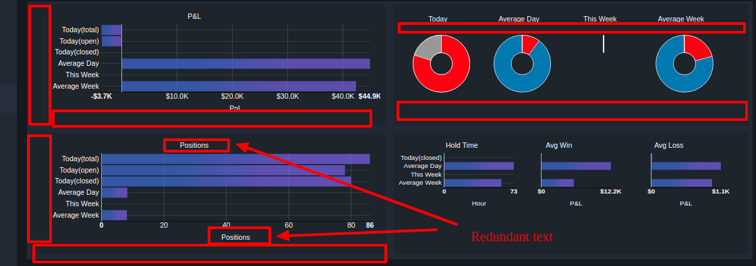

2. Consistent Font and Font Size in the Page.

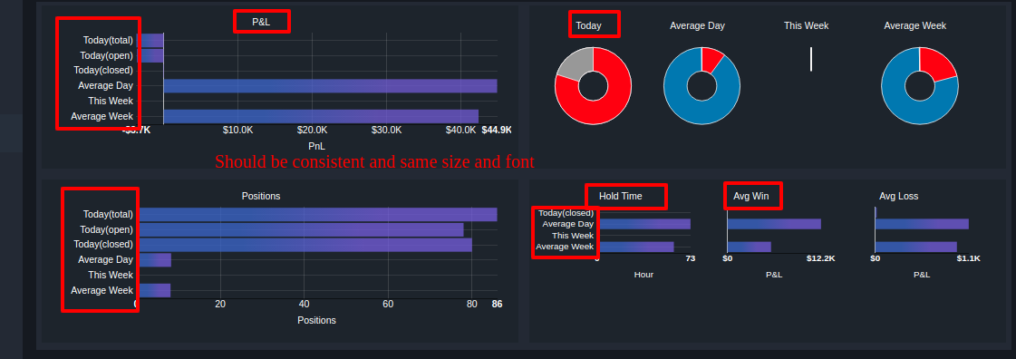

3. Negative bar chart should be red in color.

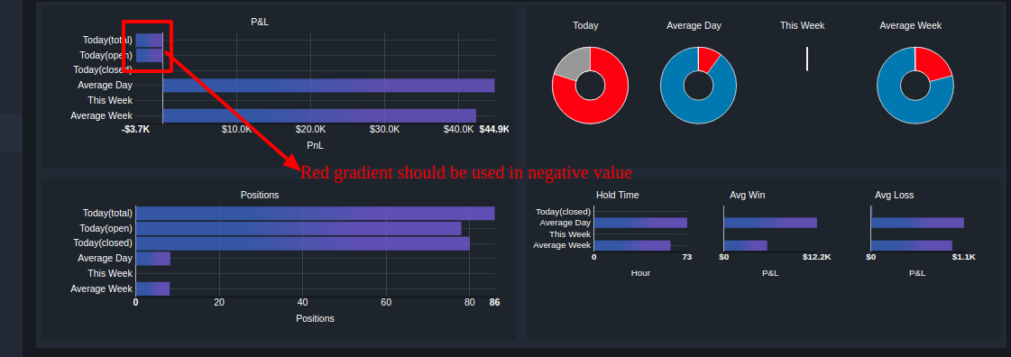

4. Gradient color in the Donut chart

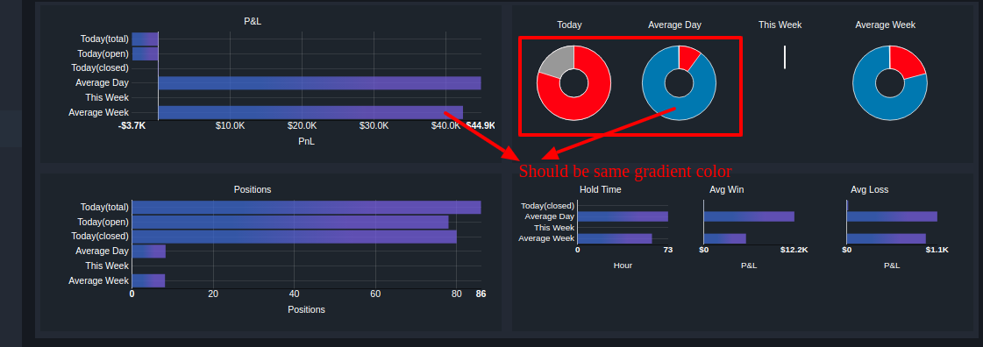

Development changes

1.Profit Factor

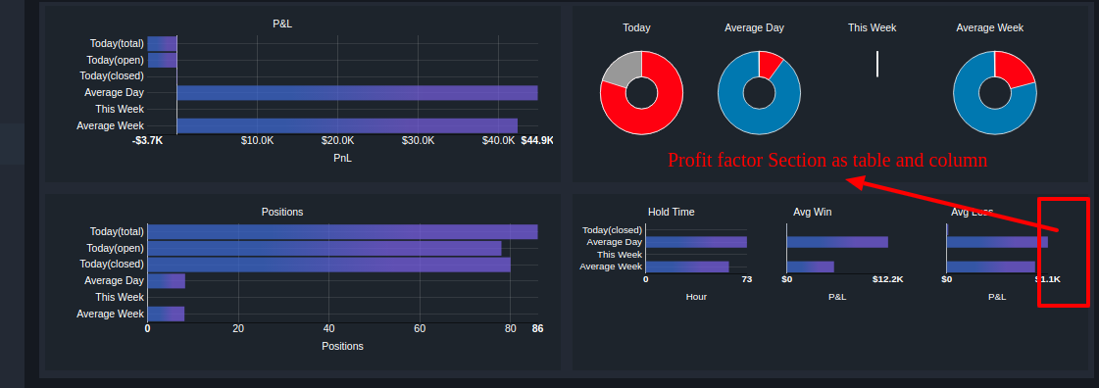

ETA - 1 Hour

2. Label Color Pills

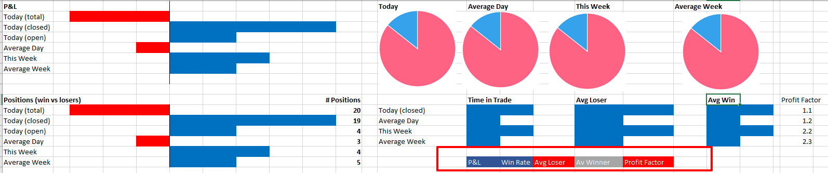

ETA – 1 Hour

3. Show Hide option

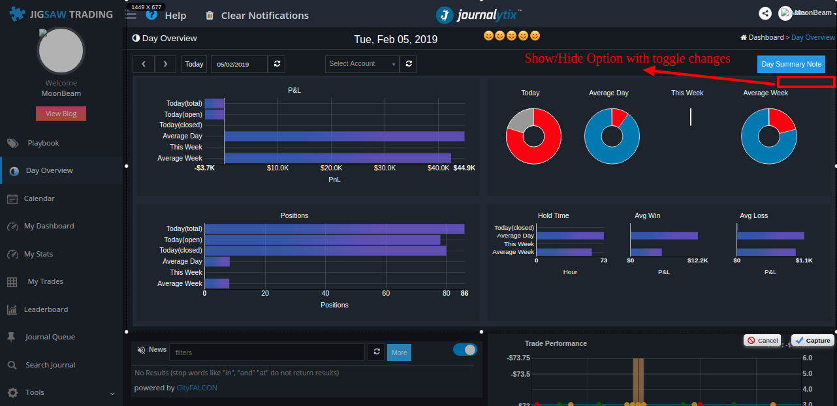

ETA – 30 minutes