Butun2019

Jing2014

Virtual machine (linux based) with TP-Link TLWN772N USB adapter.

* Monitor mode
* Signal strength

Docker (different images)

* Image (Linux-based) for network scanning
* Image (Linux-based) for DDoS attack
* Image (linux-based) network sniffer for capturing wifi traffic
* Controlling system to control and manage smart devices

Devices

* Raspberry pi
* Arduino

Sensors

* Energy consumption measurement sensor

FAP:

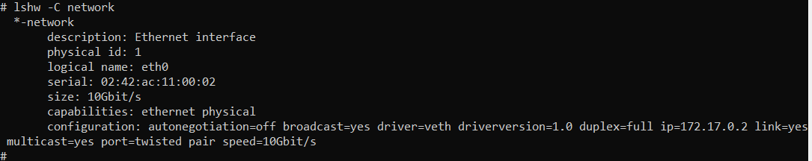

sudo cp 88x2bu.ko /lib/modules/[5.4.72-microsoft-standard-WSL2]/kernel/drivers/net/wireless/ #[kernel version] is the directory name of the system kernel version

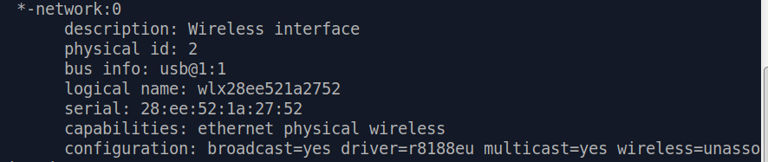

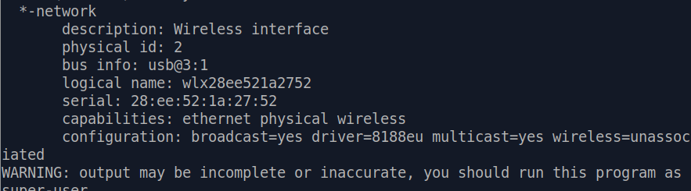

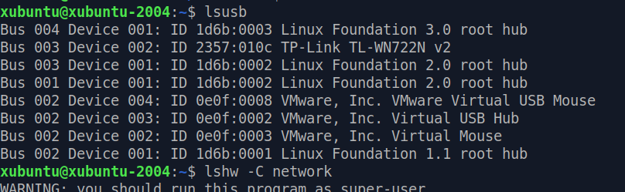

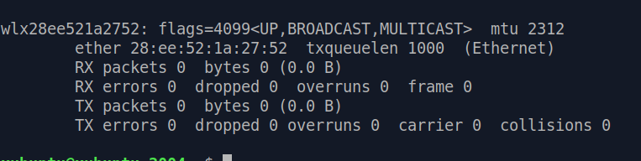

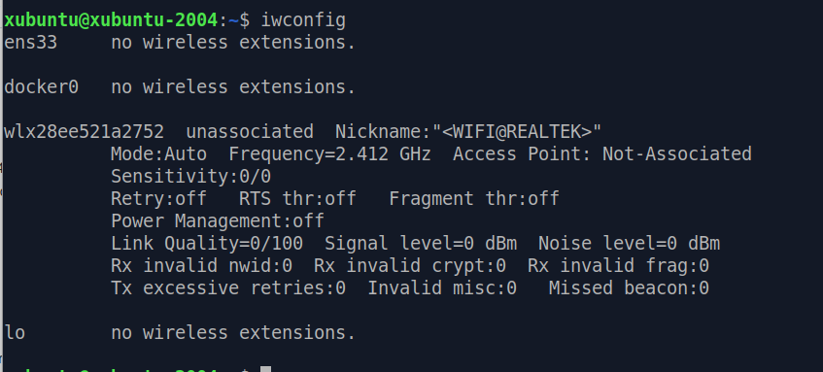

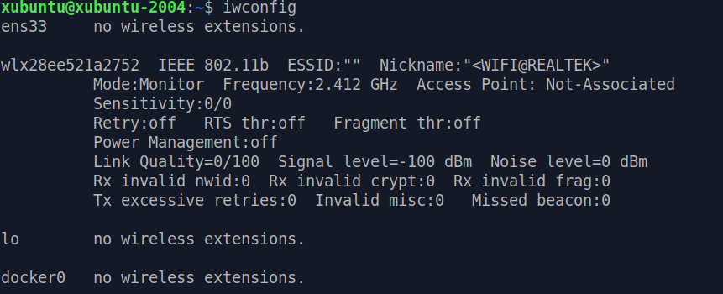

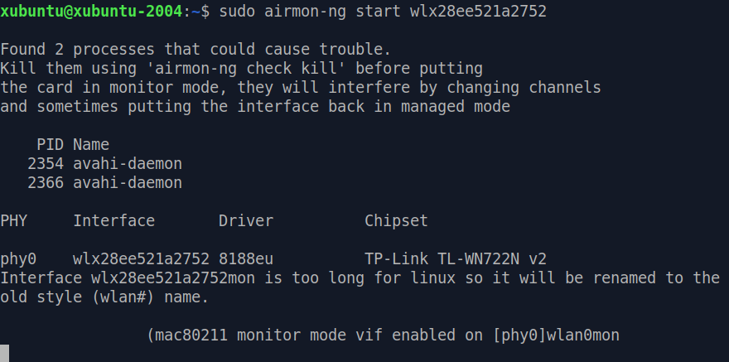

Start

Input: sniff air for network scanning

Output: cosume more energy

If the devices is connected to AP

Calculate power consumption

Then disconnec using DDoS attack (by sending different packets)

Claculate power consumption

Else connect to F-Aps

Then monitor packets of the smart home devices

Send malicous attacks

Calculate power consumption

End

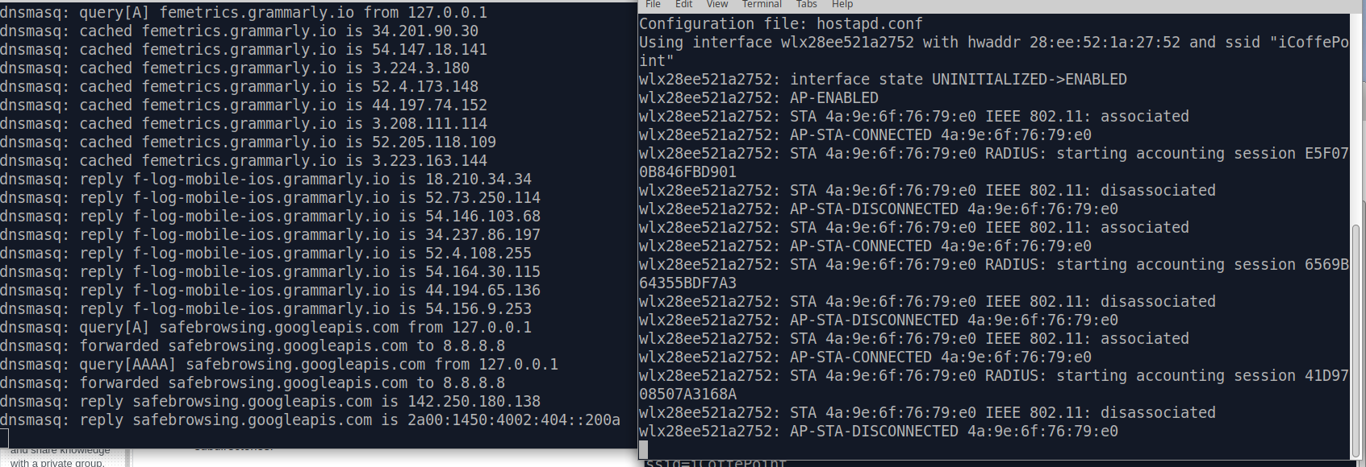

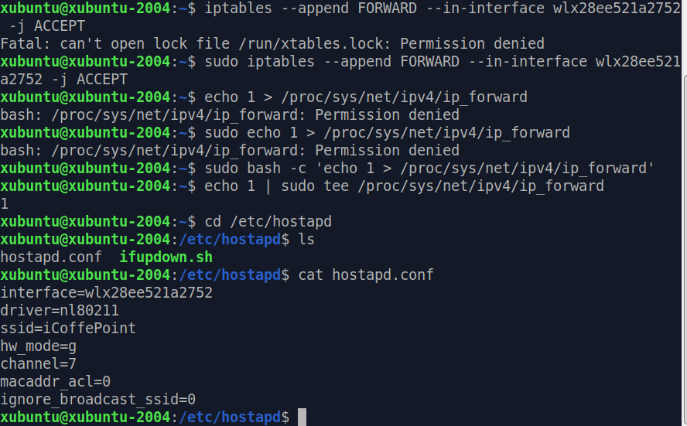

Wlx28ee521a2752

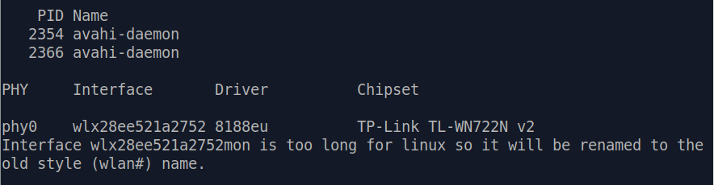

Raspberry pi scan

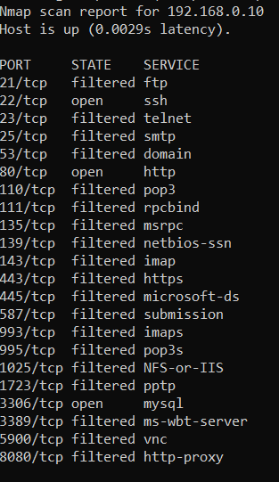

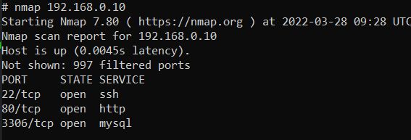

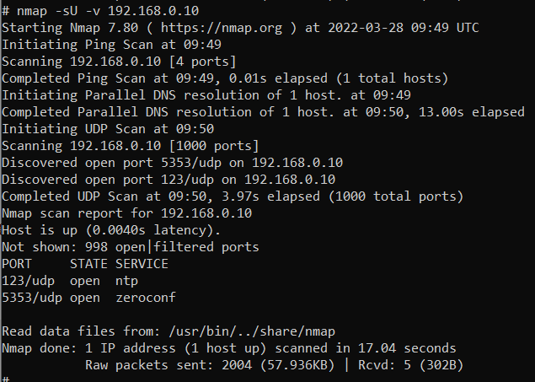

Arduino

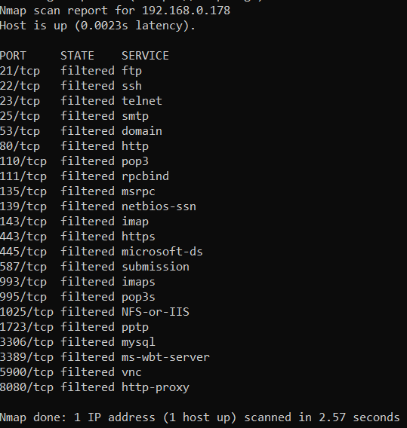

Raspberry pi

