* **key features offered by Corefactors Teleduce:**

1. **Lead Management:** Corefactors Teleduce allows you to capture leads from multiple sources such as web forms, emails, and social media. It provides lead scoring, lead assignment, and lead nurturing capabilities to help you manage and prioritize leads effectively.
2. **Contact Management:** With Teleduce, you can store and manage contact information in a centralized database. It enables you to track interactions, maintain customer profiles, and segment contacts based on various criteria.
3. **Sales Pipeline Management:** Teleduce helps you track and manage your sales opportunities through different stages of the sales pipeline. It provides visibility into the sales process, allowing you to monitor progress, forecast revenue, and identify bottlenecks.
4. **Email Marketing Automation:** Teleduce offers email marketing automation features to streamline your email campaigns. It includes functionalities such as email templates, email scheduling, and automated follow-ups. It also provides insights into email open rates, click-through rates, and other metrics.
5. **SMS Marketing Automation:** In addition to email automation, Teleduce allows you to automate SMS campaigns. You can send personalized SMS messages to your leads and contacts, schedule SMS campaigns, and track SMS delivery and response rates.
6. **Call Tracking and Analytics:** Teleduce provides call tracking features that enable you to track and analyze incoming and outgoing calls. It helps you measure call effectiveness, monitor call durations, and gather data for better customer engagement.
7. **Task and Activity Management:** Teleduce helps you manage tasks, appointments, and follow-ups related to sales and marketing activities. It allows you to set reminders, assign tasks to team members, and track task completion.
8. **Reporting and Analytics:** Teleduce provides reporting and analytics features to track key sales and marketing metrics. It offers various pre-built reports and custom reporting options, allowing you to gain insights into campaign performance, lead conversion rates, and more.
9. **Auto Email template generator:**
10. **Email & SMS Scheduling**

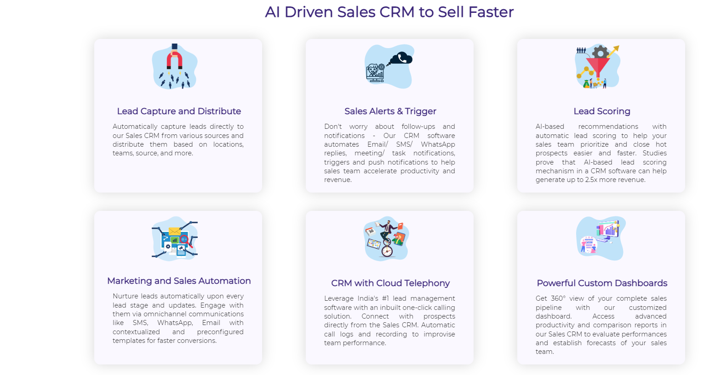

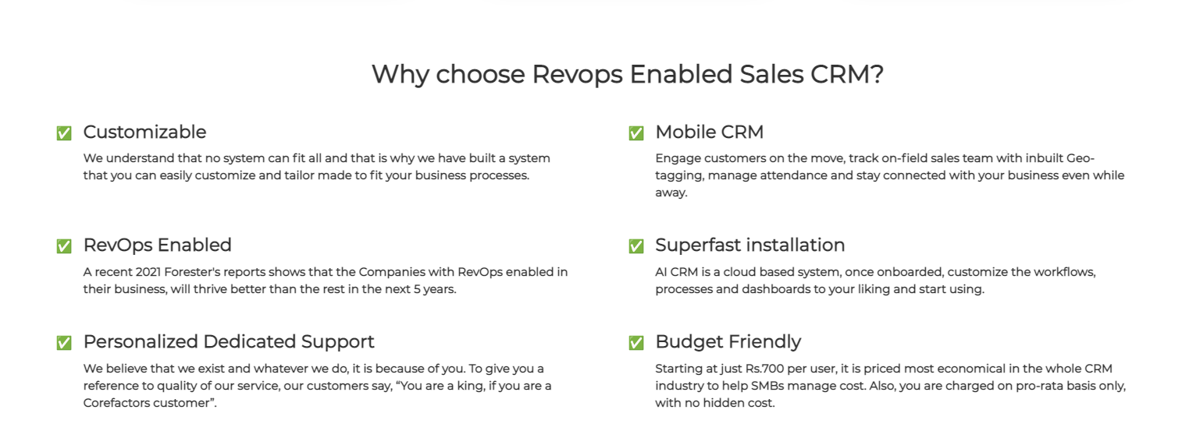

* **RevOps (Revenue Operations)** enabled CRM refers to a CRM system that integrates and aligns sales, marketing, and customer success teams to optimize revenue generation and customer lifecycle management. It focuses on breaking down silos, improving collaboration, and leveraging data-driven insights to drive revenue growth. Here are some key features.

**typically associated with RevOps enabled CRM:**

1. **Data Integration and Centralization: The** CRM consolidates data from various sources, such as marketing automation platforms, customer support systems, and sales tools, into a centralized database. This ensures a single source of truth and enables better visibility into customer interactions.
2. **Sales and Marketing Alignment:** RevOps CRM facilitates alignment between sales and marketing teams by providing shared visibility into customer data, campaigns, and lead management. It enables collaboration, streamlines lead handoff processes, and helps align marketing efforts with sales goals.
3. **Revenue Analytics and Reporting:** The CRM provides comprehensive analytics and reporting capabilities to track revenue-related metrics, conversion rates, sales pipeline health, and campaign performance. It helps identify bottlenecks, optimize sales processes, and make data-driven decisions to drive revenue growth.
4. **Automated Workflows and Processes:** RevOps CRM automates and streamlines workflows and processes across sales, marketing, and customer success teams. It includes features like automated lead assignment, personalized email workflows, task automation, and automated customer onboarding processes.
5. **Customer Journey Tracking:** The CRM tracks and visualizes the customer journey from initial contact to conversion and beyond. It helps identify touchpoints, track customer interactions, and enables personalized engagement at each stage of the customer lifecycle.
6. **Revenue Forecasting:** RevOps CRM provides forecasting capabilities to predict future revenue based on historical data, pipeline analysis, and sales trends. It helps sales leaders make informed decisions, set realistic targets, and allocate resources effectively.

**AI and RevOps (Revenue Operations) enable CRM systems**

* **Lead Scoring and Qualification:** AI algorithms can analyze lead data and engagement patterns to assign scores based on the likelihood of conversion. This helps prioritize leads and focus efforts on high-quality prospects.
* **Predictive Analytics:** AI algorithms can leverage historical data and customer behavior to predict sales trends, identify upsell or cross-sell opportunities, and forecast revenue. This helps in making data-driven decisions and optimizing sales strategies.
* **Personalized Marketing Automation:** AI can enable dynamic content creation and targeted messaging based on individual customer preferences and behavior. This leads to personalized marketing campaigns and improved customer engagement.
* **Chatbots and Virtual Assistants:** AI-powered chatbots can handle basic customer inquiries, provide instant responses, and assist with lead qualification or support ticket resolution. Virtual assistants can automate repetitive tasks and offer recommendations to sales representatives.
* **Sales Pipeline Optimization:** AI algorithms can analyze sales data and provide insights into pipeline health, identify bottlenecks, and suggest actions to improve sales performance. This helps sales teams prioritize deals and close them faster.
* **Customer Sentiment Analysis:** AI algorithms can analyze customer feedback, social media mentions, and support interactions to gauge customer sentiment and identify areas for improvement. This helps in proactive customer engagement and reducing churn.
* **Revenue Attribution:** RevOps-focused CRM systems provide visibility into revenue attribution across different marketing and sales activities, allowing for better tracking of the impact of marketing campaigns and sales efforts on revenue generation.
* **Data Integration and Centralization:** CRM systems with RevOps enablement integrate data from various sources (e.g., marketing automation platforms, customer support systems) to provide a unified view of customer interactions and revenue generation.
* **Collaboration and Alignment:** RevOps CRM systems foster collaboration among sales, marketing, and customer success teams by providing shared access to customer data, communication history, and task management capabilities.

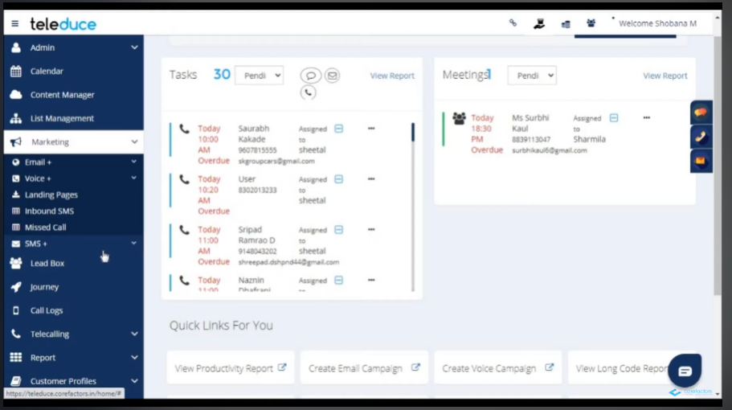

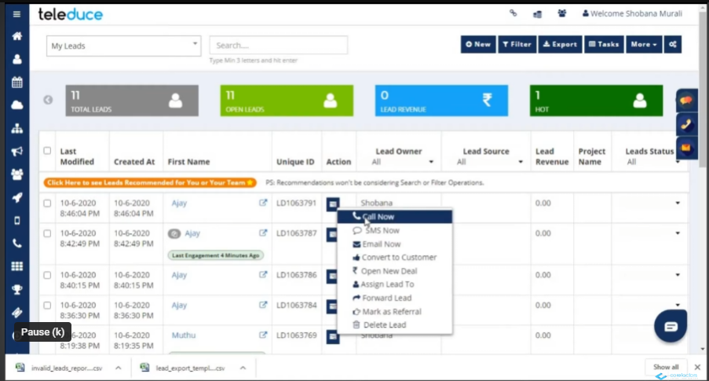

**Auto Email template generator:**

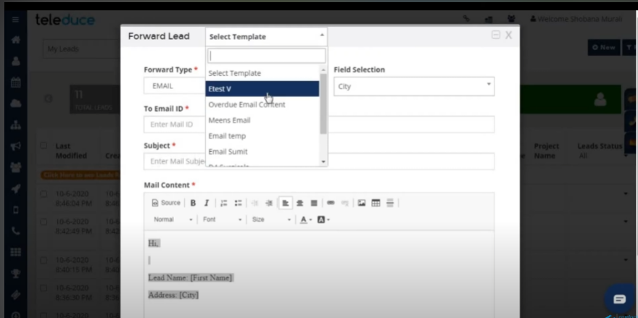

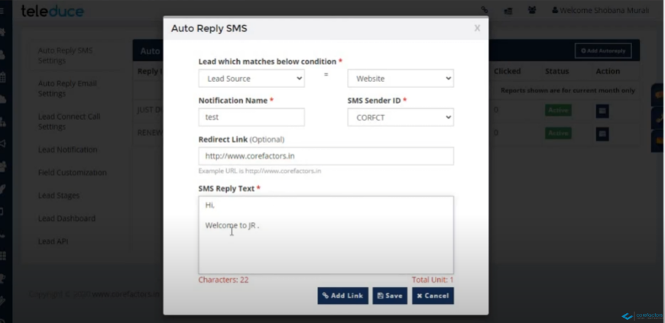

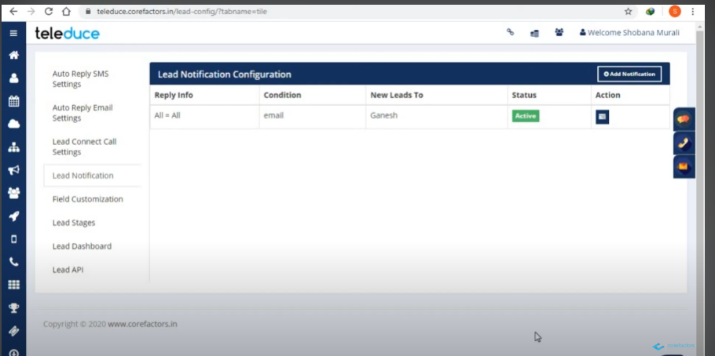

**Some CRM API’s**

1. **Corteza:** Corteza is an open-source CRM and low-code platform built with Node.js. It offers features like contact management, lead management, case management, and customizable modules. It provides REST APIs and integrates with various third-party systems.
2. **Zurmo:** Zurmois an open-source CRM platform written in PHP but offers a RESTful API that can be used with Node.js. It includes features like lead management, contact management, opportunity management, andworkflow automation.
3. **Vtiger CRM:** Vtiger CRM is a popular CRM platform that provides REST APIs for integration with Node.js applications. It offers features such as contact management, lead management, sales pipeline management, and marketing automation.
4. **OroCRM:** OroCRM is an open-source CRM platform written in PHP, but it provides a REST API that can be used with Node.js. It offers features like customer management, sales and marketing automation, and reporting.

**AI libraries in NodeJS**

**1.TensorFlow.js:** TensorFlow.js is the JavaScript version of the popular TensorFlow library. It allows you to build and deploy machine learning models directly in the browser or on Node.js. TensorFlow.js provides a range of tools and pre-trained models that can be used for tasks like sentiment analysis, customer behavior prediction, and recommendation systems.

**2.Brain.js:** Brain.jsis a lightweight machine learning library for Node.js. It provides neural networks and a simple API for creating and training models. Brain.js can be used for CRM applications such as customer segmentation, churn prediction, and lead scoring.

**3.Natural Language Understanding (NLU) Libraries:** For CRM tasks involving natural language processing, Node.js has libraries like Natural, NLP.js, and Compromise. These libraries offer features like tokenization, part-of-speech tagging, named entity recognition, and sentiment analysis. They can be used for tasks like customer feedback analysis, sentiment analysis, and chatbot development.

**4.Node.js Data Analysis Libraries:** Libraries such as NumJS, ndarray, and math.js provide numerical computing capabilities in Node.js. They offer functionalities for data manipulation, statistical analysis, and linear algebra. These libraries can be used for CRM tasks like customer segmentation, customer value analysis, and predictive modeling.

**5.Apache MXNet:** Apache MXNet is an open-source deep learning framework that supports Node.js. It provides a high-level API for building and training deep learning models. MXNet can be used for various CRM tasks like image recognition, customer sentiment analysis from images, and personalized recommendations.

**6. Synaptic:** Synaptic is a powerful neural network library for Node.js. It provides a high-level interface for creating and training neural networks, as well as support for various neural network architectures and learning algorithms.

**7.Compromise:** Compromise is an NLP library for Node.js that focuses on language understanding and manipulation. It provides tools for tokenizing, parsing, and analyzing text, and supports features such as part-of-speech tagging, noun phrase extraction, and sentiment analysis.

**8.OpenAI GPT-3:** OpenAI GPT-3 is a state-of-the-art language model that can generate human-like text. Although GPT-3 itself is a cloud-based service, there are Node.js libraries and SDKs available that allow you to interact with the GPT-3 API and leverage its capabilities in your applications.

**9.** **Personalized Recommendations:**

Use collaborative filtering or other recommendation algorithms to provide personalized product or content recommendations to customers.

**Example code:**

const collaborativeFiltering = require('collaborative-filtering');

// Assuming you have customer and product data for collaborative filtering

const customerData = require('./customerData.json');

const productData = require('./productData.json');

// Train the collaborative filtering model

const model = collaborativeFiltering.train(customerData, productData);

// Get recommendations for a specific customer

const customerId = '12345';

const recommendations = collaborativeFiltering.getRecommendations(model, customerId);

console.log('Recommendations:', recommendations);

**Detail overview corefactors:**

https://www.youtube.com/watch?v=oiKa7TBlHbY&ab_channel=Corefactors